|  |
| --- |
|  |
| Report |
|  |
|  |
|  |
|  |

|  |
| --- |
|  |

Contents

Test Plan 2

Links 2

JavaScript 2

Login 2

Register 2

Post message 2

Justification of technologies used 3

W3C Validator 3

Index 3

About 4

Acts 4

Gallery 5

Dates 5

Login 6

Register 6

Index 7

Area of Further Development 8

Evaluation 8

# Test Plan

## Links

All links tested on all pages and all worked successfully.

## JavaScript

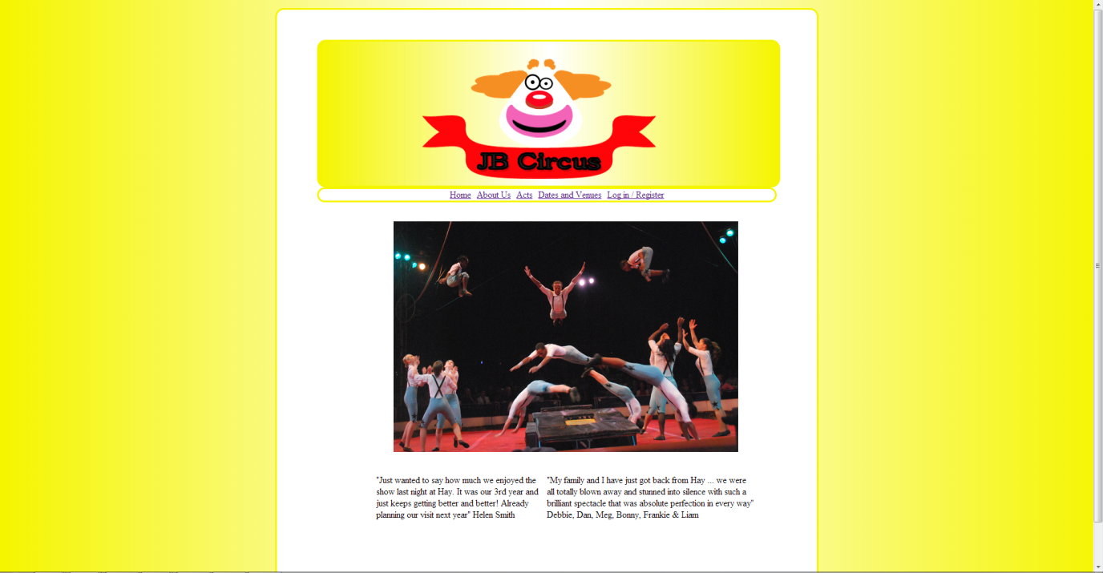

The screenshot above shows homepage which has a JavaScript slideshow starting with the first acrobatics image. The screenshot below shows the trapeze image as the JavaScript cycles through the images.

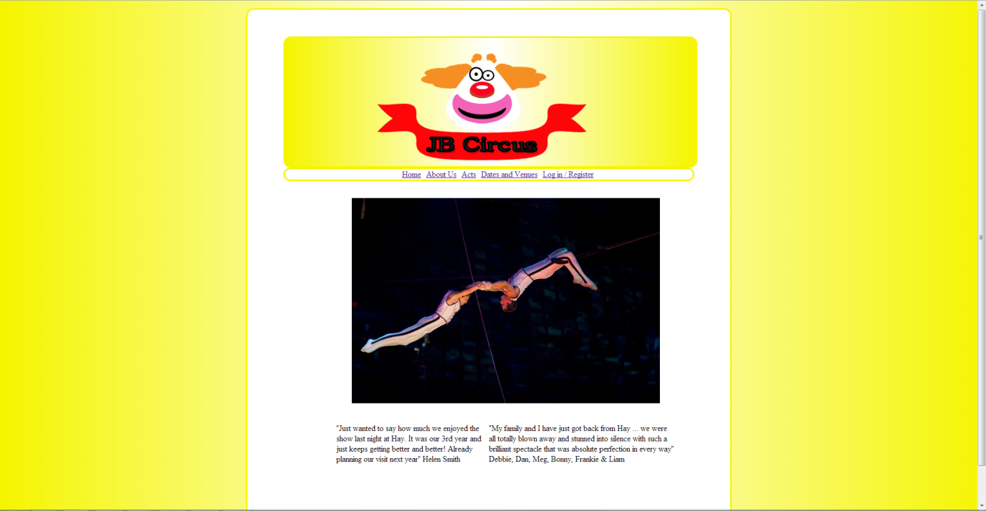

## Register

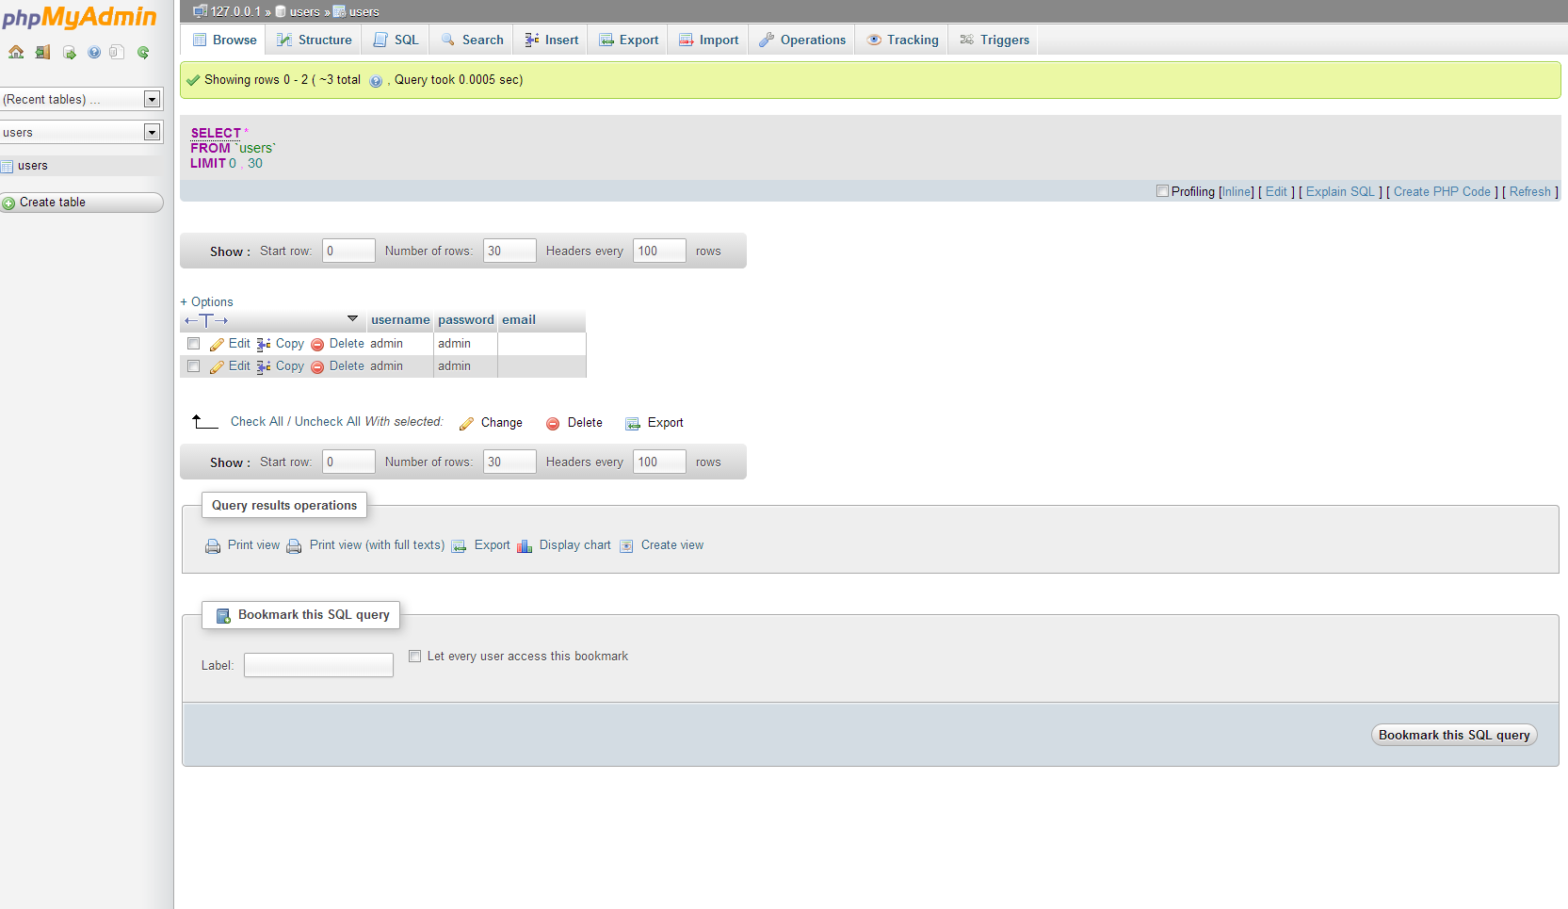

The screenshot above shows the users database before registering a new user. The screenshot below show the test data being entered into the register page on the website.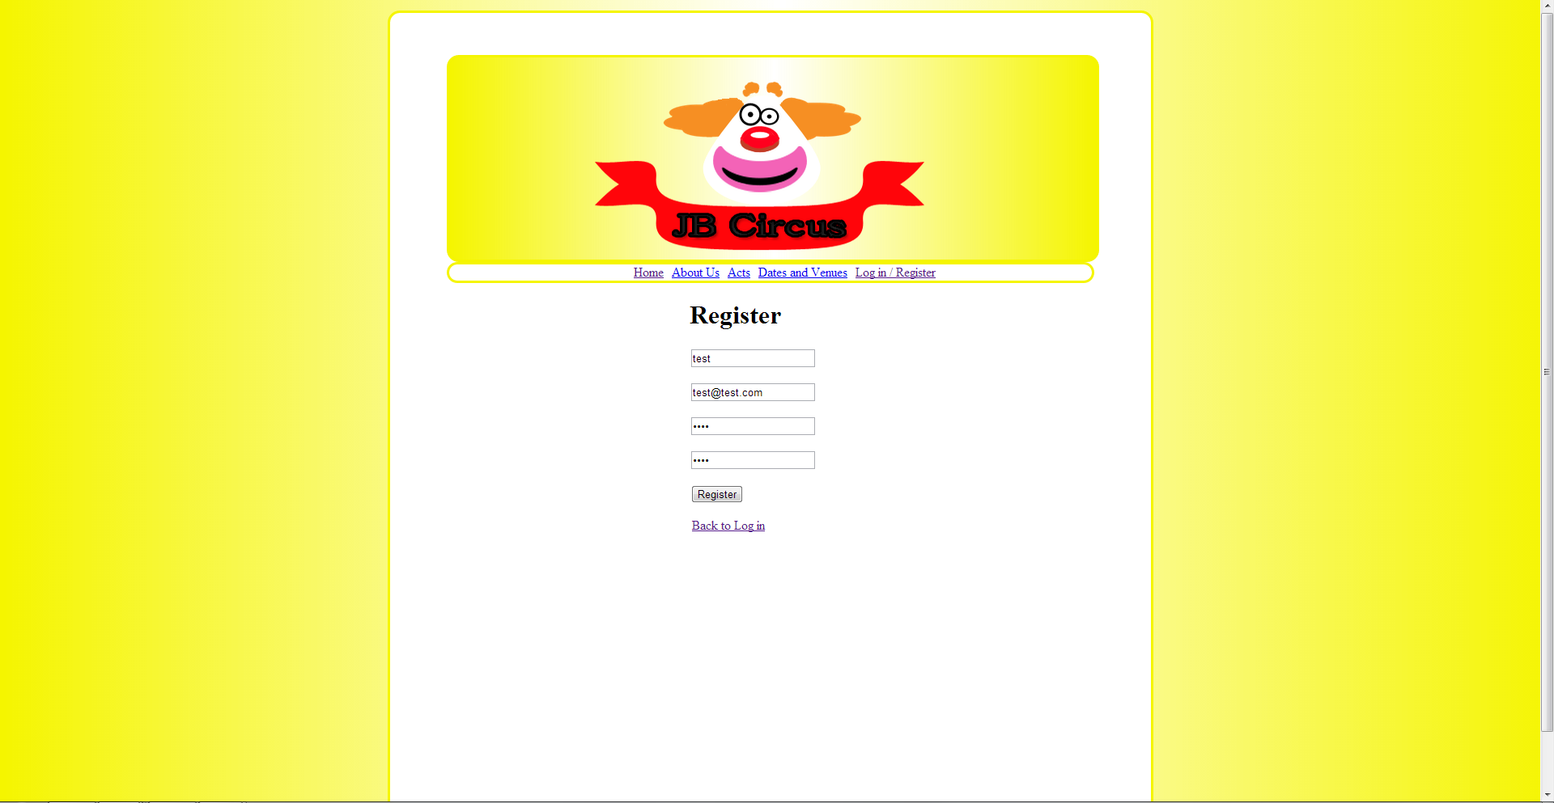

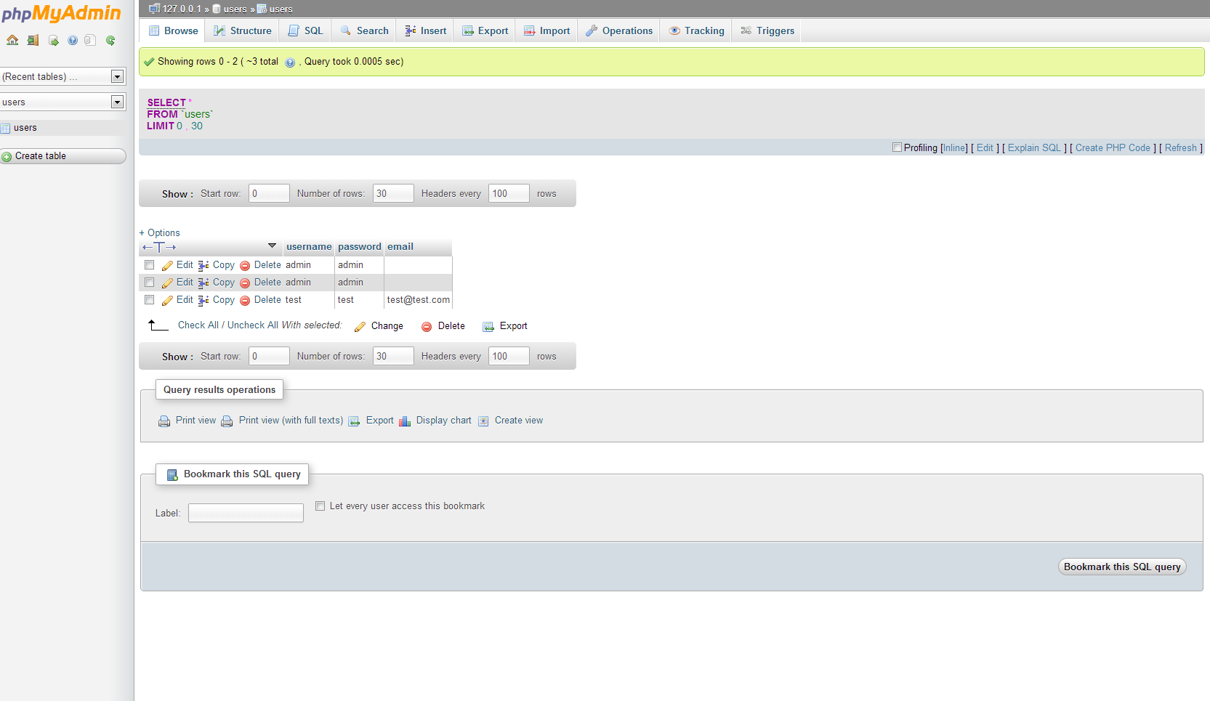

The screenshot above shows the successful registration of the test data.

## Login

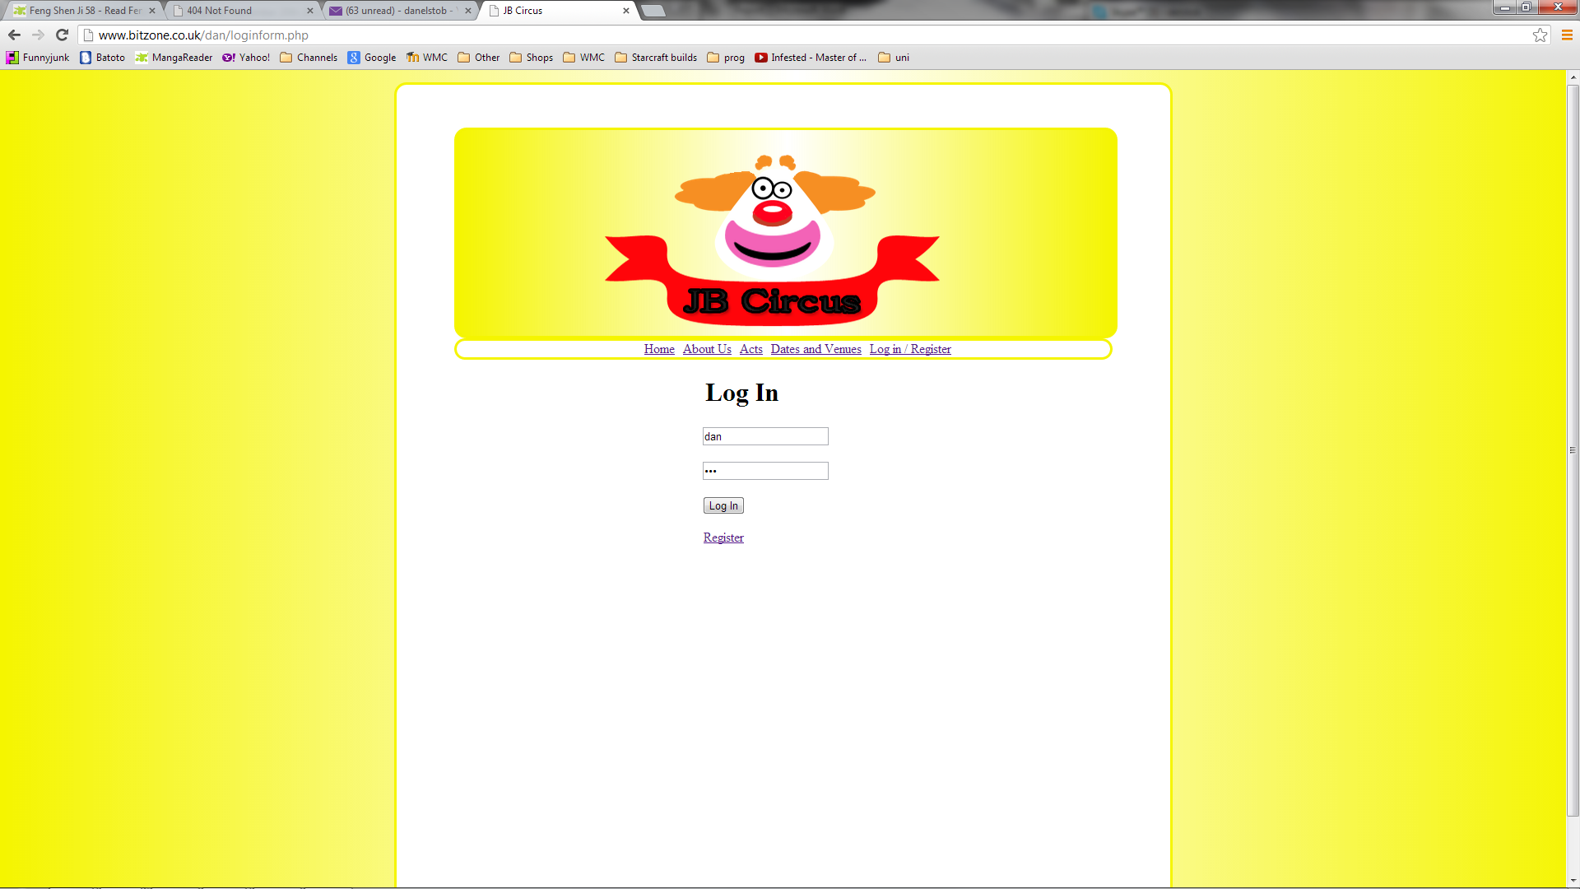

The screenshot above shows a registered user logging in. The screenshot below shows the successful log in which redirect the user to the members area to send a message.

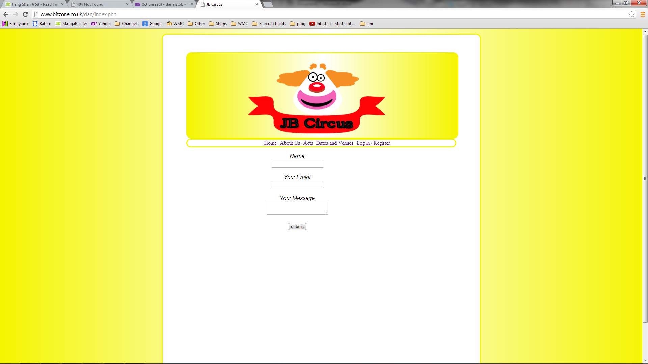

## Post message



The screenshot above shows the message form that a logged in user can access. The screenshot below show the test data being entered into the message form.

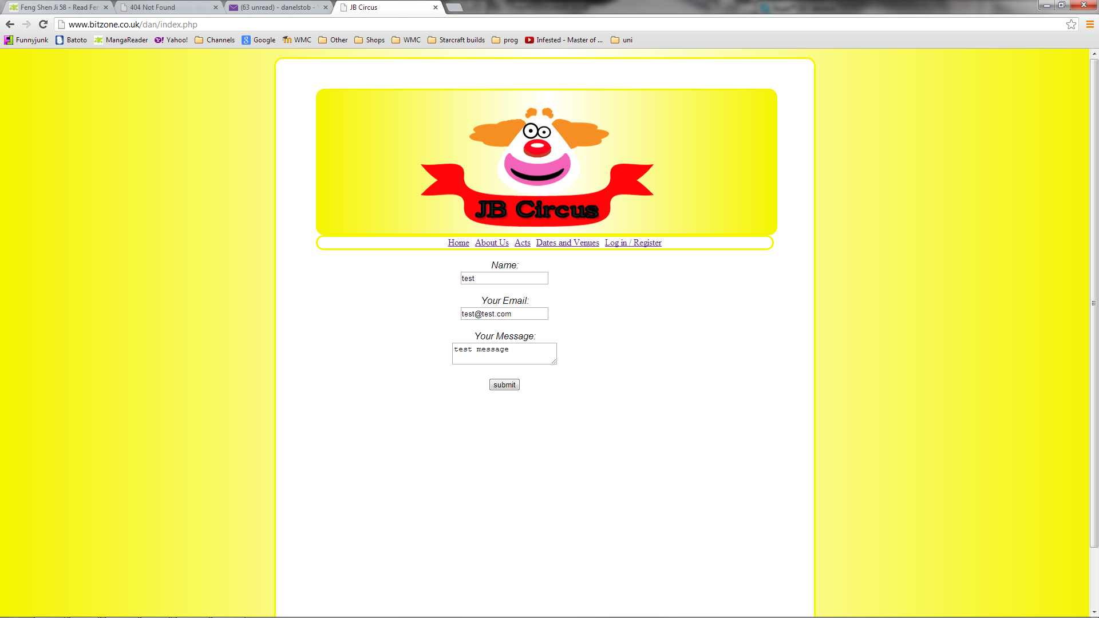

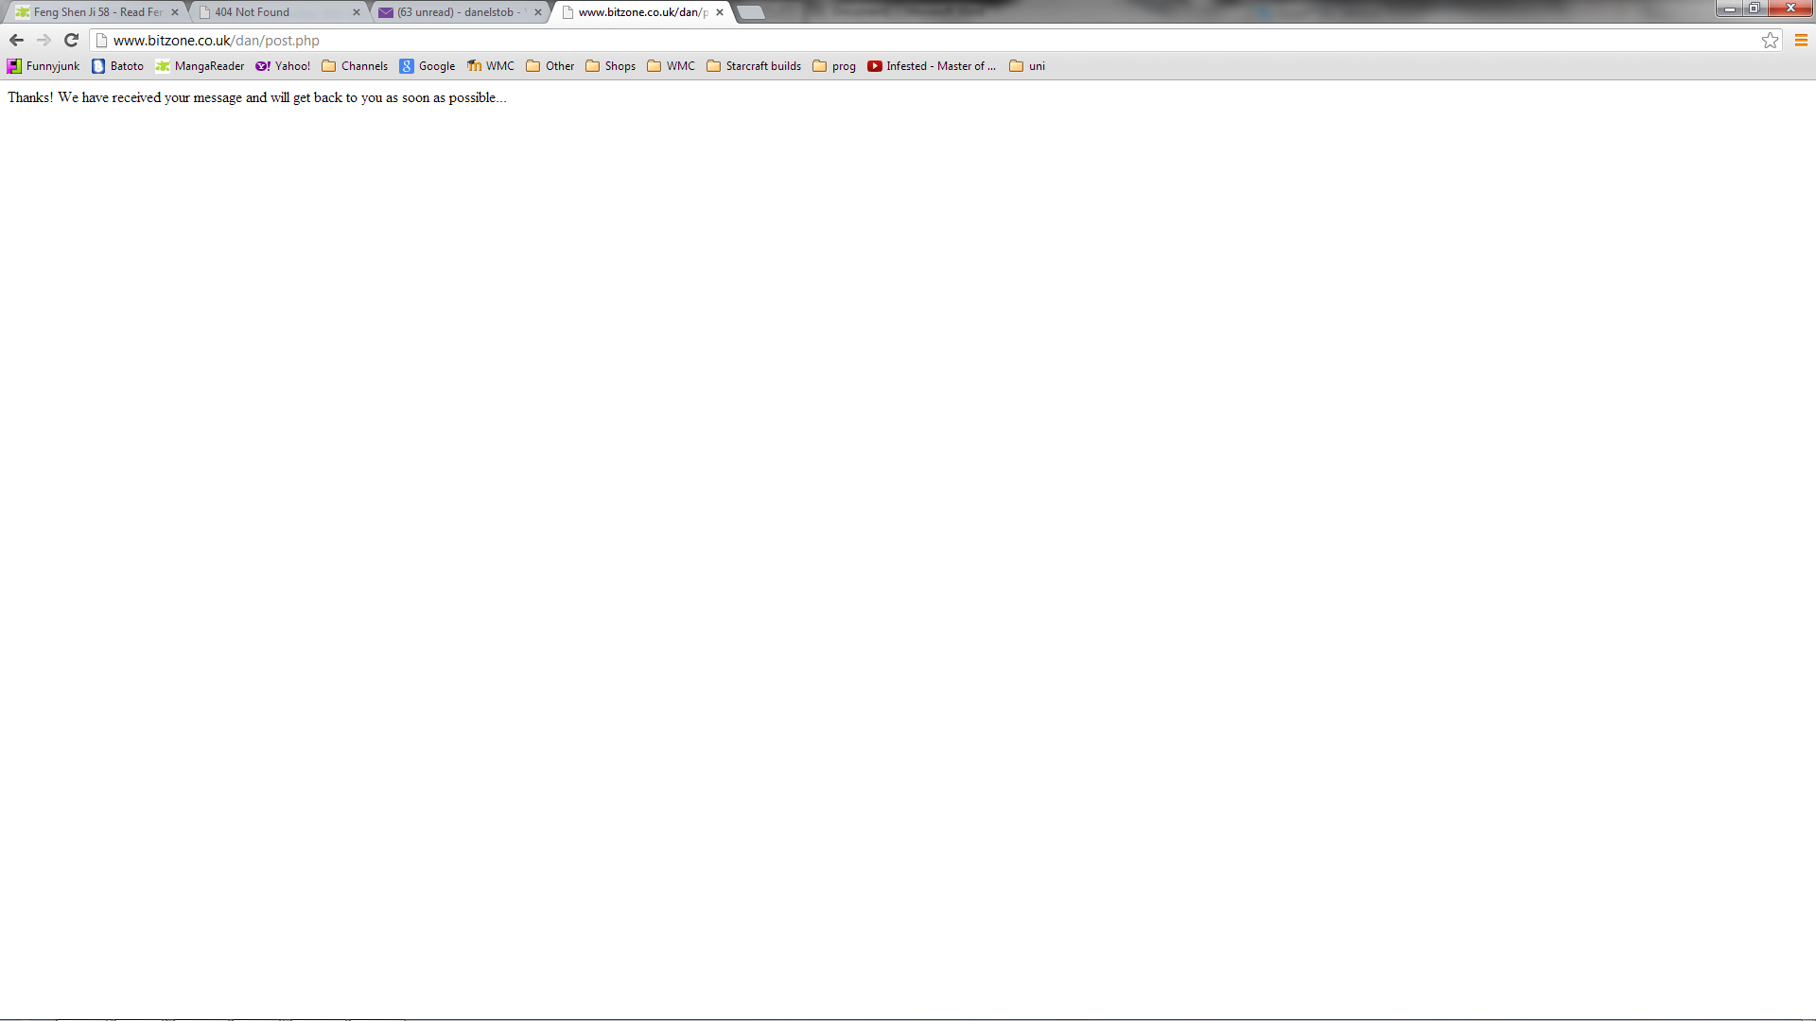

The screenshot above shows the message the user will receive is their message is successfully sent. The screenshot below shows the page the user is redirected to after the message is sent.

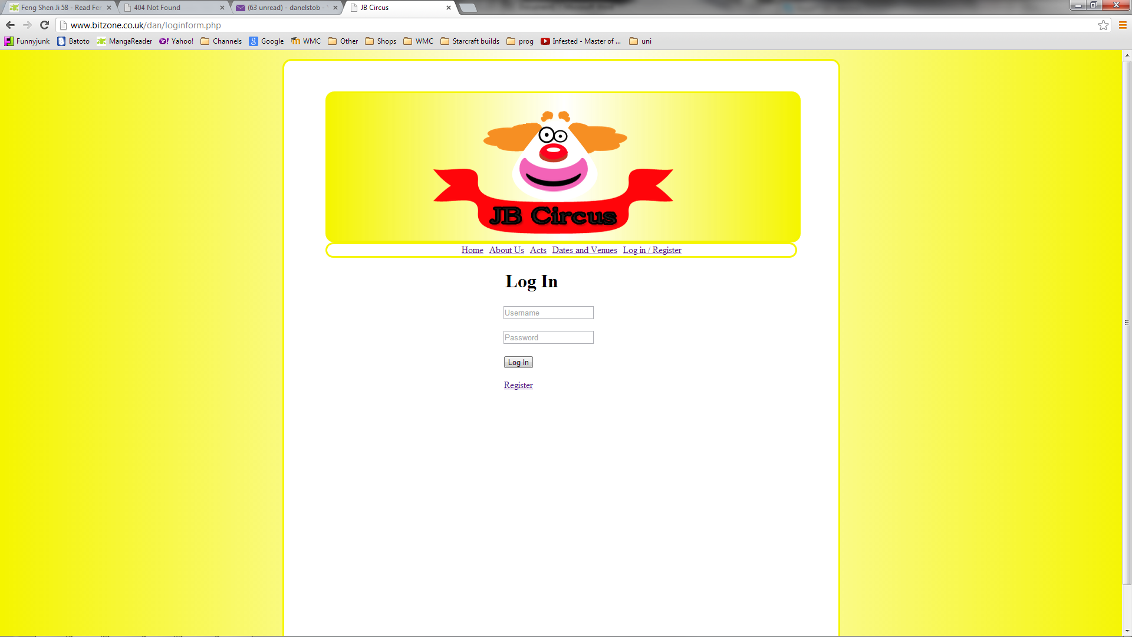

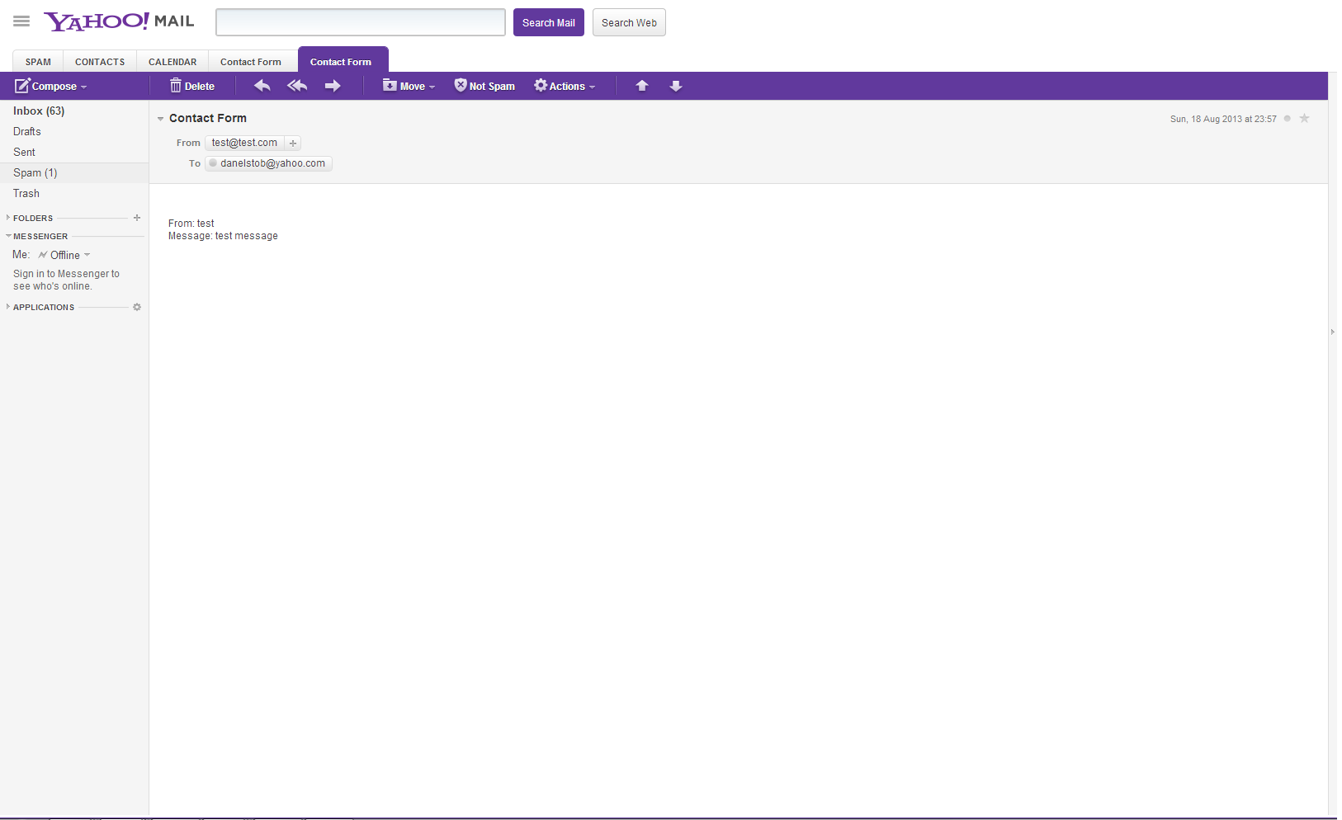

The screenshot above shows the message from the user confirming the message was sent.

# Justification of technologies used

The languages that I used to design and creating the website were HTML, CSS, PHP, SQL and JavaScript. HTML and CSS was used the design of the website as it provides many option to maintaining structure.

JavaScript was used to add more dynamic features to the website, specifically to the images on the homepage creating a slideshow. This allows the user to see some of the highlights of the circus as soon as they visit the website.

PHP is a very useful server side scripting language that provided features such as a login and register form that would allow users to gain addition features on the website. Another feature is the contact forms, only accessible to the members, which can send messages straight to the email specified in the code. This makes it useful as the client JB the Clown wanted the users contact about the circus in this way rather than a booking system and allowing him to reply to the messages through email.

SQL was used to create a database that would interact with the register and login forms to either store new users in the database or to read the usernames and passwords for the login.

# W3C Validator

Index –

<http://validator.w3.org/check?uri=http%3A%2F%2Fwww.bitzone.co.uk%2Fdan%2Findex.html>

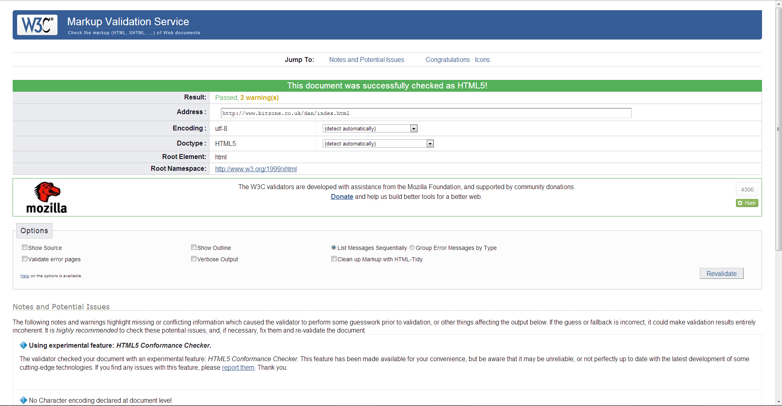

About - <http://validator.w3.org/check?uri=http%3A%2F%2Fwww.bitzone.co.uk%2Fdan%2Fabout.html>

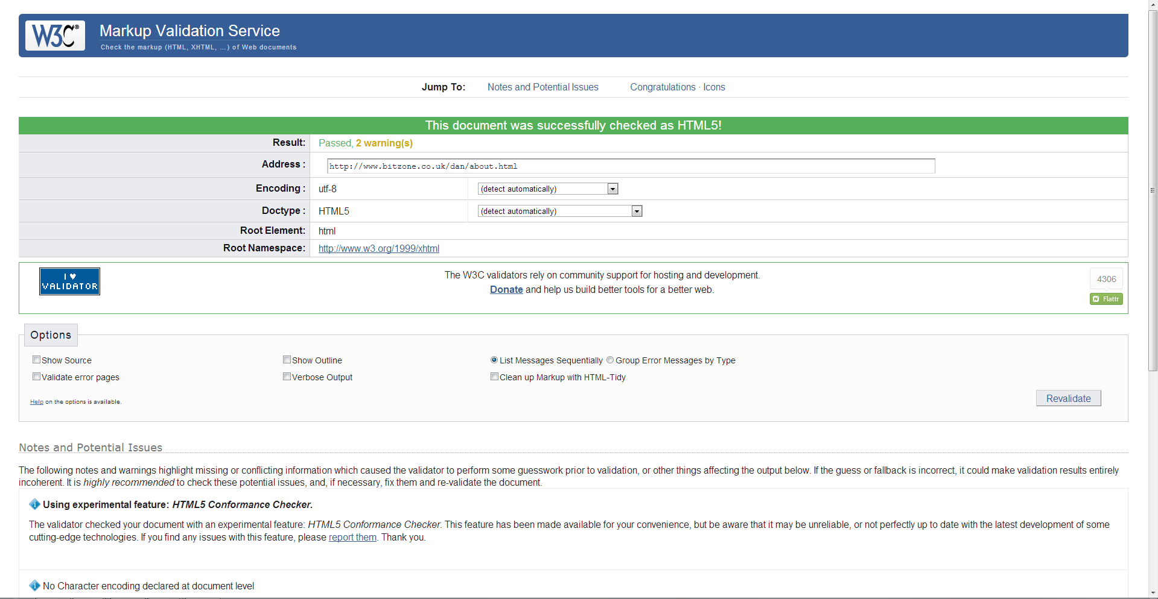

Acts - <http://validator.w3.org/check?uri=http%3A%2F%2Fwww.bitzone.co.uk%2Fdan%2Facts.html>

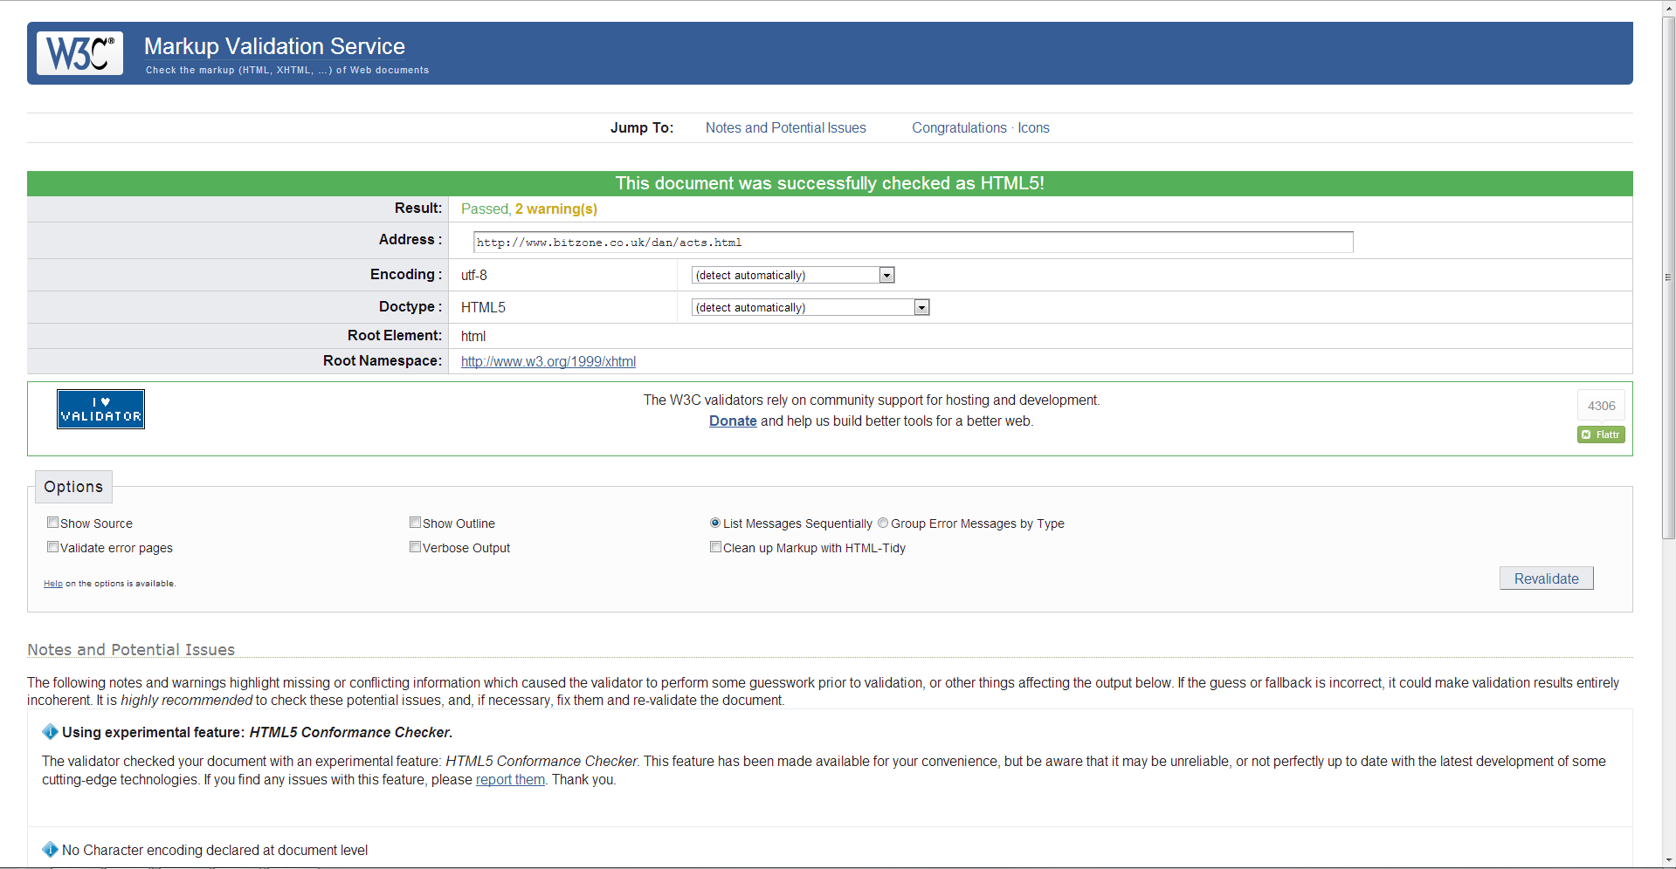

Gallery - <http://validator.w3.org/check?uri=http%3A%2F%2Fwww.bitzone.co.uk%2Fdan%2Fgallery.html>

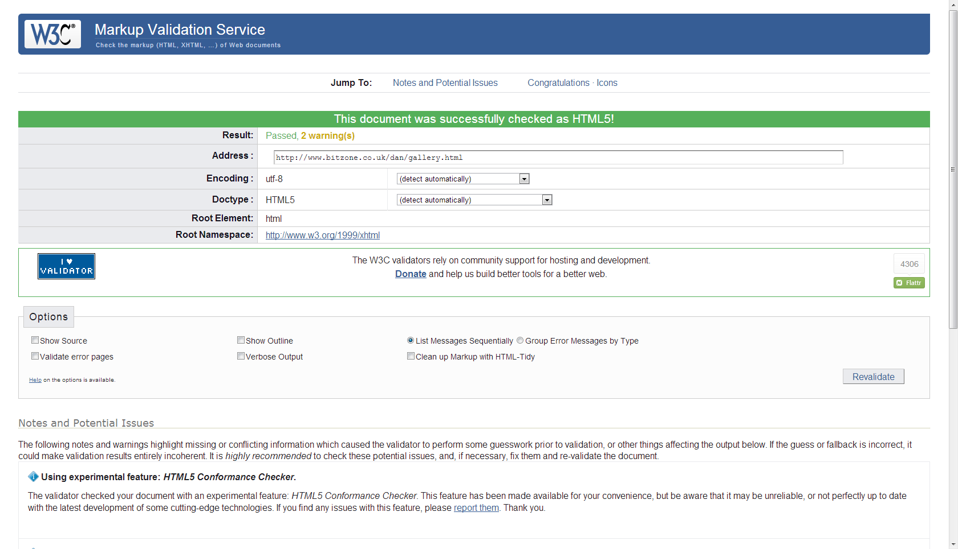

Dates - <http://validator.w3.org/check?uri=http%3A%2F%2Fwww.bitzone.co.uk%2Fdan%2Fdates.html>

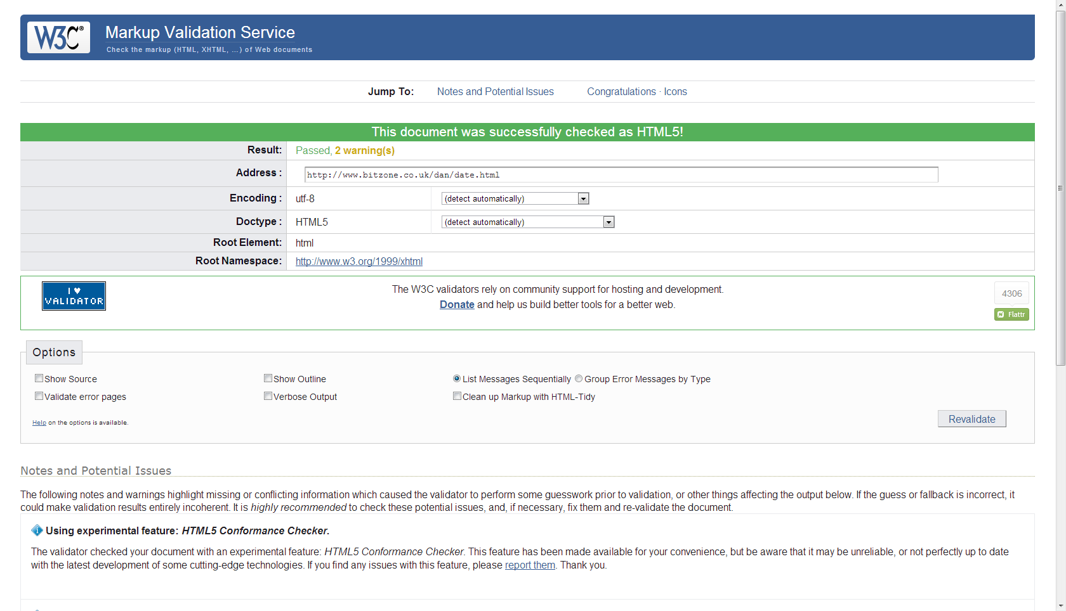

Login - <http://validator.w3.org/check?uri=http%3A%2F%2Fwww.bitzone.co.uk%2Fdan%2Floginform.php>

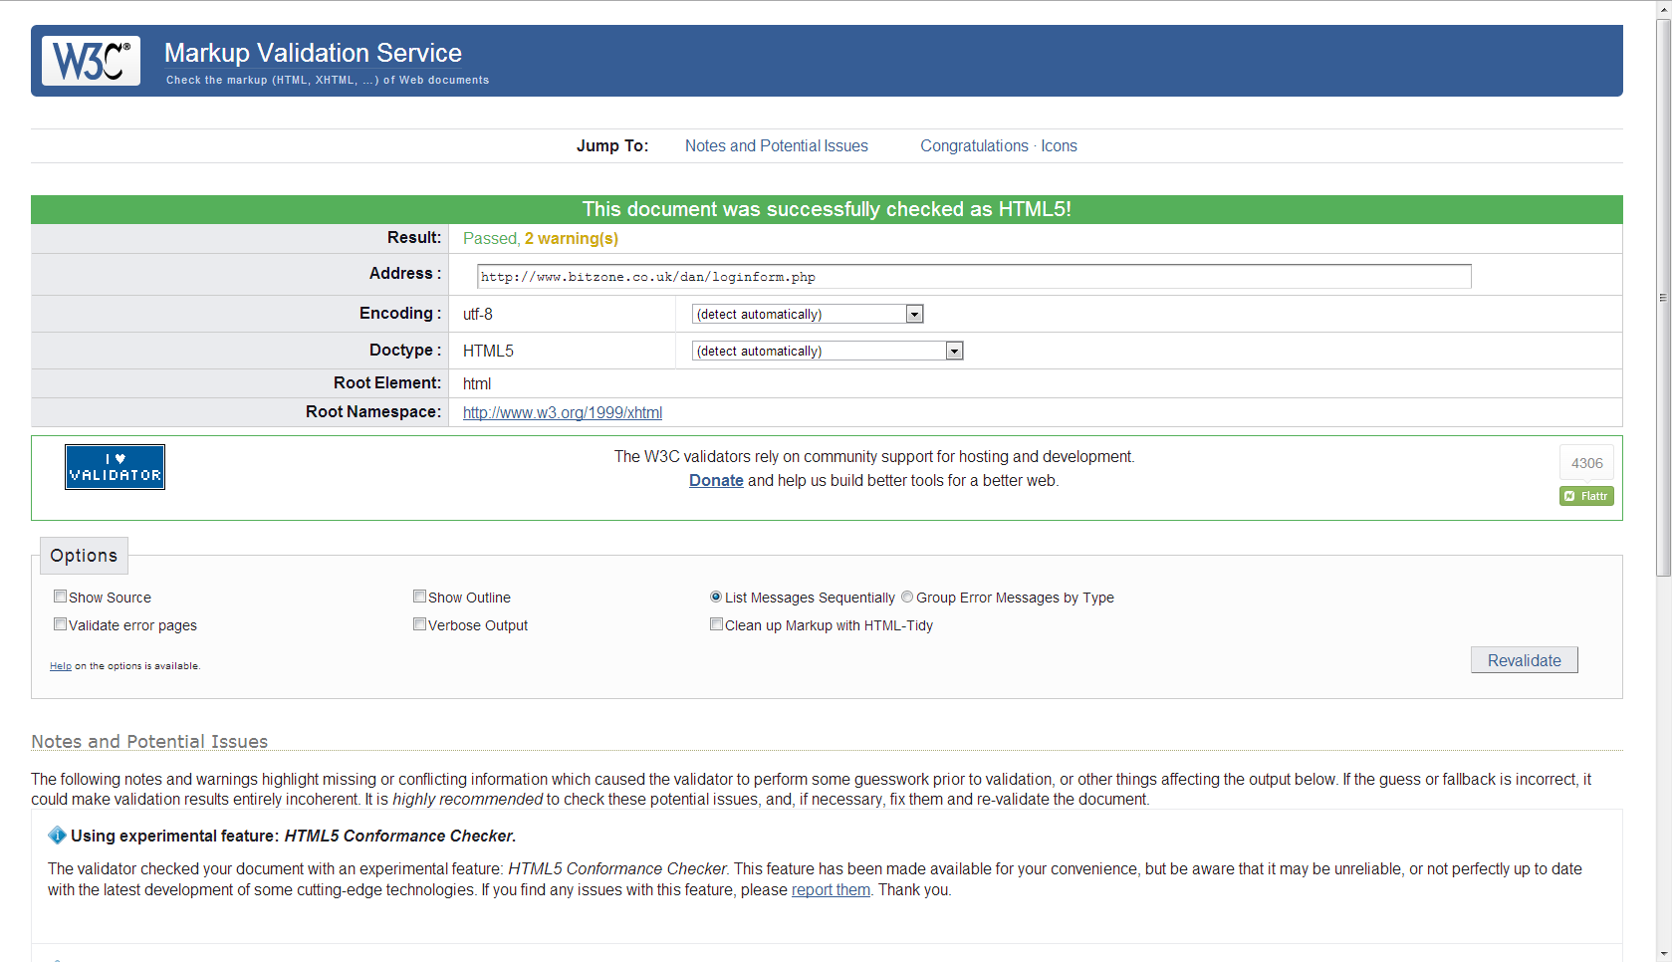

Register - <http://validator.w3.org/check?uri=http%3A%2F%2Fwww.bitzone.co.uk%2Fdan%2Fregister.php>

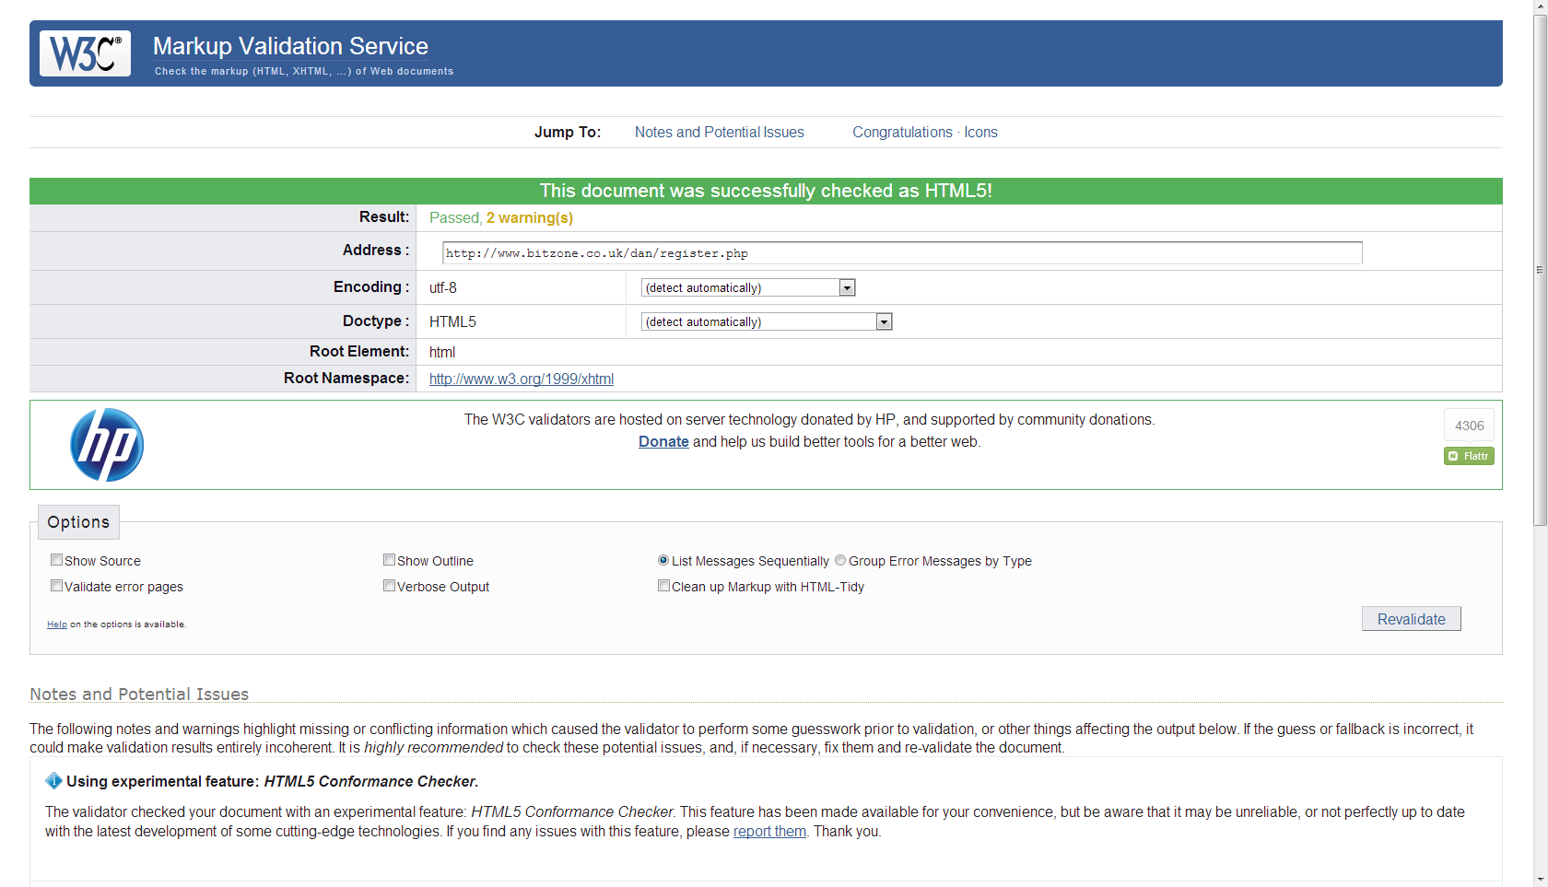

Index - <http://validator.w3.org/check?uri=http%3A%2F%2Fwww.bitzone.co.uk%2Fdan%2Findex.php>

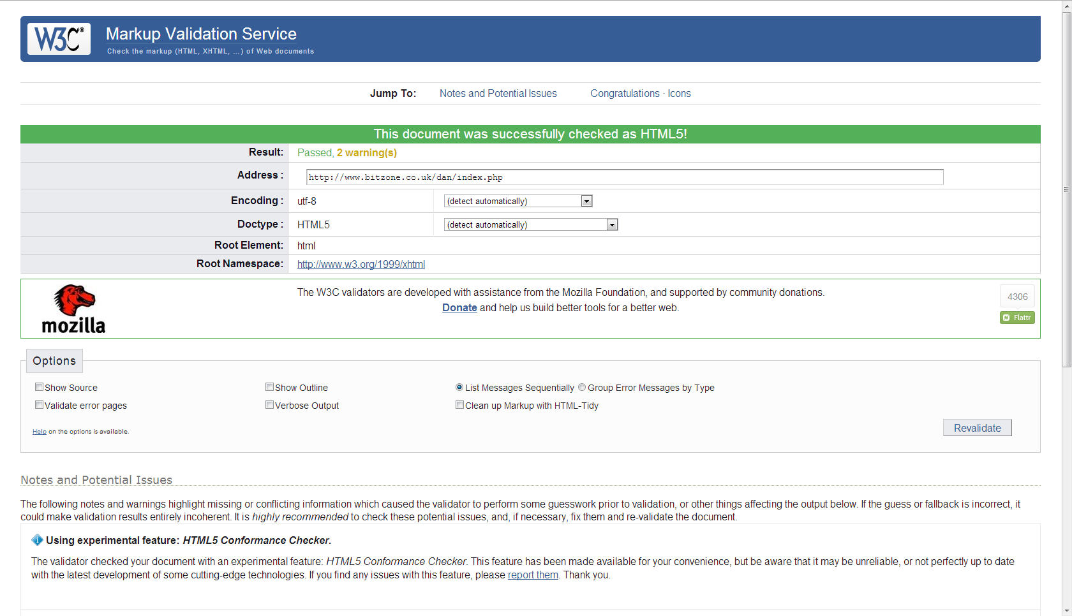

# Area of Further Development

If this website were to develop further one area that I would focus on is having a way for the user to log out from the message page. Although the user will be automatically log the user out when they have sent a message if they choose not to send one then they can’t log out.

# Evaluation

When first designing the website I had many different ideas about how the website should look and how it could be interacted with by the user. I started from a design point of view making it look good before adding in the scripting languages that would add features. Doing it this way meant that I encountered problems with the features and the design of the website and meaning I would have to figure out a compromise between the two.

The biggest issue of this was with the gallery page which was meant to use JavaScript to make the gallery more interactive however when I added it in the design of the website drastically changed. This was due to the script using a separate CSS to the website to create the interactive feature I wanted. I would have to choose between redesigning the website’s design as a whole to fit the design requirement of the script or remove the interactivity of the gallery to suit the website’s design. I chose to keep the website’s design however if I were to encounter this issue again I would either factor in the script to the design or redo the script and CSS so that it would override the website’s design and interfere with the consistency of the website.