|  |
| --- |
|  |
| Sonic Airlines |
| Daniel Elstob |
|  |
|  |
|  |

|  |
| --- |
|  |

Contents

Report 2

Chosen Relational Database Management System 2

Functionality of MSQL Server 2

Benefits of MSQL Server 2

Normalisation 2

Stored Procedures 3

Triggers 3

Views 3

Design Specification 4

Entity Attribute Relationship Diagram 4

Data Dictionary 5

tblCustomer 5

tblFlights 6

tblAircraft 7

tblPaymentDetails 8

tblBookings 9

tblAirport 10

Interface Designs 11

Homepage Interface Design 11

Forms Interface Design 12

Report Interface Design 13

# Report

## Chosen Relational Database Management System

The RDBMS that I have chosen to use is Microsoft SQL Server. I have chosen this for the relational database as it is as it is commonly used for businesses and can be used for both small businesses and larger organisations allowing the management of the company to centralise their data more easily and giving access to a large number of users at the same time.

## Functionality of MSQL Server

Microsoft SQL Server provides many more function options that can be used to improve the storage and collection of data. MSQL can be used to create tables, queries and reports and with the command that MSQL has it can create much more specific and complex queries to be exported the front end software Microsoft Access.

For example rather than creating a query in Access with a search for a keyword or phrase MSQL can used commands such as ‘COUNT’ which can count the different rows in a table or multiple table allowing for the business to find out how many customer records they have or flight for a specific period.

A tool that comes with MSQL Server 2012 is SQL profiler which is a function that can track actions performed within the database helping to troubleshoot any errors input.

## Benefits of MSQL Server

There are many benefits to using MSQL. One such benefit is stored procedures which are lines of code on the server that create queries, reports and views which can provide much more information to the users. Another benefit is the security of the database. The administrator can choose who can access certain areas of the database or make changes to the information in the tables and queries. This benefit will be important to the business as they will want to protect the customer information. The third benefit to MSQL server is that it has an automatic backup that will be useful if the data becomes corrupt or if data is changed and needs to be reverted.

## Normalisation

Normalisation would be a good thing for the management to do with the databases as it reduces the redundancy and dependency of a relational database. Normalisation can be done numerous times but normally databases will only be normalised to the 3rd form as at this point the tables will be free of insertion, update and deletion anomalies.

The first normal form sets the basic rules for a database. It eliminates duplicate columns from the same table and creates separate tables for each group of related data. It also uses a unique identifier such as a primary key.

The second normal form further addresses he removal of any duplicate data. As well as meeting all the requirements of the first normal form it will remove subset of data that apply to multiple rows of a table and place them into separate tables and create relationships with the new tables using foreign keys.

The third normal form goes another step further meeting all the requirements of the second normal form and removing columns that are not dependent upon the primary key.

Through the normalisation stages you will be able to turn one table with many columns into multiple tables with few columns that all have relationships with one another.

## Stored Procedures

Stored procedures are a set of SQL statements that can create queries views and report. The benefits from using a stored procedure are that it will provide much more flexibility in the complexity of the queries made. Using the commands available the user creating the queries will be able to choose what information they want, from which tables and how they will display the information. An example of this is if the manager wanted to know how many sales there where in a certain period or for which flights then a stored procedure can be created for this purpose.

## Triggers

A trigger is a procedural code that is executed automatically when certain events happen such as and ‘insert’ or ‘delete’ within the table. The trigger allows for responses to these changes such as email conformation to sales or if customer details change. The benefit to this would be that the manager could react to situations differently based of this information.

## Views

Views are the result of a stored query which can be used to limit the amount of information a user can have access to. An example of this is that if the manager of the business wanted a report that only contains certain private information such as the emails of the customers, by creating a view you can show only the information wanted rather than a table with card details and addresses.

# Design Specification

## Entity Attribute Relationship Diagram

Payment_ID Amount_Paid Payment_Date Payment_Type Card_Number Issue_Number Start_Date End_Date CV2 Name_On_Card Payment_Ref_Nmber Payment_Complete

tblPaymentDetails

tblCustomer

Customer_Ref_Number Forename Surname House_Number Address_1 Address_2 Postcode Date_Of_Birth Phone_Number Mobile_Number Email_Address

tblBookings

Booking_Ref_Number Customer_Ref_Number Flight_Number Payment_ID Date_Of_Booking Time_Of_Booking Price

tblAirport

Airport_ID Airport_Name Postcode Flight_Number

tblFlights

Flight_Number Aircraft_ID Departure Location Departure Date Departure Time Arrival Location Arrival Date Arrival Time Route

tbAircraft

Aircraft_ID Aircraft_Model Total_Seating Seating_Available

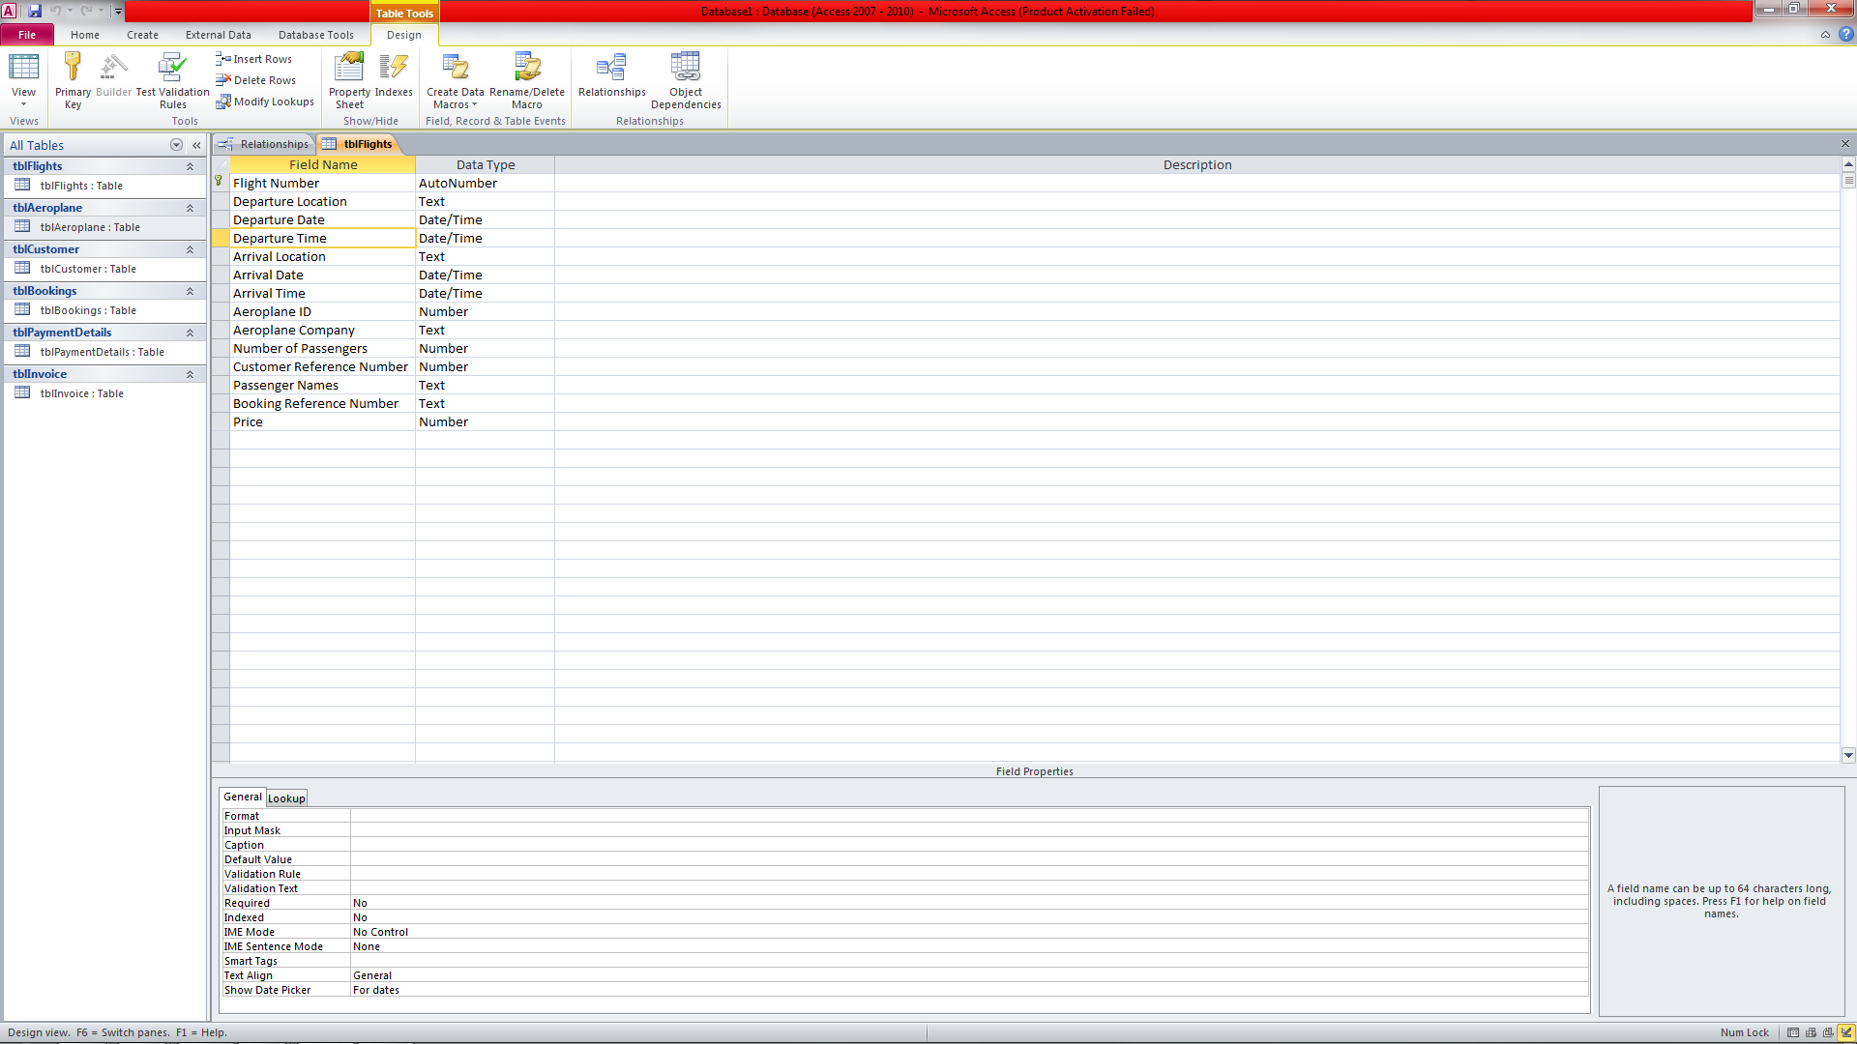













## Data Dictionary

### tblCustomer

|  |  |  |  |
| --- | --- | --- | --- |
| Field Name | Data Type | Input Mask | Validation |
| Customer_Ref_Number | int | n/a | n/a |
| Forename | nvarchar(25) | n/a | Not Like "*[!((a-z) or (A-Z))]*" |
| Surname | nvarchar(25) | n/a | Not Like "*[!((a-z) or (A-Z))]*" |
| House_Number | int | n/a | <0 |
| Address_1 | nvarchar(20) | n/a | n/a |
| Address_2 | nvarchar(20) | n/a | "Liverpool" |
| Postcode | text | >LL00\ 0LL;;_ | n/a |
| Date_Of_Birth | Date/Time | 00/00/00:00;00;_ | n/a |
| Phone_Number | nvarchar(8) | n/a | Not Like "*[!0-9]*" |
| Mobile_Number | nvarchar(11) | n/a | Not Like "*[!0-9]*" |
| Email_Address | varchar(50) | n/a | Like "*?@?*.?*" |

### tblFlights

|  |  |  |  |
| --- | --- | --- | --- |
| Field Name | Data Type | Input Mask | Validation |
| Flight_Number | varchar(50) | n/a | n/a |
| Aircraft_ID | int | n/a | n/a |
| Departure_Location | varchar(50) | n/a | n/a |
| Departure Date | Date/Time | n/a | n/a |
| Departure Time | Date/Time | 00:00;0;_ | n/a |
| Arrival Location | varchar(20) | n/a | n/a |
| Arrival Date | Date/Time | 00:00;0;_ | n/a |
| Arrival Time | Date/Time | n/a | n/a |
| Route | varchar(20) | n/a | n/a |

### tblAircraft

|  |  |  |  |
| --- | --- | --- | --- |
| Field Name | Data Type | Input Mask | Validation |
| Aircraft_ID | int | n/a | n/a |
| Aircraft_Model | varchar(20) | n/a | n/a |
| Total_Seating | nvarchar(3) | n/a | n/a |
| Seating_Available | nvarchar(3) | n/a | n/a |

### tblPaymentDetails

|  |  |  |  |
| --- | --- | --- | --- |
| Field Name | Data Type | Input Mask | Validation |
| Payment_ID | int | n/a | n/a |
| Amount_Paid | money | n/a | n/a |
| Payment_Date | Date/TIme | n/a | n/a |
| Payment_Type | varchar(50) | n/a | n/a |
| Card_Number | nvarchar(50) | n/a | n/a |
| Issue_Number | nvarchar(50) | n/a | n/a |
| Start_Date | Date/Time | n/a | n/a |
| End_Date | Date/Time | n/a | n/a |
| CV2 | nvarchar(50) | n/a | n/a |
| Name_On_Card | varchar(50) | n/a | n/a |
| Payment_Ref_Number | varchar(50) | n/a | n/a |
| Payment_Completed | text | n/a | n/a |

### tblBookings

|  |  |  |  |
| --- | --- | --- | --- |
| Field Name | Data Type | Input Mask | Validation |
| Booking_Ref_Number | int | n/a | n/a |
| Customer_Ref_Number | int | n/a | n/a |
| Flight_Number | varchar(50) | n/a | n/a |
| Payment_ID | int | n/a | n/a |
| Date_Of_Booking | date | n/a | n/a |
| Time_Of_Booking | time(7) | 00:00;00;_ | n/a |
| Price | money | n/a | n/a |

### tblAirport

|  |  |  |  |
| --- | --- | --- | --- |
| Field Name | Data Type | Input Mask | Validation |
| Airport_ID | int | n/a | n/a |
| Airport_Name | varchar(50) | n/a | n/a |
| Postcode | nvarchar(50) | >LL00\ 0LL;;_ | n/a |
| Flight_Number | Varchar(50) | n/a | n/a |

## Interface Designs

### Homepage Interface Design

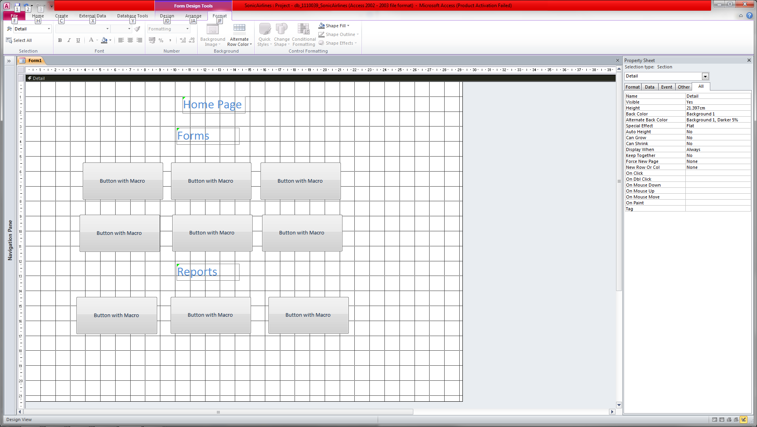

The homepage will be how the user navigates around the six forms and three reports. It will be similar to this design.

### Forms Interface Design

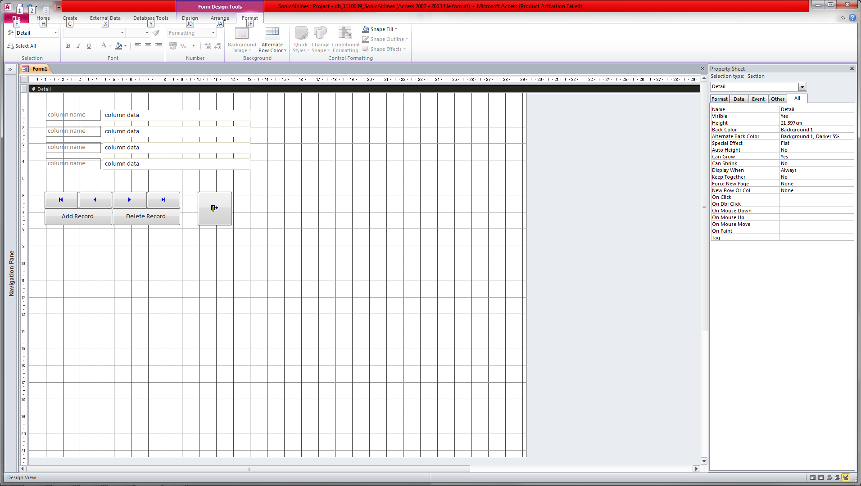

The forms will all have the same basic design so that the user will be able to navigate more easily and use the different macro button to view and change data more easily. Each form will display the table data in a clear format with the buttons bellow for the user to look through the records, to add a record or to delete a record. There will also be a button the close the form taking the user back to the homepage.

### Report Interface Design

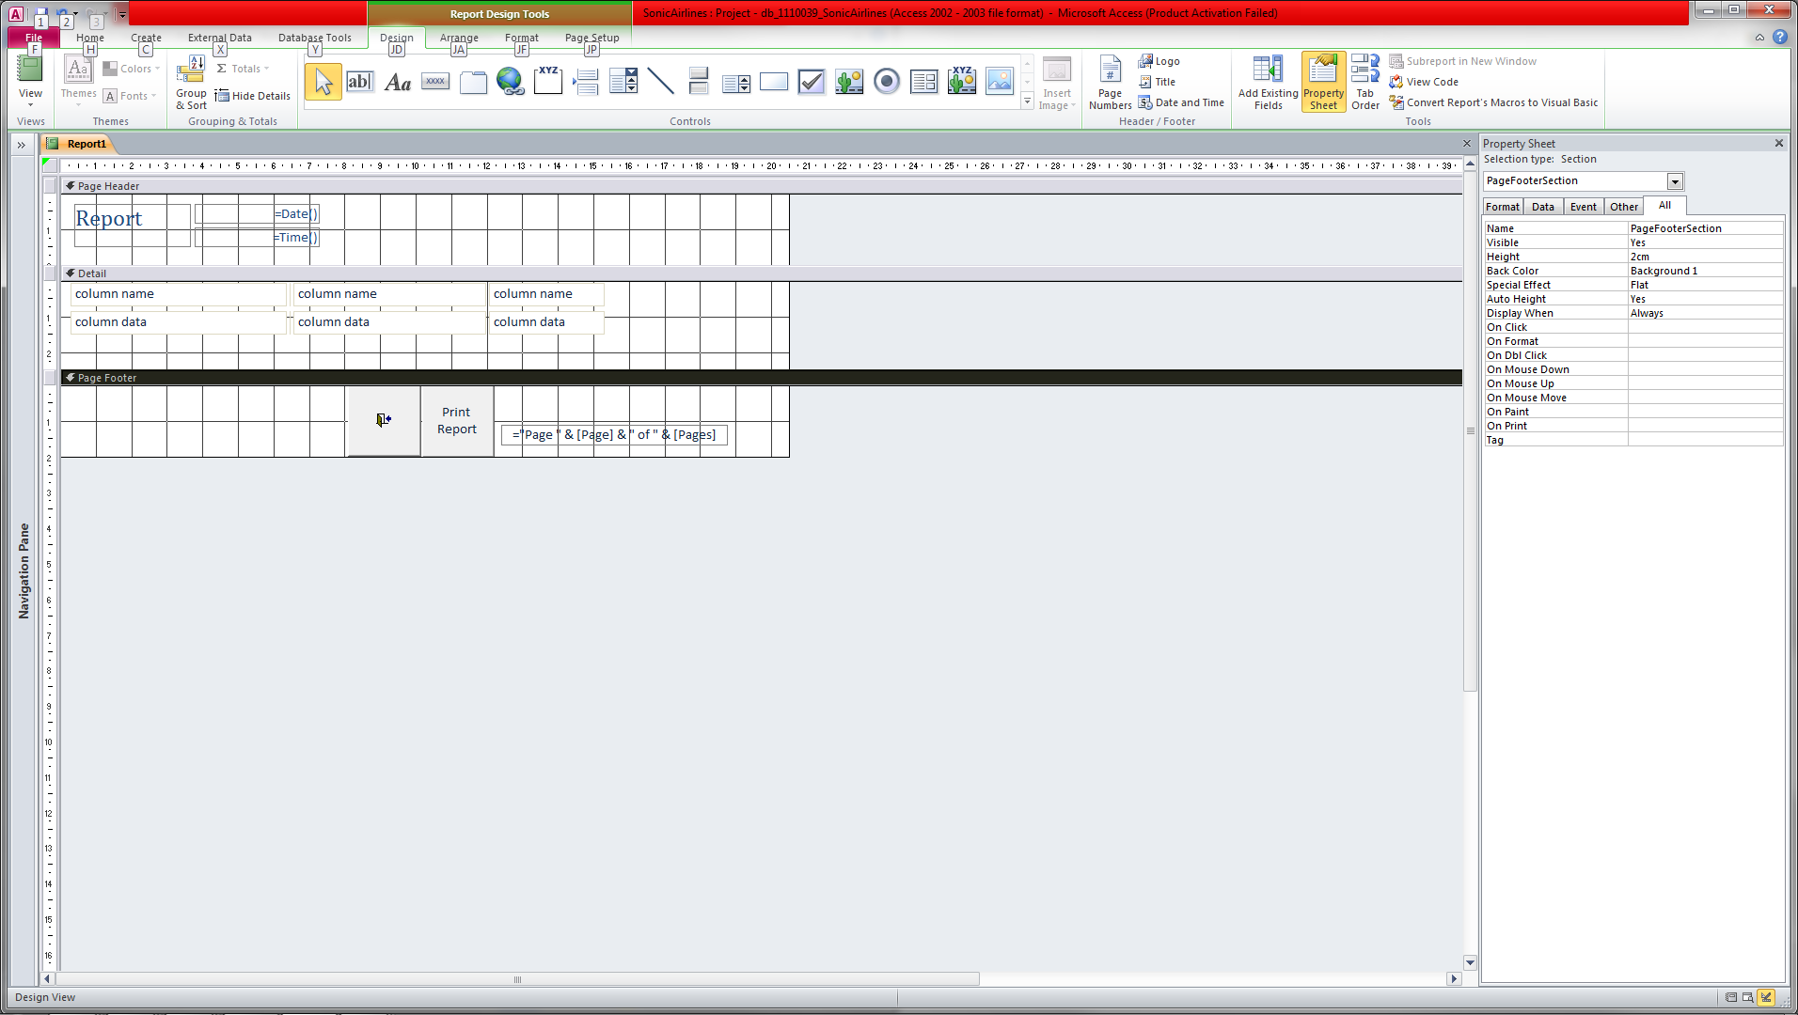

The reports will all have the same basic design so that the user will be able to navigate more. Each report will display the query data in a clear format with two buttons bellow for the user print the report or to close the report and go back to the homepage.