|  |
| --- |
|  |
| Amazon |
| Requirements Specification |

|  |
| --- |
|  |

Contents

Project Goals 3

Constraints 3

Technological 3

Physical 3

Resource 3

Risks 3

Staff 3

Organisation 3

Technical 4

External Suppliers 4

Benefits 4

Context Diagram 4

Dataflow Diagrams 5

Dataflow Diagram Level 1 5

Dataflow Diagram Level 2 5

Functional Requirements 6

The system will allow customers to give feedback for support 6

The system will allow for secure payment option 6

The system will display items for sale 6

The system will dispatch sold items 6

Non Functional Requirements 6

The system should be easy to navigate 6

The system should be easy to maintain 6

The system should be easily modifiable 6

The system should be stable 6

Use Case Diagram 1 - Items Displayed for Sale 7

Use Case Narrative - Items Displayed for Sale 7

Use Case Diagram 2 - Secure Payment 8

Use Case Narrative - Secure Payment 9

Data Dictionary 11

# Project Goals

The goal of the Amazon system is to provide an online retail or e-commerce solution to the market. The project will be a success if it can be made to meet the stakeholder's requirements. In this case the stakeholder are the customers and the Amazon organisation.

The customers will require a website that offers them a better deal that other competitors or greater choice of products. They would also require the ability to order products 24/7. The requirements of the Amazon organisation would be for them to reach a global market 24/7 with easy to update catalogues and pricing.

# Constraints

There are three types of constraints; technological, physical and resource.

## Technological

The technological constraints are the sequence in which the project activities must be completed in time. Therefore the foundation and structure of the system that will be used by the website such as the databases that hold customer details much be made before the website is. If a project activity isn't completed in time it will delay the completion of the project.

## Physical

Physical constraints are caused by contractual or environmental condition such as having only one person running maintenance on the hardware or only one person performing repairs to the software.

## Resource

Resource constraints are the lack of resources. This constraint could be hardware based such as processor speed, memory, and disk space or network bandwidth. Another constraint could be budget limits. Both these constraint types would cause a delay in the completion of the project.

# Risks

There are many risks that could arise during the project.

## Staff

A risk with staff is that they don't have the right skills. Another is that a staff member leaves before project complete or that you can't hire a staff member fast enough.

## Organisation

A risk factor is that the budget is insufficient for the project and t runs out before the project's completion.

## Technical

A risk from a technical side is that an activity has insufficient time and cost spent on it or isn't completed before moving on to the next task

## External Suppliers

There is a risk that they don't deliver on time or that they go bankrupt.

# Benefits

There are many benefits to having an online business. The advantages of e-commerce are:

* The ability to buy and sell 24/7
* Low operational costs
* No need for physical set up cost
* More customers
* Customers can select product from different providers without moving around physically
* Faster buying/selling
* Easier to find products

# Context Diagram

Customer

Supplier

Order for Supplies

Supplies

Receipt

Orders

Products

Payment

Accounts

Amazon

Copy Purchase Orders

New Customer Details

Marketing

Sales and Returns Report

New Product Details

Discontinued Product List

# Dataflow Diagrams

## Dataflow Diagram Level 1

Office

1.1

Process Orders

Office

1.1

Process Payment

Products

Catalogue

Order

Delivery Note

Invoice

Receipt

Payment

Orders File

D1

## Dataflow Diagram Level 2

Goods

Order

Invoice

Orders File

D1

2.1.1

Get Order

Process Orders

2.1

Delivery Note

Goods Dispatch

2.1.2

# Functional Requirements

Functional requirements are how the system should be, therefore the system requirements for Amazon are:

## The system will allow customers to give feedback for support

There will be a feedback section to the website that will allow customers to give feedback on the delivery service of products that they have bought. The website will also allow customers to give feedback on the quality of the product. Finally the website will have a way for the customer to give feedback about the website.

## The system will allow for secure payment option

The system will allow the customer to have different secure payment option when purchasing products.

## The system will display items for sale

The system will allow for product to be displayed either I specific categories or form search queries from the customer.

## The system will dispatch sold items

The system will dispatch the product to the customer by their choice of delivery.

# Non Functional Requirements

Non functional requirements are what the system should have, therefore the system requirements for Amazon are:

## The system should be easy to navigate

The system should be easy to navigate for the customer to browse through the website and make their purchase.

## The system should be easy to maintain

The system should be easy to maintain for the staff.

## The system should be easily modifiable

The system should be easily modifiable for the staff such as changing the catalogue's products or their prices.

## The system should be stable

The system should be stable so as to not affect the customers shopping experience whilst on the website.

# Use Case Diagram 1 - Items Displayed for Sale

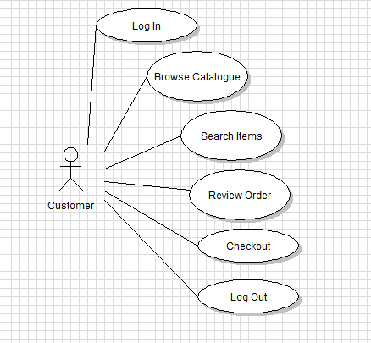

# Use Case Narrative - Items Displayed for Sale

|  |  |
| --- | --- |
| **Use Case ID:** | 1 |
| **Use Case Name:** | Items Displayed for Sale |
| **Stakeholders:** | Customers |
| Created by: | Systems Analyst |
| **Date Created:** | 10.05.2013 |
| **Description:** | The use case is performed when the Customer searches for a product to buy. |
| **Trigger:** | The customer searches for a product. |

|  |  |
| --- | --- |
| **Stages Performed** | |
| The customer logs in to their account | |
| The customer browses the catalogue. | |
| The customer searches for items. | |
| The customer reviews an order. | |
| The customer goes to checkout. | |
| The customer changes their mind and logs out.. | |
| **Alternative Flow** | |
| The customer logs in to their account | |
| The customer browses the catalogue. | |
| The customer goes to checkout. | |
| * 1. **Successful Completion:**   User is able to purchase the desired product   * 1. **Failure Condition**   User is unable to search for a product. | |
| **Preconditions:** | Customer is already on the website |

# Use Case Diagram 2 - Secure Payment

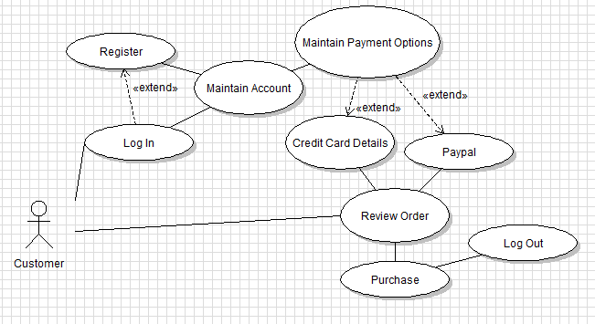

# Use Case Narrative - Secure Payment

|  |  |
| --- | --- |
| **Use Case ID:** | 2 |
| **Use Case Name:** | Secure Payment |
| **Stakeholders:** | Customers |
| **Created by:** | System Analyst |
| **Date Created:** | 10.05.2013 |
| **Description:** | The use case is performed when the logs in a to chooses the secure payment for a product. |
| **Trigger:** | The customer logs in to their account. |

|  |  |
| --- | --- |
| **Stages Performed** | |
| The customer logs in to their account | |
| The customer maintains their account. | |
| The customer maintains payment options. | |
| The customer chooses the type of payment they want. | |
| The customer review their item they are ordering. | |
| The customer purchases the items.. | |
| The customer logs out of their account. | |
| **Alternative Flow** | |
| The customer logs into their account. | |
| No account found so the customer registers an account. | |
| The customer maintains their account. | |
| The customer maintains payment options. | |
| The customer chooses the type of payment they want. | |
| The customer review their item they are ordering. | |
| The customer purchases the items.. | |
| The customer logs out of their account. | |
| * 1. **Successful Completion:**   User is able to purchase the desired product   * 1. **Failure Condition**   User is unable to supply a valid payment option. | |
| **Preconditions:** | Customer is already on the website |

# Data Dictionary

|  |  |  |  |  |
| --- | --- | --- | --- | --- |
| Field Name | Data Type | Description of Field | Validation | Input Mask |
| Customer_ID | AutoNumber | The Customer ID number |  |  |
| Customer_Name | Text | The Customer's Name | Not Like "*[!((a-z) or (A-Z))]*" |  |
| House_Number | Number | The Customer's House Number | > 0 |  |
| House_Name | Text | The Customer's House Name | Not Like "*[!((a-z) or (A-Z))]*" |  |
| Address_Line_1 | Text | The Customer's Address Line 1 | Not Like "*[!((a-z) or (A-Z))]*" |  |
| Address_Line_2 | Text | The Customer's Address Line 2 | Not Like "*[!((a-z) or (A-Z))]*" |  |
| Town/City | Text | The Customer's Town/City | Not Like "*[!((a-z) or (A-Z))]*" |  |
| County | Text | The Customer's County | Not Like "*[!((a-z) or (A-Z))]*" |  |
| Postcode | Text | The Customer's Postcode |  | >LL00\ 0LL;0;_ |
| Country | Text | The Customer's Country | Not Like "*[!((a-z) or (A-Z))]*" |  |
| Phone_Number | Text | The Customer's Phone Number | Not Like "*[!0-9]*" | \(9999") "00090009;0;_ |