
IE3010
Network Programming
3rd Year, Semester II

Assignment

NetMessenger: A Multi-Client Chat and File-Sharing Platform over TCP/IP
W.W.D.M.Fernando
IT23629844
Submitted to
Sri Lanka Institute of Information Technology

In partial fulfillment of the requirements for the
Bachelor of Science Special Honors Degree in Information Technology

October 2026
Declaration
I certify that this report does not incorporate without acknowledgement, any material previously submitted for a degree or diploma in any university, and to the best of my knowledge and belief it does not contain any material previously published or written by another person, except where due reference is made in text.

Registration Number: IT23629844
Name: W.W.D.M.Fernando

Executive Summary
NetMessenger is a TCP client/server chat and file-sharing platform implemented in C using the standard BSD sockets API. The application runs on the personalized TCP port 15844 and supports multiple simultaneous users. The implemented system provides user registration, connected-user listing, broadcast messaging, private messaging, presence notifications, chat rooms, direct file transfer, server-side file storage, graceful client disconnection, reconnection, error handling, and timestamped server logging. The completed application was tested using multiple simultaneous clients, including six connected clients, and the main communication, messaging, chat-room, file-transfer, storage, logging, and disconnect functionalities were verified during execution.
This report presents the personalized configuration, system architecture, concurrency approach, communication protocol implementation, functional features, file-sharing mechanism, error handling, server-side logging, source-code evidence, execution and testing evidence, design rationale, development process, and final testing results. Screenshots included in the report are taken from the actual project development and execution environment and are accompanied by appropriate figure titles and explanations.
GIT URL: https://github.com/DMFernando0315/IT23629844-NetMessenger

Table of Contents
Executive Summary 3
1.Introduction and Objectives 5
2.Personalization Requirements 6
2.1 Personalization Calculation 7
2.2 Project Files 7
3. System Overview and Architecture 9
4. Concurrency Model 10
5. Communication Protocol Implementation 10
6. Functional Implementation 12
6.1 Registration and Presence 12
6.2 Broadcast Messaging 13
6.3 Private Messaging 14
6.4 Chat Rooms 14
7. File Sharing Implementation 15
8. Error Handling and Graceful Disconnect 16
9. Server-Side Logging 17
10. Annotated Code Evidence 18
Socket creation, bind, listen and accept 18
Concurrency/client handling 18
REGISTER and user state. 18
BCAST and PMSG 19
JOIN, LEAVE, ROOMS and RMSG 19
SENDFILE receive/store/forward 21
Validation and ERR response. 21
Disconnect cleanup and logging 22
11. Execution and Output Evidence 22
12. Testing Summary 28
13. Design Rationale and Assumptions 29
14. Conclusion 29
15. Prompt Log / AI Interaction Record 30
16. Structured Reflection 31
17. References 32
18. Appendix 32
Appendix A – Project Files 32
Appendix B – GitHub Repository 32
Appendix C – Evidence Checklist 33

1.Introduction and Objectives
The objective of NetMessenger is to demonstrate socket-level TCP network programming in C through a central server that coordinates multiple interactive clients. The application was designed to implement the required communication protocol while handling TCP-based client-server communication and multiple simultaneous connections.
The final implementation supports user registration, connected-user listing, broadcast messaging, private messaging, presence notifications, chat rooms, room messaging, file transfer, graceful termination, error handling, server-side file storage, timestamped event logging, and client reconnection after disconnection.
The main objectives of the project are:
- To use the standard BSD sockets API directly in C on Linux.
- To support at least five simultaneous clients from a single server process.
- To implement the required protocol commands, including:
  - REGISTER
  - LIST
  - BCAST
  - PMSG
  - JOIN
  - LEAVE
  - ROOMS
  - RMSG
  - SENDFILE
  - QUIT
- To provide personalized server responses containing NID:6298.
- To implement newline-based command processing for the text communication protocol.
- To implement file transfer using the required file-size information.
- To provide personalized server logging and storage based on registration number IT23629844.
- To demonstrate the functionality through actual execution and testing with multiple clients.
- To provide evidence of messaging, room management, file transfer, logging, error handling and graceful disconnection.

2.Personalization Requirements
All registration-specific values were derived from the registration number IT23629844 and were used consistently throughout the NetMessenger project.
Item | Final Value | Derivation / Purpose
Registration Number | IT23629844 | Full student registration number
Numeric Part | 23629844 | Numeric portion used for personalization
Last Four Digits | 9844 | Used to calculate the server port and personalized filenames
Server Port | 15844 | 6000 + 9844
Node ID | NID:6298 | Digits 3–6 of 23629844 are 6298
Server Source | server_9844.c | Personalized server source filename
Client Source | client_9844.c | Personalized client source filename
Makefile | Makefile_9844 | Personalized build file
Server Log | netmsg_IT23629844.log | Personalized server log filename
Storage Root | ./storage/IT23629844 | Personalized storage directory
Storage Structure | ./storage/IT23629844/<sender_username>/<filename> | Files are stored under sender-specific directories

2.1 Personalization Calculation
The server port was calculated using the last four digits of the registration number:
Registration Number = IT23629844
Last Four Digits = 9844
Server Port = 6000 + 9844
= 15844
The Node ID was calculated from digits 3–6 of the numeric portion:
Numeric Part = 23629844
Digits 3–6 = 6298
Node ID = NID:6298
Therefore, the application uses:
TCP Port : 15844
Node ID : NID:6298

2.2 Project Files
The personalized implementation contains:
server_9844.c
client_9844.c
Makefile_9844
README.md
netmsg_IT23629844.log
storage/IT23629844/

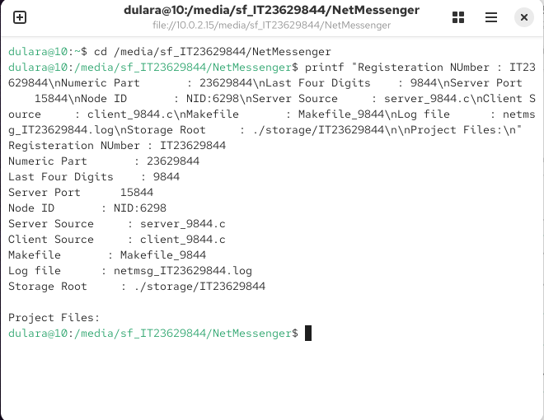
Figure 1: Configuration values
The final NetMessenger server is shown listening on the personalized TCP port 15844 on the IPv4 wildcard address 0.0.0.0. The output demonstrates that the server is actively listening for TCP client connections, while the connected client provides evidence that the server is being accessed through
the configured port.
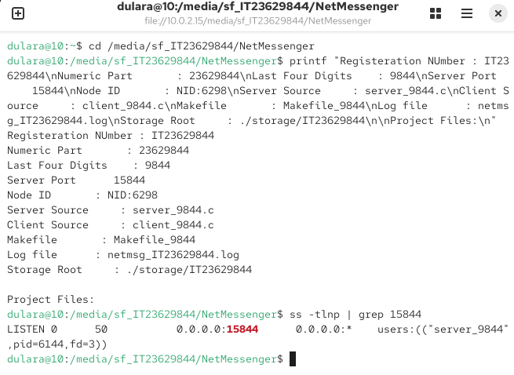
Figure 2: TCP Port 15844 LISTEN
The final NetMessenger server is shown listening on 0.0.0.0:15844. The TCP connection information also shows client connection states associated with the server port, providing evidence that the personalized listener is active and has been used by a TCP client.

3. System Overview and Architecture
NetMessenger follows a client-server architecture. A single C server listens on TCP port 15844 and accepts connections from multiple C clients. Each client registers a unique username before using the main application commands.
The server maintains connected-user and room state and coordinates messaging and file-transfer operations. Broadcast messages are delivered to other registered clients, private messages are delivered only to the named target, and room messages are delivered to room members.
During file sharing, the server receives the declared file data, stores a server-side copy under the personalized storage path and forwards the file to the requested destination.
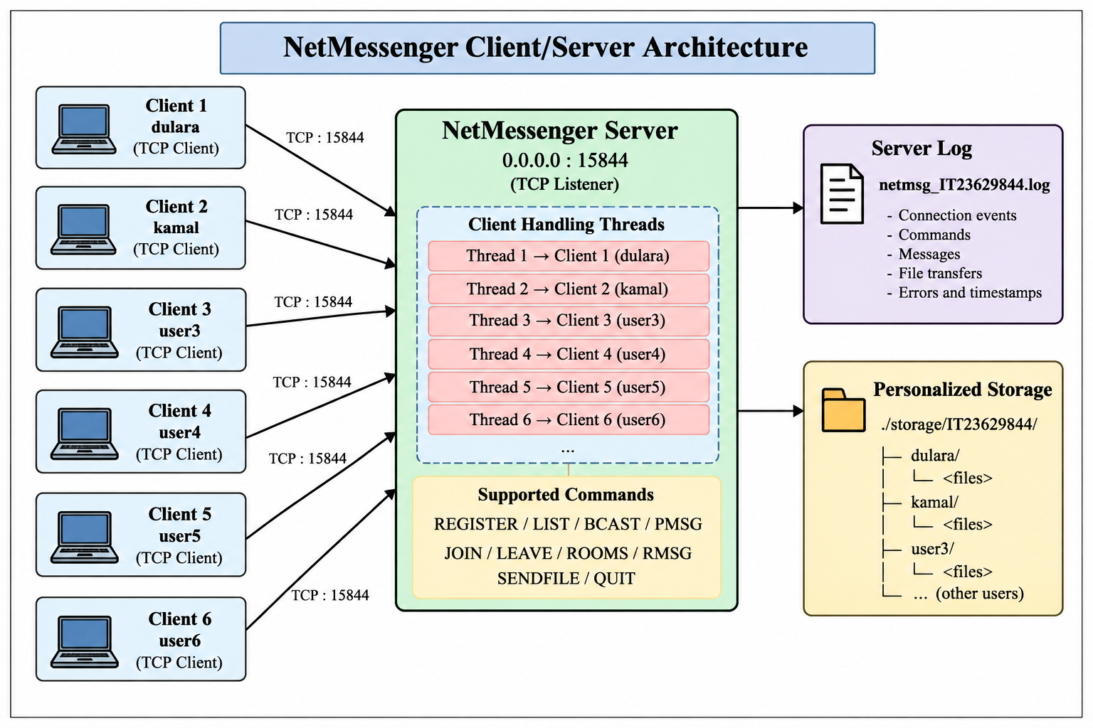
Figure 3: NetMessenger client/server architecture
Multiple C clients communicate with the central server through TCP. The server listens on port 15844, manages users and rooms, routes messages, handles file transfers, records events and stores transferred files.
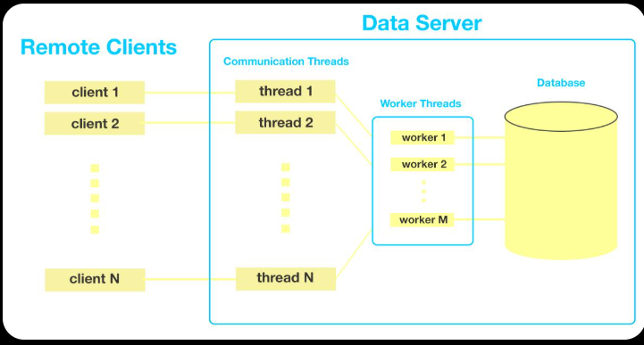

4. Concurrency Model
The submitted implementation uses a thread-per-client concurrency model. When the server accepts a TCP connection, the connection is handled independently so that multiple clients can communicate with the server at the same time.
POSIX threads are suitable for the bounded coursework workload because each client can be processed independently while the server continues accepting and serving other clients. The model is straightforward to implement and avoids forcing all client operations through one sequential connection handler.
The implementation was tested using six simultaneous clients: dulara, kamal, user3, user4, user5 and user6. This exceeds the assignment requirement of at least five simultaneous clients.
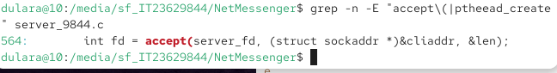
Figure 4: Server connection acceptance and per-client handling
The server accepts an incoming TCP connection and creates independent handling for the connected client, allowing multiple clients to remain active concurrently.

5. Communication Protocol Implementation
The implementation follows the fixed command set specified by the assignment. Text commands and responses use newline termination. SENDFILE is handled specially because the command header is followed by the declared raw file data.
Server-generated OK and ERR responses use the personalized Node ID tag NID:6298. Forwarded message notifications are separate from acknowledgement responses.
Command | Purpose | Successful behaviour
REGISTER <username> | Register unique user | OK REGISTERED <username> NID:6298
LIST | List connected users | OK USERS ... NID:6298
BCAST <message> | Broadcast | OK SENT; other clients receive MSG BCAST
PMSG <username> <message> | Private message | OK SENT; target receives private message
JOIN <room> | Create/join room | OK JOINED <room> NID:6298
LEAVE <room> | Leave room | OK LEFT <room> NID:6298
ROOMS | List rooms | OK ROOMS ... NID:6298
RMSG <room> <message> | Room message | OK SENT; room members receive message
SENDFILE <target> <filename> <filesize> | File transfer | File transferred, stored and acknowledged
QUIT | Graceful disconnect | OK BYE NID:6298
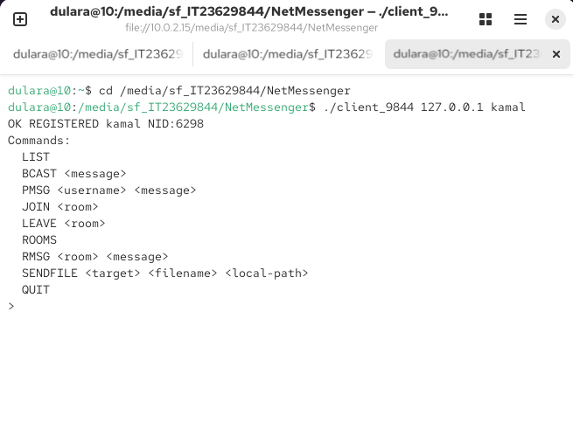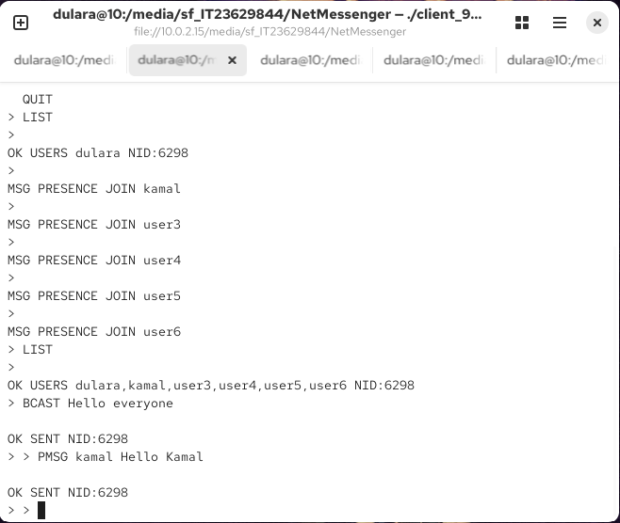

6. Functional Implementation

6.1 Registration and Presence
REGISTER is used to register a unique username on a new connection. The server stores the username and makes the user available to the other connected clients. Presence notifications are generated when users join or leave.
During testing, dulara registered successfully and additional users including kamal, user3, user4, user5 and user6 were connected. Presence JOIN notifications were observed.
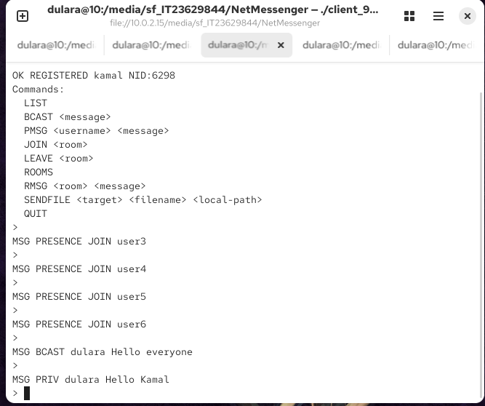

6.2 Broadcast Messaging
BCAST sends a message from one registered client to the other connected clients. The sender receives an acknowledgement while other clients receive the broadcast notification.
Broadcast messaging was tested using multiple connected clients and the message was successfully delivered.
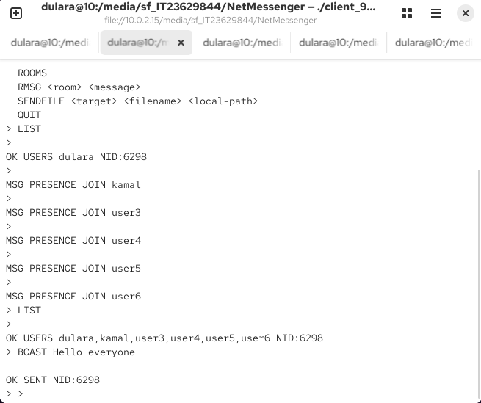

6.3 Private Messaging
PMSG identifies a target username and sends the message only to that user. A private message was tested from dulara to kamal and the recipient successfully received it.

6.4 Chat Rooms
JOIN, LEAVE, ROOMS and RMSG provide room functionality. JOIN creates or joins a room, ROOMS lists available rooms, RMSG sends a room message and LEAVE removes the client from the room.
The room operations were tested successfully with connected clients.
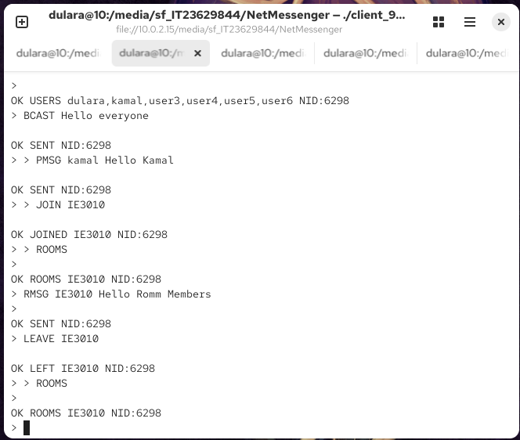

7. File Sharing Implementation
SENDFILE identifies a target, filename and file size and is followed by the file data. The server stores the received file under:
./storage/IT23629844/<sender_username>/<filename>
A test file named test.txt was created and transferred from dulara to kamal. The recipient successfully received the file and the server-side storage was checked.
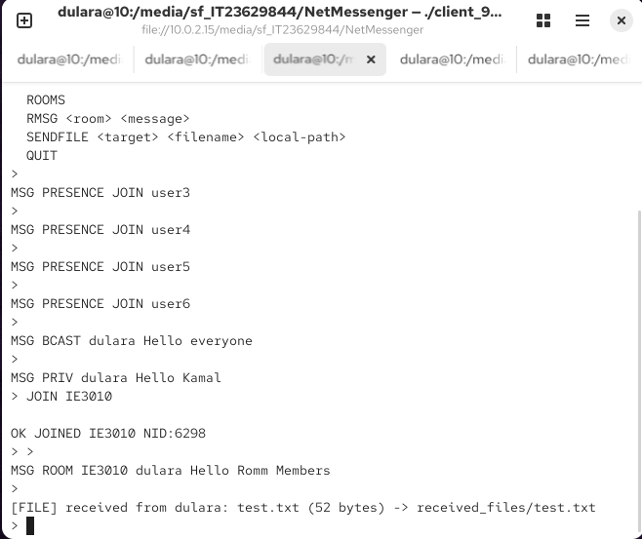
Figure 5: Successful file transfer
The evidence should demonstrate the sender issuing SENDFILE and the recipient receiving the file.
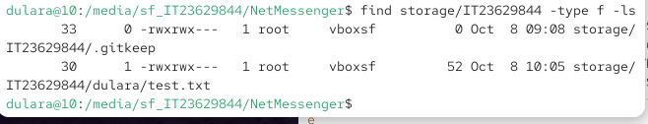
Figure 6: Personalized storage evidence
The storage evidence demonstrates the personalized IT23629844 directory and stored file.

8. Error Handling and Graceful Disconnect
The server is designed to handle invalid commands and invalid targets without terminating the server process. Protocol errors are returned to the requesting client.
QUIT provides graceful termination. The server closes the client connection and removes the associated state. Reconnection was also tested by starting the dulara client again after disconnecting.
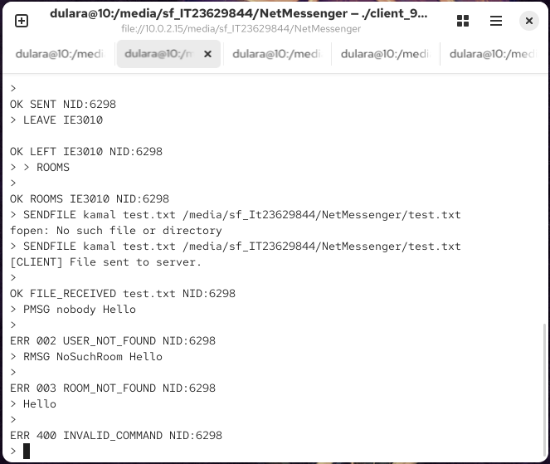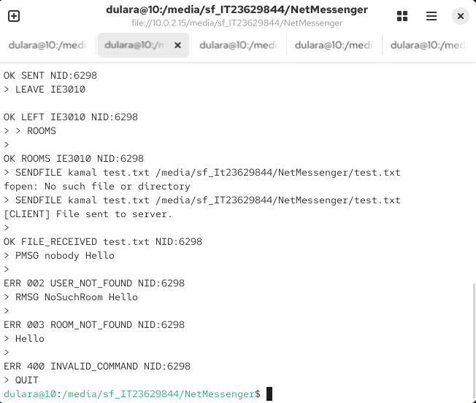

Figure 7: Error handling and graceful disconnect
The evidence should show that an invalid request produces an error response without crashing the server and that a client can disconnect and reconnect.

9. Server-Side Logging
Important runtime events are recorded in the personalized log file:
netmsg_IT23629844.log
The log was checked after the functional tests to confirm that server activity was being recorded.
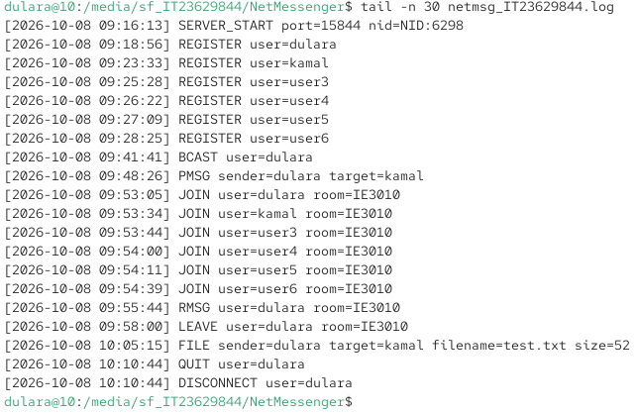
Figure 8: Server-side logging evidence
The log screenshot should show timestamped events generated by the actual NetMessenger execution.

10. Annotated Code Evidence

Socket creation, bind, listen and accept
The server creates a TCP socket, binds it to the personalised port 15844, starts listening for incoming connections, and accepts new client connections for further processing.
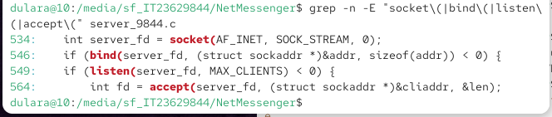

Concurrency/client handling
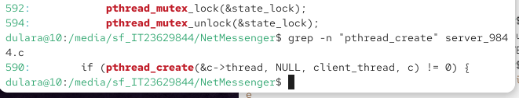

REGISTER and user state.
The REGISTER handling validates the requested username, checks whether the username is already in use, stores the registered client state, and returns the personalised NID-tagged response.
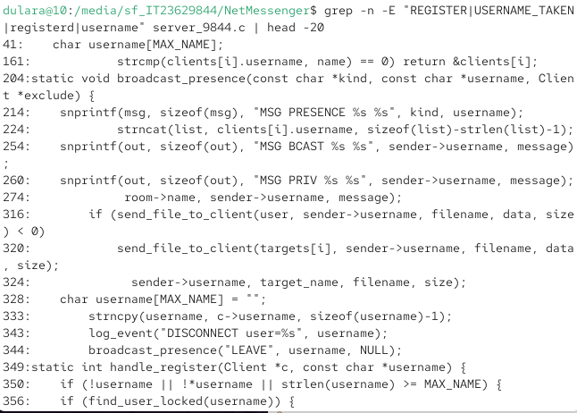
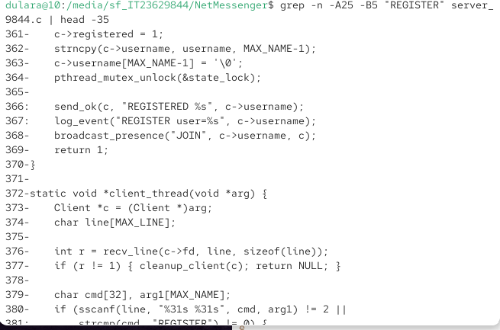

BCAST and PMSG
The server passes BCAST and PMSG commands and routes broadcast messages to connected clients while private messages are delivered only to the specified user.
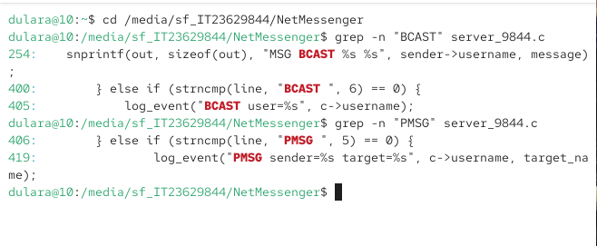
JOIN, LEAVE, ROOMS and RMSG
The server handles JOIN and LEAVE requests to manage room membership, ROOMS to list available rooms, and RMSG to route messages to members of the selected room.
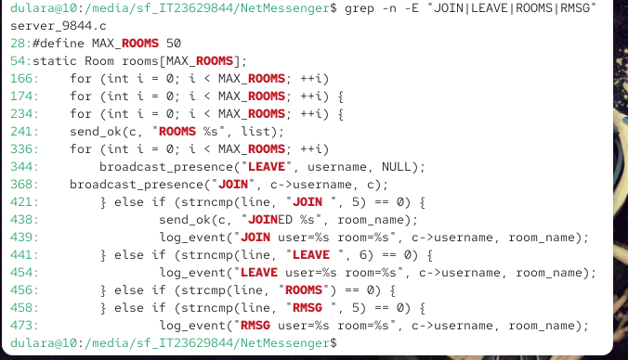
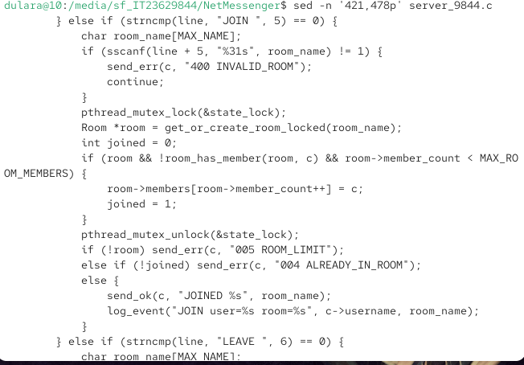
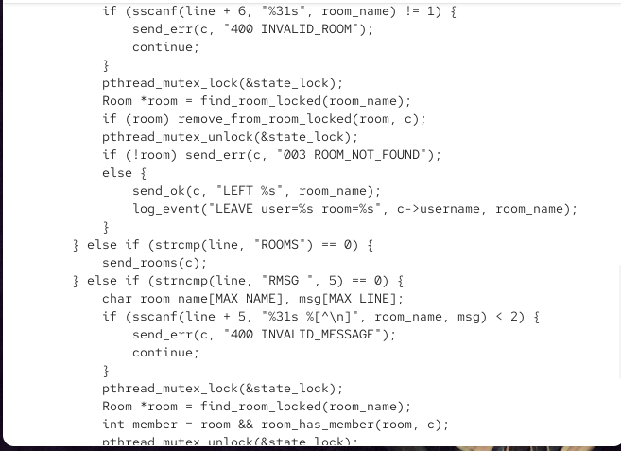
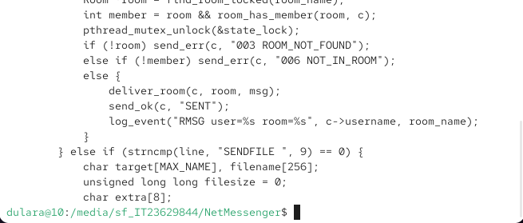

SENDFILE receive/store/forward
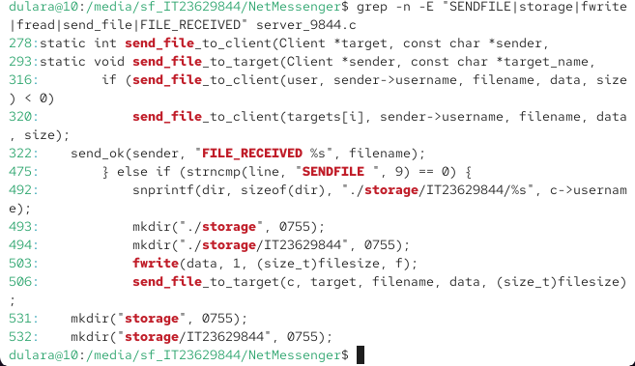

Validation and ERR response.
The server validates client requests and generates appropriate error responses for invalid or unsupported requests. The personalised NID:6298 tag is included in server responses.
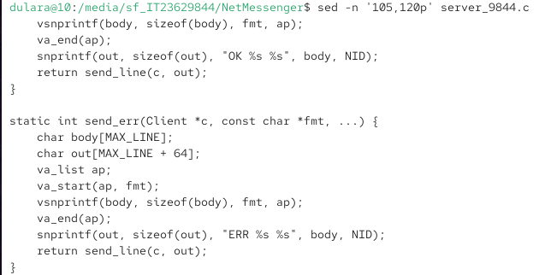
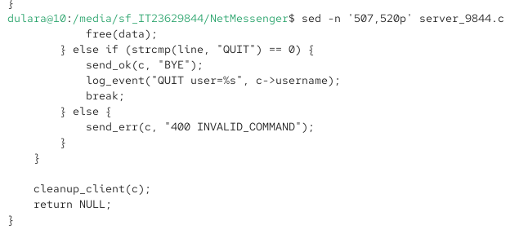

Disconnect cleanup and logging
The server records important events in the personalised log file and performs cleanup when a client disconnects, including closing the connection and removing the client from active server state.
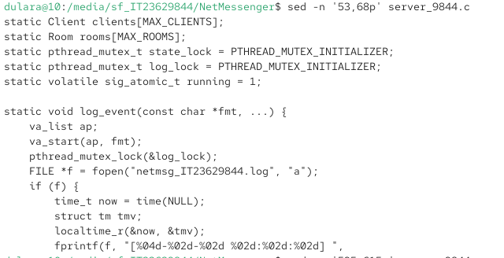
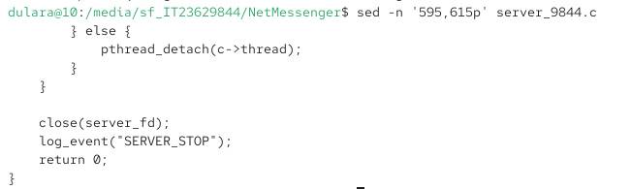

11. Execution and Output Evidence
Server startup on port 15844
The server was successfully started and displayed the personalised registration details, listening port 15844 and Node ID NID:6298.
TCP listener evidence
The ss command confirms that the NetMessenger server is actively listening for TCP connections on port 15844.
Six simultaneous clients
Six clients (dulara, kamal, user3, user4, user5, and user6) were connected simultaneously, demonstrating the multi-client capability of the server.
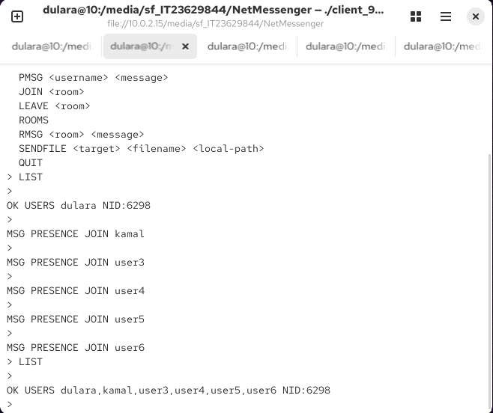
Registration/presence
The client dulara was successfully registered with the personalised response NID:6298. JOIN notifications were also received when additional clients connected.
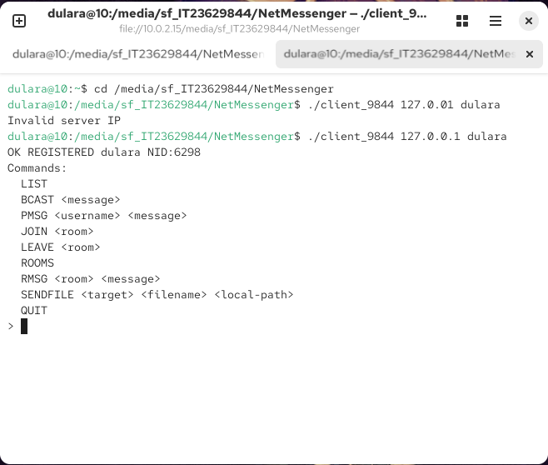
LIST
The LIST command returned the currently connected users together with the personalised server response tag.
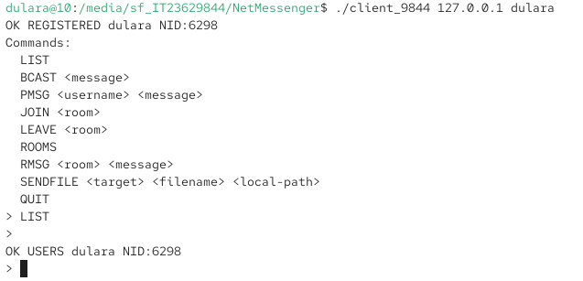
BCAST
A BCAST message was successfully sent from one client and delivered to the other connected clients.
PMSG
A private message was successfully sent to the specified client using the PMSG command.
Room operations
JOIN, ROOMS, RMSG and LEAVE operations were executed successfully, demonstrating room creation, membership, room listing, room messaging and leaving functionality.
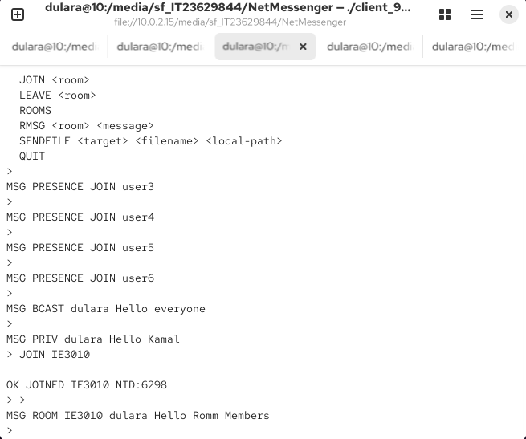
SENDFILE
A file was successfully transferred through the server using the SENDFILE command.
Storage directory
The transferred file was stored under the personalised storage hierarchy ./storage/IT23629844/<sender_username>/.
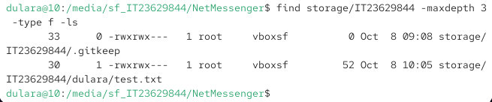
Error response
An invalid private-message request was handled without terminating the server. The server returned the appropriate USER_NOT_FOUND error together with NID:6298.
QUIT/reconnection
The client terminated its session using QUIT and subsequently reconnected successfully using the same username.
Server log
The personalised server log netmsg_IT23629844.log records server-side connection, messaging, file-transfer and disconnection events.

12. Testing Summary
The table below records the main tests performed during the development sessions. An automated 19-test regression result is not claimed because such a test suite was not part of the verified project evidence.
Test Case | Expected Result | Actual Result | Status
Unique registration | User registered with NID | dulara registered successfully with NID:6298 | PASS
LIST | Connected users returned | Six connected usernames were listed during testing | PASS
Six simultaneous clients | At least five clients served | dulara, kamal, user3, user4, user5 and user6 connected | PASS
BCAST | Other clients receive message | Broadcast successfully delivered | PASS
PMSG | Only target receives message | kamal successfully received dulara's private message | PASS
JOIN / ROOMS / RMSG / LEAVE | Room operations work | Room commands successfully tested | PASS
SENDFILE | Recipient receives file | test.txt successfully received by kamal | PASS
Storage | Server stores copy | Personalized storage checked | PASS
Logging | Events recorded | netmsg_IT23629844.log checked | PASS
QUIT / reconnect | Client disconnects and can reconnect | QUIT and reconnection tested | PASS

13. Design Rationale and Assumptions
TCP was selected because the assignment requires TCP/IP communication and reliable delivery of commands and file data. The server centralizes connected-user state, room membership, message routing and file-transfer processing.
A thread-per-client model was selected because each connected client can be processed independently and the coursework requires a bounded number of simultaneous clients. POSIX pthreads provide a direct way to implement this model.
The supplied protocol is retained rather than replaced with a custom command design. Text commands use newline framing, while SENDFILE uses the declared file size to process the file data.
User and room state is maintained in memory during the server session and is not intended to persist after a server restart. The implementation is an educational coursework system and does not provide production-level authentication, TLS or distributed scalability.

14. Conclusion
The completed NetMessenger implementation provides a TCP-based multi-client communication and file-sharing system personalized for IT23629844. It uses port 15844, NID:6298, personalized source files, server logging and personalized file storage.
The system implements registration, user listing, broadcast messaging, private messaging, presence notifications, chat rooms, file transfer, error handling and graceful disconnection. Testing with six simultaneous clients demonstrated more than the required five-client capacity.
The project provided practical experience with TCP sockets, concurrent programming, client/server state management, protocol implementation, file transfer, Linux development and Git/GitHub.

15. Prompt Log / AI Interaction Record
The following summarizes substantive AI support used during development. The entries describe how the output was evaluated or applied rather than claiming that AI output was accepted without testing.
Date | Tool | Task | Use / Change
03.10.2026 | ChatGPT | Assignment requirements and personalization | Calculated port 15844 and NID:6298 and identified required files.
04.10.2026 | ChatGPT | CentOS/Linux setup | Used commands and verified outputs in the environment.
04.10.2026 | ChatGPT | TCP server/client implementation | Implemented, compiled and tested the client/server.
04.10.2026 | ChatGPT | Compilation troubleshooting | Resolved missing pthread include and rebuilt successfully.
05.10.2026 | ChatGPT | REGISTER/LIST/multi-client testing | Tested with multiple client instances.
05.10.2026 | ChatGPT | BCAST/PMSG testing | Tested broadcast and private messaging.
05.10.2026 | ChatGPT | JOIN/LEAVE/ROOMS/RMSG testing | Tested room functionality.
06.10.2026 | ChatGPT | SENDFILE/storage testing | Created test.txt, transferred it and checked storage.
07.10.2026 | ChatGPT | Git/GitHub | Initialized repository, committed and pushed to GitHub.
08.10.2026 | ChatGPT | Report preparation | Adapted the report to the actual IT23629844 implementation and evidence.

16. Structured Reflection
During the development of the IE3010 Network Programming assignment, I used ChatGPT as a supporting tool at several stages of the NetMessenger project. I mainly used it to understand the assignment requirements, calculate personalized configuration values, configure the Linux environment, understand TCP socket programming, troubleshoot compilation problems, test client/server communication, organize the project with Git and prepare the final documentation.
AI assistance was useful when I needed to understand unfamiliar Linux commands and socket-programming concepts. It also helped me break large development tasks into smaller steps. I used guidance while testing multiple clients, broadcast messaging, private messaging, chat rooms and file transfer.
However, I learned that AI-generated technical suggestions cannot be accepted without checking them against the actual project. Some suggestions can describe different architecture or assume features that are not present in my implementation. Therefore, I compared suggestions with the assignment specification, my source code and actual terminal output. I also avoided claiming features that were not verified.
One important lesson was understanding TCP as a reliable byte-stream communication mechanism. The project improved my knowledge of socket creation, connection handling, concurrent clients, command processing, message routing, room management and file transfer.
The project also improved my confidence in Linux development and Git/GitHub. I learned that successful compilation is not enough; a network program must be tested with real connections and realistic command sequences. Overall, AI helped me work more efficiently, but the final implementation decisions, compilation, execution and testing remained my responsibility.

17. References
IE3010 Network Programming Assignment 2026 – NetMessenger: A Multi-Client Chat and File-Sharing Platform over TCP/IP.
Linux manual pages for socket, bind, listen, accept, connect, send, recv, close and pthread functions.
GNU Compiler Collection (GCC) documentation.
Git documentation.
GitHub repository: https://github.com/DMFernando0315/IT23629844-NetMessenger

18. Appendix

Appendix A – Project Files
server_9844.c
client_9844.c
Makefile_9844
README.md
netmsg_IT23629844.log
storage/IT23629844/
received_files/
test.txt

Appendix B – GitHub Repository
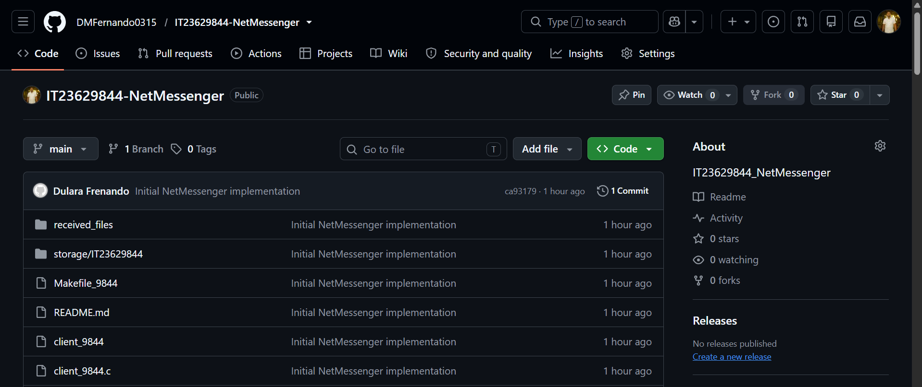
https://github.com/DMFernando0315/IT23629844-NetMessenger

Appendix C – Evidence Checklist
Server startup
TCP listener
Six clients
Registration/presence
LIST
BCAST
PMSG
Rooms
SENDFILE
Storage
Errors
QUIT/reconnect
Log
Code evidence

IE3010 – IT23629844 – NetMessenger

