DM.HR Group — Meeting Brief
Client Portal & Case Management Platform
Sources: Scope of Work · David’s requirements message · HTML mockup (UI reference)
Use this document to brief the project in meetings. Diagrams are embedded below.

1. What is this portal?
DM.HR Group helps care companies with HR and employment issues.
Today that work is messy (email, Dropbox, paperwork). This portal is one private website where:
- DM.HR manages their clients
- Each client company only sees their own stuff
- Documents live in clear folders
- Problems become cases you can track
- New clients get guided online onboarding
- Old clients skip that and just use the portal
Think: shared office online between DM.HR and each company — not a public website.

2. Actors (who uses it)
Actor | Who | Simple job
Admin / HR team | People at DM.HR | Add clients, upload docs, run onboarding, handle cases
Client user | Person at the care company (manager / contact) | Login, get docs, open cases, upload private files
(later) Employee | Staff of the care company | Not a main login in this foundation — employees are mostly records

For v1 foundation: 2 real sides — Admin and Client.

3. Two sides of the portal
Figure: Admin side vs Client side
Same system. Different menu after login.

4. What we are achieving
- Each company has its own locked room (no peeking at other companies).
- Docs are organised (not lost in email).
- Cases have a clear thread (open → update → close).
- New clients can onboard online; old ones jump straight in.
- DM.HR looks professional and organised.
One line: Admin side = control room for all clients. Client side = that company’s private folder + cases. Goal = stop chasing HR work in email.

5. Actors & use case diagram
Actors connect to their use-case groups (Admin first, then Client). Boxes inside a group are capabilities, not ordered steps.
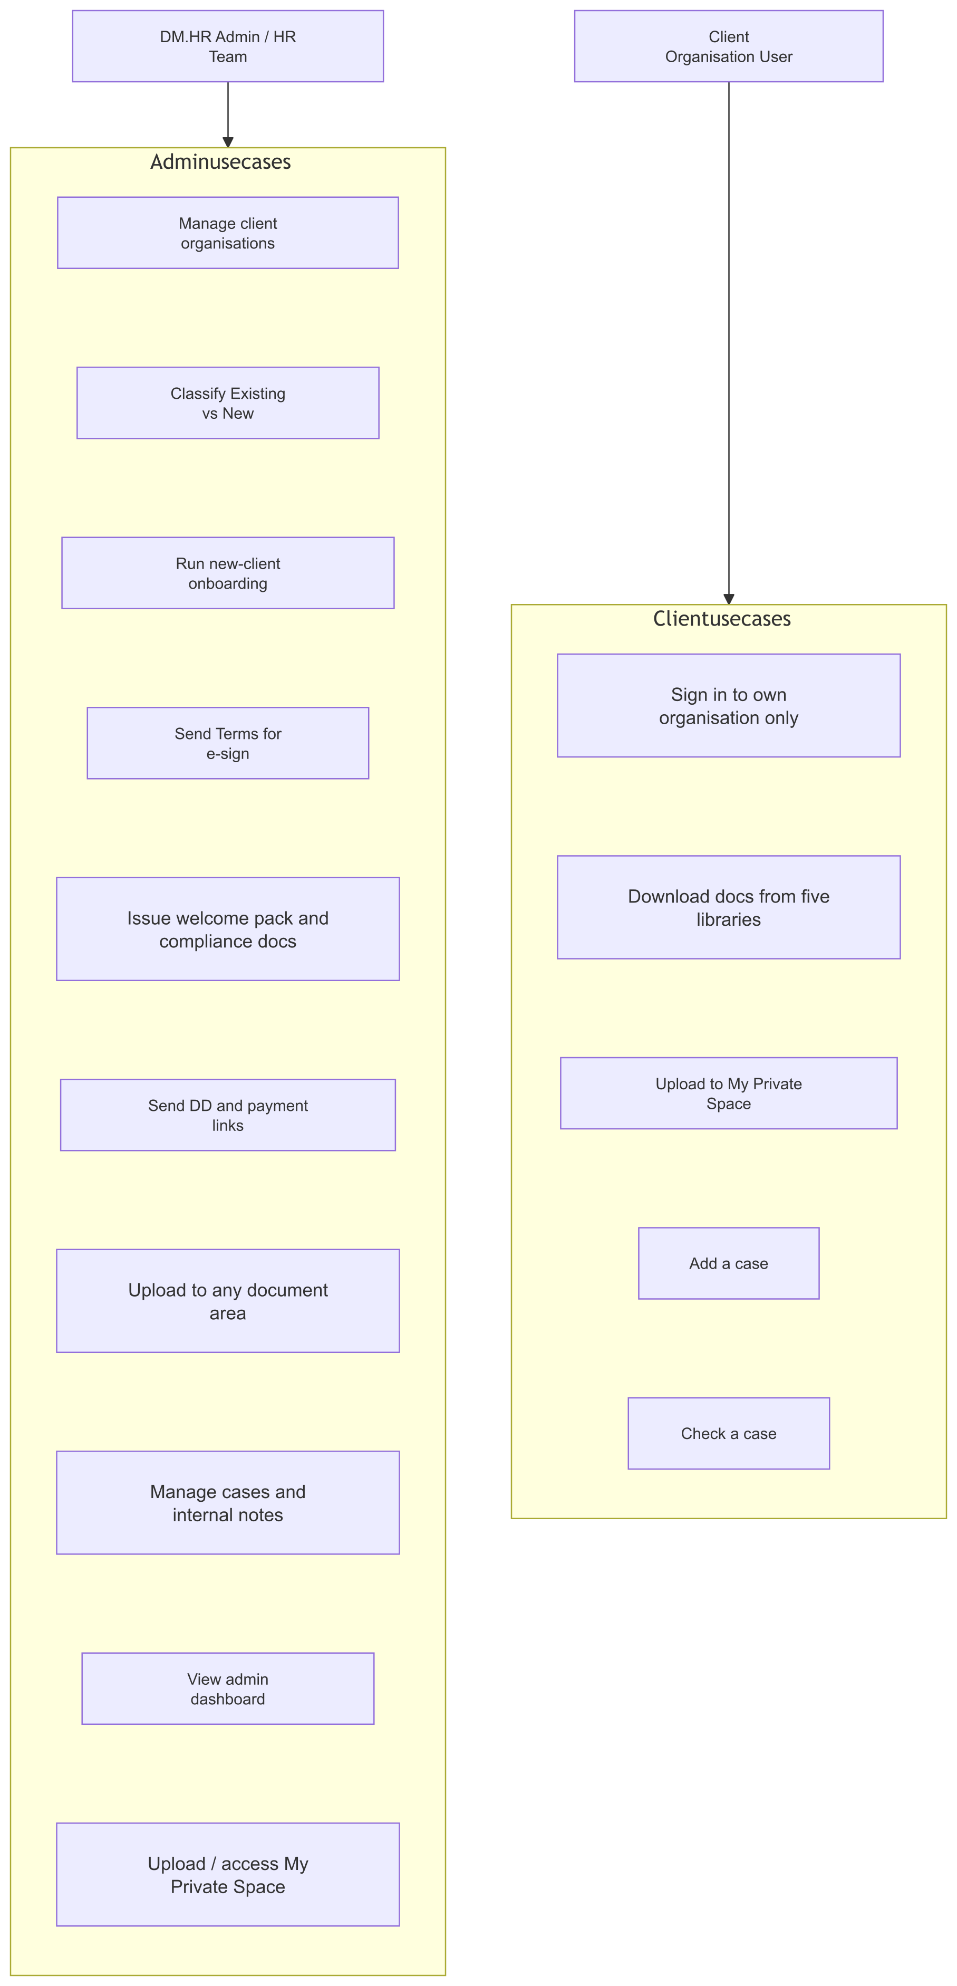
Figure: Use case diagram (vertical)

6. High-level system context
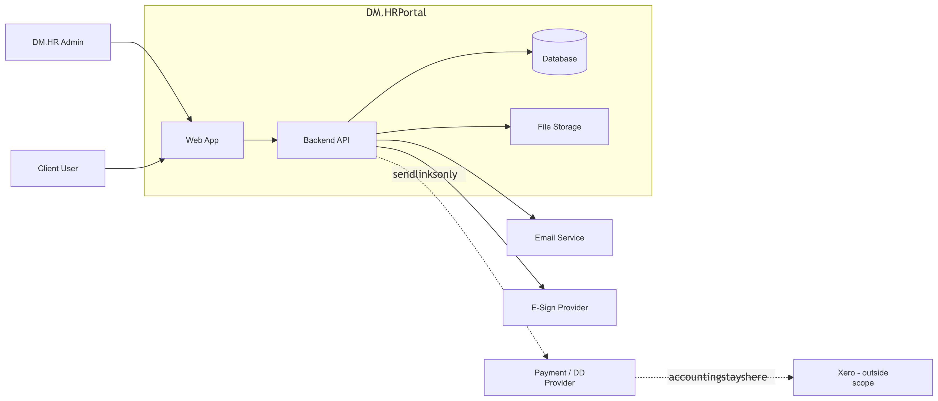
Figure: System context
Rule: Portal stores payment/DD links + status. It does not process money or replace Xero.

7. User workflows / journeys

A) Existing client (already with DM.HR)
- Admin creates/imports company + login
- Marks them Already onboarded
- Client logs in → dashboard (no onboarding)
- Uses docs + cases + private space
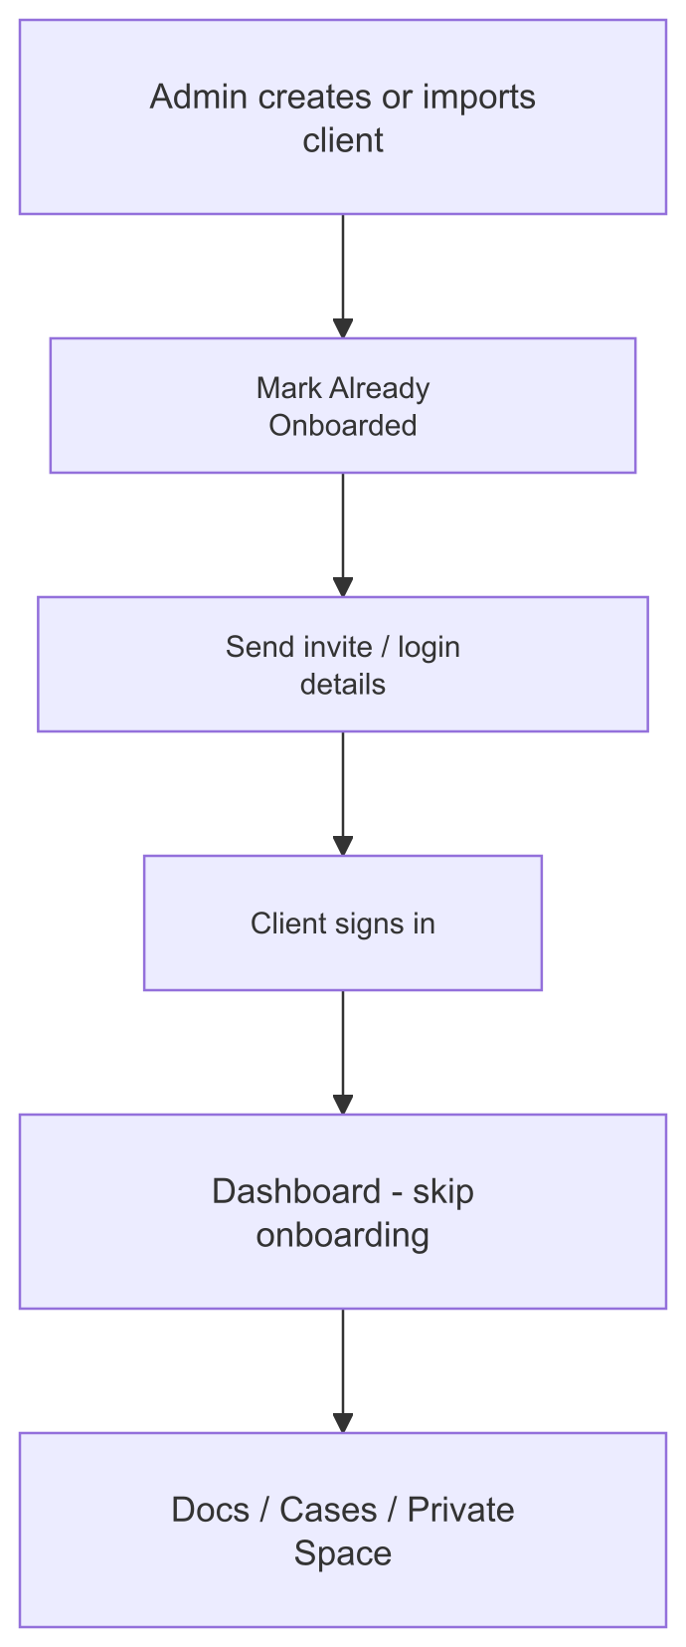
Figure: Existing client journey

B) New client
- Admin adds company
- Send Terms → client signs online
- Send welcome pack
- Issue compliance docs
- Send Direct Debit + first payment links
- Admin marks onboarding complete
- Client uses normal portal (same as existing)
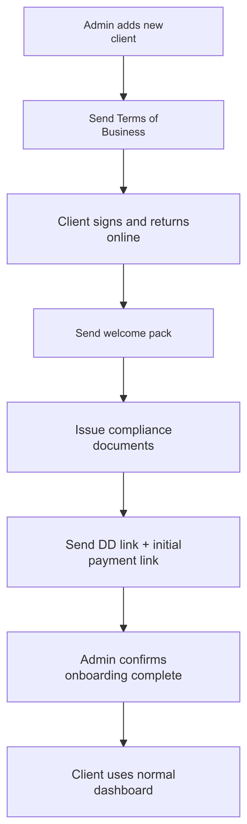
Figure: New client onboarding

C) Documents
- Admin opens Client X → picks folder (Documents / Policies / Handbook / Contracts / Useful / Private)
- Uploads file
- Client logs in → opens that folder → downloads
- In Private Space, client can also upload their own files; admin can see those too
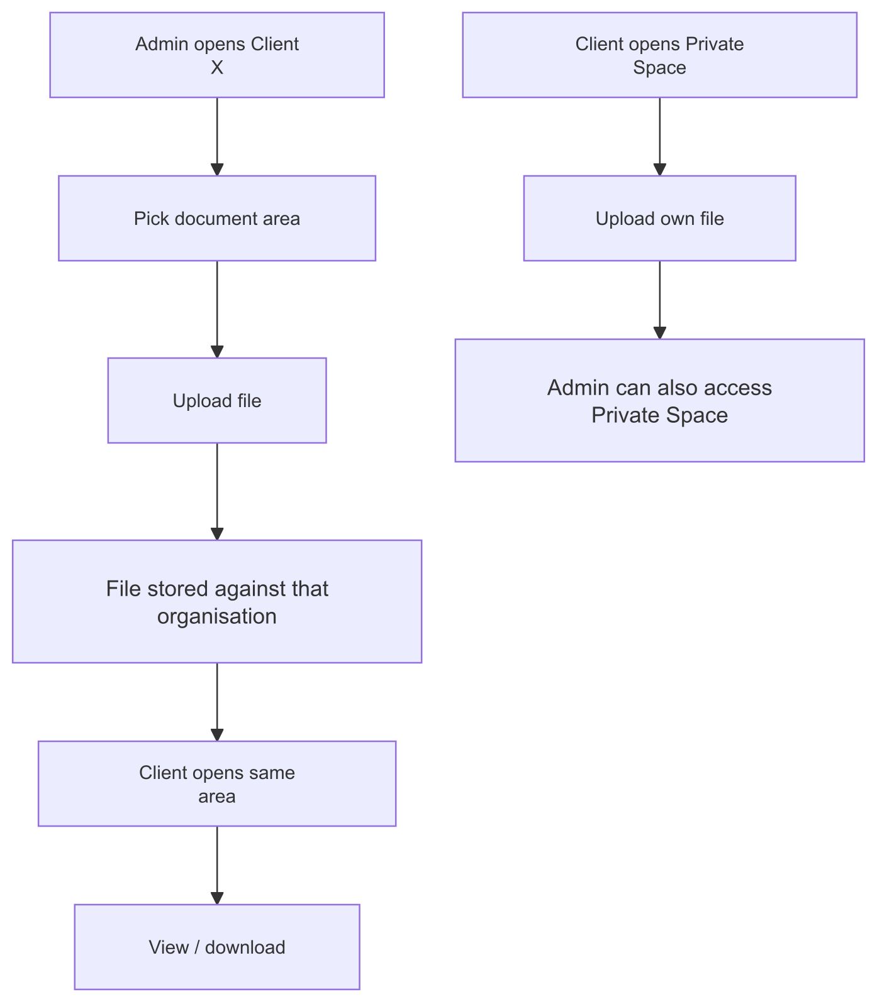
Figure: Documents flow

D) Case
- Client clicks Add a case → fills form → maybe attaches file
- DM.HR sees it → replies / asks for more / updates status
- Client clicks Check a case → sees status + client-visible updates
- Email can notify when something important updates
- Internal HR notes stay hidden from the client
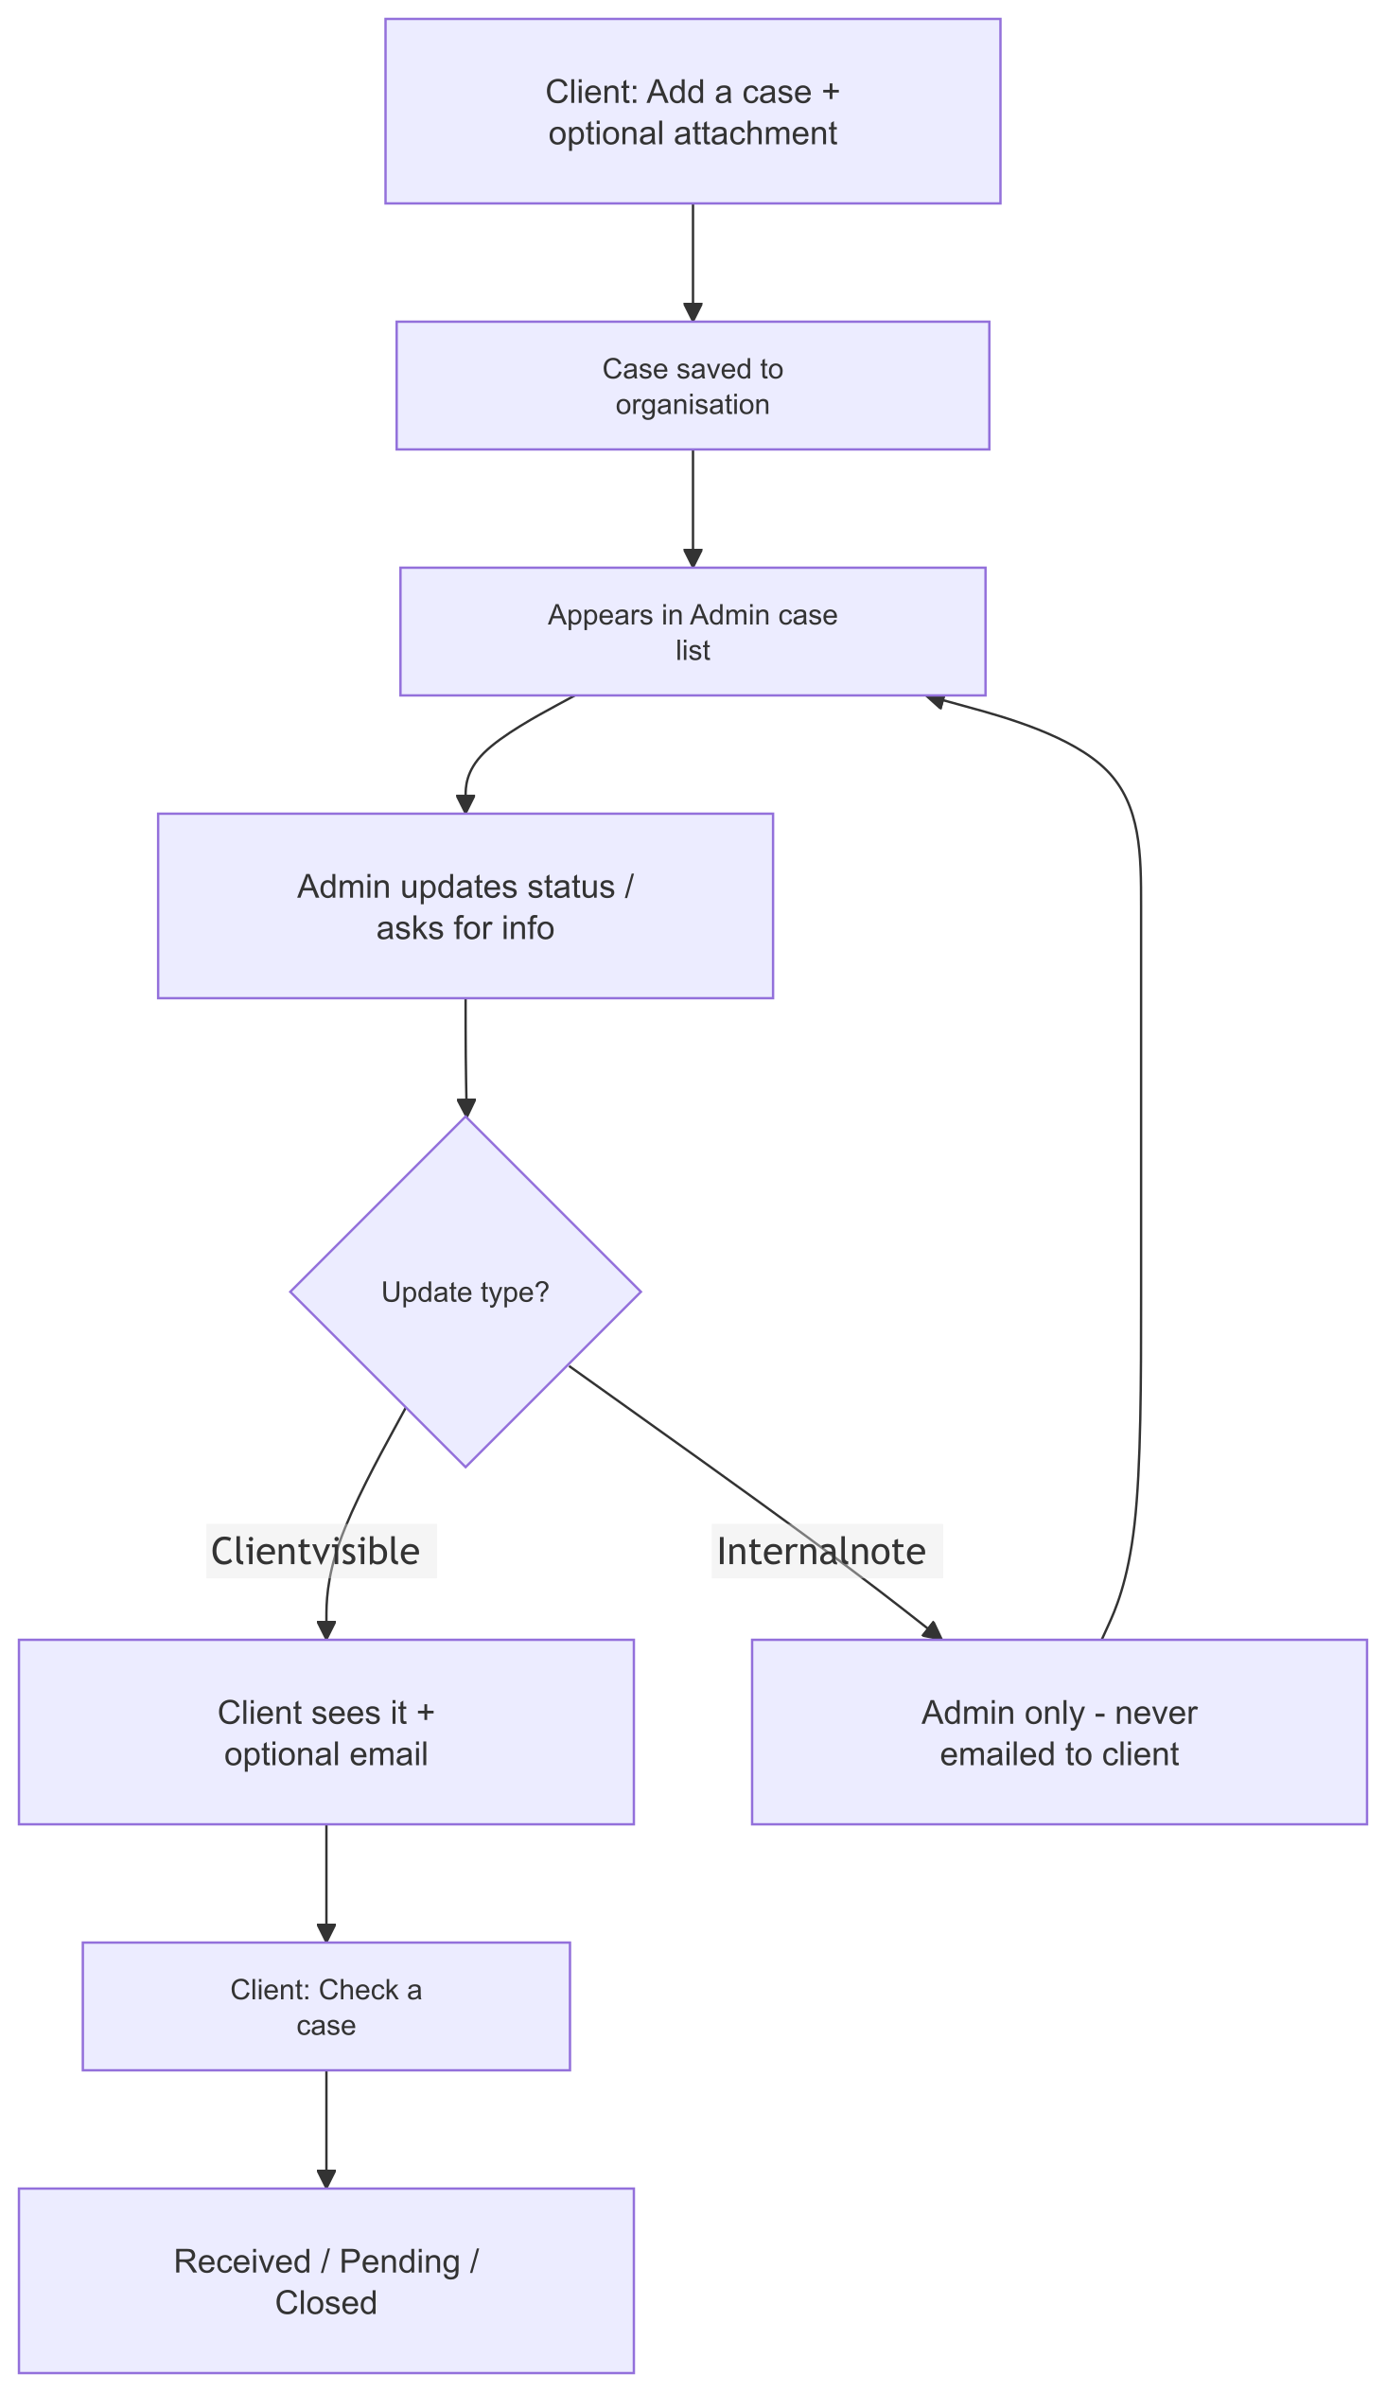
Figure: Case flow

8. Portal sides & navigation map (sitemap)
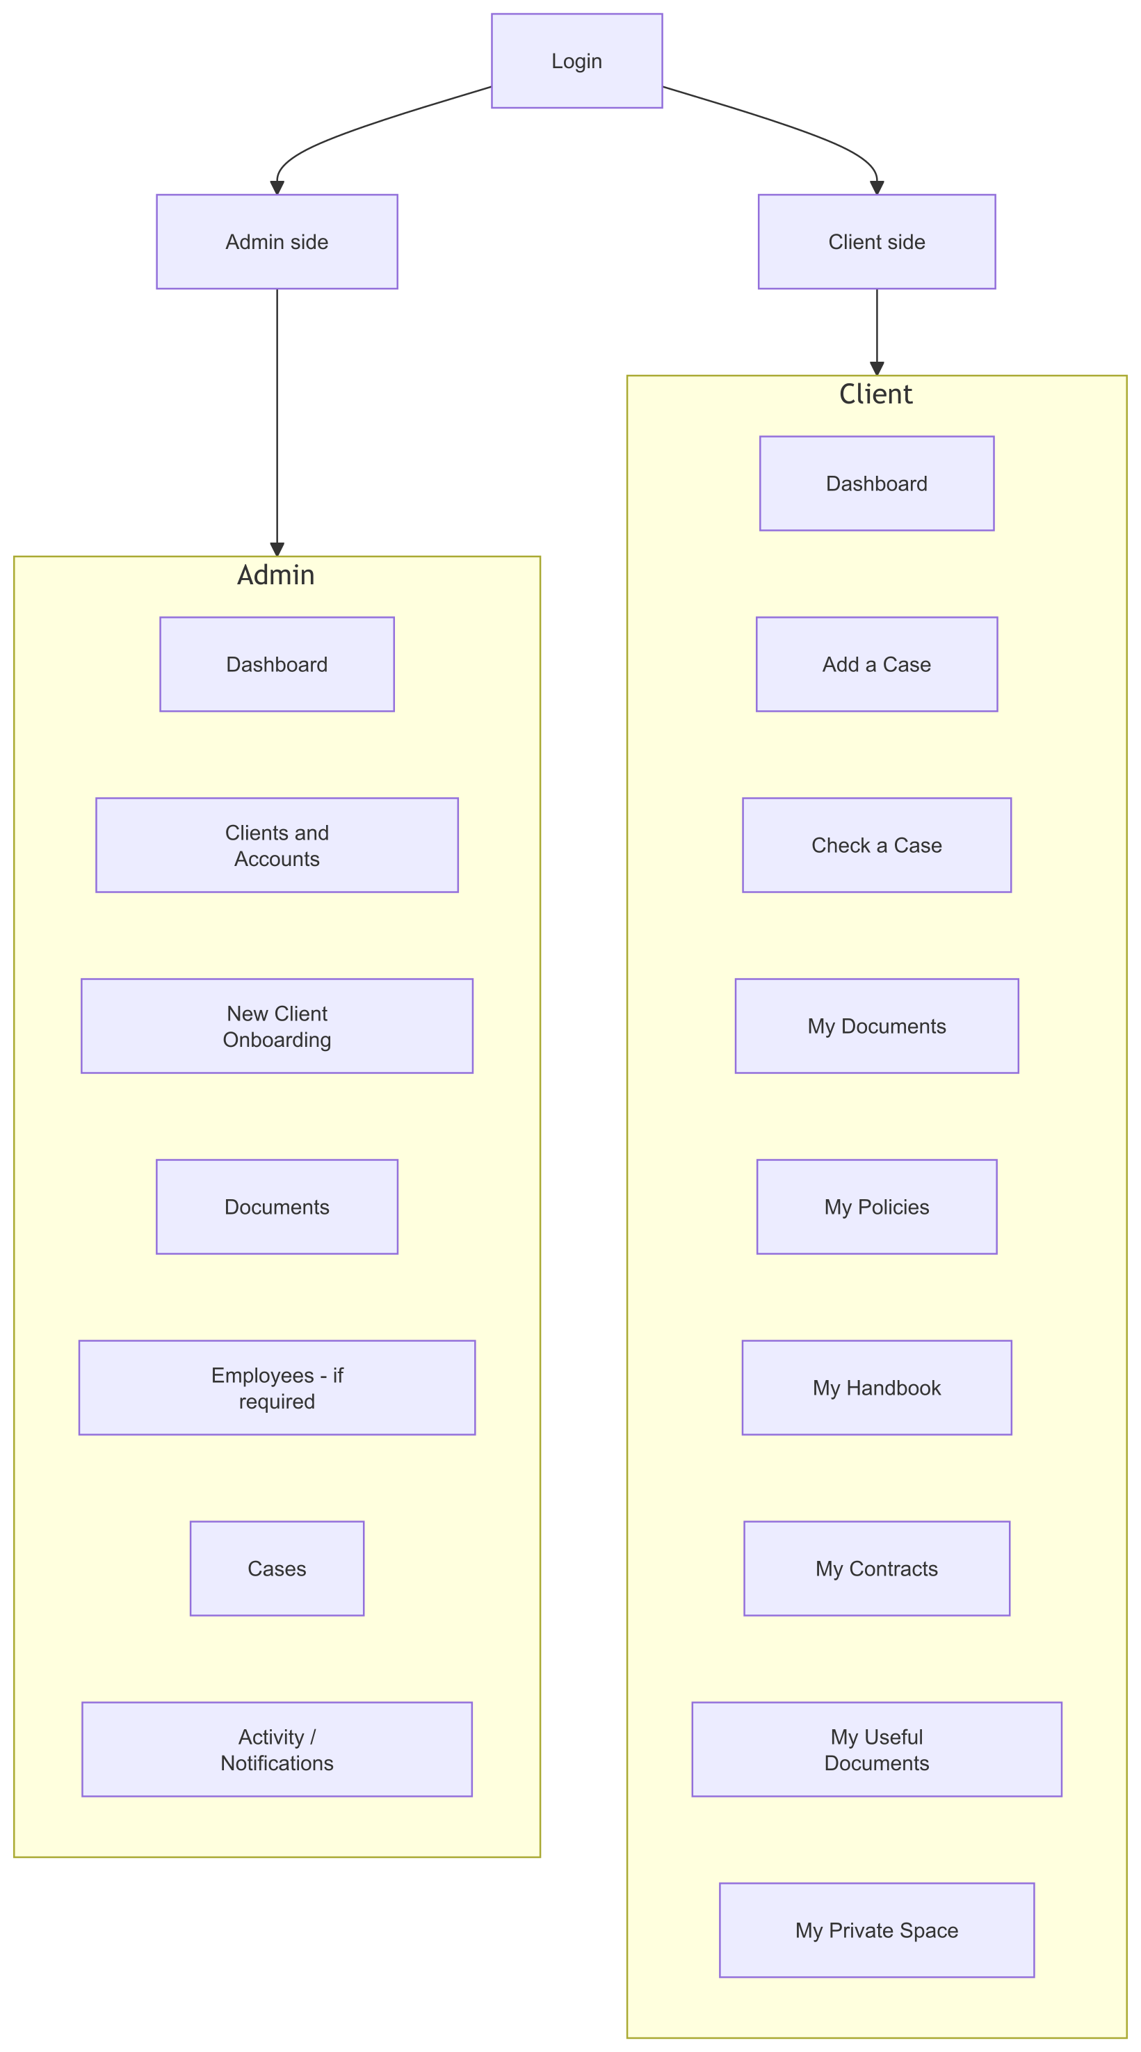
Figure: Sitemap / navigation
Client document areas (6): My Documents · My Policies · My Handbook · My Contracts · My Useful Documents · My Private Space

9. Data model (ER diagram)
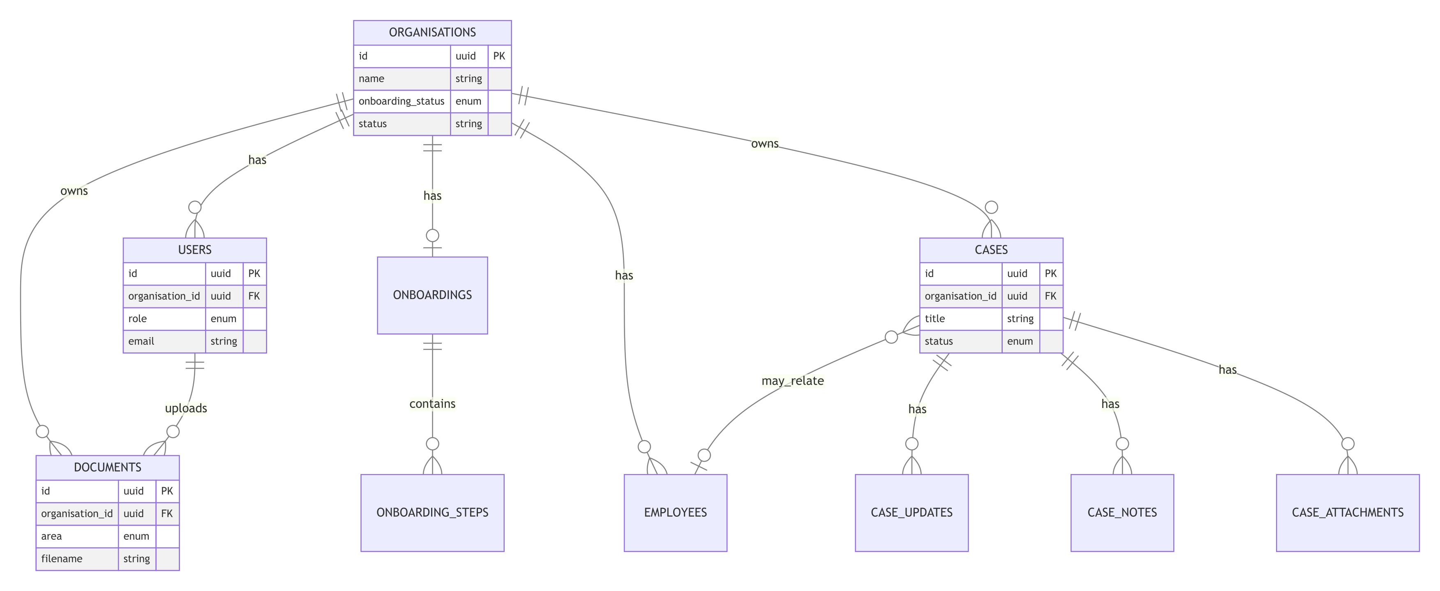
Figure: Data model (ER)
Key rules
Field | Values
onboarding_status | existing_skip · in_progress · completed
documents.area | documents · policies · handbook · contracts · useful · private
users.role | admin · client
Case updates | Client-visible updates vs internal notes (never emailed to client)

Everything business-critical hangs off organisation_id (Company A never sees Company B).

10. Finished foundation product — what we will have
You have | Meaning
Login | Admin and client accounts, secure
Clients list | Add companies; tag Existing vs New
Onboarding for new only | Steps + status; existing skip it
6 document areas per client | Admin upload; client download; Private Space both ways
Cases | Create, track, update, close; emails for updates
Separation | Company A never sees Company B
Admin dashboard | Who needs attention (onboarding / cases)

Not in this foundation (unless agreed later): full payments system, payroll, bulk Dropbox migration, employee self-login filling 30 forms.

11. Source alignment (quick)
Source | Role
SOW + David’s message | Truth for build
HTML mockup | UI feel (older: 3 doc folders; product uses 6)
Early call understanding | Rough — right on clients/docs; overstated “30 employees fill forms”

Diagram index
File | Diagram
00-two-sides.png | Admin vs Client
01-use-cases.png | Actors & use cases
02-system-context.png | System context
03a-journey-existing-client.png | Existing client journey
03b-journey-new-client.png | New client onboarding
03c-journey-documents.png | Documents flow
03d-journey-case.png | Case flow
04-sitemap.png | Navigation map
05-er-diagram.png | Data model

