
SNAP A+ HUB
Complete Chart Observation & A+ Setup Guide

Purpose
A practical guide for reading the SNAP A+ Hub, observing the chart, confirming confluence, and finding cleaner A+ entries.

Framework: SRL → Bias → Structure → Value/VWAP → FVG → EMA → Flow
Use this as a checklist, not as a random signal machine.

Contents
- 1. SNAP A+ Hub overview
- 2. SNAP 9 layers in order
- 3. Dashboard rows explained
- 4. A+ BUY setup checklist
- 5. A+ SELL setup checklist
- 6. Confirmation stack
- 7. Ghantt / Gann DRT premium-discount map
- 8. What to avoid
- 9. Practical entry model
- 10. Quick summary

1. SNAP A+ Hub Overview
- SNAP A+ Hub is the combined decision layer for the full SNAP framework.
- It brings the strongest information from the separate SNAP layers into one dashboard.
- It scores BUY and SELL conditions and shows whether the chart is building, waiting, or triggering.
- It is designed to reduce noise and help you wait for confluence.
- The Hub should be used as a confirmation dashboard, not as a random buy/sell button.
Core rule
Location first. Sweep second. Structure third. Entry zone fourth. Flow last.

2. SNAP 9 Layers in Order
Layer | Name | Purpose
1 | SNAP SRL | Sessions / Range / Liquidity
2 | SNAP Bias | Bias / PVSRA / ADR / EMA / market programme
3 | SNAP MSB / OB / BB | Market Structure Break / Order Block / Breaker Block
4 | SNAP Value Profile | POC / VAH / VAL / value location
5 | SNAP VWAP | VWAP / standard deviation bands / mean control
6 | SNAP FVG Entry Zone | Fair Value Gap / entry zone / mitigation
7 | SNAP EMA Alignment | EMA stack / mean threshold / trend alignment
8 | SNAP RSI / VSA / Order Flow | RSI / WMA / volume spread / flow pressure
9 | SNAP Bubble Flow / Delta | Delta pressure / bubble flow / cluster confirmation

3. Dashboard Rows Explained
Dashboard Row | What it tells you | How to use it
Signal | Main trade state: WAIT, A SETUP, BUY A+, SELL A+. | Only act when the rows underneath agree.
Score | BUY score versus SELL score. | Clear separation is better than close scores.
Window | Current session: Asia, London, New York, NY AM, Lunch, PM Macro, Outside. | London / New York / NY AM are usually stronger execution windows.
Range / Zone | Active range and whether price is Premium, Discount, or Mid. | Buy from discount. Sell from premium. Be careful in the middle.
Sweep | Shows which high or low has been raided. | Low sweep can prepare buy. High sweep can prepare sell.
Bias | Weighted programme read: BUYSIDE, SELLSIDE, WATCH, or NEUTRAL. | Signal should match bias.
Structure | MSS, pivot break, displacement, or waiting. | A+ needs structure confirmation.
Struct Ref | The price level being referenced for the structure read. | Shows the pivot/high/low level the Hub is reading.
Value | Below value / VAL, Above value / VAH, Inside POC. | Below value supports buy location; above value supports sell location.
VWAP | Above/below VWAP or band rejection. | VWAP confirms acceptance or rejection of value.
FVG / Entry | Bull FVG hold/wait, Bear FVG hold/wait, or No FVG. | Best entries often come from FVG retest and hold.
EMA | BUY trigger, SELL trigger, armed, above/below all EMAs, mixed. | Timing layer, not the reason alone.
Flow | Buy pressure, sell pressure, flow cluster, balanced. | Final confirmation that participation is present.
Mean | Mean threshold / fair value reference. | Useful first target or confirmation level.

4. A+ BUY Setup Checklist
- Price is in discount or below value.
- A meaningful low has been swept: Asia Low, London Low, New York Low, or PDL.
- Price rejects lower prices and closes back inside the range.
- Bias turns BUYSIDE or BUYSIDE WATCH.
- Structure confirms with Bull MSS, pivot break, or bullish displacement.
- Bull FVG forms and then holds on retest.
- VWAP supports the move: lower band reject, VWAP reclaim, or above VWAP.
- EMA shows BUY armed, BUY trigger, or above execution EMAs.
- Flow shows Buy pressure or BUY flow cluster.
- BUY score is clearly stronger than SELL score.
- Stop should usually sit below the sweep low or the structural invalidation point.
Clean BUY sequence
Discount → low sweep → rejection → bullish displacement → Bull FVG hold → VWAP/EMA support → buy pressure → BUY A+

5. A+ SELL Setup Checklist
- Price is in premium or above value.
- A meaningful high has been swept: Asia High, London High, New York High, or PDH.
- Price rejects higher prices and closes back below the swept level.
- Bias turns SELLSIDE or SELLSIDE WATCH.
- Structure confirms with Bear MSS, pivot break, or bearish displacement.
- Bear FVG forms and then holds on retest.
- VWAP supports the move down: upper band reject, VWAP loss, or below VWAP.
- EMA shows SELL armed, SELL trigger, or below execution EMAs.
- Flow shows Sell pressure or SELL flow cluster.
- SELL score is clearly stronger than BUY score.
- Stop should usually sit above the sweep high or the structural invalidation point.
Clean SELL sequence
Premium → high sweep → rejection → bearish displacement → Bear FVG hold → VWAP/EMA support → sell pressure → SELL A+

6. Confirmation Stack
Step | Question
1. Session | Are we in London, New York, NY AM, or PM Macro?
2. Location | Are we in premium, discount, or mid?
3. Liquidity sweep | Which high or low was taken?
4. Reaction | Did price reject or continue?
5. Structure | Did MSS, pivot break, or displacement confirm?
6. Entry zone | Is there a valid FVG and did it hold?
7. Value / VWAP | Is price accepting or rejecting value?
8. EMA timing | Is the move armed or triggered?
9. Flow | Is pressure confirming the move?

7. Ghantt / Gann DRT Premium-Discount Map
- The Ghantt / Gann box is a confluence map, not the entry trigger by itself.
- It helps visualise where price is relative to premium, discount, and mean.
- Use it to see whether the trade idea is coming from a sensible location.
Level | Meaning | Use
1.00 | Top / premium extreme | High risk for new buys; better area to watch sell rejection.
0.75 | Upper premium reaction zone | Potential sell reaction or profit-taking area.
0.50 | Mean / fair value | First logical target or decision area.
0.25 | Lower discount reaction zone | Potential buy reaction area.
0.00 | Bottom / discount extreme | High risk for new sells; better area to watch buy rejection.

8. What to Avoid
- Do not buy only because a low was swept.
- Do not sell only because a high was swept.
- Avoid trades when price is in the middle of the range and scores are mixed.
- Avoid BUY signals if bias remains SELLSIDE.
- Avoid SELL signals if bias remains BUYSIDE.
- Avoid entries when Structure says Waiting.
- Avoid entries when FVG says No FVG and there is no clean retest.
- Avoid trades when Flow is Balanced.
- Avoid forcing trades during Lunch or Outside / Downgrade windows.
- Avoid using 1m/2m as the main decision timeframe without higher-timeframe confirmation.

9. Practical Entry Model

BUY entry model
- Start from discount or below value.
- Wait for a low sweep and rejection.
- Wait for Bull MSS / displacement.
- Wait for Bull FVG to form and hold.
- Check VWAP and EMA support.
- Check buy pressure / BUY flow cluster.
- Enter on FVG hold, reclaim continuation, or clean pullback after displacement.
- Stop below the sweep low.
- First target: mean / 0.50.
- Next target: 0.75 or 1.00 premium side.

SELL entry model
- Start from premium or above value.
- Wait for a high sweep and rejection.
- Wait for Bear MSS / displacement.
- Wait for Bear FVG to form and hold.
- Check VWAP and EMA downside support.
- Check sell pressure / SELL flow cluster.
- Enter on FVG hold, rejection continuation, or clean pullback after displacement.
- Stop above the sweep high.
- First target: mean / 0.50.
- Next target: 0.25 or 0.00 discount side.

10. Quick Summary
- SNAP A+ Hub combines the full SNAP framework into one decision model.
- It checks session, range, sweep, bias, structure, value, VWAP, FVG, EMA, and flow.
- The strongest BUY A+ setups start from discount after a low sweep and bullish confirmation.
- The strongest SELL A+ setups start from premium after a high sweep and bearish confirmation.
- The Ghantt box helps map premium, discount, and mean.
- The best entries happen after confirmation, not at the first sweep.
- Use the dashboard as a checklist.
- Fewer trades, better quality, stronger A+ execution.
Final reminder
The Hub is a confirmation tool. Let the chart build the story: location → sweep → reaction → structure → entry zone → flow.

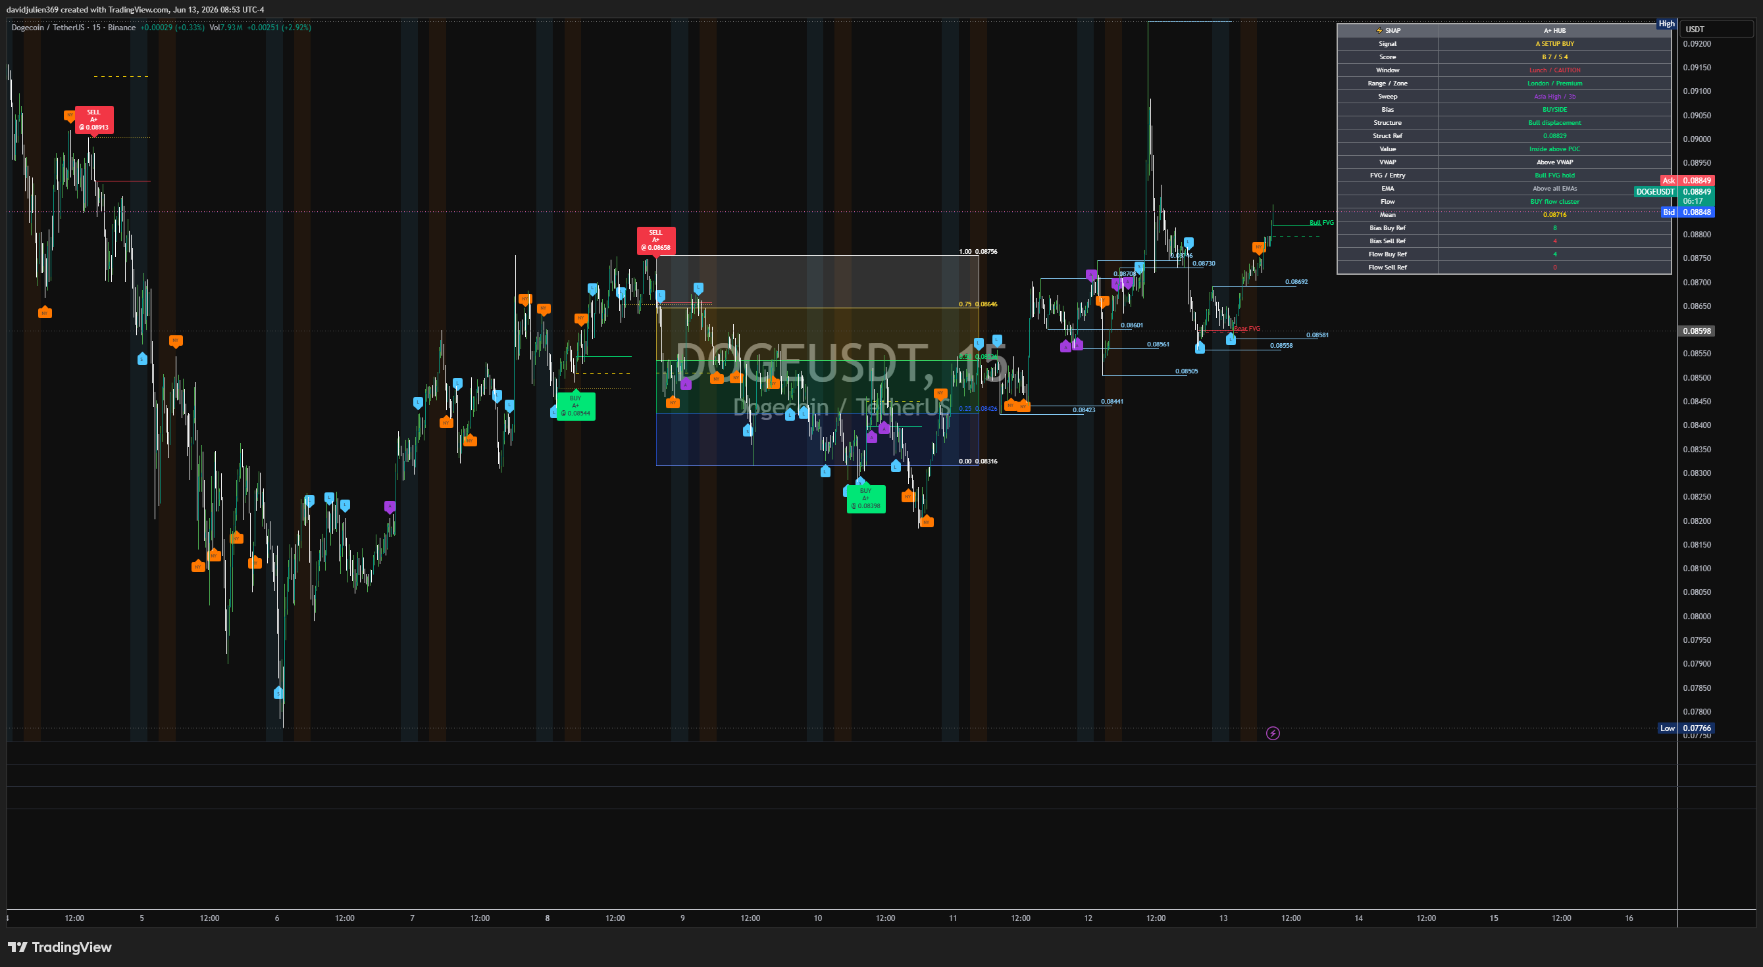

Addendum: Trade Management & Chart Markers
Good catch — this section explains the trade-management lines that appear on the chart after a BUY A+ or SELL A+ setup is active.

What the lines mean
Marker / Line | Colour / Style | What it means | How to use it
Entry line / trade box origin | Main setup box origin | The level where the Hub is basing the active trade idea. | This is the reference entry area after the sweep, structure shift, and confirmation.
1R EXIT | Thin white line | The first target at 1R (one unit of reward for one unit of risk). | A practical first take-profit area. Good for scaling partials or reducing risk.
EXT ±DEV | Faint grey / white line | The one-deviation extension target beyond the 1R target. | Used as an extended objective if price continues with strong momentum.
STOP ATR | Thin red line | ATR-based stop logic with breathing room. | This is the invalidation zone. It gives the trade extra room beyond raw structure.
Yellow dotted logic line | Thin yellow dotted line | A logic/reference line linked to the sweep / inducement / reaction area. | Use it as a visual reminder of the liquidity event or internal logic reference behind the setup.
Green dotted logic line | Thin green dotted line | A supportive directional / mean / confirmation reference line. | Use it to help read whether price is holding the bullish or bearish reaction area after entry.

How this works for BUY trades
- The BUY A+ tag appears after the Hub gets enough alignment.
- The entry is based on the post-sweep reaction and confirmation area.
- The STOP ATR red line sits below the idea and gives the trade breathing room.
- The 1R EXIT white line is the first logical target.
- The one-deviation line sits above 1R and is used if the move extends cleanly.
- The yellow and green dotted lines help show the internal logic/reference path behind the setup.

How this works for SELL trades
- The SELL A+ tag appears after the Hub gets enough alignment.
- The entry is based on the post-sweep rejection and confirmation area.
- The STOP ATR red line sits above the idea and gives the trade breathing room.
- The 1R EXIT white line is the first logical target downward.
- The one-deviation line sits beyond 1R and is used if the sell move extends cleanly.
- The yellow and green dotted lines help show the internal logic/reference path behind the setup.

Plain-English reading order
- 1. Wait for the sweep.
- 2. Wait for structure / displacement / FVG confirmation.
- 3. Use the entry area as the setup anchor.
- 4. Use STOP ATR as the invalidation level.
- 5. Use 1R EXIT as the first profit objective.
- 6. Use the one-deviation line as the stretch target if price keeps going.
Simple summary
White line = first take-profit (1R). Grey/white extension = one-deviation stretch target. Red line = ATR stop / invalidation. Yellow and green dotted lines = internal logic/reference markers around the sweep and reaction area.

