# IT 2045C Computer Programming II Prof. Tom Wulf Lab 09: Java Data Streams Spring 2022 20 pts

Explore the Java Data Stream Processing

IntelliJ Project name: DataStreams  
  
Create a Swing GUI that:

* Allows the user to load a text file using the JFileChooser
* Asks the user to enter a search string into a textField
* Uses **java data stream processing** to return the lines of the file that contain the search String. Specifically use the Stream, and filter with a lambda expression to do this.

## GUI Notes:

* I’m leaving this to you for the most part.
* You should have two parallel scrolling textAreas. Display the original file on the left-hand side and the filtered file on the right-hand side
* Provide the textField for the search string
* Provide command buttons for
  + Load a file
  + Search the file (after a file is loaded only)
  + Quit

Be sure to use the modern java file system classes Path and Files  
  
try (Stream lines = Files.lines(Paths.get(FILEPATH)))

**DO NOT THROW THE IOEXCEPTION ON MAIN** be sure to handle the errors with the usual try catch mechanism.. NO credit if you do this!

Provide screen shots which clearly show:

- A shot of your source code that shows that you used the Steam approach here.

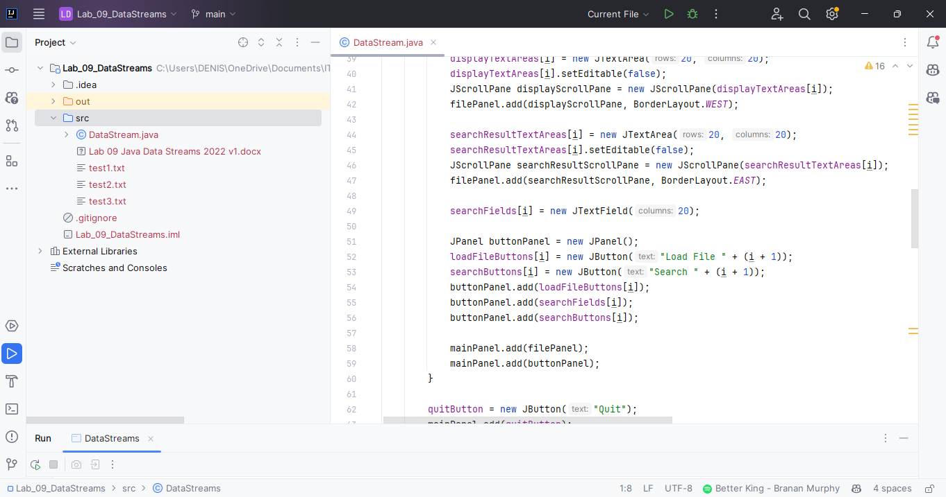

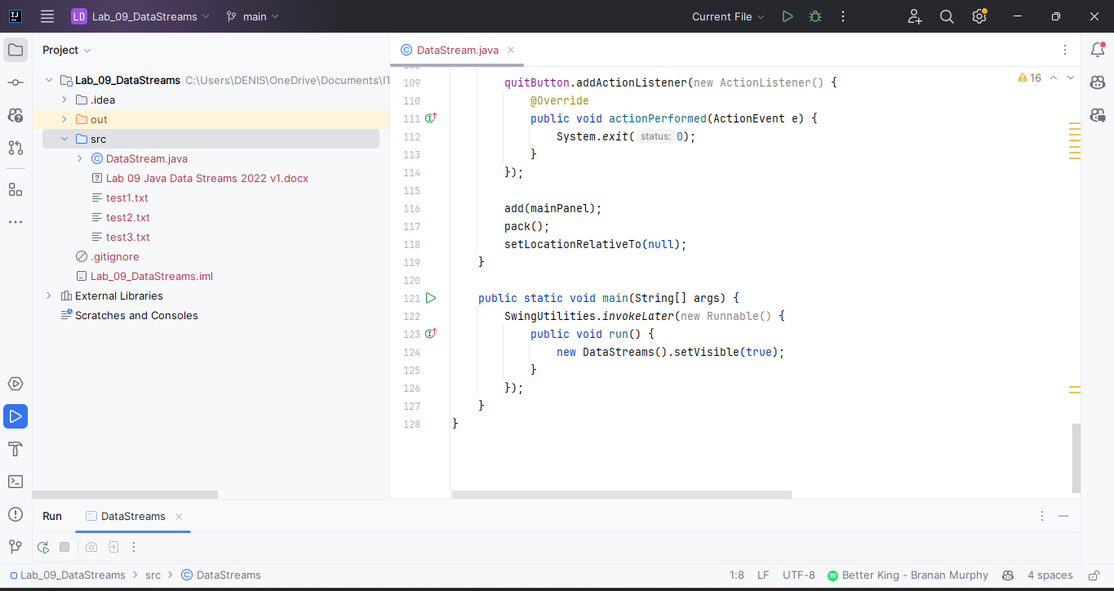  
  
- the JFileChooser selecting the file

- clear side by side displays of the file and the filtered results for at least 3 sample files.

- Use 3 different search strings, that is a different one for each example.

## Submitting your Work:

Use the Canvas Assignment mechanism to submit the link to your GitHub repo for this project and after inserting your screen and code shots this file renamed **LastnameFirstname _Lab_09.docx** (using your actual name).