**Computer Programming II   
Prof. Tom Wulf   
Lab 6: Pizza Order GUI Program   
Spring Sem 2022**

Objective: Get practice with using the Java GUI methods, especially the components that are commonly used in Web forms. For the rest of the course, all assignments will require Swing GUIs, but this is the last one that will cover new features of the Swing system.   
  
**Discussion:**   
  
 Create a JFrame-based GUI application that allows a person to construct an order for pizza. Name your IntelliJ project PizzaGUIForm and place it under GitHub source control. You should have PizzaGUIFrame.java and PizzaGUIRunner.java files.

After selecting the options and elements for the pizza, the user clicks the Order button and the program displays the order and costs in a JTextArea within a JScrollPane. For simplicity you can assume that the user only enters an order for one pizza. The technical focus here is on the details of some of the additional JComponents that are commonly used for form-based input: JCheckBox, JRadioButton, and JComboBoxComponents:

* Create a JRadioButton set for the type of crust {Thin, Regular, Deep-dish}
* Create a JComboBox for the size: {Small, Medium, Large, Super} The base cost is $8.00, $12.00, $16.00, $20.00.
* Create a set of at least 6 Toppings using JCheckBox You can make totally humorous toppings if you wish. (What would monster pizza have for ingredients?) Each topping costs an additional $1.00.
* Each of these previous items should be in a JPanel and have a Titled border.
* Include an additional JPanel with a JTextArea which will display the order as text similar to a receipt.
* Add a final JPanel with 3 JButtons Order, Clear, and Quit.
  + Quit performs in the usual fashion. However, use a JOptionPane.ConfirmMessegeDialog to ask the user if they are sure they want to quit.
  + The clear button will wipe the form (all components) so it is ready for a new order.
  + When the Order button is pressed the order is compiled from the settings of the various GUI components and displayed as text in the JTextArea. This should be nicely formatted to look like a typical cash register receipt. Note that the tax rate is 7% (.07). :  
      
    **=========================================**Type of Crust & Size Price  
    Ingredient Price

**Sub-total:** Amount  
**Tax:** Amount  
---------------------------------------------------------------------  
**Total:** Total  
**=========================================**

Note that the items in **bold** on the example should appear on the receipt as well as the divider lines. The other items will be replaced with the actual order. An order must have a Crust and Size choice and at least one ingredient. An order may have every ingredient option. Sub-total is the sum of the choices prior to calculating the tax. Tax is 7% of the order sub-total. Total is the sum of the sub-total and the tax.

* Layout: place the button panel at the bottom. Put the JTextArea panel immediately above it. I leave the layout of the rest of the panels to you with the caveat that you must not stack them vertically in one column. Please experiment with the Layout a bit here. Strive for something that is pleasing to the eye and reflects basic UI design for usability.
* Take several screen shots that establish that your program works correctly and paste them here in this document.  
    
  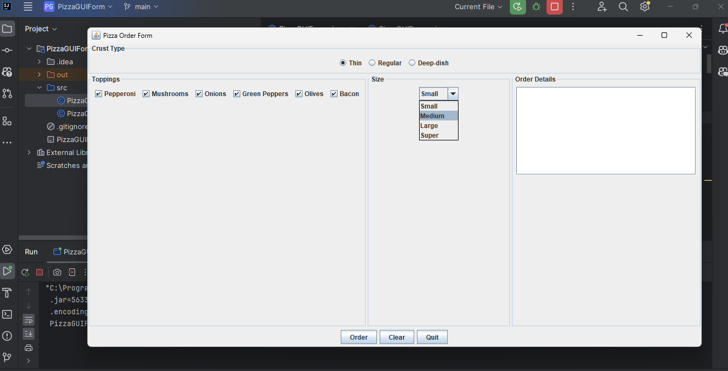

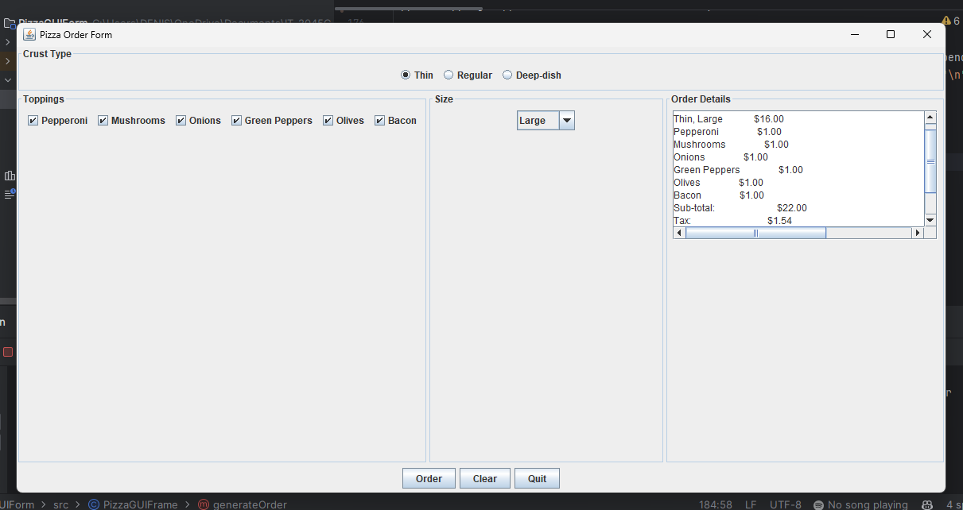

* Submit a link.to your GitHub repo as well as this file with your screen shots renamed **lastname_FirstName_Lab06.docx** using your name using the Canvas assignment link

<https://github.com/DMKALALA/Java-II-/tree/main/Labs/PizzaGUIForm>