**State machine designed using =>** [**Webgraphviz**](http://www.webgraphviz.com/)

**TODO:**

* Review state machine
* Implement using [stateless library](https://github.com/dotnet-state-machine/stateless)

**Graph:**

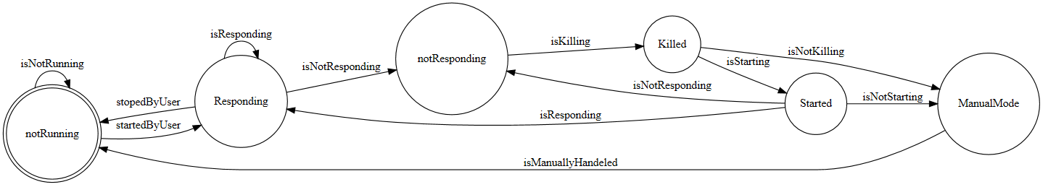

**Code:**

digraph finite_state_machine {

rankdir=LR;

size="15"

node [shape = doublecircle]; notRunning;

node [shape = circle];

notRunning -> Responding [ label = "startedByUser" ];

notRunning -> notRunning [ label ="isNotRunning"];

Started -> Responding [ label = "isResponding" ];

Started -> ManualMode [ label ="isNotStarting"];

Started -> notResponding [ label = "isNotResponding"];

Responding -> Responding [ label = "isResponding"];

Responding -> notResponding [ label = "isNotResponding"];

Responding -> notRunning [label = "stopedByUser"];

notResponding -> Killed [label = "isKilling"];

Killed -> Started [label = "isStarting"];

Killed -> ManualMode [ label = " isNotKilling"];

ManualMode -> notRunning [ label = "isManuallyHandeled"]

}