**Problem statement:** Analyzing changes in evolving data fromadvanced habitation systems.

The goal of this task is to create a framework that monitors and provides change detection in a multimodal system. **Our objective** is two-fold (a) To provide the mining of patterns from older data as changes in data could reflect long term/ previous trends. (b) Mining for patterns over near data – as recent changes in data could indicate the recurrences of the previously known pattern or an upcoming event.

**Reported outcomes:** An exhaustive survey of related works in change detection and changepoint detection and identify known implementations in R to compare and contrast.

**Specific Aims:**

1. Installed change detection and changepoint detection packages in R.
2. Gather all related papers and categorize them.
3. Implemented known functions available in R packages on synthetic random data.

**Key Accomplishments:**

1. Implementing the basic parametric approaches of both change detection and changepoint detection in R.

**Red Flags:**

1. We are not handling streaming data.
2. We are not handling multimodal data.
3. We are not data driven.

**Future Work:**

1. To implement data driven approaches that accomplish objectives (a) and (b) and a scalable approach to handle streaming data.

**Timeline (tentative timeline for the upcoming week)**

|  |  |  |  |  |  |  |
| --- | --- | --- | --- | --- | --- | --- |
| **Future Specific aims** | **09/18** | **09/19** | **09/22** | **09/23** | **09/24** | **09/25** |
| Implementation of streaming data framework (windowing) |  |  |  |  |  |  |
| Identify related data driven approaches |  |  |  |  |  |  |
| Implementation of change point detection using PCA |  |  |  |  |  |  |
| Testing with relevant data |  |  |  |  |  |  |

**References:**

[1] Boriah, S., Kumar, V., Potter, C., Steinbach, M., & Klooster, S. (2008). Land cover change detection using data mining techniques. *Technical Report March 14*.

[2] Basseville, M., & Nikiforov, I. V. (1993). *Detection of abrupt changes: theory and application* (Vol. 104). Englewood Cliffs: Prentice Hall.

[3] Zhang, Z., Vosselman, G., Gerke, M., Tuia, D., & Yang, M. Y. (2018). Change detection between multimodal remote sensing data using siamese CNN. *arXiv preprint arXiv:1807.09562*.

**Appendix A**

**Results**

1. **Change detection** provides the list of estimated points of structural change within a multivariate time-wise linear regression. Additionally, we tested the use of functions to estimate corresponding changing linear model, moving energy distance and a change-detection test.

The following functions of Change detection are implemented in R Studio

**changes( )**

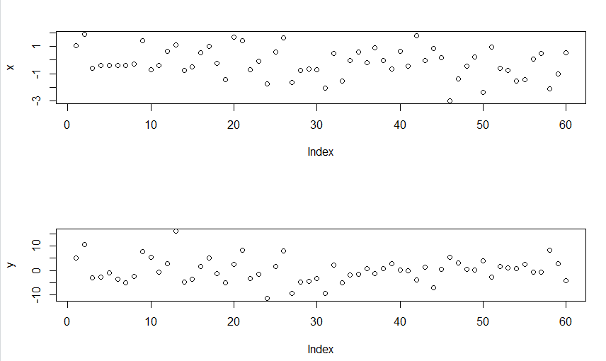

Figure 1: A list of change locations occurred in the structure having given responses ‘y’ and regressors ‘x’.

**changeTest( )** – A test showing whether two datasets have similar linear structure.

* The testResult is False.

**changingModel( )**

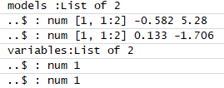

Figure 2: Changeable linear structure of the data with given change points.

**energyDistance( )** Energy distance between two datasets.

* The energy distance ed is 109.2941.

**movingEnergyDistance( )**



Figure 3: Moving energy distance.

1. **Changepoint Detection:** Implements various mainstream and specialized changepoint methods for finding single and multiple changepoints within data.

**Results**

The following functions of Changepoint detection are implemented in R Studio

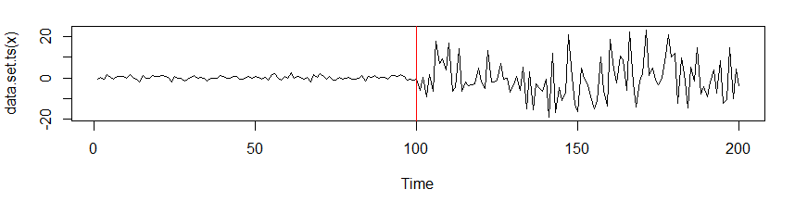

Figure 4: Change in Variance.

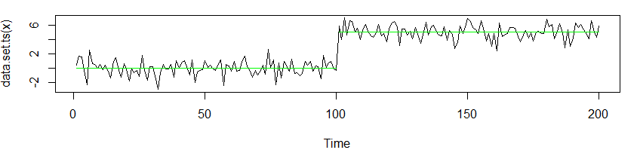

Figure 5: Change in Mean.

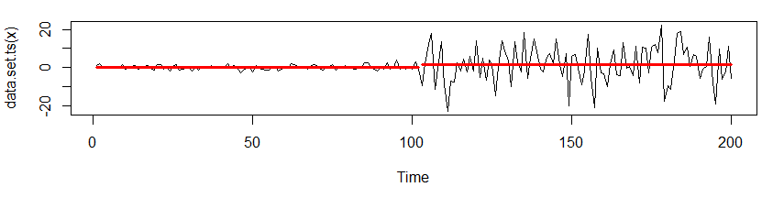

Figure 6: Change in Mean and Variance.

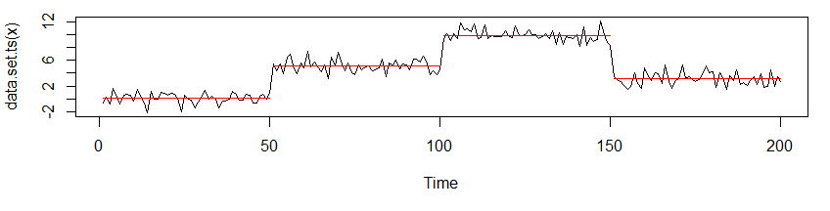

Figure 7: Example of using CROPS penalty in data set above.