**Problem statement:** Analyzing changes in evolving data fromadvanced habitation systems.

The goal of this task is to create a framework that monitors and provides change detection in a multimodal system. **Our objective** is two-fold (a) to provide the mining of patterns from older data as changes in data could reflect long term/ previous trends. (b) Mining for patterns over near data – as recent changes in data could indicate the recurrences of the previously known pattern or an upcoming event.

**Reported outcomes:** Investigating the Statistical based approaches of Concept drift detection methods.

**Specific Aims:**

1. Understanding the types of concept drift and its patterns.
2. Groundwork for the generic schema for an online adaptive learning algorithm.
3. An exhaustive research on the drift detection method.

**Key Accomplishments:** Exploring the Concept drift detection methods.

**Red Flags:**

1. We are not handling real world multimodal data.
2. We are yet to integrate change detection with the data stream framework.
3. We are yet to fix the errors while integrating MOA to R.

**Future Work:** To integrate the bearing dataset to the MOA-based techniques.

**Timeline (tentative timeline for the upcoming week)**

|  |  |  |  |  |  |
| --- | --- | --- | --- | --- | --- |
| **Future Specific aims** | **10/02** | **10/03** | **10/04** | **10/07** | **10/08** |
| Task 1: Integrating the R interface to MOA. |  |  |  |  |  |
| Task 2: Investigate the sequential analysis and window based concept drift detection methods. |  |  |  |  |  |
| Task 3: Integrating the bearings dataset to the drift detection methods. |  |  |  |  |  |

**References:**

[1] Baena-Garcıa, M., del Campo-Ávila, J., Fidalgo, R., Bifet, A., Gavalda, R., & Morales-Bueno, R. (2006, September). Early drift detection method. In *Fourth international workshop on knowledge discovery from data streams* (Vol. 6, pp. 77-86).

**Appendix A**

**Results**

**Drift Detection Method**

The Drift Detection Method (DDM), monitors the error-rate of the classiﬁer to detect concept drift. On the basis of the probably approximately correct (PAC) learning model, the classiﬁcation error-rate decreases or stays constant as the number of instances increases. Otherwise, it suggests the occurrence of a drift. Let pt be the error-rate of the classiﬁer with a standard deviation of st = √p(pt(1−pt)/t) at time t. As instances are processed, DDM updates two variables pmin and smin when pt + st < pmin + smin. DDM warns for a drift when pt + st ≥ pmin + 2∗smin, and alarms for a drift when pt + st ≥ pmin + 3∗smin. The variables pmin and smin are reset when a drift occurs.

**Types of drifts**

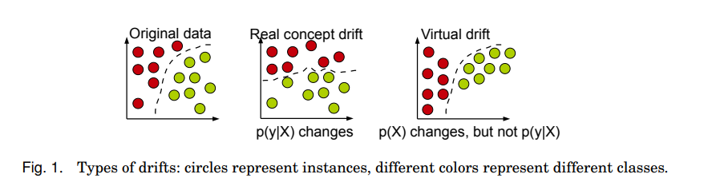

**Patterns of changes**

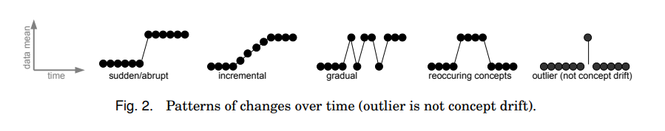

**Architecture**

