**Problem statement:** Analyzing changes in evolving data fromadvanced habitation systems.

The goal of this task is to create a framework that monitors and provides change detection in a multimodal system. **Our objective** is two-fold (a) to provide the mining of patterns from older data as changes in data could reflect long term/ previous trends. (b) Mining for patterns over near data – as recent changes in data could indicate the recurrences of the previously known pattern or an upcoming event.

**Reported outcomes:** Simulating Concept Drift in MOA and analyzing the sequential analysis based concept drift detection method.

**Specific Aims:**

1. Determining the issues while integrating R to MOA.
2. Using MOA, comparing the evaluation measures of NaiveBayes and HoeffdingTree classifiers.
3. Analyzing the fundamentals of Cumulative Sum (CUSUM) algorithm.

**Key Accomplishments:** Comparing the evaluation of NaiveBayes, HoeffdingTree and Concept Drift methods in Massive Online Analysis.

**Red Flags:**

1. We are not handling real world multimodal data.
2. Encountered issues with Spark connection while integrating R to MOA.
3. We are yet to integrate change detection with the data stream framework.

**Future Work:** To integrate R interface to MOA and bearing dataset to the MOA-based techniques.

**Timeline (tentative timeline for the upcoming week)**

|  |  |  |  |  |  |
| --- | --- | --- | --- | --- | --- |
| **Future Specific aims** | **10/09** | **10/10** | **10/11** | **10/14** | **10/15** |
| Task 1: Investigate the mining strategies. |  |  |  |  |  |
| Task 2: Integrating the R interface to MOA. |  |  |  |  |  |
| Task 3: Integrating the bearings dataset to the drift detection methods. |  |  |  |  |  |

**References:**

[1] Baena-Garcıa, M., del Campo-Ávila, J., Fidalgo, R., Bifet, A., Gavalda, R., & Morales-Bueno, R. (2006, September). Early drift detection method. In *Fourth international workshop on knowledge discovery from data streams* (Vol. 6, pp. 77-86).

**Appendix A**

**Results**

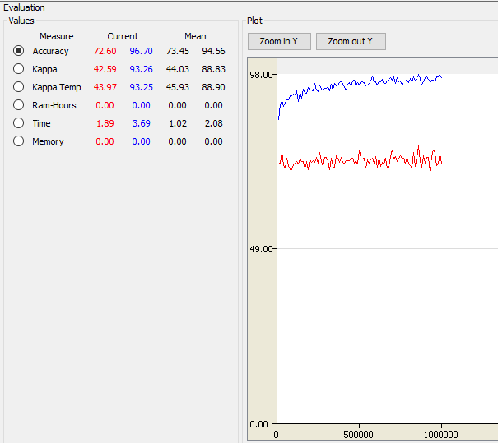

Figure 1: Comparison between the classifiers NaïveBayes and HoeffdingTree

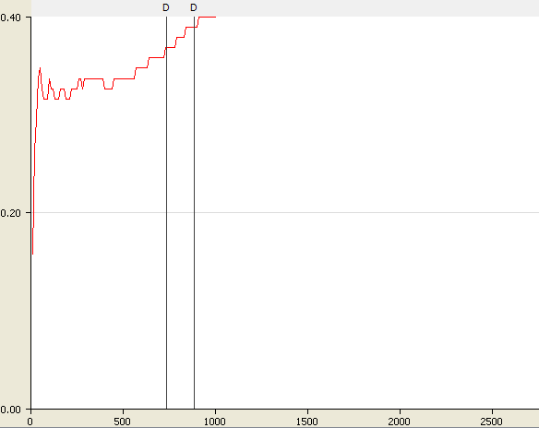

Figure 2: Evaluation of drift deduction method.

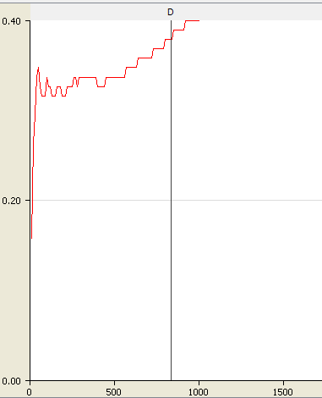

Figure 3: Evaluation of CUSUM deduction method.