Contents
Introduction 1
Experimental Setup 1
Joystick 2
LabBench I/O 2
Protocol 2
Analysis 3
Discussion 3

Introduction
The stop-signal task has become a popular tool for the study of response inhibition in cognitive psychology, cognitive neuroscience, and psychopathology (Verbruggen and Logan, 2008). Cognitive psychologists suggested that the response inhibition should be seen as a race between a go process and a stop process (horse-race model). Cognitive neuroscientists showed that these processes might activate brain regions differently, and psychopathologists showed selective deficits in inhibition.
Response-inhibition deficits have been linked to several psychopathological and neurological disorders. Some disorders, such as autism, and schizophrenia are associated with general cognitive impairments in addition to inhibitory deficits. identified in several neuropsychiatric conditions associated with impulsivity such as ADHD, trichotillomania, OCD, and chronic substance abuse (Chamberlain & Sahakian, 2007).
A cognitive task that can effectively measure inhibition is the stop-signal task. The use of this task, developed for the first time by Vince in 1948, allows to obtain an index of the reaction time (Stop Signal Reaction Time (SSRT)), necessary for the individual to successfully inhibit a motor response already programmed and in the execution phase.
The Stop-Signal task was created to study the control of thought and action by testing subjects' ability to hold back a planned movement in response to a stop signal (Logan, 1994; Logan & Cowan, 1984). Subjects are instructed to respond as quickly as possible to a go signal (go-signal trial). In a smaller percentage of trials, a stop signal is presented following which the subject must inhibit the previously planned response.
The subject's ability to inhibit the response is probabilistic and depends on the interval between go-signal and stop-signal which is referred to as Stop Signal Delay (SSD). Generally, as the SSD increases, the probability that the subject can inhibit the motor response decreases. The trials in which the response was correctly inhibited are defined as signal inhibit, while the trials in which the subject was not able to inhibit the response are called signal respond.
The protocol (vstopsignal@labbench.io) presented here demonstrates how a visual stop-signal task can be implemented in LabBench.

Experimental Setup
The protocol is implemented for two different experimental setups; one based on a standard USB joystick, and one based on the LabBench I/O, PAD, ATG devices. The joystick-based setup offers a cost-effective version of the protocol albeit at the expense of accuracy, whereas the LabBench I/O based setup offers the most intuitive setup for the subjects with a high timing accuracy (< 1ms).

EEG acquisition
Electroencephalography (EEG) is used to record neural activity during execution of the Stop Signal Task (SST). The objective is to investigate event-related potentials (ERPs) associated with response inhibition, particularly the N2 and P3 components. These ERP components have consistently been associated with inhibitory control processes and are commonly observed during SST paradigms.

The EEG recordings are obtained using a 64-channel g.HIamp acquisition system with a sampling frequency of 512 Hz. Electrode placement follows the international 10-20 system, ensuring adequate coverage of frontal, central, parietal, and occipital regions relevant for inhibitory control research.

EEG Preparation Procedure
Equipment
The following equipment is required before beginning the recording:
- 64-channel EEG cap
- G.HIamp EEG amplifier
- EEG recording computer
- Conductive EEG gel
- Syringe for gel application
- Measuring tape
- Alcohol wipes
- LabBench Runner
- LabBench Designer
- External participant display
- Joystick
Participant Preparation
- Seat the participant comfortably in a quiet testing environment.
- Explain the experimental procedure and task instructions.
- Measure the participant’s head circumference and select the appropriate EEG cap size.
- Position the EEG cap using the international 10-20 system landmarks:
- Nasion
- Inion
- Left preauricular point
- Right preauricular point
- Ensure that the CZ position is centered correctly on the scalp.
- Insert conductive gel into each electrode location.
- Connect the cap to the g.HIamp acquisition system.
- Check electrode impedances and reduce impedance levels according to laboratory recommendations (INDSÆT HVOR MANGE KILOOHM)
- Verify signal quality across selected channels
Electrodes of Interest
Although all EEG channels are recorded, primary ERP analyses focus on the following electrodes:
Region | Electrodes
Frontal | Fp1, F3, F4, Fz
Frontocentral | FC1, FC2
Central | C3, C4, Cz
Parietal | P3, P4, Pz
Occipital | Oz
Reference | A2
These electrode locations were selected based on previous studies reporting maximal N2 activity over frontal and fronto-midline regions and maximal P3 activity over fronto-central and central regions. The electrode placement can be seen in the illustrations below.
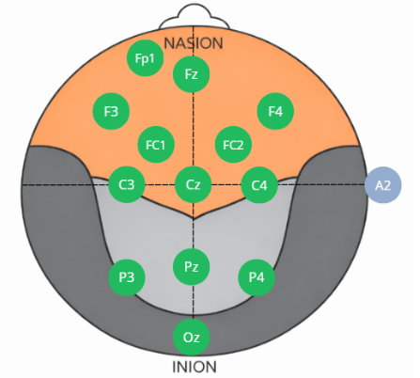
Figure 1: Electrode placement for the experiment
Stop-Signal Task Setup
Hardware Configuration
Before launching the task:
- Connect the participant display to the experimental computer.
- Connect the joystick to LabBench.
- Verify that both devices are recognized by the operating system.
- Confirm that the EEG acquisition system is running and recording correctly.
Loading the SST protocol
- Open LabBench designer.
- Locate Auditory Stop-Signal Task in the protocol library.
- Add the protocol to the experiment list.
- Save the experiment configuration if required
Starting the Experiment
- Open LabBench Runner.
- Select the created SST experiment.
- Complete the participant information questionnaire.
- Start the training session
Training Session
Before the actual SST begins, the participants complete a short practice session consisting of:
- 15 Go trials
- 5 Stop trials
The purpose of the training session is to ensure that participants understand:
- How to respond to Go stimuli
- How to inhibit responses during Stop trials
- Proper use of the joystick
The experiment can proceed once the training session is completed successfully.

Running the Stop-Signal Task
- Verify that EEG recording has started.
- Begin the SST from LabBench Runner.
- Instruct the participant to focus on the external display.
- The participant responds using the Joystick according to the instructions displayed on-screen.
- Minimize communication during task execution unless technical issues arise.
- Monitor EEG signal quality throughout the session.
No operator interaction is required after the task has started unless interruption or troubleshooting becomes necessary.
During Recording
Participants should be instructed to:
- Sit as still as possible.
- Avoid excessive blinking.
- Avoid jaw clenching and facial muscle activity.
- Keep both feet comfortably on the floor.
- Focus on the presented stimuli.
These precautions help reduce movement and muscle artefacts in the EEG recordings.
Completion
When the Stop-Signal Task is finished:
- Stop the EEG recording.
- Save the EEG dataset.
- Label the recording with the participant ID.
- Remove the EEG cap carefully.
- Clean electrodes and equipment according to laboratory procedures.
- Backup the recorded data.

Joystick

LabBench I/O

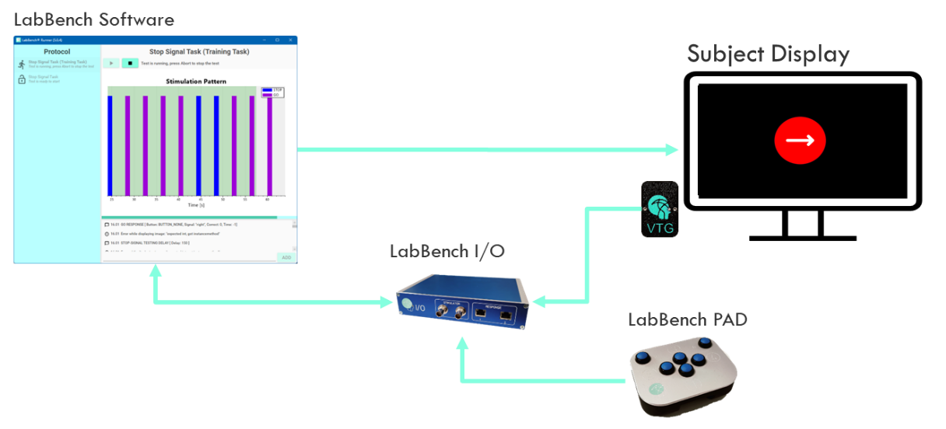
Figure 1:

Protocol

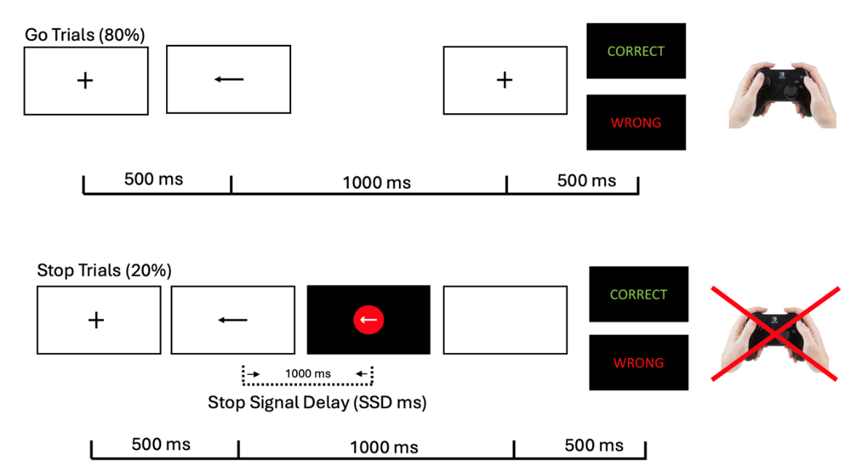
Figure 2:

Analysis

Discussion

