要求代码和实验报告规范，在算法思想中：对实验涉及的数据结构进行有效设计和分析；对算法进行分析并给出时间、空间复杂度的结论；清晰表达实验思路、出现的问题及解决方法。

- 实验环境说明
电脑环境：
系统: Ubuntu16.04LTS（Linux version 4.10.0-37-generic）
处理器: Intel® Pentium(R) CPU N3700 @ 1.60GHz × 4
内存: 7.7 GiB
操作系统类型: 64位操作系统
图形: GeForce 920M/PCIe/SSE2
编译运行环境：
CLion 2017.2.3
编程语言
C++语言
二、调试成功程序及说明
1、
题目：
编程实现书P121 ADT BinaryTree 基本操作20个，用二叉链表结构实现；
算法思想：
掌握二叉树的基本定义即可.
运行结果：
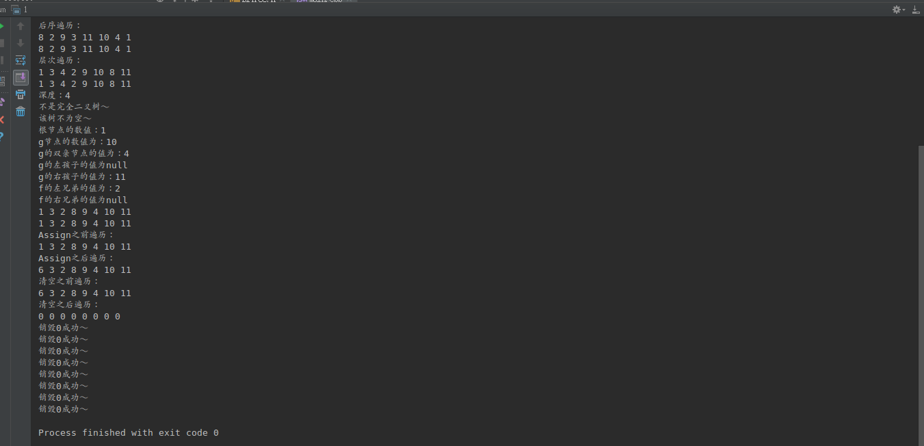
结果分析：
实现了二叉树的基本操作并对其进行测试。
核心代码：
//
// Created by dmrf on 17-11-20.
//
#ifndef INC_1_BITREE_H
#define INC_1_BITREE_H
#define TElemType int
#include <queue>
#include <stack>
#include <iostream>
#include <cmath>
using namespace std;
typedef struct BiNode {
struct BiNode *lchild;
struct BiNode *rchild;
struct BiNode *parent;
int data;
} BiNode, *BiTree;
int Depth(BiTree biTree);
void LevelOrderTraversePrint(BiTree biTree, int depth);
void InitBitree(BiTree &biTree) {
biTree = new BiNode();
biTree->lchild = NULL;
biTree->rchild = NULL;
biTree->parent = NULL;
biTree->data = 0;
cout << "初始化成功～" << endl;
}
void DestroyBiTree(BiTree biTree) {
if (biTree == NULL) {
return;
}
if (biTree->lchild != NULL) {
DestroyBiTree(biTree->lchild);
}
if (biTree->rchild != NULL) {
DestroyBiTree(biTree->rchild);
}
cout << "销毁" << biTree->data << "成功～" << endl;
free(biTree);
}
bool CreateBiTree(BiTree biTree) {
/*
* 未测试...
*/
biTree = new BiNode();
biTree->rchild = NULL;
biTree->rchild = NULL;
biTree->data = NULL;
biTree->parent = NULL;
return true;
}
void ClearBiTree(BiTree biTree) {
// cout << "清空" << biTree->data << "成功～" << endl;
if (biTree->rchild != NULL) {
ClearBiTree(biTree->rchild);
}
if (biTree->lchild != NULL) {
ClearBiTree(biTree->lchild);
}
biTree->data = 0;
}
bool BiTreeEmpty(BiTree biTree) {
if (biTree != NULL) {
if (biTree->lchild == NULL && biTree->rchild == NULL && biTree->data == NULL) {
cout << "该树为空～" << endl;
return true;
} else {
cout << "该树不为空～" << endl;
return false;
}
} else {
cout << "该树不存在，无法判空！" << endl;
}
}
int BiTreeDepth(BiTree biTree) {
if (biTree == NULL) {
cout << "该树为空，无法求深度！" << endl;
}
int depth = 0;
if (biTree->rchild != NULL) {
depth += BiTreeDepth(biTree->rchild);
}
if (biTree->lchild != NULL) {
depth += BiTreeDepth(biTree->lchild);
}
if (biTree->lchild == NULL && biTree->rchild == NULL) {
depth = 1;
}
return depth;
}
BiNode Root(BiTree biTree) {
if (biTree == NULL) {
cout << "该树不存在！" << endl;
}
return *biTree;
}
BiNode Value(BiTree biTree, BiNode *e) {
queue<BiNode *> queue1;
queue1.push(biTree);
BiNode *biNode;
biNode = queue1.front();
queue1.pop();
if (biNode == e) {
return *biNode;
}
while (biNode != NULL) {
if (biNode->lchild != NULL) {
queue1.push(biNode->lchild);
}
if (biNode->rchild != NULL) {
queue1.push(biNode->rchild);
}
biNode = queue1.front();
queue1.pop();
if (biNode == e) {
return *biNode;
}
}
}
void Assign(BiTree biTree, BiNode *e, int value) {
queue<BiNode *> queue1;
queue1.push(biTree);
BiNode *biNode;
biNode = queue1.front();
queue1.pop();
if (biNode == e) {
biNode->data = value;
return;
}
while (biNode != NULL) {
if (biNode->lchild != NULL) {
queue1.push(biNode->lchild);
}
if (biNode->rchild != NULL) {
queue1.push(biNode->rchild);
}
biNode = queue1.front();
queue1.pop();
if (biNode == e) {
BiNode *q = reinterpret_cast<BiNode *>(biNode->lchild);
DestroyBiTree(q);
biNode->lchild = NULL;
biNode->data = value;
return;
}
}
cout << "没找到节点e" << endl;
}
BiNode Parent(BiTree biTree, BiNode *e) {
queue<BiNode *> queue1;
queue1.push(biTree);
BiNode *biNode;
biNode = queue1.front();
queue1.pop();
/* if (biNode == e) {
return NULL;
}*/
while (biNode != NULL) {
if (biNode->lchild != NULL) {
queue1.push(biNode->lchild);
}
if (biNode->rchild != NULL) {
queue1.push(biNode->rchild);
}
biNode = queue1.front();
queue1.pop();
if (biNode == e) {
return *biNode->parent;
}
}
cout << "没找到节点e" << endl;
// return NULL;
}
BiNode *LeftChild(BiTree biTree, BiNode *e) {
queue<BiNode *> queue1;
queue1.push(biTree);
BiNode *biNode;
biNode = queue1.front();
queue1.pop();
if (biNode == e) {
return biNode->lchild;
}
while (biNode != NULL) {
if (biNode->lchild != NULL) {
queue1.push(biNode->lchild);
}
if (biNode->rchild != NULL) {
queue1.push(biNode->rchild);
}
biNode = queue1.front();
queue1.pop();
if (biNode == e) {
return biNode->lchild;
}
}
cout << "没找到节点e" << endl;
return NULL;
}
BiNode *RightChild(BiTree biTree, BiNode *e) {
queue<BiNode *> queue1;
queue1.push(biTree);
BiNode *biNode;
biNode = queue1.front();
queue1.pop();
if (biNode == e) {
return biNode->rchild;
}
while (biNode != NULL) {
if (biNode->lchild != NULL) {
queue1.push(biNode->lchild);
}
if (biNode->rchild != NULL) {
queue1.push(biNode->rchild);
}
biNode = queue1.front();
queue1.pop();
if (biNode == e) {
return biNode->rchild;
}
}
cout << "没找到节点e" << endl;
return NULL;
}
BiNode *RightSibling(BiTree biTree, BiNode *e) {
queue<BiNode *> queue1;
queue1.push(biTree);
BiNode *biNode;
biNode = queue1.front();
queue1.pop();
if (biNode == e) {
cout << "根节点没有兄弟" << endl;
return NULL;
}
while (biNode != NULL) {
if (biNode->lchild != NULL) {
queue1.push(biNode->lchild);
}
if (biNode->rchild != NULL) {
queue1.push(biNode->rchild);
}
biNode = queue1.front();
queue1.pop();
if (biNode == e) {
BiNode *p = biNode->parent;
if (p->rchild != NULL && p->lchild == e) {
return p->rchild;
} else {
cout << "右兄弟为空！" << endl;
return NULL;
}
}
}
cout << "没找到节点e" << endl;
return NULL;
}
BiNode *LeftSibling(BiTree biTree, BiNode *e) {
queue<BiNode *> queue1;
queue1.push(biTree);
BiNode *biNode;
biNode = queue1.front();
queue1.pop();
if (biNode == e) {
cout << "根节点没有兄弟" << endl;
return NULL;
}
while (biNode != NULL) {
if (biNode->lchild != NULL) {
queue1.push(biNode->lchild);
}
if (biNode->rchild != NULL) {
queue1.push(biNode->rchild);
}
biNode = queue1.front();
queue1.pop();
if (biNode == e) {
BiNode *p = biNode->parent;
if (p->lchild != NULL && p->rchild == e) {
return p->lchild;
} else {
cout << "左兄弟为空！" << endl;
return NULL;
}
}
}
cout << "没找到节点e" << endl;
return NULL;
}
bool InstertChild(BiTree biTree, BiNode *e, int LR, BiTree c) {
queue<BiNode *> queue1;
queue1.push(biTree);
BiNode *biNode;
biNode = queue1.front();
queue1.pop();
if (biNode == e) {
if (LR == 1) {//插入右边
BiNode *q = biNode->rchild;
biNode->rchild = c;
c->parent = biNode;
c->rchild = q;
} else {
BiNode *q = biNode->lchild;
biNode->lchild = c;
c->parent = biNode;
c->lchild = q;
}
return true;
}
while (biNode != NULL) {
if (biNode->lchild != NULL) {
queue1.push(biNode->lchild);
}
if (biNode->rchild != NULL) {
queue1.push(biNode->rchild);
}
biNode = queue1.front();
queue1.pop();
if (biNode == e) {
if (LR == 1) {//插入右边
BiNode *q = biNode->rchild;
biNode->rchild = c;
c->parent = biNode;
c->rchild = q;
} else {
BiNode *q = biNode->lchild;
biNode->lchild = c;
c->parent = biNode;
c->lchild = q;
}
return true;
}
}
cout << "没找到节点p" << endl;
return false;
}
bool DeleteChild(BiTree biTree, BiNode *e, int LR) {
queue<BiNode *> queue1;
queue1.push(biTree);
BiNode *biNode;
biNode = queue1.front();
queue1.pop();
if (biNode == e) {
if (LR == 1) {//删除右边
BiNode *q = biNode->rchild;
DestroyBiTree(q);
biNode->rchild = NULL;
} else {
BiNode *q = biNode->lchild;
DestroyBiTree(q);
biNode->lchild = NULL;
}
return true;
}
while (biNode != NULL) {
if (biNode->lchild != NULL) {
queue1.push(biNode->lchild);
}
if (biNode->rchild != NULL) {
queue1.push(biNode->rchild);
}
biNode = queue1.front();
queue1.pop();
if (biNode == e) {
if (LR == 1) {//插入右边
BiNode *q = biNode->rchild;
DestroyBiTree(q);
biNode->rchild = NULL;
} else {
BiNode *q = biNode->lchild;
DestroyBiTree(q);
biNode->lchild = NULL;
}
return true;
}
}
cout << "没找到节点p" << endl;
return false;
}
void PreOrderTraverse(BiTree biTree) {//先序遍历
if (biTree == NULL) {
cout << "该树为空，无法遍历！" << endl;
}
cout << biTree->data << " ";
if (biTree->lchild != NULL) {
PreOrderTraverse(biTree->lchild);
}
if (biTree->rchild != NULL) {
PreOrderTraverse(biTree->rchild);
}
}
void InOrderTraverse(BiTree biTree) {
if (biTree == NULL) {
cout << "该树为空，无法遍历！" << endl;
}
if (biTree->lchild != NULL) {
InOrderTraverse(biTree->lchild);
}
cout << biTree->data << " ";
if (biTree->rchild != NULL) {
InOrderTraverse(biTree->rchild);
}
}
void PostOrderTraverse(BiTree biTree) {
if (biTree == NULL) {
cout << "该树为空，无法遍历！" << endl;
}
if (biTree->lchild != NULL) {
PostOrderTraverse(biTree->lchild);
}
if (biTree->rchild != NULL) {
PostOrderTraverse(biTree->rchild);
}
cout << biTree->data << " ";
}
void LevelOrderTraverse(BiTree biTree) {
for (int i = 1; i <= Depth(biTree); ++i) {
LevelOrderTraversePrint(biTree, i);
}
}
void LevelOrderTraversePrint(BiTree biTree, int depth) {
if (biTree == NULL) {
cout << "该树为空，无法遍历！" << endl;
}
if (depth == 1) {
cout << biTree->data << " ";
return;
} else {
if (biTree->lchild != NULL) {
LevelOrderTraversePrint(biTree->lchild, depth - 1);
}
if (biTree->rchild != NULL) {
LevelOrderTraversePrint(biTree->rchild, depth - 1);
}
}
}
void InOrderTraverse2(BiTree biTree) {
if (biTree == NULL) {
cout << "该树为空，无法遍历！" << endl;
}
stack<BiNode *> stack1;
BiNode *biNode = biTree;
while (biNode != NULL || !stack1.empty()) {
if (biNode != NULL) {
stack1.push(biNode);
biNode = biNode->lchild;
} else {
biNode = stack1.top();
stack1.pop();
cout << biNode->data << " ";
biNode = biNode->rchild;
}
}
}
void PostOrderTraverse2(BiTree biTree) {
if (biTree == NULL) {
cout << "该树为空，无法遍历！" << endl;
}
stack<BiNode *> s;
BiNode *cur; //当前结点
BiNode *pre = NULL; //前一次访问的结点
s.push(biTree);
while (!s.empty()) {
cur = s.top();
if ((cur->lchild == NULL && cur->rchild == NULL) ||
(pre != NULL && (pre == cur->lchild || pre == cur->rchild))) {
cout << cur->data << " "; //如果当前结点没有孩子结点或者孩子节点都已被访问过
s.pop();
pre = cur;
} else {
if (cur->rchild != NULL)
s.push(cur->rchild);
if (cur->lchild != NULL)
s.push(cur->lchild);
}
}
}
void LevelOrderTraverse2(BiTree biTree) {
if (biTree == NULL) {
cout << "该树为空，无法遍历！" << endl;
}
queue<BiNode *> queue1;
queue1.push(biTree);
BiNode *biNode;
while (biNode != NULL && !queue1.empty()) {
biNode = queue1.front();
queue1.pop();
cout << biNode->data << " ";
if (biNode->lchild != NULL) {
queue1.push(biNode->lchild);
}
if (biNode->rchild != NULL) {
queue1.push(biNode->rchild);
}
}
}
void PreOrderTraverse2(BiTree biTree) {//先序遍历
stack<BiNode *> stack1;
BiNode *biNode = biTree;
stack1.push(biNode);
while (biNode != NULL && !stack1.empty()) {
biNode = stack1.top();
stack1.pop();
cout << biNode->data << " ";
if (biNode->rchild != NULL) {
stack1.push(biNode->rchild);
}
if (biNode->lchild != NULL) {
stack1.push(biNode->lchild);
}
}
}
int Depth(BiTree biTree) {
if (biTree == NULL) {
return 0;
}
int u = Depth(biTree->lchild);
int v = Depth(biTree->rchild);
return u > v ? u + 1 : v + 1;
}
int GetLeveNum(BiTree biTree, int depth) {
if (biTree == NULL) {
cout << "该树为空，无法遍历！" << endl;
}
int num = 0;
if (depth == 1) {
return 1;
} else {
if (biTree->lchild != NULL) {
num += GetLeveNum(biTree->lchild, depth - 1);
}
if (biTree->rchild != NULL) {
num += GetLeveNum(biTree->rchild, depth - 1);
}
}
return num;
}
bool IsCompteteTree(BiTree biTree) {
queue<BiNode *> q;
BiNode *biNode;
// 进行广度优先遍历（层次遍历），并把NULL节点也放入队列
q.push(biTree);
while ((biNode = q.front()) != NULL) {
q.pop();
q.push(biNode->lchild);
q.push(biNode->rchild);
}
// 判断是否还有未被访问到的节点
while (!q.empty()) {
biNode = q.front();
q.pop();
// 有未访问到的的非NULL节点，则树存在空洞，为非完全二叉树
if (NULL != biNode) {
cout << "不是完全二叉树～" << endl;
return false;
}
}
cout << "是完全二叉树～" << endl;
return true;
}
#endif //INC_1_BITREE_H

详细代码：
https://github.com/DMRFWIN/DataStructure_Experiment/tree/master/Code5/1
2、
题目：
二叉树的先序、中序、后序遍历非递归方法，层次遍历。
算法思想：
用栈将原有的递归算法变为非递归算法，用队列实现二叉树的层次遍历。
运行结果：
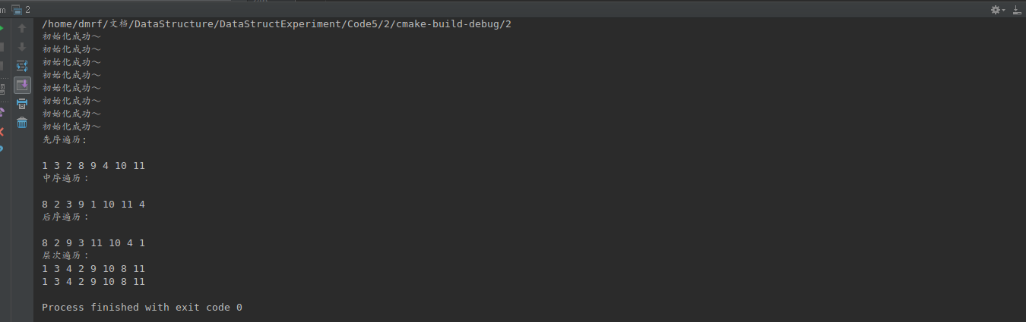
结果分析：
实现了二叉树的不同遍历方法，其中层次遍历使用了地柜和非递归两种算法。
核心代码：
//
// Created by dmrf on 17-11-20.
//
#ifndef INC_1_BITREE_H
#define INC_1_BITREE_H
#define TElemType int
#include <queue>
#include <stack>
#include <iostream>
#include <cmath>
using namespace std;
typedef struct BiNode {
struct BiNode *lchild;
struct BiNode *rchild;
struct BiNode *parent;
int data;
} BiNode, *BiTree;
int Depth(BiTree biTree);
void LevelOrderTraversePrint(BiTree biTree, int depth);
void InitBitree(BiTree &biTree) {
biTree = new BiNode();
biTree->lchild = NULL;
biTree->rchild = NULL;
biTree->parent = NULL;
biTree->data = 0;
cout << "初始化成功～" << endl;
}
void DestroyBiTree(BiTree biTree) {
if (biTree == NULL) {
return;
}
if (biTree->lchild != NULL) {
DestroyBiTree(biTree->lchild);
}
if (biTree->rchild != NULL) {
DestroyBiTree(biTree->rchild);
}
// cout << "销毁" << biTree->data << "成功～" << endl;
free(biTree);
}
bool InstertChild(BiTree biTree, BiNode *e, int LR, BiTree c) {
queue<BiNode *> queue1;
queue1.push(biTree);
BiNode *biNode;
biNode = queue1.front();
queue1.pop();
if (biNode == e) {
if (LR == 1) {//插入右边
BiNode *q = biNode->rchild;
biNode->rchild = c;
c->parent = biNode;
c->rchild = q;
} else {
BiNode *q = biNode->lchild;
biNode->lchild = c;
c->parent = biNode;
c->lchild = q;
}
return true;
}
while (biNode != NULL) {
if (biNode->lchild != NULL) {
queue1.push(biNode->lchild);
}
if (biNode->rchild != NULL) {
queue1.push(biNode->rchild);
}
biNode = queue1.front();
queue1.pop();
if (biNode == e) {
if (LR == 1) {//插入右边
BiNode *q = biNode->rchild;
biNode->rchild = c;
c->parent = biNode;
c->rchild = q;
} else {
BiNode *q = biNode->lchild;
biNode->lchild = c;
c->parent = biNode;
c->lchild = q;
}
return true;
}
}
cout << "没找到节点p" << endl;
return false;
}
void LevelOrderTraverse(BiTree biTree) {
for (int i = 1; i <= Depth(biTree); ++i) {
LevelOrderTraversePrint(biTree, i);
}
}
void LevelOrderTraversePrint(BiTree biTree, int depth) {
if (biTree == NULL) {
cout << "该树为空，无法遍历！" << endl;
}
if (depth == 1) {
cout << biTree->data << " ";
return;
} else {
if (biTree->lchild != NULL) {
LevelOrderTraversePrint(biTree->lchild, depth - 1);
}
if (biTree->rchild != NULL) {
LevelOrderTraversePrint(biTree->rchild, depth - 1);
}
}
}
void InOrderTraverse2(BiTree biTree) {
if (biTree == NULL) {
cout << "该树为空，无法遍历！" << endl;
}
stack<BiNode *> stack1;
BiNode *biNode = biTree;
while (biNode != NULL || !stack1.empty()) {
if (biNode != NULL) {
stack1.push(biNode);
biNode = biNode->lchild;
} else {
biNode = stack1.top();
stack1.pop();
cout << biNode->data << " ";
biNode = biNode->rchild;
}
}
}
void PostOrderTraverse2(BiTree biTree) {
if (biTree == NULL) {
cout << "该树为空，无法遍历！" << endl;
}
stack<BiNode *> s;
BiNode *cur; //当前结点
BiNode *pre = NULL; //前一次访问的结点
s.push(biTree);
while (!s.empty()) {
cur = s.top();
if ((cur->lchild == NULL && cur->rchild == NULL) ||
(pre != NULL && (pre == cur->lchild || pre == cur->rchild))) {
cout << cur->data << " "; //如果当前结点没有孩子结点或者孩子节点都已被访问过
s.pop();
pre = cur;
} else {
if (cur->rchild != NULL)
s.push(cur->rchild);
if (cur->lchild != NULL)
s.push(cur->lchild);
}
}
}
void LevelOrderTraverse2(BiTree biTree) {
if (biTree == NULL) {
cout << "该树为空，无法遍历！" << endl;
}
queue<BiNode *> queue1;
queue1.push(biTree);
BiNode *biNode;
while (biNode != NULL && !queue1.empty()) {
biNode = queue1.front();
queue1.pop();
cout << biNode->data << " ";
if (biNode->lchild != NULL) {
queue1.push(biNode->lchild);
}
if (biNode->rchild != NULL) {
queue1.push(biNode->rchild);
}
}
}
void PreOrderTraverse2(BiTree biTree) {//先序遍历
stack<BiNode *> stack1;
BiNode *biNode = biTree;
stack1.push(biNode);
while (biNode != NULL && !stack1.empty()) {
biNode = stack1.top();
stack1.pop();
cout << biNode->data << " ";
if (biNode->rchild != NULL) {
stack1.push(biNode->rchild);
}
if (biNode->lchild != NULL) {
stack1.push(biNode->lchild);
}
}
}
int Depth(BiTree biTree) {
if (biTree == NULL) {
return 0;
}
int u = Depth(biTree->lchild);
int v = Depth(biTree->rchild);
return u > v ? u + 1 : v + 1;
}
#endif //INC_1_BITREE_H

详细代码：
https://github.com/DMRFWIN/DataStructure_Experiment/tree/master/Code5/2
3：
题目：
编程实现，对二叉树中每个元素值为x的结点，删除以它为根的子树，并释放相应空间。
算法思想：
先找到需要删除的节点的子树，然后递归删除(销毁)。
运行结果：
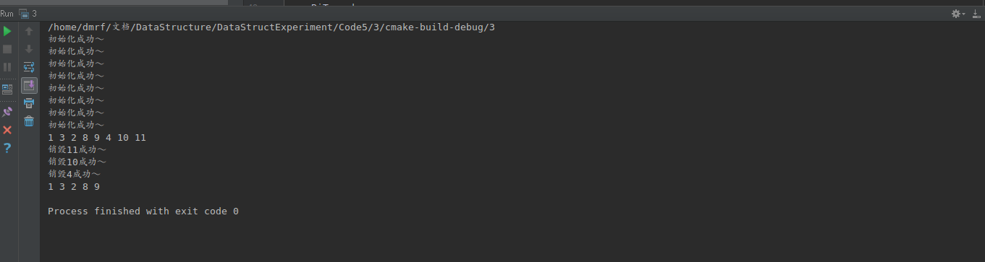
结果分析：
在原二叉树（1 3 2 8 9 4 10 11 ）的基础上删除了4这个节点的子树，删除后的二叉树为1 3 2 8 9 。
核心代码：
bool Delete(BiTree biTree, BiNode *e) {
queue<BiNode *> queue1;
queue1.push(biTree);
BiNode *biNode;
biNode = queue1.front();
queue1.pop();
if (biNode == e) {
if (biNode->rchild != NULL) {//删除右边
BiNode *q = biNode->rchild;
DestroyBiTree(q);
biNode->rchild = NULL;
}
if (biNode->lchild != NULL) {
BiNode *q = biNode->lchild;
DestroyBiTree(q);
biNode->lchild = NULL;
}
return true;
}
BiNode *pre;
while (biNode != NULL) {
if (biNode->lchild != NULL) {
queue1.push(biNode->lchild);
}
if (biNode->rchild != NULL) {
queue1.push(biNode->rchild);
}
biNode = queue1.front();
queue1.pop();
if (biNode == e) {
pre=biNode->parent;
if (pre->lchild == biNode) {
pre->lchild = NULL;
}
if (pre->rchild == biNode) {
pre->rchild = NULL;
}
DestroyBiTree(biNode);
return true;
}
}
cout << "没找到节点p" << endl;
return false;
}

详细代码：
https://github.com/DMRFWIN/DataStructure_Experiment/tree/master/Code5/3
4：
题目：
编程实现，判断给定二叉树是否是完全二叉树。
算法思想：
利用二叉树层次遍历的原理开始对二叉树进行层次遍历，特殊点在于遍历的时候将NULL也入队作为标记，如果当遍历到NULL的时候队列中仍然后非NULL元素未被遍历，说明该二叉树中有非空点在空点的右边，即不是完全二叉树。
运行结果：
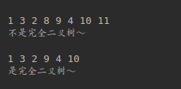
结果分析：

1 3 2 8 9 10 11不是完全二叉树，1 3 2 9 4 10是完全二叉树。
核心代码：
bool IsCompteteTree(BiTree biTree) {
queue<BiNode *> q;
BiNode *biNode;
// 进行广度优先遍历（层次遍历），并把NULL节点也放入队列
q.push(biTree);
while ((biNode = q.front()) != NULL) {
q.pop();
q.push(biNode->lchild);
q.push(biNode->rchild);
}
// 判断是否还有未被访问到的节点
while (!q.empty()) {
biNode = q.front();
q.pop();
// 有未访问到的的非NULL节点，则树存在空洞，为非完全二叉树
if (NULL != biNode) {
cout << "不是完全二叉树～" << endl;
return false;
}
}
cout << "是完全二叉树～" << endl;
return true;
}

详细代码：
https://github.com/DMRFWIN/DataStructure_Experiment/tree/master/Code5/4

- 小结
本次实验实现了二叉树的常见操作，加深了对二叉树的认识。

