Home Page

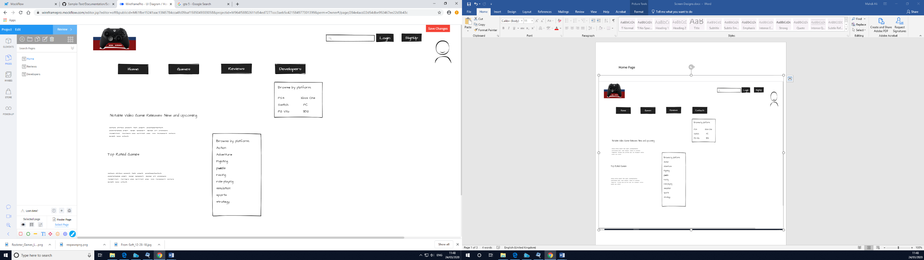

This website are game loving people that want to find the best game or share it with other people and give their option on what they thought of the games. This is the home page. By clicking the games or review button it will lead you to the next page.

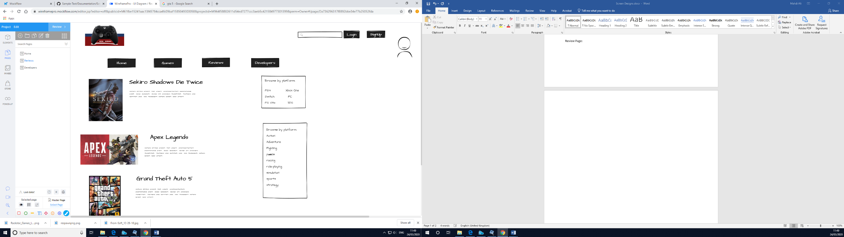Review Page:

You get here by clicking the game and review button This page is where you see all the games available and what people think of them.

People can browse by the consoles or the genre of the game. I put the review and games in the same page because they’re both the same.

Developers Page:

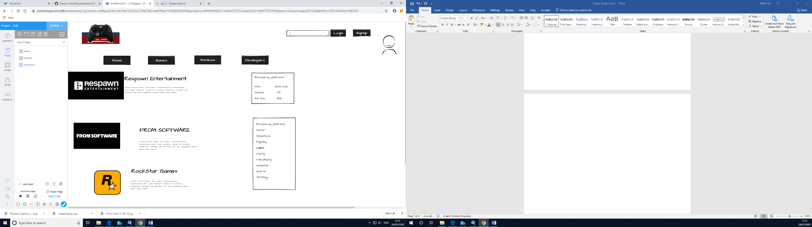

You get here by clicking the developer button. This developer page says which company are responsible for making the games and comments and reviews about any other games they might have made.

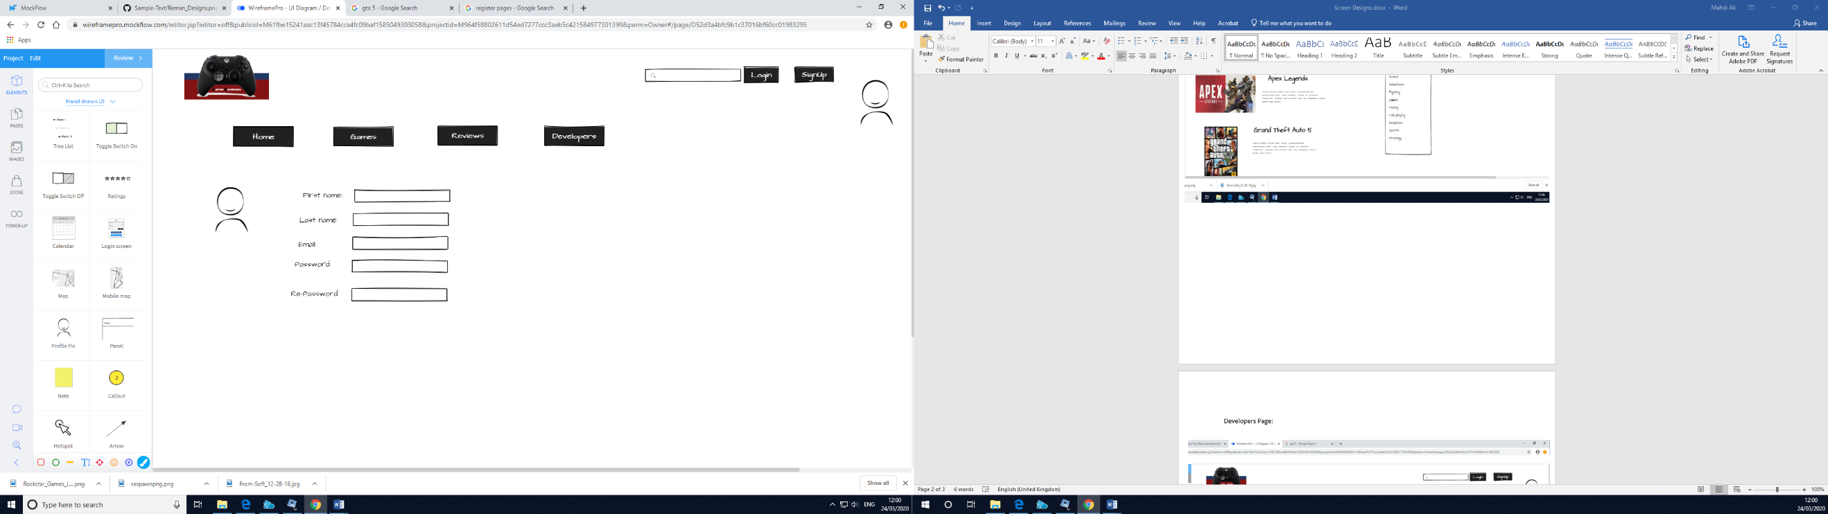Register Page:

You get here by clicking the sign-up button. The final page is where user can change from becoming a guest to a user by signing up with the correct information.