***Assignment 2:***

***Design Documentation to Correspond with a System***

Contents

1.0 Use Case Diagram 3

1.1 Use Case description 3

2.0 Storyboard 11

2.1 Homepage 11

2.2 Course page 12

2.3 Student page 14

2.4 About us page 15

2.5 Contact us page 16

2.7 Register page 17

3.0 ERD Diagram 18

4.0 Website Flow Diagram 19

5.0 UML Class Diagram 20

6.0 Test Plan 21

7.0 Issues related to the system 23

7.1 Database not connecting 23

7.2 Variables 24

7.3 Models class 24

7.4 GitHub Issue 25

7.5 Duplicate Pages 25

8.0 Future Improvements 25

# Use Case Diagram

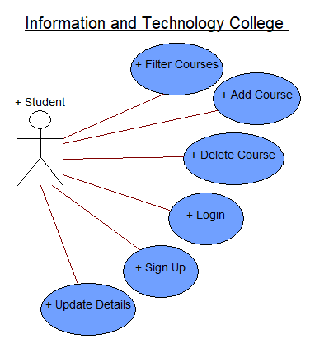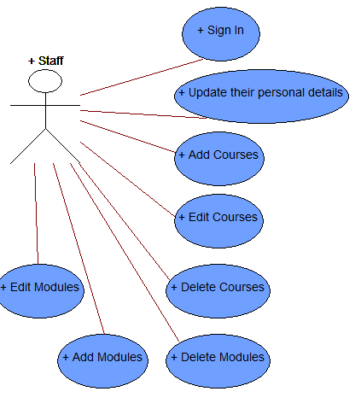

## Use Case description

|  |  |
| --- | --- |
| **Use Case Name** | Add Course |
| **Use Case Description** | The student will be able to add courses through the website or they can also do this by contacting college. |
| **Use Case Author** | Afseen and Aisha |
| **Actor** | Student |
| **Locations** | This can be done through online and the reception |
| **Primary pathway** | 1. Student will access to the website 2. Student will select and add courses they want to study 3. As soon as the student added the course and proceed 4. Student will receive confirmation email about the courses 5. Course has been added into their account |
| **Alternate pathways** | 1. Student can contact college 2. Student can request college to add course they want to study 3. Once the college added the course base on student reequipment 4. Student will receive confirmation email about the course 5. Course has been added to the student account |
| **Exception pathways** | The student will add courses through the website just to make sure that the course they applied is not existing  Because of website crashing some of the course details are not been added to the website correctly  There is internet connection problem – error will display |

|  |  |
| --- | --- |
| **Use Case Name** | Delete Course |
| **Use Case Description** | The student will be able to delete courses through the website or they can also do this by contacting college. |
| **Use Case Author** | Afseen and Aisha |
| **Actor** | Student |
| **Locations** | This can be done through online and the reception |
| **Primary pathway** | 1. Student will access to the website 2. Student have to login in order to change or update anything within the website 3. Student have to select the course they want to delete and proceed 4. Once the course has been deleted student will receive confirmation email 5. Course has been deleted from the website |
| **Alternate pathways** | 1. Student can contact college to remove or make changing to their courses 2. Student can request college to remove course 3. Once it has been removed 4. Student will receive confirmation email 5. Course has been removed from the student account |
| **Exception pathways** | There is internet connection problem – error will display  Removing more than one courses at the same time can lead to problem and an error message will display on the screen |

|  |  |
| --- | --- |
| **Use Case Name** | Sign up |
| **Use Case Description** | The student has to sign up in order to create their account into the website or they can also do this by contacting college. |
| **Use Case Author** | Afseen and Aisha |
| **Actor** | Student |
| **Locations** | This can be done through online and the reception |
| **Primary pathway** | 1. Student will access to the website 2. Student will have to fill the sign-up form by providing their personal details 3. Once the student created their account 4. Student will receive a confirmation email that they successful created their account 5. Student details has been added to the website and they can select their courses |
| **Alternate pathways** | 1. Student can contact college to create their account 2. Student have to provide their personal detail to them 3. Student sign up form has been created 4. Student will receive confirmation email 5. Student have access to the website to select course as their details has been added |
| **Exception pathways** | Incorrect data into the sign up can lead to confusion  There is no space on the password then an error will be display on the screen |

|  |  |
| --- | --- |
| **Use Case Name** | Logs in to the system |
| **Use Case Description** | The Student logs into the college website in order to access their details and to apply/view onto courses. This can also be done by calling college. |
| **Use Case Author** | Afseen and Aisha |
| **Actor(s)** | Student |
| **Location** | Online and Business office |
| **Primary Pathway** | 1. Student access the college website 2. Student logs in to make changes to their details 3. Students applies to courses 4. Students views courses 5. Student logs out the system |
| **Alternative Pathways** | 1. Student access the college website 2. Student finds college’s number on contact us page 3. Student contacts the college 4. College updates their details 5. College helps them apply to course |
| **Exception Pathways** | Logging into an account on either the website or contacting the college could sometimes bring up issues if the system is down that would affect everyone so college and students accessing it from home. |

|  |  |
| --- | --- |
| **Use Case Name** | Update Students details on the system |
| **Use Case Description** | The Students edits their details on the website in order to edit their account. The account could also be edited by making a call to the company. |
| **Use Case Author** | Afseen and Aisha |
| **Actor(s)** | Student |
| **Location** | Online and Business office |
| **Primary Pathway** | 1. Student access the college website 2. Student logs in to make changes to their details 3. Students edits their details off the system 4. System verifies the details and finishes editing the account 5. Email will be sent to the Students emails showing their account has been edited. |
| **Alternative Pathways** | 1. Student access the college website 2. Student finds college’s number on contact us page 3. Student contacts the college 4. College updates their details 5. Student would receive an email showing their account has been edited. |
| **Exception Pathways** | Editing an account on either the website or contacting the college could sometimes bring up issues if there is already an account which exists with the same email, they are trying to edit another account on or if the username is taken which would then give alternative usernames to use. |

|  |  |
| --- | --- |
| **Use Case Name** | Filter Course |
| **Use Case Description** | The student filters their course on the website or app in order to search up the courses of their choice. They could do that by filtering through A-Z and by a search bar |
| **Use Case Author** | Aisha and Afseen |
| **Actor(s)** | Student |
| **Location** | Online and application |
| **Primary Pathway** | 1. Student access the college website to view the courses 2. Website will display all the courses related to the searched 3. Student can successful view courses |
| **Alternative Pathways** | 1. Student have to download the application from either app store or play store 2. Search the courses they want to study 3. System will display the courses related to the searched 4. Student can successful view courses |
| **Exception Pathways** | Filtering an item on either the website or app could sometimes bring up errors if there is a spelling mistake with the customers search.  They would need to use the other filtering option of A-Z as they wouldn’t know what they are looking for or look by category. |

|  |  |
| --- | --- |
| **Use Case Name** | Add Modules |
| **Use Case Description** | The staff will be able to add modules on the website as well as they can do this through the application. |
| **Use Case Author** | Afseen and Aisha |
| **Actor** | Staff |
| **Locations** | This can be done through online and application |
| **Primary pathway** | 1. Staff will access to the website 2. Student will add modules into the website 3. As soon as the staff added the module and proceed 4. Staff will receive confirmation email about the modules 5. Modules has been added on to the website |
| **Alternate pathways** | 1. Staff have to download application from app store or play store in order to access to the system 2. Staff will be able to add modules to the application 3. Once, the staff added the module and proceed 4. Staff will receive a confirmation email 5. Modules has been added on the website |
| **Exception pathways** | The student will add modules through the website and application just to make sure that the module they applied is not existing  Because of website crashing some of the module’s details are not been added to the website correctly  There is internet connection problem – error will display |

|  |  |
| --- | --- |
| **Use Case Name** | Delete modules |
| **Use Case Description** | The staff will be able to delete modules within the website as well as they can do this through the application. |
| **Use Case Author** | Afseen and Aisha |
| **Actor** | Staff |
| **Locations** | This can be done through online and the application |
| **Primary pathway** | 1. Staff will access to the website 2. Staff have to login in order to delete or update anything within the website 3. Staff have to select the module they want to delete and proceed 4. Once the module has been deleted staff will receive confirmation email 5. Module has been deleted from the website |
| **Alternate pathways** | 1. Staff have to download application from app store or play store in order to access to the system 2. Staff have to login in order to delete or update anything within the website 3. Staff have to select the module they want to delete and proceed 4. Once the module has been deleted staff will receive confirmation email 5. Module has been deleted from the website |
| **Exception pathways** | There is internet connection problem – error will display  Removing more than one module at the same time can lead to problem and an error message will display on the screen |

|  |  |
| --- | --- |
| **Use Case Name** | Edit modules |
| **Use Case Description** | The Staff will be able to edits module information on the website as well as they can do this through application. |
| **Use Case Author** | Afseen and Aisha |
| **Actor(s)** | Staff |
| **Location** | Online and Business office |
| **Primary Pathway** | 1. Staff access the college website 2. Staff logs in to make changes to the module’s information 3. System verifies the details and finishes editing the modules 4. Email will be sent to the staff emails showing the module details has been edited. |
| **Alternative Pathways** | 1. Staff have to download application from app store or play store in order to access to the system 2. Staff login to make changes to the module details 3. Student would receive an email showing their account has been edited. |
| **Exception Pathways** | Editing an account on either the website or application could sometimes bring up issues if the module has already existed an error message will display on the screen. |

|  |  |
| --- | --- |
| **Use Case Name** | Update staff details on the system |
| **Use Case Description** | The Staff will be able to change or update their personal details on the website as well as they can do this through the application. |
| **Use Case Author** | Afseen and Aisha |
| **Actor(s)** | Staff |
| **Location** | Online and Application |
| **Primary Pathway** | 1. Staff access the college website 2. Staff logs to make change or update their personal details 3. System verifies the new details 4. Staff will receive a confirmation email about their details has been updated |
| **Alternative Pathways** | 1. Staff have to download application from app store or play store in order to access to the system 2. Staff login to make changes or update their personal details 3. System compare old details to new details 4. Staff will receive an email confirmation saying that their personal details has been updated |
| **Exception Pathways** | All the field must contain relevant information otherwise an error message will display on the screen.  Incorrect data into the sign up can lead to confusion  There is internet connection problem – error will display |

|  |  |
| --- | --- |
| **Use Case Name** | Logs in to the system |
| **Use Case Description** | The Staff logs into the college website in order to access their details and to apply/view onto courses. This can also be done by the college app. |
| **Use Case Author** | Afseen and Aisha |
| **Actor(s)** | Staff |
| **Location** | Online and Business office |
| **Primary Pathway** | 1. Staff access the college website 2. Staff logs in to make changes to their details 3. Staff edits courses 4. Staff views courses 5. Staff deletes courses 6. Staff logs out the system |
| **Alternative Pathways** | 1. Staff access the college app 2. Staff logs into the app 3. Staff edits courses 4. Staff views courses 5. Staff deletes courses 6. Staff logs out the app |
| **Exception Pathways** | Logging into an account on either the website or contacting the college could sometimes bring up issues if the system is down that would affect everyone so college and students accessing it from home. |

|  |  |
| --- | --- |
| **Use Case Name** | Edit Courses |
| **Use Case Description** | The Staff edits courses on the website in order to make changes of the students. The courses can also be changes through the college app |
| **Use Case Author** | Afseen and Aisha |
| **Actor(s)** | Staff |
| **Location** | Online and Business office |
| **Primary Pathway** | 1. Staff access the college website 2. Staff logs in to make changes to their details 3. Staff edits the courses on the system 4. System verifies the details and finishes editing the courses 5. Email will be sent to the Staff emails showing courses have been edited. |
| **Alternative Pathways** | 1. Staff access the college app 2. Staff logs in to the app 3. Staff find the course that needs editing 4. Staff edits the course 5. Staff receives confirmation of the course being edited |
| **Exception Pathways** | Editing a course on either the website or the college app could sometimes bring up issues if the system is down that would affect everyone so college and students accessing it from home. |

|  |  |
| --- | --- |
| **Use Case Name** | Adds Courses |
| **Use Case Description** | The Staff adds courses on the website in order to make changes for the students. The courses can also be added through the college app |
| **Use Case Author** | Afseen and Aisha |
| **Actor(s)** | Staff |
| **Location** | Online and Business office |
| **Primary Pathway** | 1. Staff access the college website 2. Staff logs in to make changes to their details 3. Staff adds the courses on the system 4. System verifies the details and finishes adding the course 5. Email will be sent to the Staff emails showing courses have been added. |
| **Alternative Pathways** | 1. Staff access the college app 2. Staff logs in to the app 3. Staff adds the course 4. Staff receives confirmation of the course being added |
| **Exception Pathways** | Adding a course on either the website or the college app could sometimes bring up issues if the system is down that would affect everyone so college and students accessing it from home. |

|  |  |
| --- | --- |
| **Use Case Name** | Delete Courses |
| **Use Case Description** | The Staff deletes courses off the website in order to make changes for the students. The courses can also be deleted through the college app |
| **Use Case Author** | Afseen and Aisha |
| **Actor(s)** | Staff |
| **Location** | Online and Business office |
| **Primary Pathway** | 1. Staff access the college website 2. Staff logs in to make changes to their details 3. Staff deletes the courses on the system 4. System verifies the details and finishes adding the course 5. Email will be sent to the Staff emails showing courses have been deleted. |
| **Alternative Pathways** | 1. Staff access the college app 2. Staff logs in to the app 3. Staff deletes the course 4. Staff receives confirmation of the course being deleted |
| **Exception Pathways** | Deleting a course on either the website or the college app could sometimes bring up issues if the system is down that would affect everyone so college and students accessing it from home. |

# Storyboard

## 2.1 Homepage

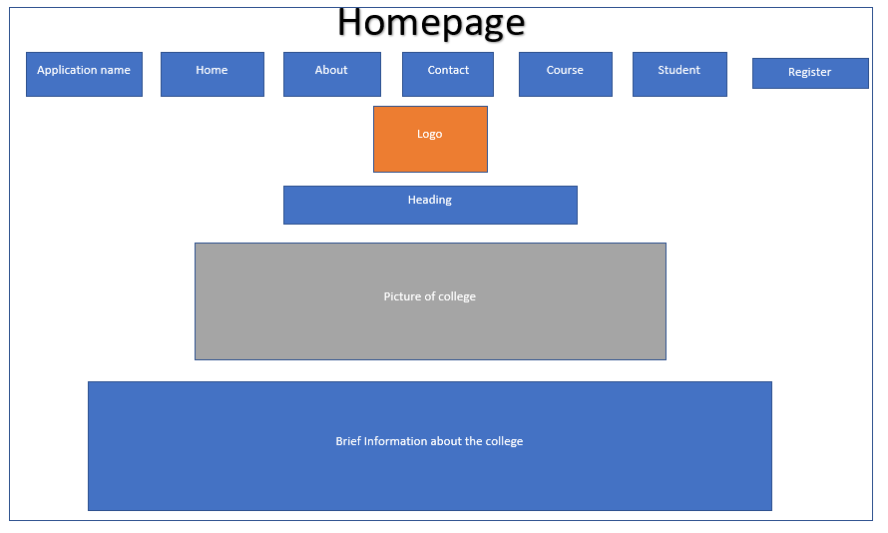

## 2.2 Course page

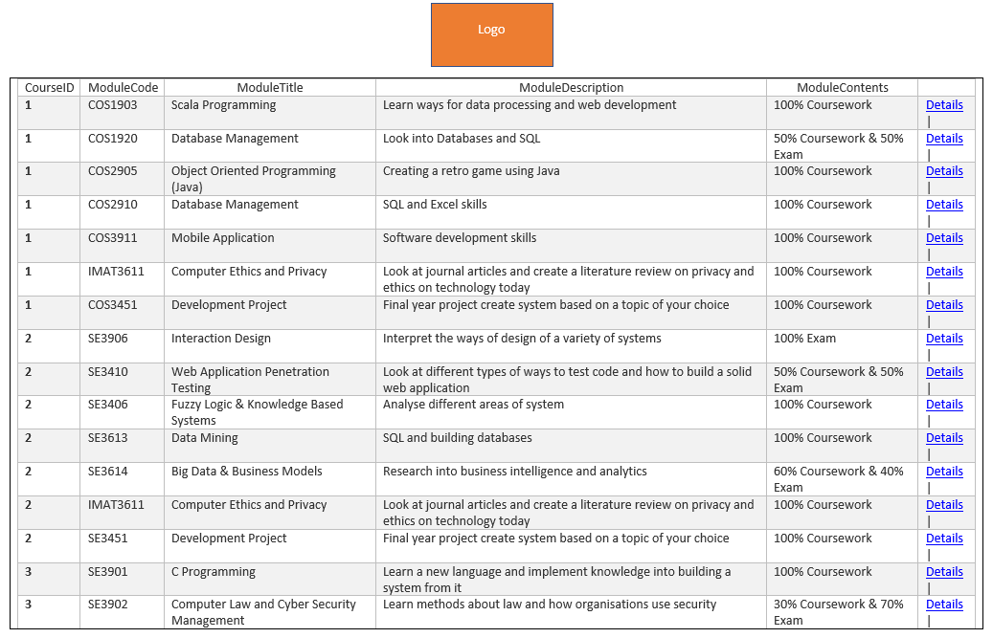Once the user clicked on course details it will display the page below.

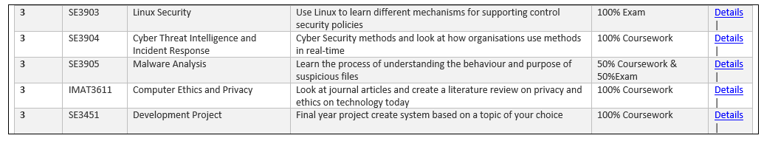

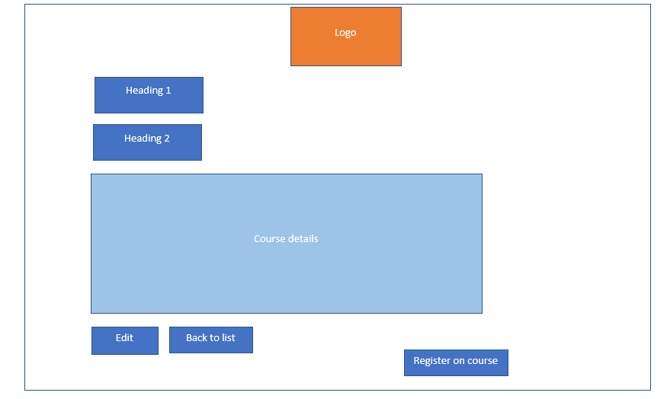When the user clicks on the course details it will display the page below.

## 2.3 Student page

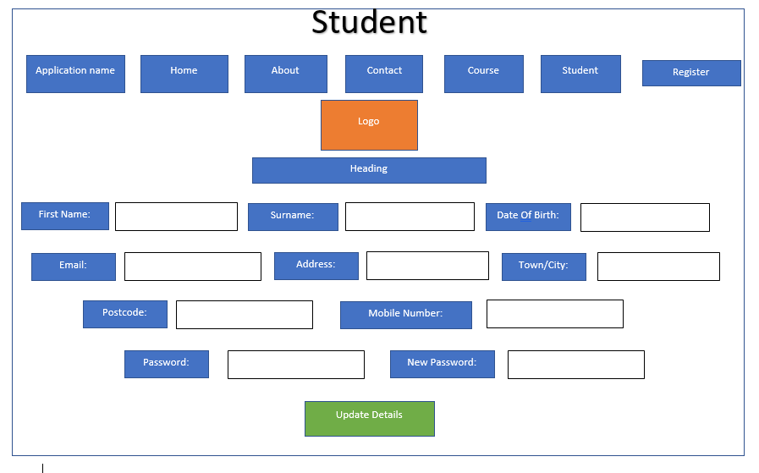

When the user clicks on the update details button it will open up this page.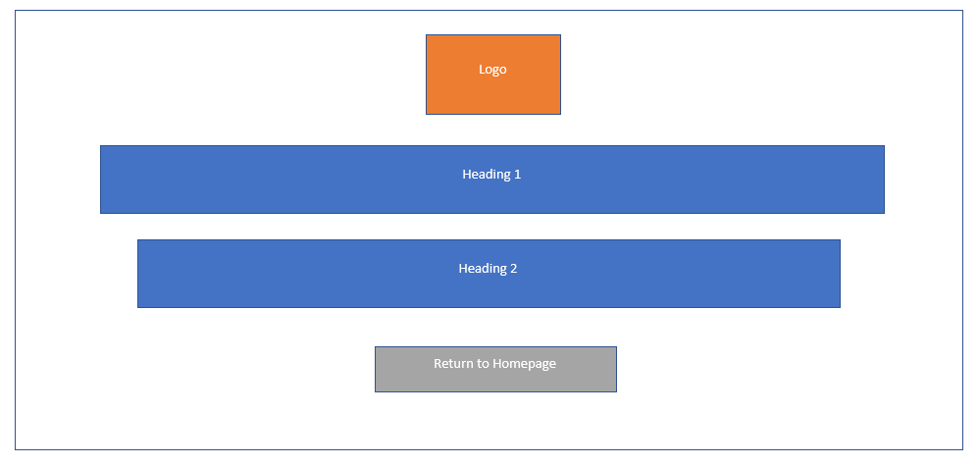

## 2.4 About us page

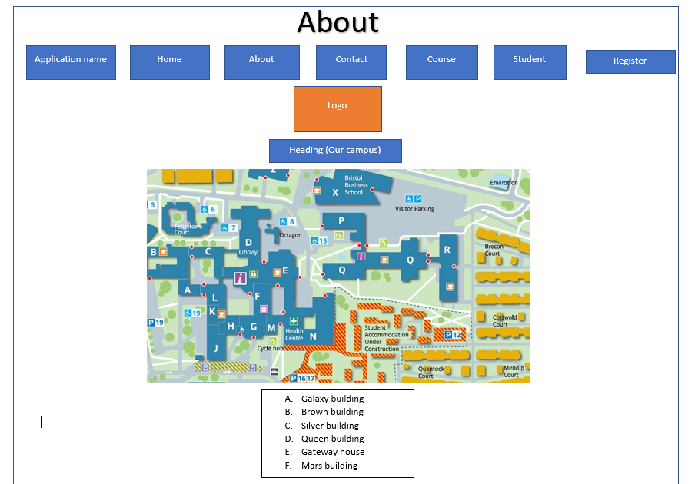

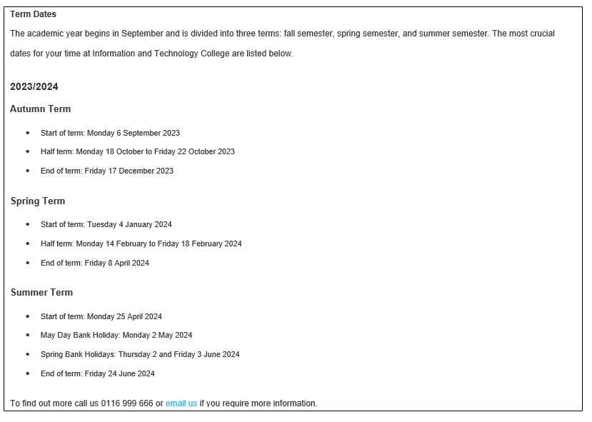

## 2.5 Contact us page

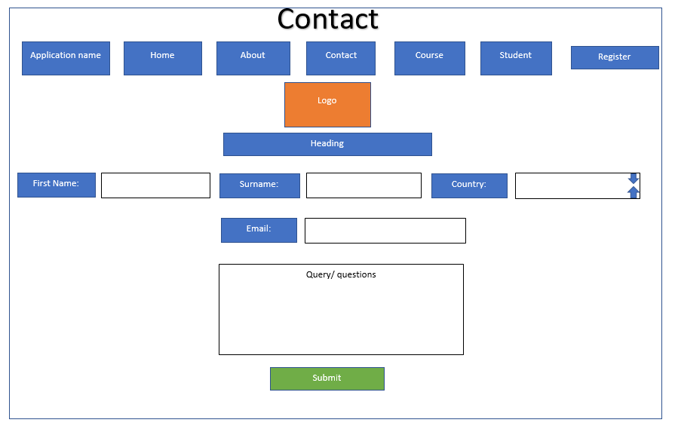

When the user clicks on the submit button it will open up this page.

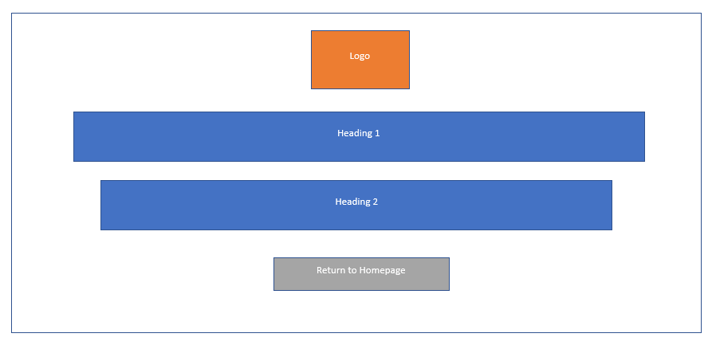

## 2.7 Register page

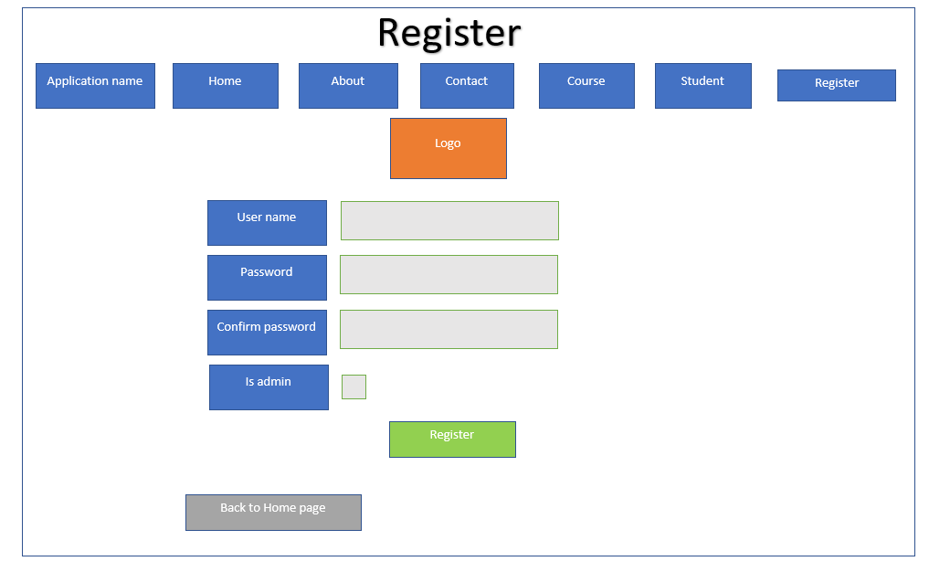

# ERD Diagram

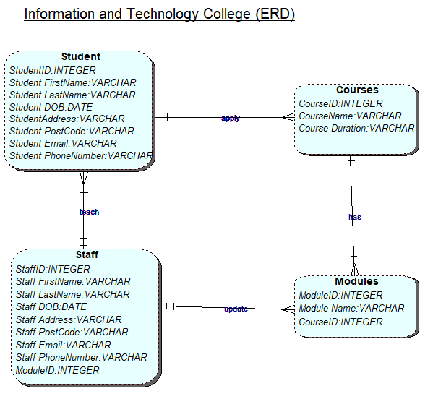

# Website Flow Diagram

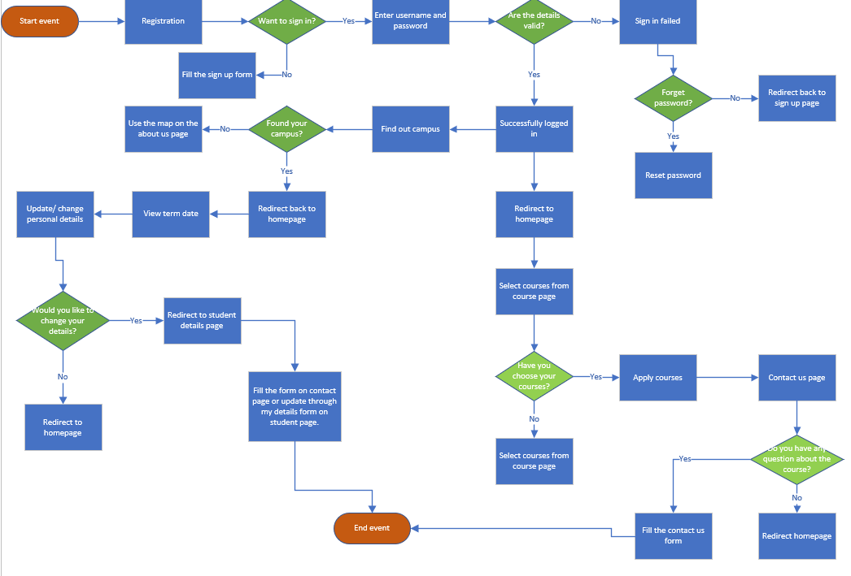

# UML Class Diagram

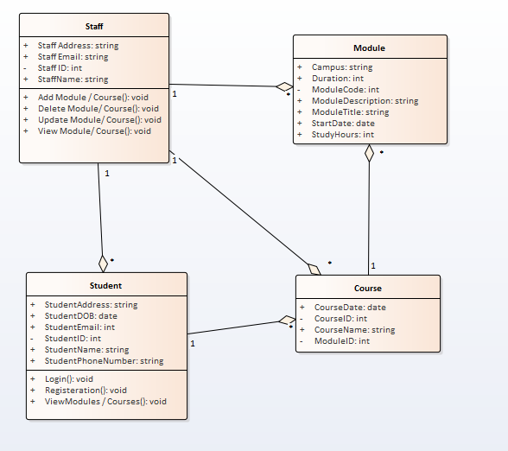

# Test Plan

**Description of Item to Be Tested:**

|  |
| --- |
| This field stores data of a user`s username on the website. This field must contain letters and numbers which means that the data type of the user`s username is string as well as this field must not be blank. |

**Required Field Yes**

|  |  |  |  |
| --- | --- | --- | --- |
| **Test Type** | **Test Data** | **Expected Result** | **Actual Result** |
| Extreme Min | Not Applicant | Not Applicant |  |
| Min -1 | ‘’Blank string | Display an error message if the field is empty. |  |
| Min (Boundary) | 1 character | The data must be accepted. |  |
| Min +1 | 2 characters | The data must be accepted. |  |
| Max -1 | 49 characters | The data must be accepted |  |
| Max (Boundary) | 50 characters | The data must be accepted. |  |
| Max +1 | 51 characters | The data must not be accepted and display an error message. |  |
| Mid | 25 characters | The data must be accepted. |  |
| Extreme Max | 100 characters | The data must not be accepted and display an error message. |  |
| Invalid data type | Not Applicant | Not Applicant |  |
| Other tests | Not Applicant | Not Applicant |  |

**Description of Item to Be Tested:**

|  |
| --- |
| This field stores data of a user’s password on the website. This field must contain letters, symbols and numbers which means that the data type of the user password is string as well as this field must not be blank. |

**Required Field Yes**

|  |  |  |  |
| --- | --- | --- | --- |
| **Test Type** | **Test Data** | **Expected Result** | **Actual Result** |
| Extreme Min | Not Applicant | Not Applicant |  |
| Min -1 | ‘’Blank string | Display an error message if the field is empty. |  |
| Min (Boundary) | 1 character | The data must be accepted. |  |
| Min +1 | 2 characters | The data must be accepted. |  |
| Max -1 | 29 characters | The data must be accepted |  |
| Max (Boundary) | 30 characters | The data must be accepted. |  |
| Max +1 | 31 characters | The data must not be accepted and display an error message. |  |
| Mid | 15 characters | The data must be accepted. |  |
| Extreme Max | 50 characters | The data must not be accepted and display an error message. |  |
| Invalid data type | Not Applicant | Not Applicant |  |
| Other tests | Not Applicant | Not Applicant |  |

# 7.0 Issues related to the system

## 7.1 Database not connecting

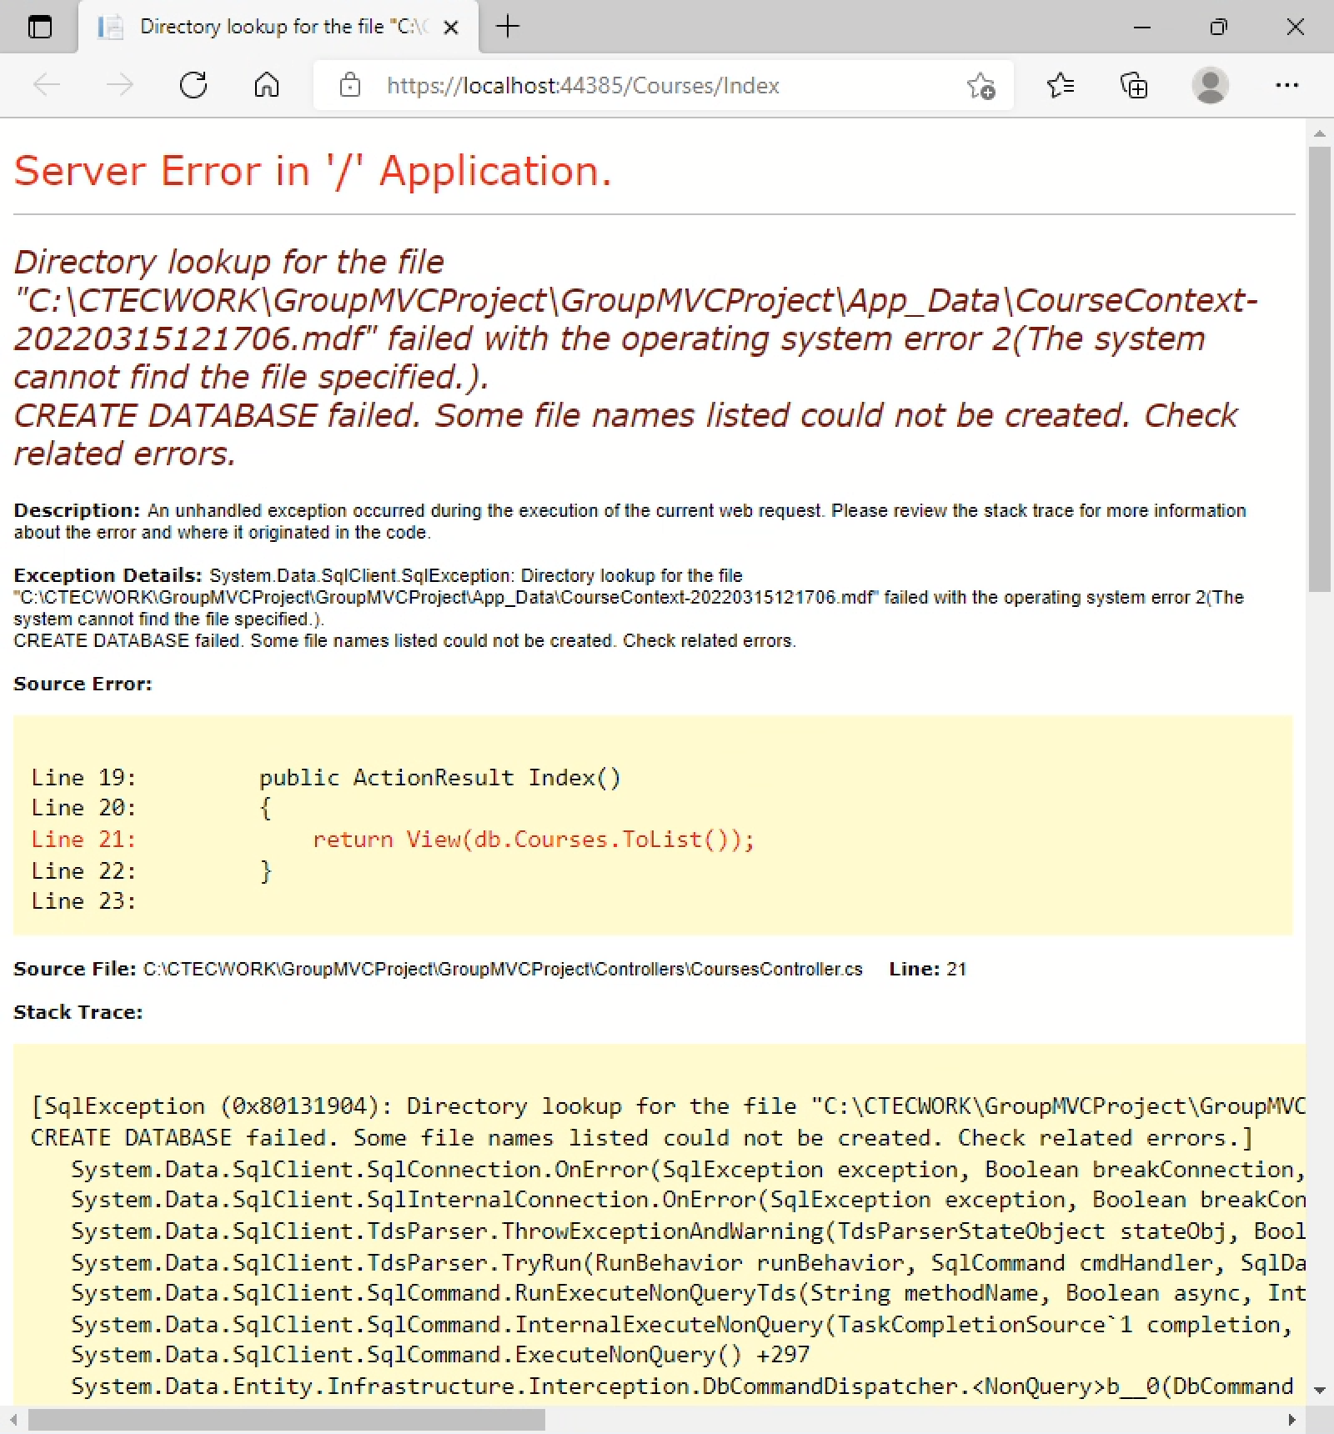

As a group we overcame this issue as it was a simple database issue. The issue above shows that the sql database was not being recognised and connected when tried to connect it would open and shut straight away. Therefore, for this issue we spoke to usama and he came up with a solution where the database was not in the app_data folder which is why we were unable to connect to the mdf. Once added on the app_data folder in the project we were able to connect to the database and it was recognised on the codes.

## 7.2 Variables

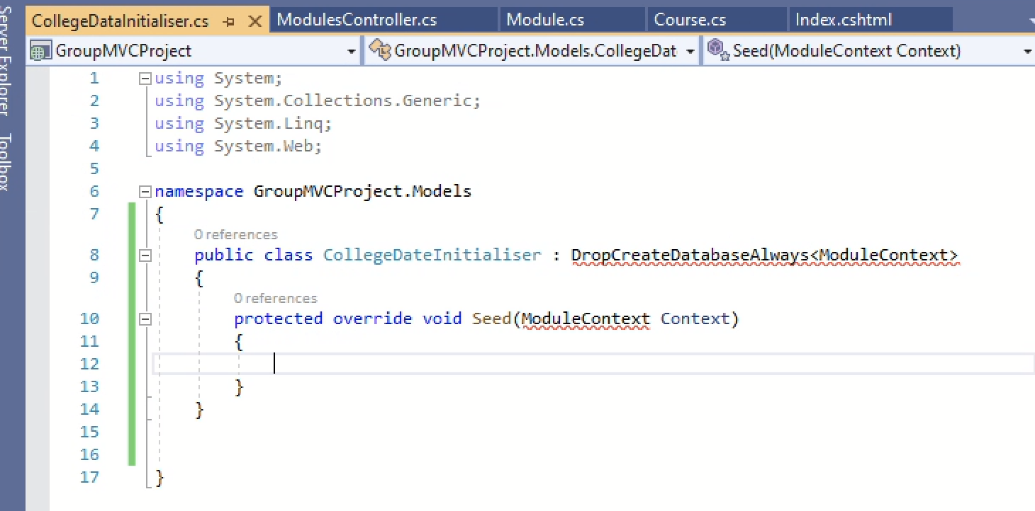

The variable that was added wasn’t recognised the reason to this was because the model class was not stated above.

## 7.3 Models class

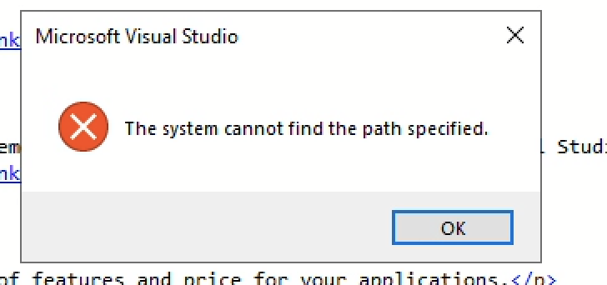

We came across this issue quite a few times as visual studio would usually crash if there were a lot of people working on dmu labs. Dhruv was unable to create a model class due to this issue we manage to sort out eventually as restarting visual studio helped.

## 7.4 GitHub Issue

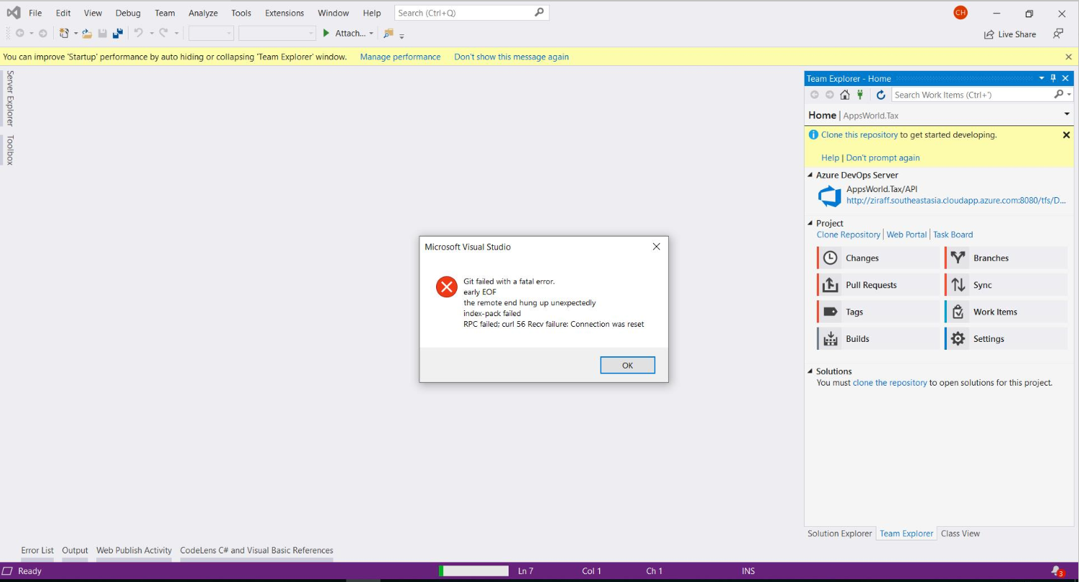

We encountered this issue quite a few times when we had to clone a new updated version of the work from github. This issue came up whenever we cloned it onto visual studio working through dmu labs (virtual machine). Therefore, we decided to work on our own desktops as the issue does still occur every now and then.

## 7.5 Duplicate Pages

One of the last issues we came across was whenever we had to run the pages on internet explorer, it would open up twice and not only once, we have still not found out a solution for this issue therefore we have decided to work through the internal browser on visual studio as the issue does not happen when we do run the pages on the visual studio browser.

# Future Improvements

Overall, we have concluded as a group there could have been quite a few improvements to the system we have created so far, but there are a few improvements we would like to focus on as they could have made our website even more interactive. One of the improvements we decided on is creating a search bar. We had planned to create a search bar during our design phase, therefore because of the amount of time we had left we could have not made one on time so we feel that the improvement we could make is creating a search bar to make it quite easier for the user to find specific information they are looking for.

Another improvement we feel we could make is adding social media platforms where users will be able to see our daily posts and updates on the college and its students. Therefore, in this platforms parents will also be able to share their views and give us feedback on what we could do better. Social media platforms would grab more user’s attention as it would be a source of interaction and not only text to read.

The final improvement we could have is users being able to view the website on their phones. At the moment we have created the website through visual studio, and it would only run-on local host. The website should run on a normal website where we can have access on not only laptops but phones, tablets, iPad etc.