Lucie Smejkalova

P2601017

Multimedia 1

TECH1015 – COURSEWORK 1

# Contents:

Website Feedback………………………………………………………………………………………………………………………….2

Evaluation………………………………………………………………………………………………………………………………………8

Appendices…………………………………………………………………………………………………………………………………….9

# Website Feedback

For the survey I decided to create a form in Google Documents which then has been shared with my classmates. This feedback form had 9 questions and had 5 responders.

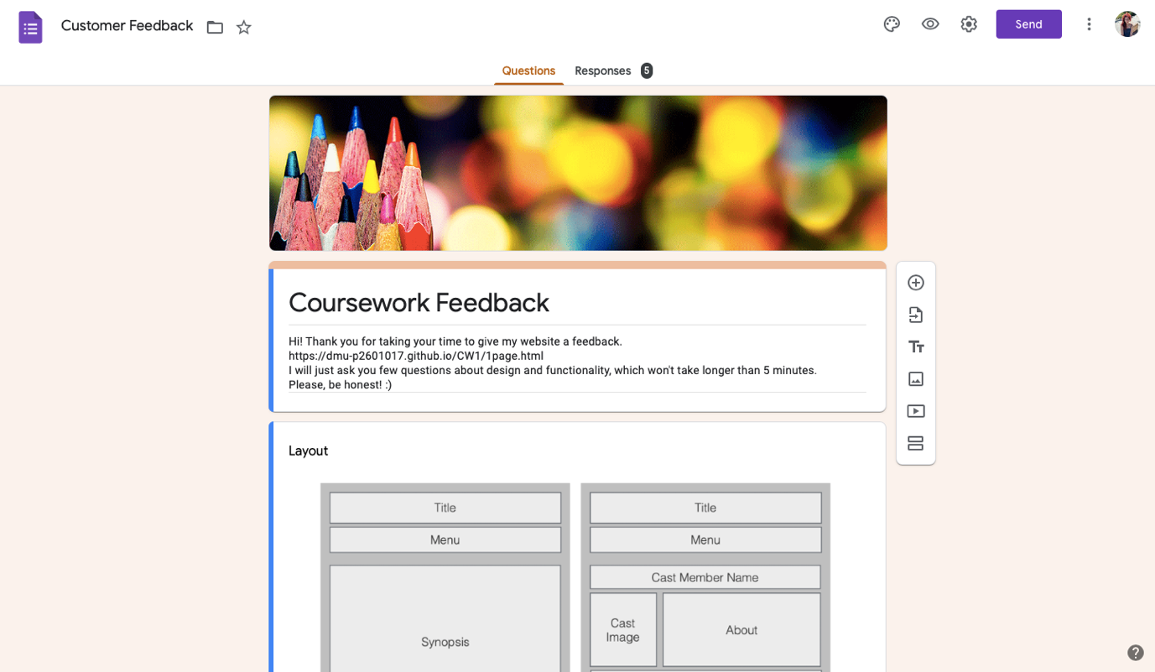

1. Question

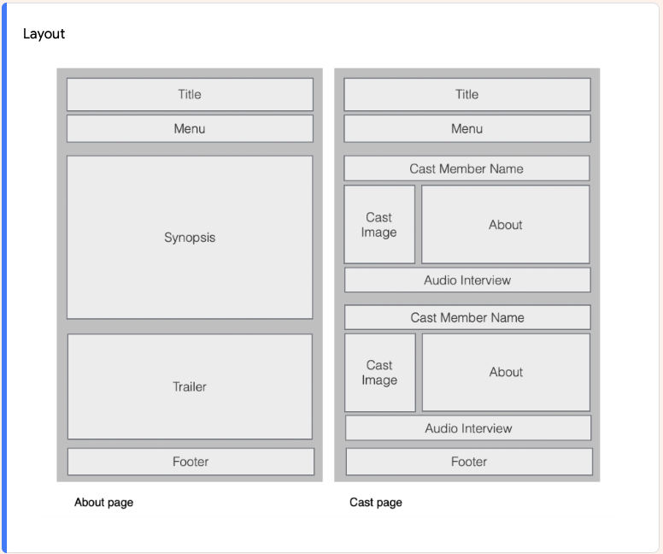

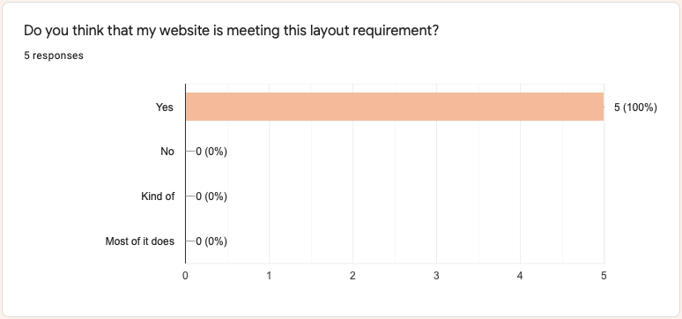

These answers gave me confidence, that I successfully made the website which covers the necessary criteria for this assessment.

1. Question:

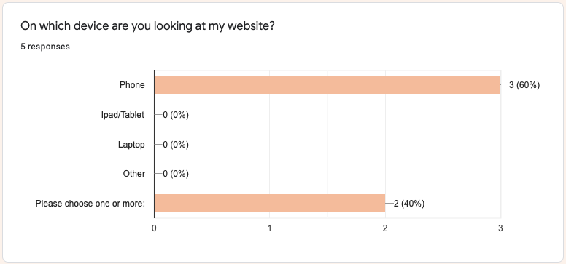

Here 3 people viewed my website on mobile and 2 on more than 1 device.

1. Question

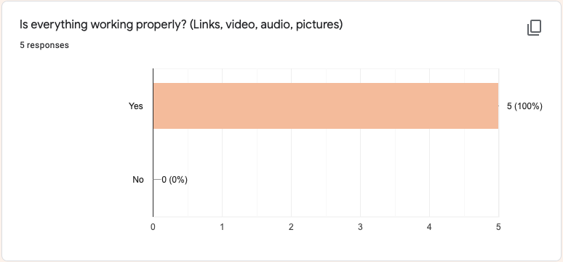

The main reason I created this question was to find out about quality of my coding, functions of external and internal links and other material.

1. Question

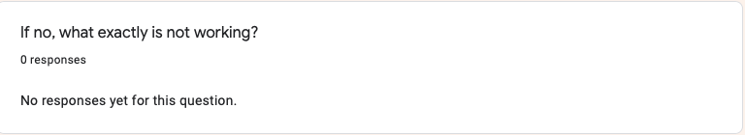

Nobody had any problem with function of my audio, video and image files.

1. Question

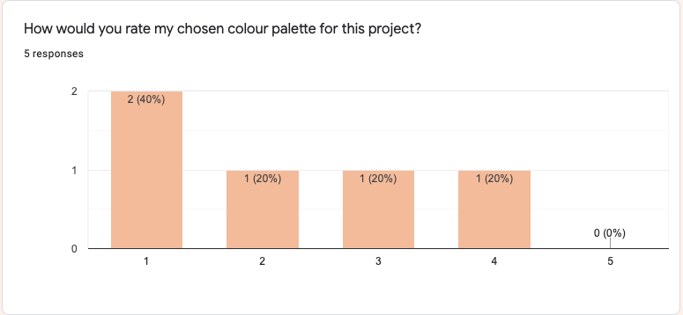

This rating was from 1 (fantastic) to 5 (horrible). Answers are mixed, even though most of the responders liked the colours I picked.

1. Question

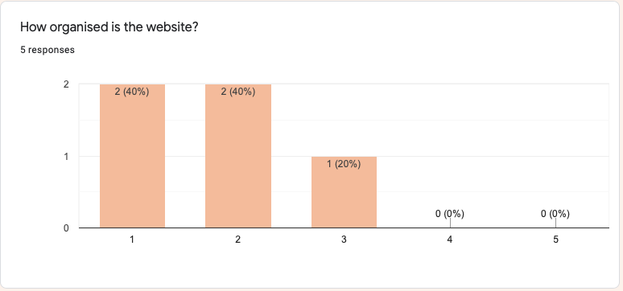

Here was important for me to find out if menu is visible enough and if viewers find my website organised. Rating was from 1 (Very well, I can find everything) to 5 (Badly, I’m completely lost).

1. Question

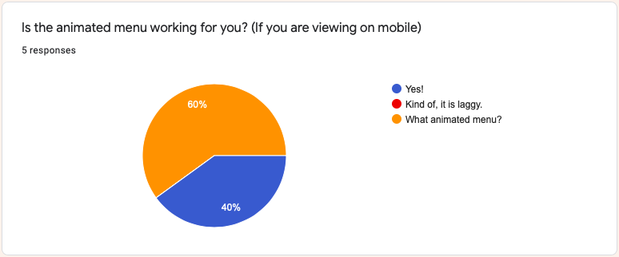

Here I wanted to know, if visitors can see animated menu when browsing on mobile as on computer it works well. This animated menu was hard to create, so I’m little bit sad not many people actually saw it.

1. Question

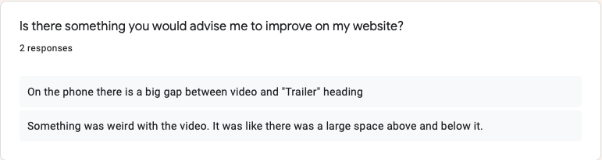

I appreciate this advice as I didn’t even notice that while coding.

1. Question

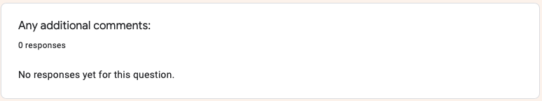

## My feedback suggests that:

I fulfilled the layout requirement, I managed to put the links to my website that work properly and my website is organised enough for viewers to find any information.

# Evaluation

Thanks to this feedback I found out that these particular things could be improved:

1. Colour scheme. This found footage psychological horror movie has dark story (black, grey colours) with hints of comedy and hope (gold, orange, light blue colours), so people who have seen the movie would probably give me more positive rating as they would understand the meaning behind this colour palette. However I could use just neutral colours instead like for example more shades of grey or white.
2. Organisation of my website. I could make the menu bigger, internal and external links and the menu in the footer more visible. I could also ask responders any advice or recommendation how to make my website more organised.
3. Menu. Here I should focus on making the animated menu more mobile friendly or maybe even use different kind of animation or different menu in general. Animated menus are usually not that visible or not functioning that good on mobile as on computer/laptop. So it is questionable if I even should put my effort in making one in the first place.
4. Spacing. I could definitely focus while coding more on mobile version when putting video on the website to make it more positive user experience. Gaps above and underneath the trailer could make the viewer think that there is some content missing even though it is not.

My website is about the horror movie Creep, which I watched few months ago and when there was a time to pick topic for this project, I thought I could make the best out of it. It gave me quite few challenges, as there is not much information out there about this movie and its cast, so the searching process was long. But on the other hand I had fun with creating a movie poster, choosing the colour palette, cropping the audio and creating the stylesheet in css.

I gained a lot of experience and learnt new things from the time I first created the lab practice exercise. This project encouraged me to search for things from different resources and also not only blindly copying the content but instead be inspired by it. I also found really useful information on W3school, where I picked different colours for my website.

I mainly focused to fulfil the layout requirement, as I have tendency to not stick to the subject and create something completely different then required.

Personally, I am happy with how this creation came out.

# Appendices

## Image References

1. Header picture

Tony Estrada, 2017, Creep movie poster, accessed 25th November 2020,

<<https://weliveentertainment.com/welivefilm/streaming-halloween-favorites/>>

1. Cast member Mark Duplass

Mark Duplass, 2014, Josef, accessed 20th November 2020, <<https://www.imdb.com/title/tt2428170/>>

1. Cast member Patrick Brice

Jason Blum, 2014, Aaron, accessed 20th November 2020,

<<https://rtv2-production-2-6.rottentomatoes.com/m/creep_2014>>

## Video and Audio References

1. Trailer

Movieclips Indie, 2015, Creep Official Trailer 1 (2015) - Mark Duplass Horror Movie HD, accessed 19th November 2020, <<https://www.youtube.com/watch?v=Gp7tBypjwDo>>

1. Mark Duplass Interview

Anne Thompson, 2014, SXSW Film Festival: Blum and Duplass on ‘Creep’, accessed 26th November 2020, <<https://www.youtube.com/watch?v=yl-tNLkZzoU&t=1s>>

1. Patrick Brice Interview

David Poland, 2015, DP/30: Creep, Patrick Brice, Mark Duplass, accessed 26th November 2020, <<https://www.youtube.com/watch?v=zzq7mgTPKzo&t=1439s>>

## Animated menu inspiration

1. Codegrid, 2017, Cool Link Hover Effect|HTML & CSS, accessed 10th November 2020, <<https://www.youtube.com/watch?v=IYTBAQRBsw0>>