**大 连 海 事 大 学**

**大数据原理与技术实验报告**

**学生： 杨显鹏**

**学号： 1120211433**

**专业： 电子信息**

**日期： 2021.11.12**

# 游戏介绍

贪食蛇（也叫贪吃蛇）是一款经典的小游戏。初始是像素版本，后来又衍生出3D版本、多人对战版本等。

玩家使用方向键操控一条长长的蛇不断吞下豆子，同时蛇身随着吞下的豆子不断变长，当蛇头撞到蛇身或障壁时游戏结束。贪吃蛇最初为人们所知的是诺基亚手机附带的一个小游戏，它伴随着诺基亚手机走向世界。现在的贪吃蛇出现了许多衍生版本，并被移植到各种平台上。

本游戏共有两方，每个玩家分别在n*m的网格中操纵三条蛇。n为垂直高度，m为水平宽度。蛇是一系列坐标构成的有限不重复有顺序的序列，序列中相邻坐标均相邻，即两坐标的x轴坐标或y轴坐标相同，序列中第一个坐标代表蛇头。玩家只能通过控制蛇头的朝向(上、下、左和右)来控制蛇。

蛇以恒定的速度前进(前进即为序列头插入蛇头指向方向下一格坐标，并删除序列末尾坐标)。蛇的初始位置为网格中的随机位置，初始长度为3格。每吃掉一个豆子长度加1。在游戏中豆子数量维持一个常数（5）不变，即被吃掉则重新随机生成等数量的豆子。

蛇头在自己蛇的身体(即序列重复)、其他蛇的身体(即与其他序列有相同坐标)均判定为死亡。当输入了非法方向时(如正在向左前进，无法选择向右)，随机选择一个合法方向。与传统贪吃蛇不同的是，蛇头超过边界时可以穿越到对称位置，不算做死亡。蛇死亡时可以按照初始化的设置重生。

到达指定步数时游戏结束。游戏结束后，蛇身长度总和大的一方获胜。

# 算法逻辑

本算法会依次判断给定条件是否满足, 从而做出下列五个动作之一:

1. defensive move: 衔尾

2. claim move: 以最短路径吃豆子

3. safe move: 最大化生存空间

4. attack move: 侵略性的动作

5. random move: 没有操作空间, 随机动作

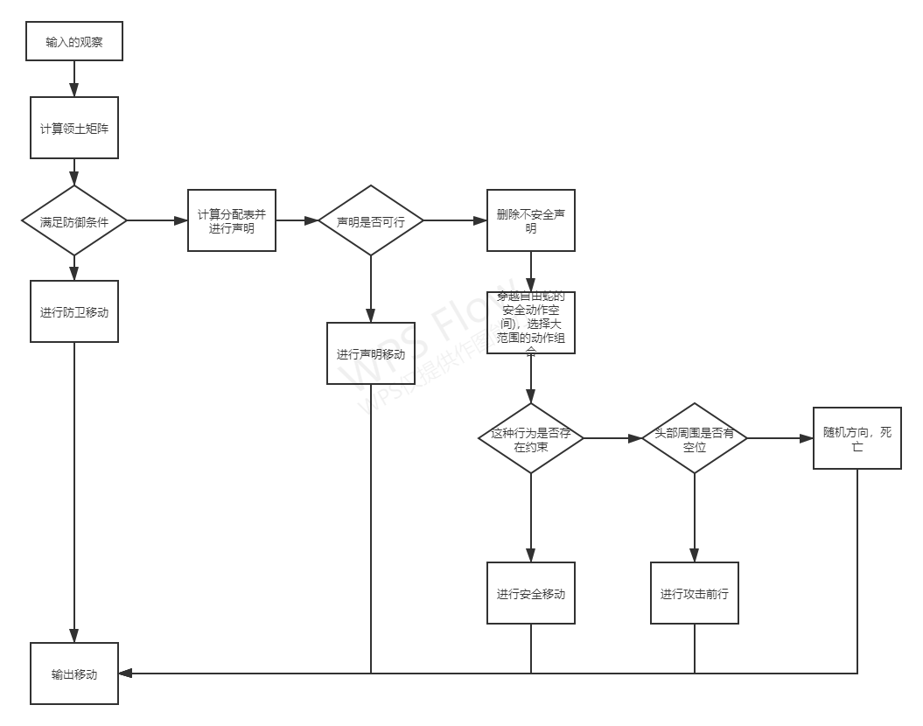

图1

计算领土矩阵的一个例子如图1所示. 简单说明如下:

领土的申明由两个循环构成:

外循环：对每条蛇, 维护一个待探列表, 外循环直至该列表为空才结束, 比如在循环开始时, 该列表即为六条蛇的蛇头.

每次循环开始首先去掉蛇尾 (若蛇尾存在的话), 这样做的目的是为了使得领土的计算更加精确, 否则将有很多蛇身未被申明.

内循环：即每条蛇按顺序申明领土, 比如下面的例子的顺序为:深绿→浅绿→青→红→粉→褐.

同一层外循环中, 短的蛇覆盖长的蛇的领土, 这可以保证短的蛇做更多攻击性的动作, 而长的蛇趋向防守.

同一层外循环中, 若蛇长度相同, 则将领土视为有争议的区域, 均放入待探列表, 并存储信息放入争议列表.

同一层外循环中, 若短的蛇可以申明一块争议区域, 且产生争议的两条蛇的长度都比其大, 则短的蛇直接申明该点, 并将该点移出争议列表。

# 代码

submission.py

class HiddenPrints:

def __enter__(self):

self._original_stdout = sys.stdout

sys.stdout = open(os.devnull, 'w')

def __exit__(self, exc_type, exc_val, exc_tb):

sys.stdout.close()

sys.stdout = self._original_stdout

def get_direction(x_h, y_h, x, y, height, width): # from (x_h, y_h) to (x, y)

if (x_h + 1) % height == x and y_h == y:

return [0, 1, 0, 0]

elif (x_h - 1) % height == x and y_h == y:

return [1, 0, 0, 0]

elif x_h == x and (y_h + 1) % width == y:

return [0, 0, 0, 1]

elif x_h == x and (y_h - 1) % width == y:

return [0, 0, 1, 0]

else:

assert False, 'the start and end points do not match'

def connected_count(matrix, pos):

height, width = matrix.shape

x, y = pos

sign = matrix[x, y]

unexplored = [[x, y]]

explored = []

_connected_count = 1

while unexplored:

x, y = unexplored.pop()

explored.append([x, y])

for x_, y_ in [((x + 1) % height, y), # down

((x - 1) % height, y), # up

(x, (y + 1) % width), # right

(x, (y - 1) % width)]: # left

if matrix[x_, y_] == sign and [x_, y_] not in explored and [x_, y_] not in unexplored:

unexplored.append([x_, y_])

_connected_count += 1

return _connected_count

class Snake:

def __init__(self, snake_positions, board_height, board_width, beans_positions):

self.pos = snake_positions # [[2, 9], [2, 8], [2, 7]]

self.len = len(snake_positions) # >= 3

self.head = snake_positions[0]

self.beans_positions = beans_positions

self.claimed_count = 0

displace = [(self.head[0] - snake_positions[1][0]) % board_height,

(self.head[1] - snake_positions[1][1]) % board_width]

print('creat snake, pos: ', self.pos, 'displace:', displace)

if displace == [board_height - 1, 0]: # all action are ordered by left, up, right, relative to the body

self.dir = 0 # up

self.legal_action = [2, 0, 3]

elif displace == [1, 0]:

self.dir = 1 # down

self.legal_action = [3, 1, 2]

elif displace == [0, board_width - 1]:

self.dir = 2 # left

self.legal_action = [1, 2, 0]

elif displace == [0, 1]:

self.dir = 3 # right

self.legal_action = [0, 3, 1]

else:

assert False, 'snake positions error'

positions = [[(self.head[0] - 1) % board_height, self.head[1]],

[(self.head[0] + 1) % board_height, self.head[1]],

[self.head[0], (self.head[1] - 1) % board_width],

[self.head[0], (self.head[1] + 1) % board_width]]

self.legal_position = [positions[_] for _ in self.legal_action]

def get_action(self, position):

if position not in self.legal_position:

assert False, 'the start and end points do not match'

idx = self.legal_position.index(position)

return self.legal_action[idx] # 0, 1, 2, 3: up, down, left, right

def step(self, legal_input):

if legal_input in self.legal_position:

position = legal_input

elif legal_input in self.legal_action:

idx = self.legal_action.index(legal_input)

position = self.legal_position[idx]

else:

assert False, 'illegal snake move'

self.head = position

self.pos.insert(0, position)

if position in self.beans_positions: # eat a bean

self.len += 1

else: # do not eat a bean

self.pos.pop()

class Board:

def __init__(self, board_height, board_width, snakes, beans_positions, teams):

print('create board, beans_position: ', beans_positions)

self.height = board_height

self.width = board_width

self.snakes = snakes

self.snakes_count = len(snakes)

self.beans_positions = beans_positions

self.blank_sign = -self.snakes_count

self.bean_sign = -self.snakes_count + 1

self.board = np.zeros((board_height, board_width), dtype=int) + self.blank_sign

self.open = dict()

for key, snake in self.snakes.items():

self.open[key] = [snake.head] # state 0 open list, heads, ready to spread

# see [A* Pathfinding (E01: algorithm explanation)](https://www.youtube.com/watch?v=-L-WgKMFuhE)

for x, y in snake.pos:

self.board[x][y] = key # obstacles, e.g. 0, 1, 2, 3, 4, 5

# for x, y in beans_positions:

# self.board[x][y] = self.bean_sign # beans

self.state = 0

self.controversy = dict()

self.teams = teams

print('initial board')

print(self.board)

def step(self): # delay: prevent rear-end collision

new_open = {key: [] for key in self.snakes.keys()}

self.state += 1 # update state

# if self.state > delay:

# for key, snake in self.snakes.items(): # drop tail

# if snake.len >= self.state:

# self.board[snake.pos[-(self.state - delay)][0]][snake.pos[-(self.state - delay)][1]] \

# = self.blank_sign

for key, snake in self.snakes.items():

if snake.len >= self.state:

self.board[snake.pos[-self.state][0]][snake.pos[-self.state][1]] = self.blank_sign # drop tail

for key, value in self.open.items(): # value: e.g. [[8, 3], [6, 3], [7, 4]]

others_tail_pos = [self.snakes[_].pos[-self.state]

if self.snakes[_].len >= self.state else []

for _ in set(range(self.snakes_count)) - {key}]

for x, y in value:

print('start to spread snake {} on grid ({}, {})'.format(key, x, y))

for x_, y_ in [((x + 1) % self.height, y), # down

((x - 1) % self.height, y), # up

(x, (y + 1) % self.width), # right

(x, (y - 1) % self.width)]: # left

sign = self.board[x_][y_]

idx = sign % self.snakes_count # which snake, e.g. 0, 1, 2, 3, 4, 5 / number of claims

state = sign // self.snakes_count # manhattan distance to snake who claim the point or its negative

if sign == self.blank_sign: # grid in initial state

if [x_, y_] in others_tail_pos:

print('do not spread other snakes tail, in case of rear-end collision')

continue # do not spread other snakes' tail, in case of rear-end collision

self.board[x_][y_] = self.state * self.snakes_count + key

self.snakes[key].claimed_count += 1

new_open[key].append([x_, y_])

elif key != idx and self.state == state:

# second claim, init controversy, change grid value from + to -

print(

'\tgird ({}, {}) in the same state claimed by different snakes '

'with sign {}, idx {} and state {}'.format(

x_, y_, sign, idx, state))

if self.snakes[idx].len > self.snakes[key].len: # shorter snake claim the controversial grid

print('\t\tsnake {} is shorter than snake {}'.format(key, idx))

self.snakes[idx].claimed_count -= 1

new_open[idx].remove([x_, y_])

self.board[x_][y_] = self.state * self.snakes_count + key

self.snakes[key].claimed_count += 1

new_open[key].append([x_, y_])

elif self.snakes[idx].len == self.snakes[key].len: # controversial claim

print(

'\t\tcontroversy! first claimed by snake {}, then claimed by snake {}'.format(idx, key))

self.controversy[(x_, y_)] = {'state': self.state,

'length': self.snakes[idx].len,

'indexes': [idx, key]}

# first claim by snake idx, then claim by snake key

self.board[x_][y_] = -self.state * self.snakes_count + 1

# if + 2, not enough for all snakes claim one grid!!

self.snakes[idx].claimed_count -= 1 # controversy, no snake claim this grid!!

new_open[key].append([x_, y_])

else: # (self.snakes[idx].len < self.snakes[key].len)

pass # longer snake do not claim the controversial grid

elif (x_, y_) in self.controversy \

and key not in self.controversy[(x_, y_)]['indexes'] \

and self.state + state == 0: # third claim or more

print('snake {} meets third or more claim in grid ({}, {})'.format(key, x_, y_))

controversy = self.controversy[(x_, y_)]

pprint.pprint(controversy)

if controversy['length'] > self.snakes[key].len: # shortest snake claim grid, do 4 things

print('\t\tsnake {} is shortest'.format(key))

indexes_count = len(controversy['indexes'])

for i in controversy['indexes']:

self.snakes[i].claimed_count -= 1 / indexes_count # update claimed_count !

new_open[i].remove([x_, y_])

del self.controversy[(x_, y_)]

self.board[x_][y_] = self.state * self.snakes_count + key

self.snakes[key].claimed_count += 1

new_open[key].append([x_, y_])

elif controversy['length'] == self.snakes[key].len: # controversial claim

print('\t\tcontroversy! multi claimed by snake {}'.format(key))

self.controversy[(x_, y_)]['indexes'].append(key)

self.board[x_][y_] += 1

new_open[key].append([x_, y_])

else: # (controversy['length'] < self.snakes[key].len)

pass # longer snake do not claim the controversial grid

else:

pass # do nothing with lower state grids

self.open = new_open # update open

# update controversial snakes' claimed_count (in fraction) in the end

for _, d in self.controversy.items():

controversial_snake_count = len(d['indexes']) # number of controversial snakes

for idx in d['indexes']:

self.snakes[idx].claimed_count += 1 / controversial_snake_count

def claim2action(self, claim_position, snake_idx, step_count, output_type):

# claim e.g. [2 ,3 ,4 ,-9] bean 2 is claimed by snake 3 within 4 steps

x, y = claim_position

x_h, y_h = self.snakes[snake_idx].head # head position

while step_count > 1:

step_count -= 1

temp = []

for x_, y_ in [((x + 1) % self.height, y), # down

((x - 1) % self.height, y), # up

(x, (y + 1) % self.width), # right

(x, (y - 1) % self.width)]: # left

sign = self.board[x_][y_]

if sign == self.blank_sign:

continue # snake too long, board not spread completely!! see example 20210815 0:41:48

state = sign // self.snakes_count if sign > 0 else -(sign // self.snakes_count)

indexes = [sign % self.snakes_count] if sign >= 0 else self.controversy[(x_, y_)]['indexes']

if step_count == state and snake_idx in indexes:

temp.append([x_, y_])

x, y = random.choice(temp)

if output_type == 'action':

return get_direction(x_h, y_h, x, y, self.height, self.width)

elif output_type == 'position':

return [x, y]

else:

assert False, 'unknown output_type {}'.format(output_type)

def state2claims(state_array, max_state, priority):

# state_array:

# array([[ 1, 30, 30, 30, 30, 30],

# [30, 30, 3, 30, 30, 30],

# [30, 1, 30, 5, 30, 30],

# [30, 30, 30, 6, 5, 30],

# [30, 30, 30, 30, 30, 6]])

beanCount, snakeCount = state_array.shape # (5, 6)

horiz = [list(state_array[_]).count(max_state) for _ in range(beanCount)] # [5, 5, 4, 4, 5]

vert = [list(state_array[:, _]).count(max_state) for _ in range(snakeCount)] # [4, 4, 4, 3, 4, 4]

claim_order = []

for b in range(beanCount):

for s in range(snakeCount):

if state_array[b][s] < max_state:

claim_order.append([b, s, state_array[b][s], -horiz[b] - vert[s]])

# priority rule: smaller state, larger horizontal or vertical cover number of max_state

if not claim_order:

return []

if priority == 'state':

temp = min(claim_order, key=operator.itemgetter(2, 3)) # [0, 0, 1, -9]

elif priority == 'cover':

temp = min(claim_order, key=operator.itemgetter(3, 2))

else:

assert False, 'unknown priority'

# update

for b in range(beanCount):

state_array[b, temp[1]] = max_state + 1

for s in range(snakeCount):

state_array[temp[0], s] = max_state + 1

return [temp] + state2claims(state_array, max_state, priority)

def my_controller(observation_list, action_space_list, is_act_continuous):

with HiddenPrints():

# detect 1v1, 3v3, 2p or 5p

observation_len = len(observation_list.keys())

teams = None

if observation_len == 7:

teams = [[0], [1]] # 1v1

# teams = [[0, 1]] # 2p

elif observation_len == 10:

teams = [[0, 1, 2, 3, 4]] # 5p

elif observation_len == 11:

teams = [[0, 1, 2], [3, 4, 5]] # 3v3

assert teams is not None, 'unknown game with observation length {}'.format(observation_len)

teams_count = len(teams)

snakes_count = sum([len(_) for _ in teams])

# read observation

obs = observation_list.copy()

board_height = obs['board_height'] # 10

board_width = obs['board_width'] # 20

ctrl_agent_index = obs['controlled_snake_index'] - 2 # 0, 1, 2, 3, 4, 5

# last_directions = obs['last_direction'] # ['up', 'left', 'down', 'left', 'left', 'left']

beans_positions = obs[1] # e.g.[[7, 15], [4, 14], [5, 12], [4, 12], [5, 7]]

snakes = {key - 2: Snake(obs[key], board_height, board_width, beans_positions)

for key in obs.keys() & {_ + 2 for _ in range(snakes_count)}} # &: intersection

team_indexes = [_ for _ in teams if ctrl_agent_index in _][0]

init_board = Board(board_height, board_width, snakes, beans_positions, teams)

bd = copy.deepcopy(init_board)

with HiddenPrints():

while not all(_ == [] for _ in bd.open.values()): # loop until all values in open are empty list

bd.step()

print(bd.board)

defense_snakes_indexes = [] # save defensive or claimed snakes, to calculate safe move for ctrl snake

# define defensive move

defensive_claim_list = [] # [pos, snake_idx, step]

# first check win side

snakes_lens = [snake.len for snake in snakes.values()]

snakes_claimed_counts = [snake.len for snake in snakes.values()]

print('snakes_lens: ', snakes_lens)

print('snakes_claimed_counts: ', snakes_claimed_counts)

# design defense threshold

# defense_threshold = 0.5 * math.pow(board_height * board_width, 1.1) / snakes_count * \

# math.sqrt(4 / (4 * teams_count + 1))

defense_threshold = board_height * board_width * teams_count / (teams_count + 1) / snakes_count

for idx in team_indexes:

if snakes_lens[idx] > defense_threshold:

# 3: player count + 1, 2: player count, 6: snake count

for _ in range(1, min(bd.state, snakes_lens[idx] // 2)):

# range should be designed more carefully!!

x, y = snakes[idx].pos[-_]

if bd.board[x, y] == idx + _ * snakes_count: # claim a loop in step _

defense_snakes_indexes.append(idx)

defensive_claim_list.append([[x, y], idx, _])

if idx == ctrl_agent_index:

action = [bd.claim2action(claim_position=[x, y],

snake_idx=idx,

step_count=_,

output_type='action')]

print('the controlled agent {} make a defensive move {} within {} step(s)'

.format(idx, action[0], _))

print(

'***********************************' +

' defensive move ' +

'***************************************')

return action

# calculate state_array

# e.g.

# array([[ 1, 30, 30, 30, 30, 30],

# [30, 30, 3, 30, 30, 30],

# [30, 1, 30, 5, 30, 30],

# [30, 30, 30, 6, 5, 30],

# [30, 30, 30, 30, 30, 6]])

max_state = board_height + board_width # 30

state_array = np.zeros((len(beans_positions), len(snakes)), dtype=int) + max_state

for i, (x, y) in enumerate(beans_positions):

sign = bd.board[x][y]

if sign >= snakes_count: # bean claimed by one snake

idx = sign % snakes_count # 0, 1, 2, 3, 4, 5

state = sign // snakes_count # 1, 2, ...

state_array[i][idx] = state

elif sign < 0 and sign % snakes_count in [_ for _ in range(snakes_count) if _ > 0]: # [2, 3, 4, 5]

state = -(sign // snakes_count)

for idx in bd.controversy[(x, y)]['indexes']:

state_array[i][idx] = state

elif sign == bd.blank_sign: # bean not reachable for any snakes! see example: 20210815, 1:10:23

pass

else:

assert False, 'unknown sign when calculating state_array'

# calculate claim list

# e.g. [[2, 3, 4, -9], [1, 1, 4, -6], [3, 2, 4, -4], [0, 4, 5, -2]]

claim_list_byState = state2claims(state_array.copy(), max_state, 'state')

claim_list_byCover = state2claims(state_array.copy(), max_state, 'cover')

print('claim_list_byState: ', len(claim_list_byState), claim_list_byState)

print('claim_list_byCover: ', len(claim_list_byCover), claim_list_byCover)

claim_list = claim_list_byState if len(claim_list_byState) >= len(claim_list_byCover) else claim_list_byCover

print('claim_list: ', claim_list)

claim_snakes_indexes = []

# for agent claiming a bean safely, simply return its action

for c in claim_list:

if ctrl_agent_index == c[1]: # the controlled agent claim a bean

print('the controlled agent {} claim a bean {} within {} step(s)'.format(c[1], c[0], c[2]))

action = [bd.claim2action(claim_position=bd.beans_positions[c[0]],

snake_idx=c[1],

step_count=c[2],

output_type='action')]

print('and play a action', action[0])

print('*********************************** claim move ******************************************')

return action

claim_snakes_indexes.append(c[1])

else:

# not claim any beans,

# traverse all possible action combination (at most 27),

# choose one that claim most grids

# calculate free team snakes indexes and safe positions list

free_team_snakes_indexes = [_ for _ in team_indexes

if _ not in claim_snakes_indexes and _ not in defense_snakes_indexes]

safe_positions_list = []

for idx in free_team_snakes_indexes:

safe_positions = [] # may be empty list

x_h, y_h = snakes[idx].head

for x, y in [((x_h + 1) % bd.height, y_h), # down

((x_h - 1) % bd.height, y_h), # up

(x_h, (y_h + 1) % bd.width), # right

(x_h, (y_h - 1) % bd.width)]: # left

if bd.board[x][y] == idx + snakes_count:

safe_positions.append([x, y]) # should be further tested if exists breath!!

safe_positions_list.append(safe_positions)

# delete snakes whose safe positions are [], which means they are dying

check_list = [_ != [] for _ in safe_positions_list]

free_team_snakes_indexes = list(np.array(free_team_snakes_indexes)[check_list]) # [idx1, idx2]

safe_positions_list = [_ for _ in safe_positions_list if _] # [[pos1, pos2, pos3], [pos1, pos2, pos3]

print('free_team_snakes_indexes: ', free_team_snakes_indexes)

print('safe_positions_list: ', safe_positions_list)

# create new snakes

snakes_next = copy.deepcopy(snakes)

for c in claim_list: # claimed snake make one move

idx = c[1]

if idx in defense_snakes_indexes:

continue # defense is prior to claim

position = bd.claim2action(claim_position=bd.beans_positions[c[0]],

snake_idx=idx,

step_count=c[2],

output_type='position')

snakes_next[idx].step(position)

for c in defensive_claim_list: # claimed snake make one move

idx = c[1]

position = bd.claim2action(claim_position=c[0],

snake_idx=idx,

step_count=c[2],

output_type='position')

snakes_next[idx].step(position)

# traverse and find the action combination with most grids claimed

max_claimed_counts_sum = 0

best_pos_comb = None

for pos_comb in itertools.product(

*safe_positions_list): # calculate cartesian product of safe positions list

# initiate claimed_count

for i, idx in enumerate(free_team_snakes_indexes): # unclaimed and undead snake make one move

snakes_next[idx] = copy.deepcopy(snakes[idx])

snakes_next[idx].step(pos_comb[i])

for snake in snakes_next.values():

snake.claimed_count = 0 # reset after deep copy !!

bd_next = Board(board_height, board_width, snakes_next, beans_positions, teams)

with HiddenPrints():

while not all(

_ == [] for _ in bd_next.open.values()): # loop until all values in open are empty list

bd_next.step()

print(bd.board)

claimed_counts = np.zeros(len(team_indexes))

for i, idx in enumerate(team_indexes): # not free, consider all team snakes!!

claimed_counts[i] = snakes_next[idx].claimed_count

claimed_counts_sum = sum(claimed_counts)

if claimed_counts_sum > max_claimed_counts_sum:

max_claimed_counts_sum = claimed_counts_sum

best_pos_comb = pos_comb # one-to-one with free_team_snakes_indexes

print('claimed_counts_sum: ', claimed_counts_sum)

print('pos_comb: ', pos_comb)

print('max_claimed_counts_sum: ', max_claimed_counts_sum, 'best_pos_comb: ', best_pos_comb)

if best_pos_comb:

for i, idx in enumerate(free_team_snakes_indexes):

if ctrl_agent_index == idx:

action = [[0, 0, 0, 0]]

direction = snakes[idx].get_action(best_pos_comb[i])

action[0][direction] = 1

print('the controlled agent {} make a safe move'.format(idx), action[0])

print(

'*********************************** safe move ******************************************')

return action

# todo: design attack moves

# no claim move, no safe move, no attack or die

action = [[0, 0, 0, 0]]

direction = snakes[ctrl_agent_index].legal_action[0]

action[0][direction] = 1

print('the controlled agent {} play a random action and is dying'.format(ctrl_agent_index), action[0])

print('*********************************** random move ******************************************')

return action

# 评价指标

本游戏共有两方，每个玩家分别在n*m的网格中操纵三条蛇。n为垂直高度，m为水平宽度。

蛇是一系列坐标构成的有限不重复有顺序的序列，序列中相邻坐标均相邻，即两坐标的x轴坐标或y轴坐标相同，序列中第一个坐标代表蛇头。玩家只能通过控制蛇头的朝向(上、下、左和右)来控制蛇。

蛇以恒定的速度前进(前进即为序列头插入蛇头指向方向下一格坐标，并删除序列末尾坐标)。蛇的初始位置为网格中的随机位置，初始长度为3格。每吃掉一个豆子长度加1。在游戏中豆子数量维持一个常数（5）不变，即被吃掉则重新随机生成等数量的豆子。

蛇头在自己蛇的身体(即序列重复)、其他蛇的身体(即与其他序列有相同坐标)均判定为死亡。当输入了非法方向时(如正在向左前进，无法选择向右)，随机选择一个合法方向。与传统贪吃蛇不同的是，蛇头超过边界时可以穿越到对称位置，不算做死亡。蛇死亡时可以按照初始化的设置重生。

到达指定步数时游戏结束。游戏结束后，蛇身长度总和大的一方获胜。

观测为一个字典，字典的键为1至7的正整数和"board_width"、"board_height"、"last_direction"、"controlled_snake_index"。其中1表示豆子，2至7表示蛇；字典的中的值为一个以[h,w]坐标为元素的列表，表示豆子的位置或蛇身的位置，其中h表示距左上角原点的垂直距离，w表示距原点的水平宽度；在2至7对应的值当中，列表元素从左至右表示对应蛇的蛇头至蛇尾的位置；"board_width"的值为地图的宽，"board_height" 的值为地图的高，"last_direction"的值为上一步各个蛇的方向，"controlled_snake_index"的值为控制蛇的序号。

动作空间为长度为n_action_dim的列表，其中n_action_dim=1，每个元素为Gym当中的Discrete类（ Discrete Link），如[Discrete(4)]。

# 实验结果

实验再及第平台进行提交，排名为14名。从提交至写作日期由系统进行多次测试，最终结果如图2所示。

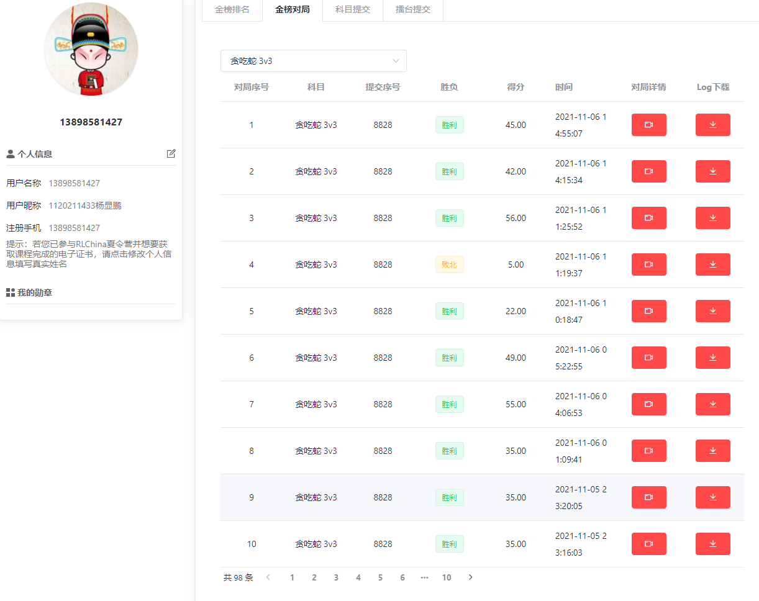

图2

可见，胜利的情形占据了多数。说明本游戏方法，性能优越。

# 比赛截图

