# 论文出处

Knowledge-aware Coupled Graph Neural Network for Social Recommendation

面向社交推荐的知识耦合图神经网络

-Chao Huang etc.

- JD Finance America Corporation, VIPS Research, Peng Cheng Laboratory etc.

AAAI-The National Conference on Artificial Intelligence)

(Association for the Advancement of Artifificial Intelligence)

The AAAI Conference on Artificial Intelligence promotes theoretical and applied AI research as well as intellectual interchange among researchers and practitioners. The technical program features substantial, original research and practices. Conference panel discussions and invited presentations identify significant social, philosophical, and economic issues influencing AI’s development throughout the world.

# 论文的大意内容

推荐系统是指，通过历史的用户购买商品记录，预测未来用户可能喜欢的商品的一项技术。在传统的推荐系统中只利用了单一用户与物品的单一关系，而是推荐并不能达到理想效果。本文在用户与商品单一的交互基础上，添加了用户与用户之间的社交关系、商品与商品之间的关系、用户与商品之间的多重关系（购买、浏览、添加入购物车等）。并将它们融合进本文提出的the Knowledge-aware Coupled Graph Neural Network (KCGN)网络中从而使推荐结果更加的准确。

# 本文的研究性质

本文是定量研究

选取了两个常用的标准数据集，Epinions、Yelp与来自京东金融的内部数据，共三个数据集。其中每个数据集的数据都分别包含着一万名用户与十万以上的商品、百万以上的交互信息。评估的标准是两个非常常用的评估准则Hit Ratio 和 Normalized Discounted Cumulative Gain来评估系统最终的准确率。

文章中提出了六个问题并进行了回答：

分别是

Does *KCGN* consistently outperform other baseline in terms of recommendation accuracy?

How is the performance of *KCGN*’s variants with the combination of different relation encoders?

How is forecasting performance of compared methods *w*.*r*.*t* different interaction density degrees?

How do the representations benefifit from the collectively encoding of global knowledge-aware crossinteractive patterns in social recommendation?

How do different hyper-parameter settings impact the performance of our *KCGN* framework?

How is the model effificiency of the *KCGN*?

# Literature Gap

The most common paradigm for state-of-the-art social recommender systems is to learn an embedding function, which unifies user-user and user-item relations into latent representations. To tackle this problem, many studies have developed various neural network techniques to integrate social information with the user-item interaction encoding as constraints.

For example, attention-based mechanism has been utilized to aggregate correlations among different users。Furthermore, inspired by the recent advance of graph neural architectures, several attempts are built upon the message passing frameworks over the user-user social graph. For example, social influence is simulated with layer-wise diffusion scheme for information fusion。

While these solutions have provided encouraging results, several key aspects have not been well addressed yet. While intuitively useful to integrate the above dimensions

into social recommendation frameworks, two unique technical challenges arise in achieving this goal. Specifically, graph-structured neural network can be applied to naturally model the topological information of social node instances, such as the graph-based convolutional network or attention mechanism。

In light of the aforementioned motivations and challenges, we study the social recommendation problem by proposing the Knowledge-aware Coupled Graph Neural Network (KCGN). To jointly deal with the user-user and item-item local and global relational structure awareness。

# 因果关系的段落

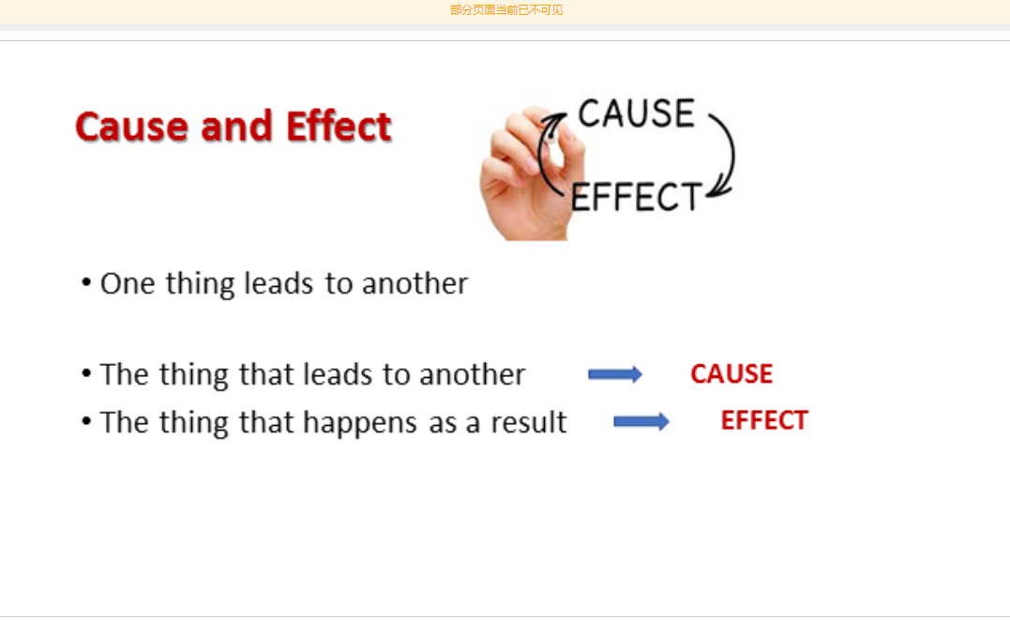

# 典型分析段落进行讲解

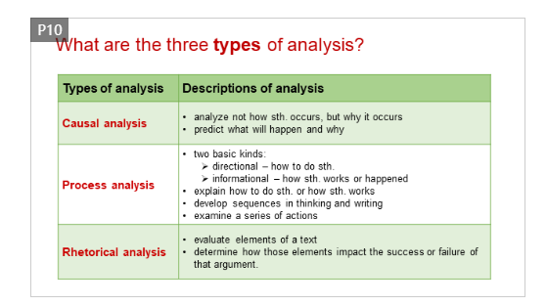

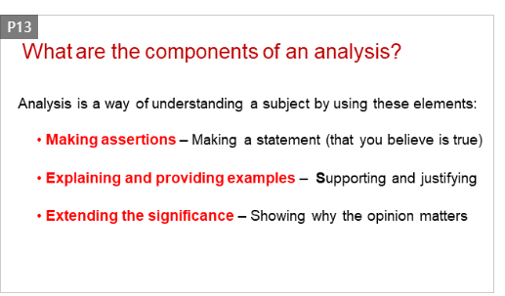

# 讲解文章的discussion 部分

找出其中interpretation的主要要素

# 比较文章的 introduction 和 discussion 部分

找出他们的主要区别