Appendix
Emails between me and my client:

Dear Mrs. I. Sochirca,
I have analysed your issue and I am confident that I can help you by building the computer program in Java, as it is cross-platform and all the users will be able to use it.
Could we meet next days to discuss more details about the software?

Best wishes,
Damian Mitrofan.

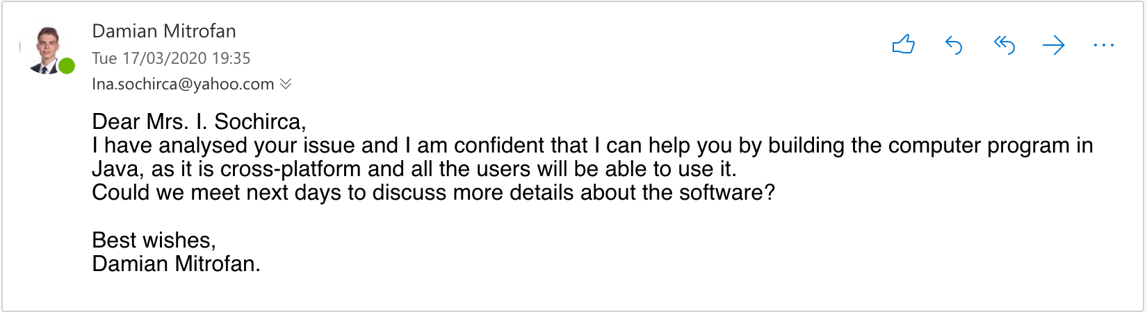

Dear Damian,
I am happy to hear that you are able to help me.
Could we meet tomorrow at 2pm, in my office, please?

Thanks,
Ina Sochirca.
Administrator of Natur House Timisoara
+40752284299

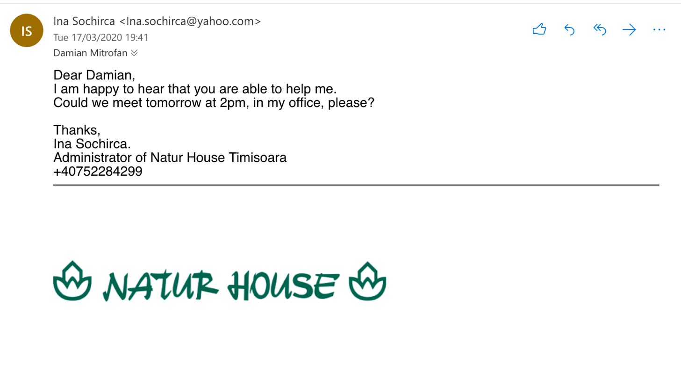

Dear Mrs. I. Sochirca,
Sure, I will be there to take notes about the program.

Best wishes,
Damian Mitrofan.

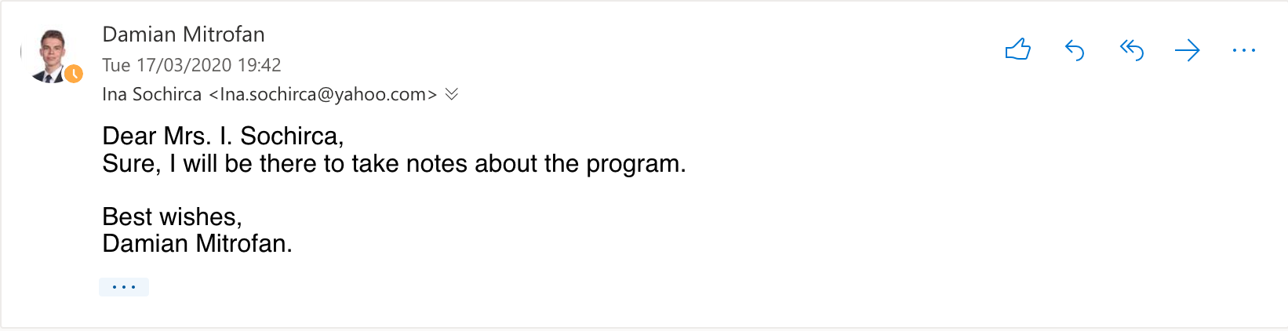

Notes from meeting:
- Minimalistic GUI, with different sections for calculator, tracking and administrator page.
- Formulas to calculate:
  - For men: (66 + (13.7 x weight) + (5 x height) - (6.8 x age)) x (Activity level points)
  - For women: (655 + (9.6 x weight) + (1.8 x height) - (4.7 x age)) x (Activity level points)
    - 1.2 points for a person who does little to no exercise.
    - 1.37 points for a slightly active person who does light exercise 1–3 days a week.
    - 1.55 points for a moderately active person who performs moderate exercise 3–5 days a week.
    - 1.725 points for a very active person who exercises hard 6–7 days a week.
    - 1.9 points for an extra active person who either has a physically demanding job or has a particularly challenging exercise routine.

- Tracking page contains weight, waist size, arms size, legs size.
- Mrs. I. Sochirca’s login.

Emails about the design section.
Hello,
I attached a sketch of the user interface for the program.
Please reply with any feedback/suggestions.

Thank you,
Damian Mitrofan.

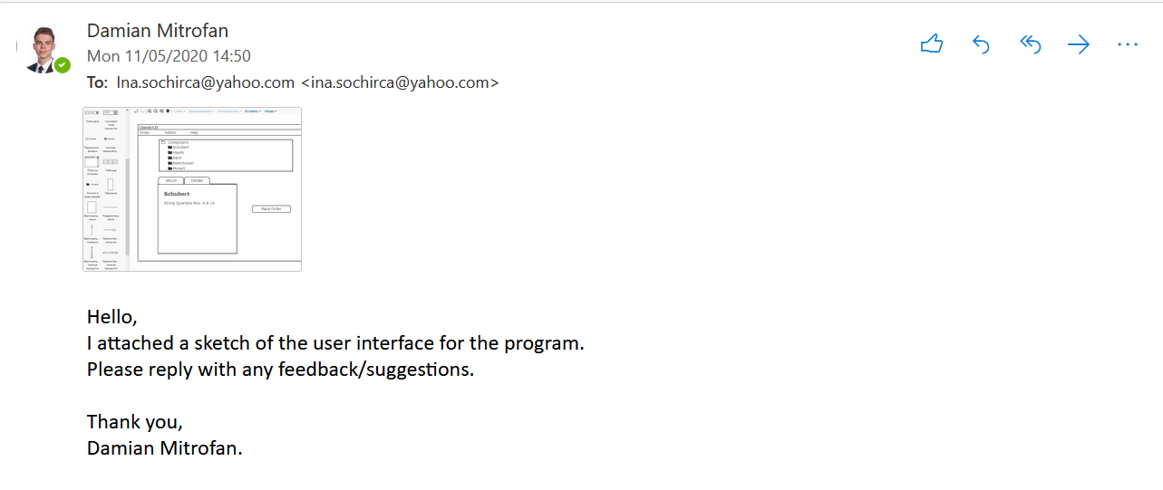

Hello Damian,
The GUI looks fine so far, but I would prefer to have all the tools in one window, with a separate section (maybe different colour) with the results.

Stay safe,
Ina.

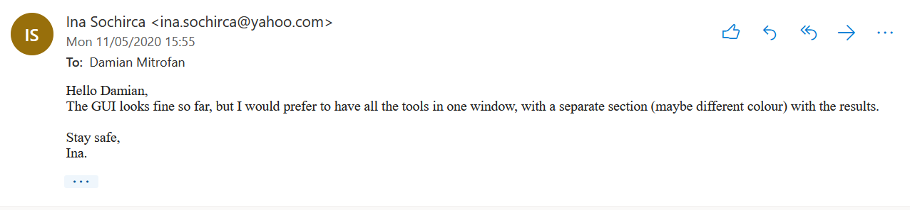

Then we had a Zoom meeting where I did screen share with the updated sketch and she approved it after small changes with the buttons position.

Emails after development section.
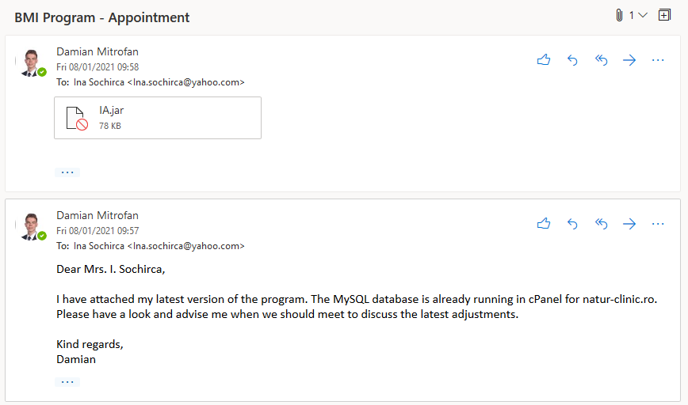
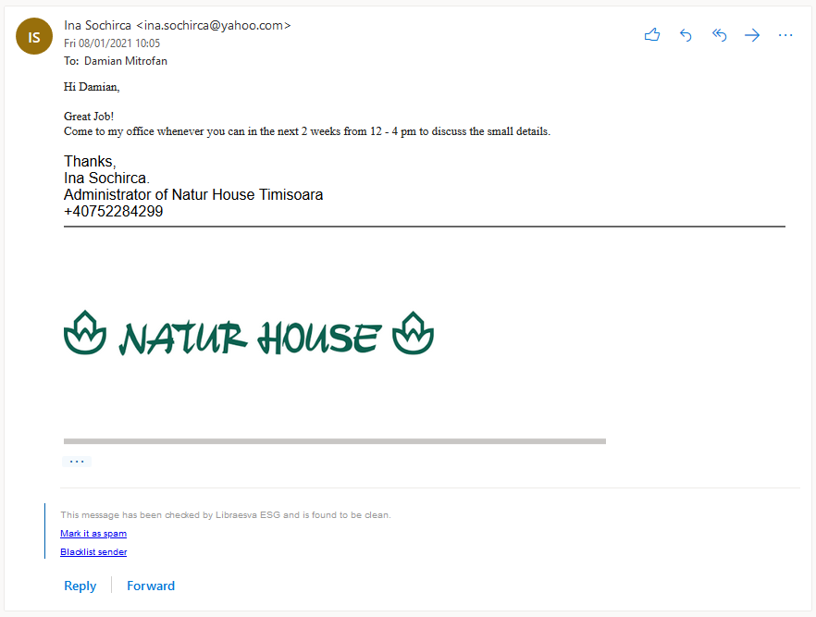
We met afterwards at her office, where she explained a few things I could improve to make it more GDPR friendly.

Code of the program

BMI class:
package com.naturhouse.ia;

/**
*
* @author Damian
*/
public class BMI {
public int MaleBMI(int Age, int Weight, int Height, double Activity){
double calories= (66 + (13.7*Weight) + (5*Height) - (6.8*Age))*Activity;
int Calories=(int)calories; //calculate calories for male
return Calories;
}
public int FemaleBMI(int Age, int Weight, int Height, double Activity){
double calories=(655 + (9.6*Weight) + (1.8*Height) - (4.7*Age))*Activity;
int Calories=(int)calories; //calculate calories for male
return Calories;
}
}

BodyFat class:
package com.naturhouse.ia;
import static java.lang.Math.log;

/**
*
* @author Damian
*/
public class BodyFat {
public int MaleBodyFat(int Waist, int Hips, int Neck, int Age, int Height){
double bodyfat=(495/(1.0324-0.19077*(log(Waist-Neck))+0.15456*(log(Height))))-450;
//calculate body fat percentage for male
int BodyFat=(int)bodyfat; //convert double to int
return BodyFat;
}
public int FemaleBodyFat(int Waist, int Hips, int Neck, int Age, int Height){
double bodyfat=(495/(1.29579-0.35004*(log(Waist+Hips-Neck))+0.22100*(log(Height))))-450;
//calculate body fat percentage for female
int BodyFat=(int)bodyfat; //convert double to int
return BodyFat;
}
}

Download class:
package com.naturhouse.ia;

import java.awt.Desktop;
import java.io.IOException;
import java.net.URISyntaxException;
import java.net.URL;
import java.sql.PreparedStatement;
import java.sql.ResultSet;
import java.sql.SQLException;
import java.util.logging.Level;
import java.util.logging.Logger;

/**
*
* @author Damian
*/
public class Download {
public void DietDownloadCut(int x){ //function to open the url
try { //according to the inputed calories, Cut version.
if (x < 1800){ //range of calories
x = 1;
} else if (x > 1800 | x < 2000){
x = 2;
} else if (x > 2000 | x < 2250){
x = 3;
} else if (x > 2250 | x < 2500){
x = 4;
} else if (x > 2500 | x < 2750){
x = 5;
} else if (x > 2750){
x = 6;
}
String CutLink = null;
PreparedStatement ps;
ResultSet rs = null;
String s=String.valueOf(x);
String query = "SELECT link FROM diets WHERE id = '" + s + "'";
ps = MyConnection.getConnection().prepareStatement(query);
if(ps.execute())
{
rs=ps.getResultSet(); //send the query to db
}
while(rs.next()){
CutLink = rs.getString(1); //receive from db once
}
OpenLink(CutLink); //pop the link in browser
} catch (SQLException ex) {
Logger.getLogger(Download.class.getName()).log(Level.SEVERE, null, ex);
}
}

public void DietDownloadBulk(int x){ //function to open the url
try { //according to the inputed calories, Bulk version.
if (x < 1800){ //range of calories
x = 1;
} else if (x > 1800 | x < 2000){
x = 2;
} else if (x > 2000 | x < 2250){
x = 3;
} else if (x > 2250 | x < 2500){
x = 4;
} else if (x > 2500 | x < 2750){
x = 5;
} else if (x > 2750){
x = 6;
}
String BulkLink = null;
PreparedStatement ps;
ResultSet rs = null;
x = x+1;
String s=String.valueOf(x);
String query = "SELECT link FROM diets WHERE id = '" + s + "'";
ps = MyConnection.getConnection().prepareStatement(query);
if(ps.execute())
{
rs=ps.getResultSet(); //send the query to db
}
while(rs.next()){
BulkLink = rs.getString(1); //receive from db once
}
OpenLink(BulkLink); //pop the link in browser
} catch (SQLException ex) {
Logger.getLogger(Download.class.getName()).log(Level.SEVERE, null, ex);
}
}

public void OpenLink(String link){
try { //open the link in the OS's default browser
Desktop.getDesktop().browse(new URL(link).toURI());
} catch (IOException | URISyntaxException e) {
}
}
}

LoginPage class:
package com.naturhouse.ia;
import java.io.BufferedWriter;
import java.io.File;
import java.io.FileNotFoundException;
import java.io.FileOutputStream;
import java.io.IOException;
import java.io.OutputStreamWriter;
import java.io.Writer;
import java.sql.PreparedStatement;
import java.sql.ResultSet;
import java.sql.SQLException;
import java.util.Scanner;
import java.util.logging.Level;
import java.util.logging.Logger;
import javax.swing.JOptionPane;

/**
*
* @author damian
*/
public class LoginPage extends javax.swing.JFrame {

/**
* Creates new form RegisterPage
*/
public LoginPage() {
initComponents();
}

/**
* This method is called from within the constructor to initialize the form.
* WARNING: Do NOT modify this code. The content of this method is always
* regenerated by the Form Editor.
*/
@SuppressWarnings("unchecked")
// <editor-fold defaultstate="collapsed" desc="Generated Code">
private void initComponents() {

jPanel1 = new javax.swing.JPanel();
jLabel1 = new javax.swing.JLabel();
jLabel2 = new javax.swing.JLabel();
jLabel3 = new javax.swing.JLabel();
EmailLogTextField = new javax.swing.JTextField();
jLabel5 = new javax.swing.JLabel();
PasswordLogTextField = new javax.swing.JPasswordField();
LoginButton = new javax.swing.JButton();
RegisterPageButton = new javax.swing.JButton();
LoggedButton = new javax.swing.JToggleButton();

setDefaultCloseOperation(javax.swing.WindowConstants.EXIT_ON_CLOSE);
setTitle("Login - Natur House");
setBackground(new java.awt.Color(255, 247, 216));
setResizable(false);

jPanel1.setBackground(new java.awt.Color(255, 247, 216));
jPanel1.addMouseListener(new java.awt.event.MouseAdapter() {
public void mouseEntered(java.awt.event.MouseEvent evt) {
jPanel1MouseEntered(evt);
}
});

jLabel1.setIcon(new javax.swing.ImageIcon(getClass().getResource("/com/naturhouse/ia/logo.png"))); // NOI18N
jLabel1.setToolTipText("");

jLabel2.setFont(new java.awt.Font("Lucida Grande", 0, 20)); // NOI18N
jLabel2.setText("LOGIN FORM");

jLabel3.setFont(new java.awt.Font("Lucida Grande", 0, 18)); // NOI18N
jLabel3.setText("EMAIL:");
jLabel3.setToolTipText("");

EmailLogTextField.addActionListener(new java.awt.event.ActionListener() {
public void actionPerformed(java.awt.event.ActionEvent evt) {
EmailLogTextFieldActionPerformed(evt);
}
});

jLabel5.setFont(new java.awt.Font("Lucida Grande", 0, 18)); // NOI18N
jLabel5.setText("PASSWORD:");
jLabel5.setToolTipText("");

LoginButton.setText("LOGIN");
LoginButton.addActionListener(new java.awt.event.ActionListener() {
public void actionPerformed(java.awt.event.ActionEvent evt) {
LoginButtonActionPerformed(evt);
}
});

RegisterPageButton.setText("REGISTER");
RegisterPageButton.addMouseListener(new java.awt.event.MouseAdapter() {
public void mouseClicked(java.awt.event.MouseEvent evt) {
RegisterPageButtonMouseClicked(evt);
}
});

LoggedButton.setText("STAY LOGGED");

javax.swing.GroupLayout jPanel1Layout = new javax.swing.GroupLayout(jPanel1);
jPanel1.setLayout(jPanel1Layout);
jPanel1Layout.setHorizontalGroup(
jPanel1Layout.createParallelGroup(javax.swing.GroupLayout.Alignment.LEADING)
.addGroup(jPanel1Layout.createSequentialGroup()
.addGroup(jPanel1Layout.createParallelGroup(javax.swing.GroupLayout.Alignment.LEADING)
.addGroup(jPanel1Layout.createSequentialGroup()
.addGap(22, 22, 22)
.addComponent(jLabel1))
.addGroup(jPanel1Layout.createSequentialGroup()
.addGap(109, 109, 109)
.addComponent(jLabel2))
.addGroup(jPanel1Layout.createSequentialGroup()
.addGap(52, 52, 52)
.addGroup(jPanel1Layout.createParallelGroup(javax.swing.GroupLayout.Alignment.TRAILING)
.addComponent(LoggedButton)
.addGroup(jPanel1Layout.createParallelGroup(javax.swing.GroupLayout.Alignment.LEADING, false)
.addGroup(jPanel1Layout.createSequentialGroup()
.addComponent(RegisterPageButton)
.addPreferredGap(javax.swing.LayoutStyle.ComponentPlacement.RELATED, javax.swing.GroupLayout.DEFAULT_SIZE, Short.MAX_VALUE)
.addComponent(LoginButton))
.addGroup(jPanel1Layout.createSequentialGroup()
.addComponent(jLabel3)
.addPreferredGap(javax.swing.LayoutStyle.ComponentPlacement.UNRELATED)
.addComponent(EmailLogTextField))
.addGroup(jPanel1Layout.createSequentialGroup()
.addComponent(jLabel5)
.addPreferredGap(javax.swing.LayoutStyle.ComponentPlacement.RELATED)
.addComponent(PasswordLogTextField, javax.swing.GroupLayout.PREFERRED_SIZE, 127, javax.swing.GroupLayout.PREFERRED_SIZE))))))
.addContainerGap(29, Short.MAX_VALUE))
);
jPanel1Layout.setVerticalGroup(
jPanel1Layout.createParallelGroup(javax.swing.GroupLayout.Alignment.LEADING)
.addGroup(jPanel1Layout.createSequentialGroup()
.addGap(21, 21, 21)
.addComponent(jLabel1)
.addPreferredGap(javax.swing.LayoutStyle.ComponentPlacement.RELATED)
.addComponent(jLabel2, javax.swing.GroupLayout.PREFERRED_SIZE, 37, javax.swing.GroupLayout.PREFERRED_SIZE)
.addGap(5, 5, 5)
.addGroup(jPanel1Layout.createParallelGroup(javax.swing.GroupLayout.Alignment.BASELINE)
.addComponent(EmailLogTextField, javax.swing.GroupLayout.PREFERRED_SIZE, javax.swing.GroupLayout.DEFAULT_SIZE, javax.swing.GroupLayout.PREFERRED_SIZE)
.addComponent(jLabel3))
.addGap(18, 18, 18)
.addGroup(jPanel1Layout.createParallelGroup(javax.swing.GroupLayout.Alignment.BASELINE)
.addComponent(jLabel5)
.addComponent(PasswordLogTextField, javax.swing.GroupLayout.PREFERRED_SIZE, javax.swing.GroupLayout.DEFAULT_SIZE, javax.swing.GroupLayout.PREFERRED_SIZE))
.addPreferredGap(javax.swing.LayoutStyle.ComponentPlacement.RELATED, 19, Short.MAX_VALUE)
.addComponent(LoggedButton)
.addGap(18, 18, 18)
.addGroup(jPanel1Layout.createParallelGroup(javax.swing.GroupLayout.Alignment.BASELINE)
.addComponent(RegisterPageButton)
.addComponent(LoginButton))
.addGap(52, 52, 52))
);

javax.swing.GroupLayout layout = new javax.swing.GroupLayout(getContentPane());
getContentPane().setLayout(layout);
layout.setHorizontalGroup(
layout.createParallelGroup(javax.swing.GroupLayout.Alignment.LEADING)
.addComponent(jPanel1, javax.swing.GroupLayout.PREFERRED_SIZE, javax.swing.GroupLayout.DEFAULT_SIZE, javax.swing.GroupLayout.PREFERRED_SIZE)
);
layout.setVerticalGroup(
layout.createParallelGroup(javax.swing.GroupLayout.Alignment.LEADING)
.addComponent(jPanel1, javax.swing.GroupLayout.PREFERRED_SIZE, javax.swing.GroupLayout.DEFAULT_SIZE, javax.swing.GroupLayout.PREFERRED_SIZE)
);

pack();
}// </editor-fold>

private void EmailLogTextFieldActionPerformed(java.awt.event.ActionEvent evt) {
// TODO add your handling code here:
}

private void RegisterPageButtonMouseClicked(java.awt.event.MouseEvent evt) {
// open the register page while closing the login one
RegisterPage rgf = new RegisterPage();
rgf.setVisible(true);
rgf.pack();
rgf.setLocationRelativeTo(null);
rgf.setDefaultCloseOperation(LoginPage.EXIT_ON_CLOSE);
this.dispose();
}
public void Login(){
main rgf = new main();
rgf.setVisible(true);
rgf.pack();
rgf.setLocationRelativeTo(null);
rgf.setDefaultCloseOperation(LoginPage.EXIT_ON_CLOSE);
this.dispose();
}
public void checkLogged(){ // function to check if user chose to stay logged
PreparedStatement ps;
ResultSet rs;
String Logged = null;
String email = null;
String pass = null;
File f = new File("credentials.txt"); //open the file
try {
Scanner read = new Scanner(f);
read.useDelimiter(":"); //save the data between : into below variable
while(read.hasNext()){
email = read.next();
pass = read.next();
Logged = read.next();
}
} catch (FileNotFoundException ex) {
Logger.getLogger(main.class.getName()).log(Level.SEVERE, null, ex);
}
if ("1".equals(Logged)){ //if it is then login using the credentials
try { //saved in the credentials.txt
String query = "SELECT * FROM `users` WHERE `email` =? AND `pass` =?";
ps = MyConnection.getConnection().prepareStatement(query);
ps.setString(1, email);
ps.setString(2, pass);
rs = ps.executeQuery();
if(rs.next())
{
Login();
}
} catch (SQLException ex) {
Logger.getLogger(LoginPage.class.getName()).log(Level.SEVERE, null, ex);
}

}
}
private void LoginButtonActionPerformed(java.awt.event.ActionEvent evt) {
// function to login to MySQL database
PreparedStatement ps;
ResultSet rs;
String email = EmailLogTextField.getText();
String pass = String.valueOf(PasswordLogTextField.getPassword());

String query = "SELECT * FROM `users` WHERE `email` =? AND `pass` =?";

try {
pass = MyConnection.encrypt(pass);
ps = MyConnection.getConnection().prepareStatement(query);

ps.setString(1, email);
ps.setString(2, pass);

rs = ps.executeQuery();

if(rs.next())
{
try (Writer writer = new BufferedWriter(new OutputStreamWriter(
new FileOutputStream("credentials.txt"), "utf-8"))) {
if (LoggedButton.isSelected()==true){ //if stay logged box
//is pressed
writer.write(email + ":" + pass +":1");
} else {
writer.write(email + ":" + pass + ":0");
}
Login();
}catch (IOException ex) {
Logger.getLogger(LoginPage.class.getName()).log(Level.SEVERE, null, ex);
}
}
else{
JOptionPane.showMessageDialog(null, "Incorrect email or password.", "Login failed", 2);
}

} catch (SQLException ex) {
Logger.getLogger(LoginPage.class.getName()).log(Level.SEVERE, null, ex);
}

}
/**
* @param args the command line arguments
*/
public static void main(String args[]) {
/* Set the Nimbus look and feel */
//<editor-fold defaultstate="collapsed" desc=" Look and feel setting code (optional) ">
/* If Nimbus (introduced in Java SE 6) is not available, stay with the default look and feel.
* For details see http://download.oracle.com/javase/tutorial/uiswing/lookandfeel/plaf.html
*/
try {
for (javax.swing.UIManager.LookAndFeelInfo info : javax.swing.UIManager.getInstalledLookAndFeels()) {
if ("Nimbus".equals(info.getName())) {
javax.swing.UIManager.setLookAndFeel(info.getClassName());
break;
}
}
} catch (ClassNotFoundException ex) {
java.util.logging.Logger.getLogger(LoginPage.class.getName()).log(java.util.logging.Level.SEVERE, null, ex);
} catch (InstantiationException ex) {
java.util.logging.Logger.getLogger(LoginPage.class.getName()).log(java.util.logging.Level.SEVERE, null, ex);
} catch (IllegalAccessException ex) {
java.util.logging.Logger.getLogger(LoginPage.class.getName()).log(java.util.logging.Level.SEVERE, null, ex);
} catch (javax.swing.UnsupportedLookAndFeelException ex) {
java.util.logging.Logger.getLogger(LoginPage.class.getName()).log(java.util.logging.Level.SEVERE, null, ex);
}
//</editor-fold>
//</editor-fold>

/* Create and display the form */
java.awt.EventQueue.invokeLater(() -> {
new LoginPage().setVisible(true);
});
}

private void jPanel1MouseEntered(java.awt.event.MouseEvent evt) {
// check if the mouse entered the app in order to call the update function
checkLogged();
}

// Variables declaration - do not modify
private javax.swing.JTextField EmailLogTextField;
private javax.swing.JToggleButton LoggedButton;
private javax.swing.JButton LoginButton;
private javax.swing.JPasswordField PasswordLogTextField;
private javax.swing.JButton RegisterPageButton;
private javax.swing.JLabel jLabel1;
private javax.swing.JLabel jLabel2;
private javax.swing.JLabel jLabel3;
private javax.swing.JLabel jLabel5;
private javax.swing.JPanel jPanel1;
// End of variables declaration
}

MyConnection class:
package com.naturhouse.ia;
import com.mysql.jdbc.jdbc2.optional.MysqlDataSource;
import java.security.MessageDigest;
import java.security.NoSuchAlgorithmException;
import java.sql.Connection;
import java.sql.SQLException;
import java.util.logging.Level;
import java.util.logging.Logger;

/**
*
* @author damian
*/
public class MyConnection {

private static String servername = "127.0.0.1";
private static String username = "root";
private static String dbname = "ia";
private static Integer portnumber = 3306;
private static String password = "";

public static Connection getConnection() //connects to the MySQL database
{
Connection cnx = null;

MysqlDataSource datasource = new MysqlDataSource();

datasource.setServerName(servername);
datasource.setUser(username);
datasource.setPassword(password);
datasource.setDatabaseName(dbname);
datasource.setPortNumber(portnumber);
datasource.setUseSSL(false); // for secure connection, needs certificate

try {
cnx = datasource.getConnection();
} catch (SQLException ex) {
Logger.getLogger(MyConnection.class.getName()).log(Level.SEVERE, null, ex);
}

return cnx;
}
public static String encrypt(String data){ //encrypts string in SHA-256
StringBuilder sb; //for a hashed password
sb = new StringBuilder();
try{
MessageDigest md = MessageDigest.getInstance("SHA-256");
md.update(data.getBytes()); //get the type of encryption
byte byteData[] = md.digest();
for (int i = 0; i < byteData.length; i++) {
//loop through the bytes and converts it to hex
sb.append(Integer.toString((byteData[i] & 0xff) + 0x100, 16).substring(1));
}
} catch(NoSuchAlgorithmException e){
}
return sb.toString();
}
}

RegisterPage class:
package com.naturhouse.ia;
import java.sql.PreparedStatement;
import java.sql.ResultSet;
import java.sql.SQLException;
import java.text.SimpleDateFormat;
import java.util.logging.Level;
import java.util.logging.Logger;
import javax.swing.JOptionPane;
/**
*
* @author damian
*/
public class RegisterPage extends javax.swing.JFrame {

/**
* Creates new form RegisterPage
*/
public RegisterPage() {
initComponents();
}

/**
* This method is called from within the constructor to initialize the form.
* WARNING: Do NOT modify this code. The content of this method is always
* regenerated by the Form Editor.
*/
@SuppressWarnings("unchecked")
// <editor-fold defaultstate="collapsed" desc="Generated Code">
private void initComponents() {

jPanel1 = new javax.swing.JPanel();
jLabel1 = new javax.swing.JLabel();
jLabel2 = new javax.swing.JLabel();
jLabel3 = new javax.swing.JLabel();
EmailRegTextField = new javax.swing.JTextField();
jLabel4 = new javax.swing.JLabel();
NameTextField = new javax.swing.JTextField();
jLabel5 = new javax.swing.JLabel();
PasswordRegTextField = new javax.swing.JPasswordField();
CancelButton = new javax.swing.JButton();
RegisterButton = new javax.swing.JButton();
jLabel6 = new javax.swing.JLabel();
PasswordRegTextField2 = new javax.swing.JPasswordField();
jDateChooser1 = new com.toedter.calendar.JDateChooser();
jLabel7 = new javax.swing.JLabel();

setDefaultCloseOperation(javax.swing.WindowConstants.EXIT_ON_CLOSE);
setTitle("Register - Natur House");
setBackground(new java.awt.Color(255, 247, 216));
setResizable(false);

jPanel1.setBackground(new java.awt.Color(255, 247, 216));

jLabel1.setIcon(new javax.swing.ImageIcon(getClass().getResource("/com/naturhouse/ia/logo.png"))); // NOI18N

jLabel2.setFont(new java.awt.Font("Lucida Grande", 0, 20)); // NOI18N
jLabel2.setText("REGISTER FORM");

jLabel3.setFont(new java.awt.Font("Lucida Grande", 0, 18)); // NOI18N
jLabel3.setText("EMAIL:");
jLabel3.setToolTipText("");

EmailRegTextField.addActionListener(new java.awt.event.ActionListener() {
public void actionPerformed(java.awt.event.ActionEvent evt) {
EmailRegTextFieldActionPerformed(evt);
}
});

jLabel4.setFont(new java.awt.Font("Lucida Grande", 0, 18)); // NOI18N
jLabel4.setText("NAME:");
jLabel4.setToolTipText("");

NameTextField.addActionListener(new java.awt.event.ActionListener() {
public void actionPerformed(java.awt.event.ActionEvent evt) {
NameTextFieldActionPerformed(evt);
}
});

jLabel5.setFont(new java.awt.Font("Lucida Grande", 0, 18)); // NOI18N
jLabel5.setText("PASSWORD:");
jLabel5.setToolTipText("");

CancelButton.setText("CANCEL");
CancelButton.addMouseListener(new java.awt.event.MouseAdapter() {
public void mouseClicked(java.awt.event.MouseEvent evt) {
CancelButtonMouseClicked(evt);
}
});

RegisterButton.setText("REGISTER");
RegisterButton.addActionListener(new java.awt.event.ActionListener() {
public void actionPerformed(java.awt.event.ActionEvent evt) {
RegisterButtonActionPerformed(evt);
}
});

jLabel6.setFont(new java.awt.Font("Lucida Grande", 0, 18)); // NOI18N
jLabel6.setText("BIRTHDAY:");
jLabel6.setToolTipText("");

jLabel7.setFont(new java.awt.Font("Lucida Grande", 0, 18)); // NOI18N
jLabel7.setText("CONFIRM:");
jLabel7.setToolTipText("");

javax.swing.GroupLayout jPanel1Layout = new javax.swing.GroupLayout(jPanel1);
jPanel1.setLayout(jPanel1Layout);
jPanel1Layout.setHorizontalGroup(
jPanel1Layout.createParallelGroup(javax.swing.GroupLayout.Alignment.LEADING)
.addGroup(jPanel1Layout.createSequentialGroup()
.addGroup(jPanel1Layout.createParallelGroup(javax.swing.GroupLayout.Alignment.LEADING)
.addGroup(jPanel1Layout.createSequentialGroup()
.addGap(72, 72, 72)
.addComponent(jLabel1))
.addGroup(jPanel1Layout.createSequentialGroup()
.addGap(78, 78, 78)
.addGroup(jPanel1Layout.createParallelGroup(javax.swing.GroupLayout.Alignment.LEADING)
.addGroup(jPanel1Layout.createParallelGroup(javax.swing.GroupLayout.Alignment.TRAILING, false)
.addGroup(javax.swing.GroupLayout.Alignment.LEADING, jPanel1Layout.createSequentialGroup()
.addComponent(CancelButton)
.addPreferredGap(javax.swing.LayoutStyle.ComponentPlacement.RELATED, javax.swing.GroupLayout.DEFAULT_SIZE, Short.MAX_VALUE)
.addComponent(RegisterButton))
.addGroup(javax.swing.GroupLayout.Alignment.LEADING, jPanel1Layout.createSequentialGroup()
.addComponent(jLabel5)
.addPreferredGap(javax.swing.LayoutStyle.ComponentPlacement.UNRELATED)
.addComponent(PasswordRegTextField))
.addGroup(jPanel1Layout.createSequentialGroup()
.addComponent(jLabel3)
.addPreferredGap(javax.swing.LayoutStyle.ComponentPlacement.UNRELATED)
.addComponent(EmailRegTextField, javax.swing.GroupLayout.PREFERRED_SIZE, 201, javax.swing.GroupLayout.PREFERRED_SIZE))
.addGroup(javax.swing.GroupLayout.Alignment.LEADING, jPanel1Layout.createSequentialGroup()
.addGap(13, 13, 13)
.addGroup(jPanel1Layout.createParallelGroup(javax.swing.GroupLayout.Alignment.TRAILING)
.addComponent(jLabel7)
.addComponent(jLabel6))
.addGap(12, 12, 12)
.addGroup(jPanel1Layout.createParallelGroup(javax.swing.GroupLayout.Alignment.LEADING)
.addComponent(PasswordRegTextField2)
.addComponent(jDateChooser1, javax.swing.GroupLayout.DEFAULT_SIZE, javax.swing.GroupLayout.DEFAULT_SIZE, Short.MAX_VALUE))))
.addGroup(jPanel1Layout.createSequentialGroup()
.addComponent(jLabel4)
.addPreferredGap(javax.swing.LayoutStyle.ComponentPlacement.UNRELATED)
.addGroup(jPanel1Layout.createParallelGroup(javax.swing.GroupLayout.Alignment.LEADING)
.addComponent(jLabel2)
.addComponent(NameTextField, javax.swing.GroupLayout.PREFERRED_SIZE, 201, javax.swing.GroupLayout.PREFERRED_SIZE))))))
.addContainerGap(73, Short.MAX_VALUE))
);
jPanel1Layout.setVerticalGroup(
jPanel1Layout.createParallelGroup(javax.swing.GroupLayout.Alignment.LEADING)
.addGroup(jPanel1Layout.createSequentialGroup()
.addGap(12, 12, 12)
.addComponent(jLabel1)
.addGap(12, 12, 12)
.addComponent(jLabel2, javax.swing.GroupLayout.PREFERRED_SIZE, 37, javax.swing.GroupLayout.PREFERRED_SIZE)
.addGap(18, 18, 18)
.addGroup(jPanel1Layout.createParallelGroup(javax.swing.GroupLayout.Alignment.BASELINE)
.addComponent(jLabel4)
.addComponent(NameTextField, javax.swing.GroupLayout.PREFERRED_SIZE, javax.swing.GroupLayout.DEFAULT_SIZE, javax.swing.GroupLayout.PREFERRED_SIZE))
.addGap(18, 18, 18)
.addGroup(jPanel1Layout.createParallelGroup(javax.swing.GroupLayout.Alignment.BASELINE)
.addComponent(jLabel3)
.addComponent(EmailRegTextField, javax.swing.GroupLayout.PREFERRED_SIZE, javax.swing.GroupLayout.DEFAULT_SIZE, javax.swing.GroupLayout.PREFERRED_SIZE))
.addGap(18, 18, 18)
.addGroup(jPanel1Layout.createParallelGroup(javax.swing.GroupLayout.Alignment.BASELINE)
.addComponent(jLabel5)
.addComponent(PasswordRegTextField, javax.swing.GroupLayout.PREFERRED_SIZE, javax.swing.GroupLayout.DEFAULT_SIZE, javax.swing.GroupLayout.PREFERRED_SIZE))
.addPreferredGap(javax.swing.LayoutStyle.ComponentPlacement.UNRELATED)
.addGroup(jPanel1Layout.createParallelGroup(javax.swing.GroupLayout.Alignment.LEADING)
.addComponent(PasswordRegTextField2, javax.swing.GroupLayout.PREFERRED_SIZE, javax.swing.GroupLayout.DEFAULT_SIZE, javax.swing.GroupLayout.PREFERRED_SIZE)
.addComponent(jLabel7))
.addPreferredGap(javax.swing.LayoutStyle.ComponentPlacement.UNRELATED)
.addGroup(jPanel1Layout.createParallelGroup(javax.swing.GroupLayout.Alignment.TRAILING)
.addComponent(jDateChooser1, javax.swing.GroupLayout.PREFERRED_SIZE, javax.swing.GroupLayout.DEFAULT_SIZE, javax.swing.GroupLayout.PREFERRED_SIZE)
.addComponent(jLabel6))
.addGap(18, 18, 18)
.addGroup(jPanel1Layout.createParallelGroup(javax.swing.GroupLayout.Alignment.LEADING)
.addComponent(CancelButton)
.addComponent(RegisterButton))
.addContainerGap(39, Short.MAX_VALUE))
);

javax.swing.GroupLayout layout = new javax.swing.GroupLayout(getContentPane());
getContentPane().setLayout(layout);
layout.setHorizontalGroup(
layout.createParallelGroup(javax.swing.GroupLayout.Alignment.LEADING)
.addGroup(layout.createSequentialGroup()
.addComponent(jPanel1, javax.swing.GroupLayout.PREFERRED_SIZE, javax.swing.GroupLayout.DEFAULT_SIZE, javax.swing.GroupLayout.PREFERRED_SIZE)
.addGap(0, 0, Short.MAX_VALUE))
);
layout.setVerticalGroup(
layout.createParallelGroup(javax.swing.GroupLayout.Alignment.LEADING)
.addComponent(jPanel1, javax.swing.GroupLayout.DEFAULT_SIZE, javax.swing.GroupLayout.DEFAULT_SIZE, Short.MAX_VALUE)
);

pack();
}// </editor-fold>

private void EmailRegTextFieldActionPerformed(java.awt.event.ActionEvent evt) {
// TODO add your handling code here:
}

private void NameTextFieldActionPerformed(java.awt.event.ActionEvent evt) {
// TODO add your handling code here:
}

private void CancelButtonMouseClicked(java.awt.event.MouseEvent evt) {
// open the login page while closing the register one
LoginPage lgf = new LoginPage();
lgf.setVisible(true);
lgf.pack();
lgf.setLocationRelativeTo(null);
lgf.setDefaultCloseOperation(RegisterPage.EXIT_ON_CLOSE);
this.dispose();
}

private void RegisterButtonActionPerformed(java.awt.event.ActionEvent evt) {
// Sign in the user to the MySQL database
String name = NameTextField.getText();
String email = EmailRegTextField.getText();
String pass = String.valueOf(PasswordRegTextField.getPassword());
String re_pass = String.valueOf(PasswordRegTextField2.getPassword());
String bdate = null;

//error checking the string to have to appropriate data
if (name.equals("")){
JOptionPane.showMessageDialog(null, "Add a name.");
}
else if(email.equals("") || email.contains("@")==false)
{
JOptionPane.showMessageDialog(null, "Add a valid email.");
}

else if(pass.length() < 8)
{
JOptionPane.showMessageDialog(null, "Add a secured password.");
}
else if(!pass.equals(re_pass))
{
JOptionPane.showMessageDialog(null, "Retype the password again.");
}

else if(checkEmail(email))
{
JOptionPane.showMessageDialog(null, "This email already exist.");
}

else if (jDateChooser1.getDate() == null){
JOptionPane.showMessageDialog(null, "Input correct birthday format.");
} else {

if(jDateChooser1.getDate() != null)
{
SimpleDateFormat dateformat = new SimpleDateFormat("yyyy-MM-dd");
// check for the default MySQL data format
bdate = dateformat.format(jDateChooser1.getDate());
}
PreparedStatement ps;
String query = "INSERT INTO `users`(`name`, `email`, `pass`, `birthday`) VALUES (?,?,?,?)";

try {
pass = MyConnection.encrypt(pass); //has password
ps = MyConnection.getConnection().prepareStatement(query); //connect to db
ps.setString(1, name);
ps.setString(2, email);
ps.setString(3, pass);

if(bdate != null)
{
ps.setString(4, bdate);
}else{
ps.setNull(4, 0);
}

if(ps.executeUpdate() > 0)
{
JOptionPane.showMessageDialog(null, "New user added. Press Cancel to return.");
}

} catch (SQLException ex) {
Logger.getLogger(RegisterPage.class.getName()).log(Level.SEVERE, null, ex);
}
}
}

public boolean checkEmail(String email) // function to check if the email is already in used.
{
PreparedStatement ps;
ResultSet rs;
boolean checkUser = false;
String query = "SELECT * FROM `users` WHERE `email` =?";

try {
ps = MyConnection.getConnection().prepareStatement(query);
ps.setString(1, email);

rs = ps.executeQuery();

if(rs.next()) // db returns only if there is something saved
{
checkUser = true; //therefore, already exist
}
} catch (SQLException ex) {
Logger.getLogger(RegisterPage.class.getName()).log(Level.SEVERE, null, ex);
}
return checkUser;
}
/**
* @param args the command line arguments
*/
public static void main(String args[]) {
/* Set the Nimbus look and feel */
//<editor-fold defaultstate="collapsed" desc=" Look and feel setting code (optional) ">
/* If Nimbus (introduced in Java SE 6) is not available, stay with the default look and feel.
* For details see http://download.oracle.com/javase/tutorial/uiswing/lookandfeel/plaf.html
*/
try {
for (javax.swing.UIManager.LookAndFeelInfo info : javax.swing.UIManager.getInstalledLookAndFeels()) {
if ("Nimbus".equals(info.getName())) {
javax.swing.UIManager.setLookAndFeel(info.getClassName());
break;
}
}
} catch (ClassNotFoundException ex) {
java.util.logging.Logger.getLogger(RegisterPage.class.getName()).log(java.util.logging.Level.SEVERE, null, ex);
} catch (InstantiationException ex) {
java.util.logging.Logger.getLogger(RegisterPage.class.getName()).log(java.util.logging.Level.SEVERE, null, ex);
} catch (IllegalAccessException ex) {
java.util.logging.Logger.getLogger(RegisterPage.class.getName()).log(java.util.logging.Level.SEVERE, null, ex);
} catch (javax.swing.UnsupportedLookAndFeelException ex) {
java.util.logging.Logger.getLogger(RegisterPage.class.getName()).log(java.util.logging.Level.SEVERE, null, ex);
}
//</editor-fold>

/* Create and display the form */
java.awt.EventQueue.invokeLater(() -> {
new RegisterPage().setVisible(true);
});
}

// Variables declaration - do not modify
private javax.swing.JButton CancelButton;
private javax.swing.JTextField EmailRegTextField;
private javax.swing.JTextField NameTextField;
private javax.swing.JPasswordField PasswordRegTextField;
private javax.swing.JPasswordField PasswordRegTextField2;
private javax.swing.JButton RegisterButton;
private com.toedter.calendar.JDateChooser jDateChooser1;
private javax.swing.JLabel jLabel1;
private javax.swing.JLabel jLabel2;
private javax.swing.JLabel jLabel3;
private javax.swing.JLabel jLabel4;
private javax.swing.JLabel jLabel5;
private javax.swing.JLabel jLabel6;
private javax.swing.JLabel jLabel7;
private javax.swing.JPanel jPanel1;
// End of variables declaration
}

Main class:
package com.naturhouse.ia;
import java.io.File;
import java.io.FileNotFoundException;
import java.io.PrintWriter;
import java.sql.PreparedStatement;
import java.sql.ResultSet;
import java.sql.SQLException;
import java.util.Scanner;
import java.util.logging.Level;
import java.util.logging.Logger;
import javax.swing.JOptionPane;

/**
*
* @author damian
*/
public class main extends javax.swing.JFrame {
int x = 0;
public int calories;
/**
* Creates new form main
*/
public main(){
initComponents();
Update();
}

/**
* This method is called from within the constructor to initialize the form.
* WARNING: Do NOT modify this code. The content of this method is always
* regenerated by the Form Editor.
*/
@SuppressWarnings("unchecked")
// <editor-fold defaultstate="collapsed" desc="Generated Code">
private void initComponents() {

jPanel1 = new javax.swing.JPanel();
jLabel1 = new javax.swing.JLabel();
jLabel4 = new javax.swing.JLabel();
jLabel5 = new javax.swing.JLabel();
HeightTextField = new javax.swing.JTextField();
WeightTextField = new javax.swing.JTextField();
jLabel6 = new javax.swing.JLabel();
jLabel7 = new javax.swing.JLabel();
SaveButton = new javax.swing.JButton();
jLabel8 = new javax.swing.JLabel();
jLabel9 = new javax.swing.JLabel();
UserLabel = new javax.swing.JLabel();
jLabel11 = new javax.swing.JLabel();
jLabel12 = new javax.swing.JLabel();
jLabel13 = new javax.swing.JLabel();
jLabel14 = new javax.swing.JLabel();
HipsTextField = new javax.swing.JTextField();
NeckTextField = new javax.swing.JTextField();
WaistTextField = new javax.swing.JTextField();
jLabel15 = new javax.swing.JLabel();
jLabel16 = new javax.swing.JLabel();
jLabel17 = new javax.swing.JLabel();
LogOutButton = new javax.swing.JButton();
jPanel2 = new javax.swing.JPanel();
jLabel20 = new javax.swing.JLabel();
jLabel21 = new javax.swing.JLabel();
jLabel22 = new javax.swing.JLabel();
jLabel23 = new javax.swing.JLabel();
jLabel24 = new javax.swing.JLabel();
CutButton = new javax.swing.JButton();
BulkButton = new javax.swing.JButton();
CutLabel = new javax.swing.JLabel();
BulkLabel = new javax.swing.JLabel();
BodyFatLabel = new javax.swing.JLabel();
jLabel28 = new javax.swing.JLabel();
jLabel29 = new javax.swing.JLabel();
jComboBox1 = new javax.swing.JComboBox<>();
jComboBox2 = new javax.swing.JComboBox<>();
RefreshButton = new javax.swing.JButton();

setDefaultCloseOperation(javax.swing.WindowConstants.EXIT_ON_CLOSE);
setTitle("BMI Calculator - Natur House");
setBackground(new java.awt.Color(255, 247, 216));
setResizable(false);

jPanel1.setBackground(new java.awt.Color(255, 247, 216));
jPanel1.addMouseListener(new java.awt.event.MouseAdapter() {
public void mouseEntered(java.awt.event.MouseEvent evt) {
jPanel1MouseEntered(evt);
}
});

jLabel1.setIcon(new javax.swing.ImageIcon(getClass().getResource("/com/naturhouse/ia/logo.png"))); // NOI18N

jLabel4.setFont(new java.awt.Font("Tahoma", 0, 18)); // NOI18N
jLabel4.setText("Weight:");

jLabel5.setFont(new java.awt.Font("Tahoma", 0, 18)); // NOI18N
jLabel5.setText("cm");

HeightTextField.addActionListener(new java.awt.event.ActionListener() {
public void actionPerformed(java.awt.event.ActionEvent evt) {
HeightTextFieldActionPerformed(evt);
}
});

WeightTextField.addActionListener(new java.awt.event.ActionListener() {
public void actionPerformed(java.awt.event.ActionEvent evt) {
WeightTextFieldActionPerformed(evt);
}
});

jLabel6.setFont(new java.awt.Font("Tahoma", 0, 18)); // NOI18N
jLabel6.setText("Height:");

jLabel7.setFont(new java.awt.Font("Tahoma", 0, 18)); // NOI18N
jLabel7.setText("kg");

SaveButton.setText("Save");
SaveButton.addActionListener(new java.awt.event.ActionListener() {
public void actionPerformed(java.awt.event.ActionEvent evt) {
SaveButtonActionPerformed(evt);
}
});

jLabel8.setFont(new java.awt.Font("Tahoma", 0, 18)); // NOI18N
jLabel8.setText("Gender:");

jLabel9.setFont(new java.awt.Font("Tahoma", 0, 12)); // NOI18N
jLabel9.setText("Hello,");

UserLabel.setFont(new java.awt.Font("Tahoma", 0, 12)); // NOI18N
UserLabel.setText("user");
UserLabel.addMouseMotionListener(new java.awt.event.MouseMotionAdapter() {
public void mouseMoved(java.awt.event.MouseEvent evt) {
UserLabelMouseMoved(evt);
}
});

jLabel11.setFont(new java.awt.Font("Tahoma", 0, 18)); // NOI18N
jLabel11.setText("Activity level:");

jLabel12.setFont(new java.awt.Font("Tahoma", 0, 18)); // NOI18N
jLabel12.setText("Hips size:");

jLabel13.setFont(new java.awt.Font("Tahoma", 0, 18)); // NOI18N
jLabel13.setText("Waist size:");

jLabel14.setFont(new java.awt.Font("Tahoma", 0, 18)); // NOI18N
jLabel14.setText("Neck size:");

HipsTextField.addActionListener(new java.awt.event.ActionListener() {
public void actionPerformed(java.awt.event.ActionEvent evt) {
HipsTextFieldActionPerformed(evt);
}
});

NeckTextField.addActionListener(new java.awt.event.ActionListener() {
public void actionPerformed(java.awt.event.ActionEvent evt) {
NeckTextFieldActionPerformed(evt);
}
});

WaistTextField.addActionListener(new java.awt.event.ActionListener() {
public void actionPerformed(java.awt.event.ActionEvent evt) {
WaistTextFieldActionPerformed(evt);
}
});

jLabel15.setFont(new java.awt.Font("Tahoma", 0, 18)); // NOI18N
jLabel15.setText("cm");

jLabel16.setFont(new java.awt.Font("Tahoma", 0, 18)); // NOI18N
jLabel16.setText("cm");

jLabel17.setFont(new java.awt.Font("Tahoma", 0, 18)); // NOI18N
jLabel17.setText("cm");

LogOutButton.setText("Log Out");
LogOutButton.addActionListener(new java.awt.event.ActionListener() {
public void actionPerformed(java.awt.event.ActionEvent evt) {
LogOutButtonActionPerformed(evt);
}
});

jLabel20.setText("Calories for cut:");

jLabel21.setText("Calories for bulk:");

jLabel22.setText("Estimated body fat:");

jLabel23.setText("Diet for cut:");

jLabel24.setText("Diet for bulk:");

CutButton.setText("Download");
CutButton.addActionListener(new java.awt.event.ActionListener() {
public void actionPerformed(java.awt.event.ActionEvent evt) {
CutButtonActionPerformed(evt);
}
});

BulkButton.setText("Download");
BulkButton.addActionListener(new java.awt.event.ActionListener() {
public void actionPerformed(java.awt.event.ActionEvent evt) {
BulkButtonActionPerformed(evt);
}
});

CutLabel.setText("000");

BulkLabel.setText("000");

BodyFatLabel.setText("00");

jLabel28.setText("%");

jLabel29.setText("For any problems, email: contact@natur-clinic.ro");

javax.swing.GroupLayout jPanel2Layout = new javax.swing.GroupLayout(jPanel2);
jPanel2.setLayout(jPanel2Layout);
jPanel2Layout.setHorizontalGroup(
jPanel2Layout.createParallelGroup(javax.swing.GroupLayout.Alignment.LEADING)
.addGroup(jPanel2Layout.createSequentialGroup()
.addContainerGap()
.addGroup(jPanel2Layout.createParallelGroup(javax.swing.GroupLayout.Alignment.LEADING)
.addGroup(jPanel2Layout.createSequentialGroup()
.addComponent(jLabel22)
.addPreferredGap(javax.swing.LayoutStyle.ComponentPlacement.UNRELATED)
.addComponent(BodyFatLabel)
.addPreferredGap(javax.swing.LayoutStyle.ComponentPlacement.UNRELATED)
.addComponent(jLabel28))
.addGroup(jPanel2Layout.createSequentialGroup()
.addGroup(jPanel2Layout.createParallelGroup(javax.swing.GroupLayout.Alignment.LEADING)
.addComponent(jLabel20)
.addComponent(jLabel21))
.addGap(18, 18, 18)
.addGroup(jPanel2Layout.createParallelGroup(javax.swing.GroupLayout.Alignment.TRAILING)
.addComponent(BulkLabel)
.addComponent(CutLabel))
.addGap(7, 7, 7)
.addGroup(jPanel2Layout.createParallelGroup(javax.swing.GroupLayout.Alignment.LEADING)
.addGroup(jPanel2Layout.createSequentialGroup()
.addGap(114, 114, 114)
.addComponent(jLabel24)
.addGap(18, 18, 18)
.addComponent(BulkButton))
.addGroup(javax.swing.GroupLayout.Alignment.TRAILING, jPanel2Layout.createSequentialGroup()
.addGap(74, 74, 74)
.addComponent(jLabel23)
.addGap(18, 18, 18)
.addComponent(CutButton))))
.addComponent(jLabel29))
.addContainerGap(164, Short.MAX_VALUE))
);
jPanel2Layout.setVerticalGroup(
jPanel2Layout.createParallelGroup(javax.swing.GroupLayout.Alignment.LEADING)
.addGroup(jPanel2Layout.createSequentialGroup()
.addContainerGap()
.addGroup(jPanel2Layout.createParallelGroup(javax.swing.GroupLayout.Alignment.BASELINE)
.addComponent(jLabel20)
.addComponent(jLabel23)
.addComponent(CutButton)
.addComponent(CutLabel))
.addPreferredGap(javax.swing.LayoutStyle.ComponentPlacement.RELATED)
.addGroup(jPanel2Layout.createParallelGroup(javax.swing.GroupLayout.Alignment.BASELINE)
.addComponent(jLabel21)
.addComponent(jLabel24)
.addComponent(BulkButton)
.addComponent(BulkLabel))
.addPreferredGap(javax.swing.LayoutStyle.ComponentPlacement.RELATED)
.addGroup(jPanel2Layout.createParallelGroup(javax.swing.GroupLayout.Alignment.BASELINE)
.addComponent(jLabel22)
.addComponent(BodyFatLabel)
.addComponent(jLabel28))
.addPreferredGap(javax.swing.LayoutStyle.ComponentPlacement.RELATED, 49, Short.MAX_VALUE)
.addComponent(jLabel29)
.addContainerGap())
);

jComboBox1.setModel(new javax.swing.DefaultComboBoxModel<>(new String[] { "None", "Low", "Medium", "High", "Performance" }));
jComboBox1.addActionListener(new java.awt.event.ActionListener() {
public void actionPerformed(java.awt.event.ActionEvent evt) {
jComboBox1ActionPerformed(evt);
}
});

jComboBox2.setModel(new javax.swing.DefaultComboBoxModel<>(new String[] { "Male", "Female" }));
jComboBox2.addActionListener(new java.awt.event.ActionListener() {
public void actionPerformed(java.awt.event.ActionEvent evt) {
jComboBox2ActionPerformed(evt);
}
});

RefreshButton.setText("REFRESH");
RefreshButton.addActionListener(new java.awt.event.ActionListener() {
public void actionPerformed(java.awt.event.ActionEvent evt) {
RefreshButtonActionPerformed(evt);
}
});

javax.swing.GroupLayout jPanel1Layout = new javax.swing.GroupLayout(jPanel1);
jPanel1.setLayout(jPanel1Layout);
jPanel1Layout.setHorizontalGroup(
jPanel1Layout.createParallelGroup(javax.swing.GroupLayout.Alignment.LEADING)
.addGroup(jPanel1Layout.createSequentialGroup()
.addGroup(jPanel1Layout.createParallelGroup(javax.swing.GroupLayout.Alignment.LEADING)
.addGroup(jPanel1Layout.createSequentialGroup()
.addGroup(jPanel1Layout.createParallelGroup(javax.swing.GroupLayout.Alignment.LEADING)
.addGroup(jPanel1Layout.createSequentialGroup()
.addContainerGap()
.addComponent(LogOutButton)
.addGap(68, 68, 68)
.addComponent(jLabel1))
.addGroup(jPanel1Layout.createSequentialGroup()
.addGap(20, 20, 20)
.addGroup(jPanel1Layout.createParallelGroup(javax.swing.GroupLayout.Alignment.TRAILING)
.addGroup(jPanel1Layout.createSequentialGroup()
.addGroup(jPanel1Layout.createParallelGroup(javax.swing.GroupLayout.Alignment.TRAILING, false)
.addGroup(javax.swing.GroupLayout.Alignment.LEADING, jPanel1Layout.createSequentialGroup()
.addComponent(jLabel11)
.addGap(18, 18, 18)
.addComponent(jComboBox1, 0, javax.swing.GroupLayout.DEFAULT_SIZE, Short.MAX_VALUE))
.addGroup(jPanel1Layout.createSequentialGroup()
.addGroup(jPanel1Layout.createParallelGroup(javax.swing.GroupLayout.Alignment.TRAILING)
.addComponent(jLabel4, javax.swing.GroupLayout.PREFERRED_SIZE, 76, javax.swing.GroupLayout.PREFERRED_SIZE)
.addComponent(jLabel6, javax.swing.GroupLayout.PREFERRED_SIZE, 76, javax.swing.GroupLayout.PREFERRED_SIZE))
.addPreferredGap(javax.swing.LayoutStyle.ComponentPlacement.RELATED)
.addGroup(jPanel1Layout.createParallelGroup(javax.swing.GroupLayout.Alignment.LEADING)
.addComponent(WeightTextField, javax.swing.GroupLayout.PREFERRED_SIZE, 100, javax.swing.GroupLayout.PREFERRED_SIZE)
.addComponent(HeightTextField, javax.swing.GroupLayout.PREFERRED_SIZE, 100, javax.swing.GroupLayout.PREFERRED_SIZE))
.addPreferredGap(javax.swing.LayoutStyle.ComponentPlacement.UNRELATED)
.addGroup(jPanel1Layout.createParallelGroup(javax.swing.GroupLayout.Alignment.LEADING)
.addComponent(jLabel15)
.addComponent(jLabel7)))
.addGroup(jPanel1Layout.createSequentialGroup()
.addComponent(jLabel8)
.addGap(18, 18, 18)
.addComponent(jComboBox2, javax.swing.GroupLayout.PREFERRED_SIZE, 131, javax.swing.GroupLayout.PREFERRED_SIZE)))
.addGap(55, 55, 55)
.addGroup(jPanel1Layout.createParallelGroup(javax.swing.GroupLayout.Alignment.LEADING)
.addGroup(jPanel1Layout.createSequentialGroup()
.addGap(49, 49, 49)
.addComponent(jLabel13)
.addGap(18, 18, 18)
.addComponent(WaistTextField, javax.swing.GroupLayout.PREFERRED_SIZE, 100, javax.swing.GroupLayout.PREFERRED_SIZE)
.addPreferredGap(javax.swing.LayoutStyle.ComponentPlacement.UNRELATED)
.addComponent(jLabel17))
.addGroup(jPanel1Layout.createSequentialGroup()
.addGroup(jPanel1Layout.createParallelGroup(javax.swing.GroupLayout.Alignment.TRAILING)
.addComponent(SaveButton, javax.swing.GroupLayout.PREFERRED_SIZE, 100, javax.swing.GroupLayout.PREFERRED_SIZE)
.addGroup(jPanel1Layout.createParallelGroup(javax.swing.GroupLayout.Alignment.TRAILING)
.addGroup(javax.swing.GroupLayout.Alignment.LEADING, jPanel1Layout.createSequentialGroup()
.addGap(59, 59, 59)
.addComponent(jLabel12)
.addGap(18, 18, 18)
.addComponent(HipsTextField, javax.swing.GroupLayout.PREFERRED_SIZE, 100, javax.swing.GroupLayout.PREFERRED_SIZE))
.addGroup(jPanel1Layout.createSequentialGroup()
.addComponent(jLabel14)
.addGap(18, 18, 18)
.addComponent(NeckTextField, javax.swing.GroupLayout.PREFERRED_SIZE, 100, javax.swing.GroupLayout.PREFERRED_SIZE)))
.addComponent(RefreshButton, javax.swing.GroupLayout.PREFERRED_SIZE, 100, javax.swing.GroupLayout.PREFERRED_SIZE))
.addPreferredGap(javax.swing.LayoutStyle.ComponentPlacement.UNRELATED)
.addGroup(jPanel1Layout.createParallelGroup(javax.swing.GroupLayout.Alignment.LEADING)
.addComponent(jLabel5)
.addComponent(jLabel16)))))
.addGroup(jPanel1Layout.createSequentialGroup()
.addComponent(jLabel9)
.addPreferredGap(javax.swing.LayoutStyle.ComponentPlacement.RELATED)
.addComponent(UserLabel)
.addGap(274, 274, 274)))))
.addGap(0, 15, Short.MAX_VALUE))
.addGroup(jPanel1Layout.createSequentialGroup()
.addContainerGap()
.addComponent(jPanel2, javax.swing.GroupLayout.DEFAULT_SIZE, javax.swing.GroupLayout.DEFAULT_SIZE, Short.MAX_VALUE)))
.addContainerGap())
);
jPanel1Layout.setVerticalGroup(
jPanel1Layout.createParallelGroup(javax.swing.GroupLayout.Alignment.LEADING)
.addGroup(jPanel1Layout.createSequentialGroup()
.addGap(14, 14, 14)
.addGroup(jPanel1Layout.createParallelGroup(javax.swing.GroupLayout.Alignment.LEADING)
.addComponent(jLabel1)
.addComponent(LogOutButton))
.addPreferredGap(javax.swing.LayoutStyle.ComponentPlacement.RELATED)
.addGroup(jPanel1Layout.createParallelGroup(javax.swing.GroupLayout.Alignment.BASELINE)
.addComponent(jLabel9)
.addComponent(UserLabel))
.addGap(38, 38, 38)
.addGroup(jPanel1Layout.createParallelGroup(javax.swing.GroupLayout.Alignment.BASELINE)
.addComponent(jLabel13)
.addComponent(WaistTextField, javax.swing.GroupLayout.PREFERRED_SIZE, javax.swing.GroupLayout.DEFAULT_SIZE, javax.swing.GroupLayout.PREFERRED_SIZE)
.addComponent(jLabel17)
.addComponent(jLabel4)
.addComponent(WeightTextField, javax.swing.GroupLayout.PREFERRED_SIZE, javax.swing.GroupLayout.DEFAULT_SIZE, javax.swing.GroupLayout.PREFERRED_SIZE)
.addComponent(jLabel7))
.addGap(25, 25, 25)
.addGroup(jPanel1Layout.createParallelGroup(javax.swing.GroupLayout.Alignment.BASELINE)
.addComponent(jLabel12)
.addComponent(HipsTextField, javax.swing.GroupLayout.PREFERRED_SIZE, javax.swing.GroupLayout.DEFAULT_SIZE, javax.swing.GroupLayout.PREFERRED_SIZE)
.addComponent(jLabel16)
.addComponent(jLabel6)
.addComponent(HeightTextField, javax.swing.GroupLayout.PREFERRED_SIZE, javax.swing.GroupLayout.DEFAULT_SIZE, javax.swing.GroupLayout.PREFERRED_SIZE)
.addComponent(jLabel15))
.addGap(29, 29, 29)
.addGroup(jPanel1Layout.createParallelGroup(javax.swing.GroupLayout.Alignment.BASELINE)
.addComponent(jLabel5)
.addComponent(jLabel14)
.addComponent(NeckTextField, javax.swing.GroupLayout.PREFERRED_SIZE, javax.swing.GroupLayout.DEFAULT_SIZE, javax.swing.GroupLayout.PREFERRED_SIZE)
.addComponent(jLabel8)
.addComponent(jComboBox2, javax.swing.GroupLayout.PREFERRED_SIZE, javax.swing.GroupLayout.DEFAULT_SIZE, javax.swing.GroupLayout.PREFERRED_SIZE))
.addGap(20, 20, 20)
.addGroup(jPanel1Layout.createParallelGroup(javax.swing.GroupLayout.Alignment.LEADING)
.addGroup(javax.swing.GroupLayout.Alignment.TRAILING, jPanel1Layout.createParallelGroup(javax.swing.GroupLayout.Alignment.BASELINE)
.addComponent(SaveButton)
.addComponent(jComboBox1, javax.swing.GroupLayout.PREFERRED_SIZE, javax.swing.GroupLayout.DEFAULT_SIZE, javax.swing.GroupLayout.PREFERRED_SIZE))
.addComponent(jLabel11, javax.swing.GroupLayout.Alignment.TRAILING))
.addPreferredGap(javax.swing.LayoutStyle.ComponentPlacement.RELATED)
.addComponent(RefreshButton)
.addGap(21, 21, 21)
.addComponent(jPanel2, javax.swing.GroupLayout.PREFERRED_SIZE, javax.swing.GroupLayout.DEFAULT_SIZE, javax.swing.GroupLayout.PREFERRED_SIZE)
.addContainerGap(javax.swing.GroupLayout.DEFAULT_SIZE, Short.MAX_VALUE))
);

javax.swing.GroupLayout layout = new javax.swing.GroupLayout(getContentPane());
getContentPane().setLayout(layout);
layout.setHorizontalGroup(
layout.createParallelGroup(javax.swing.GroupLayout.Alignment.LEADING)
.addComponent(jPanel1, javax.swing.GroupLayout.Alignment.TRAILING, javax.swing.GroupLayout.DEFAULT_SIZE, javax.swing.GroupLayout.DEFAULT_SIZE, Short.MAX_VALUE)
);
layout.setVerticalGroup(
layout.createParallelGroup(javax.swing.GroupLayout.Alignment.LEADING)
.addComponent(jPanel1, javax.swing.GroupLayout.DEFAULT_SIZE, javax.swing.GroupLayout.DEFAULT_SIZE, Short.MAX_VALUE)
);

pack();
}// </editor-fold>

private void HeightTextFieldActionPerformed(java.awt.event.ActionEvent evt) {
// TODO add your handling code here:
}

private void WeightTextFieldActionPerformed(java.awt.event.ActionEvent evt) {
// TODO add your handling code here:
}

private void HipsTextFieldActionPerformed(java.awt.event.ActionEvent evt) {
// TODO add your handling code here:
}

private void NeckTextFieldActionPerformed(java.awt.event.ActionEvent evt) {
// TODO add your handling code here:
}

private void WaistTextFieldActionPerformed(java.awt.event.ActionEvent evt) {
// TODO add your handling code here:
}

private void LogOutButtonActionPerformed(java.awt.event.ActionEvent evt) {
try {
// delete the file
new PrintWriter("credentials.txt").close();
} catch (FileNotFoundException ex) {
Logger.getLogger(main.class.getName()).log(Level.SEVERE, null, ex);
}
// change page
LoginPage rgf = new LoginPage();
rgf.setVisible(true);
rgf.pack();
rgf.setLocationRelativeTo(null);
rgf.setDefaultCloseOperation(main.EXIT_ON_CLOSE);
this.dispose();
}

private void UserLabelMouseMoved(java.awt.event.MouseEvent evt) {
// TODO add your handling code here:
}

private void SaveButtonActionPerformed(java.awt.event.ActionEvent evt) {
// Save details to MySQL database
// get details from TextFields and save to local variables
String weight = WeightTextField.getText();
String height = HeightTextField.getText();
String waist = WaistTextField.getText();
String hips = HipsTextField.getText();
String neck = NeckTextField.getText();
String gender = jComboBox2.getSelectedItem().toString();
String email = null;
String pass = null;
String activity = jComboBox1.getSelectedItem().toString();

File f = new File("credentials.txt"); //open the file
try {
Scanner read = new Scanner(f);
read.useDelimiter(":");//save the data between :
while(read.hasNext()){ //into below variable
email = read.next();
pass = read.next();
String Logged = read.next();
}
} catch (FileNotFoundException ex) {
Logger.getLogger(main.class.getName()).log(Level.SEVERE, null, ex);
}
// switch case to associate strings with numbers
// for the db
if (null != activity)switch (activity) {
case "None":
activity = "1.2";
break;
case "Low":
activity = "1.37";
break;
case "Medium":
activity = "1.55";
break;
case "High":
activity = "1.725";
break;
case "Performance":
activity = "1.9";
break;
default:
break;
}

if ("Male".equals(gender)){
gender = "0";
} else if ("Female".equals(gender)){
gender = "1";
}

PreparedStatement ps;
String query = "UPDATE users SET weight='"+ weight +"' , height='"
+ height +"' , waist='"+ waist +"' , hips='"+ hips +"' , neck='"
+ neck +"' , gender='"+ gender +"' , activity='" + activity
+ "' WHERE email='" + email +"' AND pass='" + pass + "'";
try {
ps = MyConnection.getConnection().prepareStatement(query);
ps.executeUpdate();
JOptionPane.showMessageDialog(null, "Details updated.");
} catch (SQLException ex) {
Logger.getLogger(main.class.getName()).log(Level.SEVERE, null, ex);
JOptionPane.showMessageDialog(null, "Please check your input.");
// error checking if the inputs are not accordingly
// for example: inputing string into int
}
Update(); //refresh GUI
}

public void Update(){ // Live update the details from MySQL database
BMI cals = new BMI();
BodyFat fats = new BodyFat();
int bodyfat = 0;
PreparedStatement ps;
ResultSet rs = null;
String email = null;
String pass = null;
int height = 0;
int waist = 0;
int hips = 0;
int neck = 0;
int weight = 0;
double activity = 0;
int gender = 0;
String name;
File f = new File("credentials.txt"); //open the file
try {
Scanner read = new Scanner(f);
read.useDelimiter(":"); //save the data between : into below variable
while(read.hasNext()){
email = read.next();
pass = read.next();
String Logged = read.next();
}
} catch (FileNotFoundException ex) {
Logger.getLogger(main.class.getName()).log(Level.SEVERE, null, ex);
}
String query = "SELECT height,waist,hips,neck,weight,activity,gender,name FROM "
+ "users WHERE email ='" + email + "' AND pass ='" + pass + "'";

try {
ps = MyConnection.getConnection().prepareStatement(query);
if(ps.execute())
{
rs=ps.getResultSet();
}
else {
System.err.println("Failed.");
}
while(rs.next()){ //loops while db sends data
height=rs.getInt(1);
waist=rs.getInt(2);
hips=rs.getInt(3);
neck=rs.getInt(4);
weight=rs.getInt(5);
activity=rs.getDouble(6);
gender=rs.getInt(7);
name=rs.getString(8);
UserLabel.setText(name); //below updates the GUI
HeightTextField.setText(""+height);
WaistTextField.setText(""+waist);
HipsTextField.setText(""+hips);
NeckTextField.setText(""+neck);
WeightTextField.setText(""+weight);
if (activity==1.2){ //associate numbers with choices
jComboBox1.setSelectedIndex(0);
} else if (activity==1.37){
jComboBox1.setSelectedIndex(1);
} else if (activity==1.55){
jComboBox1.setSelectedIndex(2);
} else if (activity==1.725){
jComboBox1.setSelectedIndex(3);
} else if (activity==1.9){
jComboBox1.setSelectedIndex(4);
}
if (gender==0){
jComboBox2.setSelectedIndex(0);
} else if (gender==1){
jComboBox2.setSelectedIndex(1);
}
}
} catch (SQLException ex) {
Logger.getLogger(main.class.getName()).log(Level.SEVERE, null, ex);
}
int age = getAge(email);
if (gender==0){
calories = cals.MaleBMI(age, weight, height, activity);
bodyfat = fats.MaleBodyFat(waist, hips, neck, age, height);
} else if (gender==1){
calories = cals.FemaleBMI(age, weight, height, activity);
bodyfat = fats.FemaleBodyFat(waist, hips, neck, age, height);
}
BodyFatLabel.setText(""+bodyfat);
int CutCalories=(int)calories;
CutCalories=CutCalories-300;
int BulkCalories=CutCalories+600;
CutLabel.setText(""+CutCalories);
BulkLabel.setText(""+BulkCalories);

}
public int getAge(String email){ // Calculate the user's age from his birthday
PreparedStatement ps;
ResultSet rs = null;
int age = 0;
try {
String query = "SELECT DATE_FORMAT(FROM_DAYS(DATEDIFF(CURDATE(),birthday)),"
+ "'%Y')+0 AS age FROM users WHERE email='"+ email +"'";
// change date to days and then make the difference
// ending with converting it to years
ps = MyConnection.getConnection().prepareStatement(query);
if(ps.execute())
{
rs=ps.getResultSet();
}
else {
System.err.println("Failed.");
}
while(rs.next()){
age=rs.getInt(1);
}
} catch (SQLException ex) {
Logger.getLogger(main.class.getName()).log(Level.SEVERE, null, ex);
}
return age;
}

private void jComboBox1ActionPerformed(java.awt.event.ActionEvent evt) {
// TODO add your handling code here:
}

private void jComboBox2ActionPerformed(java.awt.event.ActionEvent evt) {
// TODO add your handling code here:
}

private void jPanel1MouseEntered(java.awt.event.MouseEvent evt) {
// TODO add your handling code here:
if (x == 0) {
Update();
x = 1;
}
}

private void RefreshButtonActionPerformed(java.awt.event.ActionEvent evt) {
// Refresh the GUI using the update function
Update();
}

private void CutButtonActionPerformed(java.awt.event.ActionEvent evt) {
// Open the download link for the cut
Download DW = new Download();
DW.DietDownloadCut(calories);
}

private void BulkButtonActionPerformed(java.awt.event.ActionEvent evt) {
// Open the download link for the bulk
Download DW = new Download();
DW.DietDownloadBulk(calories);
}

/**
* @param args the command line arguments
*/
public static void main(String args[]) {
/* Set the Nimbus look and feel */
//<editor-fold defaultstate="collapsed" desc=" Look and feel setting code (optional) ">
/* If Nimbus (introduced in Java SE 6) is not available, stay with the default look and feel.
* For details see http://download.oracle.com/javase/tutorial/uiswing/lookandfeel/plaf.html
*/
try {
for (javax.swing.UIManager.LookAndFeelInfo info : javax.swing.UIManager.getInstalledLookAndFeels()) {
if ("Nimbus".equals(info.getName())) {
javax.swing.UIManager.setLookAndFeel(info.getClassName());
break;
}
}
} catch (ClassNotFoundException ex) {
java.util.logging.Logger.getLogger(main.class.getName()).log(java.util.logging.Level.SEVERE, null, ex);
} catch (InstantiationException ex) {
java.util.logging.Logger.getLogger(main.class.getName()).log(java.util.logging.Level.SEVERE, null, ex);
} catch (IllegalAccessException ex) {
java.util.logging.Logger.getLogger(main.class.getName()).log(java.util.logging.Level.SEVERE, null, ex);
} catch (javax.swing.UnsupportedLookAndFeelException ex) {
java.util.logging.Logger.getLogger(main.class.getName()).log(java.util.logging.Level.SEVERE, null, ex);
}
//</editor-fold>

/* Create and display the form */
java.awt.EventQueue.invokeLater(() -> {
new main().setVisible(true);
});
}

// Variables declaration - do not modify
private javax.swing.JLabel BodyFatLabel;
private javax.swing.JButton BulkButton;
private javax.swing.JLabel BulkLabel;
private javax.swing.JButton CutButton;
private javax.swing.JLabel CutLabel;
private javax.swing.JTextField HeightTextField;
private javax.swing.JTextField HipsTextField;
private javax.swing.JButton LogOutButton;
private javax.swing.JTextField NeckTextField;
private javax.swing.JButton RefreshButton;
private javax.swing.JButton SaveButton;
private javax.swing.JLabel UserLabel;
private javax.swing.JTextField WaistTextField;
private javax.swing.JTextField WeightTextField;
private javax.swing.JComboBox<String> jComboBox1;
private javax.swing.JComboBox<String> jComboBox2;
private javax.swing.JLabel jLabel1;
private javax.swing.JLabel jLabel11;
private javax.swing.JLabel jLabel12;
private javax.swing.JLabel jLabel13;
private javax.swing.JLabel jLabel14;
private javax.swing.JLabel jLabel15;
private javax.swing.JLabel jLabel16;
private javax.swing.JLabel jLabel17;
private javax.swing.JLabel jLabel20;
private javax.swing.JLabel jLabel21;
private javax.swing.JLabel jLabel22;
private javax.swing.JLabel jLabel23;
private javax.swing.JLabel jLabel24;
private javax.swing.JLabel jLabel28;
private javax.swing.JLabel jLabel29;
private javax.swing.JLabel jLabel4;
private javax.swing.JLabel jLabel5;
private javax.swing.JLabel jLabel6;
private javax.swing.JLabel jLabel7;
private javax.swing.JLabel jLabel8;
private javax.swing.JLabel jLabel9;
private javax.swing.JPanel jPanel1;
private javax.swing.JPanel jPanel2;
// End of variables declaration
}

