Criterion B: Design

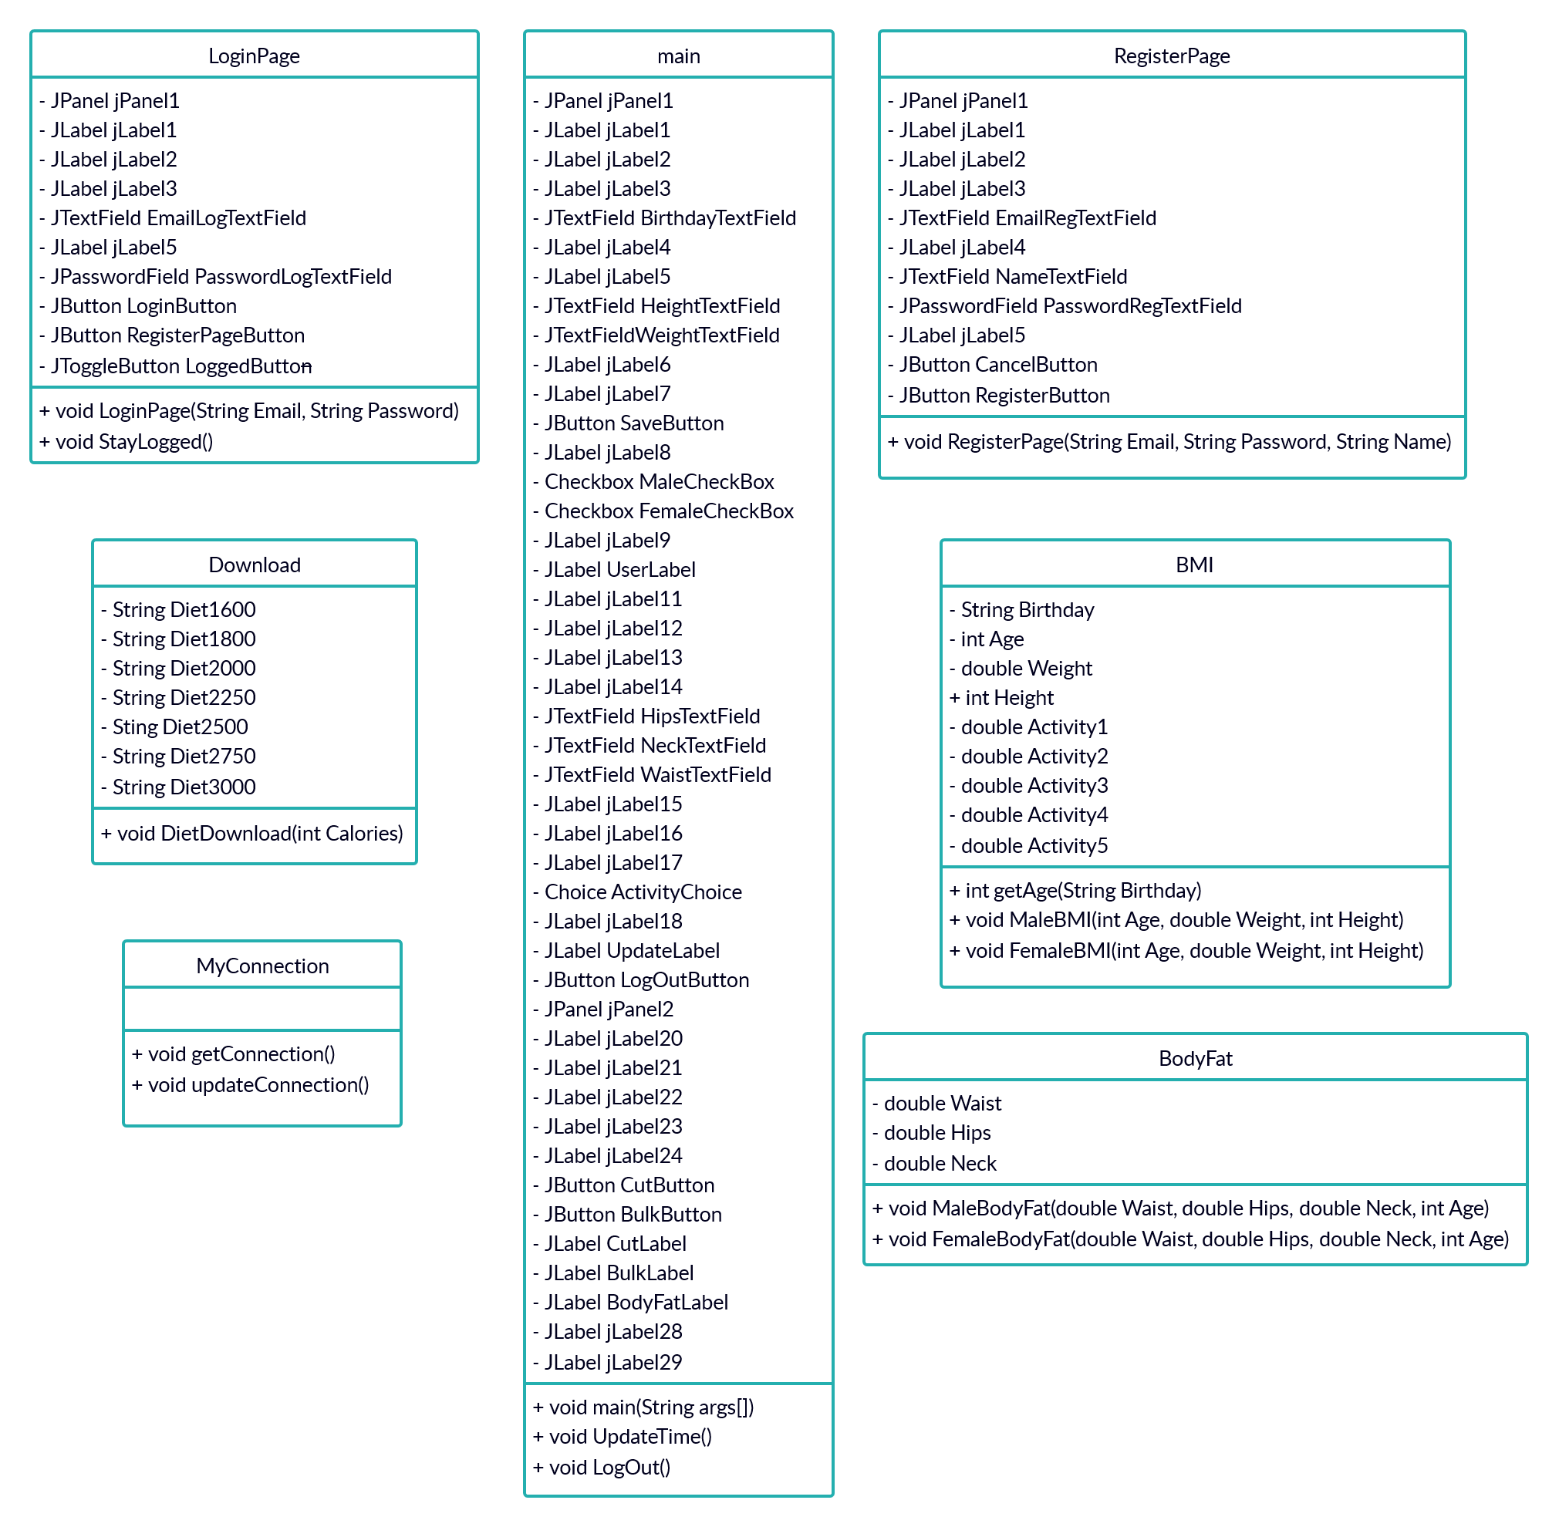

Figure 1 - UML diagram with classes the program uses.
Functionality of each class:
main – Workspace where all the variables of the program are inputted and outputted (communicates with the MySQL database). It has the gui and connects the other classes to each other.

LoginPage – Login system that connects to MySQL database.

RegisterPage – Register system that connects to MySQL database with the option to cancel, in order to get back to the login page.

MyConnection – It contains all the methods needed to connect and update from the MySQL database.

BMI – Calculates the Body Mass Index using the formula provided by my client (attached in the Appendix) and connects to BodyFat, in order to get more accurate results.

BodyFat – Calculates the body fat percentage using the formula provided by US Navy. It gets some attributes from BMI.

Download – Reads the calculated burned calories generated by BMI and suggests diets in that range, updating the download button to the corresponding link from the website.

*More classes may be added in the development, but the above ones are the most important.

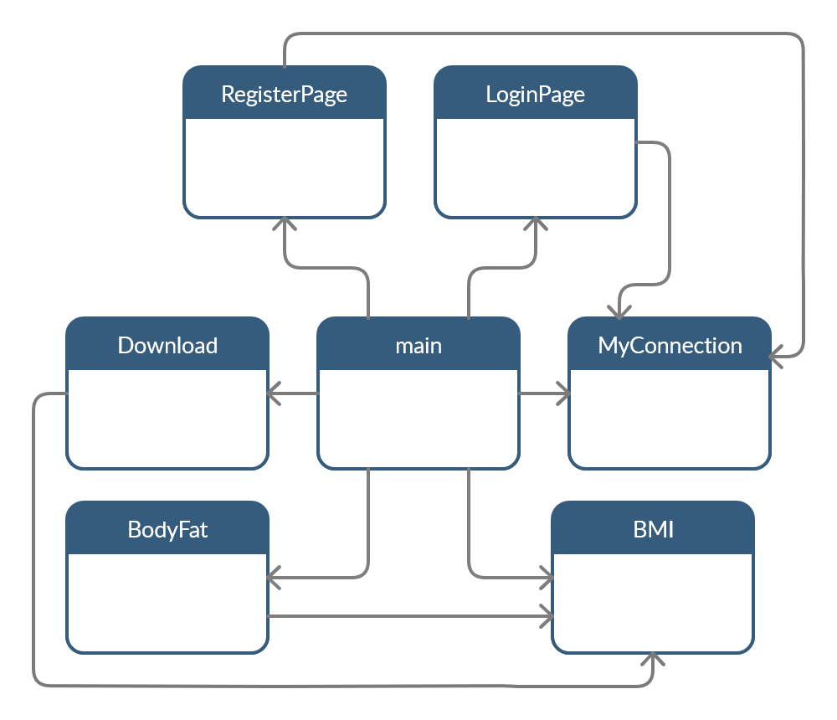
Figure 2 – Classes of the program and their links.
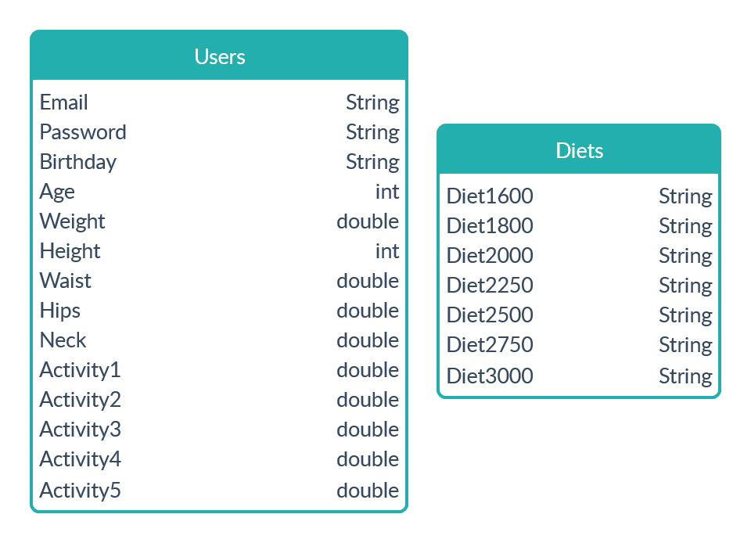
Figure 3 - Databases and files that program will require.

My key field for the MySQL database is Email.
Program will create a text file with the login credentials if the option “Stay Logged” is chosen, so the program can log in automatically. You can see the intended syntax below.

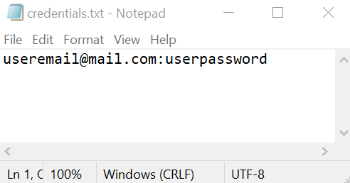
Figure 4 – Text file created by the program to store credentials encrypted.

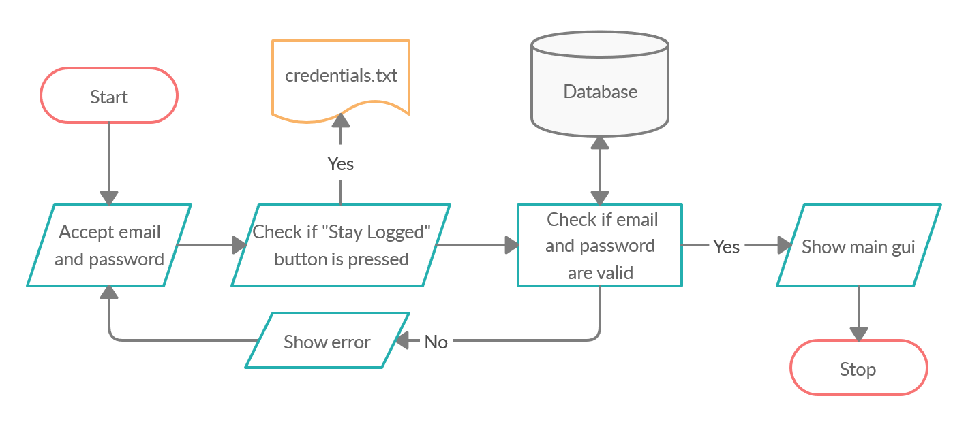
Figure 5 – Login system flowchart diagram.

User types email and password in EmailLogTextField and PasswordLogTextField, these strings are then put in LoginPage() method. If user wants the program to auto login by using StayLogged() method, presses the LoggedButton.

Login function

LoginSystem()
// function to login to MySQL database
PreparedStatement ps
ResultSet rs
String email = get text from text field
String pass = get text from text field
String query = "SELECT * FROM `users` WHERE `email` =? AND `pass` =?"

try
pass = EncyptPasswordWithSHA-256(pass)
ps = ConnectToMySQLdb.prepareStatement(query)

ps.setString(1, email)
ps.setString(2, pass)

rs = ps.executeQuery()

if rs.next()
try to write file “credentials.txt" in “utf-8” in the local directory
if LoggedButton is Selected = true //if stay logged box is pressed
Write file email + ":" + pass +":1"

else
Write file email + ":" + pass + ":0"
Open the main page
Close the login page

catch SQL Exception
Log the exception
else
show Message Dialog "Incorrect email or password."

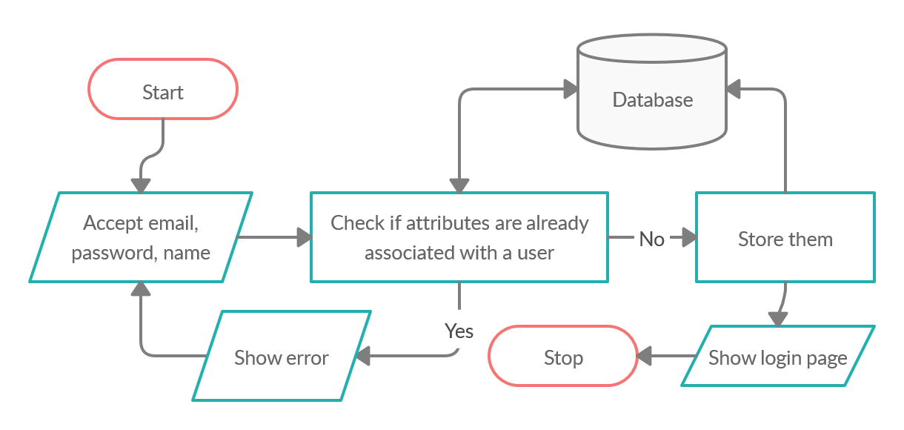
Figure 6 – Register system flowchart diagram.

User types email, password and name in EmailRegTextField, PasswordRegTextField, NameTextField, these strings are then put in RegisterPage.

Register function

RegisterSystem()
// Sign in the user to the MySQL database
String name = get text from text field
String email = get text from text field
String pass = get text from text field
String re_pass = get text from text field
String bdate = null

//error checking the string to have to appropriate data
if name = null
show Message Dialog "Add a name."

else if email = null or email contains "@" = false
show Message Dialog "Add a valid email."

else if pass.length() < 8 or pass = re_pass
show Message Dialog "Retype the password again.”

else if checkEmail(email) = true
show Message Dialog "This email already exist."

else if data = null or incorrect format
show Message Dialog "Input correct birthday format."

// check for the default MySQL data format
bdate = select data using a GUI
PreparedStatement ps
String query = "INSERT INTO `users` (`name`, `email`, `pass`, `birthday`)
VALUES (?,?,?,?)"

try
pass = EncyptPasswordWithSHA-256(pass)
ps = ConnectToMySQLdb.prepareStatement(query)

ps.setString(1, name)
ps.setString(2, email)
ps.setString(3, pass)

If changes were successfully made on database
show Message Dialog "New user added.”

catch SQL Exception
Log the exception

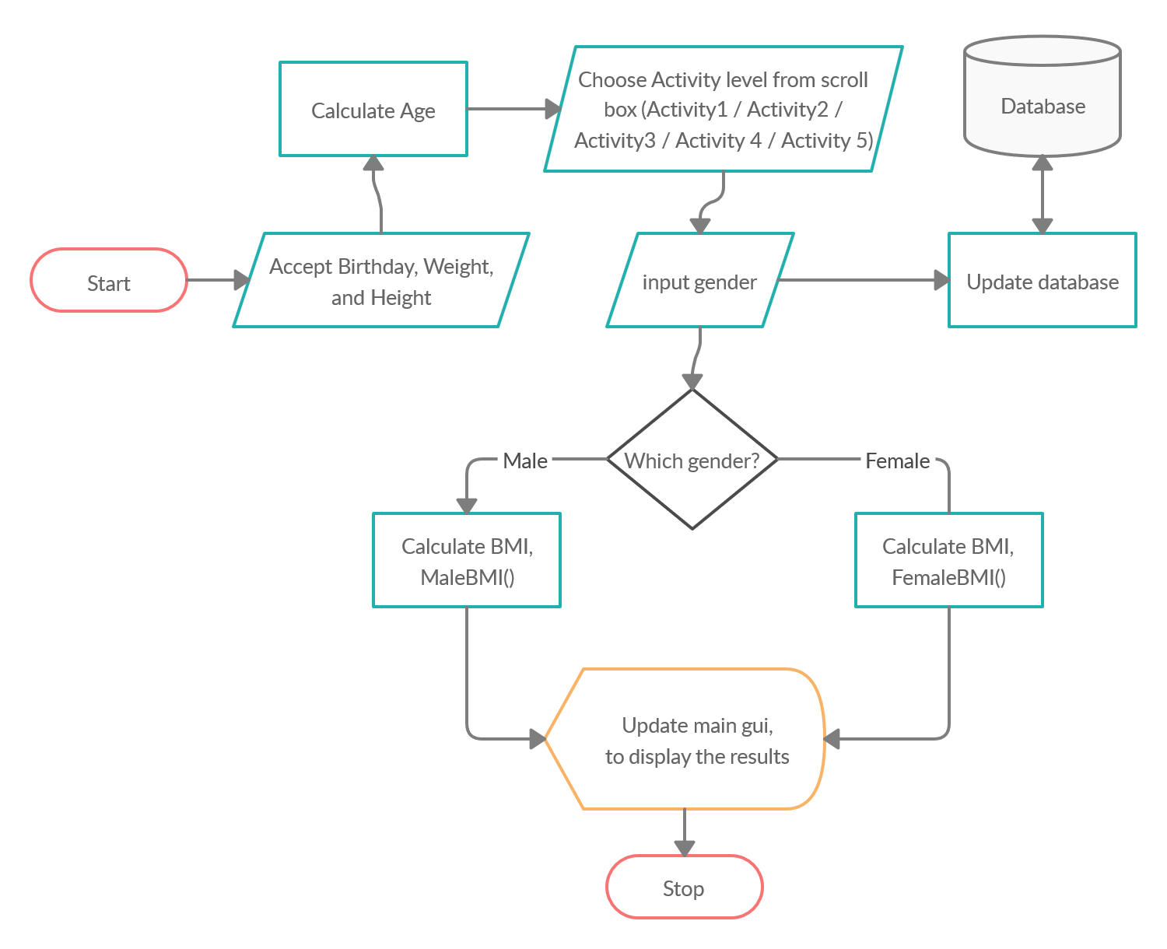
Figure 7 – BMI calculator flowchart.

User types Birthday date, weight and height. It calculates user’s age then ask user to choose his activity level (1 – low to 5 – high). User ticks the box with the gender, this then updated to the MySQL database, then calculates the Body Mass Index, displaying the results (cut and bulk calories).

BMI calculator function

public int MaleBMI (int Age, int Weight, int Height, double Activity)
double calories = (66 + (13.7*Weight) + (5*Height) - (6.8*Age))*Activity
return int Calories

public int FemaleBMI (int Age, int Weight, int Height, double Activity)
double calories = (655 + (9.6*Weight) + (1.8*Height) - (4.7*Age))*Activity
return int Calories
// Save details to MySQL database
// get details from TextFields and save to local variables
open the file
try
scan read it
delimit variables by ":"
while read.hasNext() //into below variable
email = read.next()
pass = read.next()
String Logged = read.next()

catch SQL Exception
Log the exception

// switch case to associate strings with numbers
// for the db

if null != activity switch activity
case …
activity = 1.2/1.37/1.55/1.725/1.9

if Male = gender
gender = 0
else if Female = gender
gender = 1

PreparedStatement ps
String query = "UPDATE users SET weight='"+ weight +"' , height='"
+ height +"' , waist='"+ waist +"' , hips='"+ hips +"' , neck='"
+ neck +"' , gender='"+ gender +"' , activity='" + activity
+ "' WHERE email='" + email +"' AND pass='" + pass + "'"
try
ps = ConnectToMySQLdb.prepareStatement(query)
ps.executeUpdate()
show Message Dialog "Details updated."

catch SQL Exception
Log the exception

show Message Dialog "Please check your input."
// error checking if the inputs are not accordingly
// for example: inputing string into int

Update() //refresh GUI

Update() // Live update the details from MySQL database
open the file
try
scan read it
delimit variables by ":"
while read.hasNext()
email = read.next()
pass = read.next()
String Logged = read.next()

catch SQL Exception
Log the exception

String query = "SELECT height,waist,hips,neck,weight,activity,gender,name FROM "
+ "users WHERE email ='" + email + "' AND pass ='" + pass + "'"

try
ps = ConnectToMySQLdb.prepareStatement(query)
if ps.execute()
rs = ps.getResultSet()
else
output "Failed."

while rs.next() //loops while db sends data
Save the data fetch into variables (name, height, waist, hips, neck, weight)

Set text on GUI (name, height, waist, hips, neck, weight) //below updates the GUI

if activity=1.2 //associate numbers with choices
Set combo list choice on GUI
if gender=0
Set combo list choice on GUI
else if (gender=1
Set combo list choice on GUI

catch SQL Exception
Log the exception

int age = getAge(email)

if gender=0
calories = cals.MaleBMI (age, weight, height, activity)
bodyfat = fats.MaleBodyFat (waist, hips, neck, age, height)
else if gender=1
calories = cals.FemaleBMI (age, weight, height, activity)
bodyfat = fats.FemaleBodyFat (waist, hips, neck, age, height)

Set text on GUI (bodyfat)
CutCalories=CutCalories-300
int BulkCalories=CutCalories+600
Set text on GUI (CutCalories)
Set text on GUI (BulkCalories)

getAge (String email) // Calculate the user's age from his birthday
PreparedStatement ps
ResultSet rs = null
int age = 0

try
String query = "SELECT DATE_FORMAT (FROM_DAYS (DATEDIFF (CURDATE (),birthday)), + "'%Y')+0 AS age FROM users WHERE email='"+ email +"'"
// change date to days and then make the difference
// ending with converting it to years

ps = ConnectToMySQLdb.prepareStatement(query)
if ps.execute()
rs=ps.getResultSet()
else
output "Failed."

while rs.next()
age=rs.getInt(1)

catch SQL Exception
Log the exception

return age

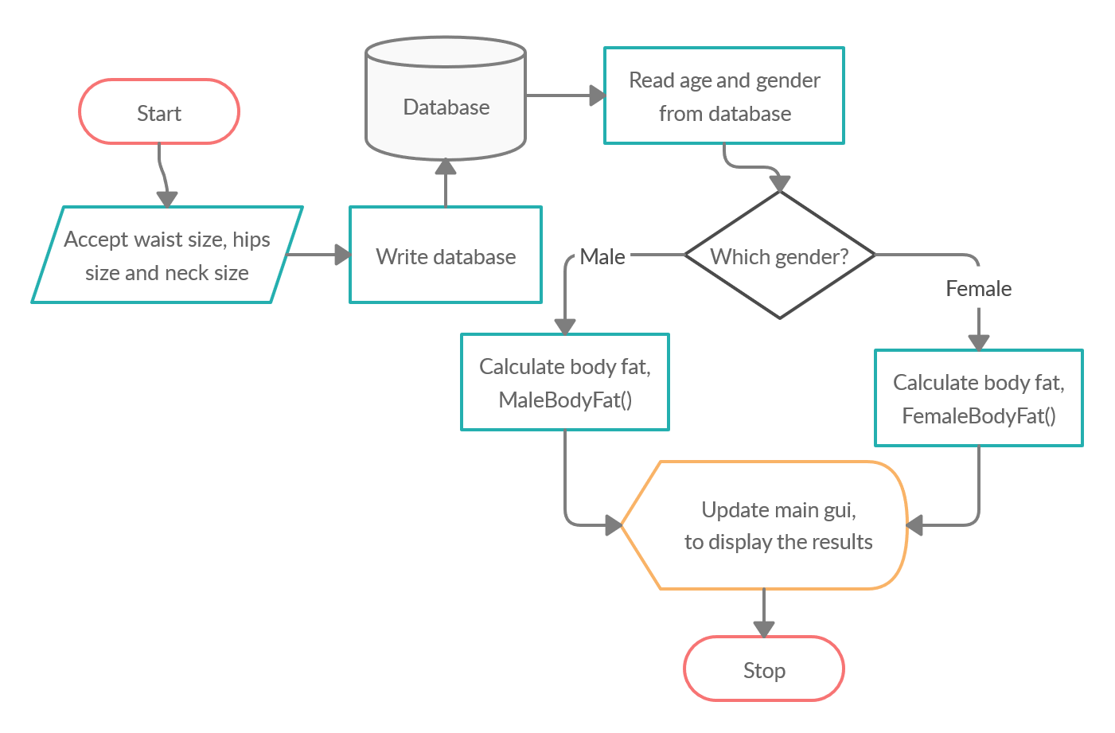
Figure 8 – Body fat percentage calculator flowchart.

User types waist size, hips size and neck size, It writes user’s information to the database and then reads user’s age and gender. It calculates the body fat and displays the results.

Body fat percentage calculator function

int MaleBodyFat (int Waist, int Hips, int Neck, int Age, int Height)
double bodyfat = (495/(1.0324-0.19077*( log (Waist-Neck)) + 0.15456 * (log (Height))))-450 //calculate body fat percentage for male
return BodyFat

int FemaleBodyFat (int Waist, int Hips, int Neck, int Age, int Height)
double bodyfat = (495/(1.29579-0.35004*(log(Waist+Hips-Neck)) + 0.22100 * (log (Height))))-450 //calculate body fat percentage for female
int BodyFat=(int)bodyfat; //convert double to int
return BodyFat

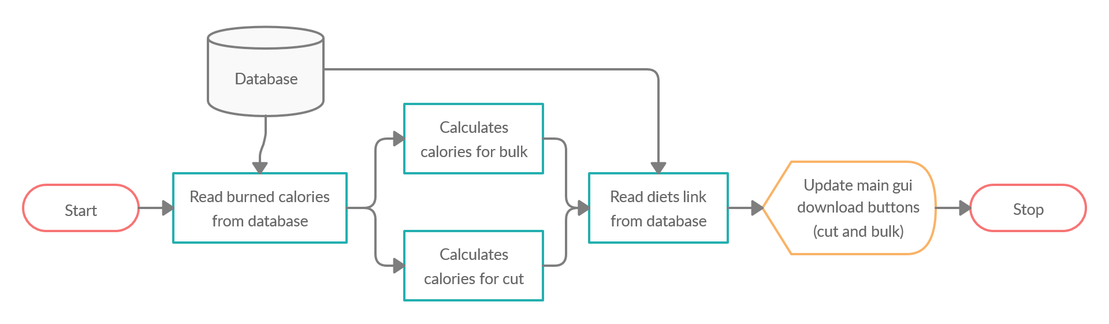

Figure 9 – Downloading diets function flowchart.

Downloading diets function

DietDownloadCut (int x) //function to open the url
try //according to the inputed calories, Cut version.
If x < 1800 //range of calories
x = 1
else if x > 1800 | x < 2000
x = 2
else if x > 2000 | x < 2250
x = 3
else if x > 2250 | x < 2500
x = 4
else if x > 2500 | x < 2750
x = 5
else if x > 2750
x = 6

PreparedStatement ps
ResultSet rs = null

String query = "SELECT link FROM diets WHERE id = '" + s + "'"
ps = ConnectToMySQLdb.prepareStatement(query)

if ps.execute()
rs=ps.getResultSet() //send the query to db

while rs.next()
CutLink = rs.getString(1) //receive from db once

OpenLink(CutLink) //pop the link in browser
catch SQL Exception
Log the exception

DietDownloadBulk (int x) //function to open the url
try //according to the inputed calories, Bulk version.
if x < 1800 //range of calories
x = 1
else if x > 1800 | x < 2000
x = 2
else if x > 2000 | x < 2250
x = 3
else if x > 2250 | x < 2500
x = 4
else if x > 2500 | x < 2750
x = 5
else if x > 2750
x = 6

PreparedStatement ps;
ResultSet rs = null;

x = x+1;
String query = "SELECT link FROM diets WHERE id = '" + s + "'"

ps = ConnectToMySQLdb.prepareStatement(query)

if(ps.execute()
rs=ps.getResultSet() //send the query to db

while rs.next()
BulkLink = rs.getString(1) //receive from db once

OpenLink(BulkLink) //pop the link in browser

catch SQL Exception
Log the exception

Check Logged function

checkLogged()
File f = new File("credentials.txt") //read file where login credentials are stored
try
Scanner read = new Scanner(f)
read.useDelimiter(":") //separates the email, pass and Logged status into different variables
loop while read.hasNext())
email = read.next()
pass = read.next()
Logged = read.next()

catch FileNotFoundException
Log error

If Logged = 1
try
String query = "SELECT * FROM `users` WHERE `email` =? AND `pass` =?"
ps = Connect to MySQL database and send query
ps.setString(1, email)
ps.setString(2, pass)
rs = ps.executeQuery()

if rs.next()
Open the main page
Close the login page

catch SQLException
Log error

Design of Graphical User Interface:
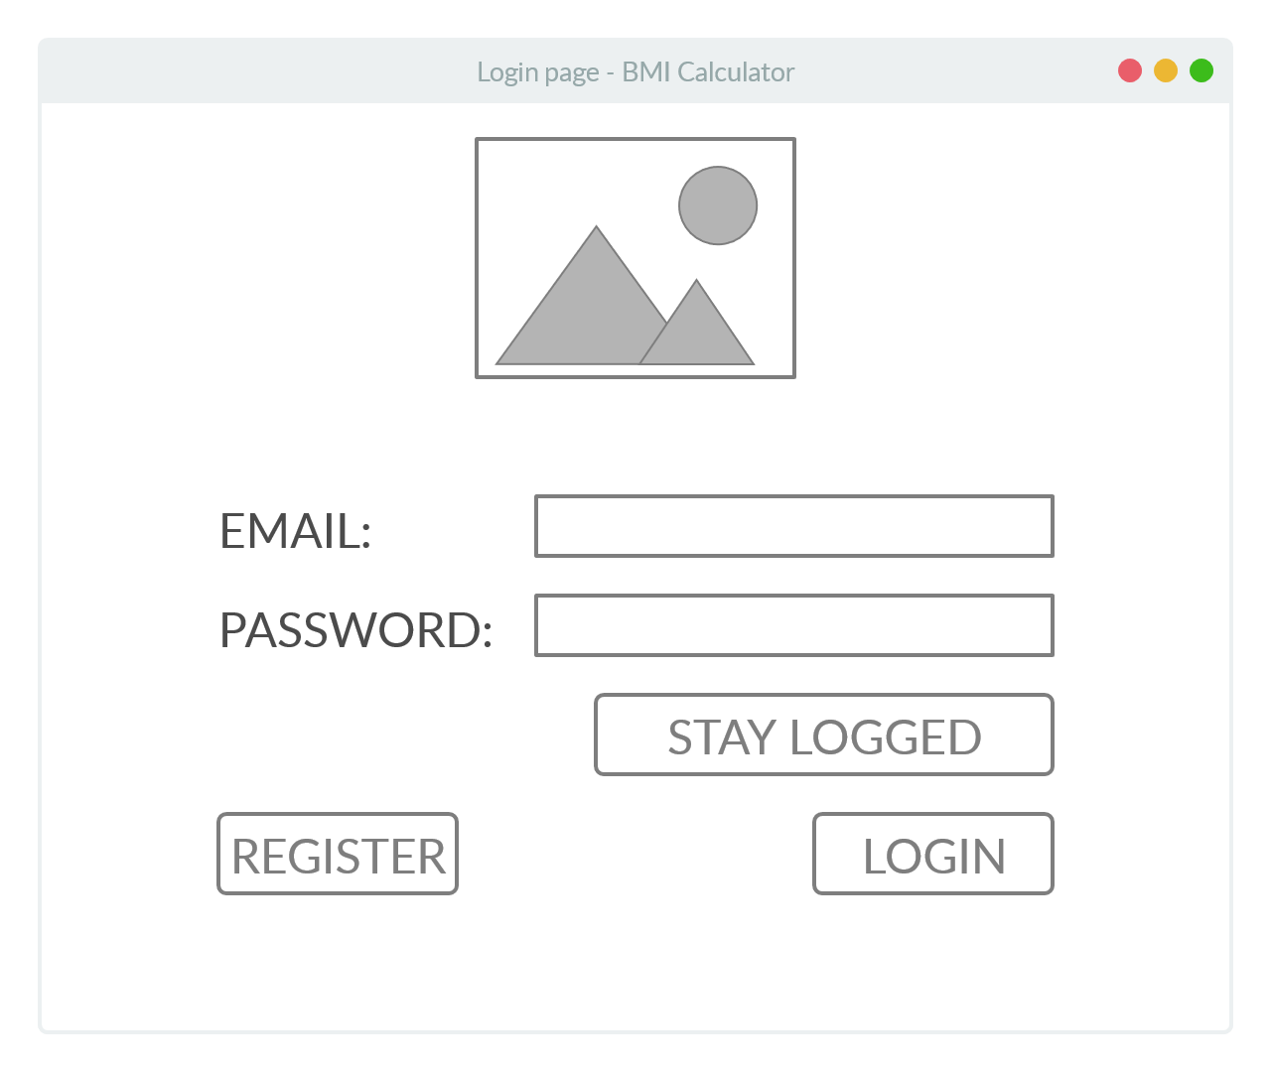
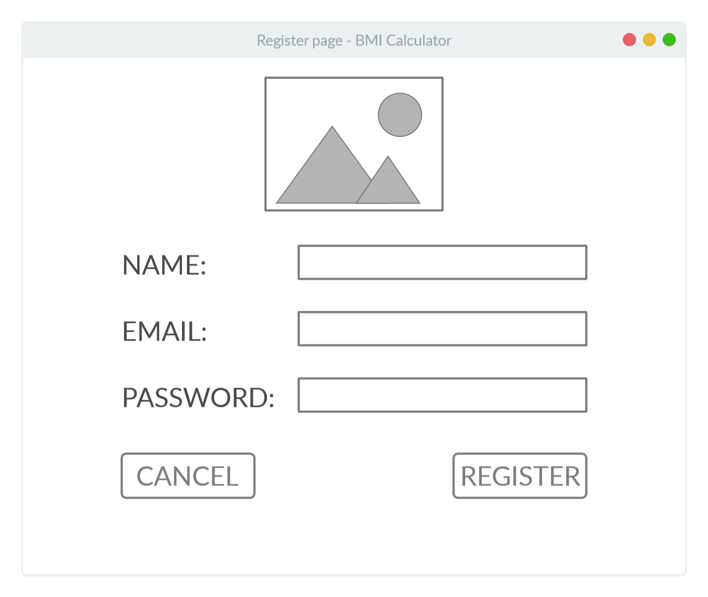
Figure 10 – Login page

Figure 11 – Register Page
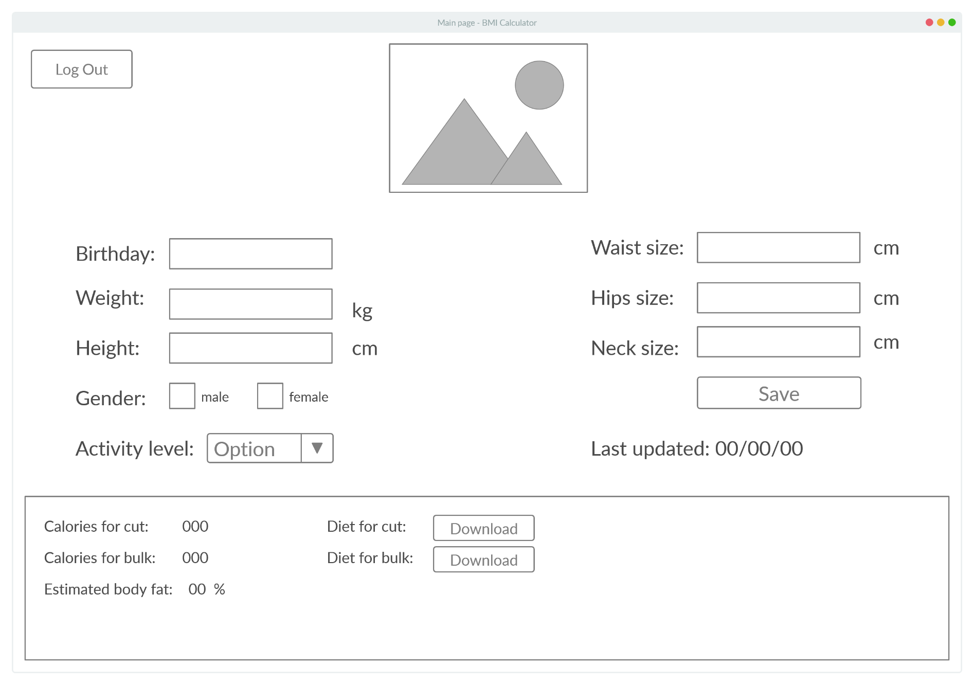

Figure 12 – Main page

I have asked Mrs. I. Sochirca if the GUI is friendly enough and she had the suggestion of having all the functions in one window (the main one) instead of different pages. I thought the idea was great, so I implemented it and sent her the final sketch (Figure 8). She approved it. You can see the emails between us in the appendix.
Test plan:

ACTION TO BE TESTED | TEST METHOD
User is able to register and login, with error checking for both. | Input the details to the register and login page.
Remain logged function works. | Reopen the program after log in choosing the “stay logged”.
Program is able to add and edit user information (name, email, birthday, height, weight, activity level, waist size, hips size and neck size) to the MySQL databases. | Input these details into the program, checking with the database if all the information is written correct. Error checking if the email and password are valid (or meet the minimum requirements).
Using MySQL as the database, program might be vulnerable to SQL injections. | Program will be tested with several SQL injection payloads, which will be then patched.
Check that the BMI and Body fat percentage calculator work as expected. | Compare them with manually using the formulas.
The algorithm updates the download buttons (for cut and bulk diets) with the correct link. | Input different BMI details in order to get all the calories range (1600 – 3000) and check that the download buttons update to the correct links.
All the graphical interfaces are showing the correct output (without any visual glitches). | Run the program multiple times to test individual features linked to graphical elements with various inputs and check if they are performing the desired functions.
The details remain in the text fields, to give the user the possibility to track his measurements. | Run the program multiple times with internet connection drops to see if the details still update.
MySQL database which is hosted on a web server can be accessed by Mrs. I. Sochirca. | Test the website locally and then send the link to Mrs. I. Sochirca for further testing.

