Criterion C: Development

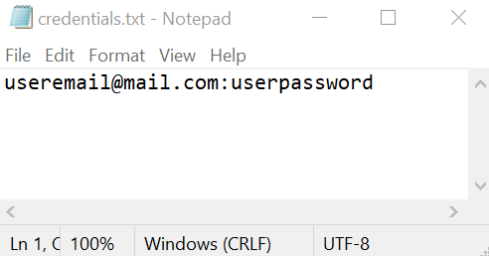
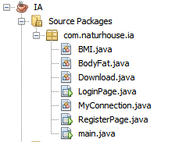
Figure 1 - All classes. Figure 2 - Random Access Files.

Functionality of each class and techniques used:
- LoginPage, RegisterPage and main use the inbuilt NetBeans GUI tool and contain the specific functions like Login, Register, CheckLogged or Update, which have files handling, loops, SQL queries, prepared statements, scanners, switch cases etc.
- BMI – contains all the formulas used to calculate the Body Mass Index.
- BodyFat – contains all the formulas used to calculate the Body Fat of the user.
- Download – contains algorithms to suggest the diet for cut or bulk from the database.
- MyConnection – contains the function to connect to the MySQL database and the password hashing SHA-256 function.

Program file:

Figure 3 – Program file.

The program was tested on Windows 10, Kali Linux and macOS Catalina. The program performed in all of the operating systems as expected. The MySQL database was hosted on a webserver running cPanel.

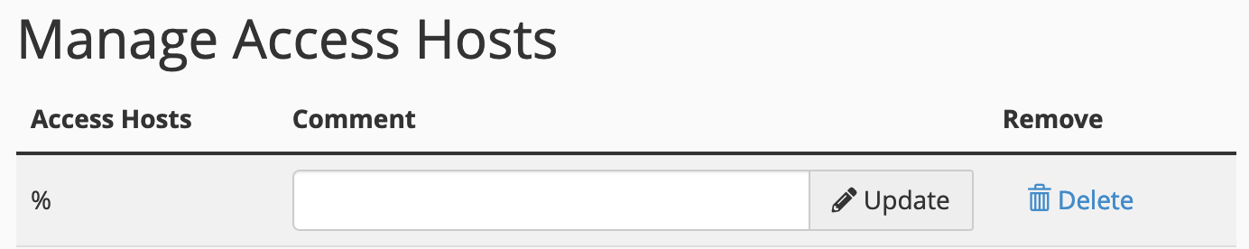

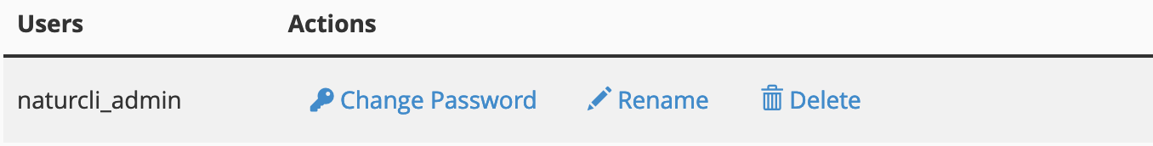

Figure 4 - Connection to the server side.

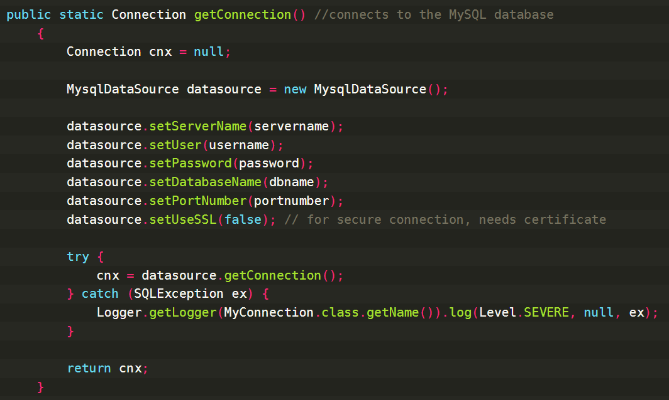

Figure 5 - Function to connect to the MySQL database.

I created a MySQLDataSource with the details used for login to the cPanel server phpMyAdmin (servername, username, password, dbname, portnumber), so I don’t have to write this on every function where I connect to the database, I will just use getConnection().

All the SQL Exceptions are logged for easier debugging. The function has the ability to use an SSL certificate for encrypted communication between the client and server (datasource.setUseSSL(false)).

The technique implemented for the communication should make the program theoretically immune to the SQL injection as everything is saved as a string and then sent rather than having one query in the end, where it can be closed using an apostrophe.

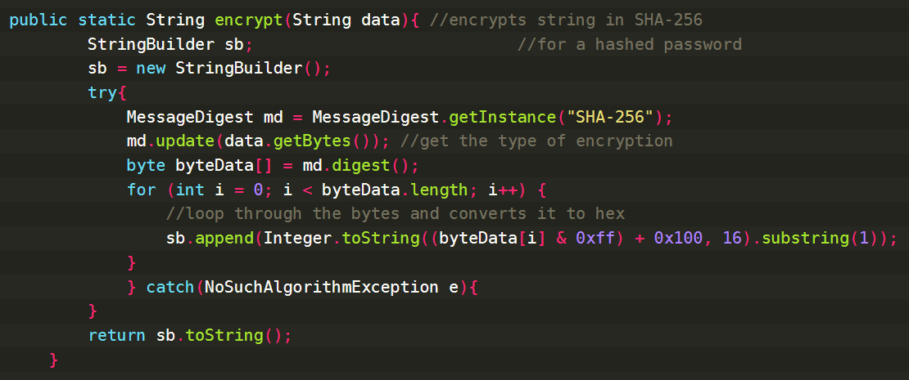
Figure 6 - Hashing password function.

I am hashing password for security reasons. If the packets are interfered using a program like WireShark, then the attacker cannot understand the password.
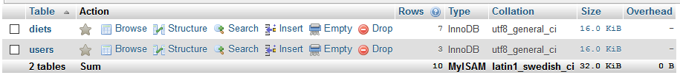

Figure 7 - MySQL database structure.

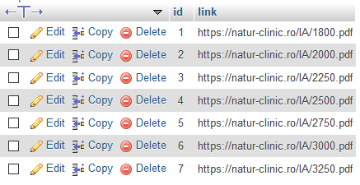
Figure 8 - Diets table.

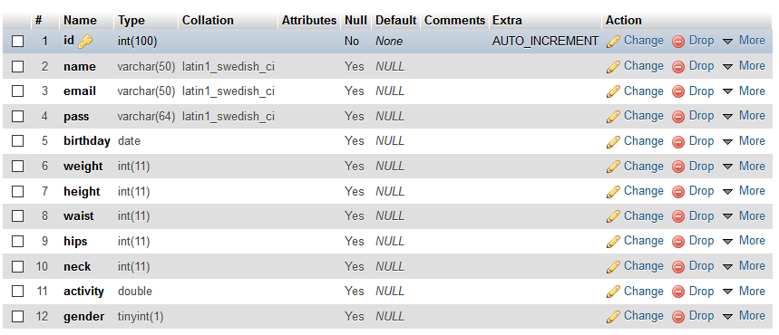

Figure 9 – Users table.

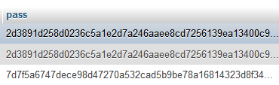
Figure 10 - Passwords are encrypted in SHA-256.
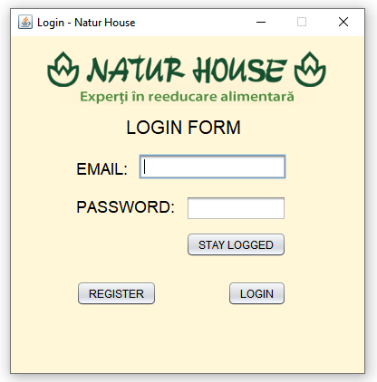
Figure 11 – Login page window.

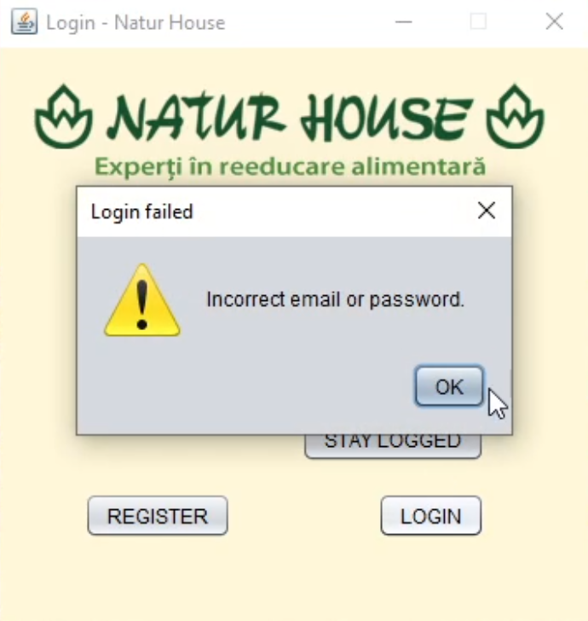

Figure 12 – Login Page window checking.

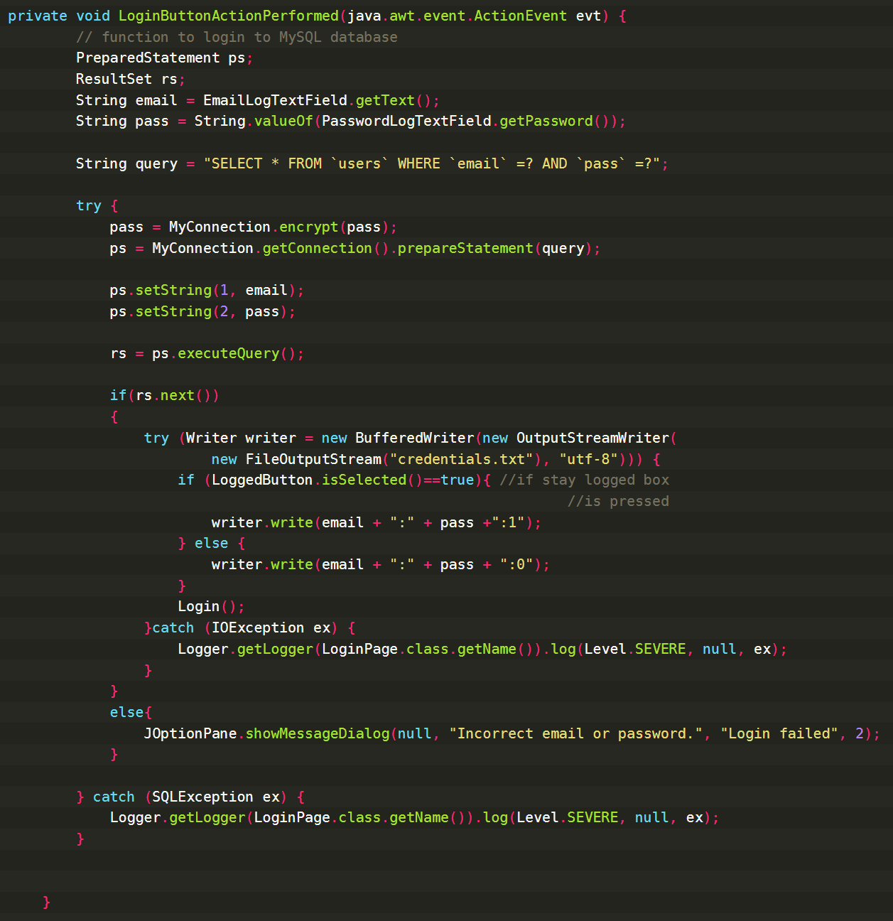

Figure 13 - Login button function.

After clicking the “LOGIN” button, the LoginButtonActionPerformed is performed. This starts by collecting the inputted information from the TextFields Email and Password into string, which are then added to the SQL query, which is send to the MySQL database for a response, if it comes back, then it is true. If the “STAY LOGGED” button is selected, then the credentials.txt file saves the email, password and 1, which shows that user wishes to save his credentials for the next time automatically login.
If it is not selected, then the saved 0 shows to the closing app button to remove all the saved credentials (although the information is secured anyway because of the hashed password). It uses Scanner for reading the file, saving the variable using the delimiter “;”.

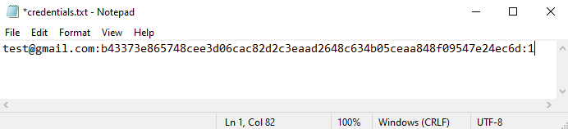
Figure 14 – Credentials saved in a text file.

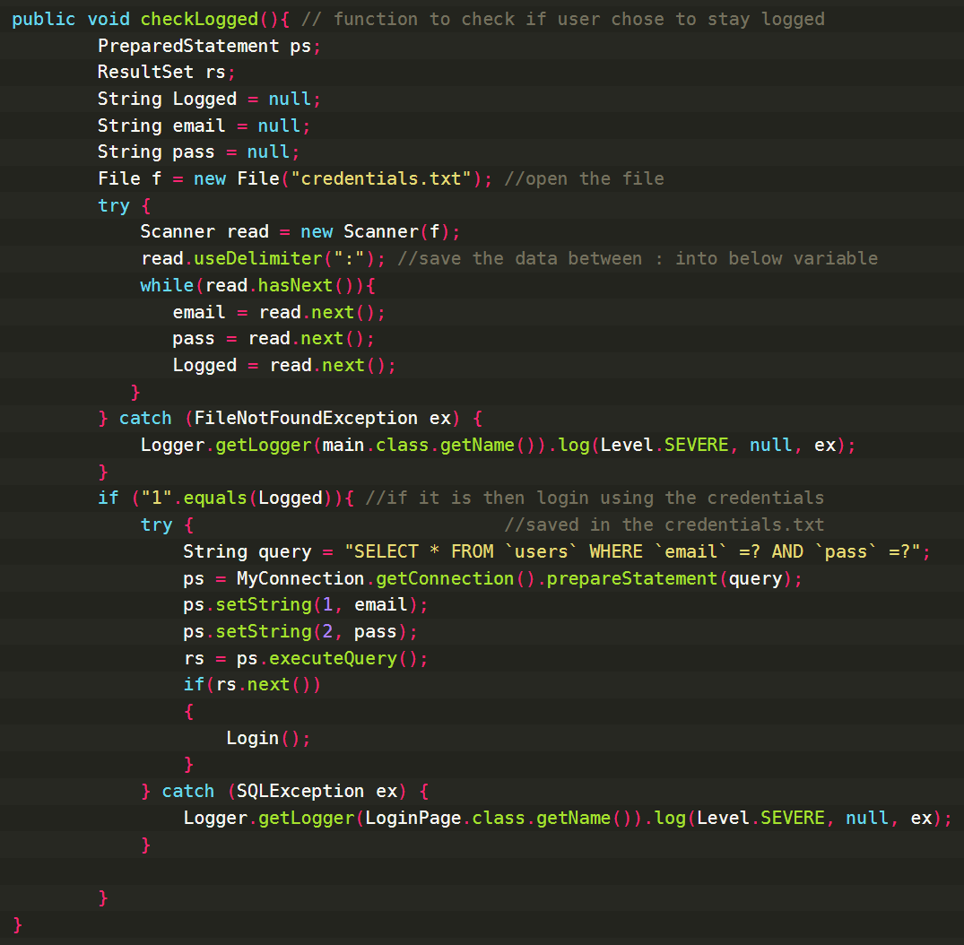
Figure 15 - Check if the user chose “STAY LOGGED” function.
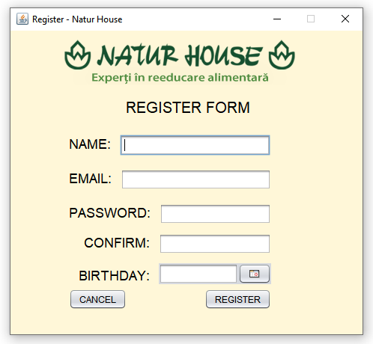

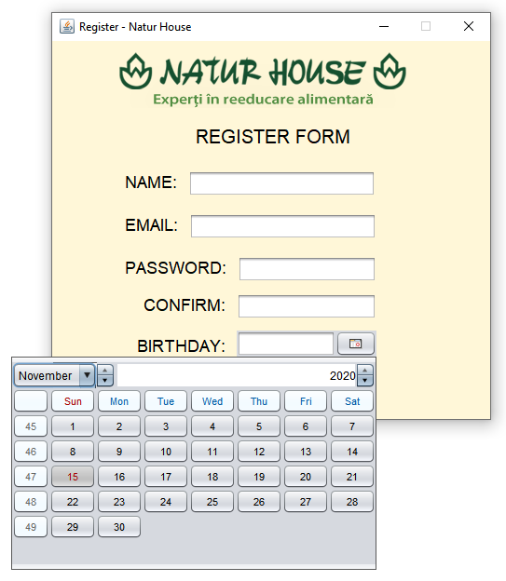
Figure 16 – Register form page.

Figure 17 – Birthday chooser.
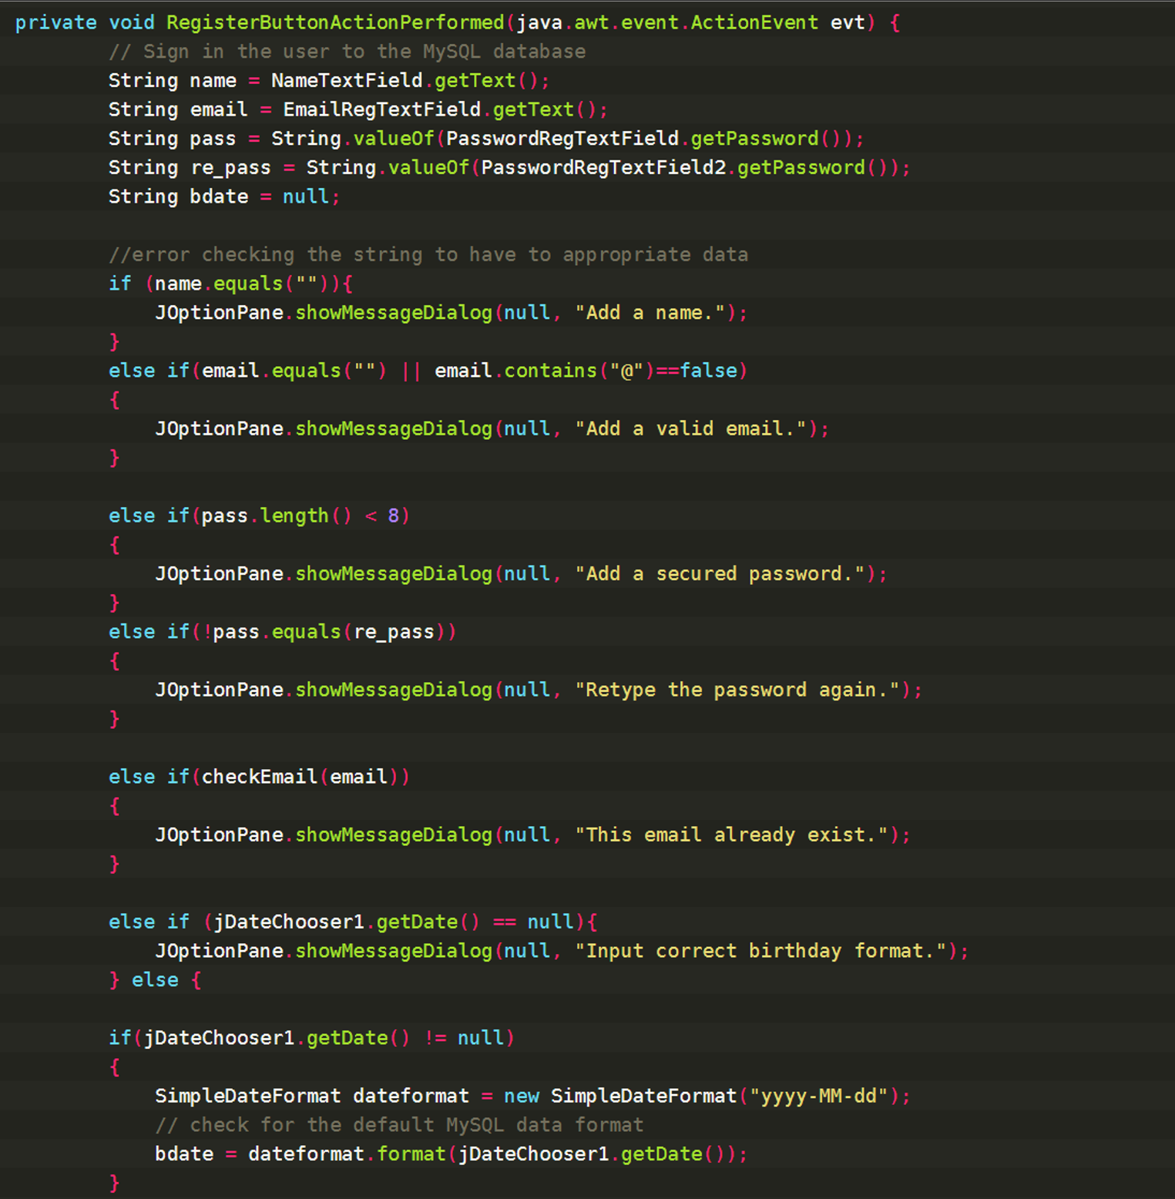
Figure 18 - Register button function.

It saves as strings the data inputted from TextFields. Then checks that all the TextFields contain the appropriate information:
- For name to be inputted.
- For email checks that the string contains “@” and it is not associated with another account using the checkEmail function represented below.
- For password to be at least 8 characters, and that the password and its confirmation are equal.
- Birthday is saved in the correct format (if the user wishes to type it instead of using jDataChooser to graphically select it).

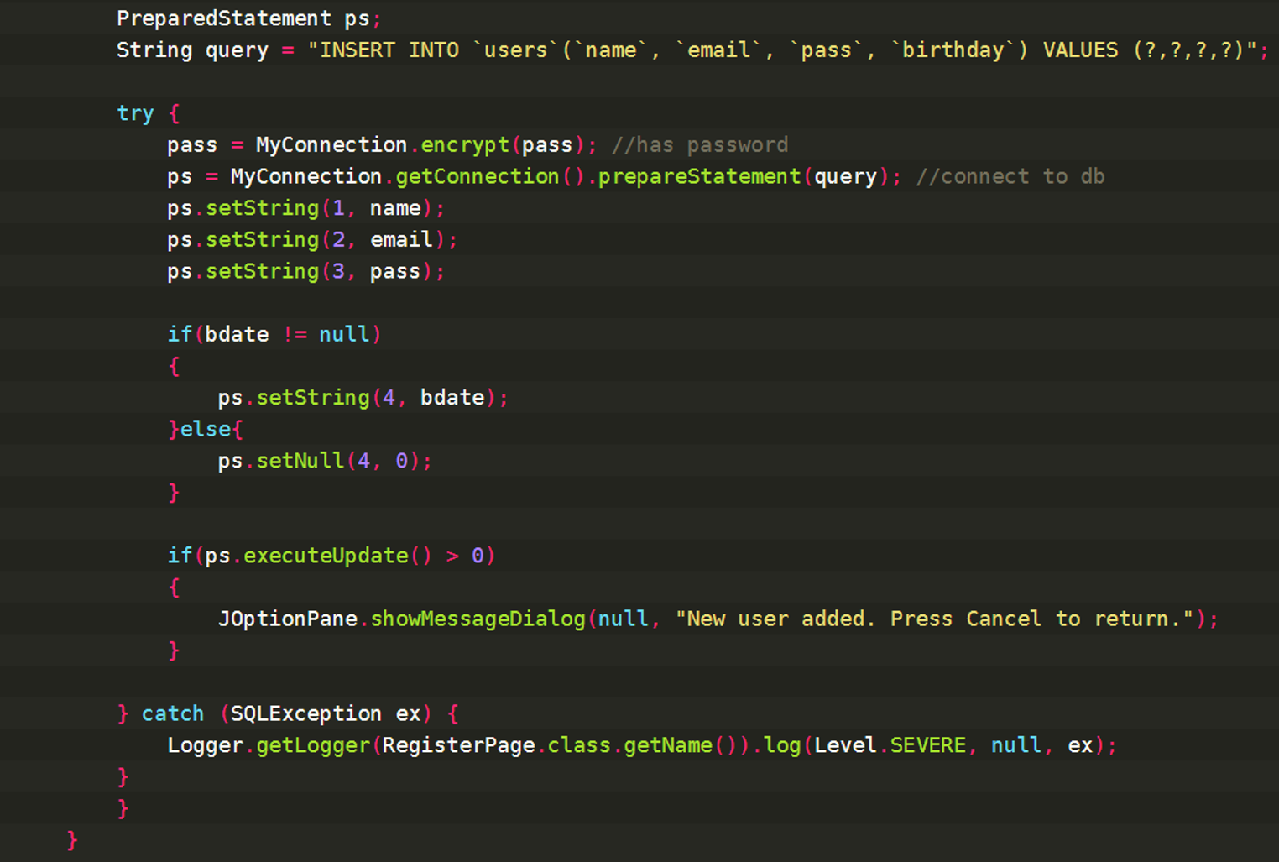
Figure 19 - Register button function (continued)

This connects to the MySQL database server, sending the variables: name, email, pass, birthday.
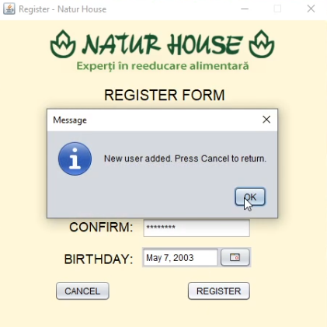
Password is encrypted beforehand using the encrypt() function. The program always encrypts when there a password input, so there is only one way to keep it secured.
The variables stored in local variables are sent using the Prepared Statement, so there is no need to send a separately string query for each variable or create a very long one. I consider this method more elegant.

If everything was successfully executed, it shows the message dialog “New user added”.
At the end there is a catch for SQL Exception in case there is a problem. The user can later send the logs with the errors for support.

Figure 20 – New user added alert.

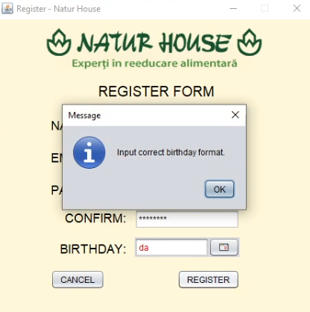
All of these return alerts if they are not correct:
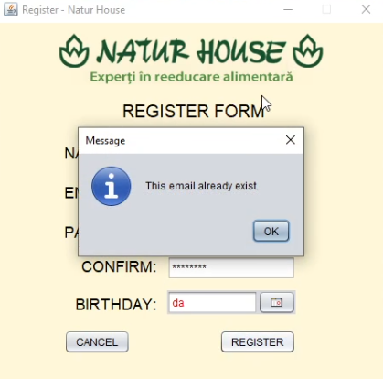

Figure 21 – Error checking alerts.

The logs text with catches of exceptions can be found in the same location as the Jar (app executable).

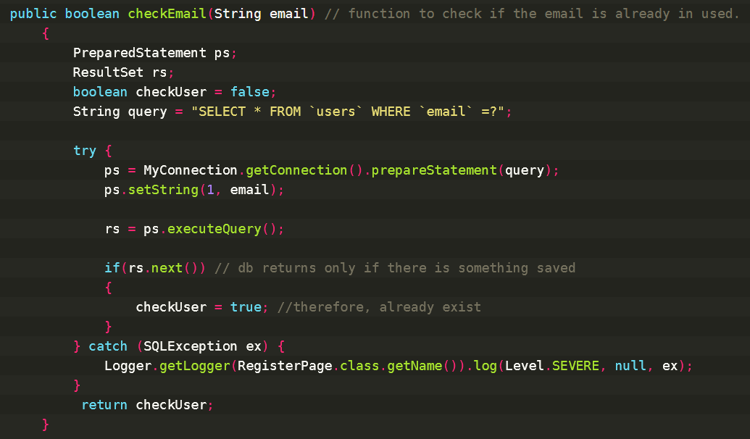
Figure 22 - Check if email is already in used function.

It checks it by looking for the email in the database, and if something comes up, then it returns true, otherwise does not enter the if and returns the pre-set checkUser = false.

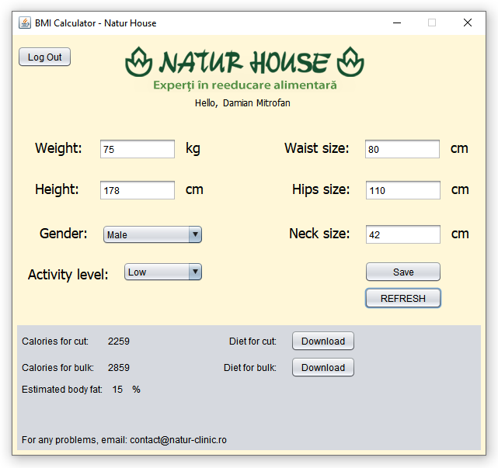

Figure 23 – Main window.

All the text, combo boxes and buttons are updated with the data from database using the below Update function. Every combo box is associated with a value that is used in BMI and BodyFat classes. The return is then output in the grey jPanelBox with calories and estimated bodyfat (the functions for these are explained at the end of this document). The “Download” buttons link to a function which opens the accordingly diet from the database. The administrator has the ability to add, change, edit or delete more diets from the MySQL database. As everything is updated live to the users, there is no delay or cache saved which might indicate previous data that is not relevant anymore. It also has error checking for all variables, so either there is a wrong input such as a String instead of an integer or detects inputs like 1kg body mass that does not make sense and the formula does not work properly.
Update function:
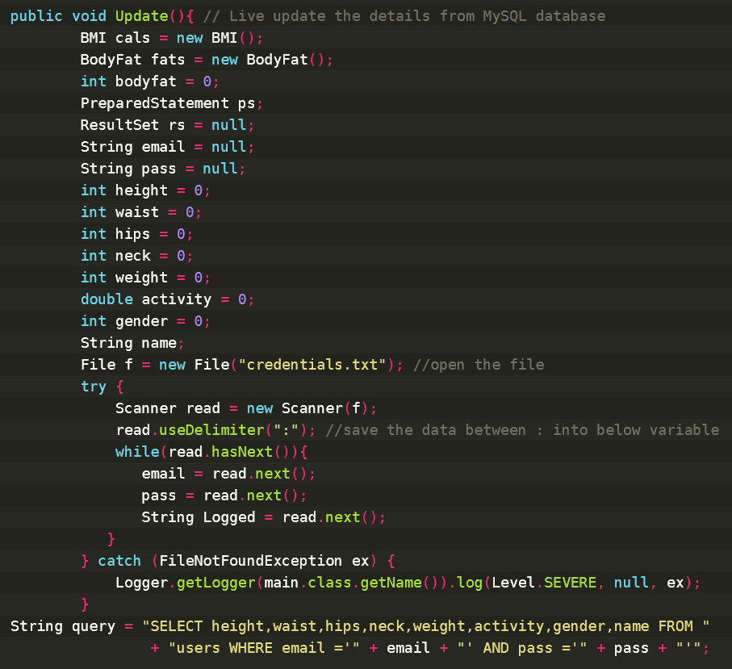

This reads the made file “credentials.txt” and continues to fetch from the database all the required data for the formulas, but only if the saved email and password combination is correct. I decided to this instead of cookies because besides that is more secure as none can just change the memory pattern to access the database, it also gives the flexibility to the user to move his account around from one computer to another.
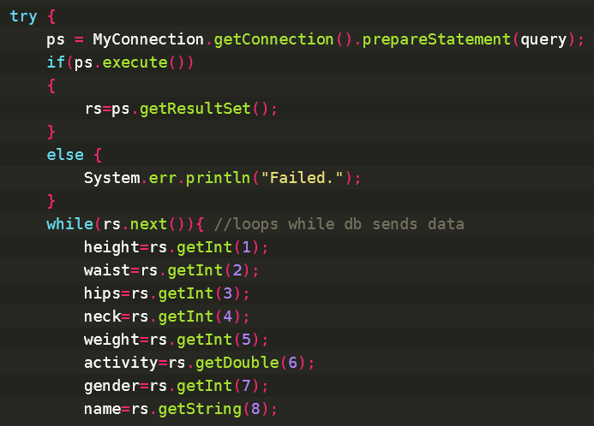

Connects to the database using the previous stated query, then it saves everything received into local variables, using the ResultSet Get method from MySQL-Connector-Java-5.1.49 library.

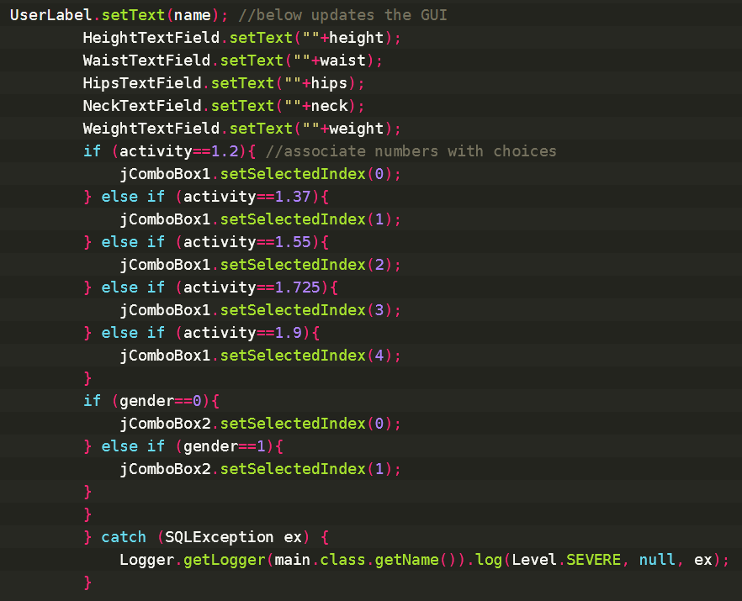

Updates the GUI accordingly with the variable values from the database, for an easy way for the user to track the progress. It either update by using the “REFRESH” button or when the user logs in / changes any variable save, because otherwise the program might be too heavy on the CPU’s tasks priority.

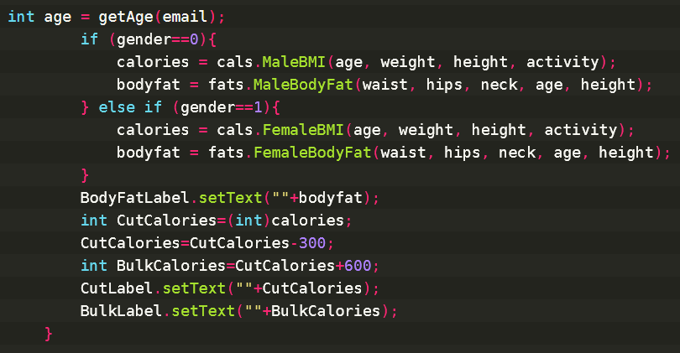
Function to get the age:
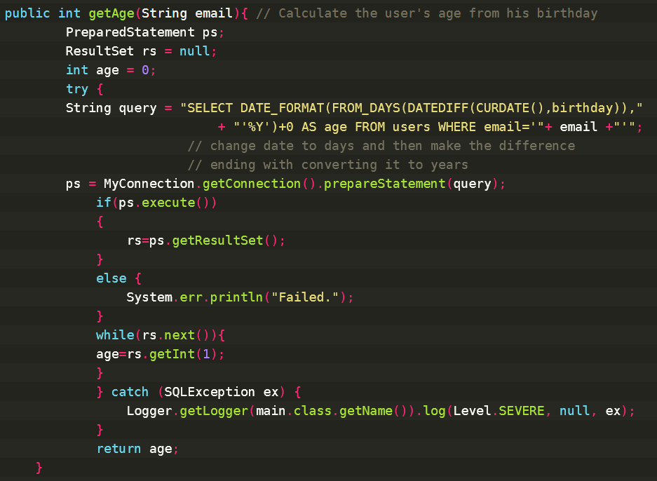

It uses SQL to get the date from database and then coverts it to days, for the difference from today’s date also in days. Days are next converted in years, saved as integer to ignore the decimals as they are irrelevant for the formulas we are using.

Save button function:
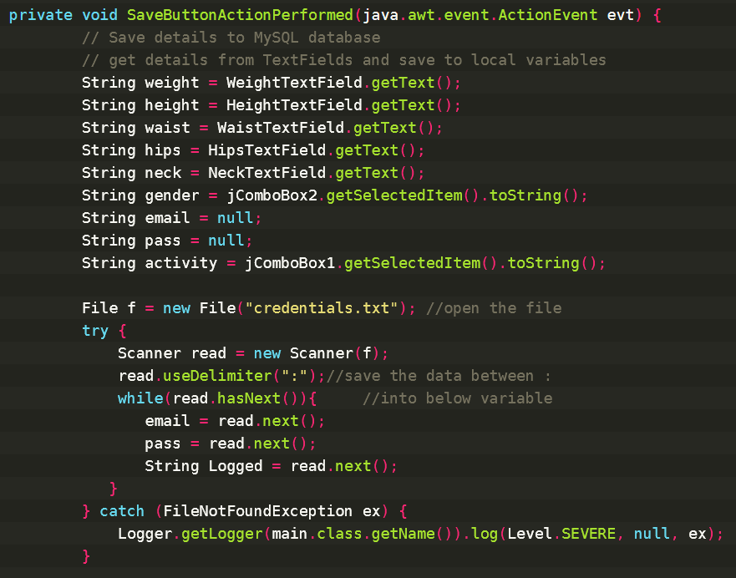
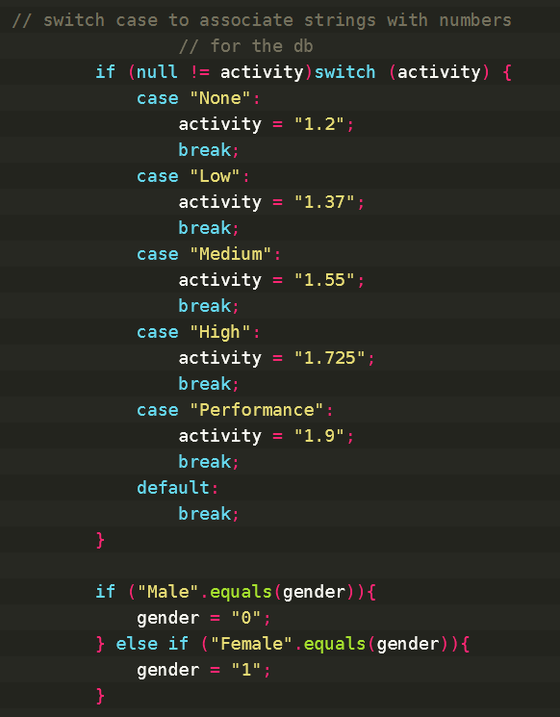

Associate numbers with the keys from combo box, for the storage in database and later use for formulas.

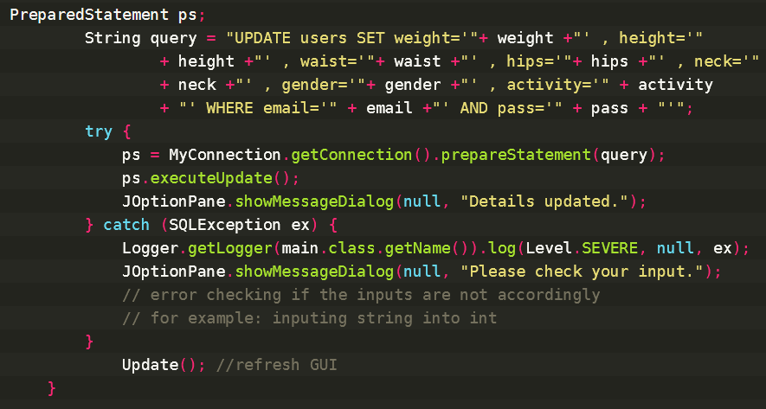

Update the new data to the database, with error checking if the input is wrong. As the MySQL database is expecting to receive an integer, if the user inputs accidently a string, then it will throw an SQL exception, not updating the database and letting the user know that the input is wrong with a dialog alert.
Functions for calculating the calories for male and female:
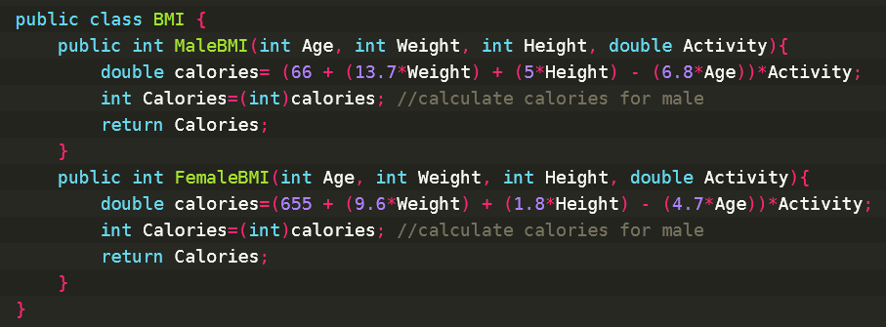

The calories are calculated in double first, as the formula requires, but it is later converted it to integer as .x calories are not relevant.

Function to fetch the correct diet from calories inputted:
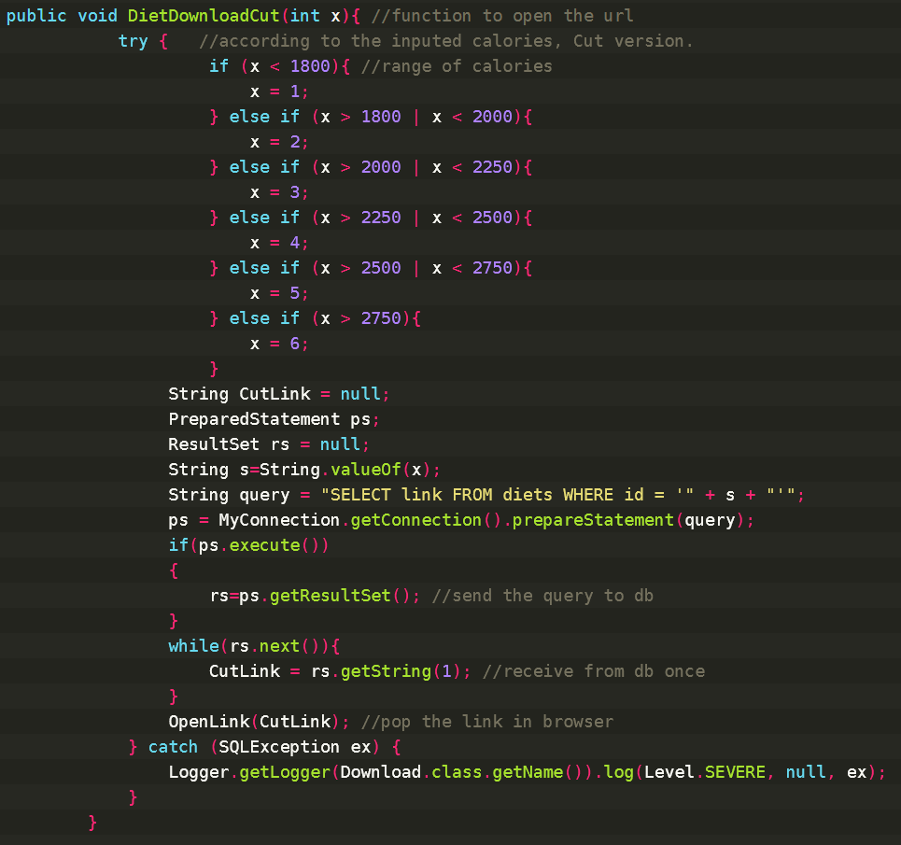
The inputted calories are compared to pre-set calories ranges, then is associated with an ID, that has a website link. The link is then saved, and it uses the OpenLink function to open it to the OS’s default browser.
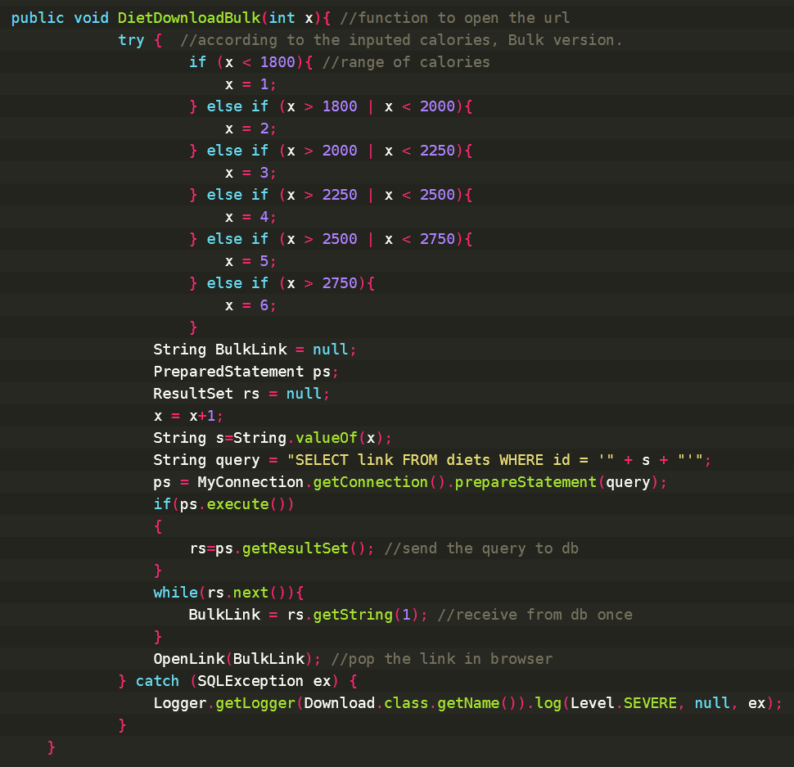

Open the website link on browser:
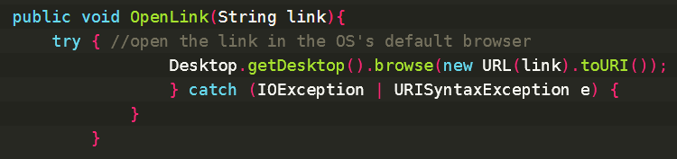

The library used for this function:
- java.net.URL
- import java.awt.Desktop
- import java.net.URISyntaxException
Functions to calculate the body fat:
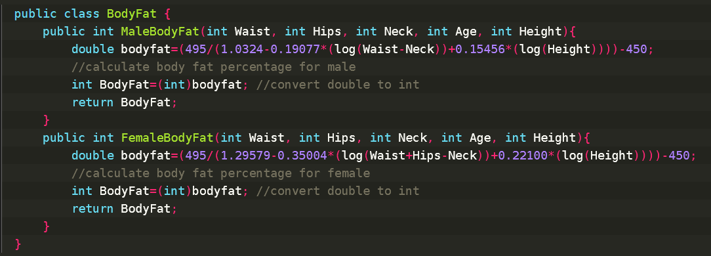

The formula gives the result as a double, but we need an integer. Mrs. Sochirca said that we should ignore the minus before the result. Therefore, the function does the absolute of the number to remove it.

Pages are changed with this:
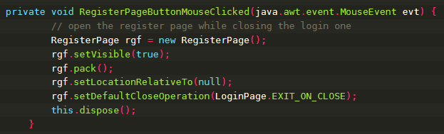

It sets the new page visible, in the same location as the one on its location, then it closes the previous page. By doing this, it processes the next page in advance, offering the user almost instantly loading times.

There is error checking for the main page where user is supposed to enter his measurements. For example, if you input a string but the expect is an integer, then SQL will timeout giving the alert to recheck your inputs.

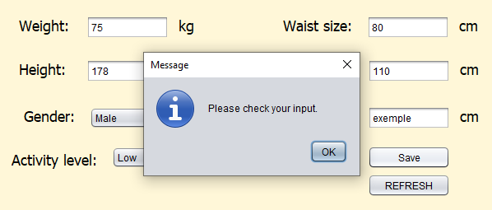
The walkthrough of the program:

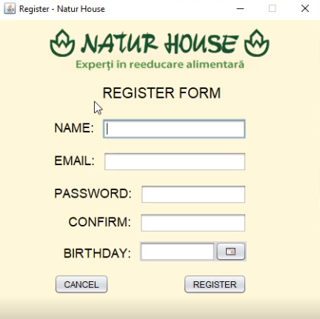
Register form page

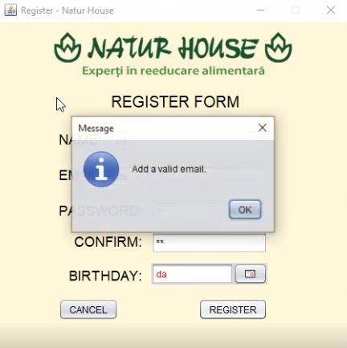
Register form page – valid email checking.
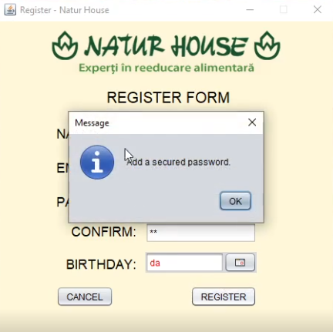
Register form page – secured password checking.

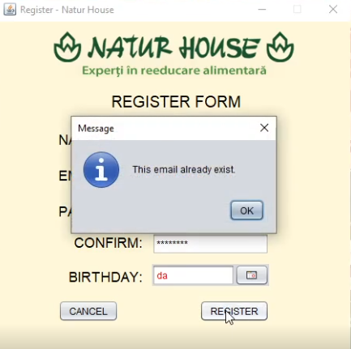
Register form page – email already exist checking.
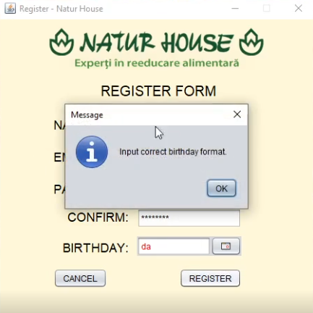
Register form page – birthday format checking.

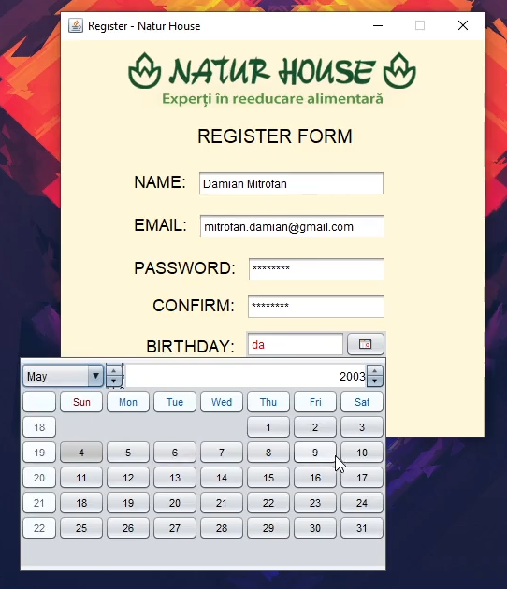
Register form page – birthday choosing table.
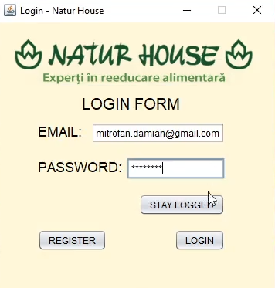
Login form page – with the stay logged function.

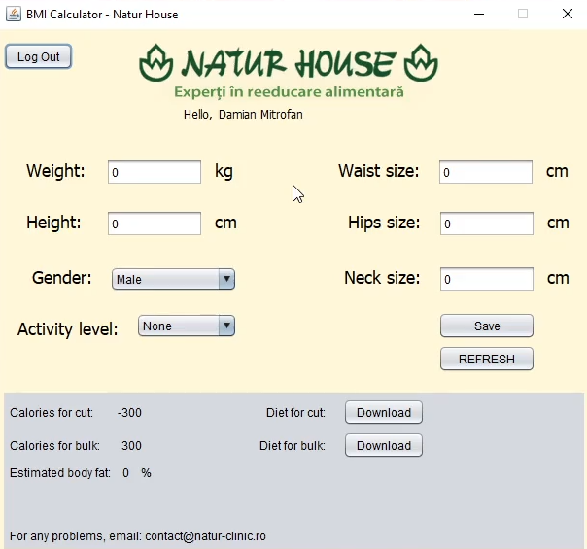
Main form page – blank details.
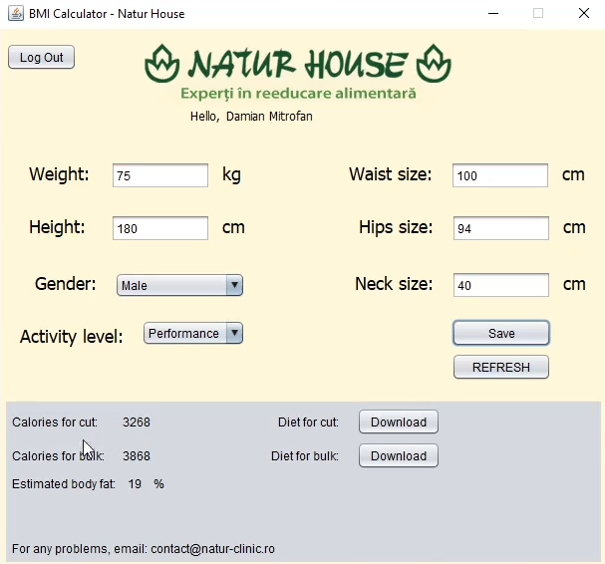
Main form page – completed example details.

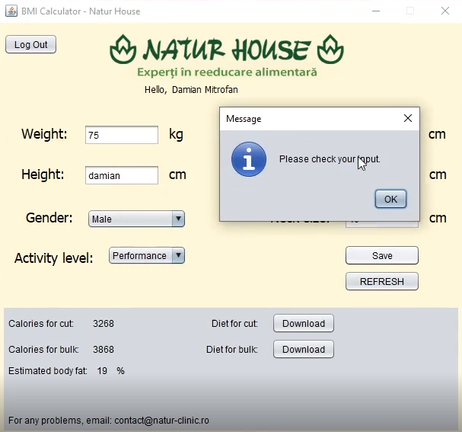
Main form page – input checking.

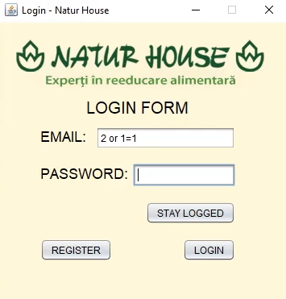
Login form page – SQL injection verification (not vulnerable).

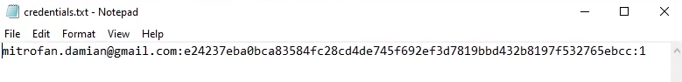

Saved files when a user logs in, 1 shows if the user selected to stay logged in or not. With this, next time the user open the program, will skip the login form page directly to the main form.

