МІНІСТЕРСТВО ОСВІТИ І НАУКИ УКРАЇНИ
НАЦІОНАЛЬНИЙ УНІВЕРСИТЕТ “ЛЬВІВСЬКА ПОЛІТЕХНІКА”
НН ІНСТИТУТ ПІДПРИЄМНИЦТВА ТА ПЕРСПЕКТИВНИХ ТЕХНОЛОГІЙ

ЗВІТ

виконання лабораторної роботи №7
з дисципліни “Розробка програмного забезпечення під мобільні платформи”

на тему:
“Проектування і реалізація БД Sql lite в Android, IOS – програмах”

Виконав:
Студент гр КН-414
Чобіт Д.І.

Прийняв:
Лагун А.Е.

Львів–2020
Лабораторна робота 7

Тема: Проектування і реалізація БД Sql lite в Android, IOS – програмах.
Мета: Навчитися проектувати і реалізовувати БД Sql lite в Android, IOS – програмах

Завдання:
Створити Android-застосунок з використанням бази даних MongoDB.

Хід роботи
Ієрархія файлів коду:
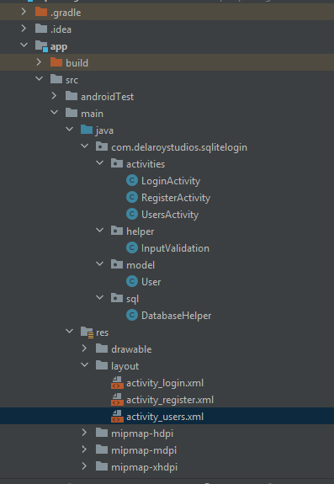

Код програми:
User.java
public class User {
private int id;
private String name;
private String email;
private String password;
public int getId(){
return id;
}
public void setId(int id){
this.id = id;
}
public String getName(){
return name;
}
public void setName(String name){
this.name = name;
}
public String getEmail(){
return email;
}
public void setEmail(String email){
this.email = email;
}
public String getPassword(){
return password;
}
public void setPassword(String password){
this.password = password;
}
}

DataBaseHelper.java
public class DatabaseHelper extends SQLiteOpenHelper{
private static final int DATABASE_VERSION = 1;
private static final String DATABASE_NAME = "UserManager.db";
private static final String TABLE_USER = "user";
private static final String COLUMN_USER_ID = "user_id";
private static final String COLUMN_USER_NAME = "user_name";
private static final String COLUMN_USER_EMAIL = "user_email";
private static final String COLUMN_USER_PASSWORD = "user_password";
private String CREATE_USER_TABLE = "CREATE TABLE " + TABLE_USER + "("
+ COLUMN_USER_ID + " INTEGER PRIMARY KEY AUTOINCREMENT," + COLUMN_USER_NAME + " TEXT,"
+ COLUMN_USER_EMAIL + " TEXT," + COLUMN_USER_PASSWORD + " TEXT" + ")";
private String DROP_USER_TABLE = "DROP TABLE IF EXISTS " + TABLE_USER;
public DatabaseHelper(Context context){
super(context, DATABASE_NAME, null, DATABASE_VERSION);
}
@Override
public void onCreate(SQLiteDatabase db){
db.execSQL(CREATE_USER_TABLE);
}
@Override
public void onUpgrade(SQLiteDatabase db, int oldVersion, int newVersion){
db.execSQL(DROP_USER_TABLE);
onCreate(db);
}
public void addUser(User user){
SQLiteDatabase db = this.getWritableDatabase();
ContentValues values = new ContentValues();
values.put(COLUMN_USER_NAME, user.getName());
values.put(COLUMN_USER_EMAIL, user.getEmail());
values.put(COLUMN_USER_PASSWORD, user.getPassword());
db.insert(TABLE_USER, null, values);
db.close();
}
public boolean checkUser(String email){
String[] columns = {
COLUMN_USER_ID
};
SQLiteDatabase db = this.getWritableDatabase();
String selection = COLUMN_USER_EMAIL + " = ?";
String[] selectionArgs = { email };
Cursor cursor = db.query(TABLE_USER,
columns,
selection,
selectionArgs,
null,
null,
null);
int cursorCount = cursor.getCount();
cursor.close();
db.close();
if (cursorCount > 0){
return true;
}
return false;
}
public boolean checkUser(String email, String password){
String[] columns = {
COLUMN_USER_ID
};
SQLiteDatabase db = this.getWritableDatabase();
String selection = COLUMN_USER_EMAIL + " = ?" + " AND " + COLUMN_USER_PASSWORD + " =?";
String[] selectionArgs = { email, password };
Cursor cursor = db.query(TABLE_USER,
columns,
selection,
selectionArgs,
null,
null,
null);
int cursorCount = cursor.getCount();
cursor.close();
db.close();
if (cursorCount > 0){
return true;
}
return false;
}
}

InputValidation.java
public class InputValidation {
private Context context;
public InputValidation(Context context){
this.context = context;
}
public boolean isInputEditTextFilled(TextInputEditText textInputEditText, TextInputLayout textInputLayout, String message){
String value = textInputEditText.getText().toString().trim();
if (value.isEmpty()){
textInputLayout.setError(message);
hideKeyboardFrom(textInputEditText);
return false;
} else {
textInputLayout.setErrorEnabled(false);
}
return true;
}
public boolean isInputEditTextEmail(TextInputEditText textInputEditText, TextInputLayout textInputLayout, String message){
String value = textInputEditText.getText().toString().trim();
if (value.isEmpty() || !Patterns.EMAIL_ADDRESS.matcher(value).matches()){
textInputLayout.setError(message);
hideKeyboardFrom(textInputEditText);
return false;
}else {
textInputLayout.setErrorEnabled(false);
}
return true;
}
public boolean isInputEditTextMatches(TextInputEditText textInputEditText1, TextInputEditText textInputEditText2, TextInputLayout textInputLayout, String message ){
String value1 = textInputEditText1.getText().toString().trim();
String value2 = textInputEditText2.getText().toString().trim();
if (!value1.contentEquals(value2)){
textInputLayout.setError(message);
hideKeyboardFrom(textInputEditText2);
return false;
}else {
textInputLayout.setErrorEnabled(false);
}
return true;
}
private void hideKeyboardFrom(View view){
InputMethodManager imm = (InputMethodManager) context.getSystemService(Activity.INPUT_METHOD_SERVICE);
imm.hideSoftInputFromWindow(view.getWindowToken(), WindowManager.LayoutParams.SOFT_INPUT_STATE_ALWAYS_HIDDEN);
}
}

LoginActivity.java
public class LoginActivity extends AppCompatActivity implements View.OnClickListener {
private final AppCompatActivity activity = LoginActivity.this;
private NestedScrollView nestedScrollView;
private TextInputLayout textInputLayoutEmail;
private TextInputLayout textInputLayoutPassword;
private TextInputEditText textInputEditTextEmail;
private TextInputEditText textInputEditTextPassword;
private AppCompatButton appCompatButtonLogin;
private AppCompatTextView textViewLinkRegister;
private InputValidation inputValidation;
private DatabaseHelper databaseHelper;
@Override
protected void onCreate(Bundle savedInstanceState) {
super.onCreate(savedInstanceState);
setContentView(R.layout.activity_login);
getSupportActionBar().hide();
initViews();
initListeners();
initObjects();
}
private void initViews(){
nestedScrollView = (NestedScrollView) findViewById(R.id.nestedScrollView);
textInputLayoutEmail = (TextInputLayout) findViewById(R.id.textInputLayoutEmail);
textInputLayoutPassword = (TextInputLayout) findViewById(R.id.textInputLayoutPassword);
textInputEditTextEmail = (TextInputEditText) findViewById(R.id.textInputEditTextEmail);
textInputEditTextPassword = (TextInputEditText) findViewById(R.id.textInputEditTextPassword);
appCompatButtonLogin = (AppCompatButton) findViewById(R.id.appCompatButtonLogin);
textViewLinkRegister = (AppCompatTextView) findViewById(R.id.textViewLinkRegister);
}
private void initListeners(){
appCompatButtonLogin.setOnClickListener(this);
textViewLinkRegister.setOnClickListener(this);
}
private void initObjects(){
databaseHelper = new DatabaseHelper(activity);
inputValidation = new InputValidation(activity);
}
@Override
public void onClick(View v){
switch (v.getId()){
case R.id.appCompatButtonLogin:
verifyFromSQLite();
break;
case R.id.textViewLinkRegister:
Intent intentRegister = new Intent(getApplicationContext(), RegisterActivity.class);
startActivity(intentRegister);
break;
}
}
private void verifyFromSQLite(){
if (!inputValidation.isInputEditTextFilled(textInputEditTextEmail, textInputLayoutEmail, getString(R.string.error_message_email))) {
return;
}
if (!inputValidation.isInputEditTextEmail(textInputEditTextEmail, textInputLayoutEmail, getString(R.string.error_message_email))) {
return;
}
if (!inputValidation.isInputEditTextFilled(textInputEditTextPassword, textInputLayoutPassword, getString(R.string.error_message_email))) {
return;
}
if (databaseHelper.checkUser(textInputEditTextEmail.getText().toString().trim()
, textInputEditTextPassword.getText().toString().trim())) {
Intent accountsIntent = new Intent(activity, UsersActivity.class);
accountsIntent.putExtra("EMAIL", textInputEditTextEmail.getText().toString().trim());
emptyInputEditText();
startActivity(accountsIntent);
} else {
Snackbar.make(nestedScrollView, getString(R.string.error_valid_email_password), Snackbar.LENGTH_LONG).show();
}
}
private void emptyInputEditText(){
textInputEditTextEmail.setText(null);
textInputEditTextPassword.setText(null);
}
}

RegisterActivity.java
public class RegisterActivity extends AppCompatActivity implements View.OnClickListener {
private final AppCompatActivity activity = RegisterActivity.this;
private NestedScrollView nestedScrollView;
private TextInputLayout textInputLayoutName;
private TextInputLayout textInputLayoutEmail;
private TextInputLayout textInputLayoutPassword;
private TextInputLayout textInputLayoutConfirmPassword;
private TextInputEditText textInputEditTextName;
private TextInputEditText textInputEditTextEmail;
private TextInputEditText textInputEditTextPassword;
private TextInputEditText textInputEditTextConfirmPassword;
private AppCompatButton appCompatButtonRegister;
private AppCompatTextView appCompatTextViewLoginLink;
private InputValidation inputValidation;
private DatabaseHelper databaseHelper;
private User user;
@Override
protected void onCreate(Bundle savedInstanceState){
super.onCreate(savedInstanceState);
setContentView(R.layout.activity_register);
getSupportActionBar().hide();
initViews();
initListeners();
initObjects();
}
private void initViews(){
nestedScrollView = (NestedScrollView) findViewById(R.id.nestedScrollView);
textInputLayoutName = (TextInputLayout) findViewById(R.id.textInputLayoutName);
textInputLayoutEmail = (TextInputLayout) findViewById(R.id.textInputLayoutEmail);
textInputLayoutPassword = (TextInputLayout) findViewById(R.id.textInputLayoutPassword);
textInputLayoutConfirmPassword = (TextInputLayout) findViewById(R.id.textInputLayoutConfirmPassword);
textInputEditTextName = (TextInputEditText) findViewById(R.id.textInputEditTextName);
textInputEditTextEmail = (TextInputEditText) findViewById(R.id.textInputEditTextEmail);
textInputEditTextPassword = (TextInputEditText) findViewById(R.id.textInputEditTextPassword);
textInputEditTextConfirmPassword = (TextInputEditText) findViewById(R.id.textInputEditTextConfirmPassword);
appCompatButtonRegister = (AppCompatButton) findViewById(R.id.appCompatButtonRegister);
appCompatTextViewLoginLink = (AppCompatTextView) findViewById(R.id.appCompatTextViewLoginLink);
}
private void initListeners(){
appCompatButtonRegister.setOnClickListener(this);
appCompatTextViewLoginLink.setOnClickListener(this);
}
private void initObjects(){
inputValidation = new InputValidation(activity);
databaseHelper = new DatabaseHelper(activity);
user = new User();
}
@Override
public void onClick(View v){
switch (v.getId()){
case R.id.appCompatButtonRegister:
postDataToSQLite();
break;
case R.id.appCompatTextViewLoginLink:
finish();
break;
}
}
private void postDataToSQLite(){
if (!inputValidation.isInputEditTextFilled(textInputEditTextName, textInputLayoutName, getString(R.string.error_message_name))) {
return;
}
if (!inputValidation.isInputEditTextFilled(textInputEditTextEmail, textInputLayoutEmail, getString(R.string.error_message_email))) {
return;
}
if (!inputValidation.isInputEditTextEmail(textInputEditTextEmail, textInputLayoutEmail, getString(R.string.error_message_email))) {
return;
}
if (!inputValidation.isInputEditTextFilled(textInputEditTextPassword, textInputLayoutPassword, getString(R.string.error_message_password))) {
return;
}
if (!inputValidation.isInputEditTextMatches(textInputEditTextPassword, textInputEditTextConfirmPassword,
textInputLayoutConfirmPassword, getString(R.string.error_password_match))) {
return;
}
if (!databaseHelper.checkUser(textInputEditTextEmail.getText().toString().trim())) {
user.setName(textInputEditTextName.getText().toString().trim());
user.setEmail(textInputEditTextEmail.getText().toString().trim());
user.setPassword(textInputEditTextPassword.getText().toString().trim());
databaseHelper.addUser(user);
// Snack Bar to show success message that record saved successfully
Snackbar.make(nestedScrollView, getString(R.string.success_message), Snackbar.LENGTH_LONG).show();
emptyInputEditText();
} else {
// Snack Bar to show error message that record already exists
Snackbar.make(nestedScrollView, getString(R.string.error_email_exists), Snackbar.LENGTH_LONG).show();
}
}
private void emptyInputEditText(){
textInputEditTextName.setText(null);
textInputEditTextEmail.setText(null);
textInputEditTextPassword.setText(null);
textInputEditTextConfirmPassword.setText(null);
}
}

UserActivity.java
public class UsersActivity extends AppCompatActivity {
private TextView textViewName;
@Override
protected void onCreate(Bundle savedInstanceState){
super.onCreate(savedInstanceState);
setContentView(R.layout.activity_users);
textViewName = (TextView) findViewById(R.id.text1);
String nameFromIntent = getIntent().getStringExtra("EMAIL");
textViewName.setText("Welcome " + nameFromIntent);
}
}

activity_login.xml
<?xml version="1.0" encoding="utf-8"?>
<android.support.v4.widget.NestedScrollView xmlns:android="http://schemas.android.com/apk/res/android"
xmlns:tools="http://schemas.android.com/tools"
android:id="@+id/nestedScrollView"
android:layout_width="match_parent"
android:layout_height="match_parent"
android:background="@color/colorPrimaryDark"
android:paddingBottom="@dimen/activity_vertical_margin"
android:paddingLeft="@dimen/activity_horizontal_margin"
android:paddingRight="@dimen/activity_horizontal_margin"
android:paddingTop="@dimen/activity_vertical_margin"
tools:context=".activities.LoginActivity">
<android.support.v7.widget.LinearLayoutCompat
android:layout_width="match_parent"
android:layout_height="match_parent"
android:orientation="vertical">
<android.support.v7.widget.AppCompatImageView
android:layout_width="wrap_content"
android:layout_height="wrap_content"
android:layout_gravity="center_horizontal"
android:layout_marginTop="40dp"
android:src="@drawable/logo" />
<android.support.design.widget.TextInputLayout
android:id="@+id/textInputLayoutEmail"
android:layout_width="match_parent"
android:layout_height="wrap_content"
android:layout_marginTop="40dp" >
<android.support.design.widget.TextInputEditText
android:id="@+id/textInputEditTextEmail"
android:layout_width="match_parent"
android:layout_height="wrap_content"
android:hint="@string/hint_email"
android:textColorHint="@color/colorText"
android:inputType="text"
android:maxLines="1"
android:textColor="@color/colorText" />
</android.support.design.widget.TextInputLayout>
<android.support.design.widget.TextInputLayout
android:id="@+id/textInputLayoutPassword"
android:layout_width="match_parent"
android:layout_height="wrap_content"
android:layout_marginTop="20dp" >
<android.support.design.widget.TextInputEditText
android:id="@+id/textInputEditTextPassword"
android:layout_width="match_parent"
android:layout_height="wrap_content"
android:hint="@string/hint_password"
android:textColorHint="@color/colorText"
android:inputType="textPassword"
android:maxLines="1"
android:textColor="@color/colorText" />
</android.support.design.widget.TextInputLayout>
<android.support.v7.widget.AppCompatButton
android:id="@+id/appCompatButtonLogin"
android:layout_width="match_parent"
android:layout_height="wrap_content"
android:layout_marginTop="40dp"
android:textColor="@color/colorText"
android:background="@color/colorTextHint"
android:text="@string/text_login" />
<android.support.v7.widget.AppCompatTextView
android:id="@+id/textViewLinkRegister"
android:layout_width="fill_parent"
android:layout_height="wrap_content"
android:layout_marginTop="30dp"
android:gravity="center"
android:text="@string/text_not_member"
android:textSize="16sp"
android:textColor="@color/colorText" />
</android.support.v7.widget.LinearLayoutCompat>
</android.support.v4.widget.NestedScrollView>

activity_register.xml
<?xml version="1.0" encoding="utf-8"?>
<android.support.v4.widget.NestedScrollView xmlns:android="http://schemas.android.com/apk/res/android"
xmlns:tools="http://schemas.android.com/tools"
android:orientation="vertical"
android:layout_width="match_parent"
android:layout_height="match_parent"
android:id="@+id/nestedScrollView"
android:background="@color/colorPrimaryDark"
android:padding="20dp"
tools:context="activities.LoginActivity">
<android.support.v7.widget.LinearLayoutCompat
android:layout_width="match_parent"
android:layout_height="match_parent"
android:orientation="vertical">
<android.support.v7.widget.AppCompatImageView
android:layout_width="wrap_content"
android:layout_height="wrap_content"
android:layout_gravity="center_horizontal"
android:layout_marginTop="40dp"
android:src="@drawable/logo" />
<android.support.design.widget.TextInputLayout
android:id="@+id/textInputLayoutName"
android:layout_width="match_parent"
android:layout_height="wrap_content"
android:layout_marginTop="40dp" >
<android.support.design.widget.TextInputEditText
android:id="@+id/textInputEditTextName"
android:layout_width="match_parent"
android:layout_height="wrap_content"
android:hint="@string/hint_name"
android:textColorHint="@color/colorText"
android:inputType="text"
android:maxLines="1"
android:textColor="@color/colorText" />
</android.support.design.widget.TextInputLayout>
<android.support.design.widget.TextInputLayout
android:id="@+id/textInputLayoutEmail"
android:layout_width="match_parent"
android:layout_height="wrap_content"
android:layout_marginTop="20dp" >
<android.support.design.widget.TextInputEditText
android:id="@+id/textInputEditTextEmail"
android:layout_width="match_parent"
android:layout_height="wrap_content"
android:hint="@string/hint_email"
android:textColorHint="@color/colorText"
android:inputType="text"
android:maxLines="1"
android:textColor="@color/colorText" />
</android.support.design.widget.TextInputLayout>
<android.support.design.widget.TextInputLayout
android:id="@+id/textInputLayoutPassword"
android:layout_width="match_parent"
android:layout_height="wrap_content"
android:layout_marginTop="20dp" >
<android.support.design.widget.TextInputEditText
android:id="@+id/textInputEditTextPassword"
android:layout_width="match_parent"
android:layout_height="wrap_content"
android:hint="@string/hint_password"
android:textColorHint="@color/colorText"
android:inputType="textPassword"
android:maxLines="1"
android:textColor="@color/colorText" />
</android.support.design.widget.TextInputLayout>
<android.support.design.widget.TextInputLayout
android:id="@+id/textInputLayoutConfirmPassword"
android:layout_width="match_parent"
android:layout_height="wrap_content"
android:layout_marginTop="20dp" >
<android.support.design.widget.TextInputEditText
android:id="@+id/textInputEditTextConfirmPassword"
android:layout_width="match_parent"
android:layout_height="wrap_content"
android:hint="@string/hint_confirm_password"
android:textColorHint="@color/colorText"
android:inputType="textPassword"
android:maxLines="1"
android:textColor="@color/colorText" />
</android.support.design.widget.TextInputLayout>
<android.support.v7.widget.AppCompatButton
android:id="@+id/appCompatButtonRegister"
android:layout_width="match_parent"
android:layout_height="wrap_content"
android:layout_marginTop="40dp"
android:textColor="@color/colorText"
android:background="@color/colorTextHint"
android:text="@string/text_register" />
<android.support.v7.widget.AppCompatTextView
android:id="@+id/appCompatTextViewLoginLink"
android:layout_width="fill_parent"
android:layout_height="wrap_content"
android:layout_marginTop="30dp"
android:gravity="center"
android:text="@string/text_member"
android:textSize="16sp"
android:textColor="@color/colorText" />
</android.support.v7.widget.LinearLayoutCompat>
</android.support.v4.widget.NestedScrollView>

Activity_users.xml
<?xml version="1.0" encoding="utf-8"?>
<LinearLayout xmlns:android="http://schemas.android.com/apk/res/android"
android:orientation="vertical" android:layout_width="match_parent"
android:layout_height="match_parent"
android:background="@color/colorPrimaryDark">
<TextView
android:layout_width="wrap_content"
android:layout_height="wrap_content"
android:id="@+id/text1"
android:layout_marginTop="20dp"
android:layout_marginLeft="20dp"
android:textSize="20sp"
android:textStyle="bold"
android:padding="16dp"
android:textColor="@color/colorText"/>
</LinearLayout>

Результат:
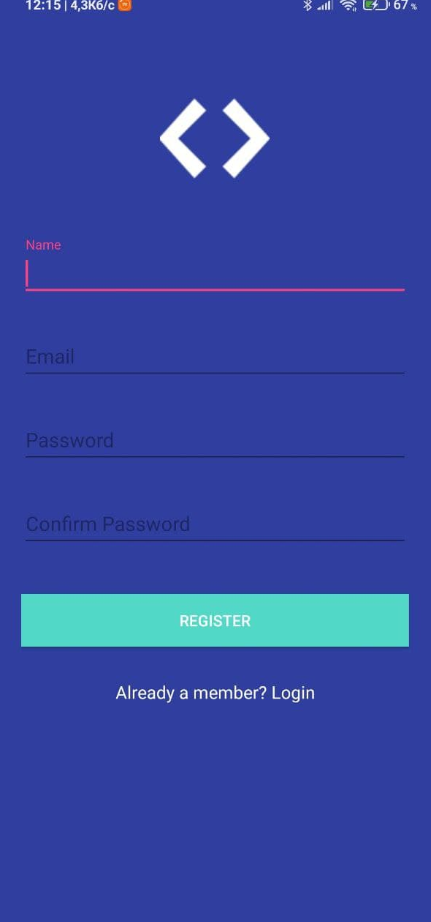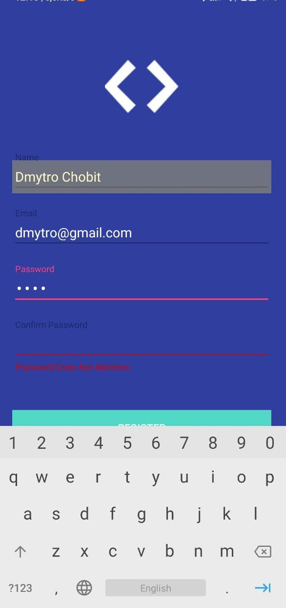
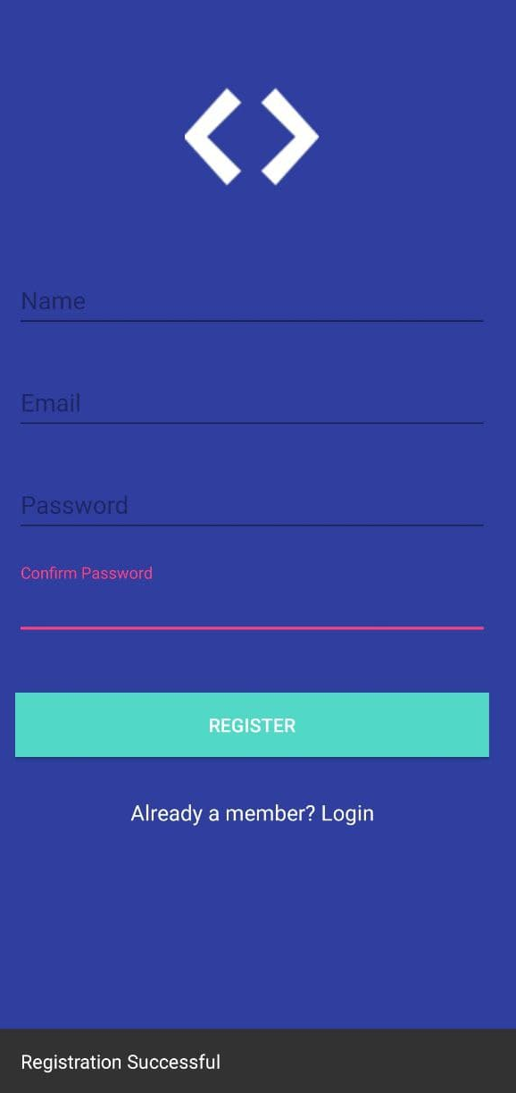
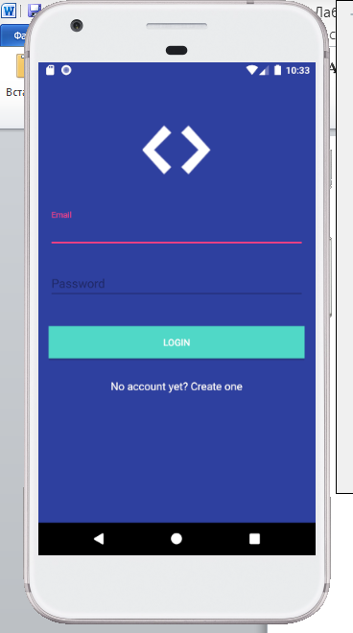
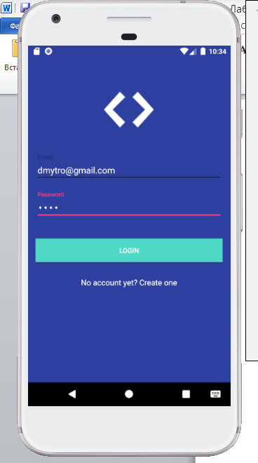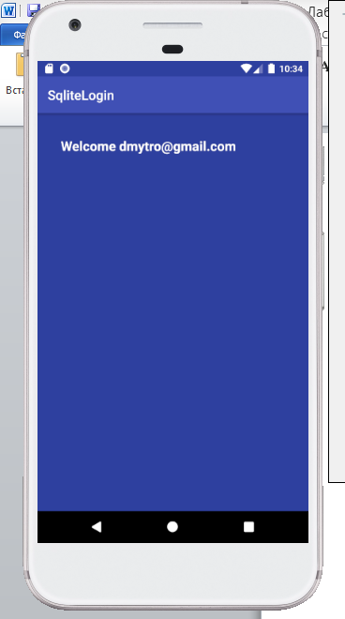

Висновок: У цій лабораторній роботі я навчився проектувати і реалізовувати БД Sql lite в Android– програмах

