Automatic Data Analysis and Distribution with Python

Dennis Mamrenko
Department of Computer Science and Information Systems
Murray State University
Murray, Kentucky
dmamrenko@murraystate.edu

Abstract—In this paper, we discuss the benefits of incorporating simple python scripts to automate tasks, and how such scripts can increase productivity. Throughout the paper we have implementation we will discuss, but we will be able to see how this general idea can be used for a variety of applications and datasets. These applications can include using the scripts for many kinds of numerical business calculations and routines, for things like labor, expense, and profit tracking, among other uses. Nevertheless, this implementation of Python for automation reads CSV data files for automating student grade update notification through emailing. (Abstract)
Keywords—Scripting, email, automation, Python, CSV, Excel (key words)

Introduction
The use of Python for automating simple tasks is not new, and that is one of the main reasons Python was created. Python works as a programming language and as a scripting language. It is easy to read, easy to write, and therefore usually it is easy to learn.
Implementation can be relatively quick, and the developer can quickly put together a working prototype for their Python automation script. It is important instead to not focus on the final product but all the pieces that make it up. Planning the project is always the first step to creating the project in an efficient manner.
My data analysis and distribution script, as stated in the abstract, analyzes student grade data and distributes that data to the corresponding students. Here forth, my project will be regarded to as AGE (Automatic Grade Emailer). I broke my project into multiple parts:

Reading the data

Analyzing the data

Distributing the data

Let us take this approach to creating a data distribution script, as each step can be nuanced depending on what the data is, what the analysis needs to be, and how it needs to be distributed.

Reading the data
Before your script can analyze or send any data, it must read the data you want to use. I would recommend staying to a general format no matter the application for which you are writing the script.
For AGE, I had to use two separate files, each of them saved as .csv files. The first file my script reads in contains student grade data for an individual term. The second file read in my be the script is a contacts file, which provides a context for student contact information.

Reading the data file:
Again, I recommend keeping to a format with your data files. My grade data file contains the students on a column to the left as well as all the assignments across the top. This is how I expect many data sets are stored for small businesses, organizations, and anyone who stores basic numerical information for any reason. My grade files look like this:
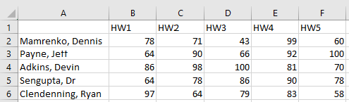

Reading the contacts file:
Similarly, keep a format for your contacts as well, and keep in mind that your contacts file should reflect your data file in whatever way is appropriate for your situation. Perhaps the people to be contacted the analysis of the data file do not exist in your data file. This is all a case by case development process. Maybe a safeguard should be in check to see if your contacts file is valid with your data file, it depends on each implementation.
Further, It may make sense for your contacts file to have their address, their phone number, or another contact method, as your script might send mass emails, texts, or sort the mail-outs for a list of contacts. The contents of the file can sway the script in many different directions.
AGE simply read a contacts.csv file that contains the first and last name of the student, as well as their email, and this is what that file looks like:
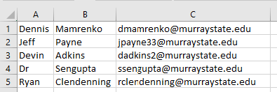

Improvements to be made data reading:
AGE can make improvements on multiple aspects of its data reading, and this is something that the developer must be thinking about. How long software lasts depends on how it was built, and if it was built to be expanded on or just for one purpose. Generalizing a program enough to be ready for multiple kinds of input create a better experience for the user, but this is generally very difficult. Here are some things that AGE needs to improve upon regarding data reading and acquisition:
- A feature or file system that organizes data file vs. contact files for the user to discriminate between the two.
- A feature that notifies the user whether their data file is complete or not.
- AGE should have a feature for logging previous queries and notification efforts for reusing the same data.

Analyzing the data
For this portion of the process, you want to do something with the data you have read that makes it meaningful for you to be automating the process. This would be different for each application. For example, a labor tracking system created with the same general idea will store employees and their clock in and clock out times, but the results are tabulated in a manner different than AGE analyzes its data.
The analysis is the heart of the script, as it will manipulate the information from the data to specifically gather the data that would be too tedious to manually gather and from there it will be routed to the right recipient.
AGE has a relatively simple analysis process based on the query of the user. When the user selects a specific assignment for analysis, my Analyzer class is responsible for finding the minimum, maximum, and average scores for that assignment. By extracting that row from the grade data comma separated value file, we can find the students that did the best and worse.

Minimum:
The script attaches words of encouragement to the student(s) that receives the lowest score on the queried assignment.
i.e.
“You’re falling behind, email me for extra help!”

Maximum:
The script attaches words of encouragement to the student(s) that receives the hightest score on the queried assignment.
i.e.
“Great job, leading the pack!”

Average:
The script also averages all the grades for that assignment and attaches that average to everyone’s personalized message.

Message (if notifying recipients):
The script will iterate through each student and create a custom message for them, including the assignment that was graded, their score, the statistics above for the class, as well as a bar graph of the data.

Distributing the Data
Finally, when the files have been read and analyzed, the last thing to happen is the appropriate distribution of data. Once again, this will be custom to the scenario for which this example is being built upon. Perhaps only one person is to be sent the results from the analysis perhaps multiple. Perhaps some people get contacted only if a major discrepancy is found in the analysis, or who knows how complex the distribution could be.
For AGE, the distribution of the data is quite readable, but has some hardcoding that wouldn’t make sense if generalized:
The code:
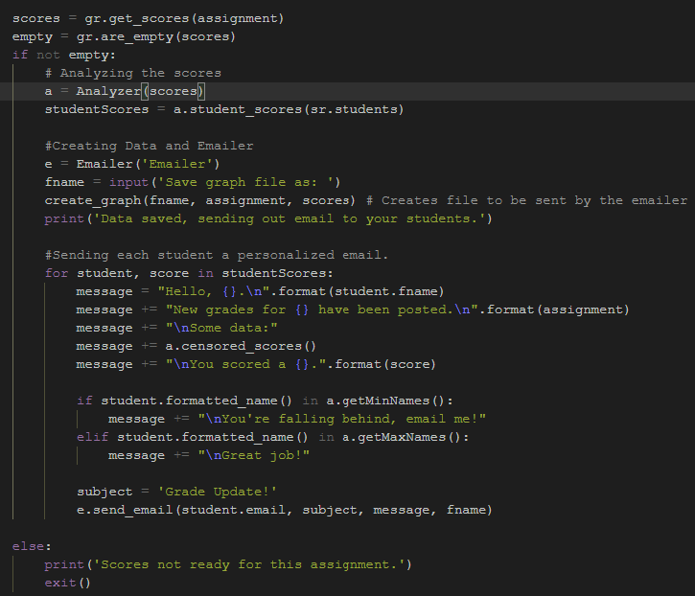
The outcome:
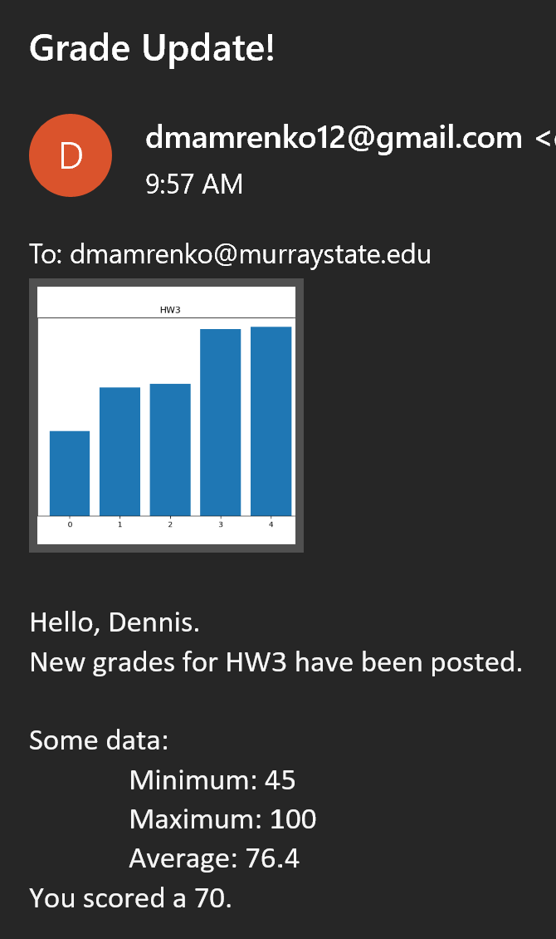

Acknowledgments
Thanks for a great semester!

References
https://www.youtube.com/watch?v=q5uM4VKywbA&t=733s

