Parallel and HPC
HW8 Report
Link to GITHUB repository:
https://github.com/DMelkonyan111/Parallel-and-HPC-Homeworks

Exercise 1

The main function generates a DNA sequence of length N = 10,000,000 and populates it with random nucleotides {A, C, G, T}. The host prints the first 50 characters to establish a baseline. The data is then copied from the host to four distinct device arrays to test different execution configurations. In the kernel cuda_func, each thread calculates its global thread ID (gid) and performs a bounds check. If within bounds, the thread reads one character and replaces it with its complement directly in global memory. The program executes this kernel with block sizes of 64, 128, 256, and 512. After synchronization, the results are copied back to the host, and the execution time is measured using clock_t to compare performance across different thread configurations.

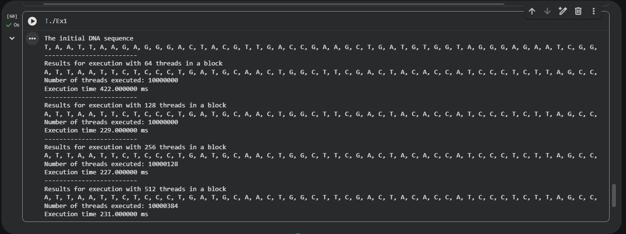

Exercise 2

The program initializes a DNA sequence of N = 20,000,000. Unlike the first task, this implementation requires global counters for each base. An array of four integers is allocated on both the host and the device. The cuda_func kernel uses each thread's gid to read a nucleotide and then utilizes atomicAdd to increment the corresponding index in the device counter array. The use of atomicAdd is essential here to prevent data races, as multiple threads frequently attempt to update the same counter simultaneously. The main function launches the kernel four times with varying block sizes (64 to 512). The results show that while the nucleotide counts remain consistent and accurate, the execution time is heavily influenced by "atomic contention," as 20 million threads compete for only four memory locations.

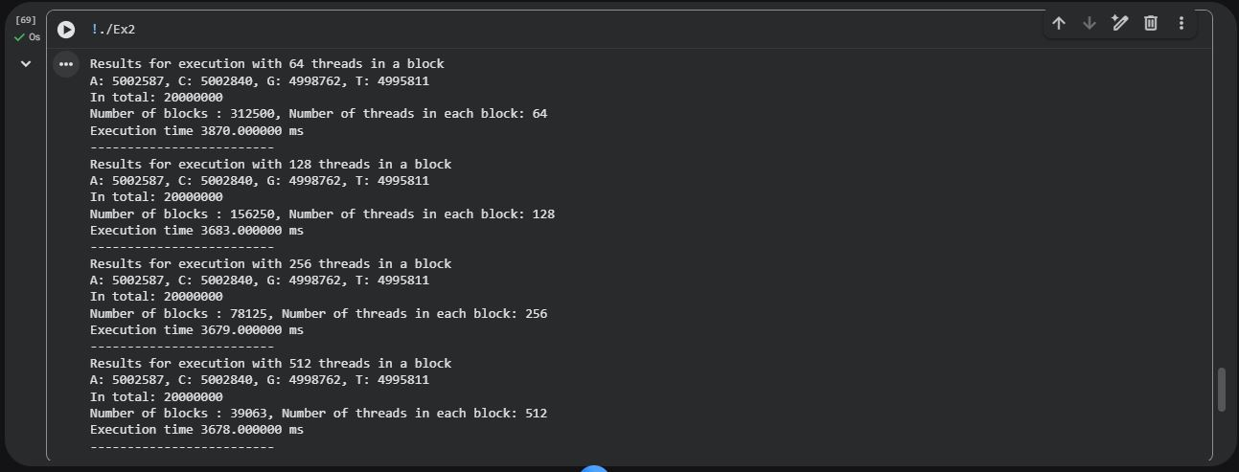

Exercise 3

This program generates a sequence of N = 24,000,000 nucleotides, a size specifically chosen to be divisible by 3. The data is moved to the GPU, and the kernel is launched with a standard block size of 256 threads. Within the kernel, each thread identifies its place in the biological hierarchy by calculating a codon_id (determined by gid / 3). Simultaneously, the thread identifies its place in the hardware hierarchy by calculating its warp_id (determined by threadIdx.x / 32) and its lane_id (the specific thread position within that warp).

