Report

Link to github repository:
https://github.com/DMelkonyan111/Parallel-and-HPC-Homeworks

Assignment 1
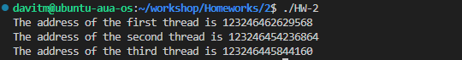

Assignment 2
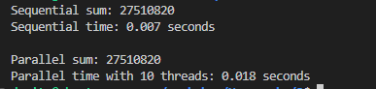

Assignment 3
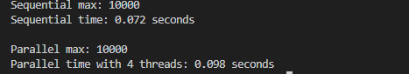

Assignment 4
