Parallel and HPC
HW6 Report
Link to GITHUB repository:
https://github.com/DMelkonyan111/Parallel-and-HPC-Homeworks

Assignment 1

In assignment 1 I have allocated memory for arr holding N integer values, initialized 3 histogram arrays each for a version of the algorithm (naïve, critical, reduction), and then come the 3 versions of the program. For each of them I have calculated the execution time, which you can see in the result (also in the screenshot). In the naïve version there is race conditioning as there is no lock for threads to block each other’s access in the process of working on the array at specific index. In “critical” version and in reduction versions the threads don’t interfere with each other. However, critical is locking the index, while reduction is creating local copies for each thread, and sums them up in the end, that is why we can see such a vast difference in execution time. For critical and reduction parts I have done for declaration with num_threads together in one statement.

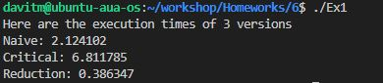

Assignment 2

For assignment 2, there is again memory allcoation for N double values and made the omp part of declaring threads then an inner for omp declaration which uses reduction for the double min_diff. Inside the loop the difference between 2 consecutive values is calculated and if that value is less than min_diff then min_diff becomes that new difference.

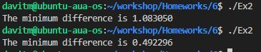

Assignment 3

For assignment 3, after allocating memory for N ints and assigning them random values from 1 to 1000, I have declared an omp for loop with 4 threads and reduction for finding the maximum value, then after the omp scope I have calculated the threshold and in another omp for loop with 4 threads I have reduced the sum variable holding the sum of values above the threshold.

