

Quick Start Guide
Version 2.0
Dylan Meville

- Create a new Unity Project, and Import the DMMap package.

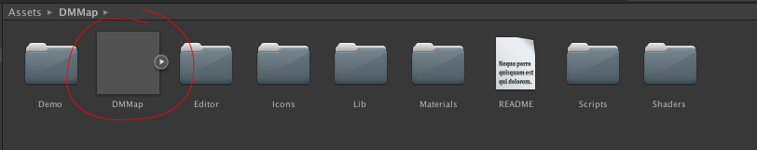
- Select the DMMap prefab, found in the Assets>DMMap folder, and drag it into the Hierarchy Window. Ensure it's position is (0,0,0).

- The first thing we need to do is create a new layer for DMMap to use. To do this go into the Edit>Project Settings > Tags and Layers menu. Then, in any of the empty user layers type in “DMMap”.
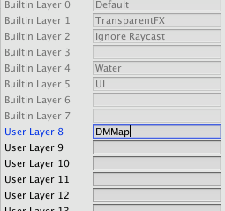

This is the bare minimum setup – everything will work now!
Continue reading to see how to set up map shapes & icons

- Now we're going to create a map shape. Create a new Cube Primitive by going GameObject>Create Other>Cube. Lets also place this cube so it's position is at (0,0,0)

- In order to setup a map shape, we need to add a DMMapShape component to an object. With our cube selected, go Component>Add... and type in DMMapShape, and click on the DMMapShape component.
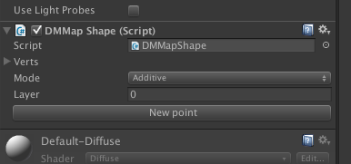
- The DMMapShape component has 2 main properties, and the “New point” button
- Mode: (Additive, Subtractive). Determines the draw mode of the shape. It should be noted that ALL additives are combined first, then the subtractions happen.
- Layer: The generation happens with all other shapes on the same layer. This is used for multi-layer maps/
- New Point creates a new point for our shape for us to position.

- Let's leave the settings as they are and click the “New Point” button on the DMMapShape component once. You'll see that now our cube has a child object called “mappoint_0”, and it has been selected for us in the Scene view. Let's move it so it's aligned to one of the top corners of the cube (holding V while moving snaps to vertices)

- Now that the first point is placed, with it still selected look in the Inspector and you'll see a DMMapPoint component, which also has a New Point button. Click that once to add a second vertex and snap it to an adjacent point on the top of the cube. You should see a green line being drawn between your two points now.

- Continue doing this two more times, so that the top of the cube has a green box around it. We've just made our first shape!
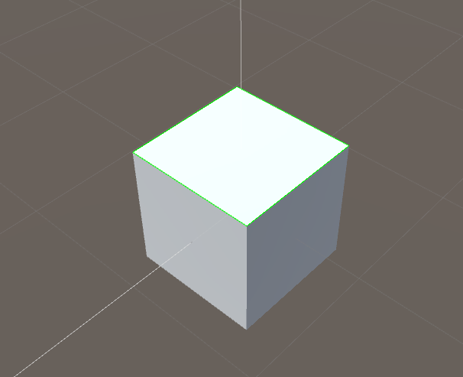

- Let's test the project now! Hit the play button. If everything is done right you should see something like the image below. See that Cyan rectangle in the top-left of our Game window? That's the map of our cube! There are a few things we need to fix though.. but lets exit play mode first.

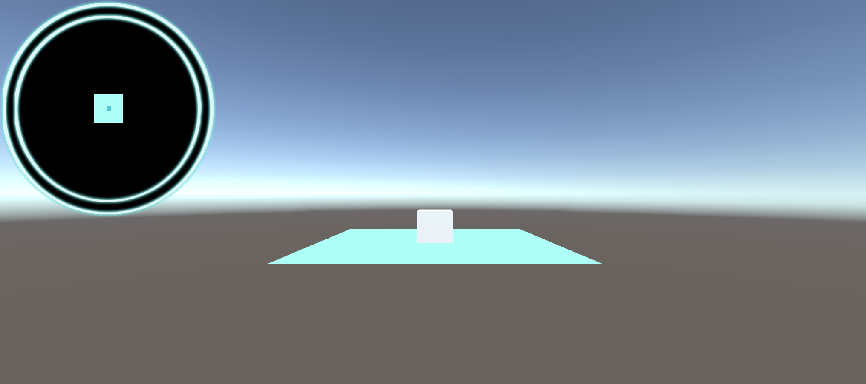

- First of all our map has an outline that is way too thick! The map itself is shown in the top left corner as the dark blue box – the light blue surrounding it is the outline. Lets scale that down a bit. We can do this by selecting our DMMap object in our hierarchy and find the “Configs” dropdown box. This is where all the “settings and properties” of how our map is displayed are stored. By default there are two configs already set up for you – one for the minimap currently visible in the top left corner, and another for a fullscreen map (more on that later!)

Lets open the Configs > Element 0 box – and find the “Mesh Outline Width” property, and turn that down to 0.1. While we're here, lets decrease the “zoom” property as well to 5 and hit play. As you can see, now our map looks a bit nicer!

- We should have a little bit of fun. Select the cube and duplicate it a few times (ctrl+d/cmd+d), scale it, translate it, rotate it, overlap them whatever! Then hit play again! As you can see all the shapes are added together and gives us a nice looking map! Here's what I did..
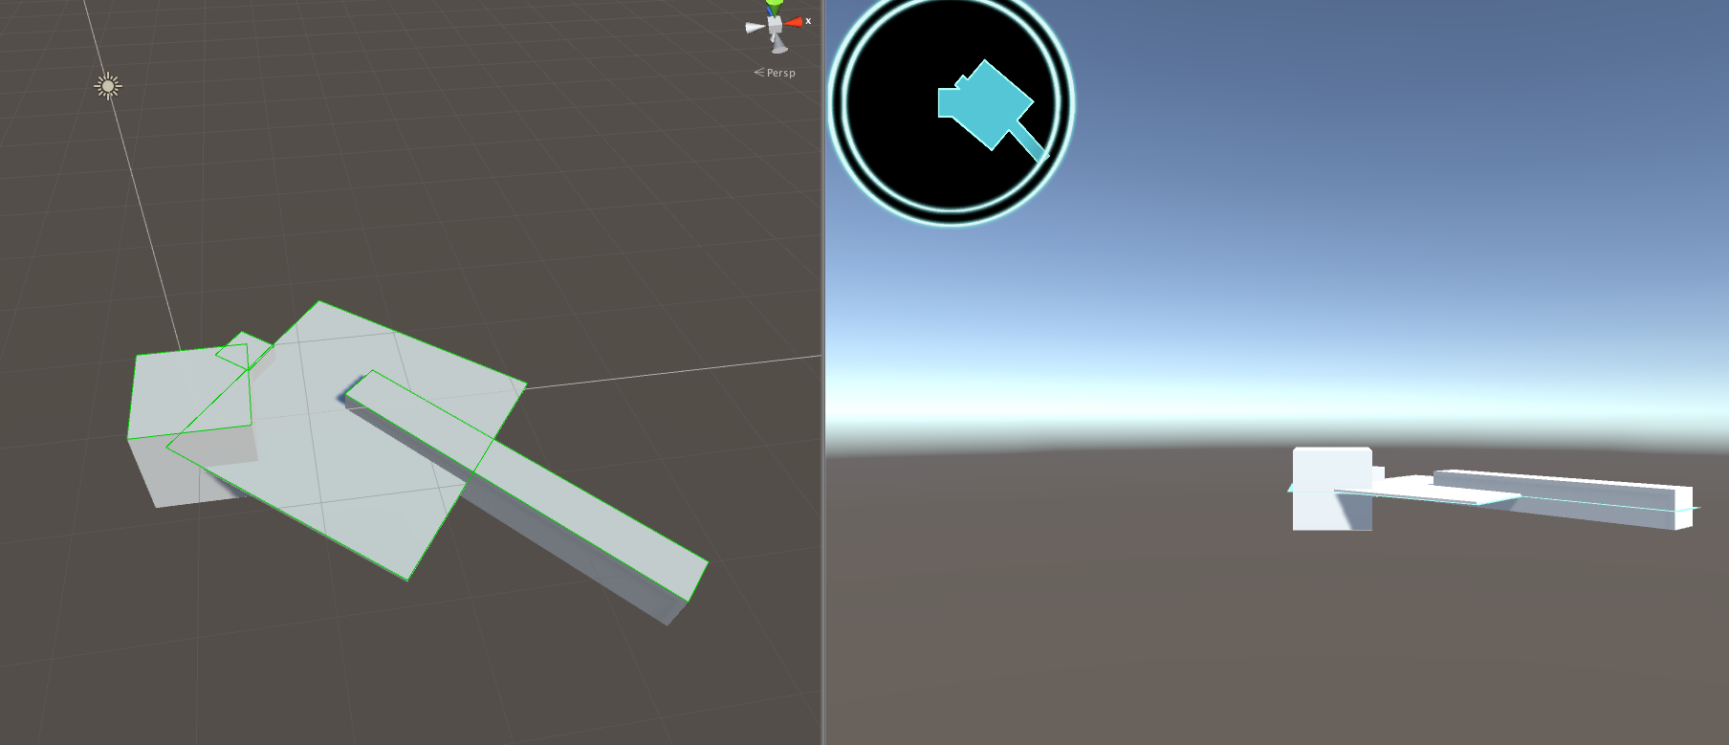

- Lets change which config loads by default at runtime to the default fullscreen config. Select the DMMap object in the hierarchy again, and change the “Loaded Config” int from 0 to 1. You can also change the config at runtime with “DMMap.instance.LoadConfig(int). Hit play now and you'll see the default fullscreen map being shown. (zoom changed to 7, outline changed to 0.5) Hooray!

As you can see DMMap supports transparent backgrounds to the maps, and semitransparent (see-through) maps to be overlaid on the screen without covering important gameplay entirely.
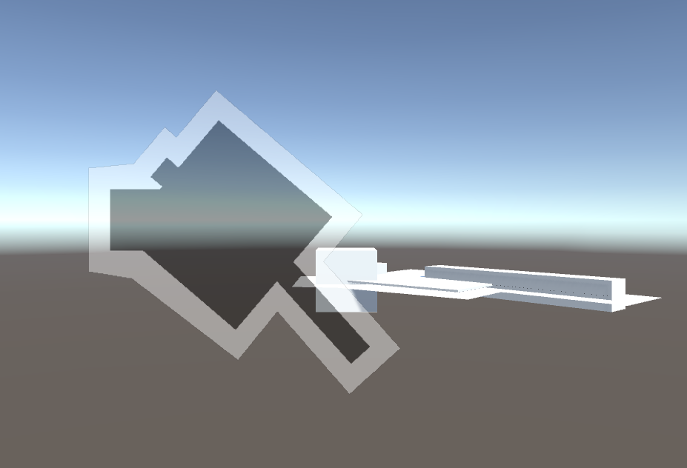

Important!!

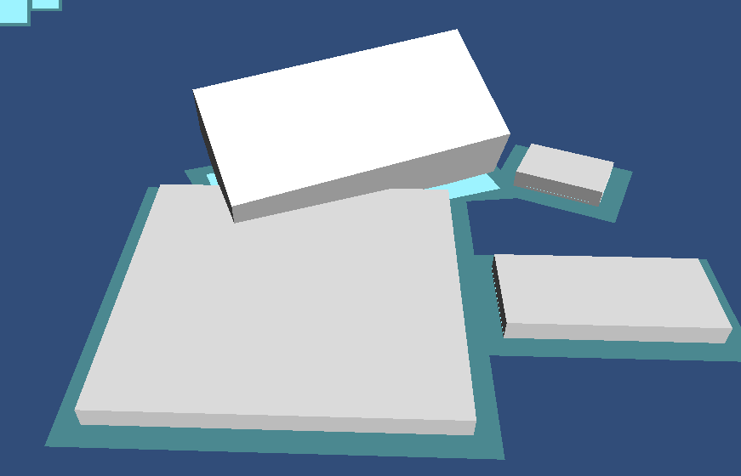
- Are you seeing the map being drawn under your shapes in the game view? (like this)

That just means that your game camera is set to render the map layers. In most cases we don't want this, but we can change it easily. In the hierarchy window select your “Main Camera” and in the Culling Mask dropdown, uncheck the “DMMap” layer.
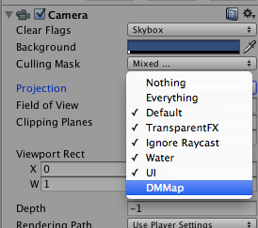

If you'd like to disable seeing this in the “Scene” view as well, you can simply toggle off the layer visibility of the “DMMap” layer. The layers drop down is found on the top-right corner of Unity. You can also disable the green shape lines under the Gizmos tab.
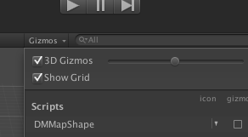
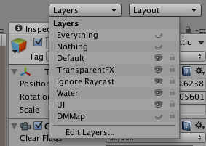

- We're going to create an icon now. Let's create a sphere now, the same way we created our cube. GameObject>Create Other >Sphere. Place it on top of one of our cubes.

- Next we need to give our Sphere a DMMapIcon component. With the sphere selected go to Component>Add.. and find the DMMapIcon component.

- Our icon needs a texture to be used as the icon texture. DMMap comes with a few icons, found in the DMMap>Icons folder. Let's grab the “EventIcon” from there, and drag it into the Icon (Texture2d) field on our DMMapIcon component.
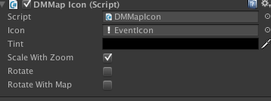
- Now let's go ahead and test our project. If all worked correctly, we should be seeing a black “!” mark on our map. Hurray!
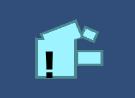

That's it for now!

That's everything for now. Take a bit of time looking over the documentation and playing around with the properties on DMMap. All the properties are heavily commented in code! Be sure to take a look at the demo scenes located in DMMap>Demo for examples of how to set up procedural levels, and multi-layer maps, as well as other features.

Questions? Contact me:
Twitter: Dmeville
Unity Forums: Thread
Email: support@dylanmeville.com

Happy mapping!

