

BU 610.615

Simulation for Business Applications

Homework 2

Name: Minghao Du

Class Section Number: BU.610.615.T1.SP21

Part A: Simulation Application Questions

2.

Having an inventory of 105 yields the best average profit

It sure would not hurt to have an automated function to test different input values instead of manually punching in different numbers

3.

* Mean: 91
* Std. dev.: 35.5
* 95th %: 149.39

Yes, the histogram does look like a normal distribution



4.

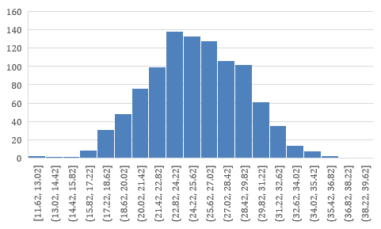

Yes, the histogram does look like a graph of normal probability distribution function