HOW TO IMPORT SQL (MS SQL SERVER)

1. BUAT DATABASE BARU. Klik Kanan pada server -> Pilih “New Database”

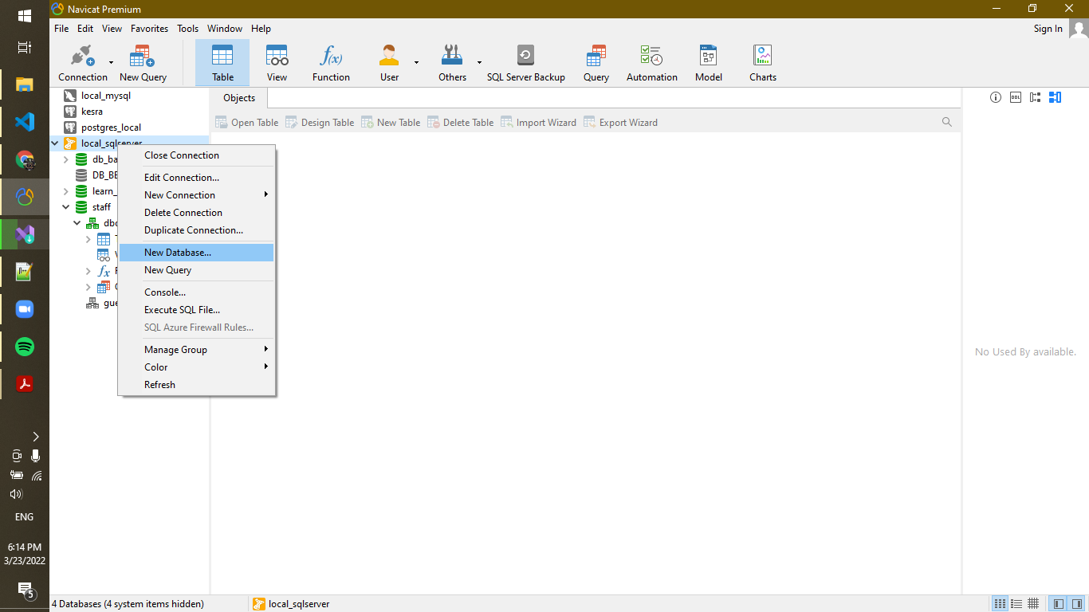

1. Akan muncul Window seperti dibawah. Masukan nama pada “Database name” -> lalu “OK”

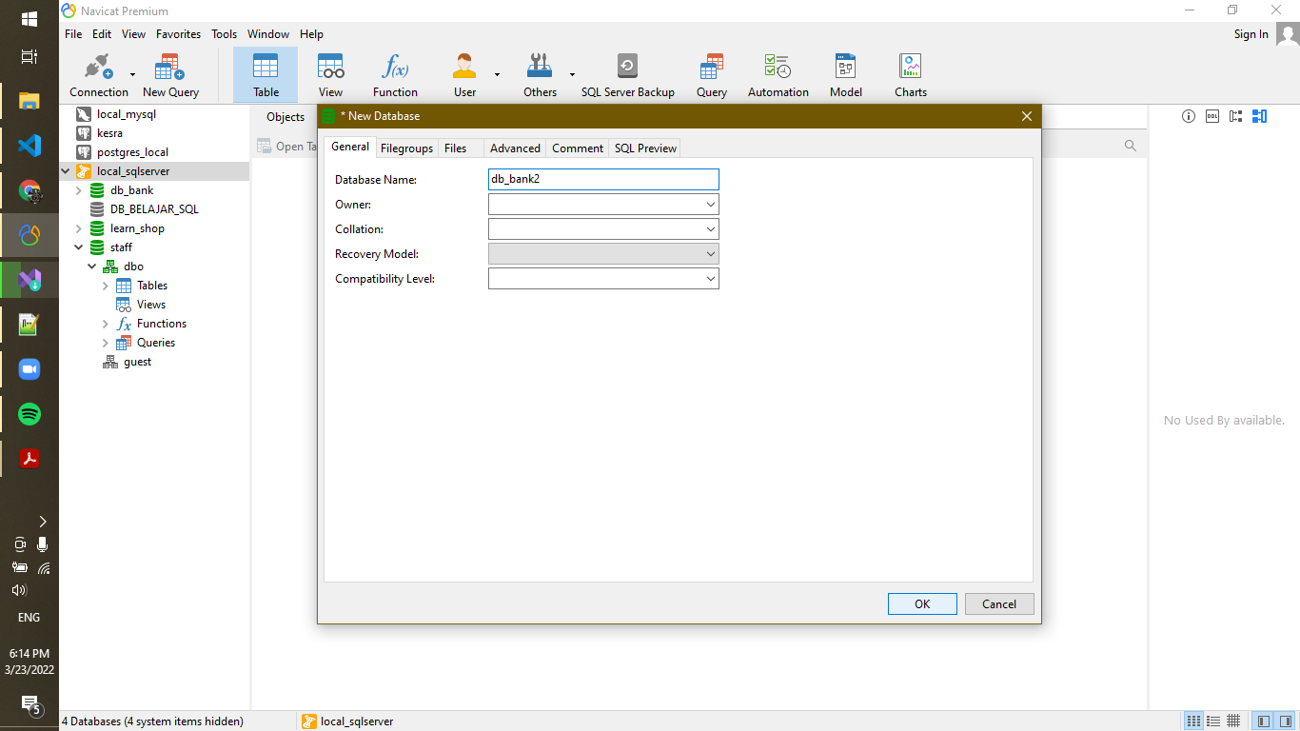

1. Klik 2x pada database (db_bank2) lalu klik kanan pada database (db_bank2) pula -> lalu pilih Execute file SQL

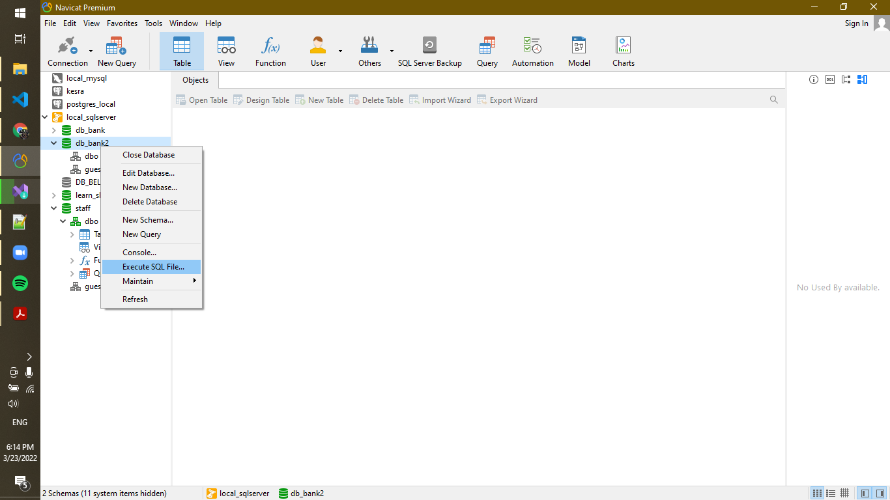

1. Akan muncul windows seperti dibawah ini. Klik pada “...” (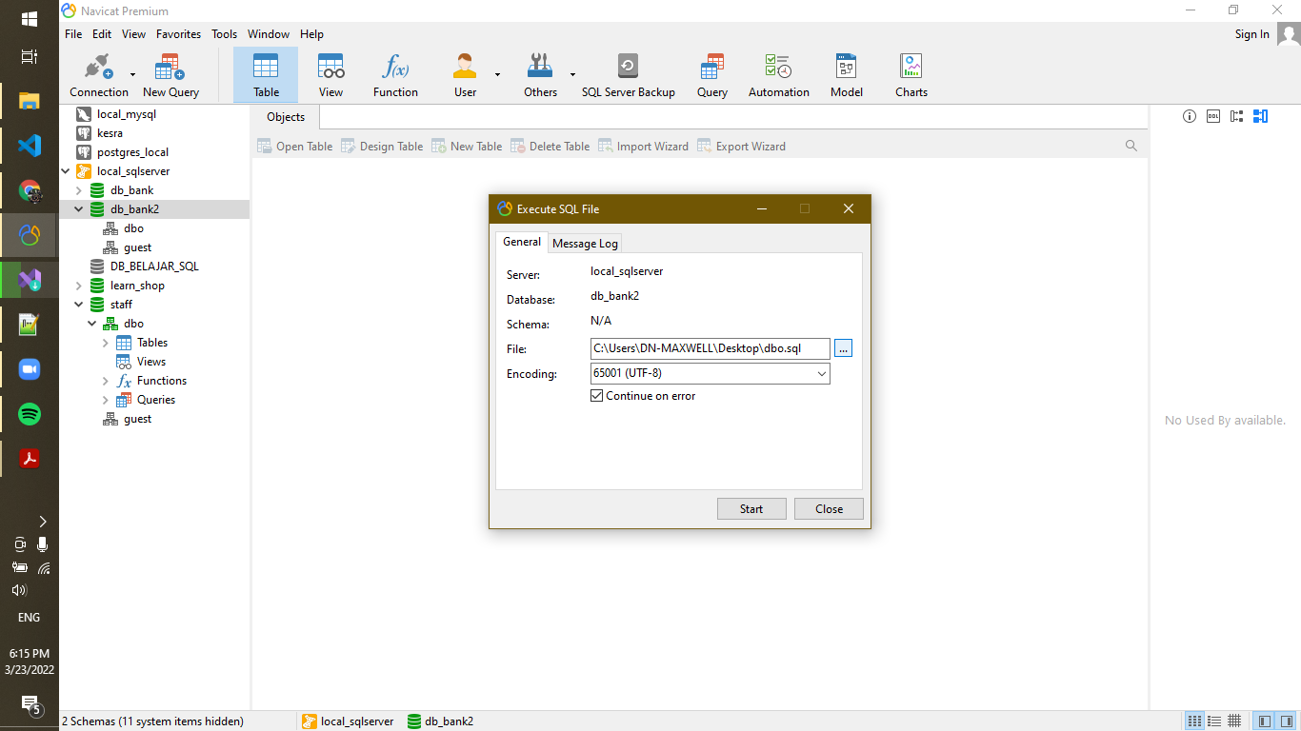) untuk memilih file yang akan di import yakni “dbo.sql” -> lalu klik “Start”



Tunggu hingga loading selesai -> klik “close”

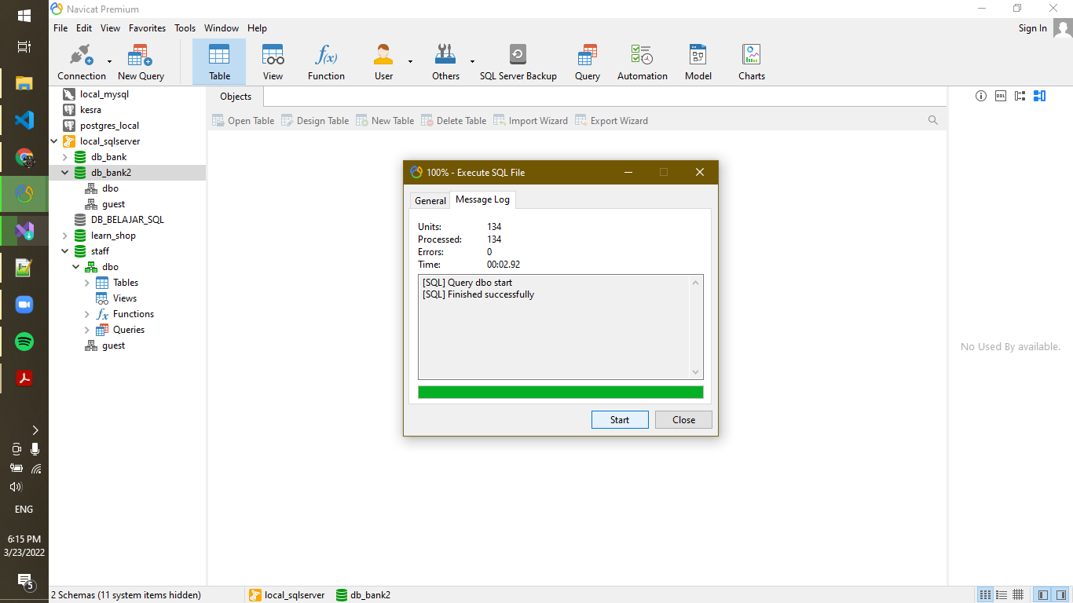

1. Sql berhasil diimport

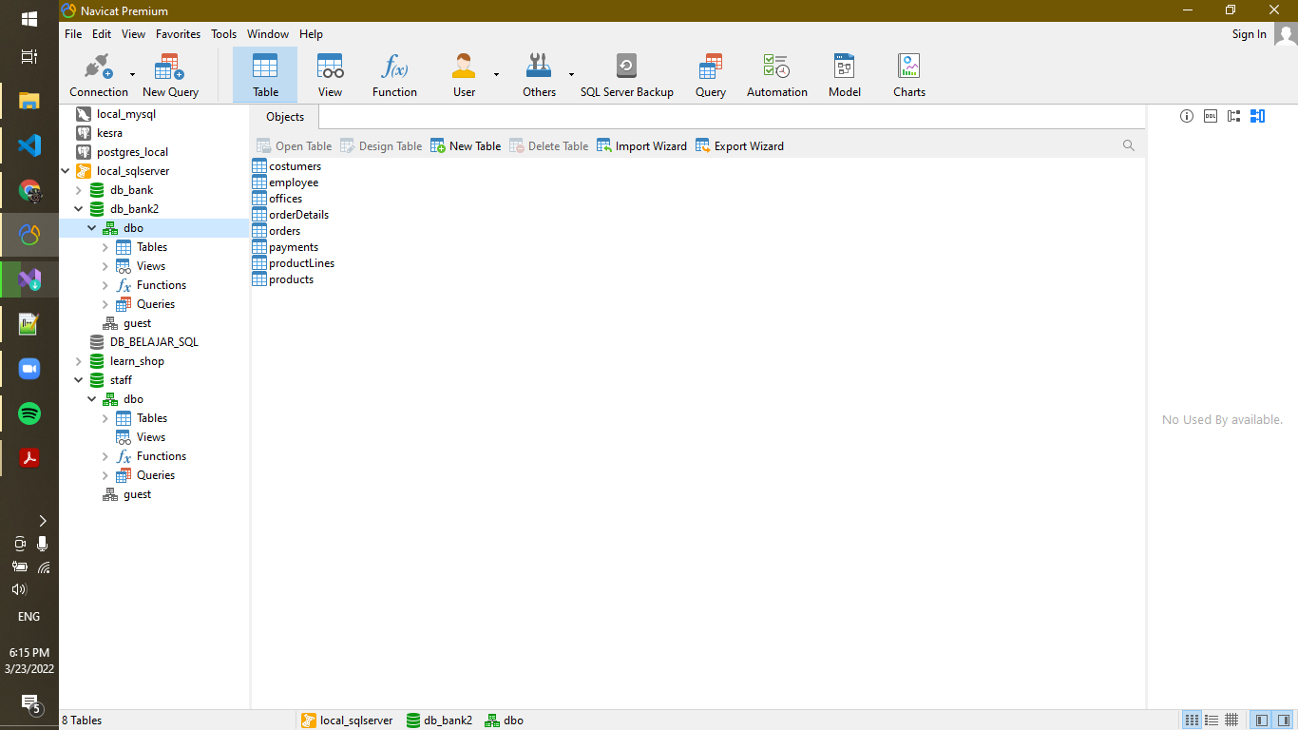

JAWABAN DARI PERTANYAAN

1. Customers => stores data customer

|  |
| --- |
| CREATE TABLE tb_costumers(  costumer_id INT IDENTITY(1,1) PRIMARY KEY,  FirstName VARCHAR(50) NOT NULL,  LastName VARCHAR(100) NOT NULL,  phoneNumber VARCHAR(15) NOT NULL,  address1 TEXT NOT NULL,  address2 TEXT,  city VARCHAR(50) NOT NULL,  state VARCHAR(50) NOT NULL,  postCode VARCHAR(10) NOT NULL,  salesRep_Employee_id INT NOT NULL,  creditLimit FLOAT  );  ALTER TABLE costumers  ADD CONSTRAINT FK_salesRep  FOREIGN KEY (salesRep_Employee_id)  REFERENCES employee (employee_id)      ON DELETE NO ACTION      ON UPDATE CASCADE;  INSERT INTO costumers(FirstName, LastName, city, phoneNumber, address1, state, postCode, salesRep_Employee_id) VALUES  ('ABC', 'ABC', 'PASURUAN', '0811234456', 'Jl. ABCDEFG' , 'INDONESIA', '133231', '10'),  ('DEF', 'DEF', 'JAKARTA', '0815676412', 'Jl. ABCDEFG' , 'INDONESIA', '125231', '10'),  ('GHI', 'DEF', 'BANDUNG', '0813456134', 'Jl. ABCDEFG' , 'INDONESIA', '128231', '10'),  ('JKL', 'AEF', 'PASURUAN', '0811234478', 'Jl. ABCDEFG' , 'INDONESIA', '113231', '10'),  ('LMN', 'BEF', 'JAKARTA', '0815676490', 'Jl. ABCDEFG' , 'BRUNEI', '123231', '10'),  ('OPQ', 'CEF', 'PASURUAN', '0811231205', 'Jl. ABCDEFG' , 'BRUNEI', '123231', '11'),  ('RST', 'FEF', 'JAKARTA', '0815673205', 'Jl. ABCDEFG' , 'BRUNEI', '123231', '11'),  ('UVW', 'GEF', 'PASURUAN', '0811234505', 'Jl. ABCDEFG' , 'BRUNEI', '122231', '11'),  ('YXZ', 'HEF', 'JAKARTA', '0815676675', 'Jl. ABCDEFG' , 'BRUNEI', '123131', '11'),  ('CBA', 'IEF', 'PASURUAN', '0811238905', 'Jl. ABCDEFG10' , 'BRUNEI', '123231' , '10'),  ('FED', 'DEF', 'JAKARTA', '0815670905', 'Jl. ABCDEFG' , 'BRUNEI', '121231' , '10'); |

1. Products => stores daftar/list model product ( dalam hal ini bisa mobil/motor dll )

|  |
| --- |
| CREATE TABLE products(      product_id INT IDENTITY(1,1) PRIMARY KEY,      productName TEXT,      productLine INT,      productScale DATE,      productVendor VARCHAR,      productDesc TEXT,      quantityInStock INT,      buyPrice FLOAT,      MSRP VARCHAR  );  ALTER TABLE products  ADD CONSTRAINT FK_productLine  FOREIGN KEY (productLine)  REFERENCES productLines (productLine_id)      ON DELETE SET NULL      ON UPDATE CASCADE;  INSERT INTO products(productName, productVendor, quantityInStock, buyPrice, MSRP) VALUES  ('Zenbook Pro Duo 15 OLED UX582', 'ASUS', 5, 40999000, 50999000),  ('Zenbook Pro 15 OLED UX535', 'ASUS', 3, 24999000, 27999000),  ('Zenbook S UX393', 'ASUS', 0, 22999000, 24999000),  ('Zenbook 14 UX435EG', 'ASUS', 0, 20499000, 22499000),  ('Zenbook Flip 13 OLED UX363 i7', 'ASUS', 0, 20499000, 22499000),  ('Vivobook S14 S433 i7', 'ASUS', 15, 14299000, 15299000),  ('Vivobook Ultra 15 OLED K513', 'ASUS', 15, 9099000 , 10099000),  ('Vivobook E410', 'ASUS', 10, 6599000, 6999000),  ('ROG Zephyrus Duo 15 SE GX551', 'ASUS', 2, 60999000, 70999000),  ('Vivobook Pro 15 OLED K3500PC', 'ASUS', 2, 15799000 , 17799000),  ('Vivobook Pro 14 OLED K3400PH', 'ASUS', 1, 14799000, 16799000); |

1. Productlines => stores daftar/list kategori product

|  |
| --- |
| CREATE TABLE productLines(      productLine_id INT IDENTITY(1,1) PRIMARY KEY,      textDesc TEXT,      htmlDesc TEXT,      img_loc TEXT  ); |

1. Orders => store Order Sales oleh customer

|  |
| --- |
| CREATE TABLE orders(      order_id INT IDENTITY(1,1) PRIMARY KEY,      orderDate DATE,      requiredDate DATE,      shipDate DATE,      status INT,      comments TEXT,      costumer_id INT  );  ALTER TABLE orders  ADD CONSTRAINT FK_customer  FOREIGN KEY (costumer_id)  REFERENCES costumers (costumer_id)      ON DELETE NO ACTION      ON UPDATE CASCADE;  INSERT INTO orders(orderDate, requiredDate, shipDate, costumer_id) VALUES  (GETDATE() - 2, GETDATE() + 1, GETDATE() - 2, 1),  (GETDATE() - 2, GETDATE() + 1, GETDATE() - 2, 2),  (GETDATE() - 2, GETDATE() + 1, GETDATE() - 2, 4),  (GETDATE() - 2, GETDATE() + 1, GETDATE() - 2, 5),  (GETDATE() - 2, GETDATE() + 1, GETDATE() - 2, 3),  (GETDATE() - 1, GETDATE() + 2, GETDATE() - 1, 3),  (GETDATE() - 1, GETDATE() + 2, GETDATE() - 1, 6),  (GETDATE() - 1, GETDATE() + 2, GETDATE() - 1, 4),  (GETDATE() - 1, GETDATE() + 2, GETDATE() - 1, 2),  (GETDATE(), GETDATE() + 3, GETDATE(), 1),  (GETDATE(), GETDATE() + 3, GETDATE(), 3); |

1. OrderDetails => store Item Order sales dalam setiap order sales

|  |
| --- |
| ALTER TABLE orderDetails  ADD CONSTRAINT FK_product  FOREIGN KEY product_id  REFERENCES products (product_id)      ON DELETE SET NULL      ON UPDATE CASCADE;  ALTER TABLE orderDetails  ADD CONSTRAINT FK_order  FOREIGN KEY (order_id)  REFERENCES orders (order_id)      ON DELETE CASCADE      ON UPDATE CASCADE;  INSERT INTO orderDetails(order_id, product_id, priceEach, quantityOrder) VALUES  (1, 3, 1),  (1, 3, 1),  (2, 11, 2),  (2, 12, 1),  (2, 13, 2),  (3, 12, 1),  (3, 13, 3),  (4, 10, 2),  (4, 12, 1),  (5, 11, 3),  (6, 13, 1),  (7, 5, 2),  (7, 6, 1),  (8, 4, 1),  (9, 4, 1),  (10, 3, 1),  (11, 6, 1),  (11, 7, 1),  (11, 8, 5); |

1. Payments => store Pembayaran oleh customer sesuai dengan akun pembayaran

|  |
| --- |
| CREATE TABLE payments(      payment_id INT IDENTITY(1,1) PRIMARY KEY,      costumer_id INT,      checkNumber INT,      paymentDate DATE,      amount FLOAT  ); |

1. Employee => store informasi karyawan dalam sebuah organisasi struktur

|  |
| --- |
| CREATE TABLE tb_employee(  employee_id INT IDENTITY(1,1) PRIMARY KEY,  FirstName VARCHAR(50) NOT NULL,  LastName VARCHAR(100) NOT NULL,  extension VARCHAR (15),  email VARCHAR(100),  office_id INT NOT NULL,  reportsTo INT NOT NULL,  jobTitle VARCHAR(100) NOT NULL,  );  ALTER TABLE employee  ADD CONSTRAINT FK_reportsTo  FOREIGN KEY (reportsTo)  REFERENCES employee (employee_id)      ON DELETE NO ACTION      ON UPDATE NO ACTION  ALTER TABLE employee  ADD CONSTRAINT FK_office  FOREIGN KEY office_id  REFERENCES offices (office_id)      ON DELETE NO ACTION      ON UPDATE CASCADE  INSERT INTO employee(FirstName, LastName, email, office_id, reportsTo, jobTitle) VALUES  ('Freya', 'Maxwell', 'freyamaxwell@frm.co.id', 1, 1, 'CEO'),  ('Steve', 'Maxwell', 'stevemaxwell@frm.co.id', 1, 1, 'COO'),  ('Naomi', 'Keith', 'naomikeith@frm.co.id', 1, 1, 'CTO'),  ('Laura', 'Maxwell', 'lauramaxwell@frm.co.id', 1, 1, 'CFO'),  ('Maya', 'Stonefield', 'mayastonefield@frm.co.id', 1, 1, 'CMO'),  ('Marcel', 'Gerald', 'marcelgerald@frm.co.id', 2, 2, 'Manager of HRD'),  ('Steven', 'Phillips', 'stevenphillips@frm.co.id', 2, 3, 'Manager of IT Department'),  ('Carmilla', 'Beck', 'carmillabeck@frm.co.id', 3, 5, 'Manager of Marketing and Sales Department'),  ('Xavier', 'Tan', 'xaviertan@frm.co.id', 2, 7, 'IT STAFF'),  ('Soya', 'Swift', 'soyaswift@frm.co.id', 3, 8, 'Marketing Officer'),  ('Marcellia', 'Rein', 'marcelliarein@frm.co.id', 3, 8, 'Sales Officer'),  ('Dana', 'Baek', 'danabaek@frm.co.id', 2, 6, 'HR Staff'); |

1. Offices => store data sales office

|  |
| --- |
| CREATE TABLE offices(      office_id INT IDENTITY(1,1) PRIMARY KEY,      city VARCHAR(50) NOT NULL,      phoneNumber VARCHAR(15) NOT NULL,      address1 TEXT NOT NULL,      address2 TEXT,      state VARCHAR(50) NOT NULL,      postCode VARCHAR(10) NOT NULL,      territory VARCHAR,  );  INSERT INTO offices(city, phoneNumber, address1, state, postCode)  VALUES  ('JAKARTA', '(021) 29865920', 'Dipo Tower, Jl.Gatot Subroto No.51-52, Jakarta Pusat 7, Petamburan, Tanah Abang,', 'INDONESIA', '10260'),  ('SURABAYA', '(031) 28937000', 'Jl. Mayjen HR. Muhammad No.36, Pradahkalikendal, Kec. Dukuhpakis', 'INDONESIA', '60189'),  ('SURABAYA', '(031) 5458241', 'Jl. Raden Saleh No.10A, Bubutan, Kec. Bubutan', 'INDONESIA', '60174'),  ('SURABAYA', '(031) 5320578', 'Jl. Pemuda No.104-106, Embong Kaliasin, Kec. Genteng', 'INDONESIA', '60271'),  ('SURABAYA', '(031) 5678271', 'Jl. Ciliwung No.14, Darmo, Kec. Wonokromo', 'INDONESIA', '60241'); |