目录
错误日志： 1
二进制日志： 1
查询日志 5
慢查询日志 6

错误日志：
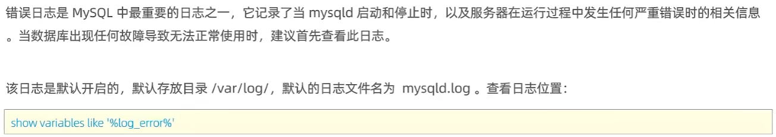
show variables like '%log_error%';
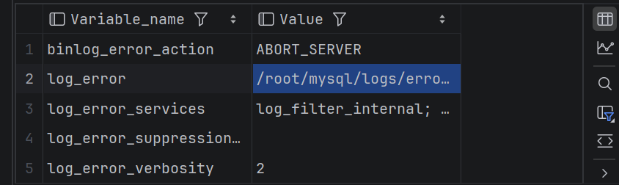
[root@xuniji mysql]# systemctl restart mysqld
[root@xuniji mysql]# mysql -u root -p
Enter password:
ERROR 2002 (HY000): Can't connect to local MySQL server through socket '/root/mysql/mysql.sock' (2)

2026-08-10T02:33:43.822866Z 0 [System] [MY-013602] [Server] Channel mysql_main configured to support TLS. Encrypted connections are now supported for this channel.
2026-08-10T02:33:43.854516Z 0 [System] [MY-010931] [Server] /root/mysql/bin/mysqld: ready for connections. Version: '8.0.39' socket: '/root/mysql/mysq.sock' port: 3307 MySQL Community Server - GPL.
2026-08-10T02:33:43.854588Z 0 [System] [MY-011323] [Server] X Plugin ready for connections. Bind-address: '::' port: 33060, socket: /tmp/mysqlx.sock

二进制日志：
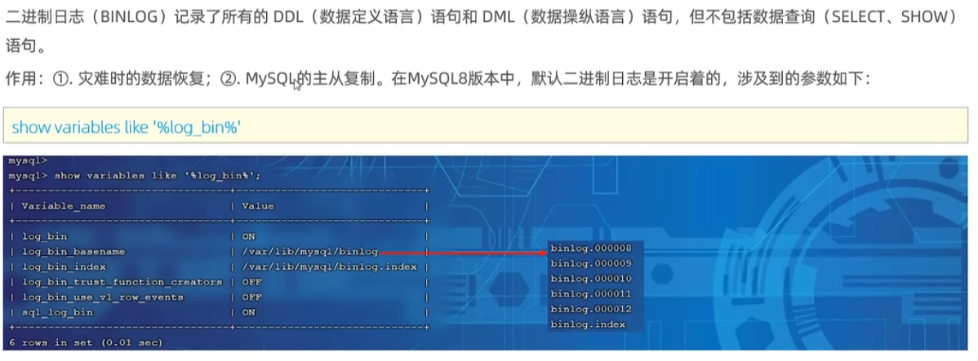
show variables like '%log_bin%';
+---------------------------------+-------------------------------+
| Variable_name | Value |
+---------------------------------+-------------------------------+
| log_bin | ON |
| log_bin_basename | /root/mysql/data/binlog |
| log_bin_index | /root/mysql/data/binlog.index |
| log_bin_trust_function_creators | OFF |
| log_bin_use_v1_row_events | OFF |
| sql_log_bin | ON |
+---------------------------------+-------------------------------+

Cd /root/mysql/data/
Cat binlog.index

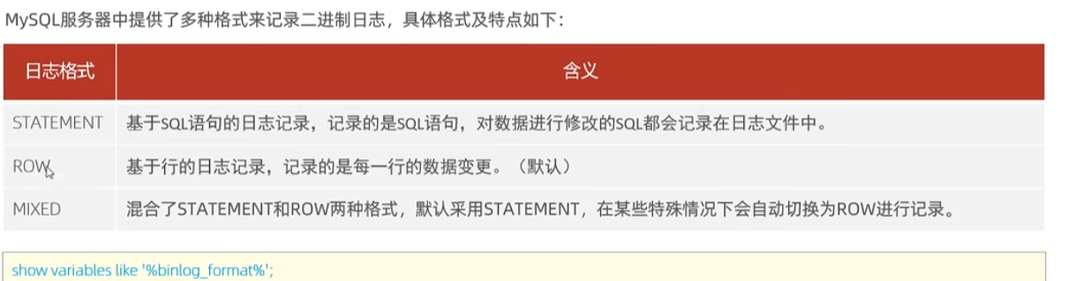
STATEMENT（基于语句）
- 直接记录执行的 SQL 语句，比如 UPDATE users SET status=1 WHERE id<100
- 优点：日志紧凑，适合批量操作
- 风险：含 NOW()、RAND()、UUID() 等函数或 LIMIT 无 ORDER BY 时，主从执行结果可能不同，导致数据不一致
ROW（基于行） — 当前默认
- 记录每行数据变更前后的实际值（before/after image）
- 优点：复制一致性最强，精确捕获数据变化
- 缺点：大批量 UPDATE 会产生很大的日志，I/O 开销高，可读性差
MIXED（混合模式）
- 智能切换：普通语句用 STATEMENT，遇到非确定性函数、临时表等场景自动切换为 ROW
- 目的：在日志体积和复制安全之间取得平衡

/etc/my.cnf

systemctl restart mysqld.service
查看默认日志格式
mysql> show variables like '%binlog_format%';
+---------------+-------+
| Variable_name | Value |
+---------------+-------+
| binlog_format | ROW |
+---------------+-------+
1 row in set (0.00 sec)

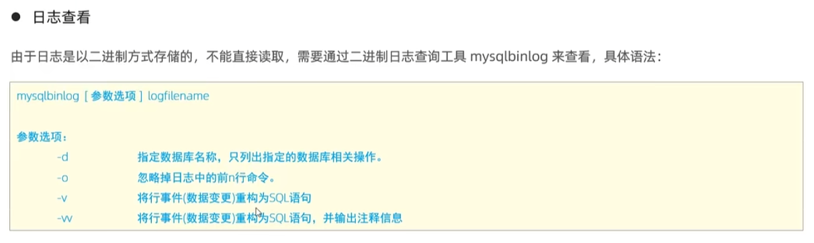
use itcast;
update tb_user set age = 34 where id=1;
执行这个更新操作后查询二进制日志文件：

mysqlbinlog -v binlog.000013
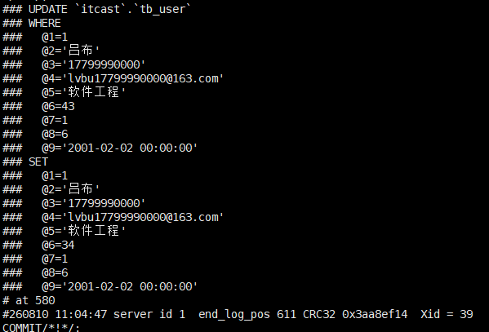
binlog_format=STATEMENT

mysql> show variables like '%binlog_format%';

+---------------+-----------+
| Variable_name | Value |
+---------------+-----------+
| binlog_format | STATEMENT |
+---------------+-----------+
1 row in set (0.01 sec)

mysqlbinlog -v binlog.000019
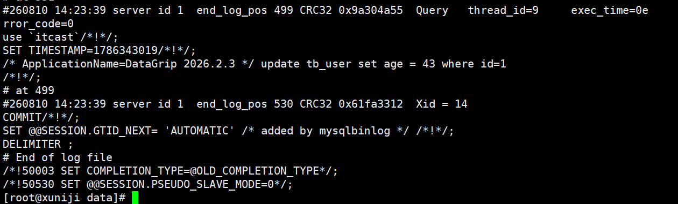
STATEMENT记录sql语句，查询不会记录在二进制日志，DDL与DML语句会被记录

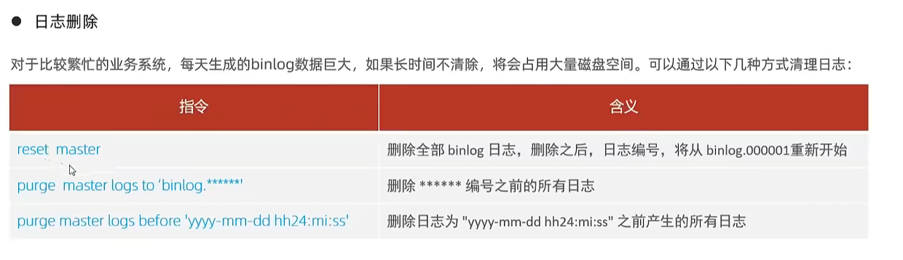
purge master logs to 'binlog.000012';
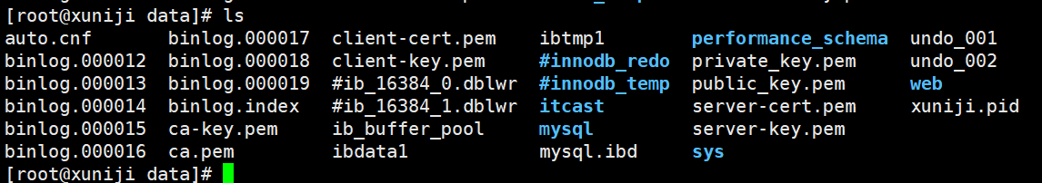
删除指的编号之前的日志文件

Reset master
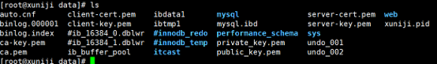
删除所有日志并从1号开始

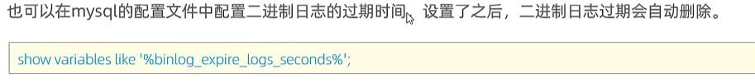
Show variables like ‘%binlog_expire_logs_seconds%’；
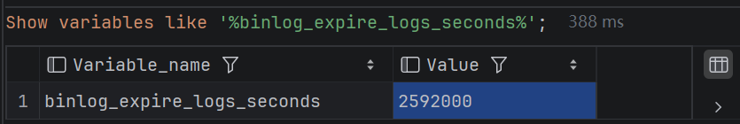

查询日志

mysql> show variables like '%general%';

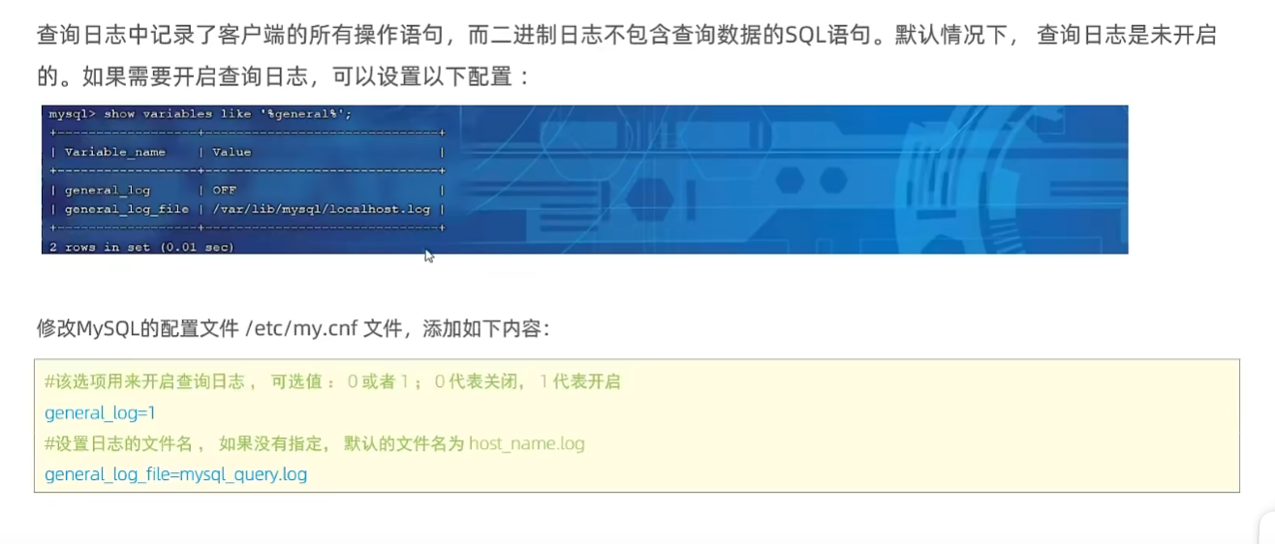
在配置文件中添加
general_log=1
general_log_file=/root/mysql/data/mysql_query.log
并重启服务
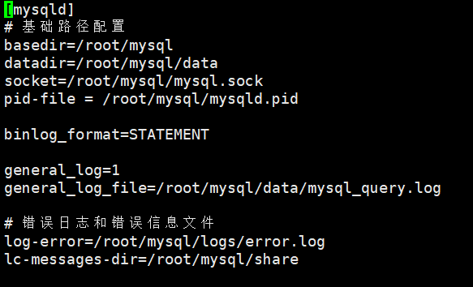

mysql> show variables like '%general%';
+------------------+----------------------------------+
| Variable_name | Value |
+------------------+----------------------------------+
| general_log | ON |
| general_log_file | /root/mysql/data/mysql_query.log |
+------------------+----------------------------------+
2 rows in set (0.00 sec)

[root@xuniji data]# tail -f mysql_query.log
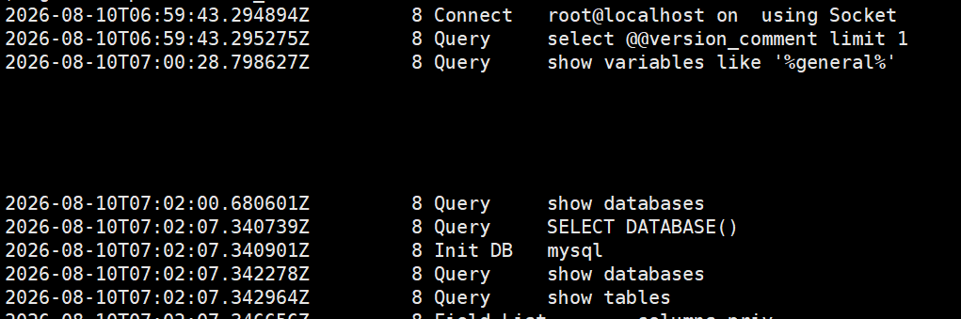
可以记录所有的增删改查，与DDL语句；（包括执行失败了的）
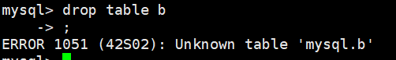

慢查询日志
