视图
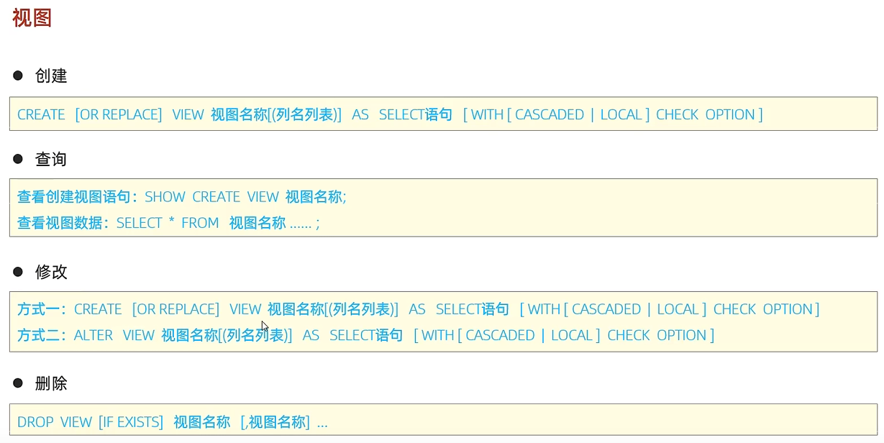
CREATE or replace view tb_user_v as select id,name from tb_user where id<=10;

show CREATE view tb_user_v;
SELECT * from tb_user_v where id <3;

CREATE or replace view tb_user_v as select id,name,phone from tb_user where id<=10;

ALTER view tb_user_v as select id,name from tb_user where id <=10;

drop view tb_user_v;

视图是一张虚拟存在的表，我们可以像操作表一样操作视图；

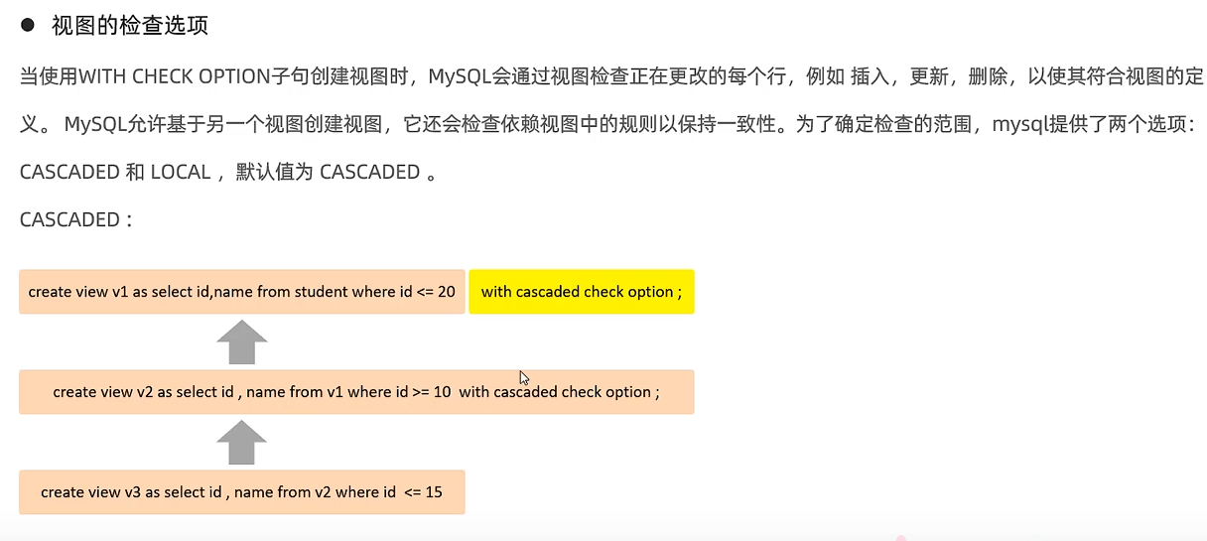
Csacad级联，添加了with cascaded check option的视图会向上检查正在更改的行

create or replace view tb_user_v1 as select id,name from tb_user where id<=20;
create or replace view tb_user_v2 as select id,name from tb_user_v1 where id >=10 with cascaded check option;

LOCAL
使用了local的
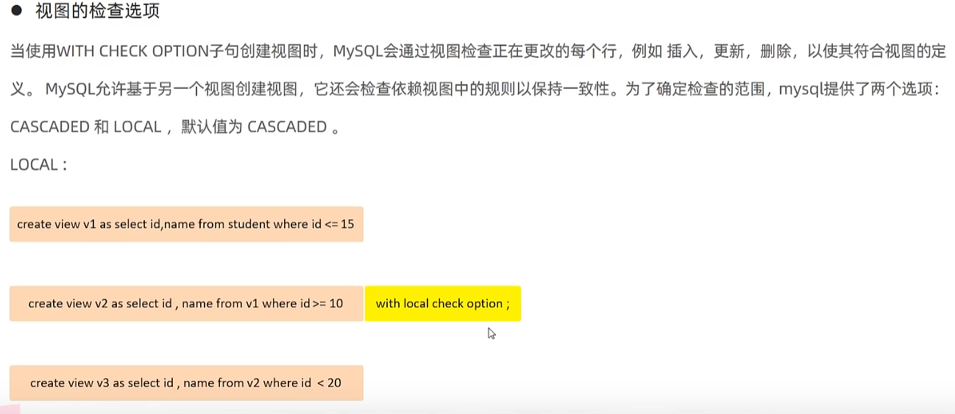
插入数据时只检查添加了local检查选项的，比如v2插入id=17的数据，其实可以插入到视图中。

视图的作用：
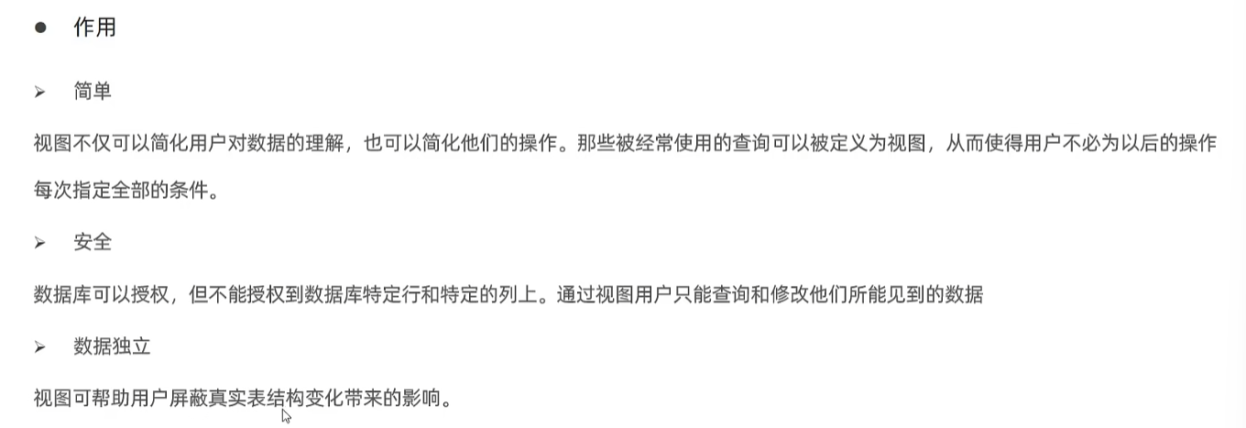
案例：
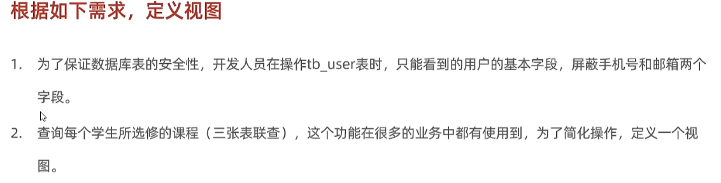
create or replace view tb_user_v_base as select id,name,age from tb_user with cascaded check option ；
create view xx_v as select sc.id, st.name, teacher, score, age from courses co,scores sc,students st where co.id=sc.course_id and st.id =sc.student_id;
select * from xx_v;
这样就可以使用视图查看成绩信息

