触发器介绍
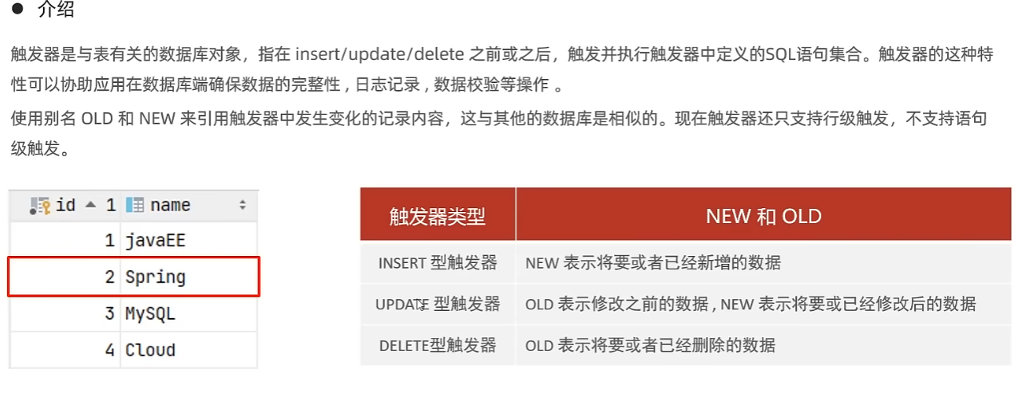
MySQL只支持行级触发器，即一条SQL语句影响的每一行都将触发，如一个update影响3行触发器触发3次，而语句触发器不管影响多少行，仅仅触发一次。

触发器语法
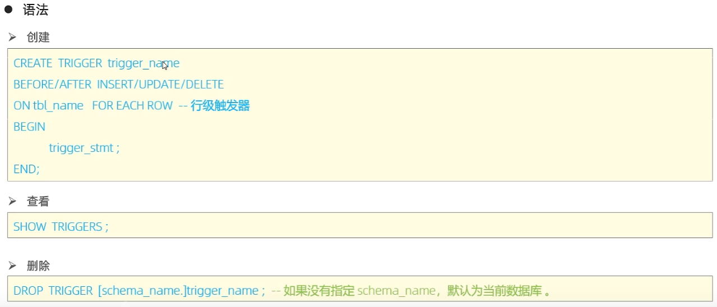
练习：
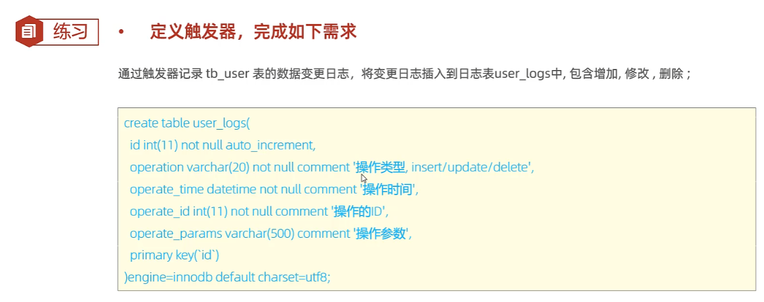

use itcast;
create table user_logs(
id int (11) not null auto_increment,
operation varchar(20) not null comment '操作类型,insert/update/delete',
operate_time datetime not null comment '操作时间',
operate_id int(11) null comment '操作的ID',
operate_params varchar(500) comment '操作参数',
primary key(id)
)engine =innodb default charset=utf8;
#创建触发器
create trigger tb_user_insert_trigger
after insert on tb_user for each row
begin
insert into user_logs(id,operation,operate_time,operate_id,operate_params) values
(null,'insert',now(),new.id,concat('插入的数据内容为:id=',new.id,',name=',new.name,',email=',new.email,',phone=',new.phone,',profession=',new.profession));
end ;
#查看触发器
show triggers;
#删除触发器
drop trigger tb_user_insert_trigger;
#插入数据到tb_user
insert into tb_user(id, name, phone, email, profession, age, gender, status, createtime)
VALUES (null,'asda','1829324328','dsaad@qq.com','软件工程',23,'1','1',now());

数据插入会被触发器记录
delimiter $$
create trigger tb_user_update_trigger
after update on tb_user for each row
begin
insert into user_logs(id, operation, operate_time, operate_id, operate_params) values
(null,'update',now(),NEW.id,concat('更新之前的数据：id=',old.id,',name=',old.name,',phone=',OLD.phone,',email=',old.email,',profession=',OLD.profession,
'更新后：',NEW.id,NEW.name,NEW.phone,NEW.email,NEW.profession));
end $$
update tb_user set name = '吕布' where id=1;
删除数据触发器同理

总结：
