Investigation Background
You work for a state health department that has identified several cases of Carbapenem Resistant Acinetobacter baumannii (CRAB). Based on your state’s investigation guidelines, you need to investigate all the facilities that an identified case has visited in the last 90 days. Additionally, if there are known roommate(s) at any location then they are also tested. If a roommate tests positive, then point prevalence screening (PPS) is conducted at the location to identify the extent of the spread. Your assignment is to explore the investigation data using MicrobeTrace and identify how CRAB is spreading in this outbreak.
MicrobeTrace Instructions:
- From the GitHub Repository (https://github.com/DNA-Bioboss/2026_AMD_Academy_MicrobeTrace_S1.git), download and/or clone the data into a folder on your computer.
  - To download, green “< > Code” > “Download ZIP”
- Read the Outbreak Overview below and use the information provided to complete the node and link list files. Some epidemiologic information from the investigation—particularly related to Facility B—is not included in the provided datasets. Use the narrative description to add the missing individuals and epidemiologic links to the files.
- Compare the Microbetrace_node_April2026_exercise and Microbetrace_link_April2026_exercise files to the Microbetrace_node_April2026_complete and Microbetrace_link_April2026_complete files to ensure your data entries are correct.
  - What error do you see on the first row of the Microbetrace_link_April2026_exercise file when you compare it to the Microbetrace_link_April2026_complete file?
  - Based on what you learned in the MicrobeTrace presentation, should this be changed? Why or why not?
- In your web browser, open a tab to MicrobeTrace (https://microbetrace.cdc.gov/MicrobeTrace/)
- Load your updated Microbetrace_node_April2026_exercise and Microbetrace_link_April2026_exercise files to MicrobeTrace by dropping them into the homepage.
- A file window will appear with tabs that categorize the file types loaded. Verify that the correct tab is selected for each file, as shown below.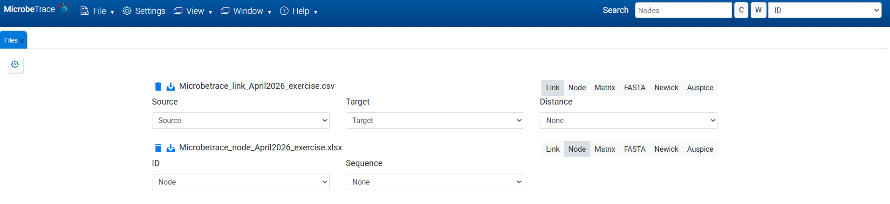
  - If the wrong tab is selected, choose the correct tab by clicking on it.
- Click Launch
- Below is what the transmission network appears without making any changes:
A “Files”tab will appear, categorizing the loaded file. Verify that the correct tab is chosen for each of the files as shown below.

  - If the wrong tab is selected, choose the correct tab by clicking on the tab.
- The transmission network that appears should look similar to the one shown below:

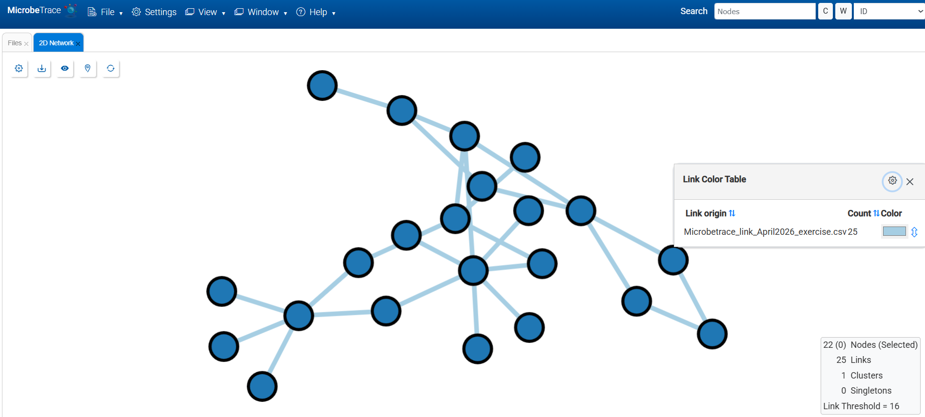

  - The number of nodes in the network should match the number of nodes in the node list. Likewise, the number of links should match the link count in the link file.
    - What types of data entry or formatting errors could cause the number of nodes or links in the network to differ from those in the node and link files?
    - What could happen if a link references a node ID that does not exist in the node list?
MicrobeTrace allows you to adjust the properties of network components, such as nodes, links, networks and groupings. This exercise will cover customizing node and link properties.
- Click the cog icon in the upper left corner, and the “2D Network Settings” window will appear.
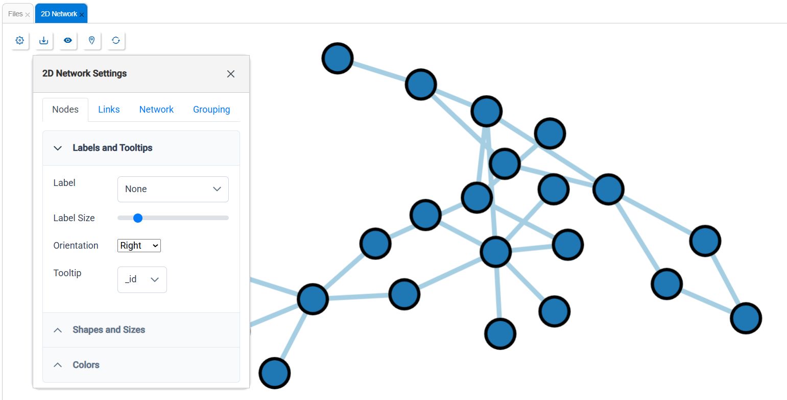
- To modify and add labels to the nodes, click the “Labels and Tooltips” dropdown menu. Select the “Node” column and see the labels appear. Use “Label Size” and “Orientation” to adjust the labels. “Tooltip”, allows you to add additional information to a node. This information appears in a small pop-up window when you hover over the node. Under “Tooltip” unselect “_id” and select “Node” and “Diagnosis Date.”
- Use the “Shapes and Sizes” dropdown menu to adjust the shape of the nodes.
  - Under “Shape By”, what column should be chosen to distinguish between facilities and cases?
    - Hint: Review the Microbetrace_node_April2026_exercise file, and identify which column categorizes the nodes.
  - To adjust the size of the nodes according to the number of links connecting to each node. Under “Size By”, select “Degree.”
- Use the “Node Symbol Table” to change the category name and shapes.
  - Double-click on “person” and type “Case.”
  - Under “Facility”, click the dropdown menu and select “Diamond.”
- Use the “Global Settings” window to color the nodes.
  - Click “Colors” > “Show Colors”, then under the “Styling” select “Color Nodes By” to color the nodes to distinguish the different categories associated with each node visually.
  - HINT: What column differentiates facility types and AMR genes associated with each case?
- Use the “Node Color Table” to change the node colors and format the legend.
  - Double-click on Hospital’s color patch and slide the color bar to yellow, and move the white circle along the gradient to select golden-yellow.
  - Click the bidirectional arrow next to the yellow patch, then slide the knob halfway down to decrease the color’s transparency.
  - Click on the double arrows next to “Node Specificity”, to reorganize the categories.
  - Click the cog on the “Node Color Table” and select “Show Frequencies.”
    - What percentage of the nodes are OXA-23?
- Click the cog and select the “Links” tab to adjust the link properties as needed.
  - Multiple variables can be manipulated for links, but as you investigate, you may want to show some while leaving fields empty or unchanged when creating a visualization for stakeholders. As you may realize, the transmission network can get crowded quickly.
  - For now, color the nodes based on the “Exposure” column.
- Before adding genetic data to the transmission network, save your work and the style of your node and link properties.
  - Save your session: Click File > Save, name your session, verify “session” is selected in the dropdown menu and click “Save.”
    - Saving your work lets you save your dataset and come back to it later.
  - Save your style: Click File > Save, name your style, select “style” from the dropdown menu, and click Save.
    - This will allow you to apply the same settings when loading data for another investigation. Keep in mind to use the same file types (i.e., node vs link) with the same variable headers when you apply the style file in your new session, or the saved styles will not apply correctly.
- Load the genomic data onto MicrobeTrace.
  - Select the “Files” tab, select “Add File(s)”, load the microbetrace_tree_exercise.newick file, verify that the “Newick” tab is selected, and then select “Update.”
- Using the “Global Settings” window, apply the style saved in step 17.
  - Click “Settings” under the “Styling” tab, scroll down to “Apply Style”, select “Browse”, and select your saved style file.
  - After setting node and link properties, adding genomic data will reset them, removing your customizations. Simultaneously loading epidemiological and genomic data to MicrobeTrace can also make it harder to clearly visualize and adjust node and link properties. For this reason, it is recommended to first load epidemiological data, customize the node and link properties and save your style. Then add the genomic data and apply the saved style.
- Move the nodes around to improve the visualization of the transmission network.
- Change the link threshold in “Global Settings.”
  - Select “Settings” > “Filtering” tab, under “Filtering Threshold” type “2”, and select “Done.”
- Review the transmission network.
- Review the Heatmap.
  - View > Heatmap
- View the time player that provides the timeline of the investigation.
  - Select “Settings” > “Timeline” tab > Timeline By > Diagnosis Date
- Draw conclusions of the investigation by reviewing data and tools used throughout the exercise.
- What recommendations would you make to the facilities?

Outbreak Overview
On February 22, 2024 you are notified by your State Public Health Laboratory of a positive Oxa-23 clinical isolate (DOC 15-Feb-2024) from a patient, Person 1 at healthcare facility D. Person 1 has a roommate, Person 16.
Working with the Infection Preventionist of Facility D and the medical record for Person 1, you are able to reconstruct the following healthcare history:
Facility | Dates of Admission | Roommate?
Facility D | 10-Feb-2024 to present | Person 16
Facility A | 2-Jan-2024 to 10-Feb-2024 | Person 40
Facility E | 20-Nov-2023 to 2-Jan-2024 | Person 18
Facility C | 10-Nov-2023 to 20-Nov-2023 | Person 48

On 28-Feb-2024, Person 16, the current roommate of Person 1 at Facility D is screened. Person 16 screens positive for Oxa-23.
Based on these findings, you decide to conduct a PPS at Facility D, and to screen the Roommates at the prior healthcare facilities. These screenings occur on 4-March-2024.
The results of testing conducted on 4-March-2024 are as follows:
Facility | Date | Screening | Results
Facility D | 4-March-2024 | PPS | Oxa-23: Person 10
Facility A | 4-March-2024 | Person 40 | Oxa-23 and Oxa-24!!
Facility E | 4-March-2024 | Person 18 | Oxa-23
Facility C | 4-March-2024 | Person 48 | Oxa-24!!

The investigation has now expanded to include 4 facilities, and PPS are planned at each. These PPS are conducted on multiple dates between 15-March-2024 and 22-March-2024. The results of these screenings are presented below:
Facility | Date | Screening | Results
Facility E | 15-March-2024 | PPS | Oxa-23: Person17  Oxa-23 and Oxa-24: Person 41
Facility A | 20-March-2024 | PPS | Oxa-24: Persons 43, 46, 49
Facility C | 22-March-2024 | PPS | Oxa-24: Persons 42,45

Additional case investigation at Facility E reveals that Person 41 was the roommate of Person 40 following the discharge of Person 1.
Healthcare histories of colonization cases are collected. The information for these is included in the link file.
Two individuals are identified to have recent stays at the same long term care facility, Facility B.
Case | Resistance Gene | Facility | Dates of Admission
Person 45 | Oxa-24 | Facility B (LTCF) | 26-Aug-2023 to 16-Sept-2023
Person 49 | Oxa-24 | Facility B (LTCF) | 1-July-2023 to 26-Aug-2023

A PPS is conducted at Facility B on 2-April-2024. The results of that PPS are presented below:
Facility | Date | Screening | Results
Facility B | 2-April-2024 | PPS | Oxa-24: Persons 44, 47, 50

The healthcare histories of these additional cases is collected.
Case | Resistance Gene | Facility | Dates of Admission
Person 44 | Oxa-24 | Facility B (LTCF) | 21-Aug-2023 to present (4-April-2024)
Person 47 | Oxa-24 | Facility B (LTCF) | 7-Sept-2023 to present (4-April-2024)
Person 47 | Oxa-24 | Facility C | Visit (date not specified)
Person 50 | Oxa-24 | Facility B (LTCF) | 12-Sept-2023 to present (4-April-2024)
Person 50 | Oxa-24 | Facility A | Dates not specified

