**For mac users:**  you're all set. You have everything you need for the workshop (skip next section and go to downloads)

**For windows users:**

Download and install GitBash: <https://msysgit.github.io>

Click on <http://www.fosshub.com/ConEmu.html#clickToStartDownload> and then download **"Download ConEmu Preview, Installer (32-bit, 64-bit)"** file. Finish installing.

Now open ConEmu application from the "All Programs"

Choose the following options:

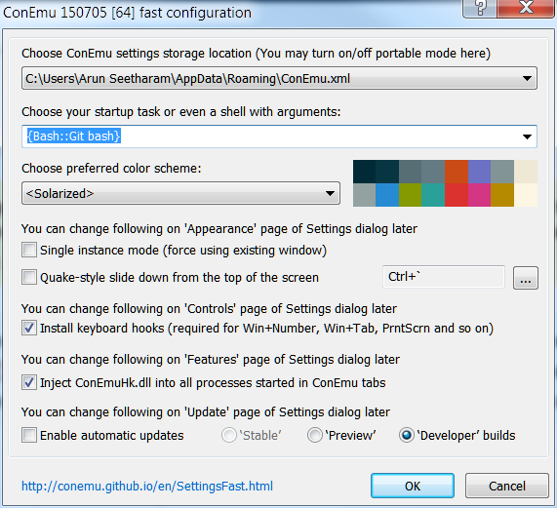

And click OK. Now you're all set for the workshop

**Downloads**:

Please download the file from this link:

<https://github.com/ISUgenomics/basic_UNIX_2015/archive/master.zip>

Once downloaded, extract the files and put it in some place/directory that is easier to access. It would be great if you place the extracted folders in "/home/username/" (mac users) or in the "Documents" folder (for Windows users).