Challenge Lab 5

Total points: x/25
Time limit: 15 minutes
Screenshots made after 15 minute = 2 point deduction for each minute or partial minute over 15 minutes

Purpose
The purpose of this challenge lab is to give you more practice using commands learned in chapters covered to date in a semi-realistic setting by trying to complete a set of tasks.
I recommend you read through the entire lab first to get a sense of what is trying to be accomplished. That will help you determine the overall context so that if you are unsure about what I am asking you to do, you can ask for clarification before starting.

Make a reservation on the Redhat Admin I pod, log in to the KIOSK (password= redhat)
Start the workstation virtual machine: rht-vmctl start workstation

After the workstation is up and running you can ssh to the work station (it may take a minute or two).

Open a terminal window and type: date
Use the Netlab screenshot option and take a screenshot
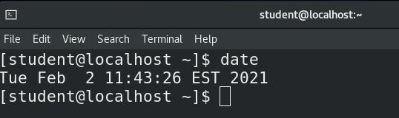
This is your start time. Your 15 minutes starts now

Task 1: Make sure you have a clear history file
- Login to student@workstation on netlab (1 point)
- Type history -c
- Type the command that tells you your currently location in the directory structure: (1 point).

Task 2: Create some directories and files
- Create a new directory and move into it.
  - While in your home directory, make a directory called Challenge_Directory and make it your current directory (1 point).
- In a previous Challenge lab you used brace expansion to create a few files and wildcards/globbing to pattern match files to copy and move around. This time we will create many more to illustrate the need to master this skill of using wildcards.
  - With a single command, create numerous empty files quickly using brace expansion.
    - The filenames will have the following structure:
      - PART1_PART2_Number1Number2
      - Part 1 on the file name should be one of the following
        - tshirt
        - hoodie
        - sweater
      - Part 2 of the file name should be one of the following:
        - silk
        - soft
        - substandard
      - The first number will be 3, 4 or 5
      - the second number will be 5,7,or 9
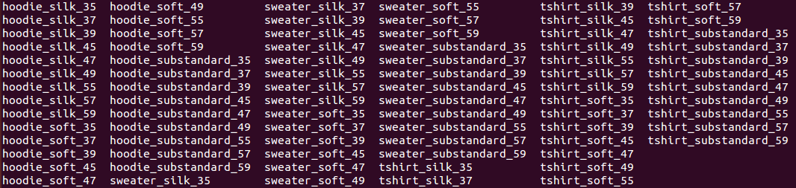
examples of what I mean:
tshirt_soft_39
hoodie_silk_55
Here are a few more examples of what I’m looking for:
(5 points)
  - If you've done this commands correctly there will be a total of 81 (you may see the 84 depending on how you use the ls command files), use the wc command with the appropriate option to display JUST the number of files created in that directory.
(2 points)
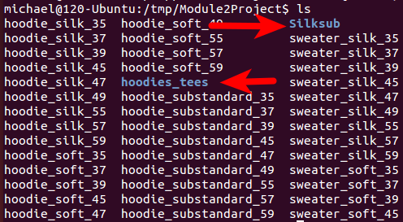
- Create multiple directories with a single command
  - Make two other directories inside the Challenge_Directory directory called Silksub and hoodies_tees
full points if you create both with a single command (do not use brace expansion)
half points by completing this with 2 separate commands
(5 points)
- Control multiples files at once with wildcard symbols (this is called globbing)
  - Using the * and [ ] wildcards at least once, copy only files that match the pattern:
    - the file starts with hoodie, and have silk or substandard in the name to the directory you called Silksub
    - list the files in the Silksub directory

Use the Netlab screenshot option to take a screenshot list of the results call it T2_4ii.

5 points if you correctly match the file names and you use a relative path
2.5 points if you correctly match the file names and use an absolute path
- A more complex matching task using multiple pattern matching meta-characters
  - Using different meta-characters in a single pattern match, list the files that refer to sweater, or tshirts, silk or substandard and end with 47, 49, 57, or 59
Full points for creating a glob that uses at least 2 different wildcards is a single pattern match
Half points for using multiple pattern matching commands to accomplish the task
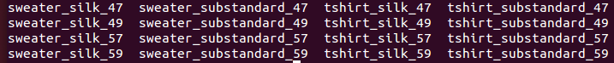
no points for doing this manually
Use the Netlab screenshot option and take a screenshot of the result. Call it T2_5a.

(6 points)

Type: date
Use the Netlab screenshot option and take a screenshot
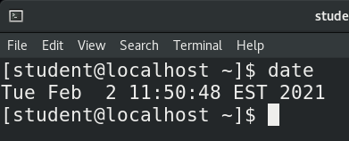
This is your finish time
====================================================================

Submit your work

Run the history|less command and take screenshots of each screen

There should be minimum of 5 screenshots; the start and finish date screenshots, the T2_4ii and T2_5a screenshots and the screenshot(s) showing your command history.

If you do not include the required screenshots you receive a 0 on that part.

Submit your reservation number to Bb

