Challenge Lab 6

Total points: 35
Time limit: 40 minutes
Screenshots made after 40 minutes = 2 point deduction for each minute or partial minute over the time limit.

Purpose
This challenge lab focuses on practicing the different redirection operators, file ownership and permissions. To practice those commands you will also get a chance to get practice with adding users.
I recommend you read through the entire lab first to get a sense of what is trying to be accomplished. That will help you determine the overall context so that if you are unsure about what I am asking you to do, you can ask for clarification before starting.

Make a reservation on the Redhat Admin I pod, log in to the KIOSK (password= redhat)
Start the workstation virtual machine: rht-vmctl start workstation

After the workstation is up and running you can ssh to the work station (it may take a minute or two).

Open a terminal window and type: date
Use the Netlab screenshot option and take a screenshot
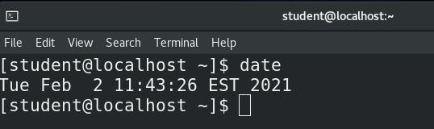
This is your start time. Your time starts now

Task 1: Make sure you have a clear history file
- Login to student@workstation on netlab
- Type history -c
- Type the command that tells you your currently location in the directory structure

Task 2: Create New User (9 points)
For this lab we need 2 users. Each will have a different history file. The Root user will also have a history file. Wanna guess how many history file screenshots you’ll need? :)
- Display your history file
Take a screenshot in Netlabs and call it T2_1a
  - in the comment box of the screenshot tell me who’s history file you are looking at (1 point).
- We need to add a new user. But before we do, I want you to orient your self to make sure you understand what is happening.
  - Type the command to switch to the root user (1 point)
  - Type in the command to determine your present working directory (1 point).
  - Type the command that shows you who you are (1 point)
  - Display your history file again
Take a screenshot in Netlabs and call it T2_2d.
  - In the comment box of the screenshot tell me who’s history file you are looking at (1 point).
- Time to create that second user. (before you start, verify your present working directory is /root).
  - Create a new user account for Francis Cecil Sumner (look him up, if you like). The username will be fsumner and the password will be FSumner123$. (2 points)
  - Use the chage command and set the minimum number of days between changing passwords to 7 and the maximum number of days the password is valid to 90. (2 points).
    - full points if you can set both at the same time
    - ½ points if you can accomplish the task

Task 3: Verify Your Work So Far (4 points)
- Use the tail command to show just fsunmer’s entry in the /etc/passwd file and the /etc/shadow (2 points).
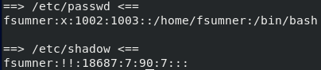
  - full points if you can use the tail command once and view both files
  - ½ points if you accomplish the task.
- Repeat this task, except this time redirect the output to a file called new_user_RootAcct1. (1 point)
- Repeat this task, except this time use the command the send the output to the terminal and to a file at the same time. Name that file: new_user_RootAcct2. (1 point)
**as a tip, review chapter 5 for the command.
- Verify that these files exist by listing the contents of the /root directory. Use the option flag for the long listing format (1 point).
Take a screenshot in Netlabs and name the screenshot T3_4.

Task 4: Let’s Switch over to fsumner’s account and do a little work (8 points)
You should still be in the root account. Verify this and if you are not switch to this account before starting the next task.
- From the root user account, switch to the user fsumner. (1 point)
  - Verify your present working directory is /home/fsumner (1 point) and you are currently acting as fsumner (tip: review chapter 2 for a reminder of how to do that) (1 point).
- Francis wants to create a few different files to store facts and trivia about his famous psychoanalyst colleagues. Create the following empty files:
Sigmund_Freud
Carl_Jung
Karen_Horney
Erik_Erikson
Otto_Rank
Frantz_Fanon
(3 points)
- List the contents of the directory in long listing format and redirect the output to a file called: Famous_psychoanalysts. (2 points)
- View your current history and redirect the output to a file called fsumner_history.
Take a netlab screenshot. Call it: T4_4

Task 5: Now for some more advanced work (14 points)
Exit out of the fsumner account and return to the root user account.
Verify that your present working directory is /root and you are the user root.
- From the root user account, create a file called Multiple_users_work (1 point).
- Using the cat command and the correct redirection operator (tip: review chapter 5), append the contents of the Famous_psychoanalysts file and the fsumner_history to the Multiple_users_work file. (5 points)
full points if you can do both files at once using brace expansion
½ points if you can correctly accomplish this.
- Using the correct command and the correct redirection operator, append the history of the root user to the Multiple_users_work file. (2 points)
- Change the groupowner of the Multiple_users_work file to student (1 points)
- Change to file permissions of the Multiple_users_work file to allow group members to write to the file. (1 point)
- Move the file to the home directory of student and call it Multiple_users_work_Student. (2 points)
- Run the history|less command and take screenshots of each screen

Take a Screenshot in netlabs showing this result. Call it: Task5_7a,b,etc.
- Exit the root user account. Verify you are the user student and make sure your present working directory is /home/student/
- Append the command history is user student to the Multiple_users_work_Student file. (2 points)

Type: date
Use the Netlab screenshot option and take a screenshot
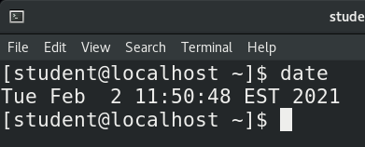
This is your finish time

==============================================Submit your work

Run the less| Multiple_users_work_Student command and take screenshots of each screen

There should be minimum of 6 screenshots. 5 from earlier in the lab and the screenshot(s) showing the contents of the Multiple_users_work_Student file.

Submit your reservation number to Bb.

