“Challenge” Hands On Lab 2
Score x/25

This is a timed challenge. You have 15 minutes.
Screenshots made after 15 minute = 2 point deduction for each minute or partial minute over 15 minutes
Make a reservation on the Redhat Admin I pod, log in to the KIOSK (password= redhat)
Start the workstation virtual machine: rht-vmctl start workstation
After the workstation is up and running you can ssh to the work station (it may take a minute or two): ssh workstation

Open a terminal window and type: date
Use the Netlab screenshot option and take a screenshot
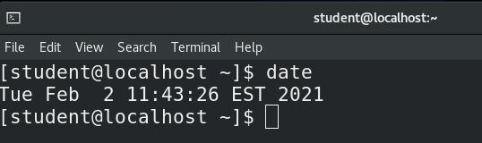
This is your start time. Your 15 minutes starts now

- Check to determine your present working directory.
1 point

- Review how man pages work and search for the pattern “short description” within the man pages.
1 point

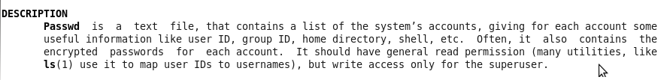
- Read both man passwd and man 5 passwd and determine the file location of the passwd file passwd file (NOT the changing password command, the passwd file. It will look like the image on the right)
2 points

- From your present working directory, copy the passwd file to your current directory
10 points if you use a relative path
5 points if you use an absolute path
3 points if you get a copy of the file to your home directory
Take a screenshot from within netlabs showing the passwd file in your home directory

- Use the command that displays the first few lines of a file and the correct option to change to default number of lines from 10 to only the first 5 lines of the passwd file
2 points

- Use the command that displays the last few lines of a file and the correct option to change to default number of lines from 10 to only the last 5 lines of the passwd file
2 points

- Run wc passwd (if you were not able to correctly copy the file to your home directory run wc /etc/password)
1 point
½ point if running wc /etc/passwd

- View the man page for the wc command and determine which flag to use to display only the number of lines in a file
1 point

- Run the command again but with the correct flag to only show the number of lines in the file to the screen
1 point

- Run the command again but instead of sending the result to the screen, send the results to a file called "number_of_system_accounts"
1 point

- In the /tmp directory, create a directory called Challenge_Lab_2
1 point

- From the Challenge_Lab_2 directory, create a soft link to number_of_system_accounts inside the Challenge_Lab_2 directory called soft_number and a hard link to number_of_system_accounts called hard_number
2 points (1 point each)

Type: date
Use the Netlab screenshot option and take a screenshot
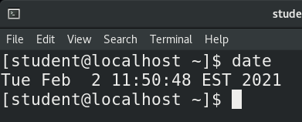
This is your finish time
=========================================================================
Run the history|less command and take screenshots of each screen

Submit your reservation number to Bb

