“Challenge” Lab 1: Creating, copying and moving files
Score x/25

Time limit: 15 minutes
Screenshots made after 15 minutes = 2 point deduction for each minute or partial minute over 15 minutes.
Make a reservation on the Redhat Admin I pod, log in to the KIOSK (password= redhat)
Start the workstation virtual machine: rht-vmctl start workstation
After the workstation is up and running you can ssh to the workstation (it may take a minute or two): ssh workstation

Open a terminal window and type: date
Use the Netlab screenshot option and take a screenshot
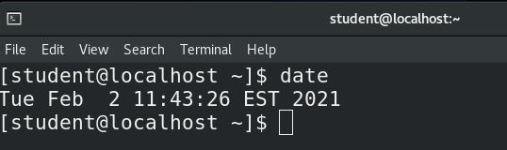
This is your start time. Your 15 minutes starts now

1. login to student@workstation on netlab
2 points

2. Ensure your present working Directory is ~/Public (if it does not exist….what should you do?) and verify you are in the correct directory
2 points

3. Make the following files:
10 points if you correctly use brace expansion
5 points if just correctly create them

file1
file2
file3
Pale1
Pale2
Pale3
pail1
pail2
pail3

4. Make a directory called "Surprise" in the ~/Public directory
2 points

5. Copy all files that have an "e" in their name to the directory Surprise
4 points if correctly use wildcards (*, ? and/or [ ] only)
2 points if you correctly complete without wildcards

6. Move all files that have a 1 or a 3 in their name to the ~/Documents Directory (if it does not exist….what should you do?). You can use *, ? and/or [ ] wildcards only.
5 points if correctly achieve this using a relative path
2.5 points maximum if you use an absolute path

Type: date
Use the Netlab screenshot option and take a screenshot
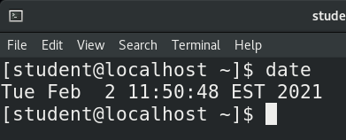
This is your finish time
=========================================================================

Run the history|less command and take screenshots of each screen

Submit your reservation number to Bb

