“Challenge” Lab 2: Using man pages and file manipulation
Score x/25

Time limit: 15 minutes
Screenshots made after 15 minutes = 2 point deduction for each minute or partial minute over 15 minutes.
Make a reservation on the Redhat Admin I pod, log in to the KIOSK (password= redhat)
Start the workstation virtual machine: rht-vmctl start workstation
After the workstation is up and running you can ssh to the workstation (it may take a minute or two): ssh workstation

Open a terminal window and type: date
Use the Netlab screenshot option and take a screenshot
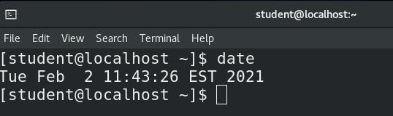
This is your start time. Your 15 minutes starts now

- Check to determine your present working directory.
1 point

- Review how man pages work by looking at the manual page for man. Once you are looking at that man page, and search for the pattern “short description” within the man pages by typing /short description

if you’ve done this correctly you should see something that looks like this:

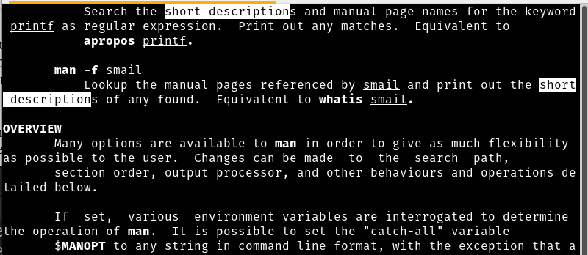
1 point

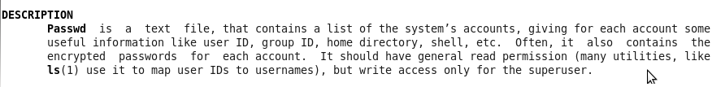
- Read both man passwd and man 5 passwd and determine the file location of the passwd file passwd file (NOT the changing password command, the passwd file. It will look like the image on the right)

2 points

- From your present working directory, copy the passwd file to your current directory
10 points if you use a relative path for both source and destination
5 points if you use a relative path for either source or destination
3 points if you get a copy of the file to your home directory

Take a screenshot from within netlabs showing the passwd file in your home directory. Name it screenshot 4

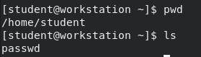

- Use the command that displays the first few lines of a file. Use the correct option to change to default number of lines from 10 to show only the first 5 lines of the passwd file
2 points

- Use the command that displays the last few lines of a file. Use the correct option to change to default number of lines from 10 to only the last 5 lines of the passwd file
2 points

- Run wc passwd (if you were not able to correctly copy the file to your home directory run wc /etc/password)
1 point
½ point if running wc /etc/passwd

- View the man page for the wc command and determine which option to use to display only the number of lines in a file
1 point

- Run the command again but wthis time with the correct option to only show the number of lines in the file to the screen
1 point

- Run the command again but instead of sending the result to the screen, send the results to a file called "number_of_system_accounts"
1 point

- From your present working directory, create a directory called Challenge_Lab_2 in the /tmp directory,
1 point

- Change directory from your present working directory to the Challenge_Lab_2 directory.

- Create a soft link to number_of_system_accounts file you created in your home directory inside the Challenge_Lab_2 directory called soft_number.
1 point

- Create a hard link to number_of_system_accounts file you created in your home directory inside the Challenge_Lab_2 directory called hard_number
1 point
- I need to see where you are and if you’ve created the links correctly. Run pwd command then the ls -l *_number

Take a screenshot in netlabs called Screenshot 15. The results of this step it should look like this:

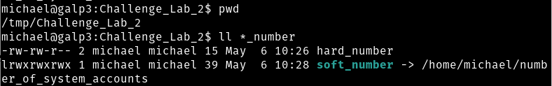

Type: date
Use the Netlab screenshot option and take a screenshot
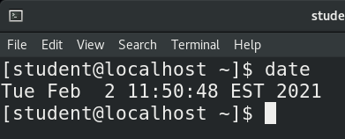
This is your finish time
=========================================================================
Run the history|less command and take screenshots of each screen (Pressing the space bar or the PgDn/PgUp key will move you between screens).

In total, you must have at least 5 screenshots: Start time, Screenshot 4, Screenshot 15, your history

Submit your reservation number to Bb

