Creating virtual WLAN interfaces
Simulating wireless connectivity with a machine without access to real wireless hardware

The walkthrough used here is heavily derived from this site: https://www.suse.com/c/creating-virtual-wlan-interfaces/

The virtual machine specifically used for this assignment is kali 2022.4 for Intel/AMD machines. You can explore more recent versions and/or machines for other architecture here: https://www.kali.org/get-kali/

How to understand the instructions:
Bolded text is an actual text to type at the command line
File names will be italicized (they may also be bolded if they are part of the command you need to enter in the terminal.)

You are eventually going to be using 2 separate terminal windows (both as the root user).

There will be references to entering commands in either the Left Terminal or the Right Terminal. Make sure you position your terminal windows to make these instructions easier to follow.

Included screenshots are for reference only. Specific values and interface names are going to be specific to your machine and may not be identical to those presented here. Pay attention to your machine output and make the appropriate substitutions.

Boot the machine, open the first terminal window and switch to the root account.

Switch into the root account

sudo su

password is kali

Install required applications, if not already installed
apt install hostapd dnsmasq wpasupplicant iw

(These should already be installed so you may see a message that says XXXX is already the newest version)

If any of these applications are not available in the default repositories you can add new repositories by following these instructions:

In the /etc/apt/ directory verify the file sources.list exists

ls /etc/apt/*

(the * is a wildcard character that matches all the contents of the directory)

If the file does not exist, the following command will create it and open it in preparation for adding the new source lines.

nano /etc/apt/sources.list

If sources.list does exist, edit it using the command above and either verify the following lines exist or add them if they do not.

deb http://http.kali.org/kali kali-rolling main non-free contrib
deb-src http://http.kali.org/kali kali-rolling main non-free contrib
Save the file. Exit and run the following command to force the apt application to re-read the sources.list file.
apt update

Setup WLAN interfaces

Since this is a virtual machine it does not directly connect to your host machine’s wireless card for internet connectivity. There are ways to force this, but the approach used here makes it easier to maintain internet connectivity and learn about wireless connectivity and communications at the same time.

Verify required kernel module (mac80211_hwsim ) is installed

grep HWSIM /boot/config-*

If it is already compiled in the kernel you will something similar to this:

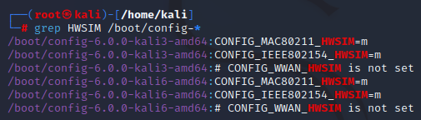

/boot/config-6.0.0-kali6-amd64:CONFIG_MAC80211_HWSIM=m <-- the “=m” means already compiled and ready to use.
============================================
what to do if not installed ?
We will have to troubleshoot together later
============================================

Setup Wifi interfaces

Have a quick look to see what network interfaces currently exist
ip a or ip link
(the command ip a is just a shortened form of the ip address command. You may see it in several forms: ip a, ip add, ip addr)
This shows the virtual network interface hardware the machine currently knows about. It should look similar to this:

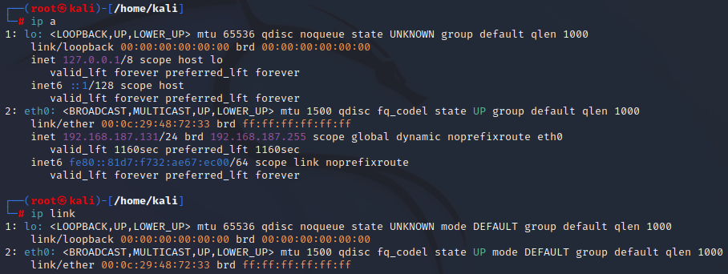
It shows that there is a loopback interface called lo and an ethernet interface called eth0. You also get some useful information like MAC addresses (as well as ip and broadcast addresses for the network).
Notice, there are no wlan interfaces.

Add simulated wlan interfaces
The kernel module mac80211 is installed, we just need to used it and specify how many radios we want to use.
modprobe mac80211_hwsim radios=2

radios=2 is defining how many virtual interfaces to create
(default is 2: WLAN0 and WLAN1)

use ip a or ip link to verify WLAN interfaces now exists
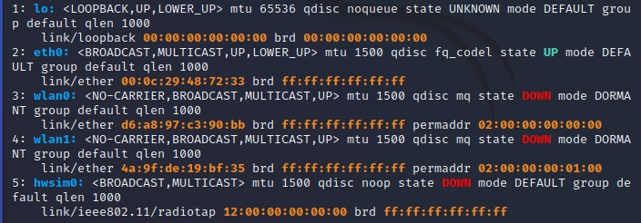

hwsim0 is a virtual interface that can listen to all radio frames on all channels but is not needed for this assignment.

Isolate the interfaces into Namespaces
Currently the system can see both interfaces.
This is because they live in the same “namespace”

What are namespaces? That topic is beyond the scope of this class, but namespace separation allows us to separate interfaces from each other. We can run a separate shell, where one of the WLAN interfaces will be. In that config, the system must route packets over WLAN interfaces to reach the other one.)

We need to create a new namespace and place the WLAN0 interface into that namespace. This makes it “invisible” to the host/primary namespace.

Create a network namespace called “wifi_master” for WLAN0 and run a separate shell in that namespace.

ip netns add wifi_master

We end up having two shells: One for the WiFi hotspot (wifi_master) and one for the WiFi client.
Both shells only see their corresponding WLAN interface and don’t know the other exists.

Verify wifi_master namespace exist

ip netns list

The output should look similar to this:
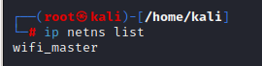

Assign the wifi_master namespace to a specific interface using the iw utility.

Launch wifi_master in the new namespace

ip netns exec wifi_master bash

This moves the interface to the specified network namespace and runs the wifi_master namespace in a separate bash shell (with it’s own unique PID,for those who are familiar with linux).

Obtain the specific process ID for this new netns bash shell. We will need this PID number later.

echo $BASHPID

This command prints the value ($) of this process ID (PID) for this new shell (BASH) to the terminal window (echo).

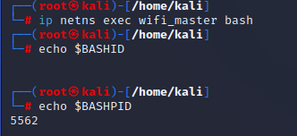

In this example the PID is 5562 you will use the value obtained from your machine.

The wifi_master namespace will be our hotspot AP.

Open a new, separate terminal window and switch to the root account
(place it on the right side of the screen, and the original on the left side. I will refer to either the left or right terminal to indicate where commands should be typed)

Right Terminal

sudo su

password is kali

Your screen should now look similar to this:

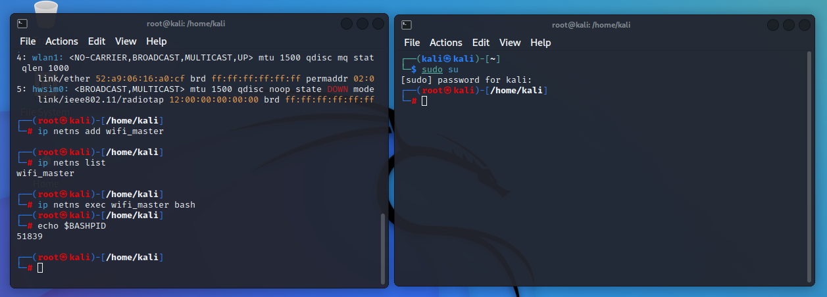

We will now use the iw utility to assign the wlan0 interface the the wifi_master namespace bash shell we just setup based on it’s PID.

Verify the wlan0 interface is currently NOT in the netns from the first root account.

Left Terminal

ip link
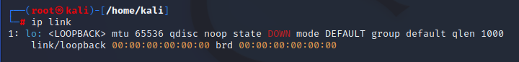

In the Right Terminal, assign the wlan0 interface to the wifi_master namespace (using the PID we obtained earlier)

Right Terminal

iw phy phy0 set netns 5582
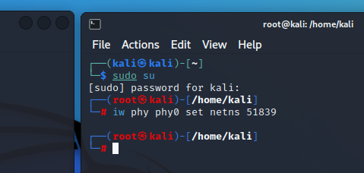
Verify the wlan0 interface is now in the wifi_master namespace

Left Terminal

ip link

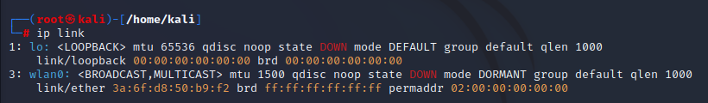

In right terminal, verify that wlan0 is no longer present but wlan1 is present. wlan1 will be our wifi client interface.

Right Terminal

ip a or ip link

(I used the grep command to create a clean output for the screenshot, you do not need to do that)

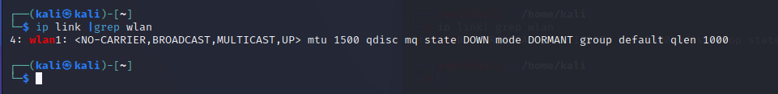

Configure wifi_master AP
In the left terminal window, assign an ip address to the wlan0 interface.

Left Terminal

ip addr add 192.168.10.1/24 dev wlan0

If you make and error you can simply retype this command with the correction and it will replace the address with the new one.

Verify the ip address is correct on the wlan0 interface
(the interface will show that it is in a DOWN state but we deal with that issue later)

Left Terminal

ip a

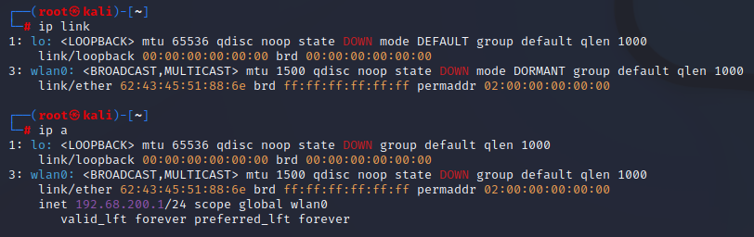

Configure the dnsmasq application to act as a DHCP server
In the Right Terminal, review the current state of the dnsmasq service to verify that it exists, the Loaded: state is disabled and Active: state is inactive.

Right Terminal

systemctl status dnsmasq.service

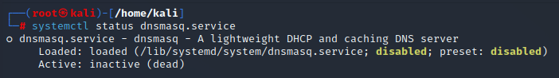
(pressing q returns you to the command line)

Since this service is not running, this allows us to create a custom config file that will load properly when we start it.

Create a custom dnsmasq.conf file without destroying the original

Right Terminal

mv /etc/dnsmasq.conf /etc/dnsmasq.conf.orig

nano /etc/dnsmasq.conf
(Use your favorite cli text editor. I like vim myself but apparently nano is easier for those new to text editors. There’s no accounting for taste :) )

The contents of that file should be as follows:

#Listening interface
interface=wlan0

#Pool of IP addresses served via DHCP
dhcp-range=192.168.10.2,192.168.10.30,255.255.255.0,12h
dhcp-option=3,192.168.10.1
dhcp-option=6,192.168.10.1
server=8.8.8.8
log-queries
log-dhcp
log-facility=/var/log/dnsmasq.log
#listen-address=127.0.0.1,192.168.10.1

If you’re interested what the numbers mean in the dhcp-option=X, visit this site:
https://blog.abysm.org/2020/06/human-readable-dhcp-options-for-dnsmasq/

Modify the sysctl.conf file to turn on ipv4 forwarding

Right Terminal

nano /etc/sysctl.conf

search for and uncomment the line (remove the #): net.ipv4.ip_forward=1

Start run dnsmasq as a DHCP server in the background

Right Terminal

dnsmasq -i wlan0 --dhcp-range=192.168.10.2,192.168.10.30 &

Configure the hostapd application to act as a AP server

Verify the hostapd service is in the following state:
Load: status is masked
Active: state is inactive

Right Terminal

systemctl status hostapd.service

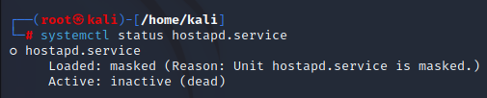

Next we need to configure the host AP daemon to specify the interface to listen to, the SSID,and channel to use, security measures, the beacon interval and a few other elements.

To do that we are going to create a custom config file in the home directory of the root user in the Left Terminal.

This is a very basic configuration but you can see some others here: https://wiki.gentoo.org/wiki/Hostapd#Frequency_Bands

More info on how hostapd can be configured here: https://wireless.wiki.kernel.org/en/users/documentation/

Left Terminal

Make sure you are in the /root directory
pwd
if the output is not /root use cd /root #if necessary

Create custom hostapd.conf file

nano /root/hostapd.conf

Enter this into the file:

# hostapd.conf
# Set country code (using the 2 character ISO/IEC 3166-1 standard)

country_code=US

# Limit the frequencies used to those allowed in the country
# This is accomplished by implementing the 802.11d amendment

ieee80211d=1

#WLAN SSID

ssid=CWNP_OPEN

# Mode options: a=5GHz / g=2.4GHz / ad=60GHz

hw_mode=g

# Set channel to use, 0=AP will search for channel with least interference

channel=11

# Set wlan interface and driver

interface=wlan0
driver=nl80211

# Enable WMM (wireless Multi Media capabilities

wmm_enabled=1

# Enable use of IEEE 11n PARAMETERS
ieee80211n=1

# ht_capab=[HT40+][SHORT-GI-20][SHORT-GI-40][DSSS_CCK-40]

# not used in this lab but specifies features involved in communication between supplicant and AP you saw in figure 3.24 of your text

Now we will start the hostapd service and using the config file we just created in the root user account.
Left Terminal
hostapd hostapd.conf
If correctly setup the results should look something like this:
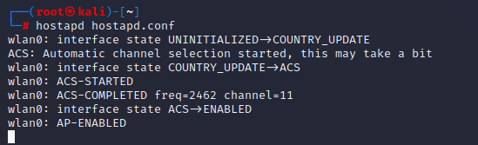
WOOT! Your wifi AP is now running!

Connect our wpa_supplicant (AKA wifi client) to the AP

Create custom wpa_supplicant.conf file

In the Right terminal window, where you are also root … but using a different process, create a basic config file that we can use to configure our virtual radio interface (wlan1).

You will create this file in the /root directory on the Right Terminal

Right Terminal

Make sure you are in the /root directory
pwd
if the output is not /root use cd /root #if necessary

create custom wpa_supplicant.conf file

nano wpa_supplicant.conf

Enter this into that file:

# wpa_supplicant.config file
# For open network

network={
ssid="CWNP_OPEN"
key_mgmt=NONE
}

Connect client to AP. Watch what happens in the terminal window running hostapd
Right Terminal

wpa_supplicant -B -i wlan1 -c wpa_supplicant.conf

Read the man page for wpa_supplicant to fully understand the options (man wpa_supplicant.conf) but briefly:

-B run in the background
-i use this interface (wlan1)
-c use this configuration file (wpa_supplicant.conf)

It will take a few seconds but the Left Terminal AP output should show something like this:

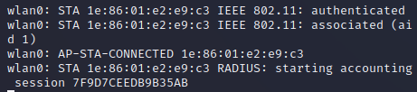
Notice that there 3 messages here.
1. the STAtion has been authenticated (password match – which in this case is none)
2. The STAtion is associated (We’ve exchanged info about our capabilities and come to a consensus on what to use)
3. AP-STA-CONNECTED Connection successful

Verify the mac address you see connected in the Left Terminal matches the mac address of wlan1 in the Right Terminal.

Right Terminal

ip a show dev wlan1
(using ip a will show all network interfaces)

Review the information wlan1 receives from our AP

Right Terminal

iw wlan1 link

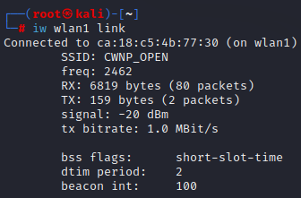
You should see something like this:

But we are NOT done yet! We still need an ip for wlan1.

Request an ip from wlan0

Right Terminal

dhclient -d wlan1

the -d option is not required but ...Normally the DHCP client runs in the foreground until is has configured an interface. It reverts to running in the background. The -d option is useful for seeing the DHCPDISCOVER/DHCPOFFER communications that are happening and for debugging.

If successful you will see something like this:
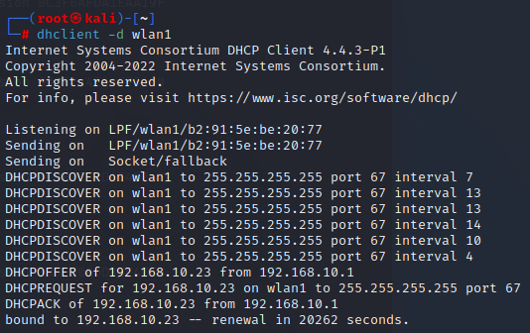

**NOTE: if this does not happen you may need to restart the dnsmask service and the hostapd service. See instructions a little further down in this document.

At this point you can cancel the dhclient process and verify the wlan1 interface has an ip

Right Terminal

press the Ctrl and C keys (Ctrl+C) to cancel the dhclient command

ip a show wlan1

You should see something like this:

Verify connectivity with a few pings to the AP

Right Terminal

ping -c4 192.168.10.1

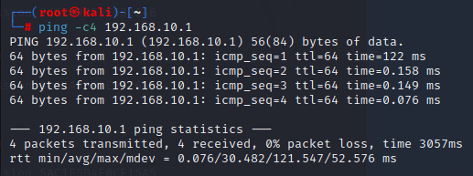

**dhclient not obtaining an ip?

It’s possible that dnsmasq is running in the background as a service. Let’s stop that service and run dnsmasq manually
Left Terminal

The hostapd process should be running in the foreground. Cancel it with

Ctrl+c

Stop the dnsmasq service

systemctl stop dnsmasq.service

Run dnsmasq manually in the background

dnsmasq -i wlan0 --dhcp-range=192.168.10.2,192.168.10.30 &

hostapd hostapd.conf

