Monitoring WLAN communications
Using Wireshark to capture and analyze management, control and data frames on a machine without access to real wireless hardware.

The walk-through used here is heavily derived from these sites:

https://www.suse.com/c/creating-virtual-wlan-interfaces/

https://linuxhint.com/capture_wi-fi_traffic_using_wireshark/

https://www.linuxembedded.fr/2020/05/emulating-wlan-in-linux-part-i-the-80211-stack

https://linuxembedded.fr/2021/01/emulating-wlan-in-linux-part-ii-mac80211hwsim

https://howiwifi.com/2020/07/13/802-11-frame-types-and-formats/

The virtual machine specifically used for this assignment is kali 2022.4 for Intel/AMD machines. You can explore more recent versions and/or machines for other architecture here: https://www.kali.org/get-kali/

How to understand the instructions:
Bolded text with gray background is the actual text to type at the command line.

File names will be italicized (they may also be bolded if they are part of the command you need to enter in the terminal.)

You are eventually going to be using multiple separate terminal windows.

Included screenshots are for reference only. Specific values and interface names are going to be specific to your machine and may not be identical to those presented here.

Pay attention to your machine output and make the appropriate substitutions.

Boot the machine, open the first terminal window and switch to the root account.

Switch into the root account

sudo su

password is kali

Install required applications, if not already installed

apt install hostapd dnsmasq wpasupplicant iw

(These should already be installed so you may see a message that says XXXX is already the newest version)

If any of these applications are not available in the default repositories you can add new repositories by following these instructions:

Verify the file sources.list exists In the /etc/apt/ directory.

ls /etc/apt/*

(the * is a wildcard character that matches all the contents of the directory)

If the file does not exist, the following command will create it and open it in preparation for adding the new source lines.

nano /etc/apt/sources.list

If sources.list does exist, edit it using the command above and either verify the following lines exist or add them if they do not.

deb http://http.kali.org/kali kali-rolling main non-free contrib
deb-src http://http.kali.org/kali kali-rolling main non-free contrib
Save the file. Exit and run the following command to force the apt application to re-read the sources.list file.
apt update

Setup WLAN interfaces

Similar to the other lab, this virtual machine does not directly connect to your host machine’s wireless card for internet connectivity. We do need to verify the required kernel module is installed and then create some virtual wlan interfaces (3 this time, not 2).

Verify required kernel module (mac80211_hwsim ) is installed

grep HWSIM /boot/config-*

If it is already compiled in the kernel you will something similar to this:

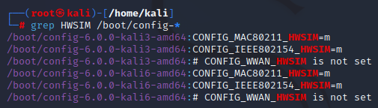

/boot/config-6.0.0-kali6-amd64:CONFIG_MAC80211_HWSIM=m <-- the “=m” means it is already compiled and ready to use.

=================================================================
What to do if not installed ?
We will have to troubleshoot together later
If you’re interested, you can also see the 802.15.4 HWSIM is installed: used in IoT
=================================================================

Take a Screenshot for submission

Setup Wifi interfaces

Have a quick look to see what network interfaces currently exist
ip a or ip link
(The command ip a is just a shortened form of the ip address command. You may see it in several forms: ip a, ip add, ip addr)
This shows the network interface hardware the machine currently knows about. It should look similar to this:

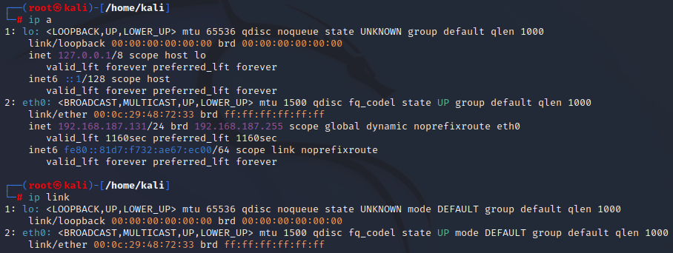
It shows that there is a loopback interface called lo and an ethernet interface called eth0. You also get some useful information like MAC addresses (as well as ip and broadcast addresses for the network).
Notice, there are no wlan interfaces.

Add simulated wlan interfaces
Since the kernel module mac80211 is installed, we just need to used it and specify how many radios we want to use. In this assignment we want 3.
One for the AP. A second for the Client and a third that we will use as a monitoringinterface that should capture all wireless traffic, including management and control frames. Not just data frames.
modprobe mac80211_hwsim radios=3

Use ip a or ip link to verify 3 WLAN interfaces now exists
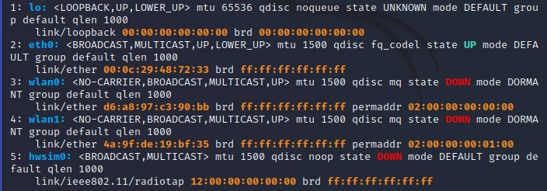
Take a Screenshot for submission

Isolate one interface into Namespaces
Currently the system can see all interfaces.
This is because they live in the same “namespace”

What are namespaces? That topic is beyond the scope of this class, but namespace separation allows us to separate interfaces from each other. We can run a separate shell, where one of the WLAN interfaces will be. In that config, the system must route packets over WLAN interfaces to reach the other one.)

We need to create a new namespace and place the WLAN0 interface into that namespace. This isolates it from the current userspace.

Create a network namespace called “wifi_AP” for WLAN0 and run a separate shell in that namespace.

ip netns add wifi_AP

We will end up having multiple terminals shells: One for the WiFi hotspot (wifi_AP) and ones for the WiFi client and to monitor wifi traffic.
These shells only see their corresponding WLAN interface and don’t know the other exists.

Verify wifi_AP namespace exist

ip netns list

The output should look similar to this:
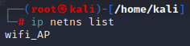

Assign the wifi_AP namespace to a specific interface using the iw utility.

Launch wifi_AP in the new namespace

ip netns exec wifi_AP bash

This starts a bash shell in the wifi_AP namespace and we can move a wireless interface into that shell (with it’s own unique PID,for those who are familiar with linux).

Obtain the specific process ID for this new netns bash shell. We will need this PID number later.

echo $BASHPID

This command prints the value ($) of this process ID (PID) for this new shell (BASH) to the current terminal window (echo).

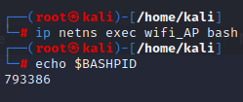

In this example the PID is 793386 you will use the value obtained from your machine.

The wifi_AP namespace will be our hotspot AP.

Open a new, separate terminal window and switch to the root account
(place it on the right side of the screen, and the original on the left side. I will refer to either the left or right terminal to indicate where commands should be typed).

Right Terminal

sudo su

password is kali

Your screen should now look similar to this:

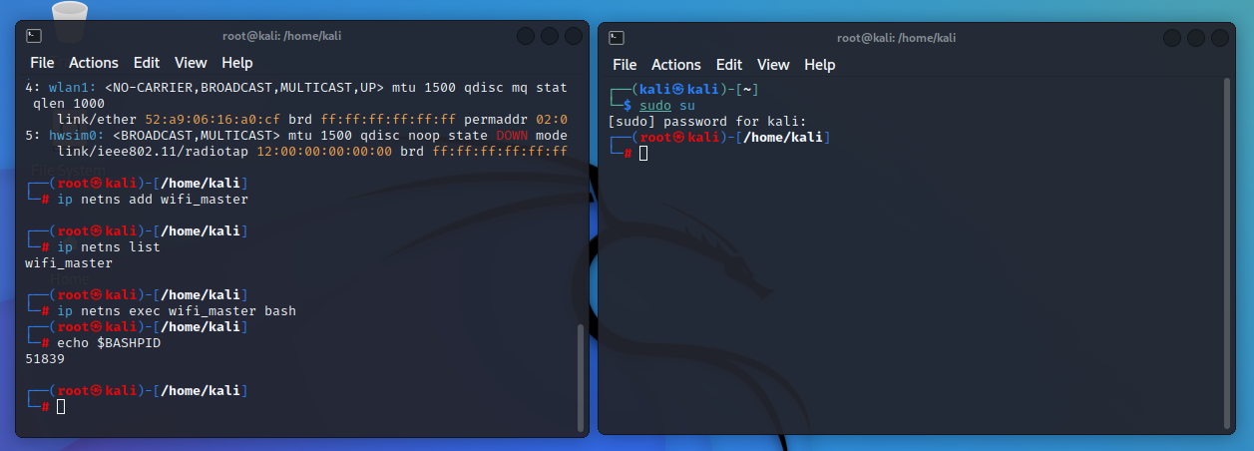

We will now use the iw utility to assign the wlan0 interface the the wifi_AP namespace bash shell we just setup based on it’s PID.

Verify the wlan0 interface is currently NOT in the netns from the first root account.

Left Terminal

ip link
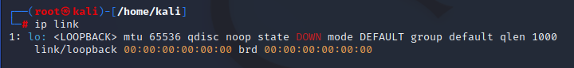

In the Right Terminal, assign the wlan0 interface to the wifi_AP namespace (using the PID we obtained earlier)

Right Terminal

iw phy phy0 set netns 793386
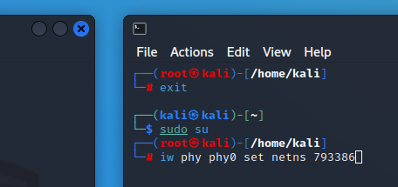
Verify the wlan0 interface is now in the wifi_AP namespace

Left Terminal

ip link

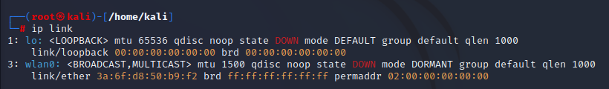

In right terminal, verify that wlan0 is no longer present but the other two are present. wlan1 will be our wifi client interface and wlan2 will be our monitoring interface.

Right Terminal

ip a or ip link

(I used the grep command to create a clean output for the screenshot, you do not need to do that).

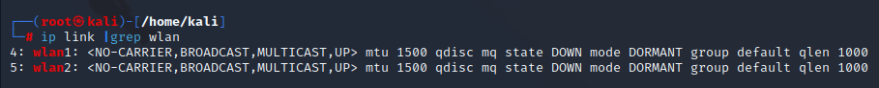
Take a Screenshot for submission

Configure wifi_AP
In the left terminal window, assign an ip address to the wlan0 interface.

Left Terminal

ip addr add 192.168.10.1/24 dev wlan0

If you make and error you can simply retype this command with the correction and it will replace the address with the new one.

Another thing to keep in mind here is that when you reboot this machine none of this persists. It is live but not saved (similar to what happens when you add an address to a cisco router interface but do not use the copy run start command. It’s in RAM and takes effect immediately but it not saved to a file).

Verify the ip address is correct on the wlan0 interface.
(the interface will show that it is in a DOWN state but we deal with that issue later)

Left Terminal

ip a

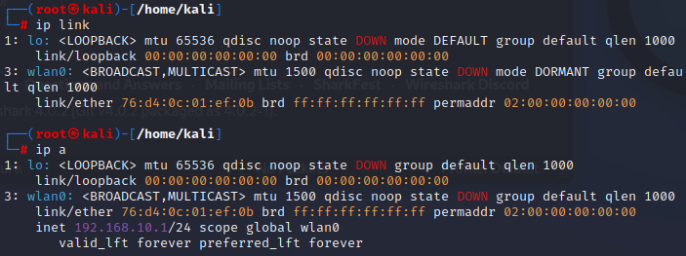

Modify the sysctl.conf file to turn on ipv4 forwarding.

IP forwarding happens when an OS accepts incoming network packets on one interface, recognizes that it is not meant for the system itself, and passes to another network. This is needed when a system sits in between networks and needs to pass traffic between the networks.

Right Terminal

nano /etc/sysctl.conf

Search for and uncomment the line (remove the #):

net.ipv4.ip_forward=1

Configure the dnsmasq application to act as a DHCP server
In the Right Terminal, review the current state of the dnsmasq service to verify that it exists, the Loaded: state is disabled and Active: state is inactive.

Right Terminal

systemctl status dnsmasq.service

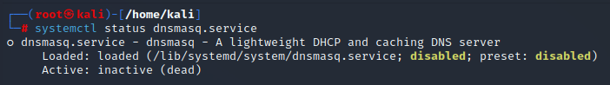
(pressing q returns you to the command line)

Since this service is not running, this allows us to run the dnsmasq application manually (non persistently) in the same namespace as our AP.

Start run dnsmasq as a DHCP server in the background

Left Terminal

dnsmasq -i wlan0 --dhcp-range=192.168.10.2,192.168.10.30 &

-i specifies the interface to listen to
--dhcp-range is the first, last ip in the dhcp pool to use for supplicants requesting ip’s on the specified interface (wlan0)
& is the symbol linux uses to start a process in the background and you get your command prompt back to continue working in that terminal.

Configure the hostapd application to act as a AP server

Verify the hostapd service is in the following state:
Load: status is masked
Active: state is inactive

Left Terminal

systemctl status hostapd.service

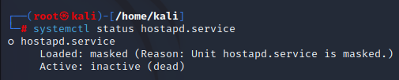

Next we need to configure the host AP daemon to specify the interface to listen to, the SSID,and channel to use, security measures, the beacon interval and a few other elements.

To do that we are going to create a custom config file in the home directory of the root user in the Left Terminal.

Left Terminal

Make sure you are in the /root directory

pwd

if the output is not /root use cd /root #if necessary

Create custom hostapd.conf file

nano /root/hostapd.conf

Enter this into the file:

# hostapd.conf
# Set country code (using the 2 character ISO/IEC 3166-1 standard)

country_code=US

# Limit the frequencies used to those allowed in the country
# This is accomplished by implementing the 802.11d amendment

ieee80211d=1

#WLAN SSID

ssid=CWNP_OPEN

# Mode options: a=5GHz / g=2.4GHz / ad=60GHz

hw_mode=g

# Set channel to use, 0=AP will search for channel with least interference

channel=11

# Set wlan interface and driver

interface=wlan0
driver=nl80211

# Enable use of IEEE 11n PARAMETERS
ieee80211n=1

Now we will start the hostapd service using the config file we just created in the root user account.
Left Terminal
hostapd hostapd.conf
If correctly setup the results should look something like this: ho

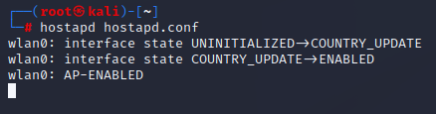
Take a Screenshot for submission

Configure a wlan interface in preparation for monitoring wireless traffic

Set a wlan interface to monitor mode
We are going to use wlan2 as a monitoring interface since we’ve already done a lab where we configured wlan0 and wlan1 for specific purposes. No need to make it more complicated than it already is. Just know that the choice of interface is arbitrary.

Right Terminal

In order to capture all wireless traffic, the radio interface cannot be associated with any AP. It needs to be in “monitor” mode (just plucking information from the air).

Verify the wlan2 interface supports monitor mode.

iw wlan2 info

This will show you the wireless physical dev number (wiphy 2)

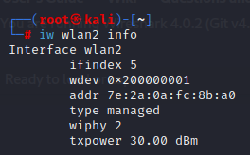

As you can see, this interface type is currently in managed mode.

There is also an entry called wiphy. This interface is index number 2 of the wireless physical devices. We can use that to get all the capabilities of this device. The output is going to be very long and extensive, but we only need to find the supported modes. So lets look at the information one screen at a time.

iw phy#2 info| less

Press the spacebar until you find this part (it should be be on the first 2-3 screens).

If you want to be more efficient and practice your linux skills, you can run iw phy#2 info| grep -A 10 modes| less
(the -A adds however many lines (10) after finding a line containing the string “modes”.)

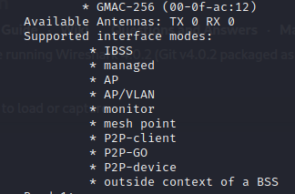
As you can see, it does support monitor mode

Now, it’s simply a matter of changing the interface from managed mode to monitor mode and verifying that change worked as expected.

ifconfig wlan2 down (this disables the interface if it is enabled)
iwconfig wlan2 mode monitor (change interface mode. Note: it is iwconfig not ifconfig)
iw wlan2 info (verifies interface mode has changed)

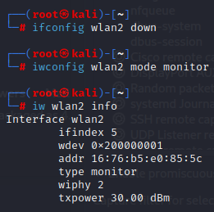

Set what channel we want to monitor

We will match the channel we are using in these lab but after it is successful, I encourage you to go back and modify the AP to use a different channel (in both the 2.4 GHz and 5GHz bands) and practice making the appropriate changes to monitor those different channels

For this lab we are using channel 11

Right Terminal

iwconfig wlan2 channel 11

Open wireshark and select the wlan2 interface to monitor all traffic (including management and control frames).

On the kali desktop, go to the upper left corner, click the kali icon and type wireshark in the search box. Open Wireshark.
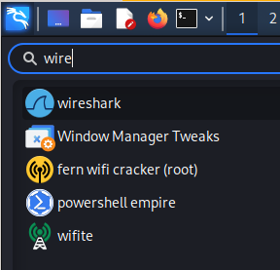
Highlight wlan2, right click and select capture. This should only have beacon frames right now since we have turned on the AP but not turned on the supplicant interface (wlan1) and requested any authentication, association or ip from the dhcp server yet.)
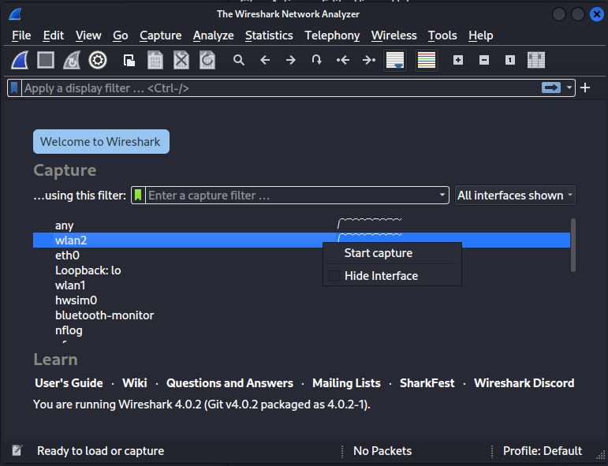
Your wireshark capture should look similar to the image below:

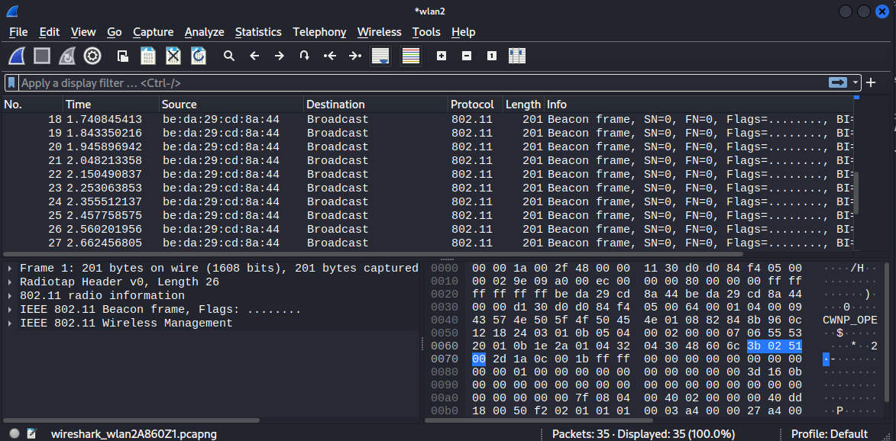
Take a Screenshot for submission

I would stop the capture and highlight a frame and look at some of the details then start a new capture when you are ready to move to the next step.
In particular, expand the Beacon frame and Wireless management sections in the lower left panel to see what information is included in a beacon frame and think about why this might be important in assisting devices of unknown capabilities to authenticate and associate with this AP.
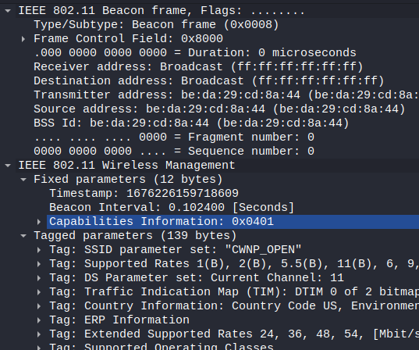

Create custom wpa_supplicant.conf file

In the Right terminal window, where you are also root, you will create the wpa_supplicant.conf file in the /root directory on the Right Terminal

Right Terminal

Make sure you are in the /root directory

pwd

If the output is not /root use cd /root #if necessary

create custom wpa_supplicant.conf file.

nano wpa_supplicant.conf

Enter this into that file:

# wpa_supplicant.config file
# For open network

network={
ssid="CWNP_OPEN"
key_mgmt=NONE
}

Connect wlan1 to AP and capture the traffic in wireshark
Start the frame/packet capture in wireshark on the interface being used to monitor traffic.
In the right terminal, start the wpa_supplicant, then request an ip using dhclient
Right Terminal

ensure you are in the root directory

cd /root

start the AP search process

wpa_supplicant -B -i wlan1 -c wpa_supplicant.conf

Read the man page for wpa_supplicant to fully understand the options (man wpa_supplicant.conf) but briefly:

-B run in the background
-i use this interface (wlan1)
-c path to configuration file (wpa_supplicant.conf)

It will take a few seconds but the Left Terminal AP output should show something like this:

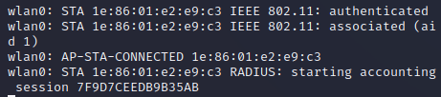
Notice that there 3 messages here.
1. the STAtion has been authenticated (AP knows this client exists and is prepared to move to the next step).
2. The STAtion is associated (We’ve exchanged any passwords and info about our capabilities and communicate pass control frames with the AP itself).
3. AP-STA-CONNECTED Connection successful

Verify the mac address you see connected in the Left Terminal matches the mac address of wlan1 in the Right Terminal.

Right Terminal

iw wlan1 link

Request an ip from wlan0

Right Terminal

dhclient -d wlan1

the -d option is not required but ...Normally the DHCP client runs in the foreground until is has configured an interface. It reverts to running in the background. The -d option is useful for seeing the DHCPDISCOVER/DHCPOFFER communications as they are happening and for debugging.

If successful you will see something like this:
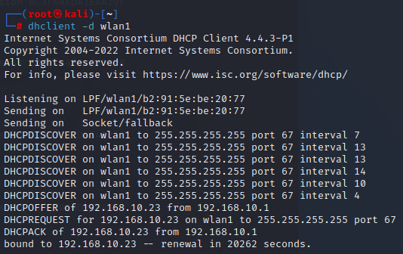

Take a Screenshot for submission

**NOTE: if this does not happen you may need to restart the dnsmask service and the hostapd service. See instructions a little further down in this document.

At this point you can cancel the dhclient process.

Right Terminal

press the Ctrl and C keys (Ctrl+C) to cancel the dhclient command

ip a show wlan1

You should see something like this:

Verify connectivity with a few pings to the AP

Right Terminal

ping -c4 192.168.10.1

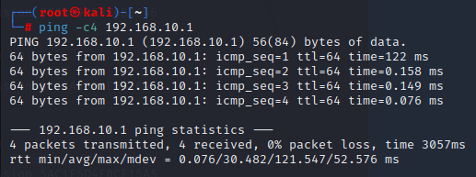

Stop the capture in wireshark and search for the communication between the client and the AP

Click the red square in the upper left corner of the Wireshark application to stop the capture.
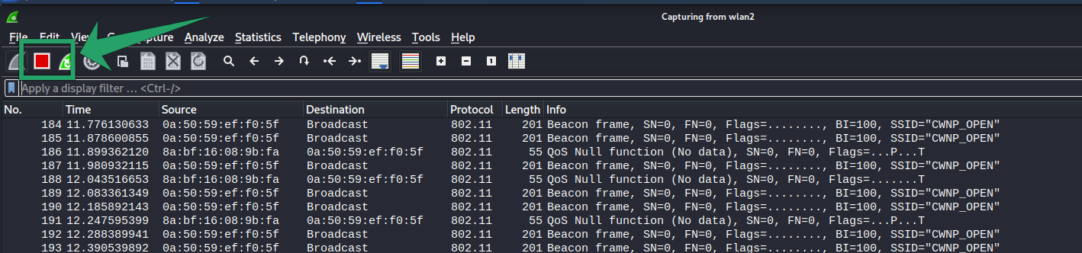
There is going to be a tremendous amount of frames captured here. We do not want to manually scroll through this. We want to use the capabilities of wireshark to filter for the communications we are interested in viewing.
Since we are interested in not just data packets but also management and control communications between the client and the AP, we can filter our captured data to look for a specific MAC address. The MAC address of our wireless client.
At the top of the pane showing the captured frames there is a field with the text “Apply a display filter…”.
Lets filter on the MAC address of the wireless client interface (wlan1)
in the right terminal run the command to view the MAC address of our interfaces and copy the values (highlight with your mouse and right click to select copy).

In Wireshark, enter “wlan.” in the filter field. A whole lot of types of characteristics related to wlan traffic should show up. Scroll down through those options and select: wlan.addr.
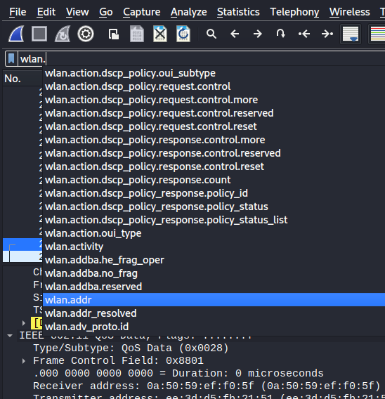
We want that address to match the MAC address of your wireless client, so add == (2 equal signs) after wlan.addr and the MAC address you copied andpress enter. You should see something similar to this:

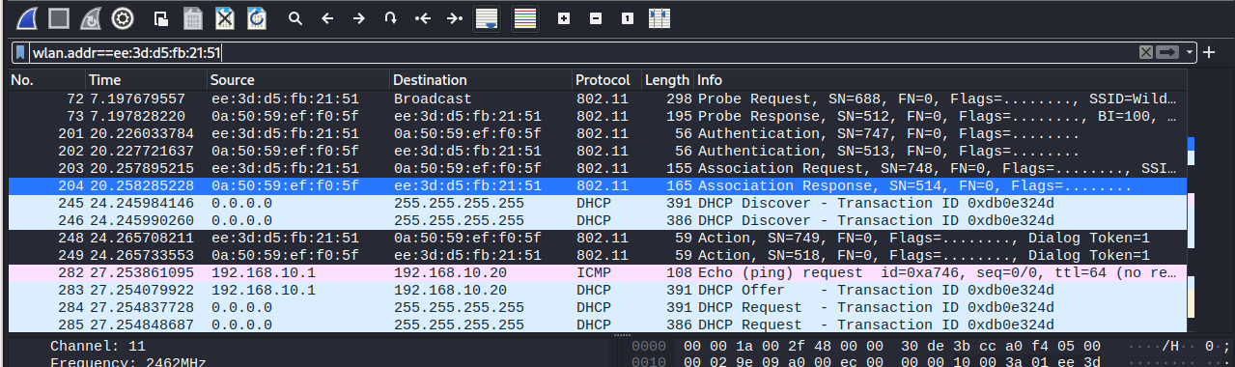
Take a Screenshot for submission

We can now see the all communication between the AP and the client. From the initial probe request/response, the authentication and association request/responses as well as the DHCP communication.
Click on each of these steps and document the frame type
go to the website that I provided that documents the different types and subtypes for reference
Probe request:
Probe Response:
Authentication
Association Request
Association Response
DHCP Discover
DHCP Offer
DHCP Request
DHCP ACK
Submit a text file with this info

Can we force the client off the AP with a Deauthentication attack?

Follow the guide outlined here and see if you can force the client off the AP

**dhclient not obtaining an ip?

It’s possible that dnsmasq is running in the background as a service. Let’s stop that service and run dnsmasq manually
Left Terminal

The hostapd process should be running in the foreground. Cancel it with

Ctrl+c

Stop the dnsmasq service

systemctl stop dnsmasq.service

Run dnsmasq manually in the background

dnsmasq -i wlan0 --dhcp-range=192.168.10.2,192.168.10.30 &

hostapd hostapd.conf

