**Exercise 5**

*Get started with Apache Spark and Python*

**Prior Knowledge**

Unix Command Line Shell

Simple Python

**Learning Objectives**

Understand the Spark system

Use the Spark Python shell to interactively work with data

Submit Spark jobs locally and using YARN

Write SparkSQL code in Python  
WordCount!

**Software Requirements**

(see separate document for installation of these)

* Apache Spark 2.0.0
* Python 2.7.12
* Nano text editor, Sublime, PyCharms or other text editor

**Part A. Spark Python Shell (pySpark)**

1. We are going to do a wordcount against a set of books downloaded from Project Gutenberg. Wordcount is the definitive Big Data program (sort of Hello World for Big Data) and it is frankly embarrassing that we haven’t done one yet.
2. Apache Spark has a useful Python shell, which we can use to interactively test and run code. Since we have our data in HDFS, *we need to ensure HDFS is running.* (Follow the instructions from the Hadoop lab).
3. Let’s load some books into HDFS. In a terminal window (Ctrl-Alt-T)

hadoop fs -mkdir -p /user/oxclo/books

hadoop fs -put ~/datafiles/books/* /user/oxclo/books/

1. Now, change to the Spark directory:  
   cd ~/spark
2. Now start the Spark Python command line tool – pyspark  
   bin/pyspark  
   1. You should see a lot of log come up, ending in something like:

Python 2.7.12 (default, Jul 1 2016, 15:12:24)

[GCC 5.4.0 20160609] on linux2

Type "help", "copyright", "credits" or "license" for more information.

Using Spark's default log4j profile: org/apache/spark/log4j-defaults.properties

Setting default log level to "WARN".

To adjust logging level use sc.setLogLevel(newLevel).

16/09/08 09:24:49 WARN NativeCodeLoader: Unable to load native-hadoop library for your platform... using builtin-java classes where applicable

16/09/08 09:24:49 WARN Utils: Your hostname, oxclo resolves to a loopback address: 127.0.1.1; using 172.16.64.199 instead (on interface ens33)

16/09/08 09:24:49 WARN Utils: Set SPARK_LOCAL_IP if you need to bind to another address

Welcome to

____ __

/ __/__ ___ _____/ /__

_\ \/ _ \/ _ `/ __/ '_/

/__ / .__/\_,_/_/ /_/\_\ version 2.0.0

/_/

Using Python version 2.7.12 (default, Jul 1 2016 15:12:24)

SparkSession available as 'spark'.

>>>

1. Now let’s load some data. We already have a SparkContext object defined in the shell (in a program you need to define one, which we will see later)
2. Unfortunately some of the input is handled as Unicode by Python and we want to get rid of that. So let’s start:  
     
   import unicodedata
3. Then type (on one line):  
     
   def u2a(u): return str(unicodedata.normalize('NFKD',u).  
   encode('ascii','ignore'))
4. We also want to remove any non-alphanumeric characters:  
   def strip(s): return ''.join(filter(str.isalpha, s))
5. Now we would like to load the books from HDFS. Now let’s load some data. We already have a SparkContext object defined in the shell (in a program you need to define one, which we will see later)  
     
   books = sc.textFile("hdfs://localhost:54310/user/oxclo/books/*")
6. Let’s split the lines into words:  
     
   split = books.flatMap(lambda line: line.split())
7. Now let’s transform from Unicode to ascii   
   asc = split.map(u2a)
8. And remove non-alpha characters

stripped = asc.map(strip)

1. And we should put everything to lower case while we are cleaning it up
2. Finally we are ready to do the classic “WordCount” Map Reduce.   
   We first create a simple <K,V> pair of <word, count>. In the map phase, the count is always 1, since we haven’t yet reduced this.  
     
   numbered = lower.map(lambda word: (word, 1))
3. Next we reduce by adding the counts together for the same words:  
     
   wordcount = numbered.reduceByKey(lambda a,b: a+b)
4. Finally, we need to collect the results and print them. In Spark, they may be distributed across different RDD partitions on different machines, so the collect() method brings them together.  
     
   for k,v in wordcount.collect(): print k,v
5. You should see a lot of word counts go flying past.
6. Congratulations!
7. While the pyspark is still running browse to <http://localhost:4040>
8. You will see the Spark web console:  
   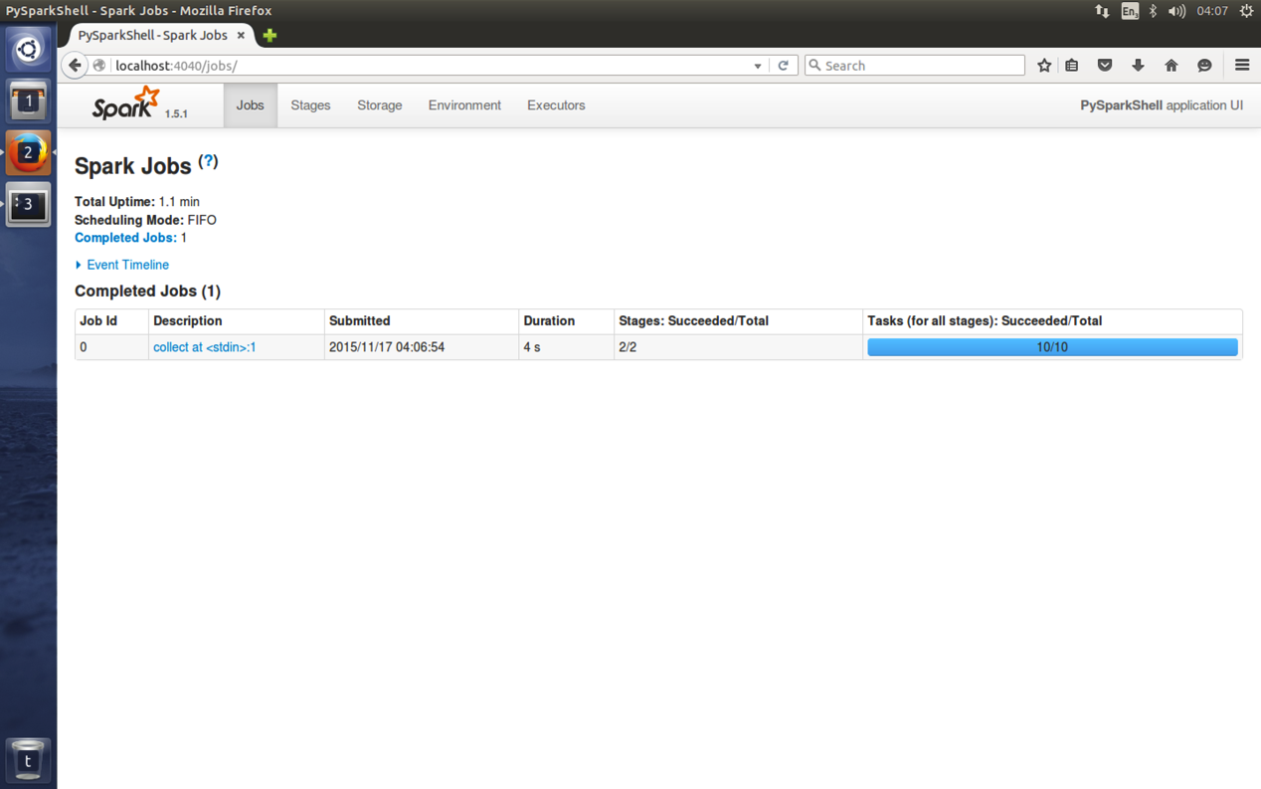
9. Click on the blue link “collect at stdin”  
   This shows you how Spark converted your code into stages:  
   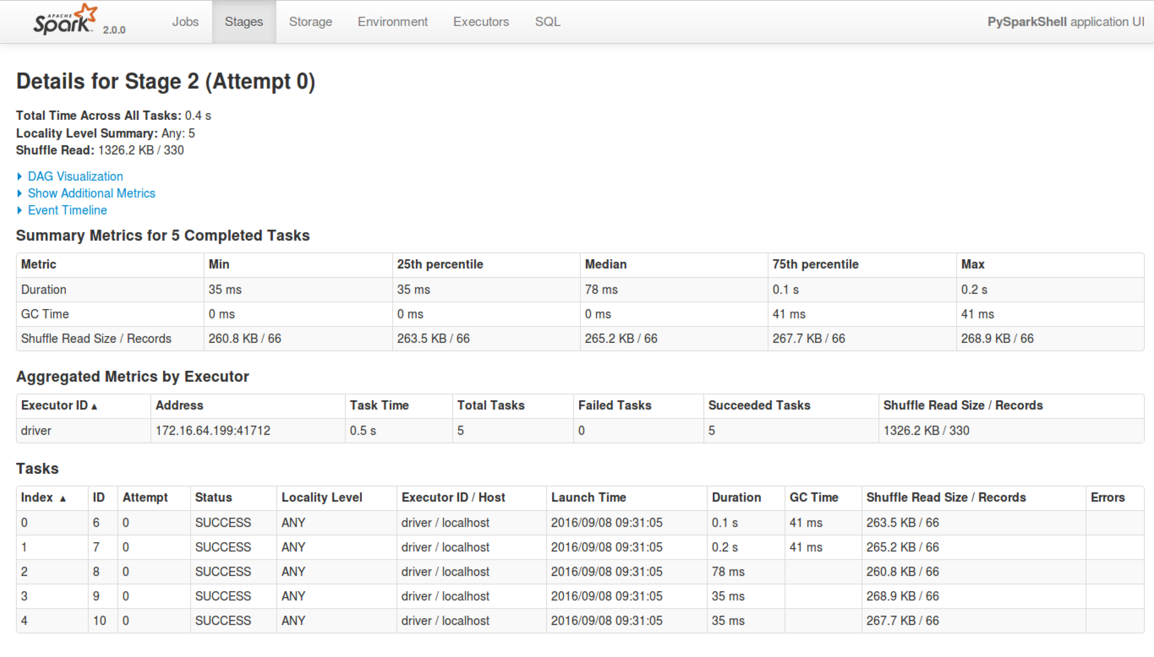
10. Expand the DAG visualization:  
    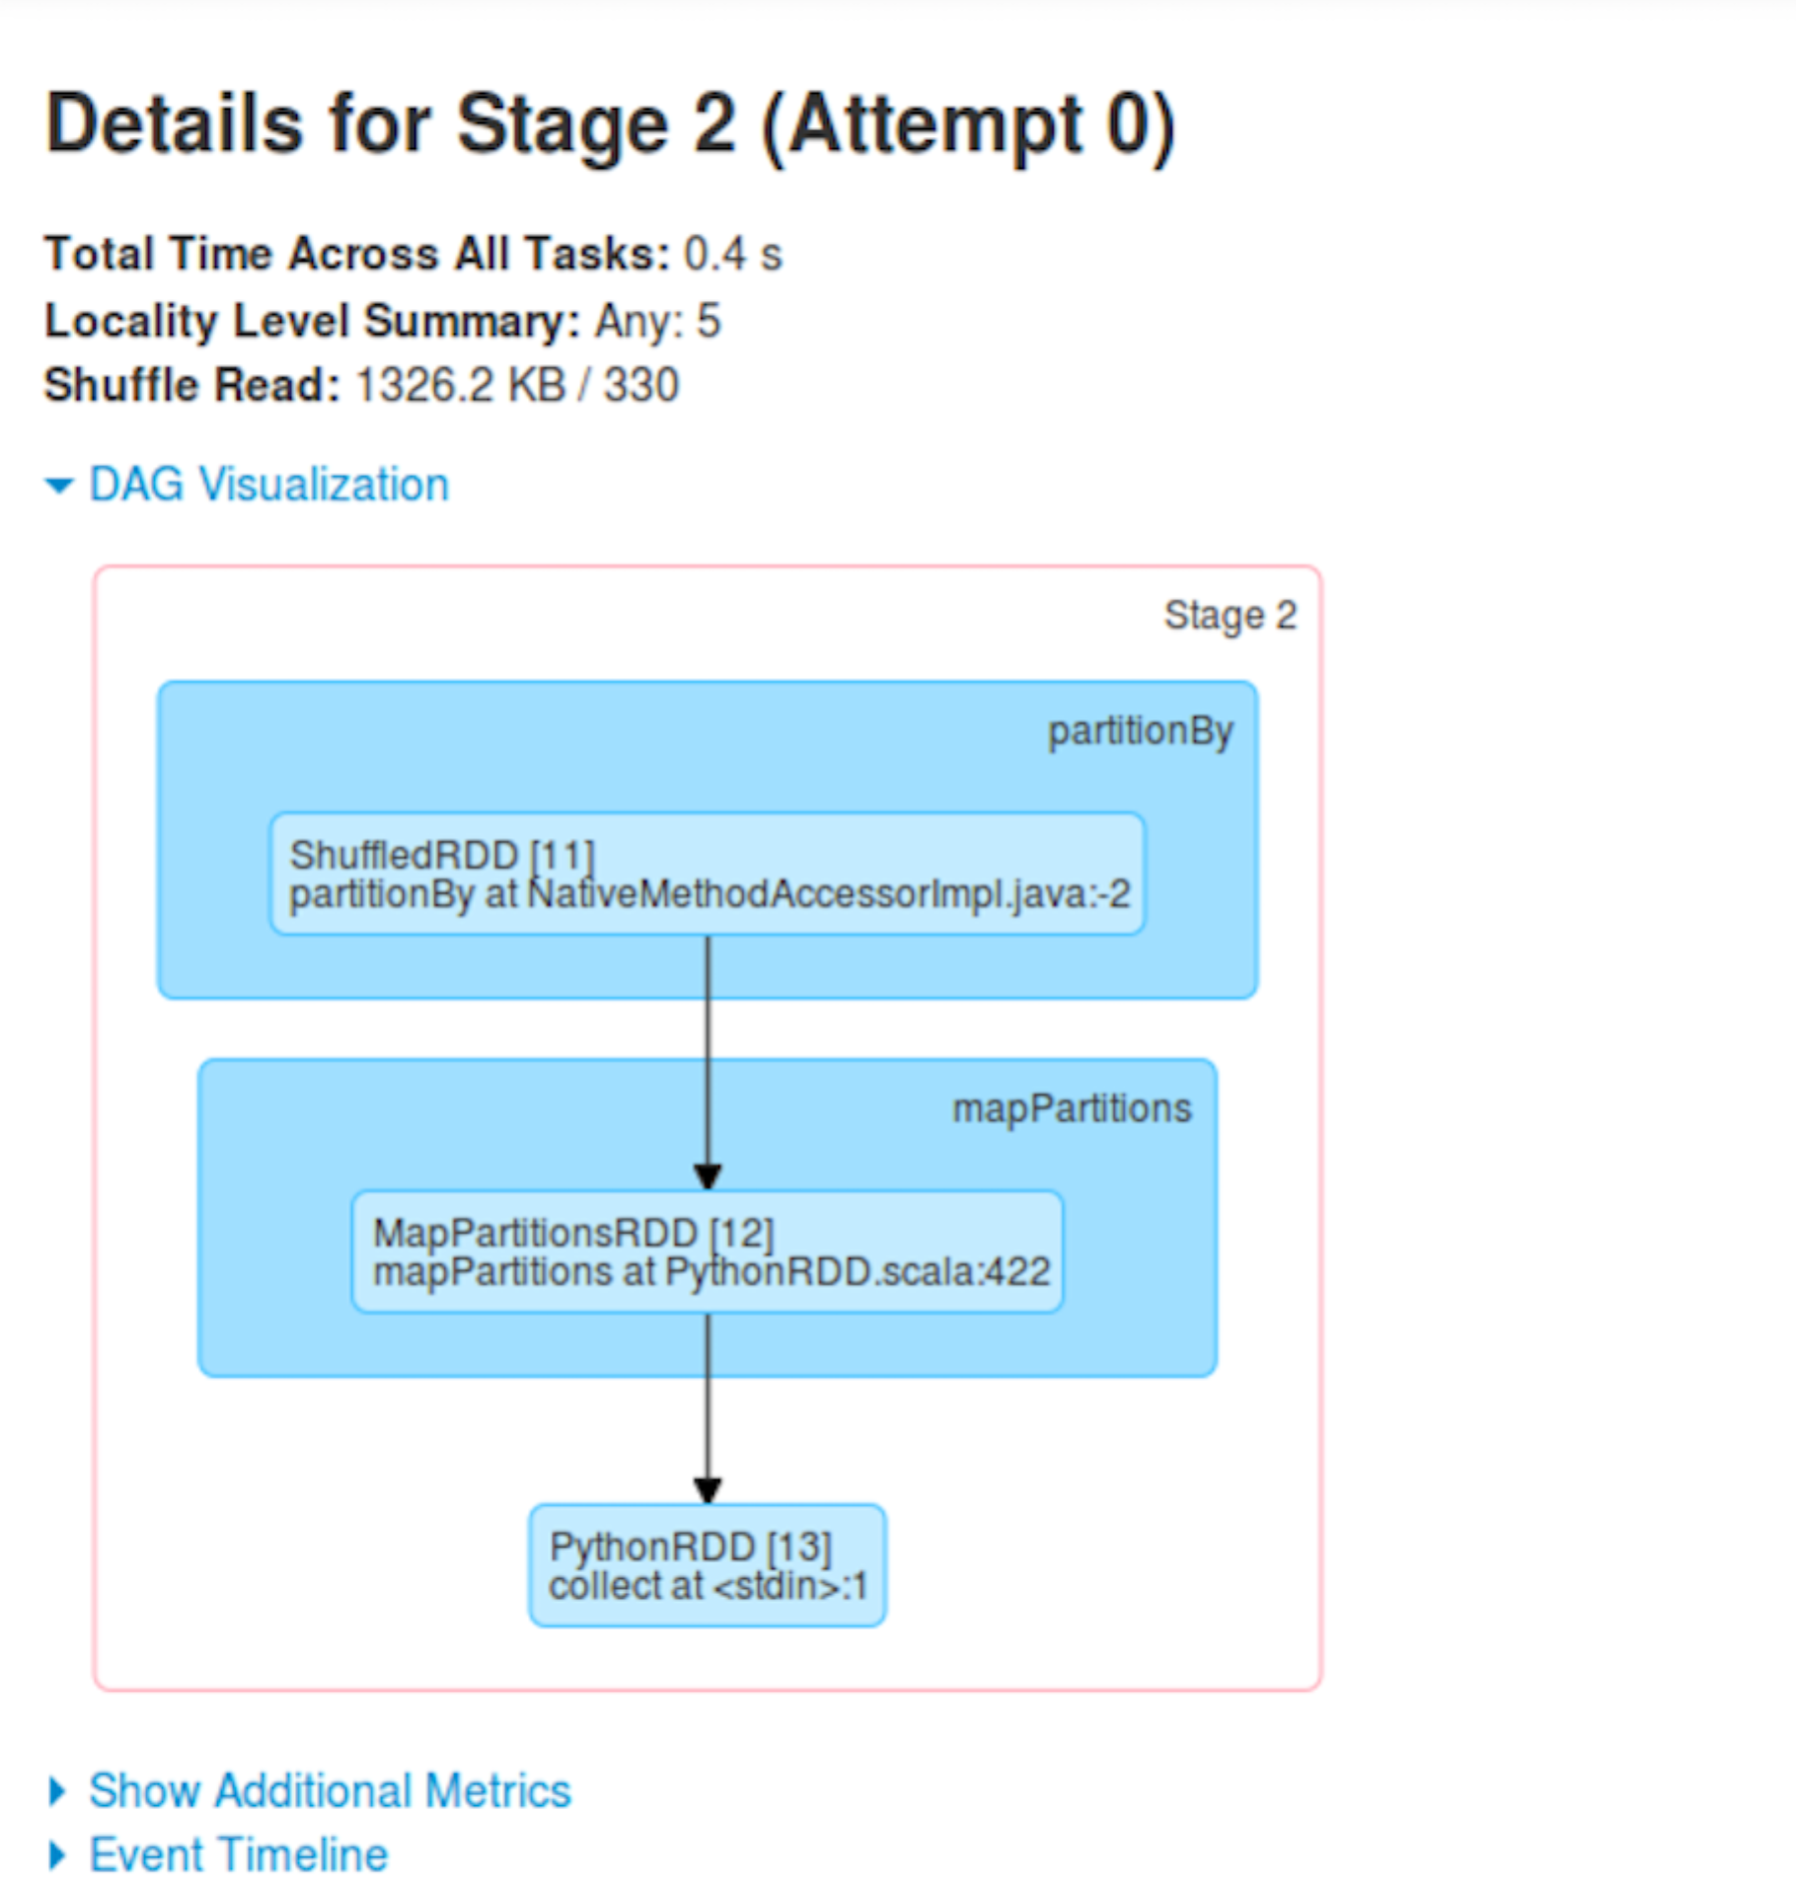
11. And the Event Timeline:

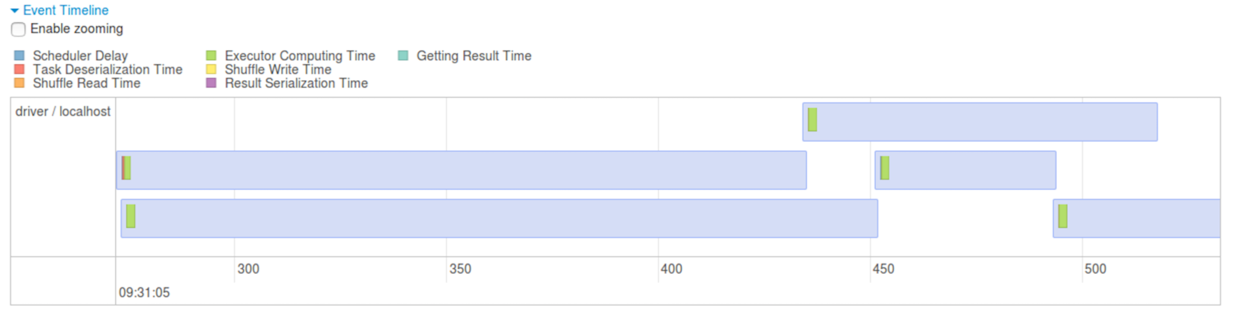

1. Quit the pyspark shell by typing   
   quit()
2. Now let’s run the same code as a “job” instead of interactively.
3. Make a directory for your spark python code:  
   mkdir ~/pysp  
   cd ~/pysp
4. From <http://freo.me/oxclo-wc-py> copy the code into a file wc.py
5. You will notice that there is a bunch of “setup” code that we didn’t need in the pyspark command line tool. That is because pyspark assumes you want all this and does it for you.
6. Now configure the correct setup so Spark can find the Yarn system:  
     
   export HADOOP_CONF_DIR=/usr/local/hadoop/etc/hadoop/
7. We run jobs locally on a single node directly on Spark:  
   The local[*] indicates to use as many threads as you have cores on your system:  
   ~/spark/bin/spark-submit --master local[*] wc.py "hdfs://localhost:54310/user/oxclo/books/*"
8. You could also use Spark’s own cluster manager, YARN or Apache Mesos as other options in a larger setup.  
     
   *In general, unless you are running mixed workloads with other Hadoop or Mesos workloads, I would always use Spark’s cluster manager.*
9. Congratulations, the lab is complete!