

**New Feeds 05.00.01 User Manual**

Contents

[News Feeds 2](#_Toc428975666)

[Editors 2](#_Toc428975667)

[Adding News Feeds 2](#_Toc428975668)

[Adding Syndicated News Feeds 4](#_Toc428975669)

[Managing News Feeds 4](#_Toc428975670)

[Refreshing the Feed Cache 5](#_Toc428975671)

[Settings 5](#_Toc428975672)

[Configuring News Feeds Settings 5](#_Toc428975673)

[Overview of News Feeds Layouts 6](#_Toc428975674)

# News Feeds

The News Feeds (RSS) module displays a summary list of news feeds from one or more sources. A news feed is a dynamically generated list of news items. RSS is an acronym for Really Simple Syndication. Each news item typically includes a date/time stamp, a linked title to read the news item in full, and a brief description. A selection of pre-defined layouts allows news items to be displayed in a static list, as a single scrolling 'ticker' list, as a vertical scrolling list or in a custom format. Users must be granted Edit Module permissions to add, edit and delete new feeds.

News Feeds (RSS) must be deployed and installed by a Super User. Install and source packages can be downloaded from the [releases page](https://github.com/DNNCommunity/DNN.NewsFeeds/releases) and feature requests, bug links and general questions can be submitted via the [issues page](https://github.com/DNNCommunity/DNN.NewsFeeds/issues).

Module Version: 05.00.01 / Minimum DNN Version: 07.00.00

  
News Feeds (RSS)

# Editors

## Adding News Feeds

Module editors can add a syndication news feed by selecting C:\Users\Lorraine\Documents\DNN.Documentation\Output\Lorraine\Word Test\Dnn.Platform\Documentation\Resources\Images\Icons\ico_edit.png Edit > C:\Users\Lorraine\Documents\DNN.Documentation\Output\Lorraine\Word Test\Dnn.Platform\Documentation\Resources\Images\Icons\EditContent.gif Edit Newsfeeds from the module actions menu, choosing to "Add Feed" and then entering and updating the news feed URL. All other fields are optional unless "User" and "Password" security information are required to access the feed. Once this feed is updated the process can be repeated to add more news feeds.

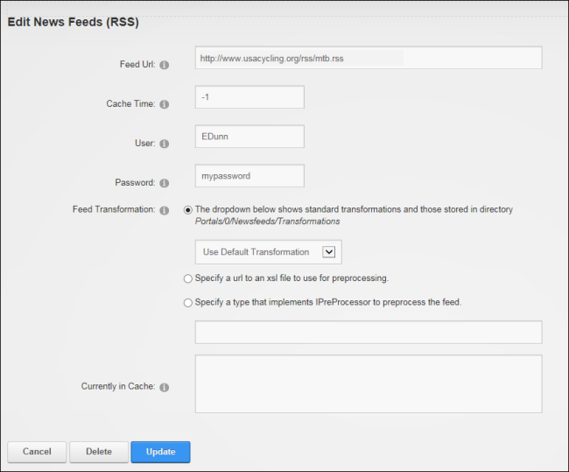

Other options include setting cache time and choosing a transformation to suit the feed. A selection of transformations are included such as the Internal Twitter Transformation transforms tweets into correctly formatted links to tags and people. An alternative is to "Specify a URL to an XSL file to use for preprocessing" to define a pre-processor that will make non-compliant feeds compliant using an XSL transformation (also called a pre-processor). Note: A URL or file link can be set to the transformation (XSL) file. If however the file link displays the "failure to compile the XSL" error then use the URL option and enter the full URL to the XSL sheet.

A second alternative is to "Specify a type that implements IPreProcessor to preprocess the feed" to use a custom preprocessor that implements the IPreProcessor interface and enter the name of the preprocessor into the text box. E.g. CustomPreprocessor

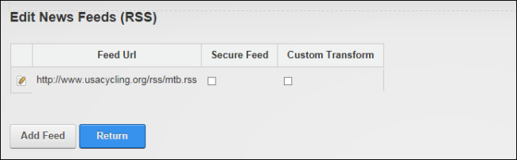

## Adding Syndicated News Feeds

Module editors can add news feeds from syndicated module. The URL for the feed can be obtained by selecting C:\Users\Lorraine\Documents\DNN.Documentation\Output\Lorraine\Word Test\Dnn.Platform\Documentation\Resources\Images\Icons\ico_manage.png Manage > C:\Users\Lorraine\Documents\DNN.Documentation\Output\Lorraine\Word Test\Dnn.Platform\Documentation\Resources\Images\Icons\rss_17x17.gif Syndicate from the module actions menu of syndicated module and copying the URL that is displayed in the Address bar of the Web browser.

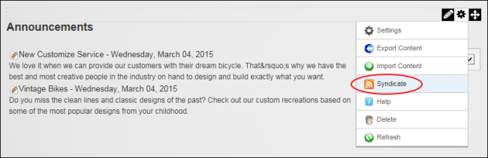

## Managing News Feeds

News feeds can be edited by selecting C:\Users\Lorraine\Documents\DNN.Documentation\Output\Lorraine\Word Test\Dnn.Platform\Documentation\Resources\Images\Icons\ico_edit.png Edit > C:\Users\Lorraine\Documents\DNN.Documentation\Output\Lorraine\Word Test\Dnn.Platform\Documentation\Resources\Images\Icons\EditContent.gif Edit Newsfeeds from the module actions menu and then clicking the Edit C:\Users\Lorraine\Documents\DNN.Documentation\Output\Lorraine\Word Test\Dnn.Platform\Documentation\Resources\Images\Icons\EditContent.gif button beside the required feed and editing or deleting as required.

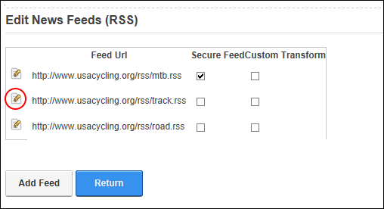

## Refreshing the Feed Cache

Module editors can select C:\Users\Lorraine\Documents\DNN.Documentation\Output\Lorraine\Word Test\Dnn.Platform\Documentation\Resources\Images\Icons\ico_edit.png Edit > C:\Users\Lorraine\Documents\DNN.Documentation\Output\Lorraine\Word Test\Dnn.Platform\Documentation\Resources\Images\Icons\Refresh_16x16_Standard.png Refresh Feed Cache from the module actions menu to reload all feeds from their original source location to ensure the latest information is displayed on the page.

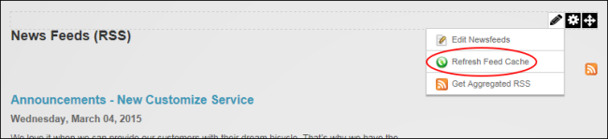  
Refreshing the Feed Cache

# Settings

## Configuring News Feeds Settings

Administrators and page editors can configure News Feeds settings for the current News Feeds module. Here they can set the default cache time in minutes for all news items within the current News Feeds module and configure the retry settings for retrieving news feeds by choosing number of times the module will attempt to load a feed and the number of minutes it will wait before retrying if still unsuccessful.

Administrators can change the layout of news items using one of the XSL Transformations provided or by choosing "Other" and setting a link to the XSL file. Additional XSL transformations can be added to this list by uploading them to the portals/[id]/Newsfeeds/Transformations/ folder. [See "Overview of News Feeds Layouts"](#_Overview_of_News)

Administrators can set the number of news items displayed and choose the details displayed for each news item. Choosing to "Show Item Details" will display a brief description that is taken from the beginning of the each item. Note: "Show Item Details" and "Show Item Date" are passed as parameters to the XSL sheet. These parameters must be included on any custom XSL sheet being used. See the default sheets for an example.

Finally, Administrators can configure the methods by which the News Feeds (RSS) module retrieves information from news sources. The two options provided are using Ajax, and/or Background Loading. Ajax renders the module immediately without any content and then the module uses Ajax to load its contents directly once the complete page has loaded. This is useful if the module appears to hamper page loading. Background loading uses the Schedule to determine how frequently new data is retrieved. The Schedule runs independently of the News Feeds module which enabling the data to be retrieved at the optimum time rather than when the module is being viewed, which can cause delays. Note: Ajax is disabled and Background Download is enabled by default and these are the recommended settings.

## Overview of News Feeds Layouts

Default.xsl [System]: Displays the title, date and summary of news items in a static list down the module.



Ticker.xsl [System]: Displays the date, time and title of news items display in a single line that repeatedly scrolls from left to right across the module.

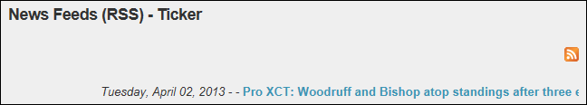

Ticker2.xsl [System]: Displays the title of news items in a single line that repeatedly scrolls from left to right across the module.

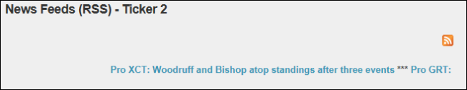

Twitter.xsl [System]: Suitable for Twitter feeds, this layout displays the date, time, title and summary of news items in a static list down the module.



VScroll.xsl [System]: Displays the date, title and summary. News items in a list which repeatedly scrolls up from the base to the top of the module.

