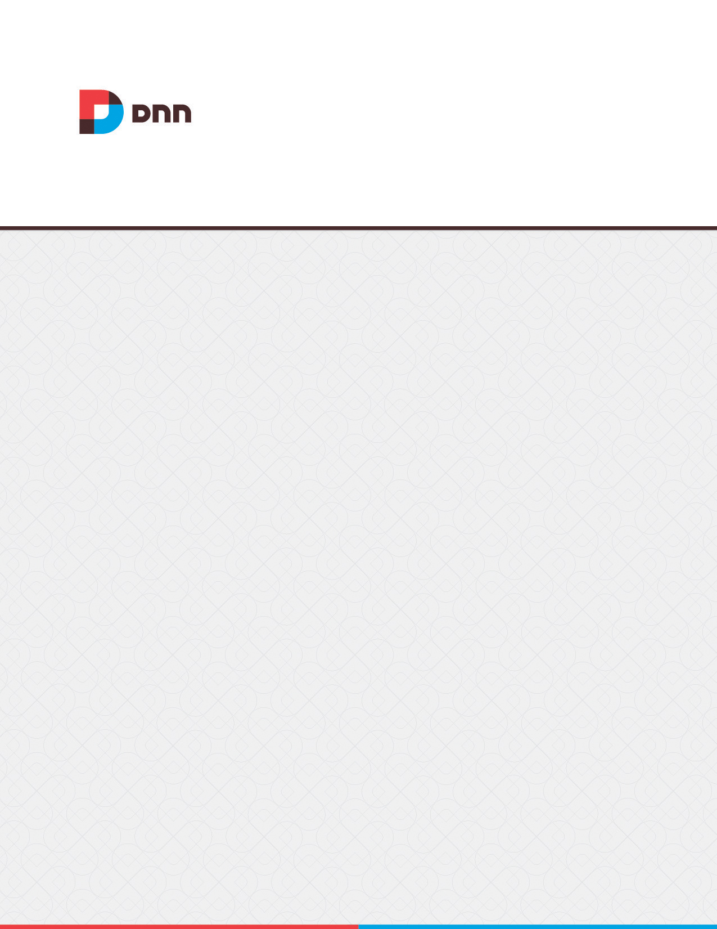

**Wiki 05.00.01**

**User Manual**

Contents

[Wiki 3](#_Toc429483798)

[Configuration 3](#_Toc429483799)

[Setting Editor Roles 3](#_Toc429483800)

[Configuring Notification Settings 4](#_Toc429483801)

[Configuring Comment Settings 5](#_Toc429483802)

[Configuring Rating Settings 6](#_Toc429483803)

[All Users 7](#_Toc429483804)

[Navigating the Wiki 7](#_Toc429483805)

[Adding a Comment 8](#_Toc429483806)

[Adding a Rating 9](#_Toc429483807)

[Viewing Topic History 9](#_Toc429483808)

[Editors 9](#_Toc429483809)

[Adding the Home Page 10](#_Toc429483810)

[Creating Wiki Pages 10](#_Toc429483811)

[Adding Wiki Topics 10](#_Toc429483812)

[Managing Wiki Pages 10](#_Toc429483813)

[Managing Comments 11](#_Toc429483814)

[Managing Page Ratings 11](#_Toc429483815)

[Restoring Previous Versions 11](#_Toc429483816)

# Wiki

The Wiki module enables authorized users to create and manage a Wiki website. Wiki's are designed to enable multiple contributors to build a community based information resource. Contributors can add content and update existing information to progressively enrich the caliber of the content. Wiki's are typically accessible to anonymous contributors however the usual security levels can be set on this Wiki. Each Wiki topic is a Wiki page. Links between pages are created by adding a link the topic name. This Wiki includes searching, version history, comments and ratings. Note: This module is intended for production use only.

The Wiki must be deployed and installed by a Super User. Install and source packages can be downloaded from the [releases page](https://github.com/DNNCommunity/DNN.Wiki/releases) and feature requests, bug links and general questions can be submitted via the [issues page](https://github.com/DNNCommunity/DNN.Wiki/issues).

Important. It is recommended that the Wiki is configured prior to use.

Module Version: 05.00.01 / Minimum DNN Version: 06.00.00

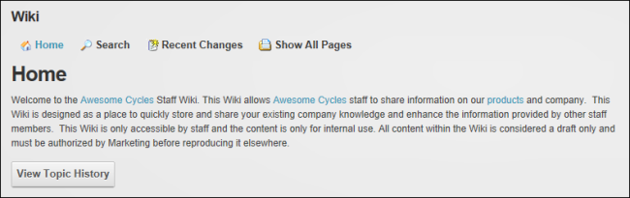  
The Wiki

# Configuration

## Setting Editor Roles

Administrators can configure Wiki security settings to determine the Wiki editor roles. Standard DNN module security, as managed on the Module Settings page, can be used to allow the users with Edit permissions to add and edit Wiki content. Alternatively one or more roles can be added to the editor role via the Wiki configuration page. This option doesn't give editors access to the module action menu.

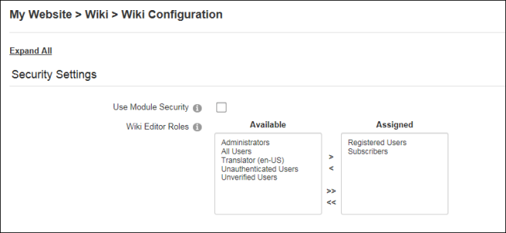  
Configuring Wiki Editor Roles

## Configuring Notification Settings

Administrators can configure the Wiki to allow users to subscribe to receive notification when a Wiki page is updated or a comment is added. Notification can be enabled for editors (users with editing rights) and/or viewers (users who can view the Wiki), or custom roles can be selected.

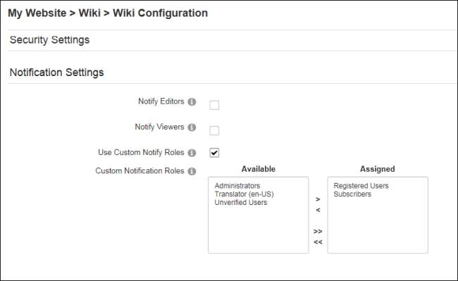  
Configuring Wiki Notification Settings

## Configuring Comment Settings

Administrators can configure the Wiki to allow editors to comment on Wiki pages and send notifications (user comments) when a comment is added if notification is enabled. [See "Configuring Notification Settings".](#_Configuring_Notification_Settings) Once commenting has been allowed it can be enabled or disabled on individual pages when adding or editing the page.

Commenting can be allowed on individual pages by marking the "Allow Page Comments" check box and ensuring the "Enable on Existing" and "Enable Comments by Default" check boxes are unmarked.

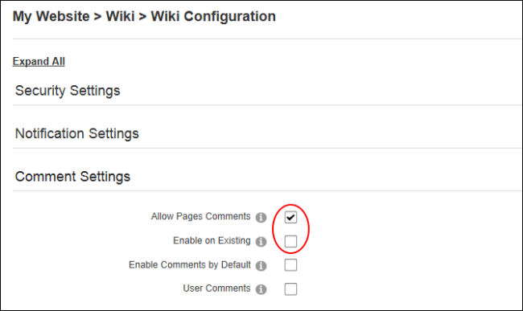  
Enabling Comments on individual Wiki pages

Commenting can be enabled for all Wiki pages by marking the "Allow Pages Comments", "Enable on Existing" and "Enable Comments by Default" check boxes. Alternatively the "Enable on Existing" check box can be unmarked to only add commenting to new pages.

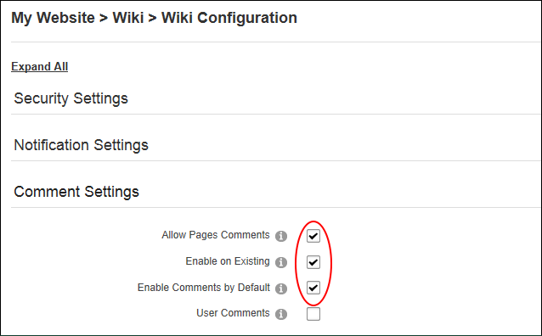  
Enabling Comments on all Wiki pages

## Configuring Rating Settings

Administrators can configure the Wiki to allow editors to rate Wiki pages. Once ratings have been allowed they can be enabled or disabled on individual pages when adding or editing the page. [See "Managing Page Ratings".](#_Managing_Page_Ratings)

Ratings can be enabled on all Wiki pages by marking the "Allow Page Ratings" and "Enable on Existing" check boxes. Alternatively ratings can be allowed for individual pages by marking the "Allow Page Ratings" and unmarking the "Enable on Existing" check boxes.

In addition, Administrators can choose to enable ratings by default when adding a new page. Editors will still have the option of disabling ratings for that page when adding or edit the page.

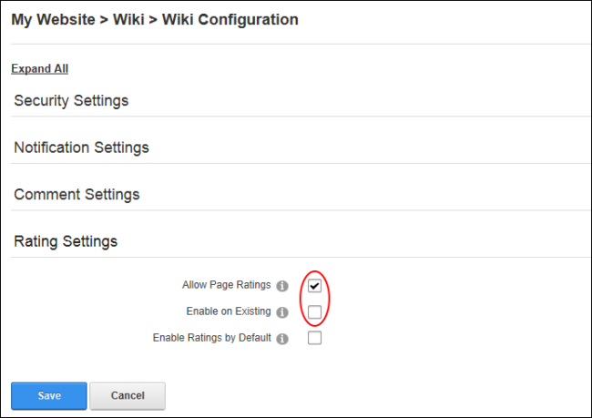  
Configuring Wiki Rating Settings

# All Users

## Navigating the Wiki

Users can navigate to and find Wiki topics using the links displayed across the top of each page. The C:\Users\Lorraine\Documents\DNN.Documentation\Output\Lorraine\Word Test\Dnn.Platform\Documentation\Resources\Images\Icons\Btn_Home.gif Home link returns to the Wiki home page. The C:\Users\Lorraine\Documents\DNN.Documentation\Output\Lorraine\Word Test\Dnn.Platform\Documentation\Resources\Images\Icons\Btn_Search.gif Search link displays the search box that returns results for all or part of the search criteria. The C:\Users\Lorraine\Documents\DNN.Documentation\Output\Lorraine\Word Test\Dnn.Platform\Documentation\Resources\Images\Icons\Btn_RecentChanges.gif Recent Changes link displays recent changes for all pages during the last 24 hours, 7 day or in the last month.

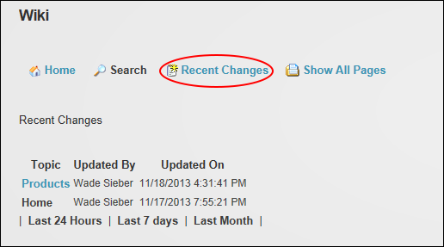

Users can locate Wiki topics by selecting the C:\Users\Lorraine\Documents\DNN.Documentation\Output\Lorraine\Word Test\Dnn.Platform\Documentation\Resources\Images\Icons\Btn_Index.gif Show All Pages link and then selecting the required page. Alternatively they can navigate to a page by clicking on the Topic Name link displayed the content of a page.

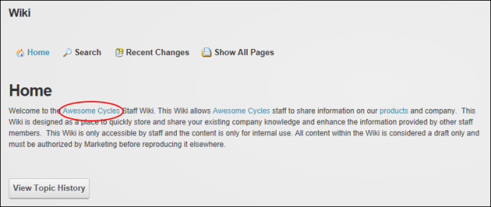  
Navigating to the "Awesome Cycles" Wiki page

## Adding a Comment

Users can add and/or view comments to Wiki pages that display the Comments section below the page content. Users may also be able to subscribe to receive an email notification to be notified of any page updates.

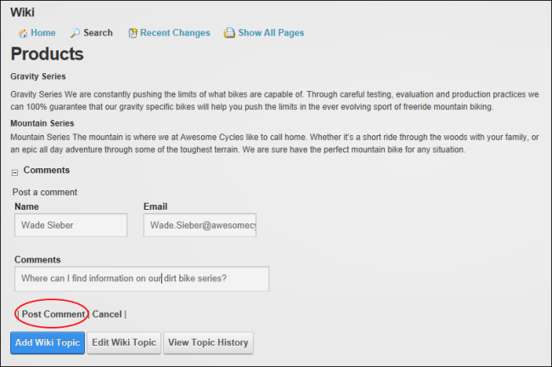  
Adding a Comment to a Wiki page

## Adding a Rating

Users can view the average and total rating for a page and add one rating per page. Ratings are tracked using a browser cookie. Ratings may be disabled on some or all pages.

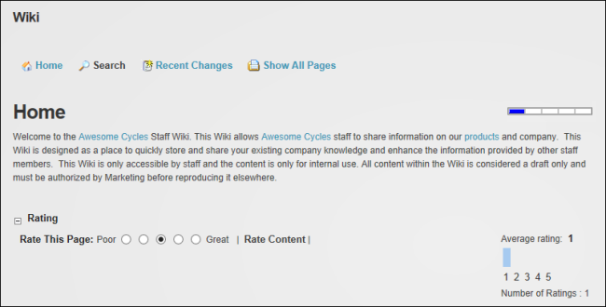  
Adding a Wiki page Rating

# Editors

## Viewing Topic History

Users can select the View Topic History button located on a topic page to view the topic history and then click on a version to view the full topic content.

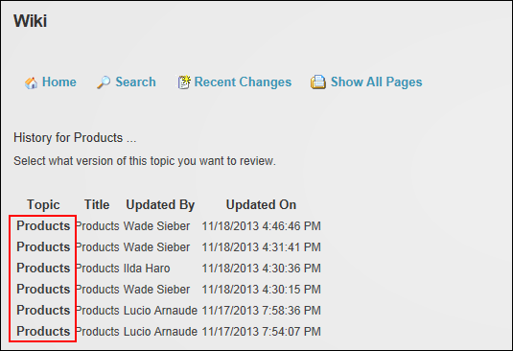  
Viewing Topic History

## Adding the Home Page

A new page with the Page Name "WikiHomePage" must be added to the Wiki to create the C:\Users\Lorraine\Documents\DNN.Documentation\Output\Lorraine\Word Test\Dnn.Platform\Documentation\Resources\Images\Icons\Btn_Home.gif Wiki Home page.

## Creating Wiki Pages

Topics that have been created by adding a page link to the content of another Wiki topic need to have a Wiki page created and content added to the page. This can be done by navigating to the page that contains the topic link and clicking on the link, or by adding a new Wiki topic and ensuring the Page Name is spelled exactly the same as linked Topic Name. Once the Wiki page has been created then the topics will be displayed in the Show All Pages list.

## Adding Wiki Topics

Editors can add new Wiki pages. The "Page Name" is the only required field. This allows users to add multiple empty pages to create a skeleton outline for the Wiki and then return to add content at a later stage. Links to Wiki topics can be included in the topic content. If the linked page does not yet exist it will not appear in the Wiki Index until the page content is added. Page comments and/or ratings can optionally be enabled to allow editors to add comments or ratings. Maximize C:\Users\Lorraine\Documents\DNN.Documentation\Output\Lorraine\Word Test\Dnn.Platform\Documentation\Resources\Images\Icons\max.gif the Wiki Text Directions section for more help on adding page links.

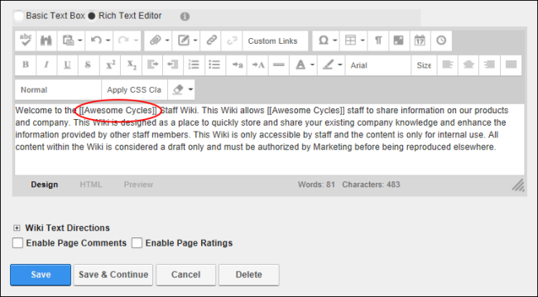  
Adding a Topic link

## Managing Wiki Pages

Editors can edit and delete Wiki pages. Deleting a Wiki page deletes all of the page history however links on other pages that have been added to the now deleted page are not deleted. The Home page cannot be deleted. Note: The Wiki home page ([See "Adding Wiki Topics"](#_Adding_Wiki_Topics)) must be created before it can be edited.

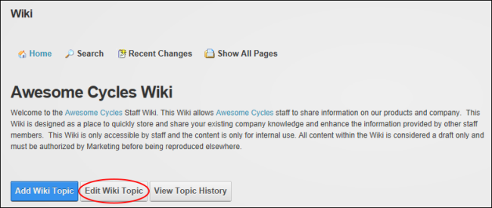  
Managing Wiki Pages

## Managing Comments

Editors can delete existing comments and enable/disable page commenting on individual pages by adding or editing the Wiki page.

## Managing Page Ratings

Editors can enable or disable ratings for individual pages when adding or editing a Wiki page.

## Restoring Previous Versions

Editors can restore previous versions of a Wiki page using the Topic History page.

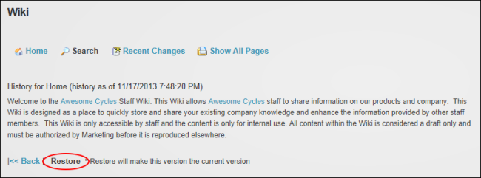  
Restoring Previous Page Version