# 

**XML 06.00.02**

**User Manual**

Contents

XML 3

Editors 4

Creating an XML/XSL Transformation 4

Managing XSL Parameters 5

Setting Transformation Output 6

Enabling DNN Searching 8

Setting Query String Parameter Value Pair 9

Viewing the XML Source File 10

# XML

The XML module, also called the XML/XSL or DNN/XML, displays the result of an XML/XSL transform by combining the transformation language of XSL (Extensible Style Sheet Language) to the data contained in an XML (Extensible Markup Language) file. XML allows users to create multiple output formats from the same XML document. The results can be displayed inside the module as HTML, accessed by clicking a download link or as a direct download. Users must be granted Edit Module permissions to add and manage XML.

XML must be deployed and installed by a Super User. Install and source packages can be downloaded from the [releases page](https://github.com/DNNCommunity/DNN.XML/releases) and feature requests, bug links and general questions can be submitted via the [issues page](https://github.com/DNNCommunity/DNN.XML/issues).

XML can be extended using additional XML data providers and rendering providers other than XSL such as Razor and Pretty Print. These providers are not part of the project and must be downloaded separately. See the XML project page (<http://dnnxml.codeplex.com/documentation>) for more details.

Module Version: 06.00.02 / Minimum DNN Version: 05.06.02

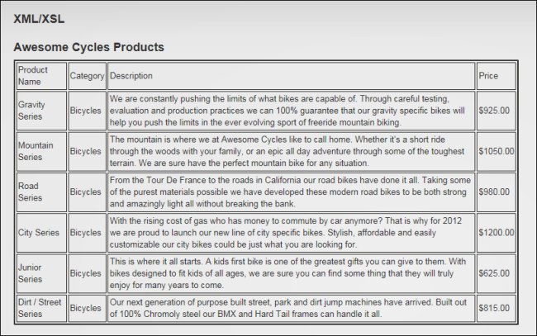  
XML/XSL

# Editors

## Creating an XML/XSL Transformation

Editors can create an XML/XSL transformation using an internal or external XML file. This example uses internal XML and XSL files and the default settings are used which display the results as HTML inside the XML/XSL module. To create an XML/XSL transformation, select C:\Users\Lorraine\Documents\DNN.Documentation\Output\Lorraine\Word Test\Dnn.Platform\Documentation\Resources\Images\Icons\EditContent.gif Edit Module Configuration from the XML/XSL module actions menu and set the "Data Source Type" and choose the XSL Transformation file.

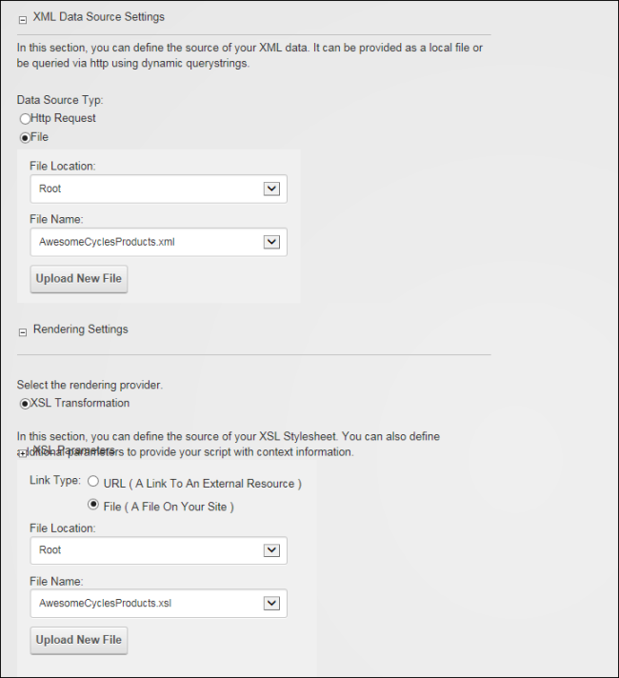

Optional settings include adding XSL parameters, rendering the output as link to download or direct download, setting the querystring parameters, and including output in DNN site searches.

## Managing XSL Parameters

Editors can add, edit and delete query string parameters that have been added to an XML/XSL transformation. The URL Query string parameters data will be passed to the URL that is producing the XML. The source of the XML does not need to be an XML file it could be a dynamic page that takes in the parameters and process them and produces an XML output. Security settings allow access to secure services that provide XML such as weather or stock prices services. These parameters are managed in the Rendering Settings - XSL Parameters section when adding or editing a transformation. To add a XSL Parameter, click the Add Parameter link and enter a name for this query string parameter and select a value from the Data Origin drop down list. Parameters can be set as required or optional.

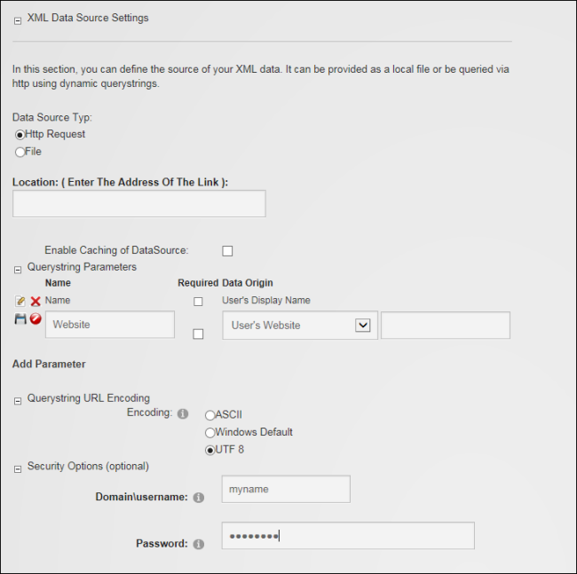

## Setting Transformation Output

XML/XSL transformations display on the page as HTML inside the XML/XSL module by default.

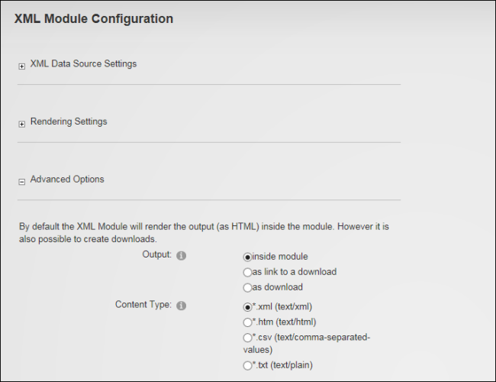  
Setting XML/XSL Transformation output

Editors can modify XML module configuration to instead display the transformation as a download link that displays on the page and can be selected to view the transformation.

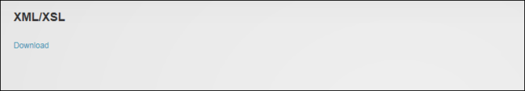  
Transformation file rendered as a Download link

Alternatively, the transformation can be set to automatically download from the page. Both these options can render in xml, htm or csv, or text format.

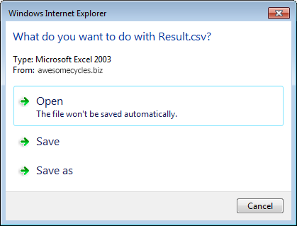  
Direct Download of a Transformation file

Automatic download changes the way page navigation typically works so that when a user chooses to navigate to the page where this module is located a file download message is displayed rather than the site page. This prevents the content of modules on that page from being edited. Because of this, it is recommended that XML modules which are set "As Download" are the only module on the page. A workaround for this problem is to display the site in Layout Mode and then navigate to the page. Once in Layout mode the Module Settings page for any module can be accessed which allows modules to be moved to another page. This allows the XML module to be moved to another page where no other modules are located. See "Configuring Advanced Page Settings for a Module" in the DNN Platform Administrators Manual. To test this setting, navigate to the page where the module is located. A download message similar to the image below is displayed.

## Enabling DNN Searching

Editors can include the XML/XSL module in DNN searches and determine how frequently (next run, always, hourly or daily) data is updated. The current search index can also be clearing to run a new search the next time a search is made. Note: Parameters must not be set to allow the module to be included in DNN search.

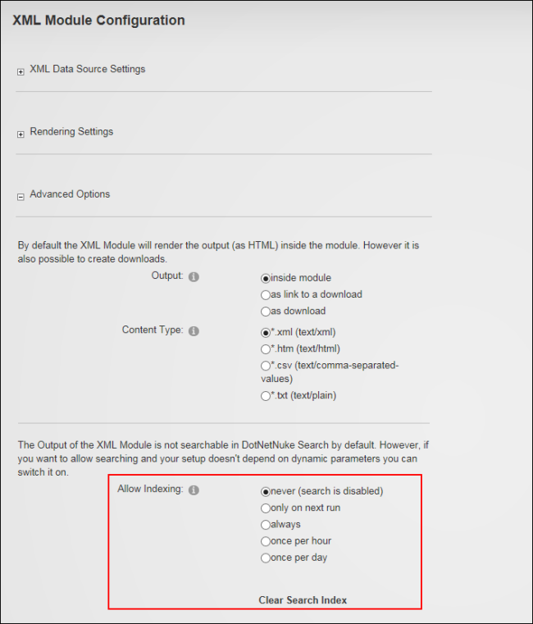  
Enabling DNN Searching

## Setting Query String Parameter Value Pair

Editors can set a defined query string parameter/value pair that must match exactly to allow the XML/XSL module to execute. E.g. this could be used to only display content to users in a particular locale by setting the query string parameter Name to locale and the Data origin to User's Locale. Then in the Advanced Options section set Querystring Param to locale and set Querystring Value = en-US, this will then only show the content to users from the US. Query string values can be cleared/disabled at any time.

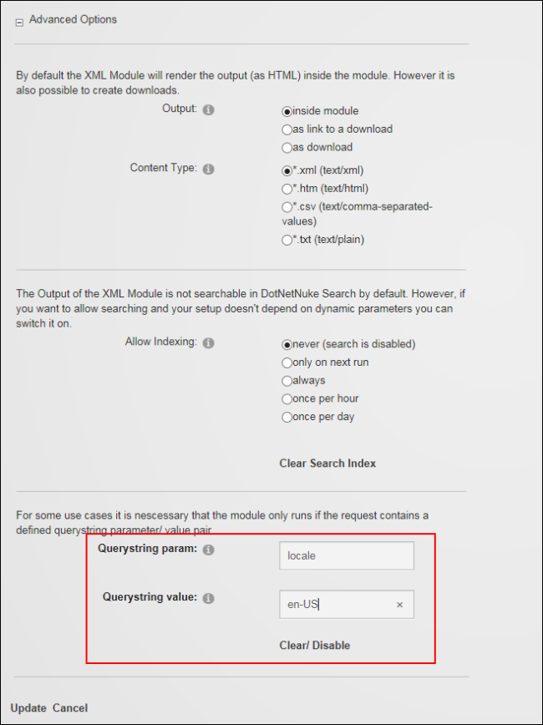

## Viewing the XML Source File

Editors can view the XML file that is being used to perform an XML/XSL transform by selecting C:\Users\Lorraine\Documents\DNN.Documentation\Output\Lorraine\Word Test\Dnn.Platform\Documentation\Resources\Images\Icons\EditContent.gif "Show Source" from the XML module actions menu.

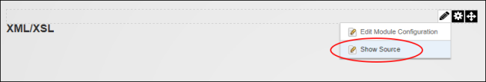

This displays the data within XML file inside the current Web browser and allows the XML source to be viewed by right clicking inside the web browser and selecting "View Source" from the drop down menu.