|  |
| --- |
|  |
| DNNspot – Store Manual |
|  |
|  |
| http://www.dnnspot.com/Portals/0/DNNspot%20Rev2/large_icons/shoppingcart_large.png |
|  |

|  |
| --- |
| For up-to-date information, visit http://www.dnnspot.com. Create for Store version 2.0.9 |

Contents

DNNspot Store 3

Requirements 3

Setup 3

DNNspot Store - Admin 3

Store Settings 3

Email Templates 5

Shipping Options 10

Sales Tax 12

Payment Processors 13

Catalog Settings 14

Categories 15

Products 16

Import 20

Export 22

Coupons 22

Add Coupon 23

Discounts 24

Add Discount 24

Orders 25

Reports 27

Customer List 27

Order List 28

DNNspot Module License 29

DNNspot Store – Featured Products 30

Filter 30

Template 31

Template Tokens 31

DNNspot Store – My Orders 31

# DNNspot Store

## Requirements

DotNetNuke 05.03.01 or later is required for DNNspot Store version 2.x and higher.

## Setup

It’s recommended that the store administrator setup two pages. One page will be used for the “DNNspot Store” modules and the other one will be used for the “DNNspot Store – Admin” module. Be sure to make the Admin page viewable only by Administrators.

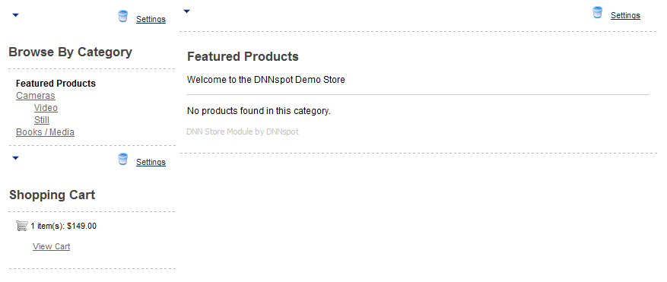

A commonly used two-column layout for the store setup

# DNNspot Store - Admin

## Store Settings

**Store Name:** This text is used throughout the store, in emails, and a variety of labels to help identify the store.

**Store GUID:** Specific GUID used to identify a particular installation.

**Customer Service Email:** Email address used to communicate with customers.

**Order # Prefix:** The prefix that each order will begin with.

**Default country:** The Billing/Shipping Country will be pre-selected depending on what is selected in this drop down menu.

**Currency:** The currency that the store should use.

**Secure Checkout:** Used for those that have an SSL certificate and want to ensure checkout is secure.

**My Store Location:** Used to calculate Shipping Estimates.

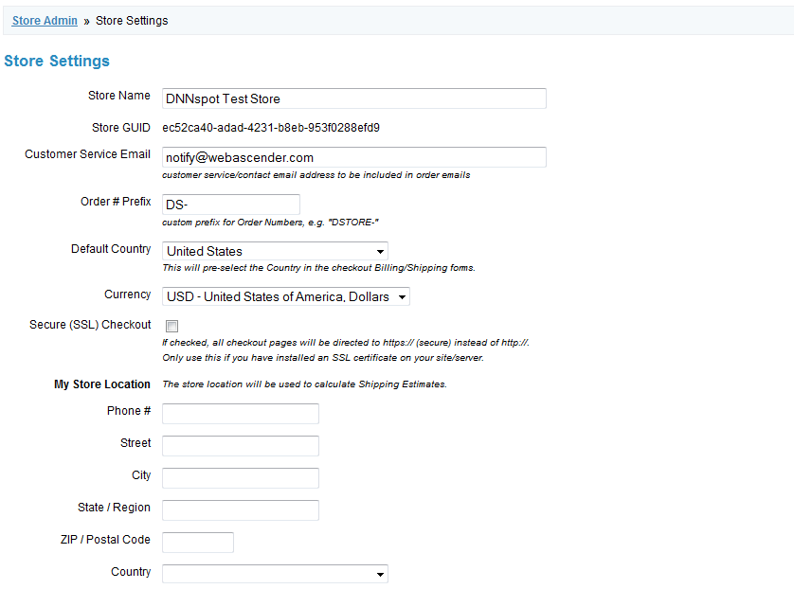

Basic store settings.

**Allow checkout as guest:** A checked value allows users to checkout anonymously. An unchecked value requires a login to the site in order to checkout.

**Display “create account” link:** Allows user to quickly create an account.

**Send email to store owner:** Comma-separated email address of who receives an email when a customer places an order.

**POST the order to a URL:** Posts details of an order to a URL. Parameters include: Id, StoreId, IsDeleted, UserId, OrderNumber, OrderStatusId, PaymentStatusId, CustomerFirstName, CustomerLastName, CustomerEmail, BillAddress1, BillAddress2, BillCity, BillRegion, BillPostalCode, BillCountryCode, BillTelephone, ShipRecipientName, ShipRecipientBusinessName, ShipAddress1, ShipAddress2, ShipCity, ShipRegion, ShipPostalCode, ShipCountryCode, ShipTelephone, CreditCardType, CreditCardNumberLast4, CreditCardNumberEncrypted, CreditCardExpiration, CreditCardNameOnCard, ShippingServiceOption, SubTotal, ShippingAmount, DiscountAmount, TaxAmount, Total, CreatedOn, CreatedByIP, CreatedFromCartId, ModifiedOn, ShippingServiceProvider, ShippingServicePrice, ShippingServiceTrackingNumber, ShippingServiceLabelFile, CustomerNotes

### Email Templates

#### OrderReceived

This is the email template that is received by a customer when their order is received.

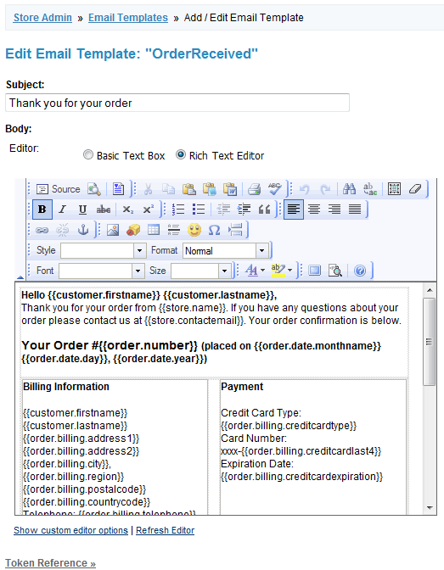

OrderReceived email template

##### Token Reference

* {{store.name}}
* {{store.contactemail}}
* {{customer.userid}}
* {{customer.firstname}}
* {{customer.lastname}}
* {{customer.email}}
* {{order.number}}
* {{order.status}}
* {{order.payment.status}}
* {{order.payment.summary}}
* {{order.date}}
* {{order.date.monthname}}
* {{order.date.day}}
* {{order.date.year}}
* {{order.subtotal}}
* {{order.shippingcost}}
* {{order.couponcodes}}
* {{order.tax}}
* {{order.total}}
* {{order.billing.address1}}
* {{order.billing.address2}}
* {{order.billing.city}}
* {{order.billing.region}}
* {{order.billing.postalcode}}
* {{order.billing.countrycode}}
* {{order.billing.telephone}}
* {{order.billing.creditcardtype}}
* {{order.billing.creditcardlast4}}
* {{order.billing.creditcardexpiration}}
* {{order.payment.status}}
* {{order.shipping.recipientname}}
* {{order.shipping.address1}}
* {{order.shipping.address2}}
* {{order.shipping.city}}
* {{order.shipping.region}}
* {{order.shipping.postalcode}}
* {{order.shipping.countrycode}}
* {{order.shipping.telephone}}
* {{order.shipping.option}}
* {{order.shipping.cost}}
* {{order.shipping.trackingnumber}}
* {{order.itemstable}}
* {{order.itemsdelim}}
* {{order.itemsjson}}

#### OrderReceivedAdmin

##### Token Reference

* {{store.name}}
* {{store.contactemail}}
* {{customer.userid}}
* {{customer.firstname}}
* {{customer.lastname}}
* {{customer.email}}
* {{order.number}}
* {{order.status}}
* {{order.payment.status}}
* {{order.payment.summary}}
* {{order.date}}
* {{order.date.monthname}}
* {{order.date.day}}
* {{order.date.year}}
* {{order.subtotal}}
* {{order.shippingcost}}
* {{order.couponcodes}}
* {{order.tax}}
* {{order.total}}
* {{order.billing.address1}}
* {{order.billing.address2}}
* {{order.billing.city}}
* {{order.billing.region}}
* {{order.billing.postalcode}}
* {{order.billing.countrycode}}
* {{order.billing.telephone}}
* {{order.billing.creditcardtype}}
* {{order.billing.creditcardlast4}}
* {{order.billing.creditcardexpiration}}
* {{order.payment.status}}
* {{order.shipping.recipientname}}
* {{order.shipping.address1}}
* {{order.shipping.address2}}
* {{order.shipping.city}}
* {{order.shipping.region}}
* {{order.shipping.postalcode}}
* {{order.shipping.countrycode}}
* {{order.shipping.telephone}}
* {{order.shipping.option}}
* {{order.shipping.cost}}
* {{order.shipping.trackingnumber}}
* {{order.itemstable}}
* {{order.itemsdelim}}
* {{order.itemsjson}}

#### PaymentCompleted

##### Token Reference

* {{store.name}}
* {{store.contactemail}}
* {{customer.userid}}
* {{customer.firstname}}
* {{customer.lastname}}
* {{customer.email}}
* {{order.number}}
* {{order.status}}
* {{order.payment.status}}
* {{order.payment.summary}}
* {{order.date}}
* {{order.date.monthname}}
* {{order.date.day}}
* {{order.date.year}}
* {{order.subtotal}}
* {{order.shippingcost}}
* {{order.couponcodes}}
* {{order.tax}}
* {{order.total}}
* {{order.billing.address1}}
* {{order.billing.address2}}
* {{order.billing.city}}
* {{order.billing.region}}
* {{order.billing.postalcode}}
* {{order.billing.countrycode}}
* {{order.billing.telephone}}
* {{order.billing.creditcardtype}}
* {{order.billing.creditcardlast4}}
* {{order.billing.creditcardexpiration}}
* {{order.payment.status}}
* {{order.shipping.recipientname}}
* {{order.shipping.address1}}
* {{order.shipping.address2}}
* {{order.shipping.city}}
* {{order.shipping.region}}
* {{order.shipping.postalcode}}
* {{order.shipping.countrycode}}
* {{order.shipping.telephone}}
* {{order.shipping.option}}
* {{order.shipping.cost}}
* {{order.shipping.trackingnumber}}
* {{order.itemstable}}
* {{order.itemsdelim}}
* {{order.itemsjson}}

#### ShippingUpdate

##### Token Reference

* {{store.name}}
* {{store.contactemail}}
* {{customer.userid}}
* {{customer.firstname}}
* {{customer.lastname}}
* {{customer.email}}
* {{order.number}}
* {{order.status}}
* {{order.payment.status}}
* {{order.payment.summary}}
* {{order.date}}
* {{order.date.monthname}}
* {{order.date.day}}
* {{order.date.year}}
* {{order.subtotal}}
* {{order.shippingcost}}
* {{order.couponcodes}}
* {{order.tax}}
* {{order.total}}
* {{order.billing.address1}}
* {{order.billing.address2}}
* {{order.billing.city}}
* {{order.billing.region}}
* {{order.billing.postalcode}}
* {{order.billing.countrycode}}
* {{order.billing.telephone}}
* {{order.billing.creditcardtype}}
* {{order.billing.creditcardlast4}}
* {{order.billing.creditcardexpiration}}
* {{order.payment.status}}
* {{order.shipping.recipientname}}
* {{order.shipping.address1}}
* {{order.shipping.address2}}
* {{order.shipping.city}}
* {{order.shipping.region}}
* {{order.shipping.postalcode}}
* {{order.shipping.countrycode}}
* {{order.shipping.telephone}}
* {{order.shipping.option}}
* {{order.shipping.cost}}
* {{order.shipping.trackingnumber}}
* {{order.itemstable}}
* {{order.itemsdelim}}
* {{order.itemsjson}}

### Shipping Options

#### Custom Shipping

The store administrator can turn Custom Shipping options off and on. Entering a new shipping option will give you the option to set a different price for a particular country or region. You can add a weight constraint to the particular price you set for each region.

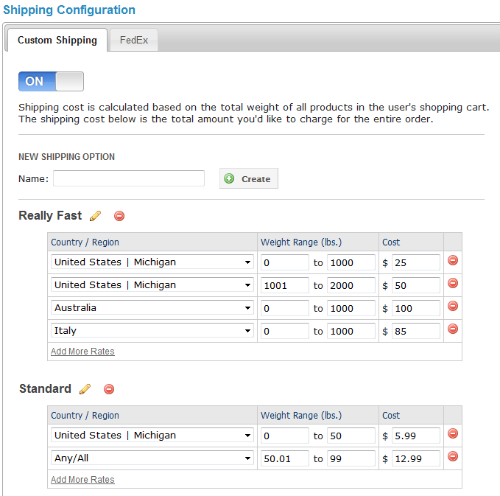

Add different shipping options and configurations for each option

There is an unlimited amount of Custom Shipping options the store administrator can add. “Standard”, “2-Day”, and “Next Day” could be three different shipping options. Then, within each shipping option the administrator could add different rates for different countries / regions / states, a weight range for that particular rate, and a price.

#### FedEx

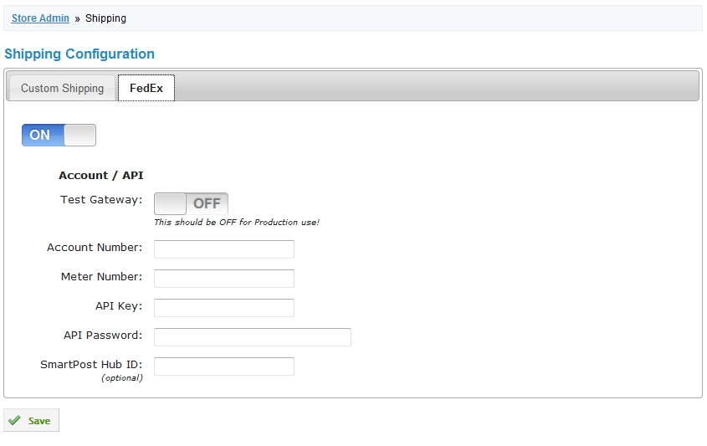

FedEx shipping configuration

### Sales Tax

Charge tax based on a billing address or shipping address. Add a different percentage tax for each country, region, or state selected.

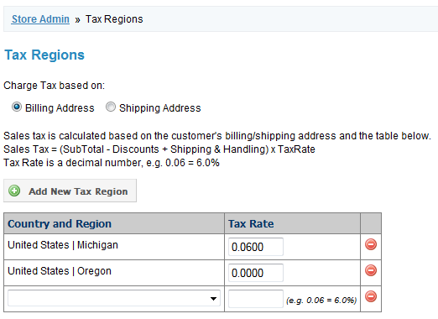

Charge sales tax based on the location of the customer

### Payment Processors

#### On-Site / Integrated Processors

On-site / Integrated Processors will keep the customer on the site for the entire checkout process. An SSL Certificate is required for this option.

* **Pay by Check, Money Order, Phone, etc:** Allows user to complete the checkout process, and then complete payment instructions that are given to the customer. Display Text and Customer Instructions will appear to the customer to tell them how to complete the payment process (e.g “Mail a check to:…”). The store administrator will have to mark a user “Paid” in order for the customer to receive the “Payment Completed” email.
* **Capture Credit Card – Manual Processing:** To be used with a virtual terminal or card-swipe machine. The store administrator will have to mark a user “Paid” in order for the customer to receive the “Payment Completed” email.
* **Authorize.Net – AIM Integration:** Checkout is completed through Authorize.net credit card processing. API Login ID and Transaction Key are needed to use this processor.
  + The Authorize.net API Login ID and Transaction Key can be found using the instructions found on the Authorize.net site: <http://www.authorize.net/support/merchant/Integration_Settings/Access_Settings.htm>
* **PayPal Pro (Direct Payment):** API Username, API Password, and API Signature are needed in order to enable customers to use PayPal Pro checkout.
  + The store administrator can create an API username, API Password, and API Signature by following the instructions found on PayPal’s website: <https://www.paypal.com/cgi-bin/webscr?cmd=xpt/Marketing/merchant/wppro/WPProIntegrationSteps-outside#SectionB>

#### Off-Site / External Processors

* **PayPal – Website Payments Standard:** Customers do not need their own PayPal account to complete the checkout process.
  + Test / Sandbox Mode allows the store administrator to test the checkout process
  + Shipping Calculations can be made by PayPal or by the DNNspot Store Shipping customizations that have been setup under the Shipping Options screen
  + The email address is the address that will receive money when a customer completes the checkout process
* **PayPal – Express Checkout:** Payment option where users need a PayPal account in order to complete the checkout process.

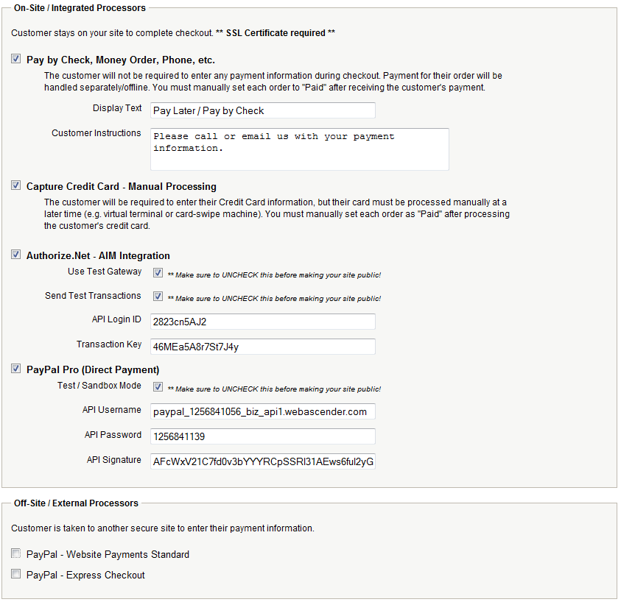

On-site and off-site payment processors

### Catalog Settings

* **Default Sort Order:** Sort by Name, Bestselling, and Price (low to high or high to low)
* **Max Products Per Page:** Choose how many products appear on each category page.

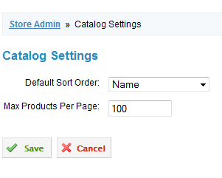

Catalog Settings

## Categories

Rearrange the order of each category. The store administrator can also delete categories from this page. When a customer views the main store page, the store will list products from the Category that is listed first on this page. It is suggested that one creates a “Featured Products” category to help specify what products are shown on the main store page.

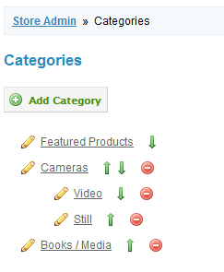

The store administrator can reorder and delete categories

#### Add Category

* **Category Name:** Name of category that appears in the Category menu and in the breadcrumbs on store pages.
* **Title:** The text that appears at the top when viewing a specific category page.
* **URL Name:** URL used for the category. Only lowercase letters, numbers, hyphens, and underscores are allowed. No spaces are allowed. This field is helpful in search engine optimization.
* **Subcategory of:** Select a parent category for the new category. This can help create a hierarchy of categories.
* **Hidden Category:** Selecting this preference allows products to be “hidden” from the navigation menu.
* **Description:** Shown under the Category Title when viewing a specific Category page.
* **Page Title:** Text used in the top of the browser. Helpful for Search Engine Optimization.
* **Meta Description:** Text used as the summary when this particular page appears in a search engine’s search results.
* **Meta Keywords:** Comma separated values used for a Category’s search engine optimization.

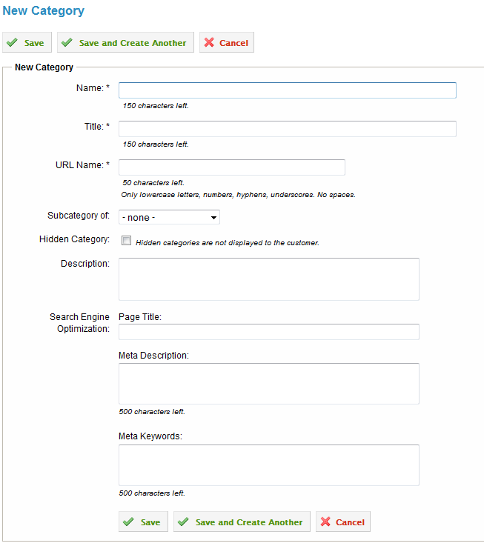

The configuration settings when adding a new catagory

## Products

This page contains a list of products in the store. A store administrator can edit or delete a product, view the product name, price, stock level, and see if the product is active or not. Users can also select the Add Product button.

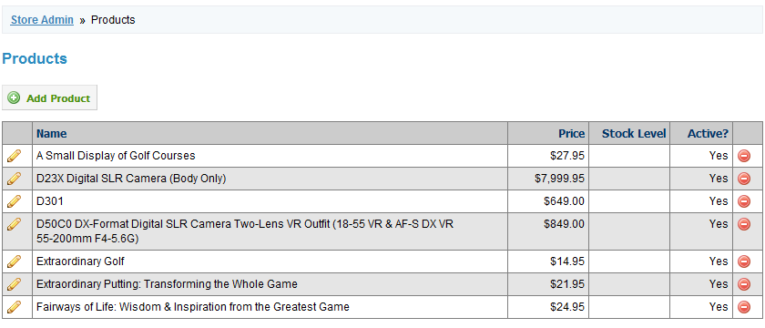

This is a list of example products and how they would appear on the products page

#### Add Product

##### Product

* **Active / Published:** Allows store administrator to make a product active or inactive. An inactive setting will hide the product for customers. A product can be re-activated at anytime.
* **Name:** Name of the product, which shows up on category and product pages.
* **URL Name:** Helpful for search engine optimization of the product page. Letters, numbers, hyphens, and underscores only.
* **Price:** Price that appears for the product on category and product pages.
* **SKU:** Product identifier
* **Page Title:** Text that appears in the top of a particular browser window.
* **Meta Description:** Text used as the summary when this particular page appears in a search engine’s search results.
* **Meta Keywords:** Comma separated values used for this product’s search engine optimization.
* **Taxable Item:** Describes whether the tax settings, setup under the Sales Tax admin screen, should apply to this particular product.
* **Delivery Method:** Shipped or Downloaded.
  + **Shipped:** Enter the Weight (lbs) and Additional Per Item Fee. The Additional Per Item Fee will be added to the shipping total for the order.
  + **Downloaded:** Allow the customer to download a particular file once the transaction is complete.
* **Special Notes:** HTML/Text that appears under the “Add to Cart” button.

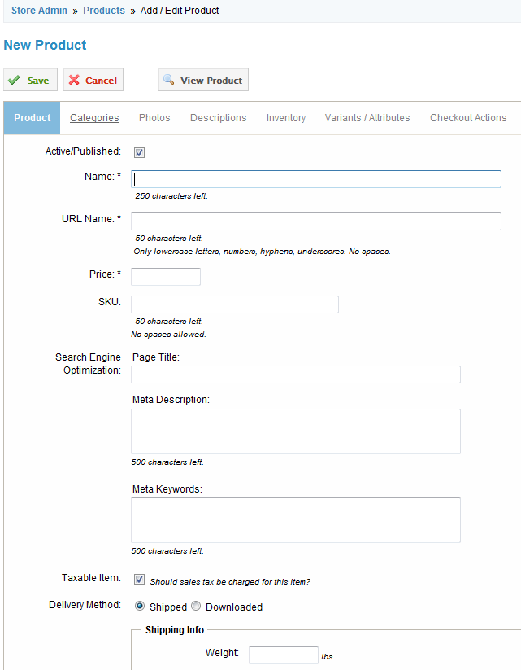

This is the main “Add Product” screen.

##### Categories

Allows the store administrator to select which particular categories the product belongs to.

##### Photos

Allows store administrator to upload multiple images at once. Once an image has been uploaded, it will be automatically resized so that it is viewable in the photo gallery on each particular product page.

##### Descriptions

The store administrator can input up to five different tabs of description and text using the built in Text/HTML editor. Each tab can be renamed.

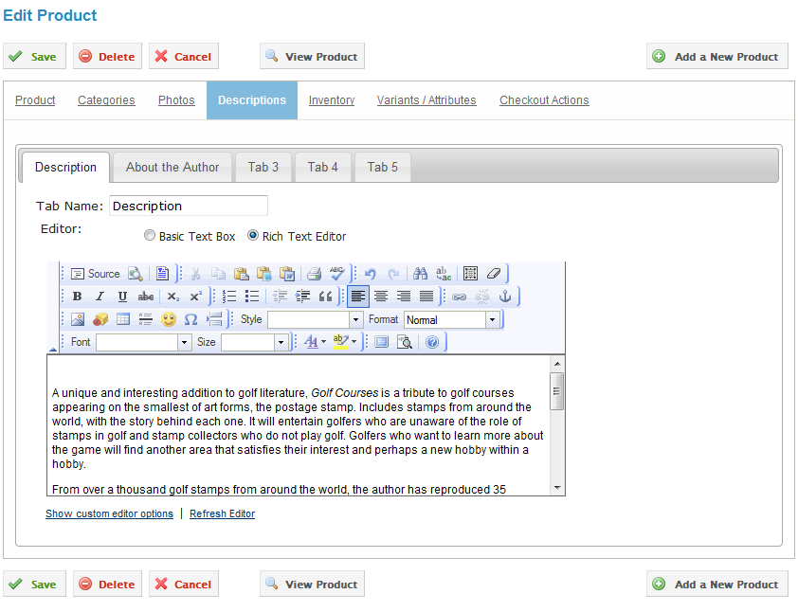

Editing a product’s description

##### Inventory

Enable or disable Inventory Management. Start the Stock Level at a particular numerical level, which will automatically decrease as the product is purchased from the store. Also, allow customers to purchase the product if the Stock Level has already reached a zero quantity.

##### Variants / Attributes

This page contains a list of Variants / Attributes for a particular product. For example, a store that sells shirts might want to add a required variant that requires customers to select their shirt size from a dropdown list.

###### New Variant / Attribute

* **Type:** Input type to be used for the variant /attributes (e.g. a shirt store might select a dropdown list to show what shirt sizes a customer can order)
  + **Textbox:** Allows customer to input text into a box
  + **Textarea:** Multi-line textbox for customers to enter in text
  + **Dropdown List:** List of Name & Values for the customer to select. Customer can only select one value. List of Names appears once the dropdown menu is selected.
  + **RadioButton List:** List of Name & Values for the customer to select. Customer can only select one value. All Names are visible for customer to select.
  + **Checkbox:** A single option for customers to select.
  + **Checkbox List:** Multiple checkboxes for customers to select. A user may select multiple options.
* **Name:** Text that customers will see to describe the variant / attribute (e.g. “Shirt Size”)
* **Required:** Whether the customer must select an option in order to add the product to the cart.
* **Options:** For a list variant, a store administrator can enter multiple options. Options include a name (visible to customers), value (hidden to customers), a price adjustment (positive or negative decimal numbers, no need to include the dollar sign), and a weight adjustment (e.g. “Small”, “Medium”, and “Large” shirt sizes. Price adjustment may be zero or a positive or negative value.

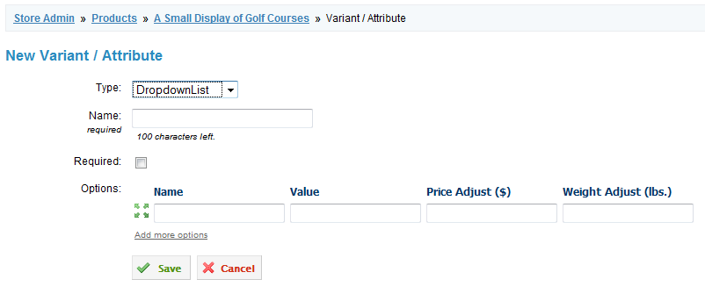

Adding a variant or attribute to a product

##### Checkout Actions

* **Add user to role(s):** Allows a customer to be added to a role. Only applies when a user has been signed in before completing the checkout process. The option is given to add a specific number of days until that particular role expires for a user.

### Import

Allows the store administrator to create, replace, update, and delete products in bulk. Use a .csv to import, replace, update, or delete products in the store. It is recommended that the site administrator create a full backup before completing this task. It is also recommended that a CSV export is used to create, replace, update, and delete products. Example CSV files that show creating a product, updating a product, and deleting a product are available on the Import page.

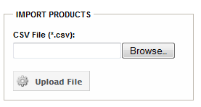

Import products

#### Create / replace / update / delete products during an import

1. Create a CSV file (.csv), 1 line per product, with the product information you wish to create/replace/update (You can create CSV files from Excel by choosing "Save As" and picking "CSV" in the "Save as type" drop-down).
2. Specify the action to take for each product in the ImportAction column (see table below)
3. Categories are specified in the CategoryNames column, separated by commas
4. Photos are specified in the PhotoFilenames column, separated by commas. Photos are also automatically matched by Product SKU (any filename that starts with the SKU).
5. The digital file (downloadable file) for a product is specified in the DigitalFilename column.
6. Photos/Files must exist in the /DesktopModules/DNNspot-Store/ImportFiles/ directory BEFORE uploading the CSV file in order to be imported

Save your CSV file and upload it!

During import, products are found by matching these fields in the following order:

* Product ID
* Url Name
* Name
* SKU

| ImportAction | Description |
| --- | --- |
| C | Create Creates/inserts a product only if it does not exist. |
| R | Replace Replaces fields if product exists, or creates a new product if not found. ALL matching fields are replaced/overwritten with the values from the CSV file (including empty fields). Existing Product Categories are first DELETED, and then re-added from the CSV file. Existing Product Photos are DELETED, and then re-added from the CSV. |
| U | Update Updates fields if product exists, or creates a new product if not found. A field is only updated if the CSV field is non-empty. Existing Product Categories are kept, and new Categories are added from the CSV file. Existing Product Photos are kept, and new Photos are added. |
| D | Delete Deletes the product completely, including all product photos, descriptions, variants, etc. This action cannot be undone. |

### Export

Download a complete CSV export of the products in the store. This feature can be helpful when trying using the mass import feature of the store. The CSV that is created is correctly formatted so a store administrator can add and edit products in the file, add an ImportAction, and upload the file to import and edit products on mass scale.

## Coupons

This page lists out the coupon name, what the price coupon applies to, the discount percentage or amount, the date the coupon is active for, and whether the coupon is currently active. This page also allows the store administrator to create, edit, and delete a particular coupon.

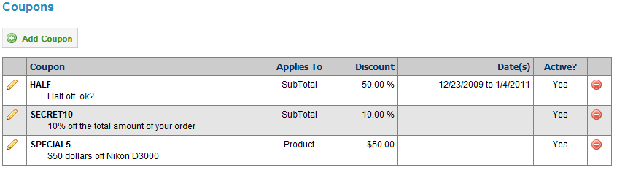

List of coupons used on the site

### Add Coupon

* **Active:** Whether the coupon is currently active or not.
* **Coupon Code:** What the customer will type in to activate the discount during the checkout process
* **Description for customer:** Text description used.
* **Allow combinations with other coupons:** Whether a customer can use two or more coupons together.
* **Discount:** Percentage or dollar amount discount to be gien
* **Applies to:** What price the discount applies to. Possible prices that discounts can be applied to:
  + Order SubTotal
  + Order SubTotal + Shipping & Handling
  + Only these Products (a checkbox list of all products, then the store administrator can select which products the discount applies to)
  + Only these Shipping & Handling Option(s) (checkbox list of all shipping options, then the store administrator can select which shipping options the discount applies to)

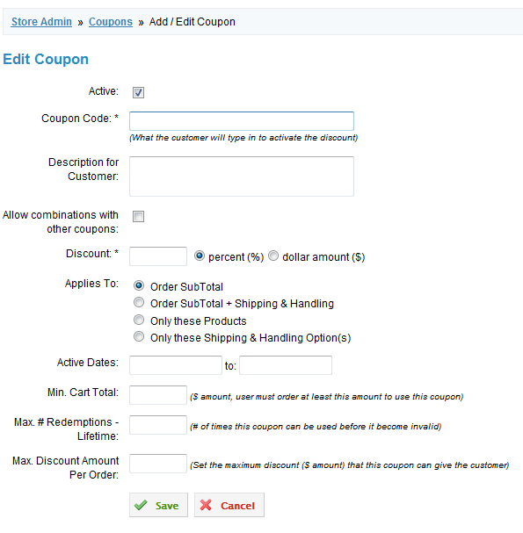

Add a coupon functionality

## Discounts

Discounts are automatically applied based on the Role of the logged-in user and the criteria selected when creating the discount. The discount page lists out the Name/Description, Role, Discount Amount, what the discount applies to, effective dates, and whether the discount is active or not. This page also allows the store administrator to add, edit, and delete a discount.

### Add Discount

* **Active:** Whether the discount currently applies. Can be enabled or disabled at any time.
* **Name / Description:** Name of discount.
* **DNN role:** Role that the discount should apply to
* **Discount:** Percentage or dollar amount that should be applied
* **Allow combinations with other discounts:** Whether this discount can be applied to other discounts.
* **Active Dates:** Starting and ending dates that this discount is good for
* **Applies to:** All Products, Only These Products (enables administrator to select a checkbox list of products to allow the discount to be used on), Only These Categories (enables administrator to select a checkbox list of categories to allow the discount to be used on)

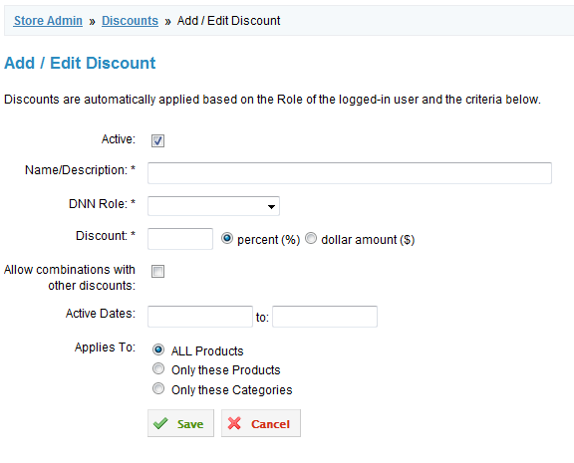

Adding a discount

## Orders

View and filter orders by an order date range, customer first name or last name, email address, and order status (completed, pendingoffsite, processing, deleted, and failed). The orders page provides a list of all orders in the store. The list shows order number, date, total, status, payment status, shipping status, and customer name and email address. This screen also gives the store administrator the option to delete an order. The store administrator can view a order but selecting the order number in the list.

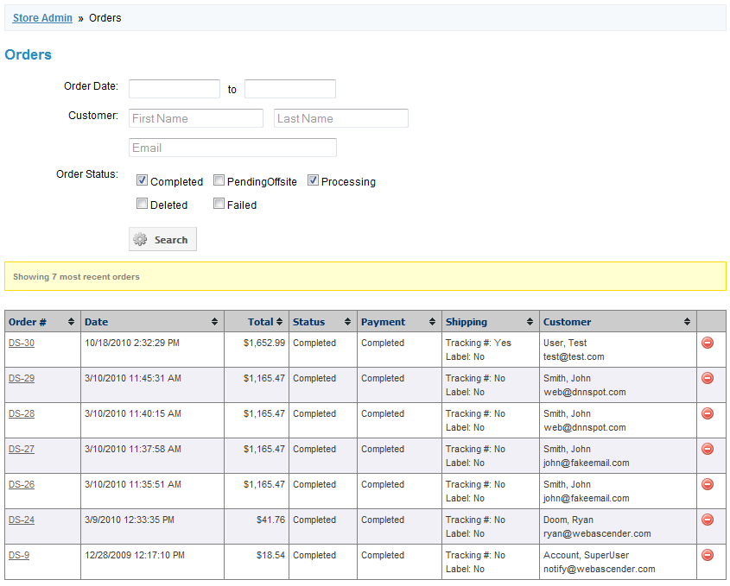

Use the Orders filter to view a range of orders

#### View Order

All order details are viewable on this page. Order information, customer information, payment information, billing information, shipping information, and details about what items were ordered are viewable on this page. Also, the store administrator can mark a user as paid, send an email to the customer, send and re-send the shipping email, and enter a tracking number for the order.

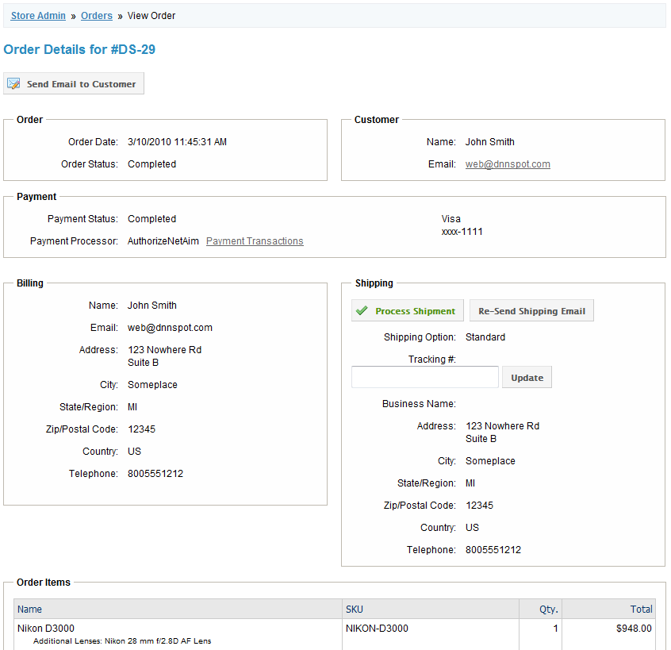

Viewing the details of an order

## Reports

### Customer List

This is a link to download a CSV file of all customers who have purchased something in the store. Includes user ID, first name, last name, email, billing address 1, billing address 2, billing city, billing region, billing postal code, billing country, billing telephone, shipping name, shipping business name, shipping address 1, shipping address 2, shipping city, shipping region, shipping postal code, shipping country, and shipping telephone.

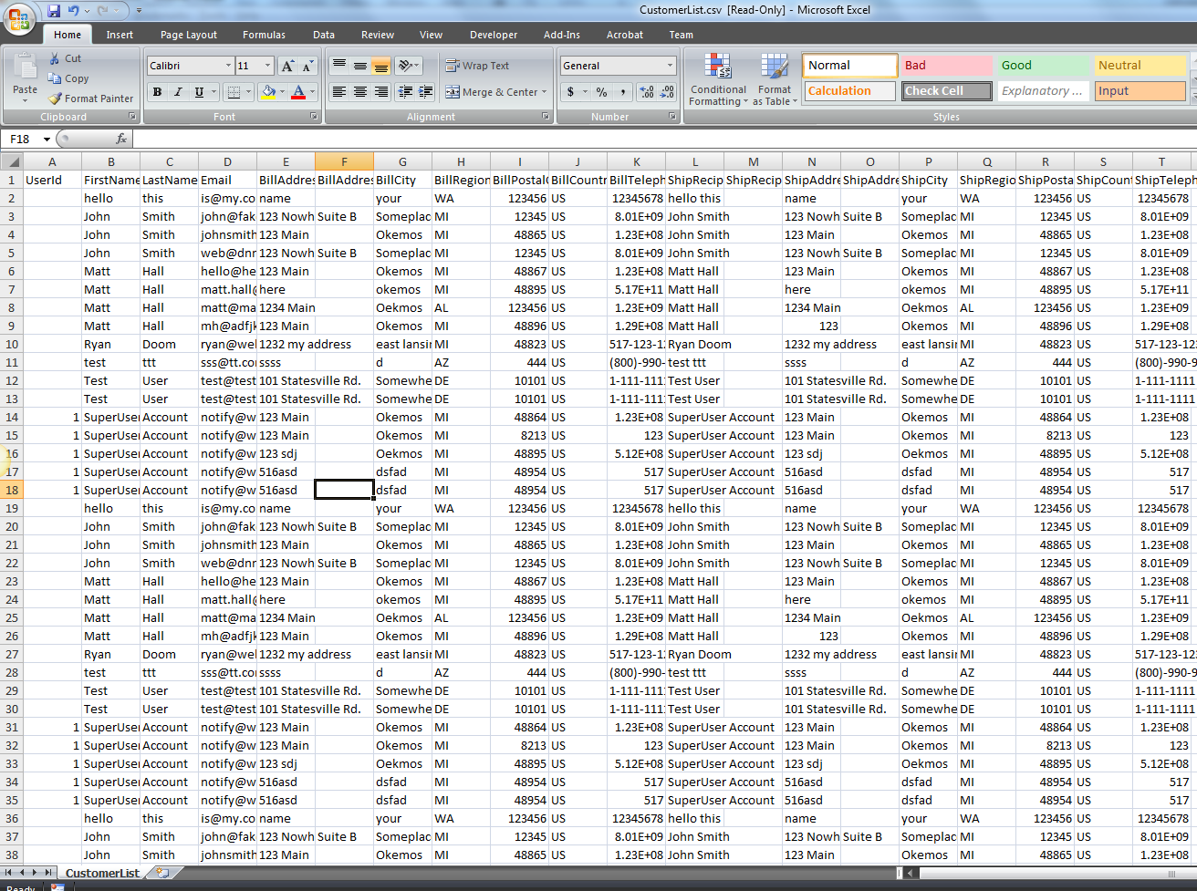

Download a CSV file of the store’s customer list

### Order List

This link provides a detail XML file of the orders placed in the store.

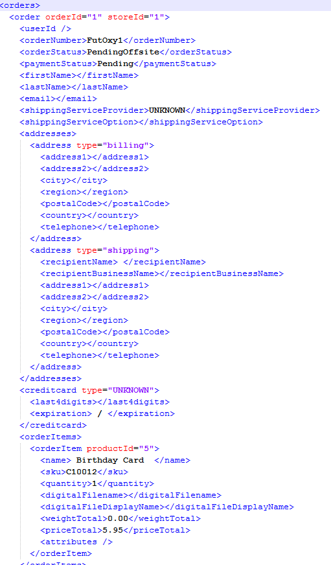

XML file of orders

## DNNspot Module License

Allows the store administrator to enter and change the license for the Store. Once a valid license is entered, a store administrator is able to see who the license key is licensed to, what the license key is, what type of license the key is, and how many portals are currently in use. The server must have outgoing internet enabled so that the module can be registered.

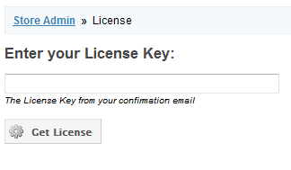

Entering in a license key

# DNNspot Store – Featured Products

The Featured Products module can be dropped on any page. This module will pull from the Store products to show particular products, depending on the filters applied, and show the product according to how the template has been configured. The Featured Products module comes with a built-in, standard template, but can be modified using HTML and the tokens listed below.

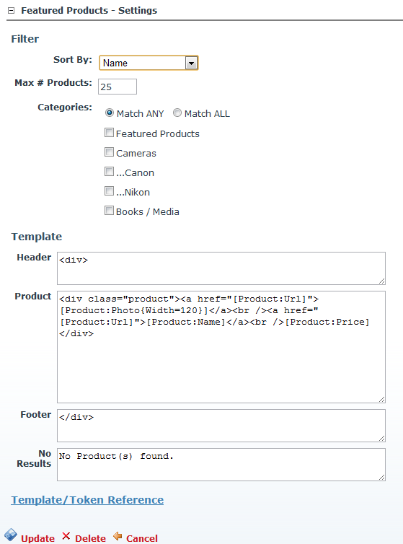

Featured Products standard configuration

## Filter

* **Sort By:** Select what to sort the listed products by (name, bestselling, price – low to high, and price – high to low)
* **Max # of Products:** The maximum number of product to be shown in this particular module.
* **Categories:** Select which categories to show. “Match ANY” will select any product that matches any one of the checked categories (e.g. if category1, category2, and category3 have been selected, a product will only appear if category1 OR category2 OR category3 have been applied to the product). “Match ALL” will only show products that are part of each category selected (e.g. if category1, category2, and category3 have been selected, a product will only appear if category1 AND category2 AND category3 have been applied to the product)

## Template

* **Header:** HTML or Text that will be applied before the products are shown.
* **Product:** HTML, text, or tokens (shown below) that will be applied for each product displayed. Each token will be replaced automatically when the page renders.
* **Footer:** HTML or Text that will be applied after the products are shown.
* **No results:** HTML or Text to appear when there are no products found.

### Template Tokens

|  |  |
| --- | --- |
| **Token** | **Description** |
| [Product:Name] | Product Name |
| [Product:UrlName] | Product Url Name (slug) |
| [Product:Price] | Product Price |
| [Product:Sku] | Product SKU |
| [Product:Url] | Url to the Product Detail |
| [Product:Photo]  [Product:Photo{Width=120}]  [Product:Photo{Width=120,Height=100}] | Main Product Photo.  Main Product Photo, width 120px.  Main Product Photo, width 120px and height 100px. |
| [Product:PhotoUrl]  [Product:PhotoUrl{Width=120}]  [Product:PhotoUrl{Width=120,Height=100}] | Url for Main Product Photo.  Url for Main Product Photo, width 120px.  Url for Main Product Photo, width 120px and height 100px. |
| [Product:DescriptionX]  [Product:DescriptionX{MaxChars=75}] | Where X is the Description Tab #. E.g. [Product:Description1] is the first description tab. Optional attribute to specify a max character count. |

# DNNspot Store – My Orders

This module allows the store administrator to search for an order by Order # and email address. The module will then list matching orders, along with the date, order status, total order, and link to the view the full order page. It’s recommended that this module is used on its own page that is viewable by administrators only.

## 

My orders search