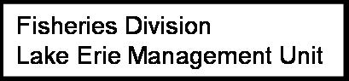

Fisheries Survey
Lake Orion
Spring 2023

 | Water: | Lake Orion
 | T/R/S: | 04N 10E Secs. 2, 3, 10, 11
 | Primary County: |  |  |  |  |  | Oakland
 | Watershed: |  |  | Clinton River
 | Status: | Approved
 | Survey begin: |  |  |  |  | 10/9/2023 |  | End: | 10/11/2023
 | Special Regs: |  |  |  | None
 | Purpose: |  | Discretionary survey: Species evaluation

Gear Types

Gear Type: Electrofishing Boat
Effort date range: 10/9/23 to 10/11/23
No. of gear used: 2 electrofishing boats
Effort quantity: 1,362.97 minutes
Depth range: 0 – 13 feet
Temperature range: 60.2°F – 60.6°F

Collection by: D. Tar, E. Plant, C. Harris, S. Thomas, T. Gonea, T. Hawley, J. Buszkiewicz, E. Somsky
Identification by: D. Tar, C. Harris, S. Thomas, T. Somers, E. Plant
Analysis by: C. Harris

Description
Lake Orion is a 470-acre impoundment of Paint Creek, located in northeast Oakland County (Figure 1). Paint Creek flows out of Indianwood Lake, another impoundment, about 430 feet downstream into the north portion of Lake Orion (Figure 1). The Lake Orion Dam is located at M-24 on the east side of the lake and controls the water levels for the lake prior to the outfall into Paint Creek (Figure 1). To assist with managing Paint Creek as a coldwater resource below the dam, a bottom draw was installed in Lake Orion that pulls water from the deeper, colder portion of the lake to then mix below the dam. With an irregular shoreline including many bays, peninsulas, canals and islands, Lake Orion has an 18-mile perimeter. The irregular shape along with 9 islands, lends to high variation in depth contours throughout the lake (Figure 1); 79% of the lake area is deeper than 5 feet and 56% is deeper than 10 feet. The maximum depth in Lake Orion is 80 feet and there are 12 small basins that reach 40 feet or more in depth.

The lake shoreline is highly developed, although the 20,605-acre catchment area of the lake is a mix of agriculture (27%), urban (26%), forest (24%), wetland (17%), water (4%), grassland (1%), and barren (1%) areas (Fry et al. 2011). A public boat launch, operated by Parks and Recreation Division of the Department of Natural Resources, is located on the north side of the lake, off Indianwood Rd. The boat launch is paved with a parking lot with 34 parking spaces. Special watercraft regulations on the lake include a 40 miles per hour speed limit and an individual is not permitted to operate a watercraft at high speed one hour before sunrise and one hour after sunset.

Lake Orion has had water temperature and dissolved oxygen profiles conducted during 10 different years since 1947. A profile was conducted on August 21, 2023 (Figure 2) in the deepest portion of the lake to identify stratification zones. Lake stratification occurs where the water density gradient, caused by warming of the upper waters, is large enough that it prevents wind currents from mixing waters throughout the water column (Wehrly et al. 2015). The epilimnion is the well-mixed, upper layer of warm water with uniform temperatures and dissolved oxygen levels, the metalimnion is the middle layer of cooler water where temperatures change rapidly with depth, and the hypolimnion is the bottom layer of cold water where mixing does not occur, and temperatures decrease slowly with depth. In the lower zones with no mixing, dissolved oxygen is not replenished over time, except where phytoplankton produces oxygen through photosynthesis (Kalff 2002). The most recent profile of Lake Orion indicated that the epilimnion extends from the surface to a depth of 16 feet. The metalimnion was observed at depths from 16-44 feet and the hypolimnion from 44-75 feet (bottom). The thermocline is the area in the lake with the greatest temperature change and was observed at a depth of 32 feet. Habitats with dissolved oxygen levels of 3.0 mg/L or higher are suitable for most fish species in Michigan (Schneider 2002). By this definition, dissolved oxygen levels in Lake Orion were suitable to a depth of 30 feet, about 81% of the lake volume. It is likely that more than two-thirds of the lake provides suitable habitat for fish during the period of peak summer stratification, which usually occurs sometime in the months of July and August. This temperature and dissolved oxygen profile is similar to those conducted in previous years, though the suitable habitat goes deeper than what was previously seen (range from 20-28 feet). The amount of suitable habitat for Lake Orion in the summer months is common for class 2 lake that typically supports warmwater fish species, has a larger surface acreage and deep basins (Wehrly et al. 2012).

History
Since the 1970’s, Lake Orion has had a reputation of excellent numbers and sizes of largemouth bass and northern pike, but also small slow-growing panfish. Findings from fisheries surveys supported this characterization and in response to the panfish problem, a chemical treatment occurred in summer of 1984 to selectively kill small panfish. In addition, northern pike were stocked in 1984 (Table 1) to increase the predator base that would target remaining small panfish. Surveys in 1985 and 1987 documented that the size and growth of panfish, primarily Bluegill and Black Crappie, did increase following the population thinning project, with no detrimental impacts on bass or pike populations. However, a fish survey in 1992 found that the panfish had reverted to their previous small size and slow growth. A fish community survey in 2001 found that panfish continued to grow slowly but the overall size structure was improved and credited to more fish living longer. Lake Orion is the only inland water in the Lake Erie Management Unit (LEMU) known to have a population of Alewife, a non-native species to Michigan. Largemouth Bass and Northern Pike are found to have average to above average growth rates and relative densities in Lake Orion. Largemouth Bass virus was found in Lake Orion in 2003 as part of regional surveillance efforts to understand the spread of the virus. There were no substantial die-offs on record attributed to the virus.

As a popular bass fishing lake, Lake Orion hosts multiple bass tournaments each year. The Michigan Tournament Information System was initiated in 2016 and has found Lake Orion to be in the top 40 most popular bass tournament lakes in Michigan. The number of tournaments held on Lake Orion averages about 21 tournaments each year from 2016 through 2024. The average bass weighed in by tournament anglers is 2.5 pounds and the average large bass of a tournament is 4.1 pounds. Tournament size and catch weighed average 22 anglers weighing 48 bass per tournament.

Multiple species have been stocked in Lake Orion over the years, dating back to 1875 (Table 1). It is uncommon to stock species like Bluegill, Largemouth Bass, Smallmouth Bass, and Yellow Perch today as they are typically self-sustaining and ubiquitous throughout the state. Other species like American Eel, Chinook Salmon, Lake Trout and Lake Whitefish have habitat requirements that Lake Orion doesn’t provide, so those efforts were abandoned. A Walleye stocking program for Lake Orion was started in 1996 to introduce a predator that would target small panfish and create a modest Walleye fishery (Table 1). Spring fingerling Walleye were stocked at a high level during the first three years to establish a population, followed by biennial stocking until 2007-2010 when the Walleye stocking program was put on hold statewide. Stocking resumed in 2011 on a biennial basis with a target stocking level of 47,000 spring fingerling Walleye (100 per acre; Table 1). In addition to the MDNR stocking efforts in Lake Orion, 1,000 fall fingerling Walleye were stocked under a private stocking permit into the connected (but private access) Indianwood Lake during 2010 and 2011.

Lake Orion has a history of nuisance vegetation issues that encompass a number of invasive plant species like Eurasian Watermilfoil and Starry Stonewort. Lake wide aquatic nuisance plant treatments have taken place annually under permits since 2007. In summer 2017, a fish kill occurred on Lake Orion immediately following a treatment. The cause of the kill was not linked to the treatment, but fisheries managers speculated that to be a likely cause. Multiple species were found dead around the lake that included Largemouth Bass, Bluegill, Pumpkinseed, Rock Bass, and bullhead species. A more recent fish kill occurred in summer 2021 when there was a Koi Herpesvirus (KHV) outbreak that resulted in mortality for hundreds of Common Carp. It is not clear what mechanism led to the introduction of KHV to Lake Orion, but one potential pathway acknowledged during investigation of the event was the introduction of a pet Goldfish or Koi. The potential for aquatic nuisance control treatments triggering the KHV outbreak was quickly dismissed. Fish kills in Lake Orion are considered uncommon though they have occurred.

Lake Orion has been drawn down by 3 feet every 5 years, using water control structures associated with Lake Orion Dam. The purpose behind the drawdown is to provide riparian landowners with the opportunity for property maintenance along with dam structure investigations. The drawdown and subsequent refilling are completed inside a two-month period during the fall. It is unknown what impact this process has on the aquatic community in Lake Orion.

Methods
This report details a fisheries survey completed during fall 2023. The objective of this survey was to develop population dynamic metrics for the Largemouth Bass population of Lake Orion. This includes the development of a population estimate, annual mortality and growth rates, along with proportional size densities.

Nighttime electrofishing was conducted for three nights using two boat electrofishing units that loosely followed the perimeter of the lake. Lake Orion has an irregular shoreline that leads to an extensive perimeter distance, therefore, some canals and a back bay were excluded from sampling to allow for an attainable distance to cover each night (Figure 1). This resulted in the nearshore zone of the entire intended area being sampled each night. Using long handled dipnets with ¼ inch mesh and 10 feet long handles, all Largemouth Bass caught were held until a chase boat was available to process the catch. The area covered for that specific catch was identified as a transect with data being recorded for each transect. The chase boat would record spatial (GPS coordinates and section numbers), temporal (start/end times and seconds electrofished), and environmental data (e.g. depth range and cover types) associated with each transect to accompany the catch. All Largemouth Bass were measured to the inch group (e.g. 8.0 to 8.9 = 8 inch group) and marked with an anal fin clip to identify if it was subsequently recaptured. Age structures were collected for a minimum of 20 Largemouth Bass per inch group if available, and those fish were measured to a tenth of an inch.

Adult Largemouth Bass (≥ 8 inches) population estimate for Lake Orion was calculated using the Chapman modification of the Peterson formula as described in the Manual of Survey Methods II: Chapter 8 (Schneider 1998):
$$N=\frac{(M+1)(C+1)}{R+1}$$
Where:
N = population estimate of adult Largemouth Bass in each length;
M = number of adult Largemouth Bass caught, marked, and released in initial marking phase;
C = total number of adult Largemouth Bass caught in recapture phase (unmarked + recaptures); and
R = number of adult Walleyes recaptured in recapture phase.

The annual mortality rate for Largemouth Bass was generated through a catch curve analysis using the FSA package (Ogle et al 2025) in R (R Core Team 2025). A catch curve analysis assumes that abundance of year classes in a given sample is related to the population mortality rate (Ricker 1975). Proportional Size Densities (PSDs) were calculated for the Largemouth Bass population based on length‑frequency data collected during the fisheries survey. PSD indices describe the relative proportion of fish that have reached key length‑class thresholds and provide a standardized measure of population size structure. The standard-length categories (Zale 2012) used were: stock (≥8 inches), quality (PSD_{Q}; ≥ 12 inches), preferred (PSD_{P}; ≥ 15 inches), memorable (PSD_{M}; ≥ 20 inches), and trophy (PSD_{T}; ≥ 25 inches).

Results
A total of 1,005 unique Largemouth Bass were caught that ranged from 2 to 21 inches (Figure 3). The minimum legal size limit for Largemouth Bass is 14 inches and 50% of the catch were legal size for harvest. Largemouth Bass growth was slightly slower than state average with a mean growth index (MGI) of -0.8 (Table 2). Significantly slower growth was observed for Largemouth Bass aged 0 through 3 years-old, but growth for older fish (≥4 years-old) was typically near state average growth (Table 2). Largemouth Bass overall catch rate (CPE) was 0.8 fish/minute of electrofishing (Table 3) and section specific CPE ranged from 0.46 to 1.18 fish/minute of electrofishing (Figure 4).The population estimate for Lake Orion is 4,446 (±753.5) adult Largemouth Bass (≥8 inches) with an estimated mortality of 26.0% (95% LCI= 16.7 and 95% UCI=34.3). PSD values were PSD_{Q} = 84, PSD_{P} = 52, and PSD_{M} = 1, which suggests that 84% of the population are quality sized fish, 52% are preferred size, and 1% are memorable sized fish (Table 3).

Discussion
The 2023 fisheries survey of Lake Orion provides an updated perspective on the status of the Largemouth Bass population within a complex and heavily used inland lake system. Overall, results indicate that Lake Orion continues to support a robust and well-balanced bass population, though several biological and environmental factors influence size structure, growth, and recruitment patterns.

Largemouth Bass abundance remains strong with an estimated 4,446 adult fish (≥ 8 inches). This population level can be standardized with the lake size, providing an estimate of 9 fish/acre, a near median estimate for popular bass lakes in the LEMU (Table 3). This estimate, coupled with a catch rate of 0.8 fish per minute, aligns with expectations for a high‑use, warmwater system with substantial structural complexity. The relatively low estimated annual mortality rate of 26% further suggests a stable population in which natural mortality and fishing mortality remain within desirable bounds. Tournament catch data from 2016–2024 also supports the conclusion that a quality bass fishery persists, with average weighed‑in fish around 2.5 pounds and frequent captures of fish exceeding 4 pounds.

Size‑structure indices reinforce the presence of a high‑quality fishery. PSD_{Q} (84) and PSD_{P} (52) values fall within or above commonly accepted ranges for balanced bass populations, indicating strong representation of fish in both the quality (≥12 inches) and preferred (≥15 inches) size groups. The low PSD_{M} (1) signals that memorable‑sized (≥20 inches) individuals are present but relatively rare. When compared to other lakes in LEMU sampled with similar methods, Lake Orion quality and preferred levels were among the highest (Table 3). Given the slow growth observed in younger bass age classes, it is likely that production of larger fish depends heavily on the subset of individuals that survive into older age groups and eventually reach near‑average growth rates. Habitat complexity and plentiful forage likely support these older fish, even as density‑dependent factors appear to influence early‑life growth.

The observed growth pattern—slow growth for ages 0–3 followed by near‑average growth in fish ≥4 years old—may reflect a combination of recruitment strength, habitat constraints, and interspecific and intraspecific competition. Slower than state average growth is common for lakes in LEMU, even though a MGI of -0.8 is not significantly slower than state average. Historically, Lake Orion panfish populations have exhibited slow growing panfish populations, which prompted the current walleye stocking program that is intended to increase predation on juvenile panfish. There is uncertainty surrounding the impact of this management action but persisting dense panfish populations may increase competition for zooplankton resources among age-0 Largemouth Bass, ultimately depressing early growth. In addition, Lake Orion’s high perimeter length and irregular shoreline provide abundant shallow habitat for juvenile fish, potentially supporting higher than average recruitment and increased competition for food resources.

Concerns are often raised that Largemouth Bass tournaments may artificially concentrate fish near weigh-in locations, a phenomenon commonly referred to as stockpiling. Although studies indicate that short-term aggregation can occur following tournament release events, fish typically redistribute throughout the lake within days, and long-term stockpiling is generally not observed (Slagle et al. 2020). Electrofishing catch-per-effort (CPE) data from Lake Orion support these findings. Higher bass densities were documented in sections located well away from the public boat launch – where most tournaments hold their weigh-ins - while the section containing the launch itself fell into a lower CPE category (Figure 4). Lake Orion’s ranking among the most popular bass tournament lakes in Michigan highlights strong angler interest and sustained fishing pressure. Despite this pressure, the Largemouth Bass population remains resilient, exhibiting stable size structure and modest mortality. Continued tournament activity also contributes valuable, long-term supplemental information through the Michigan Tournament Information System, offering insights that may complement trends observed through periodic electrofishing surveys.

Management Recommendations
- A fish community evaluation of Lake Orion was conducted in 2025 to better understand impacts of the Walleye stocking program has had on the fish community. The main objective of this survey was to look at the current state of the panfish populations and determine if the Walleye stocking program has had a positive impact on size structure and abundance. Analysis of the 2025 survey in conjunction with the results from the 2023 Largemouth Bass survey captured in this report should be used to determine next steps for the Walleye stocking program (e.g. continue status quo, modify, or discontinue).
- The 2023 Largemouth Bass survey provides sound evidence of how this key recreational species and top predator use the nearshore environment of Lake Orion. Anthropogenic actions in the nearshore environment should be scrutinized to avoid negative impacts to this important population as well as the vast variety of other species that use the near-shore environment. Shoreline hardening actions should be avoided as much as possible to limit further degradation of the nearshore environment and best management practices (e.g. use of fish sticks or soft engineering) should be pursued. Aquatic nuisance control treatments should avoid negative impacts during the Largemouth Bass spawning window that might lead to failed nests or harming already stressed spawning fish. Native aquatic vegetation should be promoted as much as possible to benefit the nearshore environment and a healthy fish community.
- The large drawdown of Lake Orion that occurs every 5 years should be discouraged. This drawdown has previously occurred during the fall, when herpetofauna are beginning to find hibernation habitats. This drawdown occurs over a short period (about 2 weeks) but is likely to cause limitations for where herpetofauna may select for hibernation habitat. The drawdown also disrupts the ability to boat and fishing on the lake when water levels are low.

References
Fry, J., Xian, G., Jin, S., Dewitz, J., Homer, C., Yang, L., Barnes, C., Herold, N., and Wickham, J., 2011. Completion of the 2006 National Land Cover Database for the Conterminous United States, PE&RS, Vol. 77(9):858-864.

Kalff, J. 2002. Limnology. Inland Water Ecosystems. Prentice-Hall Inc. Upper Saddle River, NJ.

Ogle DH, Doll JC, Wheeler AP, Dinno A (2025). _FSA: Simple Fisheries Stock Assessment Methods_. R package version 0.10.0, URL https://CRAN.R-project.org/package=FSA.

R Core Team (2025). _R: A Language and Environment for Statistical Computing_. R Foundation for Statistical Computing, Vienna, Austria. URL https://www.R-project.org/.

Ricker, W. E. 1975. Computation and interpretation of biological statistics of fish populations. Fisheries Research Board of Canada, Bulletin 191.

Schneider, J. C. 1998. Lake fish population estimates by mark-and-recapture methods. Chapter 8in Schneider, J. C. 200. Manual of fisheries survey methods II: with periodic updates. Michigan Department of Natural Resources, Fisheries Special Report 25, Ann Arbor.

Schneider, J. C. 2002. Fish as indicators of lake habitat quality and a proposed application. Michigan Department of Natural Resources, Fisheries Research Report 2061, Ann Arbor.

Slagle, Z. J., Faust, M. D., Keretz, K. R., Dufour, M. R. 2020. Post-Tournament dispersal of smallmouth bass in western Lake Erie. Journal of Great Lakes Research, 46(1), 198-206.
Wehrly, K. E., D. B. Hayes, and T. C. Wills. 2015. Status and trends of Michigan inland lake resources, 2002-2007. Michigan Department of Natural Resources Fisheries Report 08, Lansing.

Wehrly, K. E., J. E. Breck, L. Wang, and L. Szabo-Kraft. 2012. A Landscape-Based Classification of Fish Assemblages in Sampled and Unsampled Lakes. Transactions of the American Fisheries Society 141:414-425.

Zale, A. V., D. L. Parrish, and T. M. Sutton, editors. 2012. Fisheries techniques, 3rd edition. American Fisheries Society, Bethesda, Maryland.

Tables
Table 1. Stocking history for Lake Orion. Life stage is represented by Fry (newly hatched swim-up fry), Fingerlings (young of year), and Yearling (one-year-old). Year Range represents the earliest and latest a species at that life stage was stocked in Lake Orion. Avg. Number is the average number of fish stocked for the number of years stocking occurred (Count).
Species | Life Stage | Year Range | Avg. Number | Count
American Eel | Fingerling | 1878 | 20,000 | 1
Bluegill | Fingerling | 1933 – 1945 | 15,257 | 14
Chinook Salmon | Fingerling | 1875 | 10,000 | 1
Lake Trout | Fry | 1878 | 3,334 | 1
Lake Whitefish | Fry | 1878 – 1879 | 65,000 | 2
Largemouth Bass | Fingerling | 1905 – 1945 | 2,008 | 13
Northern Pike | Fingerling | 1956 – 1984 | 8,000 | 2
Smallmouth Bass | Fingerling | 1910 – 1944 | 967 | 3
Walleye | Fingerling | 1996 – 2024 | 51,441 | 19
Walleye | Fry | 1910 – 1937 | 373,333 | 3
Yellow Perch | Fingerling | 1908 – 1940 | 6,200 | 7
Yellow Perch | Yearling | 1934 | 4,000 | 1

Table 2. Mean length-at-age of Largemouth Bass collected during the Lake Orion fishery survey, October 9 through 11, 2023. Age specific MGI is the mean growth index for a given age group.
Species | Age | Number Aged | Weighted mean length (inches) | State average length (inches) | Weighted age frequency | Age Specific MGI
Largemouth Bass | 0 | 7 | 2.4 | 4.2 | 0.7% | -1.83
Largemouth Bass | 1 | 64 | 5.0 | 7.1 | 18.2% | -2.09
Largemouth Bass | 2 | 44 | 7.6 | 9.4 | 10.7% | -1.78
Largemouth Bass | 3 | 53 | 10.2 | 11.6 | 7.7% | -1.38
Largemouth Bass | 4 | 58 | 13.6 | 13.2 | 18.6% | 0.44
Largemouth Bass | 5 | 36 | 15.0 | 14.7 | 3.2% | 0.29
Largemouth Bass | 6 | 32 | 16.5 | 16.3 | 17.4% | 0.14
Largemouth Bass | 7 | 26 | 17.4 | 17.4 | 12.6% | -0.05
Largemouth Bass | 8 | 17 | 18.3 | 18.3 | 7.1% | -0.01
Largemouth Bass | 9 | 15 | 17.5 | 19.3 | 2.6% | -1.81
Largemouth Bass | 10 | 6 | 18.8 | 19.3 | 0.9% | -0.52
Largemouth Bass | 11 | 2 | 19.7 | NA | 0.2% | NA
Largemouth Bass | 12 | 1 | 20.1 | NA | 0.1% | NA

Table 3. Bass population dynamics for popular bass fishing lakes in LEMU sampled with similar fall electrofishing methods. CPE is the catch per unit effort or number of fish caught per minute of electrofishing. MGI represents the overall mean growth index for the species.
Waterbody | Woodland Lake | Woodland Lake | Woodland Lake | Union Lake | Lake Oakland | Pontiac Lake | Lake Orion
Year | 2008 | 2009 | 2010 | 2020 | 2021 | 2022 | 2023
Lake Size (Acres) | 258 | 258 | 258 | 474 | 458 | 632 | 493
Fish/Acre | 26 | 11.7 | NA | 6 | 14.6 | 7 | 9
CPE (fish/min. of efishing) | 1.6 | 1.6 | 1.2 | 0.7 | 1 | 0.8 | 0.8
Annual Mortality Rate | NA | NA | NA | 37% | 40% | 57% | 26%
PSD_{Q} (≥ 12 inches) | 49 | 40 | 71 | 74 | 46 | 55 | 84
PSD_{P} (≥ 15 inches) | 7 | 6 | 15 | 53 | 16 | 19 | 52
PSD_{M} (≥ 20 inches) | 0 | 0 | 0 | 22 | 0 | 0 | 1
MGI | -2 | -2.3 | -2 | -0.7 | -0.8 | -0.8 | -0.8
Average # of tournaments per year (2016-2024) | 19 | 19 | 19 | 8 | 14 | 24 | 21
Species | LMB | LMB | LMB | SMB | LMB | LMB | LMB

Figures

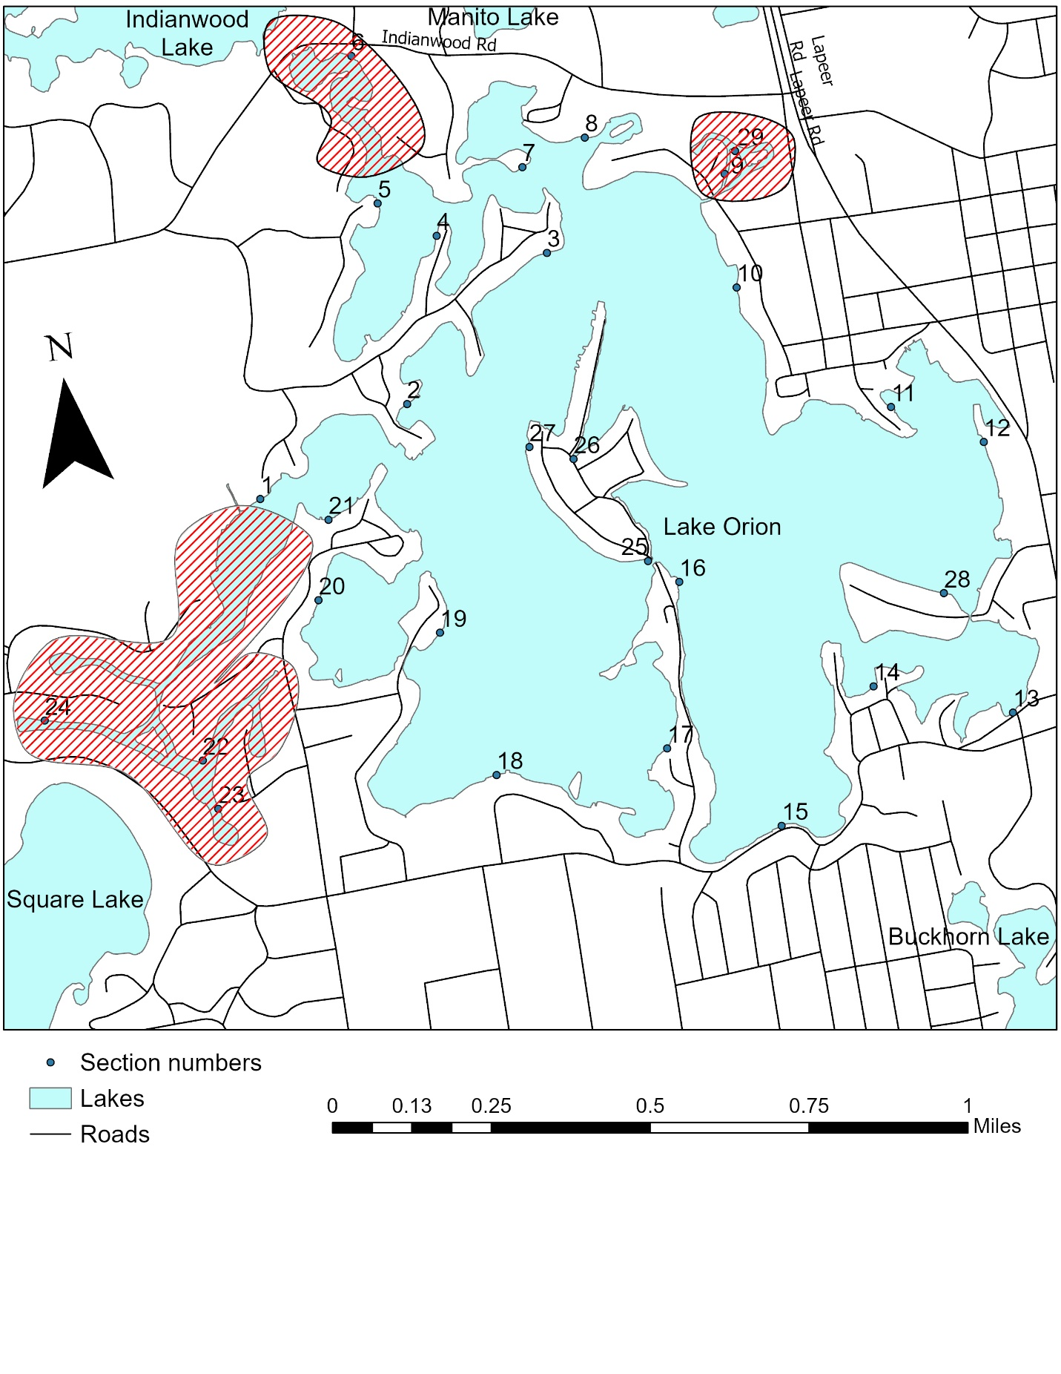

Figure 1. Map of Lake Orion, Oakland County with average relative abundance calculations for each section calculated from the fisheries survey conducted, fall 2023. The red hashed areas of the lake were unsampled and the green boat icon on the north perimeter of the lake marks the boat launch.

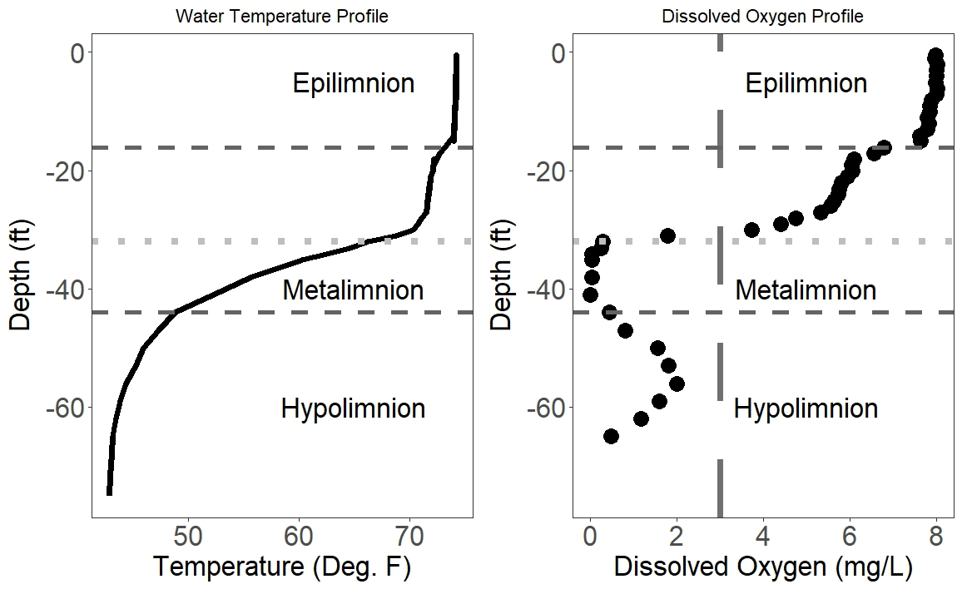
Figure 2. Water temperature (left panel) and dissolved oxygen (right panel) profiles for Lake Orion collected August 21, 2023. In the left panel, the solid black line indicates water temperature, whereas the horizontal dashed lines indicate the upper and lower bounds of the metalimnion, and the horizontal dotted line indicates the thermocline. In the right panel, the dashed black line indicates dissolved oxygen concentration, whereas the vertical dashed line represents the lower limit of suitable dissolved oxygen (3.0 mg/L); the horizontal dashed lines represent the upper and lower bounds of the metalimnion, whereas the horizontal dotted line indicates the thermocline.

Figure 3. Bar graph showing the number of Largemouth Bass per inch group caught during a fisheries survey of Lake Orion, October 9-11, 2023.

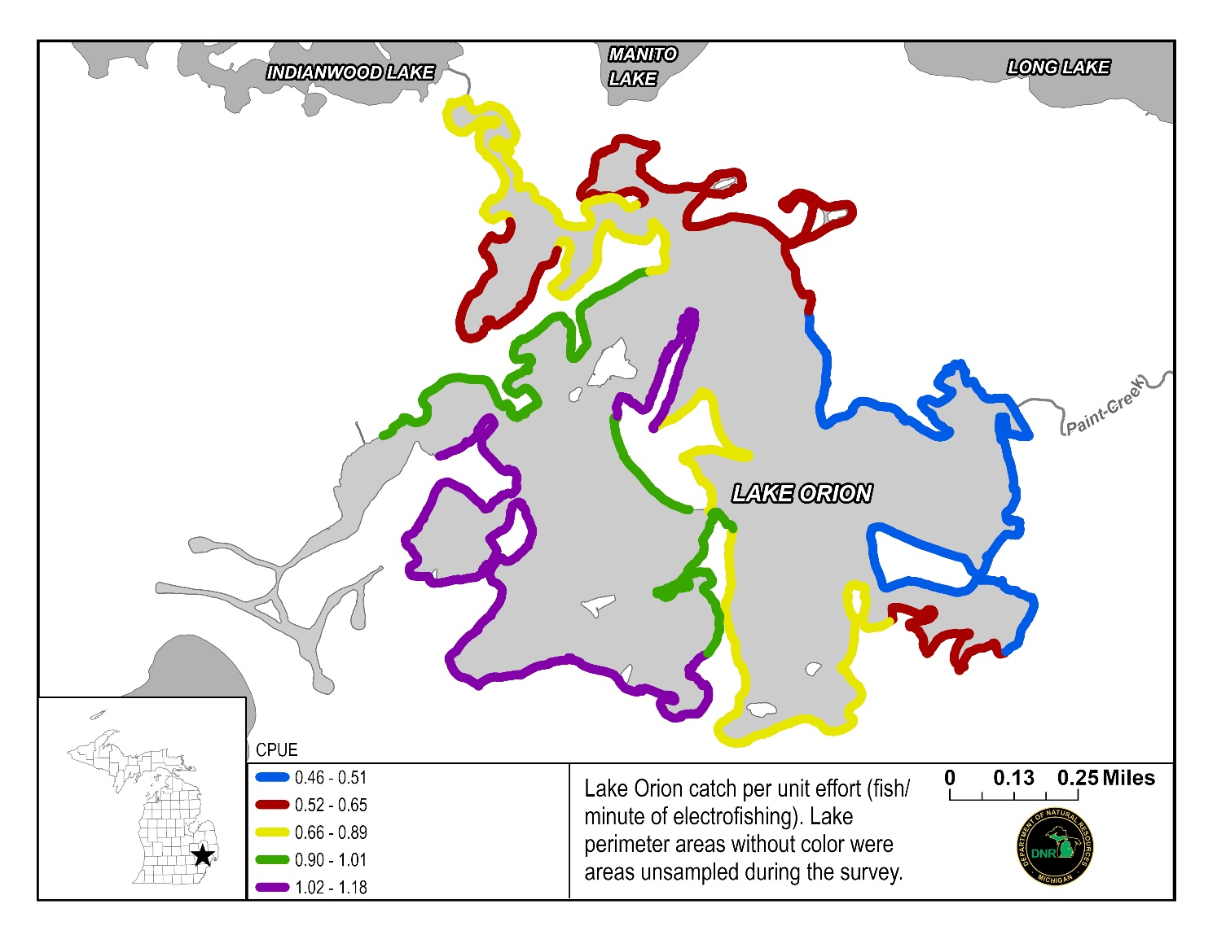
Figure 4. CPE (fish/minute of electrofishing) by section for Largemouth Bass caught in the Lake Orion fisheries survey, October 9 to 11, 2023. CPE is shown by color in 5 bins; Blue = 0.46 – 0.51, Red = 0.52 – 0.65, Yellow = 0.66 – 0.89, Green = 0.90 – 1.01, and Purple = 1.02 – 1.18.

