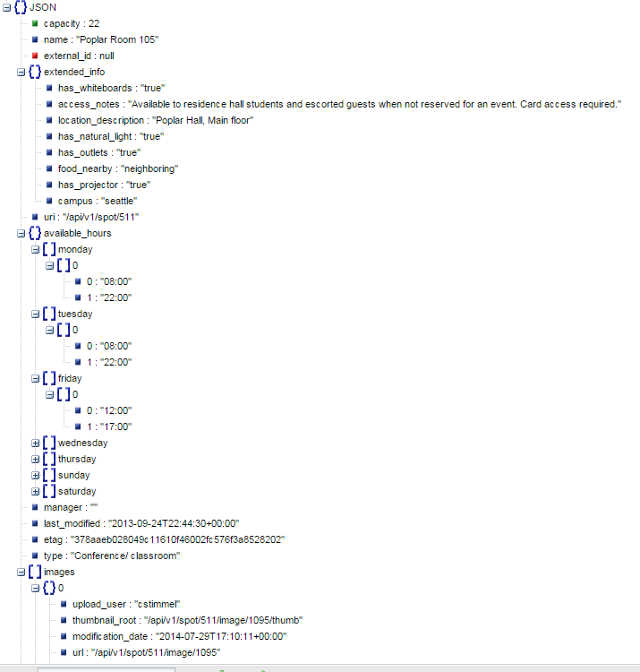

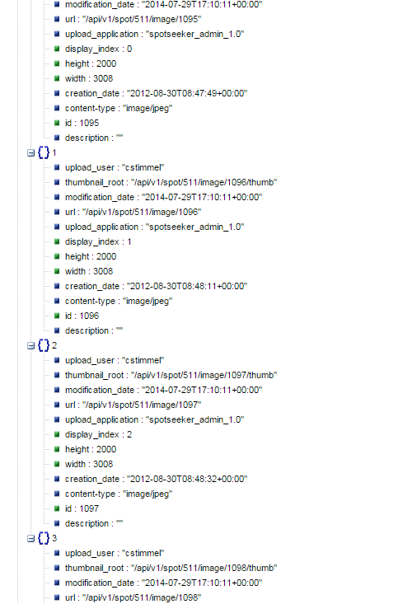

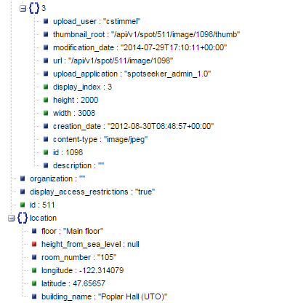

buildings?campus=SMIU an array of strings with the building names…[“”,”Alder Hall”,”Allen Library (ALB)”….]

1. 0: ""
2. 1: "Alder Hall"
3. 2: "Allen Library (ALB)"
4. 3: "Allen Library (ALB) North"
5. 4: "Allen Library (ALB) South"
6. 5: "Architecture Hall (ARC)"
7. 6: "Art Building (ART)"
8. 7: "Burke Memorial-Washington State Museum (BMM)"
9. 8: "Computer Science and Engineering Building (CSE)"
10. 9: "Electrical Engineering Building (EEB)"
11. 10: "Engineering Library (ELB)"
12. 11: "Fishery Sciences (FSH)"
13. 12: "Gould Hall (GLD)"
14. 13: "Gowen Hall (GWN)"
15. 14: "HUB (Husky Union Building)"
16. 15: "Haggett Hall (HGT)"
17. 16: "Hitchcock Hall (HCK)"
18. 17: "Hutchinson Hall (HUT)"
19. 18: "Intramural Activities Building (IMA)"
20. 19: "Magnuson Health Sciences Center A (HSA)"
21. 20: "Magnuson Health Sciences Center C (HSC)"
22. 21: "Magnuson Health Sciences Center D (HSD)"
23. 22: "Magnuson Health Sciences Center E (HSE)"
24. 23: "Magnuson Health Sciences Center I (HSI)"
25. 24: "Magnuson Health Sciences Center T (HST)"
26. 25: "Mary Gates Hall (MGH)"
27. 26: "McCarty Hall (MCC)"
28. 27: "McMahon Hall (MCM)"
29. 28: "Miller Hall (MLR)"
30. 29: "Music Building (MUS)"
31. 30: "Odegaard Undergraduate Library (OUGL)"
32. 31: "Paccar Hall (PCAR)"
33. 32: "Padelford Hall (PDL)"
34. 33: "Physics/Astronomy Building (PAB) Tower"
35. 34: "Poplar Hall (UTO)"
36. 35: "Smith Hall (SMI)"
37. 36: "Social Work/Speech & Hearing Sciences Building (SWS)"
38. 37: "South Campus Center (SOCC)"
39. 38: "Suzzallo Library (SUZ)"
40. 39: "William H. Foege Genome Sciences (GNOM)"
41. 40: "William H. Gates Hall (LAW)"