**VIETNAM NATIONAL UNIVERSITY, HO CHI MINH CITY**

**UNIVERSITY OF INFORMATION TECHNOLOGY**

**FACULTY OF COMPUTER ENGINEERING**

**Nguyễn Tuấn Dũng – 21520746**

**Lê Công Quang - 21521337**

**CAPSTONE PROJECT**

**DESIGN AN ENVIRONMENTAL CONTROL SYSTEM IN THE NURSERY GARDEN USING ESP8266 – SMART NURSERY GARDEN**

**THIẾT KẾ HỆ THỐNG KIỂM SOÁT MÔI TRƯỜNG TẠI VƯỜN ƯƠM THÔNG MINH SỬ DỤNG ESP8266 – VƯỜN ƯƠM THÔNG MINH**

**MIDTERM CAPSTONE PROJECT REPORT**

**HO CHI MINH CITY, 2023**

**VIETNAM NATIONAL UNIVERSITY, HO CHI MINH CITY**

**UNIVERSITY OF INFORMATION TECHNOLOGY**

**FACULTY OF COMPUTER ENGINEERING**

**Nguyễn Tuấn Dũng – 21520746**

**Lê Công Quang - 21521337**

**CAPSTONE PROJECT**

**DESIGN AN ENVIRONMENT CONTROL SYSTEM IN THE NUSERY GARDEN USING ESP8266- SMART NUSERY GARDEN**

**THIẾT KẾ HỆ THỐNG KIỂM SOÁT MÔI TRƯỜNG TRONG VƯỜN ƯƠM SỬ DỤNG ESP8266- VƯỜN ƯƠI THÔNG MINH**

**MIDTERM CAPSTONE PROJECT REPORT**

**MENTOR**

**PhD. TRI NHUT DO**

**HO CHI MINH CITY, 2023**

|  |  |
| --- | --- |
| VIETNAM NATIONAL UNIVERSITY  HO CHI MINH CITY  **UNIVERSITY OF INFORMATION**  **TECHNOLOGY** | **SOCIALIST REPUBLIC OF VIETNAM**  **Independence – Freedom -Happiness** |

# **DETAILED TOPICS**

|  |  |
| --- | --- |
| **VIETNAMESE PROJECT NAME: THIẾT KẾ HỆ THỐNG KIỂM SOÁT MÔI TRƯỜNG TRONG VƯỜN ƯƠM SỬ DỤNG ESP8266- VƯỜN ƯƠI THÔNG MINH** | |
| **ENGLISH PROJECT NAME: DESIGN AN ENVIRONMENT CONTROL SYSTEM IN THE NUSERY GARDEN USING ESP8266- SMART NUSERY GARDEN** | |
| **Instructor** PhD. Tri Nhut Do, Faculty of Computer Engineering | |
| **Implementation time:** From: 08/10/2023 To: 29/11/2023 | |
| **Student Perform: Nguyễn Tuấn Dũng – 21520746 , Lê Công Quang - 21521337** | |
| **Overview of the topic: Design an environment control system in the nusery garden using ESP8266**  **The goal of the subject: Control the garden system remotely or manually**  **Methods of implementation: Using microcontroller ESP8266 , Sensors through the server**  **Main contents of the topic: Build embedded systems control the garden system remotely or manually** | |
| **Certification of Instructor**  (Sign and clearly state full name) | **HCM city, 2023 October 08**  **Student**  (Sign and clearly state full name) |

Contents

**DETAILED TOPICS** 3

Chapter 1. **INTRODUCTION** 5

Chapter 2. **OVERVIEW** 6

**2.1 Research directions** 6

**2.1.1 Research directions in the world** 6

**2.1.2 Research directions in Viet Nam** 7

**2.2 Problem** 7

Chapter 3. **THEORY BASIS** 8

**3.1 Irrigation system** 8

**3.2 Soil moisture measurement system** 9

**3.3 Temperature sensor system** 9

**3.4 Server** 9

**3.5 Block Diagram** 10

**3.6 Flowchart** 10

**3.7 User diagram** 11

Chapter 4. **SYSTEM IMPLEMENTATION PROCESS** 12

**4.1** **Describe components** 12

**4.1.1** Module Node MCU ESP8266 CP2102 12

**4.1.2** Temperature and humidity sensor: DHT11 13

**4.1.3** Soil moisture sensor 15

**4.1.4** Submersible water pump 5VDC 17

**4.1.5** Brushless Cooling Fan 12V 18

**4.1.6** Module 1 Relay Size High Low 5v 18

**4.1.7** Power adapter 12V 20

**4.1.8** Breadboard MB-102 830 21

**4.1.9** LCD 1604 Green 22

**4.1.10** I2C to LCD Communication Module 23

**4.1.11**  PowerAdapter 5V 24

**4.2 Experiment** 25

**4.2.1** Actual electrical circuits 25

**4.2.2** Complete application interface 25

**4.3 Code** 29

**4.4 Result** 35

Chapter 5. **EVALUATION** 37

Chapter 6. **SUMMARY, RESTRICTIONS AND DEVELOPMENT ORIENTATIONS** 40

**6.1 Summary** 40

**6.2 Restrictions** 41

**6.3 Development orientations** 42

**REFERENCES.** 43

# Chapter 1. **INTRODUCTION**

Smart garden nurseries are revolutionizing the way we approach gardening and plant care. With advancements in Internet of Things (IoT) technology, gardeners now have the opportunity to monitor and control their garden remotely, ensuring optimal conditions for plant growth and health. This project aims to explore the potential of IoT in smart garden nurseries, focusing on enhancing efficiency, productivity, and sustainability**.**

# Chapter 2. **OVERVIEW**

## **2.1 Research directions**

The research direction of a nursery garden can encompass a wide range of topics related to plant propagation, growth, and maintenance. Nursery gardens serve as critical components of the horticultural and agricultural industries, providing the essential plants for landscaping, reforestation, food production, and more. Here are some research directions and areas of study that can be pursued in the context of a nursery garden:

* Plant Propagation Techniques: Investigate and develop efficient and cost-effective methods for propagating plants, including seeds, cuttings, grafting, tissue culture, and division.
* Propagation of Rare or Endangered Species: Research ways to propagate and conserve endangered or rare plant species to prevent their extinction.

### **2.1.1 Research directions in the world**

Nursery gardens around the world may pursue various research directions and priorities based on regional needs, environmental conditions, market demands, and sustainability goals. Here are some global research directions that nursery gardens and horticultural institutions worldwide may consider:

* Climate Resilience and Adaptation: With climate change affecting global weather patterns, research into plant varieties and propagation methods that can thrive in changing climates is crucial.
* Biodiversity Conservation: Many nursery gardens play a vital role in the preservation and reintroduction of endangered and native plant species.

### **2.1.2 Research directions in Viet Nam**

Nursery gardens in Vietnam, like those in other parts of the world, can benefit from research directions that address local needs, environmental conditions, market demands, and sustainability goals. Here are some research directions that are particularly relevant for nursery gardens in Vietnam:

* Native Plant Propagation: Research on propagating and cultivating native plant species, including trees, shrubs, and flowers, to support biodiversity conservation and ecosystem restoration efforts in Vietnam.
* Climate-Resilient Varieties: Given Vietnam's vulnerability to climate change, research can focus on developing and propagating plant varieties that are resilient to extreme weather events, droughts, and flooding.

## **2.2 Problem**

Nursery gardens face various challenges and problems, both common and specific to their location and operations. These challenges can impact the growth, health, and sustainability of the nursery. Here are some common problems faced by nursery gardens:

+ Pest and Disease Management: Nursery plants are susceptible to a range of pests and diseases, which can spread quickly in the close quarters of a nursery. Effective pest and disease management are essential to maintain plant health.

+ Environmental Stress: Extreme weather conditions, such as drought, frost, or heatwaves, can stress nursery plants. Climate change can exacerbate these challenges, leading to unpredictable weather patterns.

+ Invasive Species: Nursery gardens must be vigilant in preventing the propagation and sale of invasive plant species, which can harm local ecosystems.

Resource Constraints: Limited access to water, adequate land, and skilled labor can constrain the operations of nursery gardens, especially in regions with resource scarcity.

# Chapter 3. **THEORY BASIS**

## **3.1 Irrigation system**

Water source: Use surface water or underground water, but the quality of irrigation water must be guaranteed and the reserve is abundant. Pump: to create pressure or use terrain water columns in some high mountain areas. Engine: Can use electric motor or diesel engine. Pipeline system: Water from the source is led to the irrigation area by main pipes and branch pipes. Artificial rain nozzles are installed on branch pipes to provide water for plants. There are two commonly used types of pipes: fixed and semi-permanent pipes

Nozzle:

+ Centrifugal nozzle: Water from the nozzle exits the nozzle with a certain pressure at the tip and bounces back into raindrops distributed over a circular area. Due to the centrifugal speed and rotation speed after the jet Water separating from the nozzle will disperse evenly in all directions. Under the effect of air resistance, the water jet breaks down into raindrops along the four sides of the nozzle. The characteristic of this type is when the pressure is not great; Rain distribution is still good. Therefore, this type of nozzle can be used for low pressure and close spraying.

+ Jet nozzle: The working principle of this type of nozzle is that the pressurized water flow from the nozzle meets the resistance of the air and disperses into raindrops evenly distributed over a circular area. In order for the water flow to be sprayed far, a flow adjustment device is often placed in the large spray pipe. In large pressure sprayers, people often arrange two types of nozzles. Large nozzles spray far, small nozzles spray close. This ensures uniform spray density. This type of nozzle often has high pressure and long spray range.

## **3.2 Soil moisture measurement system**

The measuring head is plugged into the soil to detect soil moisture. When the soil moisture reaches the set threshold, the DO output will change state from low to high**.**

## **3.3 Temperature sensor system**

Includes 1 thermocouple. Thermistor (RTD) and integrated circuit (IC).

## **3.4 Server**

_ Blynk Server: responsible for central data processing between phones, tablets and hardware. You can use Blynk Cloud provided by Blynk or create your own Blynk server. Since this is open source, you can easily integrate into devices and even use Raspberry Pi as your server.

_ Library Blynk: support for almost all popular hardware platforms – allows communication with the server and processing of all incoming and outgoing commands.

_ Functions: Provides similar API & UI for all supported devices and hardware

## **3.5 Block Diagram**

## **3.6 Flowchart**

## **3.7 User diagram**

# Chapter 4. **SYSTEM IMPLEMENTATION PROCESS**

## **Describe components**

### **4.1.1** Module Node MCU ESP8266 CP2102

* ESP8266 is a module based on the ESP8266 Wifi SoC chip to develop, easy to use design, especially can directly use the Arduino compiler to program and load programs, programming applications on simple ESP8266. Node MCU Transceiver Kit ESP8266 is often used for the number of applications that need to be connected and controlled via wifi, especially those related to the Internet of Things.
* The Node MCU ESP8266, an easy-to-use, easy-to-program Wi-Fi integrated chip made by a company called Espressif Systems, was first released in August 2014. Packaged and marketed in the form of ESP-01 module, capable of connecting to the internet via wifi network and the price can be said to be very cheap compared to its features. Therefore, the ESP8266 modular product lines are expected to complement many development fields related to wifi waves. In the era of constantly developing technology, now all ESP8266 chips on the market are labeled as ESP8266EX, this is an upgraded version of the ESP8266 generation. This is a module using UART interface and input chip, the most stable is CP2102, it is capable of automatically recognizing drivers on Windown and Linux operating systems. This is also an upgrade from the version using the CH340 IC input chip

ESP8266 hardware specifications:

* + - * IEEE 802.11 b/g/n wifi standard
      * Wifi 2.4 GHz, support WPA/WPA2
      * Support WEP, APP, support both TCP and UDP interfaces
      * Integrated TCP/IP protocol
      * Work as servers that can connect to 5 submachines
      * UART serial communication standard with speeds up to 115200 baud
      * Includes 1 10-bit ADC and 16 GPIO pins
      * Operating temperature range from -40 to 125 degrees Celsius
      * Flash memory is usually 4MB

*Figure: MCU Node Pinout ESP8266*

Specifications:

* Main IC: ESP8266 Wifi SoC
* UART input and communication chip: CP2102
* Firmware version: NodeMCU lua
* 5VDC MicroUSB or Vin power
* GIPO communication level 3.3VDC
* Built-in Status Indicator LED, Flash and Reset buttons
* Compatible with Arduino compiler
* Dimensions: 25 x 50 mm

### **4.1.2** Temperature and humidity sensor: DHT11

DHT11 The temperature humidity sensor is pinned out to make it easy to connect, DHT11 takes data through wire communication, with low cost accurate signal processing, DHT11 is the optimal choice for many projects.

*Figure 3-7: DHT11 sensor*

Technical parameters:

* Working voltage: 5VDC
* Humidity measurement range: 20~90%RH
* Humidity measurement accuracy: ± 5%RH
* Temperature measurement range: 0~50°C
* 3 mm fixing screw hole for easy installation
* Size: 28x12x7.2mm

Function pins:

* + - * VCC → 5VDC
      * GND → ground
      * DATA → IO port

The process of measuring the value of DHT11 is as follows: The microcontroller ESP8266 sends the signal to be measured to the DHT11 sensor to establish communication. When communication is successful, the DHT11 sensor sends back 5 bytes of measured temperature and humidity data to the microcontroller. Where Byte 1 and Byte 2 are the integer and decimal parts of humidity, the next two bytes: Byte 3 and byte 4 are the integer and decimal parts of the temperature, and byte 5 is used to check the sum. DHT11 sensor advantages: Has relatively high accuracy, The price is cheap for students, easy to find, easy to use and stable. This is exactly why I chose the DHT11 sensor for this topic. Disadvantages of DHT11 sensor: The size is large, easily damaged, the measurement range is not wide, and the measurement values are not accurate in harsh environmental conditions.

### **4.1.3** Soil moisture sensor

The sensor includes: A sensor head plugged into the ground to detect soil moisture and the conversion module, in the normal state, the output of the sensor is low, when the soil is dry, lack of water, the output is high. In terms of sensitivity, we can adjust (module-mounted rheostat adjustment), the probe attaches to the soil to test moisture.

*Soil moisture sensor*

Technical parameters:

* Operating voltage from 3.3V –5V
* Size: 3cm*1.6cm
* Red LED indicates input source and Blue LED indicates humidity
* IC comparison: LM393
* Vcc: 3.3 – 5V
* Gnd: 0V
* Pin D0: Digital signal output (0 and 1)
* Pin A0: Analog output (analog signal)

Connection diagram :

* **VCC**: 3.3-5v
* **GND**: Grounding (Mass)
* **DO:** Outputs 0 and 1
* **AO:** Analog output

Features of the operation of the soil sensor:

The soil moisture sensor is very sensitive when exposed to environmental conditions.

Pin D0: This pin can be selected to connect directly to microcontrollers such as pic, avr, arduino to detect low or high voltage values, so it can detect soil moisture.

With Analog output as pin A0: Connect to the ADC adapter, to receive more accurate values of soil moisture

Sensors are often used in applications to control and automatically irrigate, monitor and monitor soil moisture for nurseries, products widely distributed on the market. Suitable for study and research for students. However, when put into application, it requires higher stability and accuracy, with this sensor does not meet the wishes and expectations of users. Advantages: Cheap, suitable for students to research, program and use is also relatively easy. This is exactly why I chose this soil moisture sensor for the topic.

Disadvantages: Easy to break, stability and accuracy are not high.

* + We use this sensor to pin it directly to the plant pot so that we can capture soil moisture

**4.1.4** Submersible water pump 5VDC

*5VDC submersible pump motor*

The 5VDC submersible pump motor is very compact in size, because it belongs to the submersible pump type, it is water resistant and works when submerged in water.

Specifications:

* Voltage: 3~5VDC
* Current used: 100~200 mA
* Waterproof standard: IP68

*Detailed parameter sheet 5VDC submersible pump motor*

* Because the team has determined from the beginning to implement 1 simulated but realistic project, choosing the pump as above is reasonable in terms of scale and implementation budget
* As shown in the table above, the group's pumps can operate flexibly with different supply voltage levels, but experimentally, the team found that at voltage levels from 4.5 to 5V, the maximum pressure and flow will be better

### **4.1.5** Brushless Cooling Fan 12V

* Rated Voltage 12V DC
* Rated Current 200mA / Max. 230mA
* Rated Power Consumption 2.4 Watts / Max. 2.76 Watts
* Operating Voltage Range 4.5V DC to 13.8V DC
* Starting Voltage 4.5V DC (25°C Power On/Off)
* Operating Temperature Range -10°C to +70°C
* Storage Temperature Range -40°C to +70°C

### **4.1.6** Module 1 Relay Size High Low 5v

*Relay size high/low 5VDC*

Module 1 relay 5V high-low level size can control different household appliances, optionally high or low level size with jumper. Using isolation provides stable and safe performance.

The group chose to use relay to control the drive components, in addition to limiting the power overload problem for the main circuit of the ESP8266. In fact, actuators such as fans and pumps never use DC power, but AC with a very large operating capacity, for example, the pumping system for a field of thousands of hectares or a greenhouse with kilometers long has cooling systems and domes, the high level jacking with 5VDC from the foot of the relay's Signal leg is male The relay interrupt magnet will close through the dynamic unit to activate 1 much larger source, which is very beneficial for control.

Specifications:

* Operating voltage: 5VDC
* Current: 5mA
* Use 1 high current relay AC250V-10A or DC30V-10A
* Standard interface, can connect and expand modules
* With a shut-off indicator
* Suitable for many 51/AVR/ARM platforms

How to connect the pins

*5VDC high/low size relay pinout*

### **4.1.7** Power adapter 12V

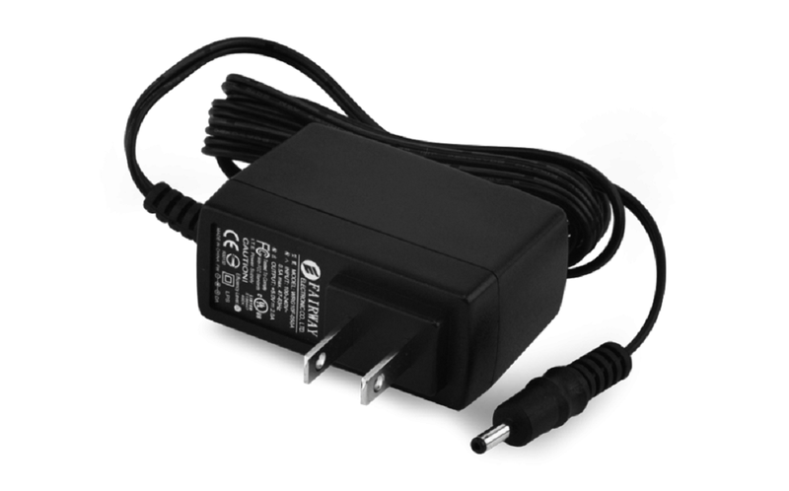

Power adapter 12V

This 12V DC power supply can provide a power source for any electronic device that has an M-type barreland requires 12 volts and up to 1 amps of power.

* Rated Voltage : 100 – 240V AC
* Variation Range : 90 – 264V AC
* Rated Frequency : 50/60Hz
* Variation Frequency : 47 – 63Hz
* Input Current : 0.6A Max. @ Any input AC voltage &
* output full load
* Inrush Current : 35A Max. Cold start @ 240V AC input,
* rated output load & 25°C ambient
* AC Leakage Current : 0.25mA Max. @ 240V AC input

### **4.1.8** Breadboard MB-102 830

MB-102 830 breadboard with holes 165*55*10mm is used to attach modules or electronic components, connect them together by plugs, test board cables to help test, test features easily before forming finished products.

MB-102 830 breadboard with holes 165x55x8mm is an international standard size, high quality and durability, can be used with a number of specially designed power supply modules.

*Breadboard MB-102 830*

Specifications:

* Breadboard MB-102 830.
* Size: 165*55*10mm.
* Divided into 2 symmetrical components.
* 200 holes for the 2-side power line.
* 630 holes for component mounting.
* Made of high-quality, non-toxic ABS plastic.
* Note the coordinate location in letters, numbers and colors to help locate components easily and easily remember.
* Compatible with copper wire sizes of 20-29 AWG.
* Long service life, up to 2500 plugs.

### **4.1.9** LCD 1604 Green

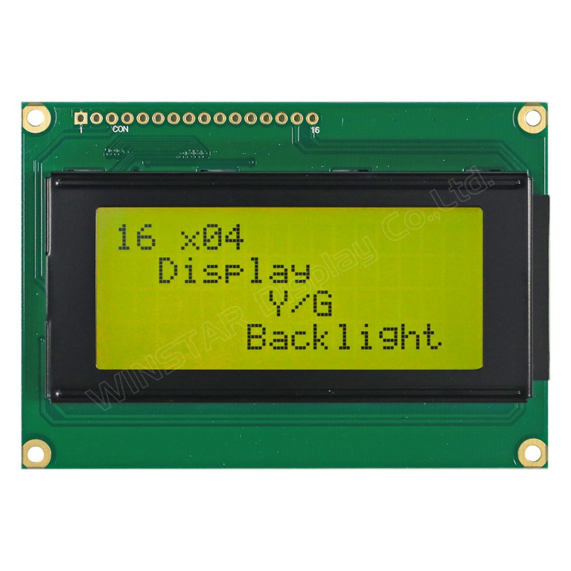

*LCD screen 16x4 – 16 columns 4 rows*

Green LCD 1604 displays 16 characters and 4 lines, the screen is well designed for high durability is very popular application.

Specifications:

* 16 Characters x 4 Lines
* arrow5 x 8 Dots with Cursor
* Built in Controller (HD44780 or equivalent)
* +5V Power Supply
* 1/16 Duty Circle
* RoHS Compliant

For this component, for complete wiring, we will need many pins and it is expensive to enter the ESP8266 expansion board. Therefore, the implementation team equipped the I2C pin switching circuit

### **4.1.10** I2C to LCD Communication Module

*I2C Pin Transfer Module for LCD*

I2C to LCD communication converter module will help you transfer LCD communication 1 way simple with only 2 pins (SCL, SDA). Support for many lcds such as LCD1602, LCD2004, ... module integrates additional pressure philosophy to adjust LCD contrast.Compatible I2C conversion

Compatible with most microcontrollers today, with low cost, high durability. Specifications:

* Operating voltage: 2.5~6VDC
* Various supports: LCD1602.1604, 2004 (driver HD44780)
* Size:41x19x15.3mm
* Weight:5 g

*External structure of the module*

For with the use of I2C modules, the connection work is much simpler.

The following is the connection diagram for LCD when welding pins with I2C module

*Pin connection models using I2C for LCD*

### **4.1.11** PowerAdapter 5V

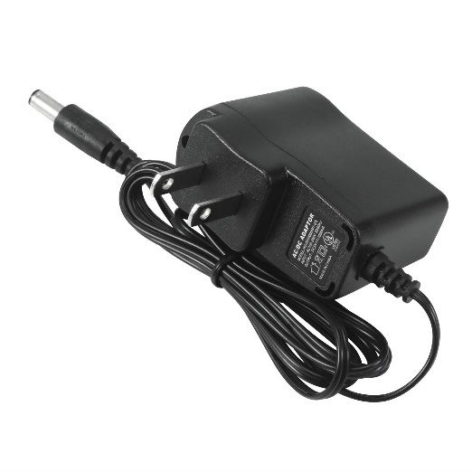

Volt 1 Amp Power Adapter takes an AC INPUT of 90-270V and gives 5V 1A DC output. Specifications:

* + Input – 90-270 VAC 50/60Hz
  + Category – Switch Mode Power Adaptor (SMPS)
  + Output Type – DC
  + Output – 5Volts 1Amp

## **4.2 Experiment**

**4.2.1** Actual electrical circuits

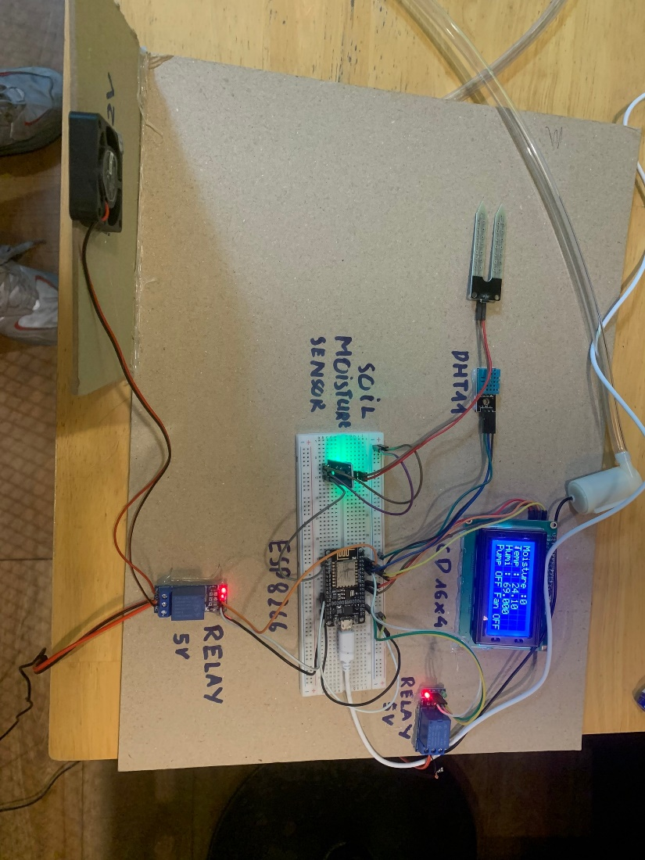

### **4.2.2** Complete application interface

4.2.2.1Gauge represents soil moisture

4.2.2.2 Gauge represents temperature

4.2.2.3 Gauge represents humidity

4.2.2.4 Water pump switch

4.2.2.5 Fan switch

## **4.3 Code**

#define BLYNK_TEMPLATE_ID "TMPL69z9nXewZ"

#define BLYNK_TEMPLATE_NAME "doan"

#define BLYNK_AUTH_TOKEN "0kaIFXHgkLRZPK6f32MR6fFCUf9S-OLv"

#include <LiquidCrystal_I2C.h>

#define BLYNK_PRINT Serial

#include <ESP8266WiFi.h>

#include <BlynkSimpleEsp8266.h>

#include <DHT.h>

//Initialize the LCD display

LiquidCrystal_I2C lcd(0x27, 16, 4);

DHT dht(D2, DHT11); //(sensor pin,sensor type)

char auth[] = "0kaIFXHgkLRZPK6f32MR6fFCUf9S-OLv";//Enter your Auth token

char ssid[] = "iPhone";//Enter your WIFI name

char pass[] = "12345678";//Enter your WIFI password

BlynkTimer timer;

bool Relay = 0;

bool Fan = 0;

//Define component pins

#define sensor A0

#define waterPump D3

#define fan D1

void setup() {

Serial.begin(9600);

Wire.begin(12,14);

pinMode(waterPump, OUTPUT);

digitalWrite(waterPump, LOW);

pinMode(fan, OUTPUT);

digitalWrite(fan, LOW);

lcd.init();

lcd.backlight();

Blynk.begin(auth, ssid, pass, "blynk.cloud", 80);

lcd.clear();

//Call the function

timer.setInterval(100L, soilMoistureSensor);

timer.setInterval(100L, sendSensor);

}

//Get the button value

BLYNK_WRITE(V1) {

Relay = param.asInt();

}

BLYNK_WRITE(V4) {

Fan = param.asInt();

}

//Get the soil moisture values

void soilMoistureSensor() {

int value = analogRead(sensor);

value = map(value, 0, 1024, 0, 100);

value = (value - 100) * -1;

Blynk.virtualWrite(V0, value);

lcd.setCursor(0, 0);

lcd.print("Moisture :");

lcd.print(value);

lcd.print(" ");

if(value < 30)

{

Blynk.logEvent("soil_moisture_alert");

}

}

///humity and temprature

void sendSensor() {

float h = dht.readHumidity();

float t = dht.readTemperature();

if (isnan(h) || isnan(t)) {

Serial.println("Failed to read from DHT sensor!");

return;

}

lcd.setCursor(0, 1);

lcd.print("Temp : ");

lcd.print(t);

lcd.setCursor(-4, 2);

lcd.print("Humi : ");

lcd.print(h);

Blynk.virtualWrite(V2, t);

Blynk.virtualWrite(V3, h);

if (t < 18 || t > 39)

{

Blynk.logEvent("temperature_alert");

}

}

void loop() {

Blynk.run();//Run the Blynk library

timer.run();//Run the Blynk timer

if (Fan == 0) {

digitalWrite(fan, LOW);

lcd.setCursor(5, 3);

lcd.print("Fan OFF ");

} else {

digitalWrite(fan, HIGH);

lcd.setCursor(5, 3);

lcd.print("Fan ONN");

}

if (Relay == 0) {

digitalWrite(waterPump, LOW);

lcd.setCursor(-4, 3);

lcd.print("Pump OFF ");

} else {

digitalWrite(waterPump, HIGH);

lcd.setCursor(-4, 3);

lcd.print("Pump ONN");

}

}

## **4.4 Result**

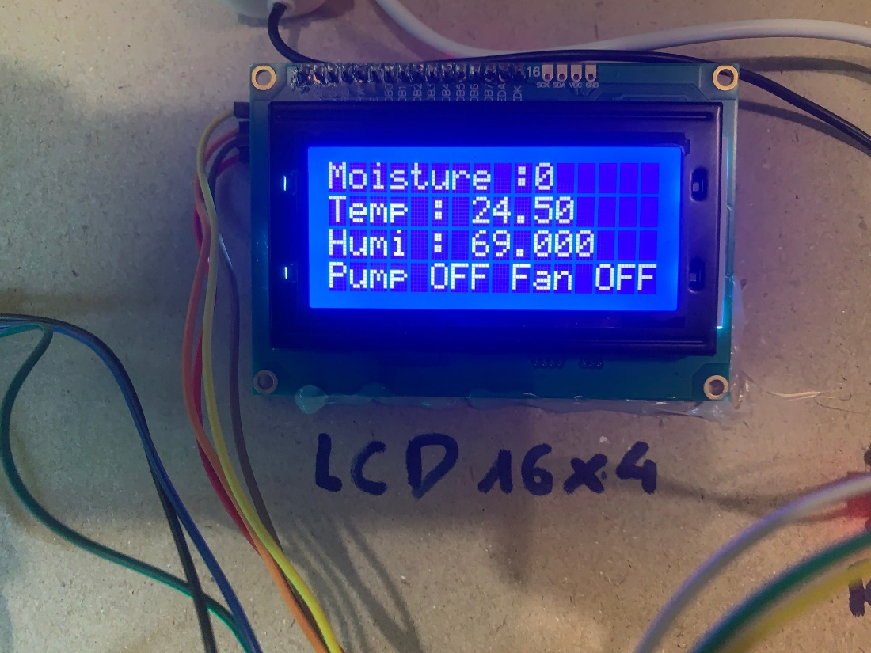

LCD displayed information about nursery garden

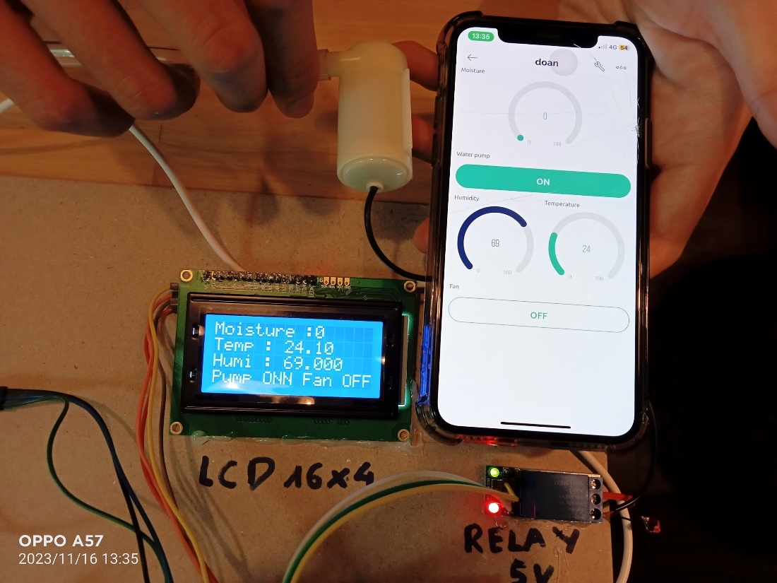

Turn pump on through blynk

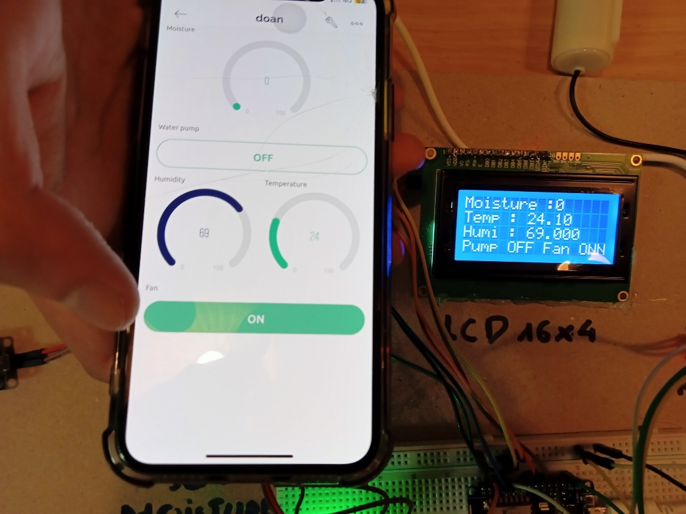  
 Turn fan on through blynk

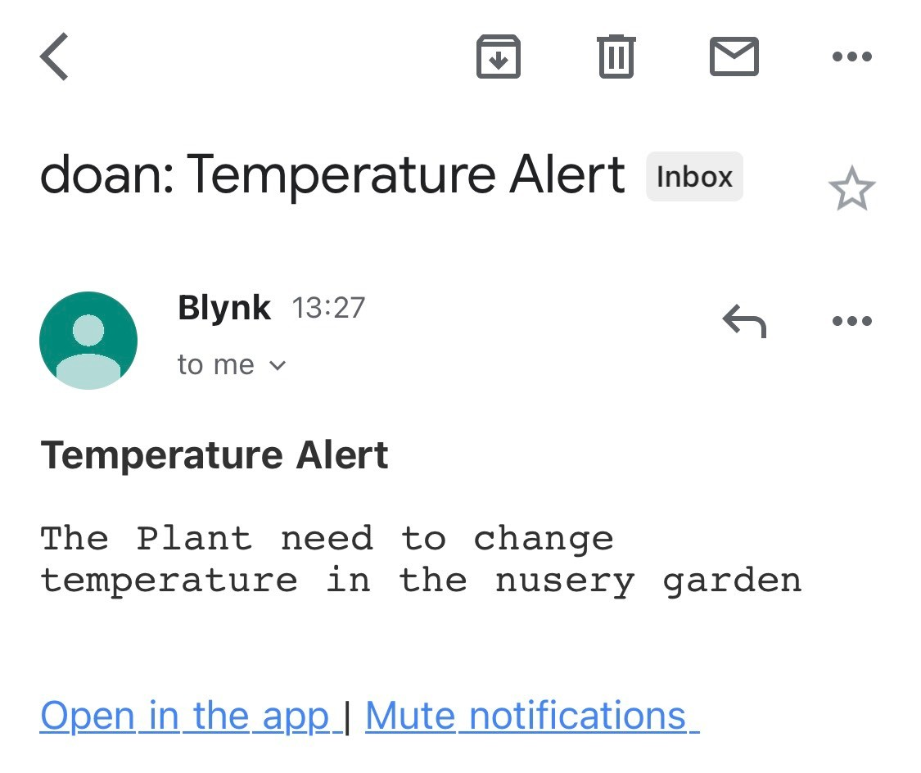

Blynk send temperature alert through email

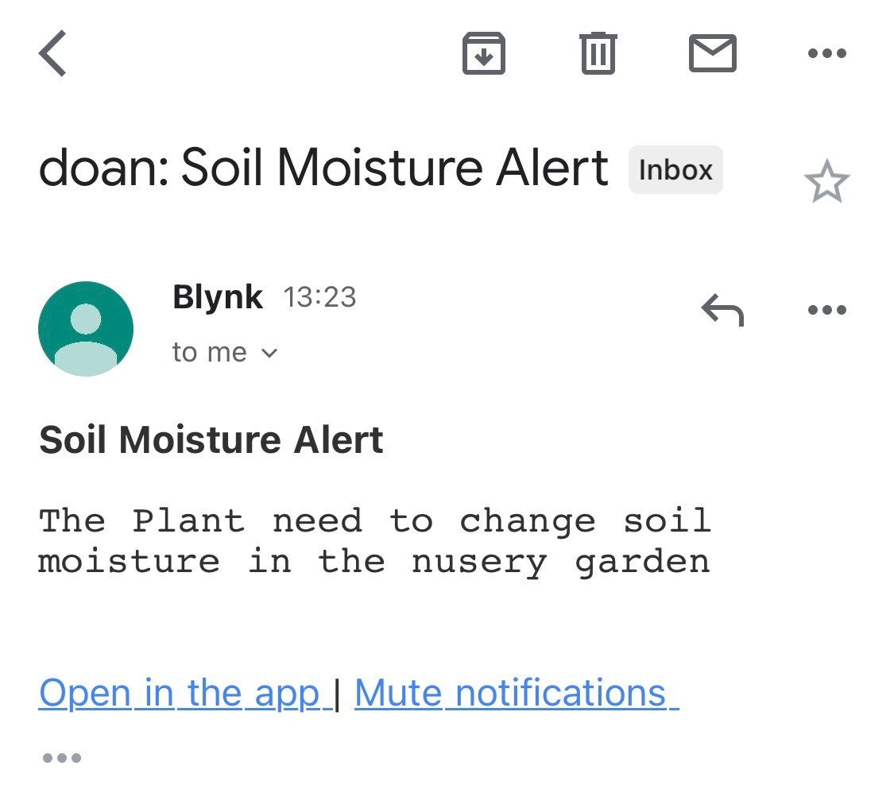

Blynk send soil moisture alert through email

# Chapter 5. **EVALUATION**

**The experiment was measured outdoors to evaluate the Accuracy and Precision of the circuit through information such as temperature and humidity of the environment (measured at 6:00 p.m.).**

|  |  |  |  |  |
| --- | --- | --- | --- | --- |
| **Serial number** | **Measured**  **temprature (℃)** | **Actual**  **temprature (℃)** | **Accuracy**  **(between measurement and reality)** | **Precision (depends on dispersion)** |
| 1 | 28**℃** | 30**℃** | (28/30) * 100% = 93.33% | 29**℃** - 28**℃** = 1**℃** |
| 2 | **29℃** | 30**℃** | (29/30) * 100% = 96.67% |
| 3 | 28.3**℃** | 30**℃** | (28.3/30) * 100% = 94,33% |
| 4 | 28.5**℃** | 30**℃** | (28.5/30) * 100% = 95% |
| 5 | 28.5**℃** | 30**℃** | (28.5/30) * 100% = 95% |

**Draw conclusions:**

**+ Accuracy: You can see that all the measurements are very close to the outdoor temperature of 30℃ (only a maximum difference of 100% - 93.33% = 6.67% from the target in all 5 measurements). Additionally, you can see that although the measured values are close to the target value, they are not close to each other but are highly scattered (from 28℃ to 29℃). And in this case, you would say that the measurements are High Accuracy.**

**+ Precision: You will notice that although these measurements are not close to the target of 30℃, the results of these measurements are very close; there is very little difference in the measurements between them (1℃), so you can say that the dispersion is very small. And in this case, you would say that the measurements are High Precision.**

|  |  |  |  |  |
| --- | --- | --- | --- | --- |
| **Serial number** | **Measured**  **moisture (%)** | **Actual**  **moisture (%)** | **Accuracy**  **(between measurement and reality)** | **Precision (depends on dispersion)** |
| 1 | 74**%** | 72**%** | (72/74) *100% = 97.3% | 74.5**%** – 73.5**%** = 1**%** |
| 2 | 74.5**%** | 72**%** | (72/74.5) *100% = 96.64% |
| 3 | 73.5**%** | 72**%** | (72/73.5) *100% = 97.95% |
| 4 | 74**%** | 72**%** | (72/74) *100% = 97.3% |
| 5 | 74**%** | 72**%** | (72/74) *100% = 97.3% |

**Draw conclusions:**

**+ Accuracy: You can see that all the measurements are very close to the ambient humidity of 72% (only a maximum difference of 100% - 96.64% = 3.36% from the target in all 5 measurements). Additionally, you can see that although the measured values are close to the target value, they are not close to each other but are highly scattered (from 73.5% to 74.5%). And in this case, you would say that the measurements are High Accuracy.**

**+ Precision: We'll notice that although these measurements are not close to the 72% target, they are very close; there is very little difference in the measurements between them (1%), so you can say that the dispersion is very small. And in this case, you would say that the measurements are High Precision.**

# Chapter 6. **SUMMARY, RESTRICTIONS AND DEVELOPMENT ORIENTATIONS**

## **6.1 Summary**

Designing an environmental control system in a nursery is crucial for optimizing plant growth, health, and overall productivity. Such a system helps create and maintain ideal growing conditions. Here's a summary of the key elements and considerations for designing an environmental control system in a nursery:

+ Temperature Control: Maintain a consistent temperature range within the nursery to meet the specific requirements of the plants being grown. Use heating and cooling systems, such as heaters and fans, along with temperature sensors and controllers to achieve this.

+ Irrigation and Water Management: Use irrigation systems like drip or sprinkler systems to deliver water efficiently to plants. Soil moisture sensors and timers can help regulate watering schedules, preventing over- or under-watering.

+ Humidity Control: Control humidity levels to prevent mold, mildew, and fungal diseases while ensuring plants receive adequate moisture. Humidifiers and dehumidifiers can help regulate humidity, with sensors and controllers for monitoring.

## **6.2 Restrictions**

Designing an environmental control system in a nursery involves various considerations and potential restrictions, which may vary depending on factors such as budget, available technology, and specific nursery goals. Here are some common restrictions and limitations to keep in mind when designing such a system :

+ Budget Constraints: Limited financial resources can restrict the selection and implementation of high-end environmental control technologies. Nursery managers may need to prioritize essential components and consider cost-effective alternatives.

Infrastructure: Existing infrastructure, such as the layout of the nursery, the type of greenhouse or growing area, and access to utilities like electricity and water, can impact the design and placement of control system components.

+ Technology Availability: Access to advanced environmental control technology may be limited in some regions or for smaller nursery operations. Nurseries must work with the available technology and adapt their systems accordingly.

+ Space Limitations: The physical space within the nursery may limit the installation of certain components, such as large-scale heating or cooling systems, or limit the capacity for expanding the nursery.

## **6.3 Development orientations**

When considering the development orientations of an environmental control system in a nursery, it's essential to align the system with the nursery's specific goals, available resources, and the broader context of sustainability and technological advancements. Here are some development orientations and strategies for designing an environmental control system in a nursery:

+ Energy Efficiency and Sustainability:

* Prioritize energy-efficient components and practices to reduce operational costs and environmental impact.
* Incorporate renewable energy sources, such as solar panels or wind turbines, to power heating, cooling, and lighting systems.

+ Precision Control:

* Invest in advanced sensors, data analytics, and automation top recisely control environmental variables like temperature, humidity, and light.
* Implement feedback loops that continuously monitor and adjust conditions based on real-time data.

+ Integrated Systems:

* + - * Develop acentralized control system that integrates all environmental components for seamless operation and monitoring.
      * Enable remote access and control for easy management and troubleshooting.

# **REFERENCES.**

[1] Concept of nursery garden [Plant nursery - Wikipedia](https://en.wikipedia.org/wiki/Plant_nursery)

[2] Learning code esp32 [Lập trình ESP32 từ A tới Z (khuenguyencreator.com)](https://khuenguyencreator.com/lap-trinh-esp32-tu-a-toi-z/)

[3] Soil Mositure [Cảm biến độ ẩm đất và những ứng dụng hay của nó | Cộng đồng Arduino Việt Nam](http://arduino.vn/bai-viet/917-cam-bien-dat-va-nhung-ung-dung-hay-cua-no)

[4] LCD and I2C [Hướng dẫn ESP8266 #4 : I2C và cách sử dụng với LCD16*2, ghép nối với E MTE (lamchucongnghe.com)](https://lamchucongnghe.com/huong-dan-esp8266-4-i2c-va-cach-su-dung-voi-lcd16-2-ghep-noi-voi-esp8266)

[5] DHT11 library [Đọc nhiệt độ, độ ẩm (DHT11) sử dụng Arduino Uno | ARDUINO KIT](https://arduinokit.vn/doc-cam-bien-nhiet-do-do-am-dht11-arduino/)